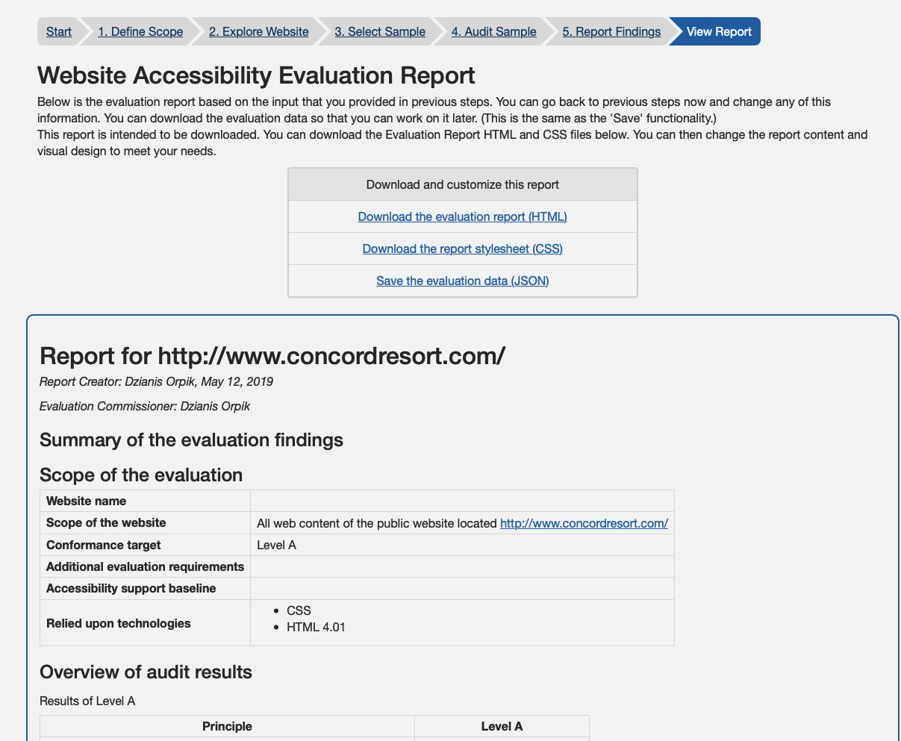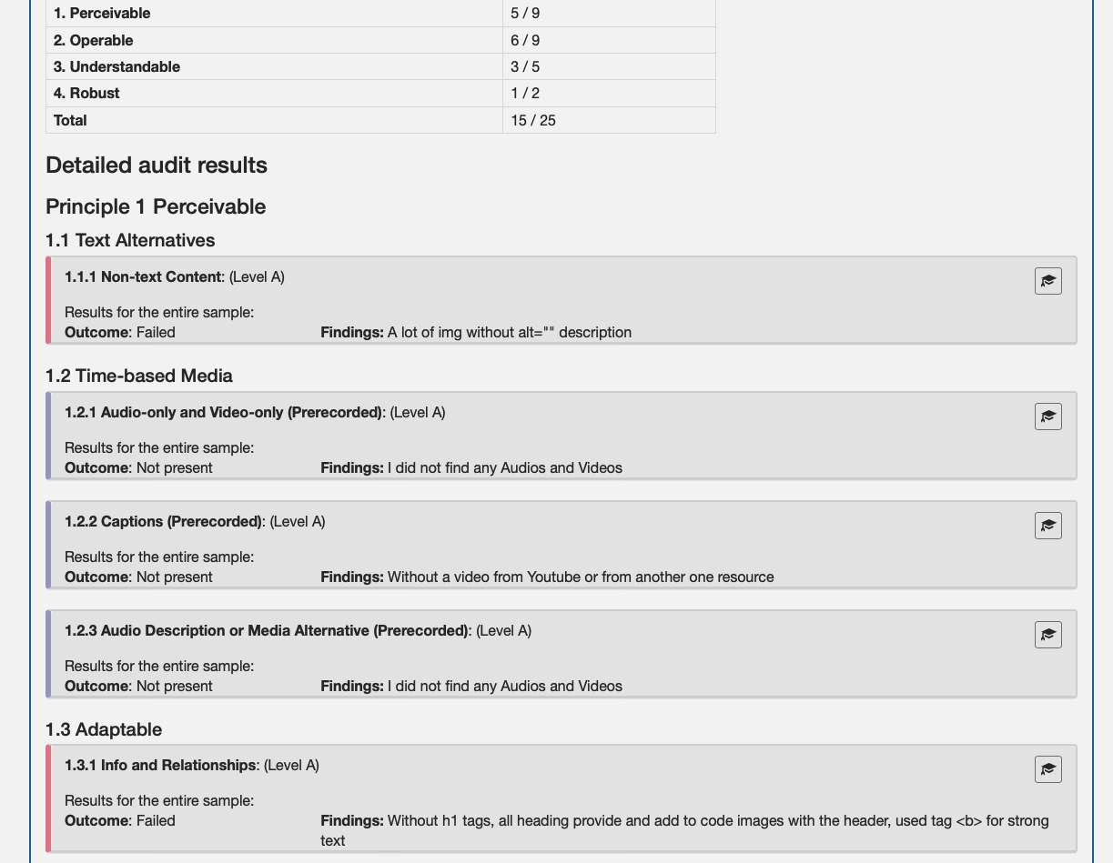

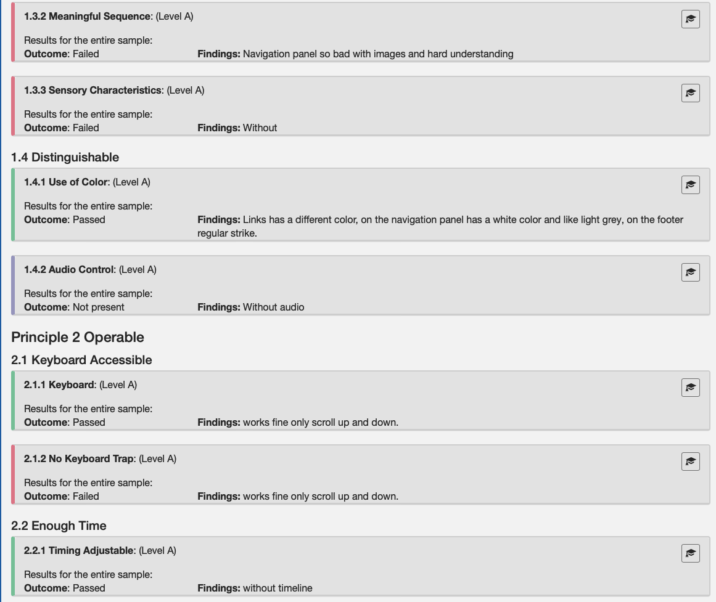

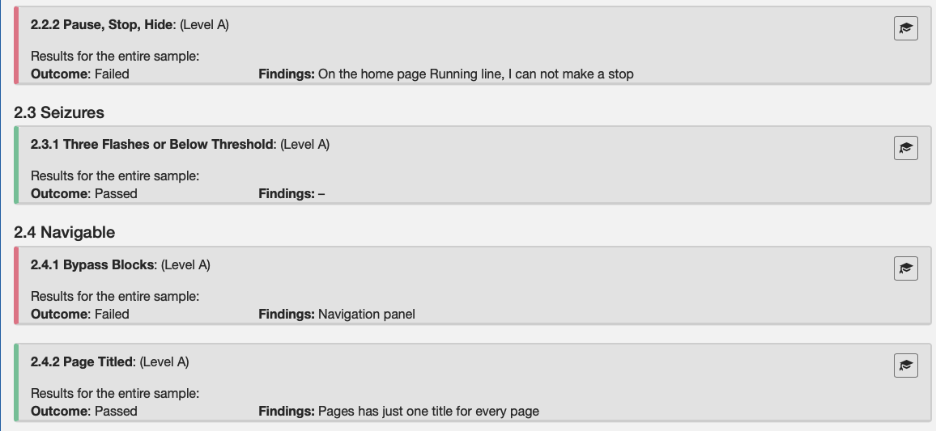
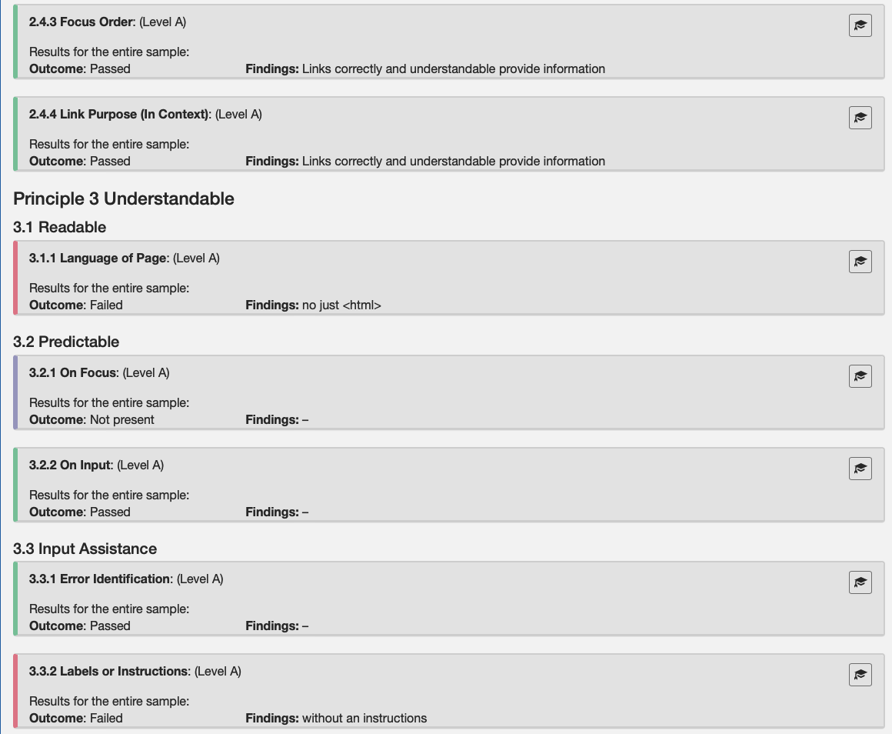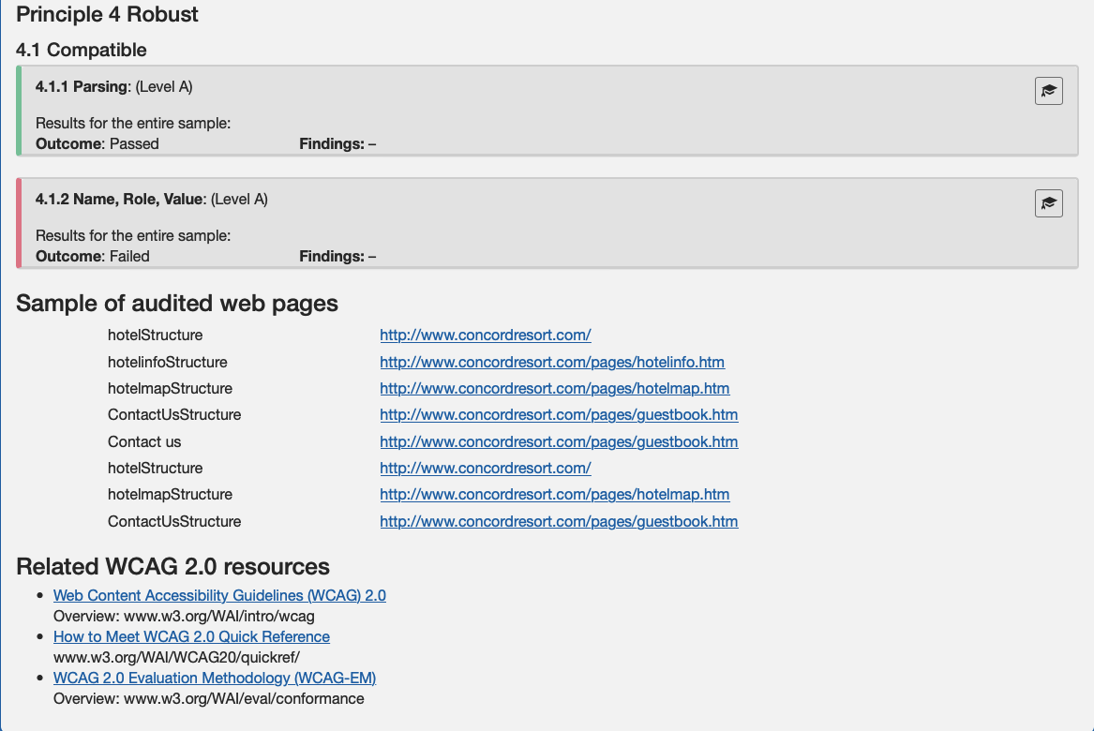
https://www.w3.org/WAI/eval/report-tool/#/view_report

Website Accessibility Evaluation Report
Below is the evaluation report based on the input that you provided in previous steps. You can go back to previous steps now and change any of this information. You can download the evaluation data so that you can work on it later. (This is the same as the 'Save' functionality.)
This report is intended to be downloaded. You can download the Evaluation Report HTML and CSS files below. You can then change the report content and visual design to meet your needs.
Download and customize this report
- Download the evaluation report (HTML)
- Download the report stylesheet (CSS)
- Save the evaluation data (JSON)

Report for http://www.concordresort.com/
Report Creator: Dzianis Orpik, May 12, 2019
Evaluation Commissioner: Dzianis Orpik

Summary of the evaluation findings

Scope of the evaluation
Website name
Scope of the website | All web content of the public website located http://www.concordresort.com/
Conformance target | Level A
Additional evaluation requirements
Accessibility support baseline
Relied upon technologies | - CSS  - HTML 4.01

Overview of audit results
Results of Level A
Principle | Level A
1. Perceivable | 5 / 9
2. Operable | 6 / 9
3. Understandable | 3 / 5
4. Robust | 1 / 2
Total | 15 / 25

Detailed audit results

Principle 1 Perceivable

1.1 Text Alternatives
1.1.1 Non-text Content: (Level A)
Results for the entire sample:
Findings: A lot of img without alt="" description

1.2 Time-based Media
1.2.1 Audio-only and Video-only (Prerecorded): (Level A)
Results for the entire sample:
Findings: I did not find any Audios and Videos
1.2.2 Captions (Prerecorded): (Level A)
Results for the entire sample:
Findings: Without a video from Youtube or from another one resource
1.2.3 Audio Description or Media Alternative (Prerecorded): (Level A)
Results for the entire sample:
Findings: I did not find any Audios and Videos

1.3 Adaptable
1.3.1 Info and Relationships: (Level A)
Results for the entire sample:
Findings: Without h1 tags, all heading provide and add to code images with the header, used tag <b> for strong text
1.3.2 Meaningful Sequence: (Level A)
Results for the entire sample:
Findings: Navigation panel so bad with images and hard understanding
1.3.3 Sensory Characteristics: (Level A)
Results for the entire sample:

1.4 Distinguishable
1.4.1 Use of Color: (Level A)
Results for the entire sample:
Findings: Links has a different color, on the navigation panel has a white color and like light grey​, on the footer regular strike.
1.4.2 Audio Control: (Level A)
Results for the entire sample:

Principle 2 Operable

2.1 Keyboard Accessible
2.1.1 Keyboard: (Level A)
Results for the entire sample:
Findings: works fine only scroll up and down.
2.1.2 No Keyboard Trap: (Level A)
Results for the entire sample:
Findings: works fine only scroll up and down.

2.2 Enough Time
2.2.1 Timing Adjustable: (Level A)
Results for the entire sample:
Findings: without timeline
2.2.2 Pause, Stop, Hide: (Level A)
Results for the entire sample:
Findings: On the home page Running line, I can not make a stop

2.3 Seizures
2.3.1 Three Flashes or Below Threshold: (Level A)
Results for the entire sample:

2.4 Navigable
2.4.1 Bypass Blocks: (Level A)
Results for the entire sample:
Findings: Navigation panel
2.4.2 Page Titled: (Level A)
Results for the entire sample:
Findings: Pages has just one title for every page
2.4.3 Focus Order: (Level A)
Results for the entire sample:
Findings: Links correctly and understandable provide information
2.4.4 Link Purpose (In Context): (Level A)
Results for the entire sample:
Findings: Links correctly and understandable provide information

Principle 3 Understandable

3.1 Readable
3.1.1 Language of Page: (Level A)
Results for the entire sample:

3.2 Predictable
3.2.1 On Focus: (Level A)
Results for the entire sample:
3.2.2 On Input: (Level A)
Results for the entire sample:

3.3 Input Assistance
3.3.1 Error Identification: (Level A)
Results for the entire sample:
3.3.2 Labels or Instructions: (Level A)
Results for the entire sample:
Findings: without an instructions

Principle 4 Robust

4.1 Compatible
4.1.1 Parsing: (Level A)
Results for the entire sample:
4.1.2 Name, Role, Value: (Level A)
Results for the entire sample:

Sample of audited web pages
- hotelStructure http://www.concordresort.com/
- hotelinfoStructure http://www.concordresort.com/pages/hotelinfo.htm
- hotelmapStructure http://www.concordresort.com/pages/hotelmap.htm
- ContactUsStructure http://www.concordresort.com/pages/guestbook.htm
- Contact us http://www.concordresort.com/pages/guestbook.htm
- hotelStructure http://www.concordresort.com/
- hotelmapStructure http://www.concordresort.com/pages/hotelmap.htm
- ContactUsStructure http://www.concordresort.com/pages/guestbook.htm

Related WCAG 2.0 resources
- Web Content Accessibility Guidelines (WCAG) 2.0
Overview: www.w3.org/WAI/intro/wcag
- How to Meet WCAG 2.0 Quick Reference
www.w3.org/WAI/WCAG20/quickref/
- WCAG 2.0 Evaluation Methodology (WCAG-EM)
Overview: www.w3.org/WAI/eval/conformance

