[SF16Functional Testing: Final Test (original task)](https://drive.google.com/file/d/1SJwSFq3sxovQZsIaJRzOGQ074Gc1xi0-/view?usp=sharing)

|  |  |
| --- | --- |
| Your name and group ID: **Pimenau Dzmitry  M-ST1-244-21** | Date: 19.04.2021 |

## Introduction to the project

Imagine that you were assigned to a new project as a tester where domain area – finances. You and your test team lead Victor is located in Minsk. The rest team – in India, China (development) and USA (business analyst, customers and supervisors).

This is a small mobile project developed for Blackberry platform. After login to the application you are redirected to the Home screen (please see the screenshot of the Home screen below):

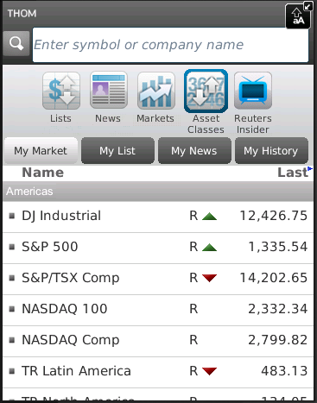

Financial content of the Home screen

Search bar

Main horizontal menu with icons

Customer of the project (named Brian) wants to implement a new feature for this project. Brian was working with business analyst John on requirements for this feature.

So, your task is:

1. Review the requirements for the new feature provided by John.
2. In case of any questions you need to write email to John with request to clarify your questions.
3. Provide estimations for test activities for this feature by email to your test lead Victor.
4. Write main test cases for the feature.
5. Review provided screens with the implemented feature.
6. Find and submit bugs in case of any.
7. (*optional task) Send test results and your decisions about quality of the feature to Victor.

**Below you will find requirements for the feature and templates for emails, test cases, bug reports and so on, please fill in only those templates that you think reasonable in scope of this feature. Also you can write any additional information that you want.**

## Requirements for the new feature

**User story #045**

**Summary**: As a user I want to access my Profile from the Home screen

**Priority**: Major

**Description**:

* 1. Profile menu icon exists in the Home screen.
* 2. Profile menu icon is positioned on the list of menu icons in the Home screen between Asset Classes and Reuters Insider icons.
* 3. Profile view is displayed when Profile icon is selected.
* 4. The Profile view must have header section (with name, company, location, thought of the day and photo).
* 5. If photo is not available then default image is used.
* 6. The rest of the person’s detail fields can be scrolled, only lines where user has added information are shown.
* 7. Text size must not be too small.

## Clarification letter for business analyst regarding the feature #045:

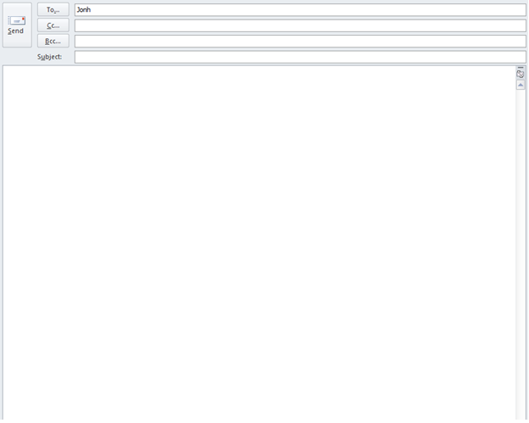

Victor

Clarification of requirements for User story #045

Hello, John!  
 I have carefully studied the requirements presented and would like to clarify some questions I have about User story #045.

1. *Is the user's story a story for mobile, desktop app, hybrid, web? (in real projects, it is unlikely that I will clarify this question with the customer, but now it seems that this is not written anywhere. This question should be raised by me.*
2. Perhaps you already have the design layout of the home screen ready? Then some questions could be clarified without further explanation on your part.
3. * In which part of the screen should the app icons be located?
4. * How many icons should be displayed on the home screen in total?
5. * Are the fonts and their sizes that will be used for the titles and other elements of the application agreed with the designers?
6. * How many percent of the screen should they take up?
7. * The profile view is displayed when you select the profile icon in a new window, either it should be a pop-up window or a tab on the home screen?
8. * Is the default image already consistent?

-- Best regards, Dzmitry Pimenau +375296086718

## Test estimations for the feature #045 to the test team lead Victor:

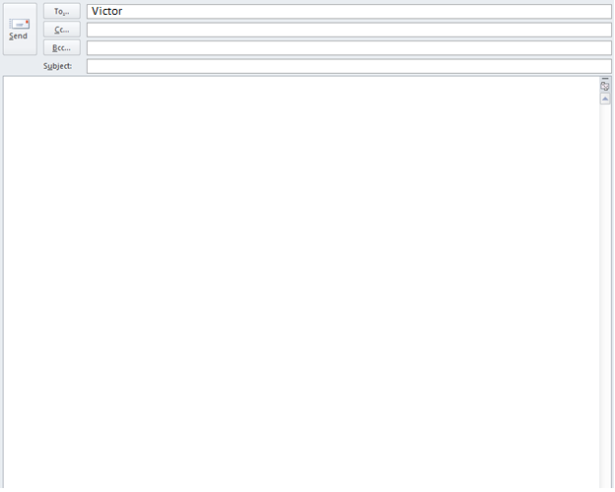

Time estimation by User story #045

Hello, Victor!

I received a task for the user story #045, as you can see, I sent the customer some clarifying questions.

I estimate the time it will take me to check as follows:

1. the optimistic time is 4 hours,
2. pessimistic time - 8 hours,
3. the most likely time is 6 hours,

At this time, I plan to have time to do:

1) writing test cases-40% of the time,

2) test runs - 10% of the time,

3) bug detection - 20 % of the time,

4) time not for meetings, business correspondence, unexpected delays-30% of the time.

Our client usually reacts quickly, so I hope that I will have time to meet the time closer to the optimistic time, but in the event of a delay on his part, my time may shift towards a pessimistic forecast.

If there is any additional important information, I will let you know in the process.

-- Best regards, Dzmitry Pimenau +375296086718

## Test cases for the feature #045:

|  |  |  |  |  |  |  |
| --- | --- | --- | --- | --- | --- | --- |
| **No** | **Req. No.** | **Module** | **Test Description** | **Expected Results** | **Passed /Failed** | **Comments** |
| P1 | 1 | Home Screen | Summary.  The layout of the items on the home screen  Steps:  1) Open the main screen of the app. | The layout of the items on the home screen matches the description. | Failed | Bug#1 |
| **No** | **Req. No.** | **Module** | **Test Description** | **Expected Results** | **Passed /Failed** | **Comments** |
| P2 | 7 | Home Screen | Summary.  All text is readable.  Steps:  1) Open the main screen of the app.  2) Read all the information written in text. | The information is being read | Passed |  |
| **No** | **Req. No.** | **Module** | **Test Description** | **Expected Results** | **Passed /Failed** | **Comments** |
| P3 |  | Home Screen | Summary.  Spelling in the app Steps:  1) Open the main screen of the app.  2) Read all the information written in text. | All text information is written without errors | Passed |  |
| **No** | **Req. No.** | **Module** | **Test Description** | **Expected Results** | **Passed /Failed** | **Comments** |
| P4 |  | Home Screen | Summary.  Clickability of icons and tabs.  Steps:  1) Open the main screen of the app. 2) Alternate clicks on the icons and tabs located on the home screen. | The icons, tabs are clickable, and some functions are called when clicked. | Passed |  |
| **No** | **Req. No.** | **Module** | **Test Description** | **Expected Results** | **Passed /Failed** | **Comments** |
| P5 |  | Home Screen | Summary.  Search bar.  Steps:  1) Open the main screen of the app. 2) Choose Asset classes. 3) Enter “NAS” in the search bar. | Search results are displayed | Passed |  |
| **No** | **Req. No.** | **Module** | **Test Description** | **Expected Results** | **Passed /Failed** | **Comments** |
| P6 |  | Home Screen | Summary.  Sort in ascending/descending order in the search bar.  Steps:  1) Open the main screen of the app. 2) Choose Asset classes. 3) Enter “NAS” in the search bar. 4) Click the ascending/descending sort icon in the right corner of the search bar. | The values are sorted in ascending/descending order. | Passed |  |
| **No** | **Req. No.** | **Module** | **Test Description** | **Expected Results** | **Passed /Failed** | **Comments** |
| P7 | 4 | Profile | Summary.  Displaying the profile tab.  Steps:  1) Open the main screen of the app. 2) Choose Ptofile. | The profile has the form and main sections described in the requirements. | Failed | Bug#2 |

|  |  |  |  |  |  |  |
| --- | --- | --- | --- | --- | --- | --- |
| **No** | **Req. No.** | **Module** | **Test Description** | **Expected Results** | **Passed /Failed** | **Comments** |
| P8 |  | Home Screen | Summary.  Reaction to pressing system buttons.  Steps:  1) Open the main screen of the app. 2) Press the home button on your phone | The app has collapsed. | Passed |  |
| **No** | **Req. No.** | **Module** | **Test Description** | **Expected Results** | **Passed /Failed** | **Comments** |
| P9 |  | Home Screen | Summary.  Changing the screen orientation.  Steps:  1) Open the main screen of the app. 2) Choose Profile. 3) Change the screen orientation. | The data that is displayed on the screen is still displayed on the screen, the layout "did not move out" | Passed |  |
| **No** | **Req. No.** | **Module** | **Test Description** | **Expected Results** | **Passed /Failed** | **Comments** |
| P10 |  | Home Screen | Summary.  How the app works on an incoming call.  Steps:  1)Open the main screen of the app. 2) Choose Asset classes. 3) Enter “NAS” in the search bar. 4) Accept an incoming call.  5)After the call ends, go back to the app page | The entered data is not lost, you can continue working with the application. | Passed |  |

## The feature #045 is ready for testing:

So, developers have finished implementation the feature #045. You received notification that the build with feature #045 was released and ready for testing. The build was successfully installed. Victor asked you to test the feature. You open the application -> login -> and see the Home screen provided below:

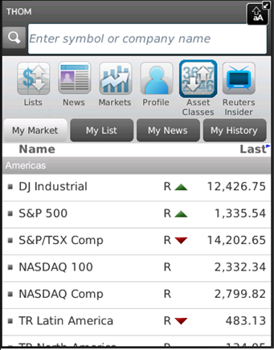

Upon clicking Profile icon in the main horizontal menu the next screen is opened:

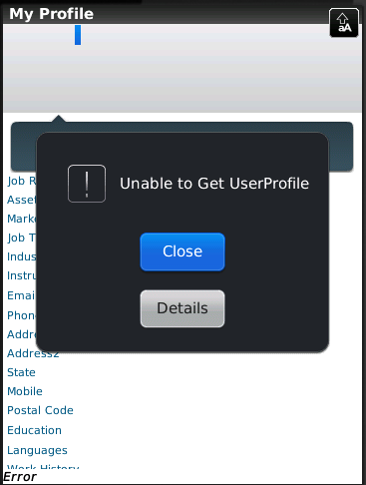

**If you see any bugs in these two screens you can post them below:**

## Templates for bug reports:

|  |  |
| --- | --- |
| **Bug ID** | **#1** |
| **Summary** | The icon layout does not meet the requirements |
| **Description** | **Act. Result:** Profile menu icon is positioned on the list of menu icons in the Home screen between Markets and Asset Classes icons. **Exp. Result:**  Profile menu icon is positioned on the list of menu icons in the Home screen between Asset Classes and Reuters Insider icons.  **Req**: 2 |
| **Severity** | Minor |
| **Steps to reproduce** | **Steps:**  1) Open the main screen of the app. 2) The bug appears  **Reproducibility:** always |
| **Bug ID** | **#2** |
| **Summary** | When you select a profile, a message appears with information about the inability to get a user profile. |
| **Description** | **Act. Result:** When you select a profile, a message appears with information about the inability to get a user profile.  **Exp. Result:**  Profile view is displayed when Profile icon is selected. The Profile view must have header section (with name, company, location, thought of the day and photo).  **Req**: 3,4 |
| **Severity** | Blocker |
| **Steps to reproduce** | **Steps:**  1) Open the main screen of the app. 2) Select “profile” tab 2) The bug appears  **Reproducibility:** always |

## Test results to the test team lead:

Test report feature #045

Hello! Here is the test report feature #045

* Test cases created – 10, time spent - 2 hours
* As a result of the test run

- passed tests: 8,

- failed tests: 2.  
time spent - 1 hours.

* Bugs created – 2, time spent - 1 hours.

Statistics on the bugs:

Blocker – 1  
 Minor – 1;

* Other (reporting, business correspondence) – 1 hours.
* Total time spent on the task: 5 hours

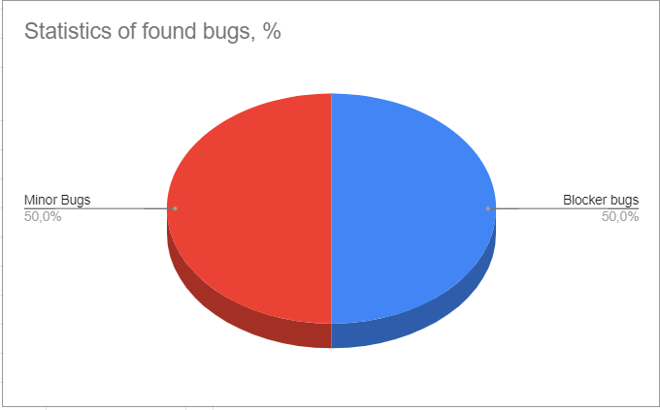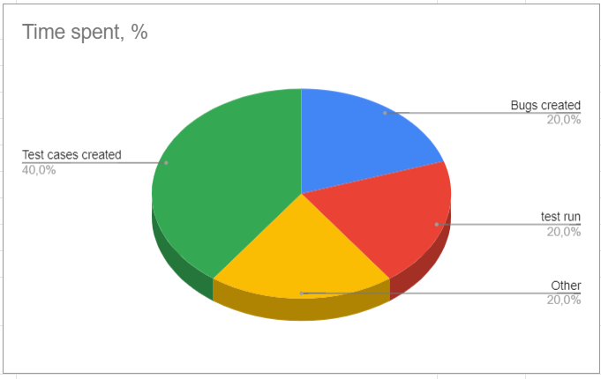

Figure 1 Figure 2

-- Best regards, Dzmitry Pimenau +375296086718