**Description of implementation of Task1-PAI**

dengzi ([dengzi@student.ethz.ch](mailto://dengzi@student.ethz.ch))

1. **Init model and select kernel**
2. **Randomly sample from training data and fit model using GPR**
3. **Test**

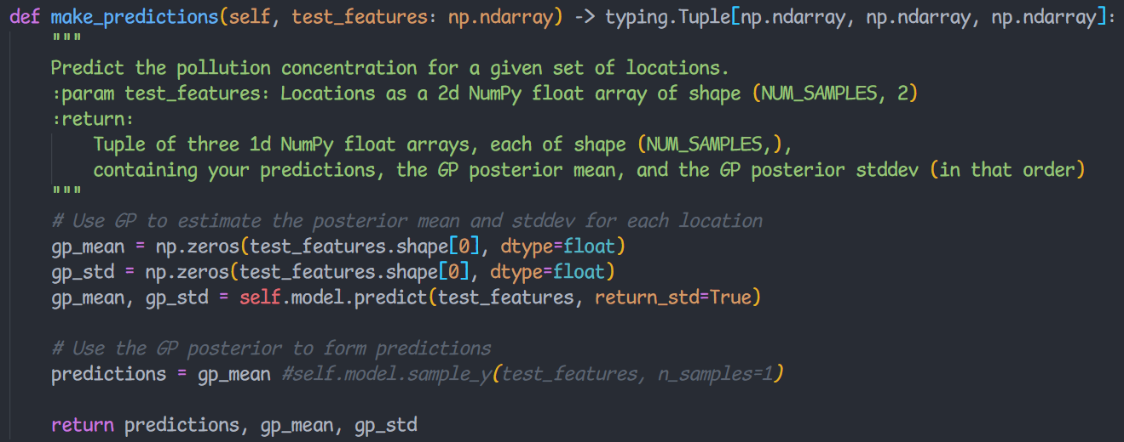

**I define and implement a Gaussian kernel, and then pass the train data and the test data to the Gaussian kernel. Using the K_AA, k_xA, and k_xx calculate by the gaussian kernel, and add some noise, I get the mean and the variance of the GP model. I choose the model parameter by adjusting the sigma_p and length_scale of the kernel and the observation noise sigma_n.**

**Ps: my computer is too slowly to process the GPR(Gaussian Process Regression), so I don’t use this method.**

To implement Gaussian Process Regression, I choose an RBF kernel with an output scale (by times a constant kernel), in order to train faster, I set the length scale of the RBF kernel as 0.05 and fixed. As for the GPR model, I add a noise 1e-8 and set the restart times of the optimizer as 1. The code is as below:

self.kernel = ConstantKernel(constant_value=0.3, constant_value_bounds=(1e-3, 1)) * RBF(length_scale=0.05, length_scale_bounds='fixed')

self.model = GaussianProcessRegressor(kernel=self.kernel, alpha=1e-8, n_restarts_optimizer=1)

Then I set a random p = 0.42, and randomly sampled data using this probability p.

choice_p = 0.42

train_set = np.random.choice([True, False], len(train_GT), p=[choice_p, 1.0-choice_p])

self.train_X = train_features[train_set,:]

self.train_Y = train_GT[train_set]

Finally, fitting the GPR model and processing prediction on the test data.

self.model.fit(self.train_X, self.train_Y)

gp_mean, gp_std = self.model.predict(test_features, return_std=True)