Create a backend for simple News Management application using all knowledge from
Training. Pay attention that your application should be without view layer (UI).

Your application should perform next operations:
- Add news;
- Edit news;
- Delete news;
- View the list of news;
- View single news message;
- Add news author;
- Search according SearchCtiteria (see details in Implementation requirements section);
- Add tag/tags for news message;
- Add comment(s) for news message;
- Delete comment(s);
- Get list of news messages should be sorted by most commented news.
- Save news message with author and tags should go as one step in service layer;
- Each news should have only one author;
- Each news may have more than 1 tag;
- Count all news;

Implementation requirements:
- Persistence layers should implement four basic C.R.U.D operations.
- Sun java coding conventions;
- Follow naming standards for all database objects;
- Use Spring Dependency Injection and Inversion of Control;
- Service layer should be tested using mocking framework - Mockito;
- Persistence layer should be tested using DBUnit framework. Default data for testing should be loaded automatically.
- Use Transfer Object to represent each database entity.
- For search functionality use SeachCriteria object which may contains: author entity and list of tags (will be using for constructing SQL queries in DAO layer);
- Note: author can be deleted – it’s possible to make him expired (not displayable in author dropdown, but visible on new list and view/update news);

System requirements:
- Database: Oracle (version 10 and higher)
- Data access: JDBC (simple SQL);
- Use bitbucket as code repository.

Definition of done:
- Code is clean, readable and documented;
- The application should has correct structure of packages;
- Database schema should be adjusted as described on page 2. Create 2 separate db scripts: one for db schema generation and one for loading default data (near 20 items for each table);
- Exception handling;
- Logging;
- Application should be built using Maven in jar file (preferable to do it manually using command line, without help of IDE);
Data model

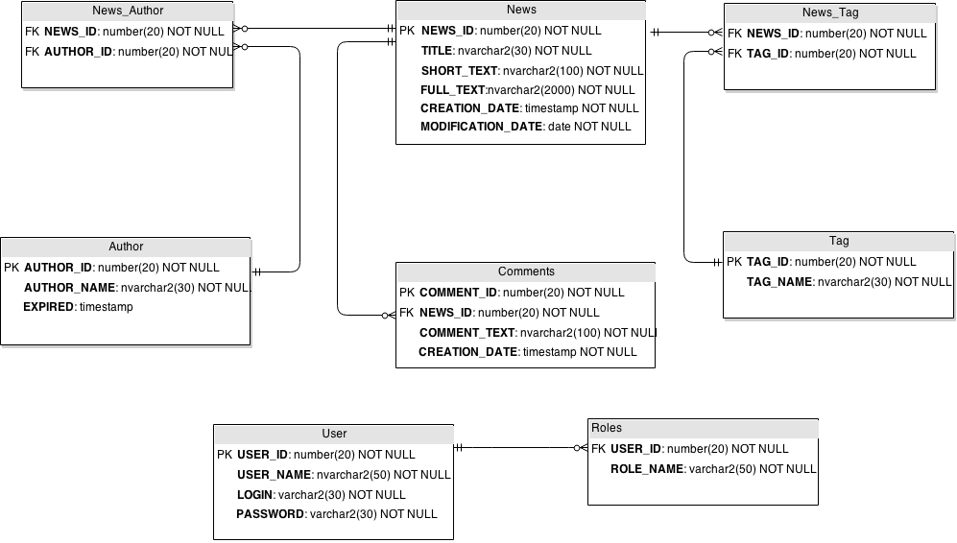
Useful links for task
- Spring tutorials:
http://evbyminsdbookz.minsk.epam.com/index.php/details/spring-action/84833?hl=spring
http://evbyminsdbookz.minsk.epam.com/index.php/details/pro-spring/90199?hl=spring
http://www.tutorialspoint.com/spring/spring_tutorial.pdf
http://simplespringtutorial.com/index.html
http://www.journaldev.com/2888/spring-framework-tutorial-with-example-projects
http://evbyminsdbookz.minsk.epam.com/index.php/details/pro-javatm-ee-spring-patterns-best-practices-design-strategies-implementing-java-ee-patterns-spring-framework/118683?hl=Pro+Java+EE+Spring+Patterns

- Sun java coding conventions:
http://www.oracle.com/technetwork/java/codeconventions-150003.pdf
http://www.oracle.com/technetwork/java/javase/documentation/codeconvtoc-136057.html

- Database naming standards:
https://docs.oracle.com/cd/E18727_01/doc.121/e12897/T302934T458266.htm
http://www.codeproject.com/Articles/232457/Database-Design-and-Naming-Conventions
http://ss64.com/ora/syntax-naming.html

- Mockito:
http://docs.mockito.googlecode.com/hg/1.9.5/org/mockito/Mockito.html
http://www.codeproject.com/Articles/516360/Mockito-a-great-mock-framework-for-Java-developmen
http://www.vogella.com/tutorials/Mockito/article.html

- DBUnit:
http://www.unitils.org/tutorial-database.html
http://www.realsolve.co.uk/site/tech/dbunit-quickstart.php
http://www.javacodegeeks.com/2012/04/dbunit-spring-and-annotations-for.html
- Training material
\\EPBYMINSA0000\Training Materials\EPAM Trainings\

