Develop News Management application. It should include backend from the first task + introduce UI layer.

UI Requirements:
- Fixed left-hand sidebar menu. Only the actions applicable to current main view should be displayed on the menu;
- Fixed footer. Footer should contain copyright and year.
- Fixed top area. Top area should contain links to change application language;
- News title, short description and creation (or modification) date should present on news list view;
- News title, short description and full news text should present on news view page;
- Pagination should be present on the news list page;
- User should be redirected to the login page after clicking on “Logout” button;
- Current page should be highlighted in the admin menu;

Technology stack:
- Spring MVC – for admin application part;
- Java Servlet – for client part;
- Apache Tiles;
- Spring Security;
- JavaScript (JQuery);

Implementation requirements:
- MVC architectural pattern should be used;
- Spring security
- The application should be designed with respect to SOLID design principles. Use appropriate design patterns.
- Public API should be properly commented. The code should contain valuable comments. The code should be self -documenting.
- Application should be divided into 3 sub-projects: news-common, news-client, news-admin.
- Maven builds the application and as a result you should have 2 war files: news-client.war and news-admin.war – both of it should contain news-common.jar file (please see page 2: package structure);
- Use Spring Dependency Injection and Inversion of Control;
- User password value should be hashed using MD5;
- News creation validation: author is mandatory, tag – is not mandatory;
- News creation/update:
- News create: creation and modification date are equals;
- News create: go to the VIEW page after clicking ‘SAVE’ button;
- News update: display modification date and update it, do not update creation date;
- New list sorting by comments count + modification date;
Package structure:
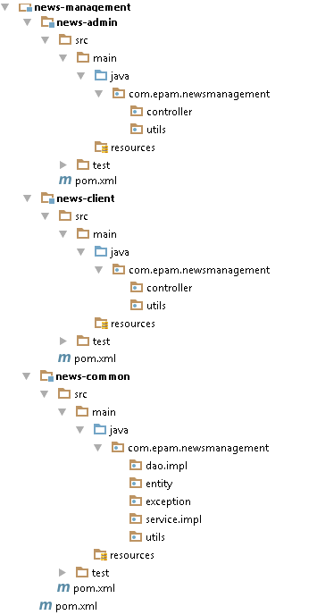

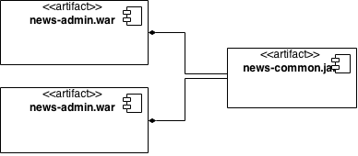
News-client: News List
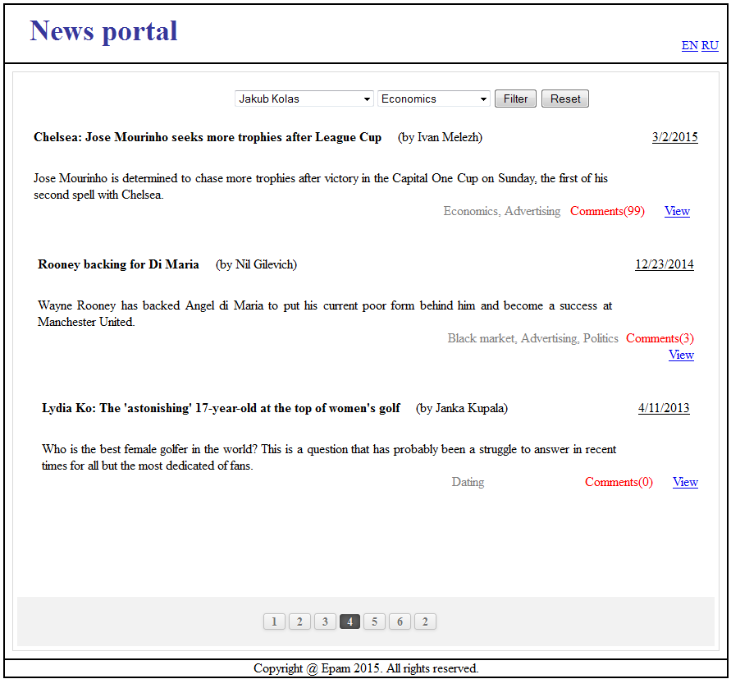
Author dropdown
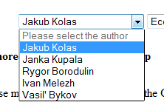
Tags dropdown
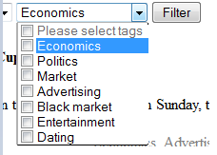
News-client: View News
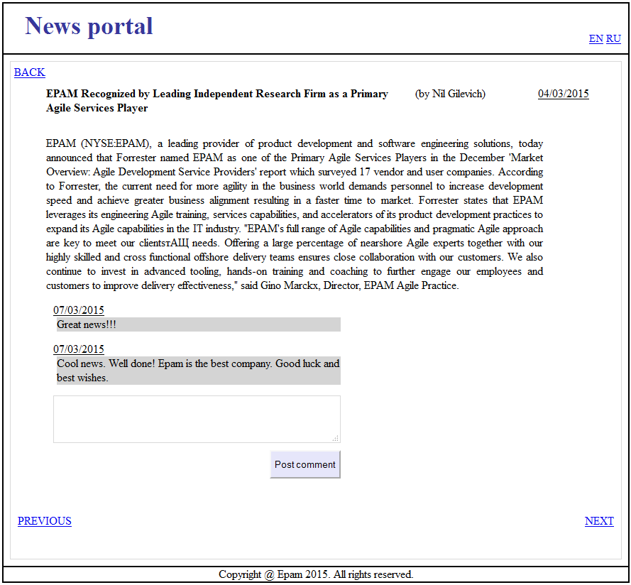

News-admin: Login
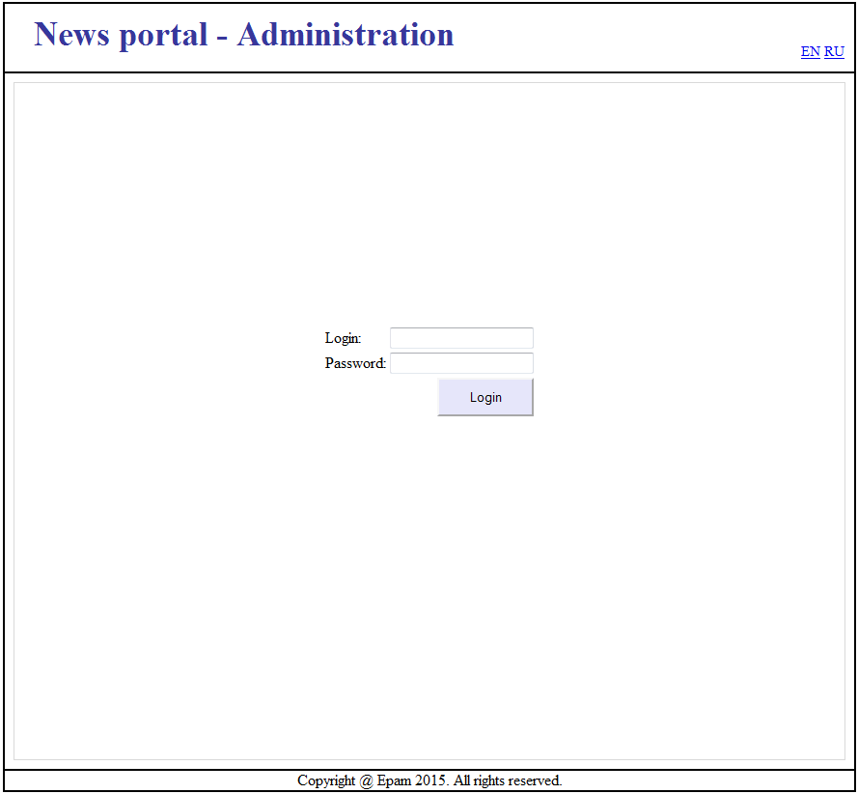

News-admin: New List
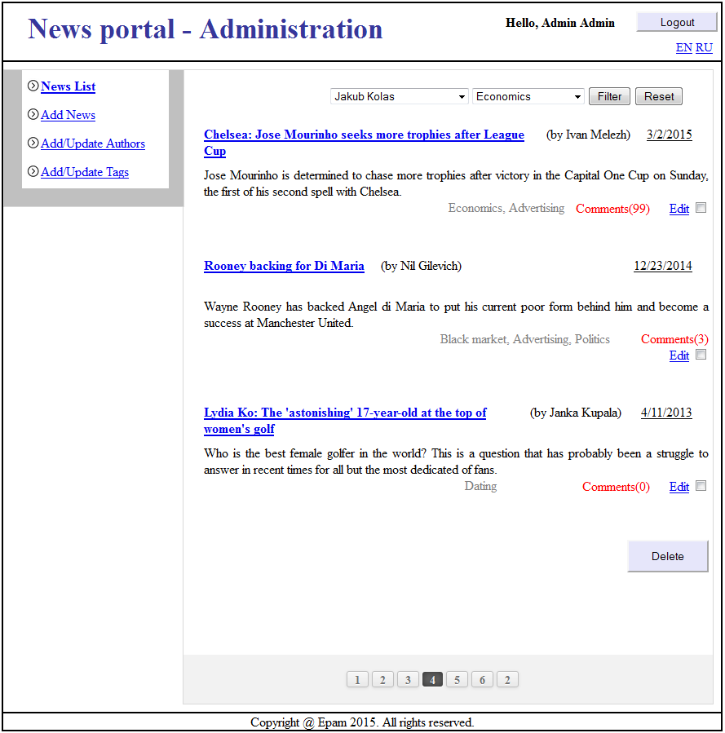
News-admin: View News (delete comments possibility)
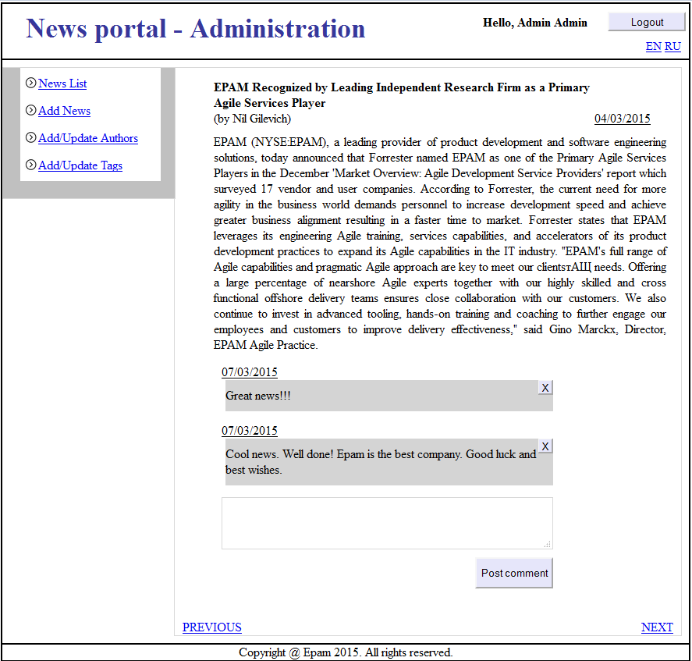
News-admin: Add News
Note: edit page the same with prepopulated fields
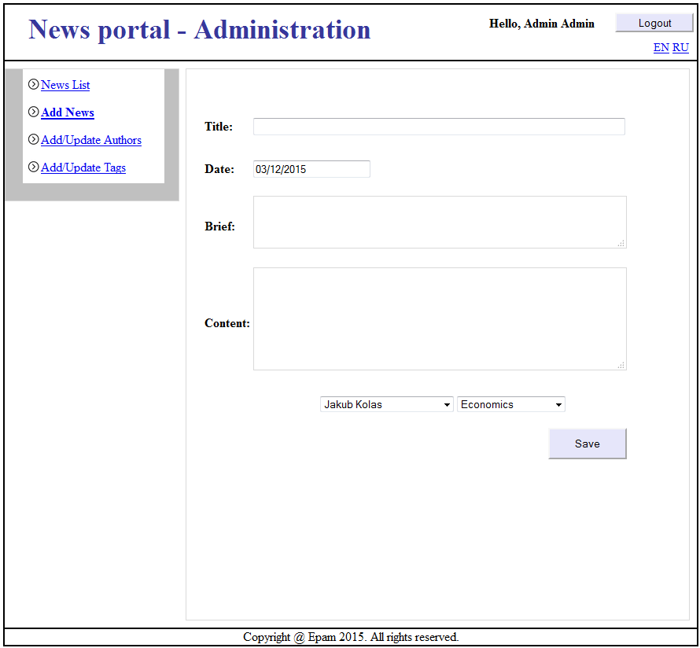
News-admin: Add/Edit/Expire authors
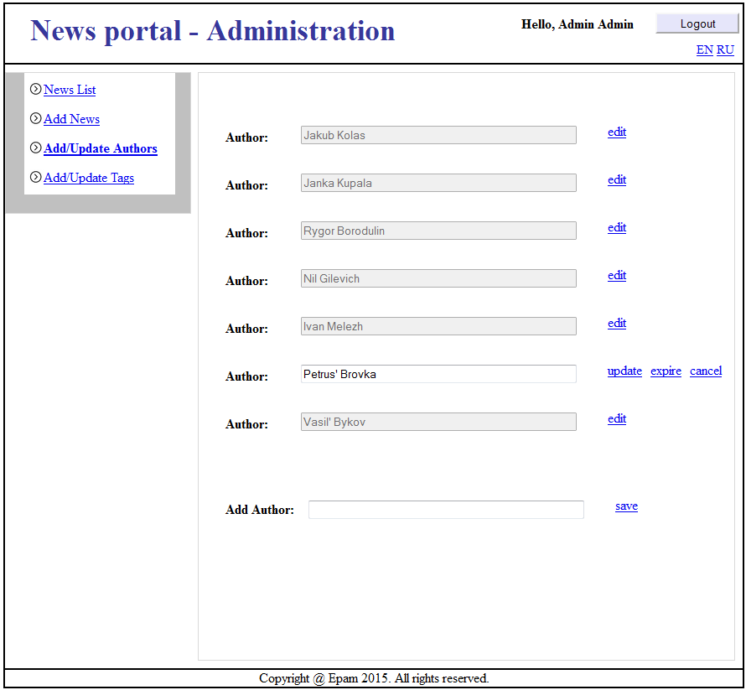

News-admin: Add/Edit/Remove tags
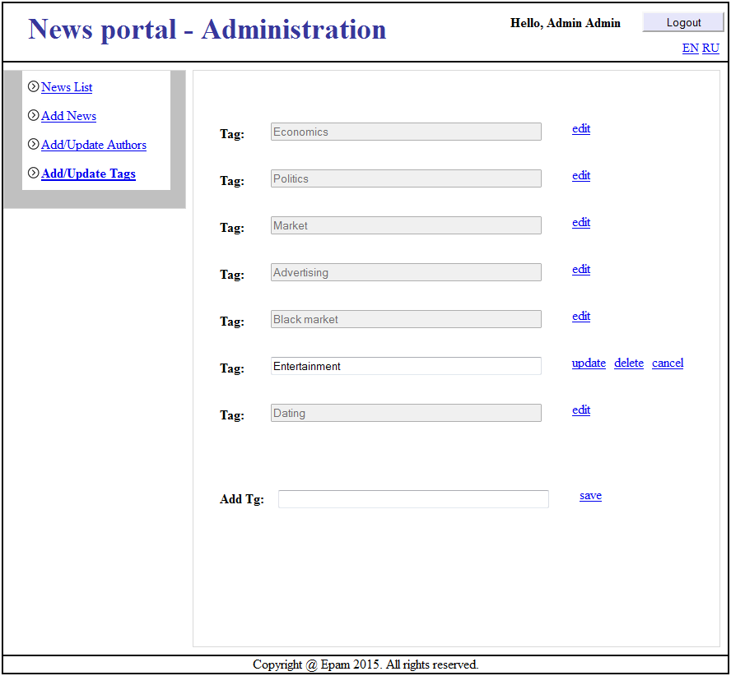
Useful links for task
- Spring MVC:
http://evbyminsdbookz.minsk.epam.com/index.php/details/pro-spring-mvc/512279?hl=Pro+Spring+MVC

- Spring security:
http://projects.spring.io/spring-security/
http://habrahabr.ru/post/203318/

- Apache tiles:
http://tiles.apache.org/framework/tutorial/
http://docs.spring.io/spring/docs/3.2.x/spring-framework-reference/html/view.html#view-tiles
http://java.dzone.com/articles/spring-mvc-tiles-3-integration

