#TASK1

###1____

vim /etc/httpd/conf.modules.d/00-mpm.conf

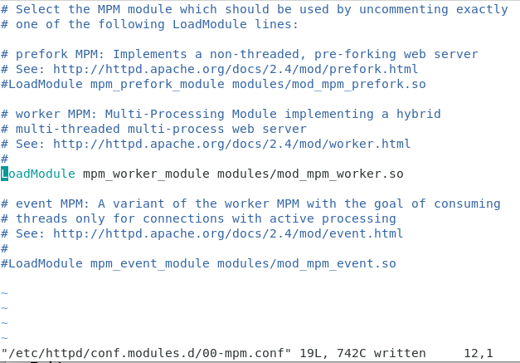

[root@worker ~]# vim /etc/httpd/modules/mod_mpm_worker.so

###2 ______

vim /etc/httpd/conf/httpd.conf

systemctl restart httpd

[root@worker ~]# systemctl status httpd

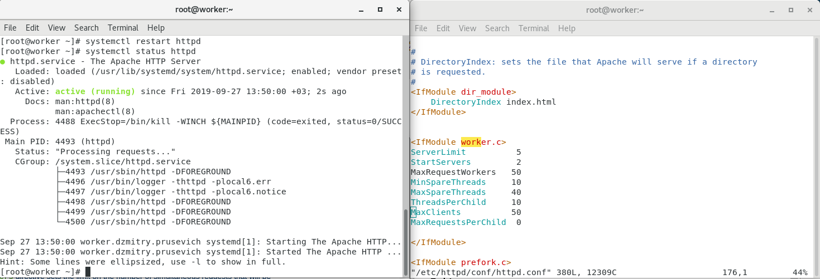

###3 Show that httpd is using worker module.

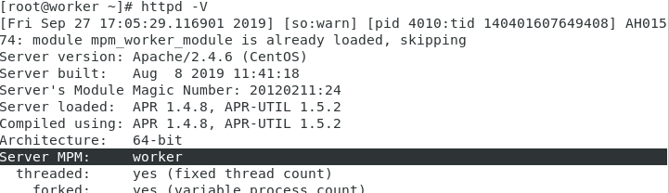[root@worker ~]# httpd -V

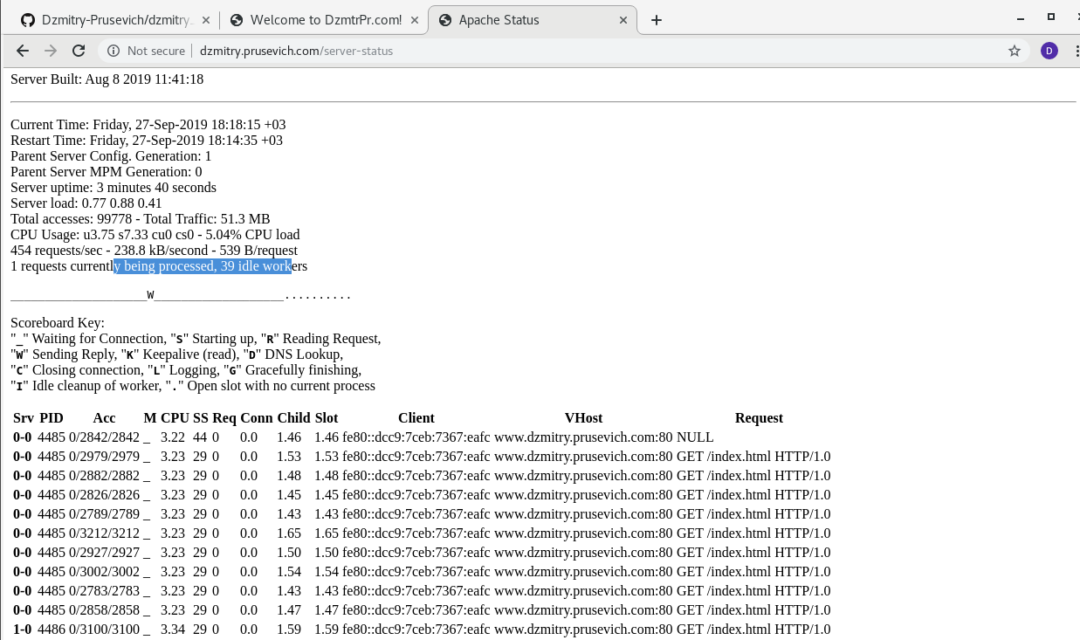

###4 task

vim /etc/httpd/conf/httpd.conf

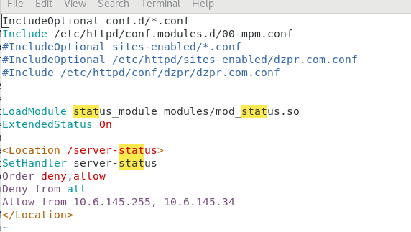

ab -n 100000 -c 500 http://worker.dzmitry.prusevich/index.html

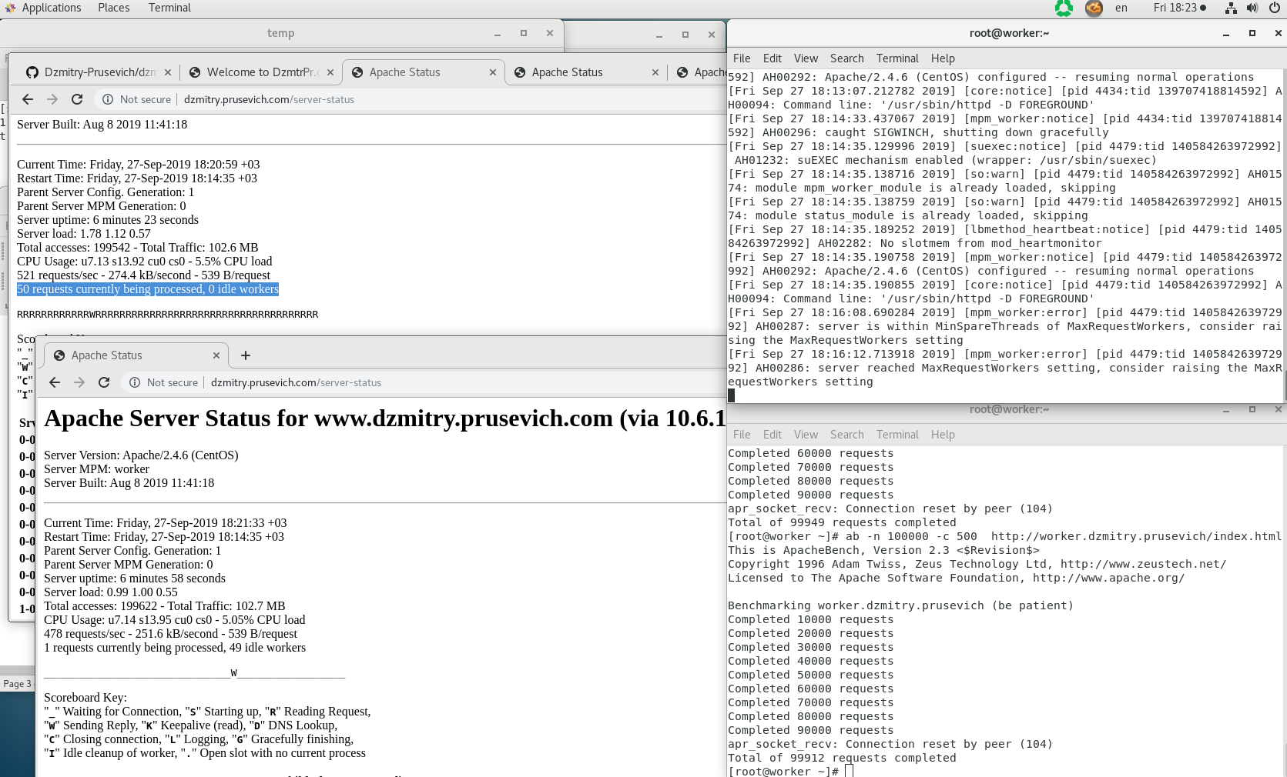tail -f /var/log/httpd/error_log



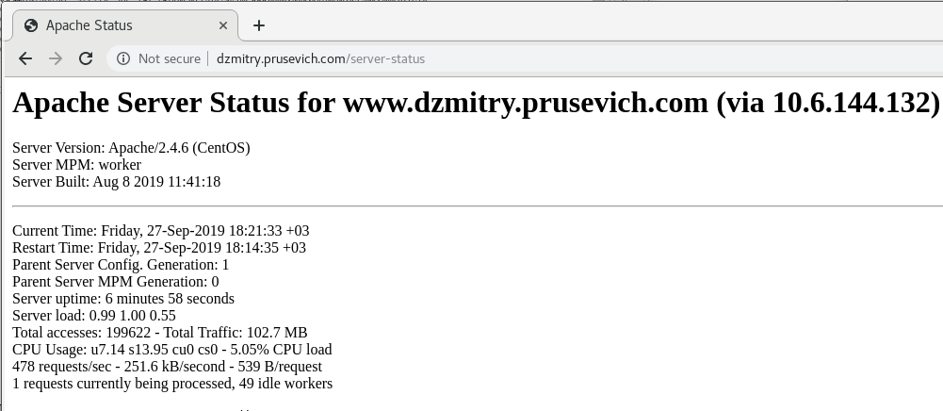

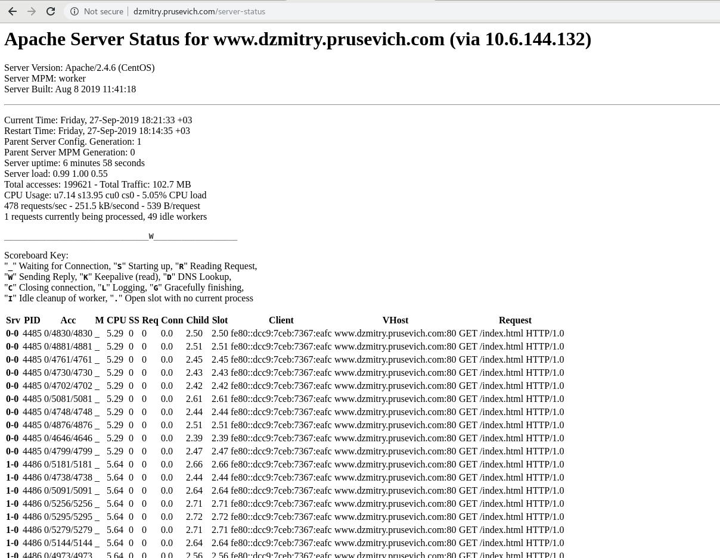

###5

Process tree:

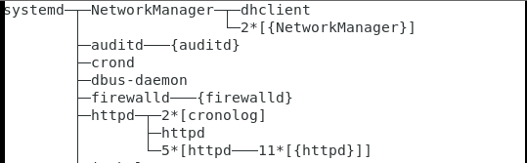

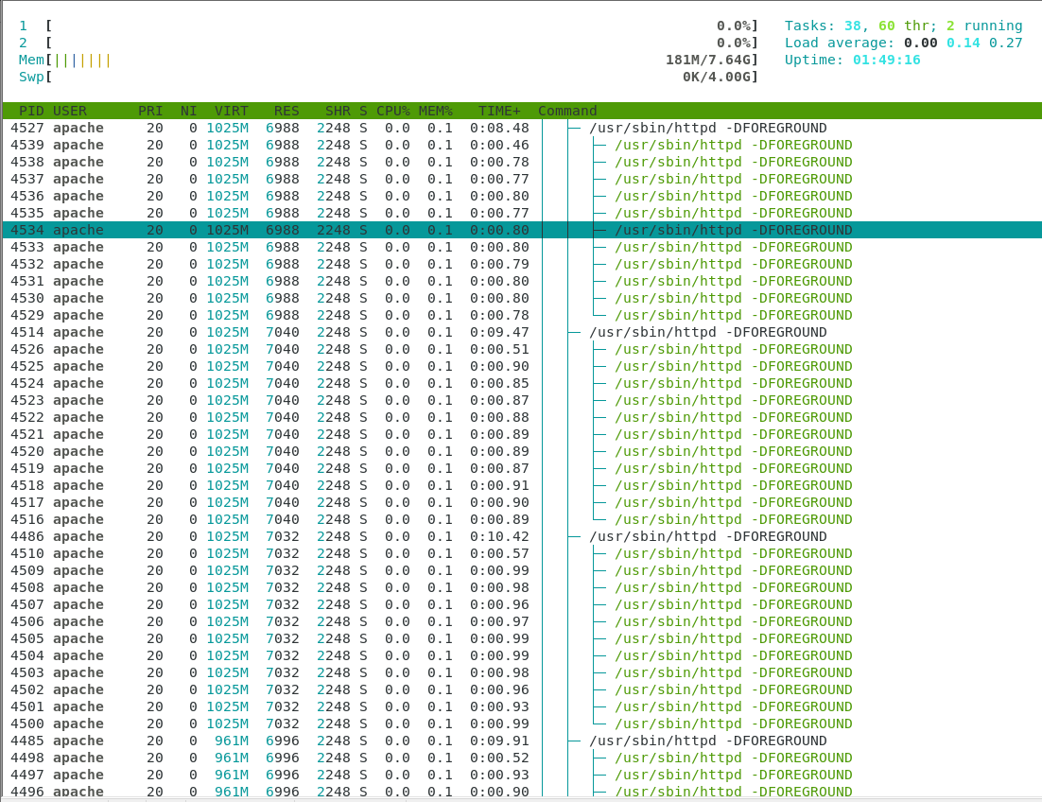

###6___7__8

Prefork:

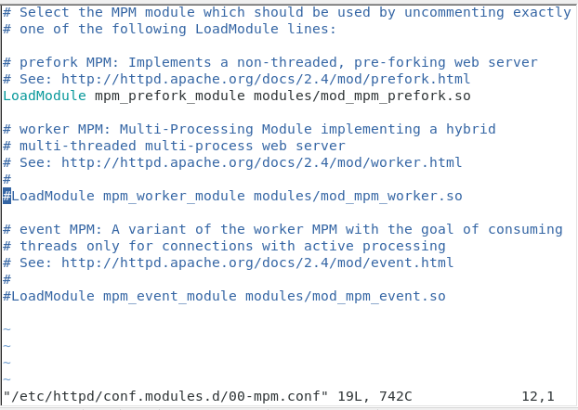

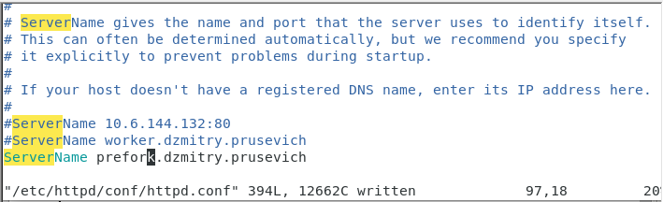

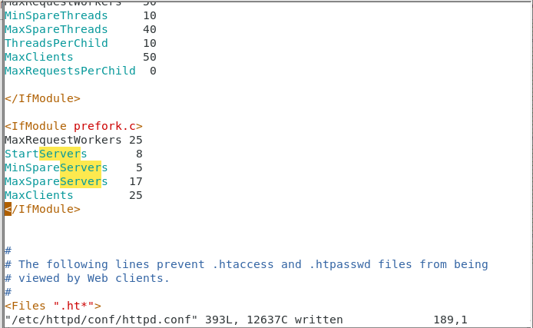

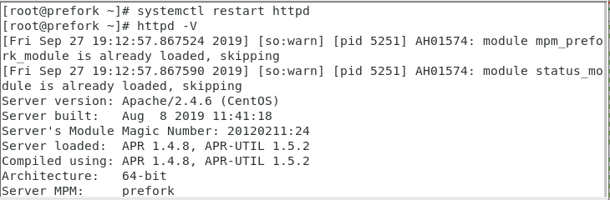

###9

Before generating ab-requests

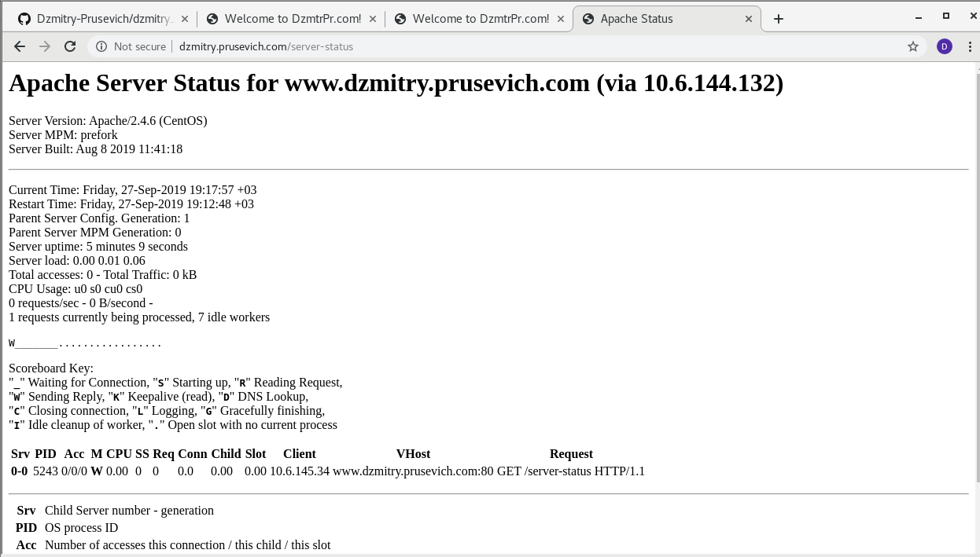

After generating 100 000 requests (up to 500 simultaneously):

Number of processes = 25 ( field - 25 requests currently being processed, 0 idle workers)

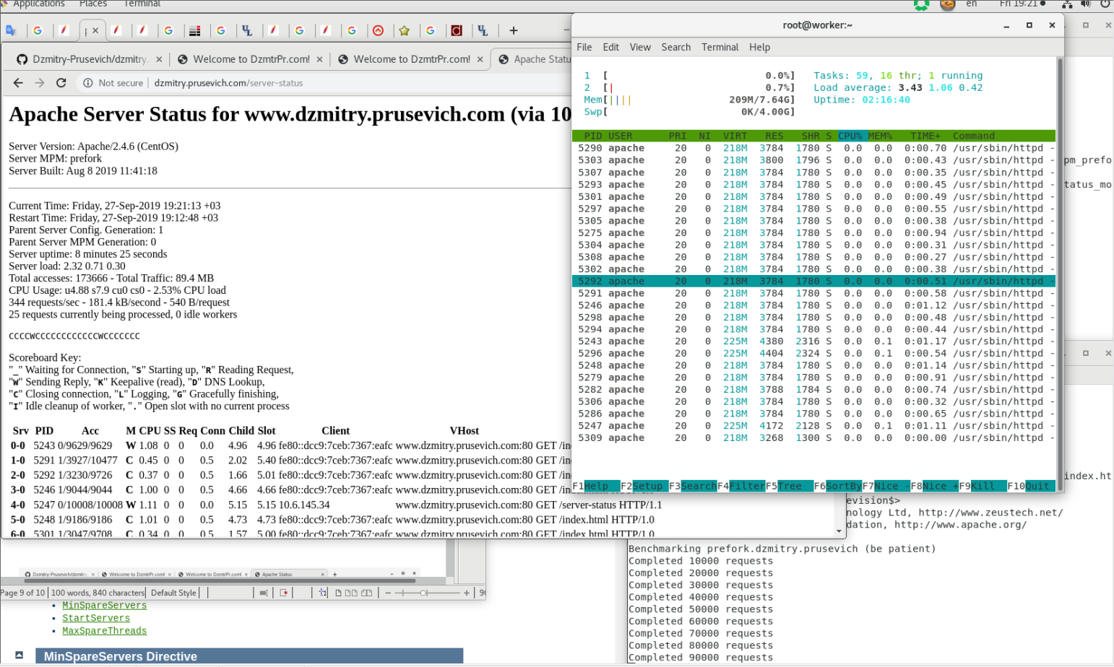

### 10

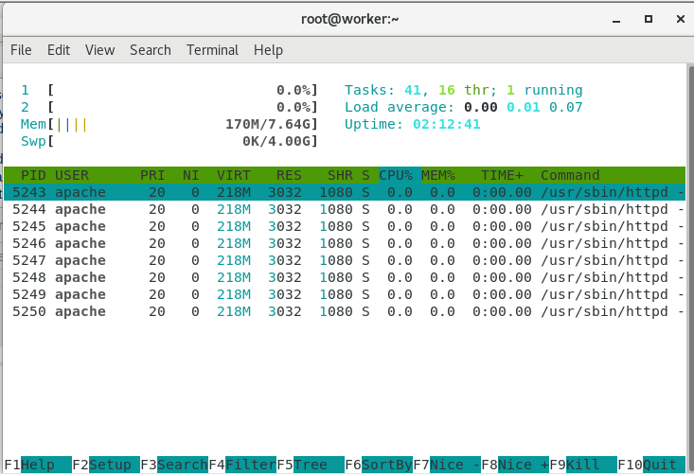

#TASK 2

###1 ----

[root@worker ~]# httpd -M | grep prox

[Fri Sep 27 19:38:29.787566 2019] [so:warn] [pid 5315] AH01574: module mpm_prefork_module is already loaded, skipping

[Fri Sep 27 19:38:29.787634 2019] [so:warn] [pid 5315] AH01574: module status_module is already loaded, skipping

proxy_module (shared)

proxy_ajp_module (shared)

proxy_balancer_module (shared)

proxy_connect_module (shared)

proxy_express_module (shared)

proxy_fcgi_module (shared)

proxy_fdpass_module (shared)

proxy_ftp_module (shared)

proxy_http_module (shared)

proxy_scgi_module (shared)

proxy_wstunnel_module (shared)

###2-----------

[root@worker ~]# vim /etc/httpd/conf.modules.d/00-proxy.conf

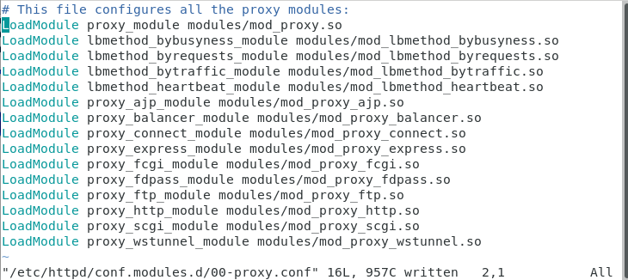

###3___4___5

vim /etc/httpd/conf.d/frd-proxy.conf

vim /etc/httpd/conf/httpd.conf

[root@forward ~]# htpasswd -c /etc/httpd/conf/.htpasswd Dzmitry_Prusevich

New password:

Re-type new password:

Adding password for user Dzmitry_Prusevich

systemctl restart httpd

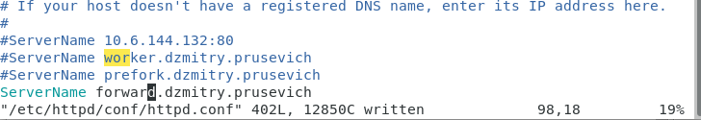

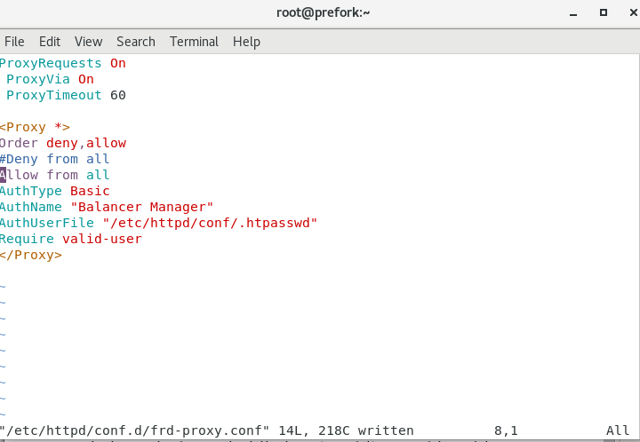

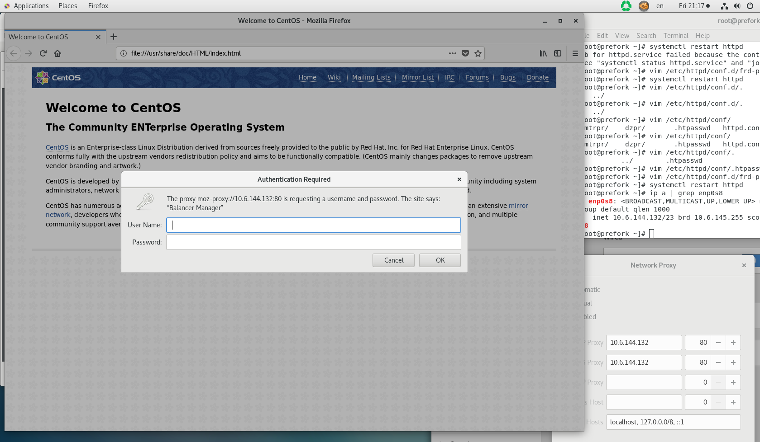

### 6

hostnamectl set-hostname reverse.dzmitry.prusevich

vim /etc/httpd/conf/httpd.conf

[root@reverse ~]# systemctl restart httpd

[root@reverse ~]# mv /etc/httpd/conf.d/frd-proxy.conf /etc/httpd/conf.d/frd-proxy._c_onf

[root@reverse ~]# vim /etc/httpd/conf.d/rev-proxy.conf

[root@reverse ~]# systemctl restart httpd

