yum install -y httpd
#2
cat << EOF > /var/www/html/index.html
<h2>Hello from httpd</h2>
<hr />
<p>Created by Name Surname</p>
EOF
#3
sudo systemctl start httpd
sudo systemctl status httpd
sudo systemctl enable httpd
sudo systemctl status httpd

sudo firewall-cmd --permanent --add-port=80/tcp
sudo firewall-cmd --permanent --add-port=443/tcp
sudo firewall-cmd –reload

  - Screenshots of test web pages being opened in browser
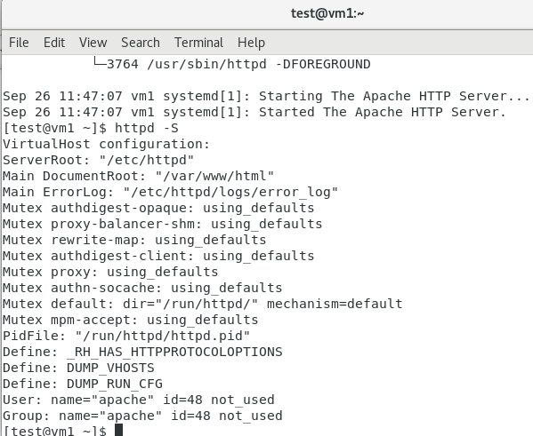
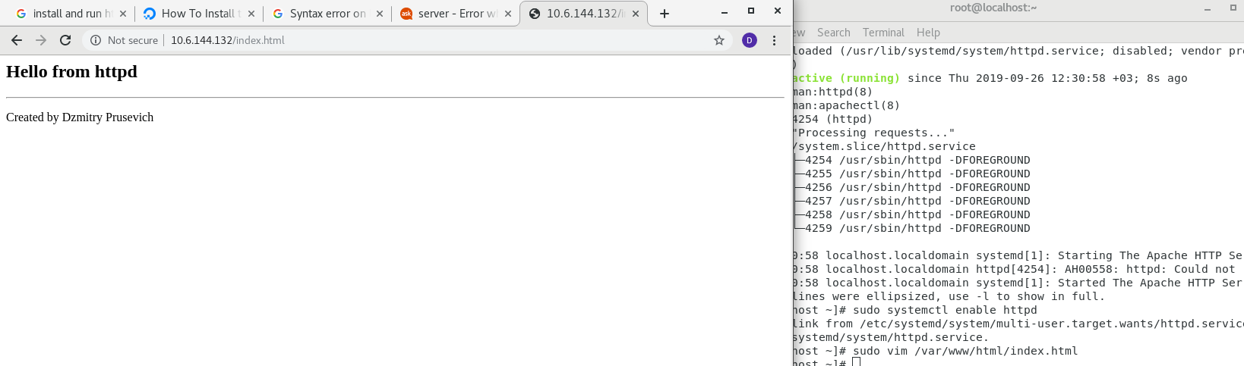

#####4 TASk

yum -y install arp apr-devel apr-util apr-util-devel pcre pcre-devel

sudo systemctl stop httpd

yum groupinstall " Development Tools" -y

yum install expat-devel pcre pcre-devel openssl-devel -y

sudo yum install -y wget
wget https://github.com/apache/httpd/archive/2.4.28.tar.gz -O httpd-2.4.28.tar.gz
wget https://github.com/apache/apr/archive/1.6.2.tar.gz -O apr-1.6.2.tar.gz
wget https://github.com/apache/apr-util/archive/1.6.0.tar.gz -O apr-util-1.6.0.tar.gz

[Dzmitry@localhost ~]$ tar -xzf httpd-2.4.28.tar.gz
[Dzmitry@localhost ~]$ tar -xzf apr-1.6.2.tar.gz
[Dzmitry@localhost ~]$ tar -xzf apr-util-1.6.0.tar.gz
sudo -i
[root@localhost ~]# cd /home/Dzmitry/

[root@localhost Dzmitry]# mv apr-1.6.2 httpd-2.4.28/srclib/apr
[root@localhost Dzmitry]# mv apr-util-1.6.0 httpd-2.4.28/srclib/apr-util
[root@localhost Dzmitry]# cd httpd-2.4.28

[root@localhost httpd-2.4.28]# ./buildconf

[root@localhost httpd-2.4.28]# ./configure --enable-ssl --enable-so --with-mpm=event --with-included-apr –prefix=/usr/local/apache2

[root@localhost httpd-2.4.28]# make

[root@localhost httpd-2.4.28]# make install

[root@localhost httpd-2.4.28]# echo “pathmunge /usr/local/apache2/bin” > /etc/profile.d/httpd.sh

[root@localhost httpd-2.4.28]# vim /etc/systemd/system/httpd.service

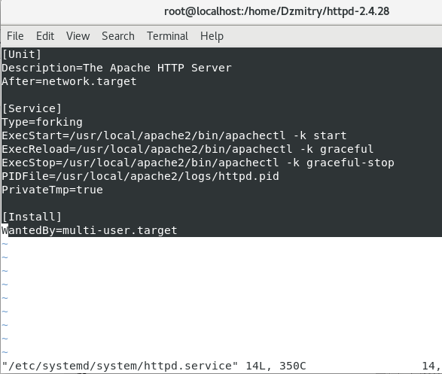

systemctl daemon-reload
systemctl start httpd
systemctl enable httpd
systemctl status httpd
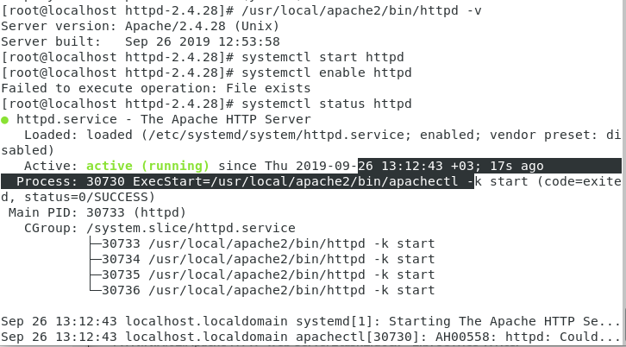

vim /usr/local/apache2/htdocs/index.html

Screenshots of test web pages being opened in browser
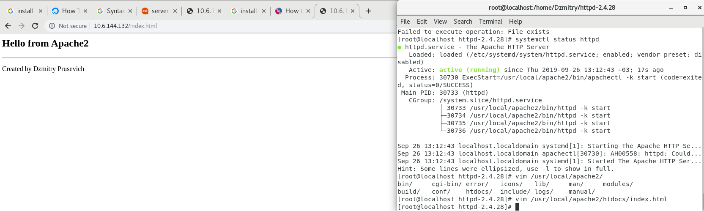

/usr/local/apache2/bin/apachectl -S

Screenshots of output of web server checks, e.g. httpd -S
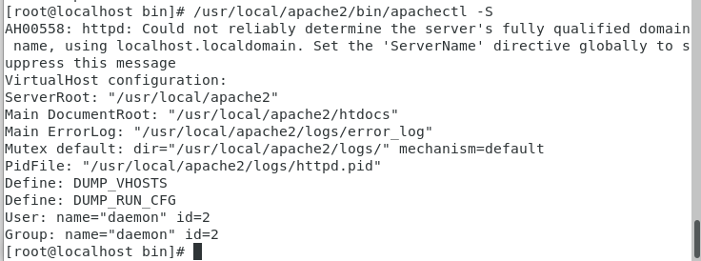
systemctl stop httpd

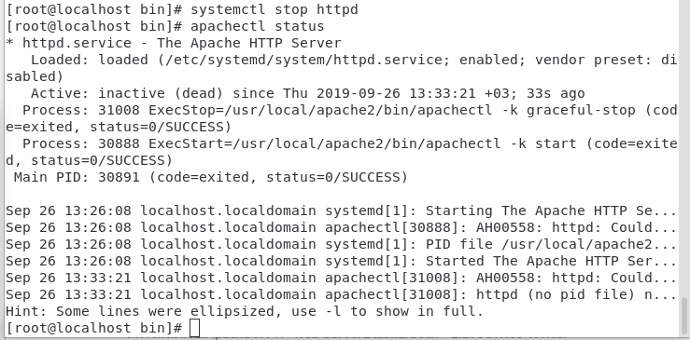

Check

Restarting Apache Gracefully

If you are restarting the web server on a live website, you should do it gracefully.
A graceful restart tells the web sever to finish any active connections before restarting. This means that active visitors to your site will be able to finish downloading anything already in progress before the server restarts.

TASK2

WITH HTTPD

[root@localhost bin]# mkdir -p /var/www/dzpr.com/public_html
[root@localhost bin]# mkdir -p /var/www/dzmtrpr.com/public_html

[root@localhost bin]# vim /var/www/dzpr.com/index.html
[root@localhost bin]# vim /var/www/dzmtrpr.com/index.html
[root@localhost bin]# mkdir /etc/httpd/sites-available
[root@localhost bin]# mkdir /etc/httpd/sites-enabled

echo “IncludeOptional sites-enabled/*.conf” >> /etc/httpd/conf/httpd.conf

vim /etc/httpd/sites-available/dzpr.com.conf

Screenshots of web server configurations used in tasks

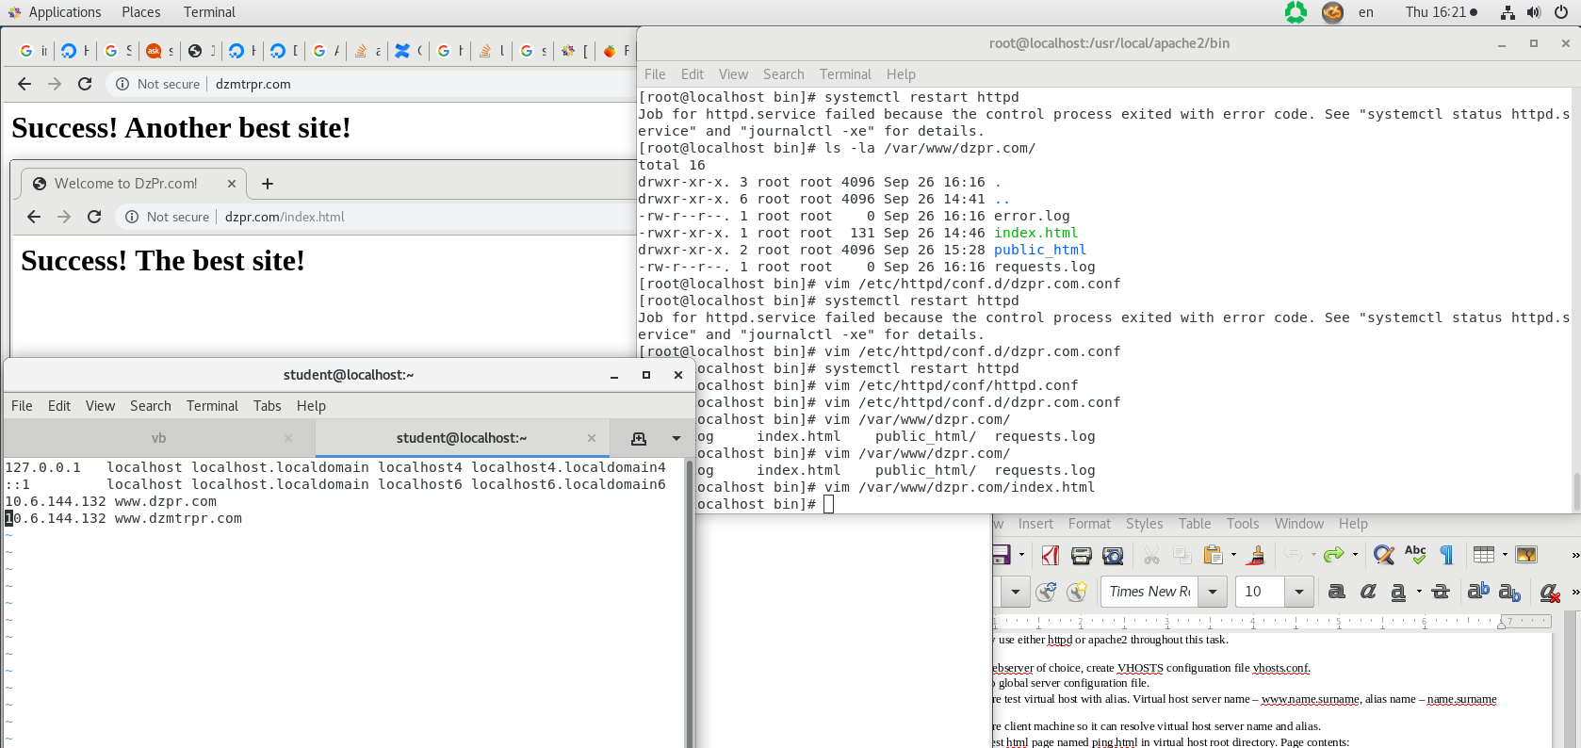
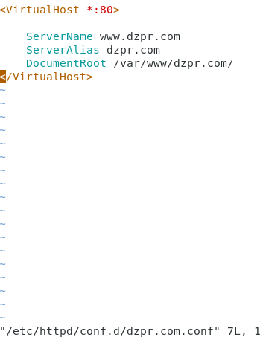
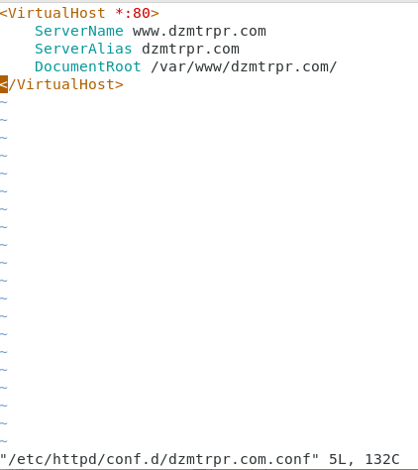

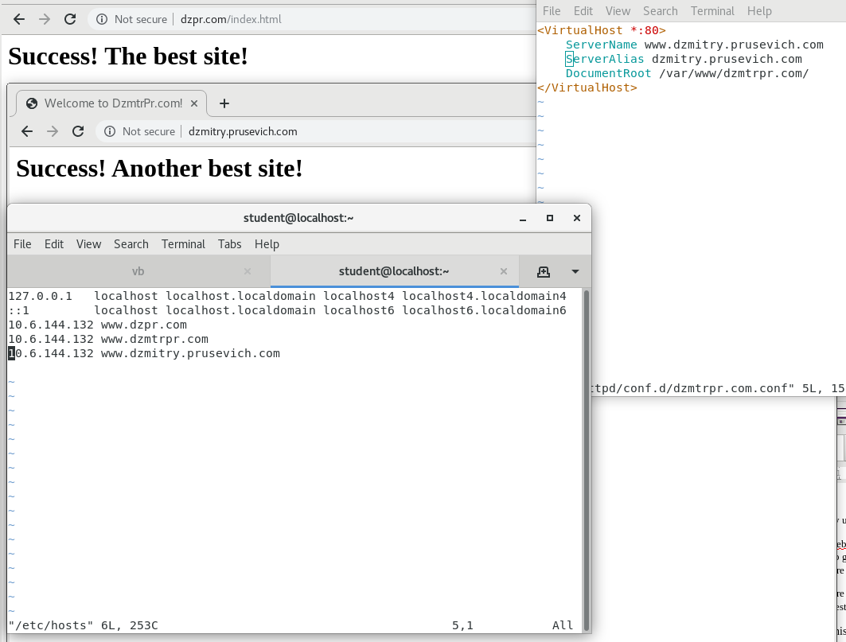
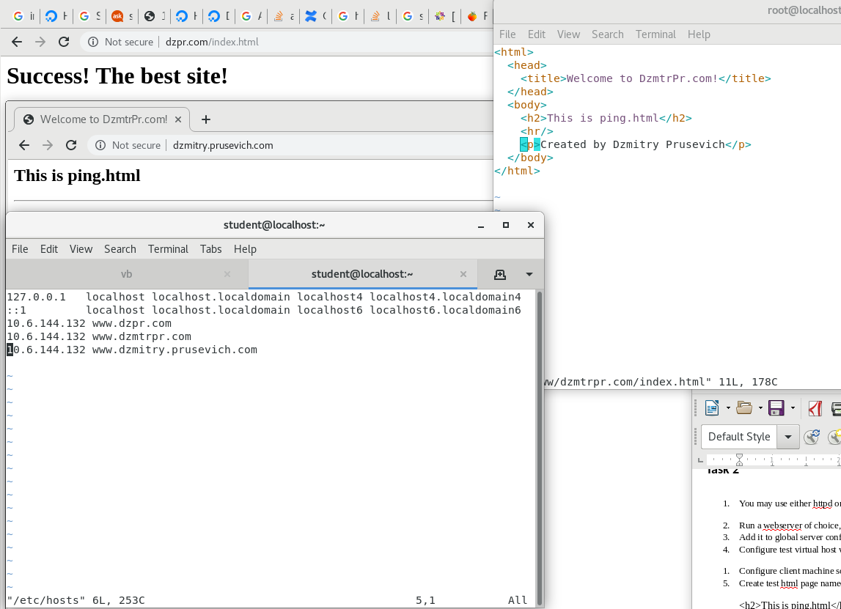

[root@localhost bin]# vim /etc/httpd/conf/httpd.conf
[root@localhost bin]# vim /etc/httpd/conf.d/dzmtrpr.com.conf
[root@localhost bin]# systemctl restart httpd
[root@localhost bin]# vim /etc/httpd/conf.d/dzmtrpr.com.conf
[root@localhost bin]# systemctl restart httpd
[root@localhost bin]# vim /etc/httpd/conf.d/dzmtrpr.com.conf
[root@localhost bin]# vim /var/www/dzmtrpr.com/index.html

[root@localhost bin]# apachectl configtest
Syntax OK
[root@localhost bin]# systemctl status httpd
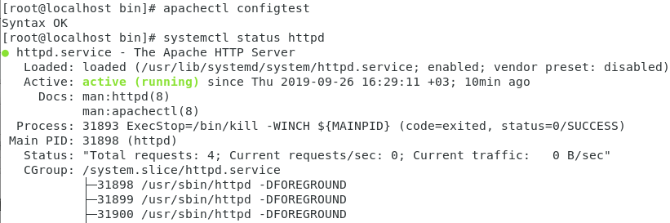
[root@localhost bin]# systemctl restart httpd

cp /var/www/dzmtrpr.com/index.html /var/www/dzmtrpr.com/ping.html
[root@localhost bin]# vim /var/www/dzmtrpr.com/index.html
[root@localhost bin]# systemctl restart httpd

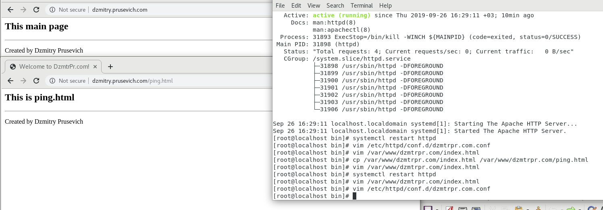

[root@localhost bin]# vim /etc/httpd/conf.d/dzmtrpr.com.conf
[root@localhost bin]# systemctl restart httpd

Screenshot of debug console to confirm mod_rewrite is working while opening /
Screenshot of debug console to confirm mod_rewrite is working while opening /index.html
Screenshot of debug console to confirm mod_rewrite is working while opening /none-existing-page

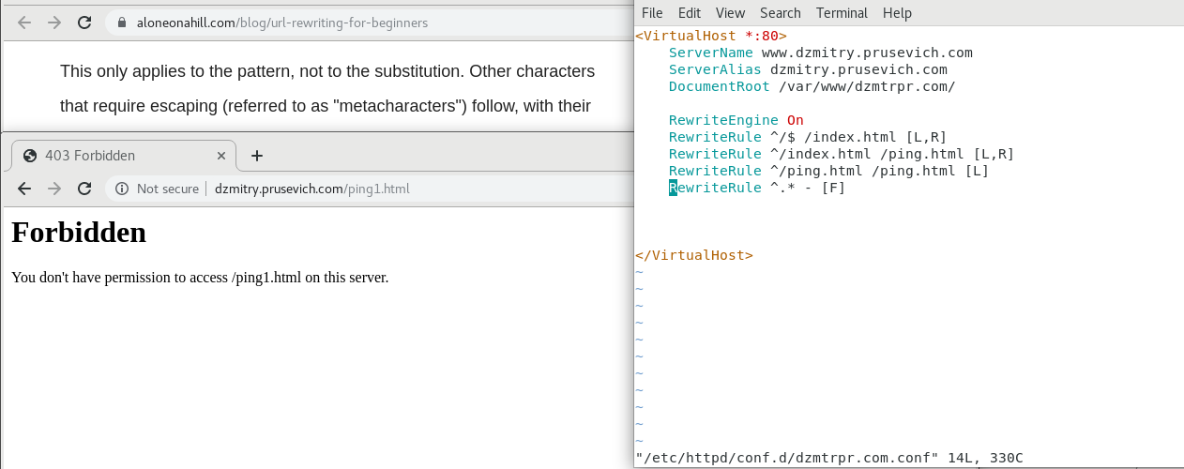

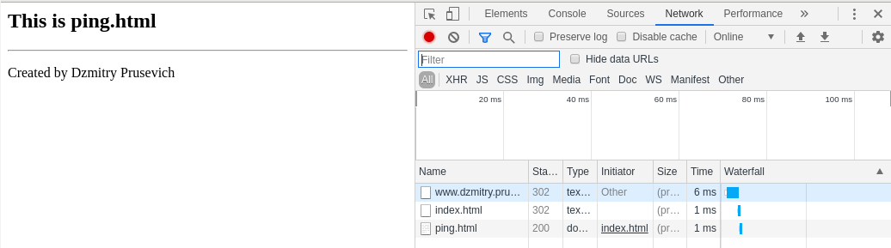
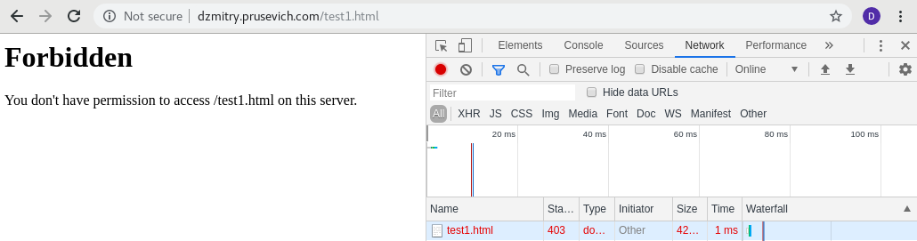

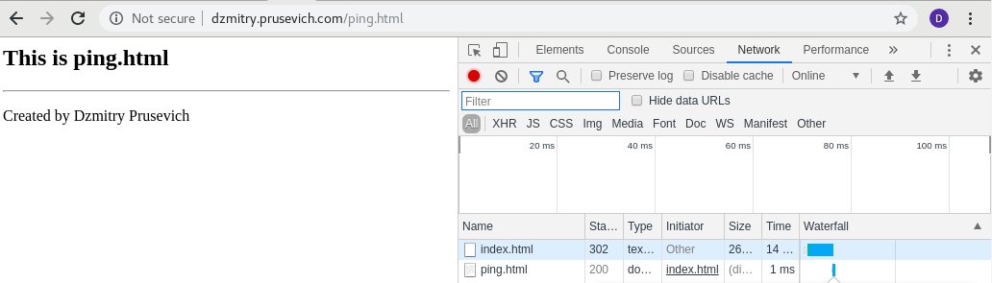

TASK 3

sudo yum install epel-release -y

yum install -y cronolog

mkdir /var/www/dzmtrpr.com/logs

vim /etc/httpd/conf.d/dzmtrpr.com.conf

setenforce 0
systemctl restart httpd
getenforce

Screenshot of virtual host with cronolog configuration, output of tree command showing layout of log files created by cronolog

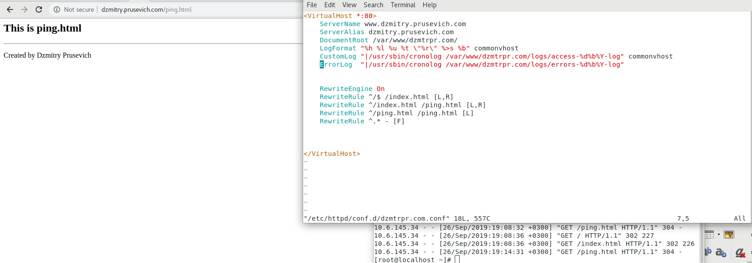

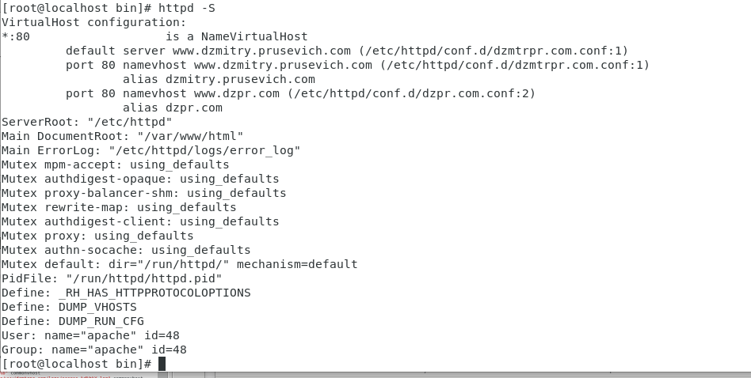

yum install -y tree
tree



TASK 4

vim /etc/httpd/conf.d/dzmtrpr.com.conf

[root@localhost logs]# systemctl restart httpd

vim /etc/httpd/conf/httpd.conf
systemctl restart httpd

Screenshot of virtual host configuration with logging to syslog. Screenshots of syslog entries related to access/error web server logging.

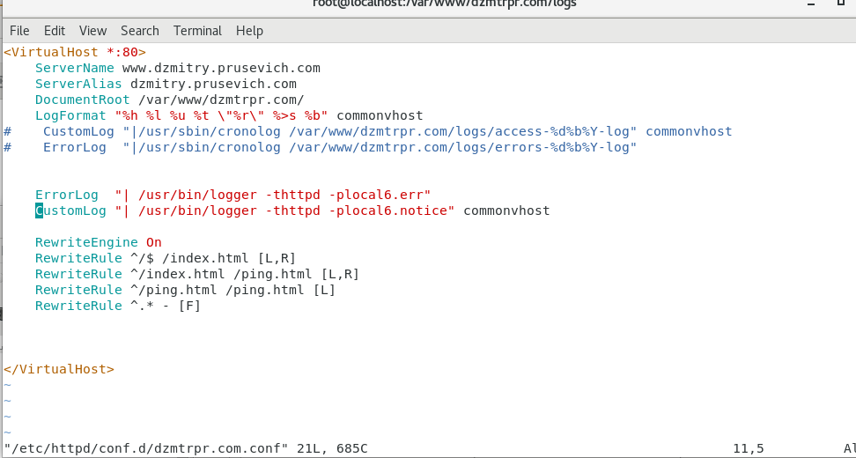
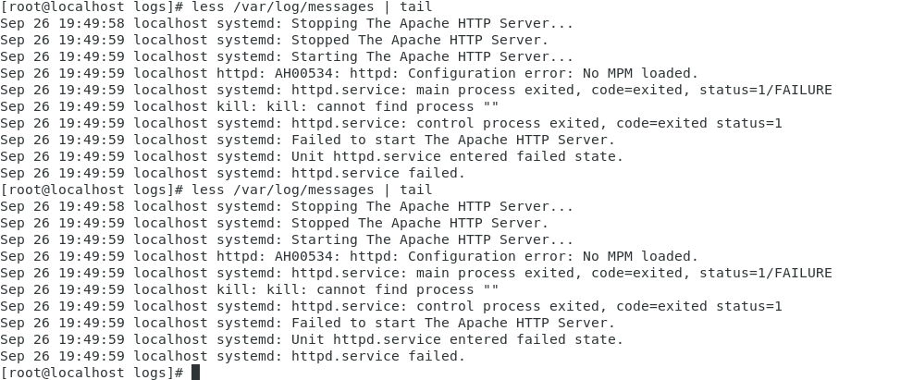

curl -il http://www.dzmitry.prusevich.com/index.html
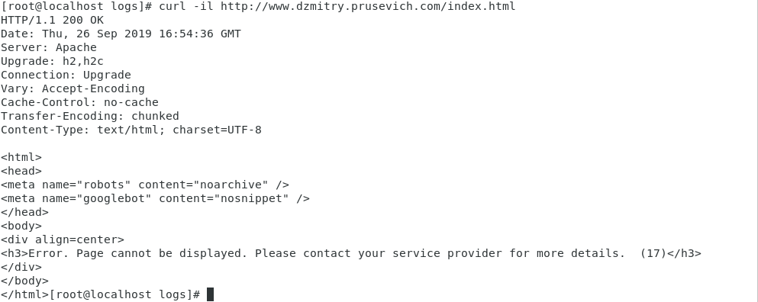
vim /etc/httpd/conf/httpd.conf

systemctl restart httpd
less /var/log/messages | tail
tail -f /var/log/messages

