BUSINESS ANALYSIS PIPELINE
System Architecture Specification
Rumica — Bitrix24-centric thin-bridge architecture

Project: artdecor-home-design
Status: Final — ready for development
Source: system-architect agent, business-analysis-pipeline

Table of Contents
Right-click and choose 'Update Field' to build the table of contents.

Overview
Rumica is built as a Bitrix24-centric thin-bridge architecture: a modular monolith-style set of backend services (not independent microservices — there is no scale or team-topology driver for that split) fronts Bitrix24 Cloud, which hosts admin/back-office, CRM, catalog, and payment processing. Custom code is limited to what Bitrix24 cannot natively provide: the React/Three.js planner front end, a thin API Gateway/BFF, and a small set of bridge/adapter services (Auth Bridge, Commerce Bridge, Catalog Sync, Projects Service, Plan Recognition Adapter). This keeps custom build/maintenance surface to the minimum needed to satisfy MVP functional requirements, consistent with BR-4. Both architecture-level ambiguities raised during the prior review — Bitrix24 edition/plan and checkout implementation approach — are now resolved and reflected below as final decisions, not options.

Context Diagram
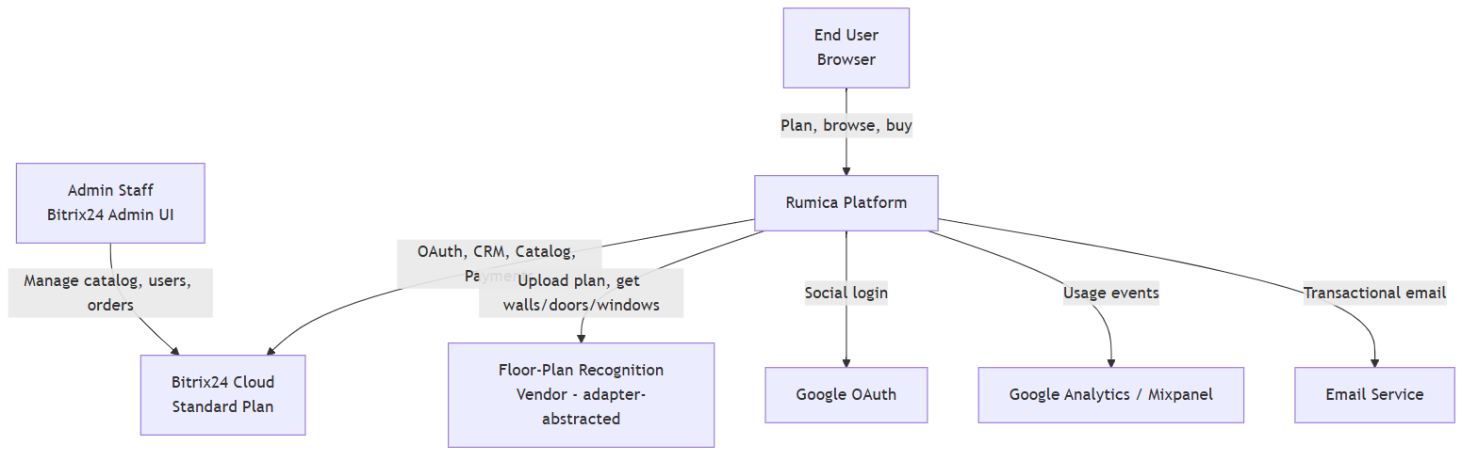
Figure: Context Diagram

Components
Component | Responsibility | Technology | Why
Web Front End | React + Three.js SPA: planner canvas, catalog browsing, cart, custom checkout form, admin-adjacent user pages | React, Three.js | Three.js is the confirmed engine per the planner-engine comparison doc; React is the standard fit for an SPA of this shape
API Gateway / BFF | Single entry point for the front end; routes to bridge services; session/token validation | Node.js (or same stack as bridge services) reverse-proxy/BFF layer | Avoids exposing multiple internal service endpoints directly to the browser; centralizes auth-token handling
Auth Bridge | Bridges Rumica user identity to Bitrix24 OAuth; issues/validates Rumica session tokens; handles Google OAuth handoff | OAuth 2.0 against Bitrix24 + Google | Bitrix24-centric direction requires user identity to reconcile with Bitrix24 records for CRM/order linkage
Commerce Bridge | Owns cart state; renders/serves the custom Rumica-built checkout form for cart/product purchases (UC-6/FR-20) — on submit, calls Bitrix24 Payment APIs directly to charge and creates/updates the corresponding CRM deal. Subscription payments (UC-8/FR-21) instead go through Bitrix24's own hosted payment flow — a genuinely separate path, not the custom checkout form — with Bitrix24 sending a webhook/callback to the Commerce Bridge on successful payment, which the Commerce Bridge relays to the Auth Bridge to update the user's tier. These are two distinct payment paths, not one shared checkout mechanism | Custom service, Bitrix24 REST (CRM + Payment APIs), Bitrix24 payment webhook receiver | Final decision: custom checkout form for cart/product checkout, chosen over Bitrix24's hosted widget for full UX/branding control (client-confirmed) — see PCI/security note below and Cost & Complexity Notes for the resulting build-effort implication. Subscription payments deliberately use Bitrix24's hosted flow instead, per client confirmation that the two payment paths are distinct
Catalog Sync/Proxy | Reads Bitrix24 catalog (products, packs, pricing) and serves it to the front end from a local read cache; kept fresh via Bitrix24 webhooks (create/update/delete) plus a periodic reconciliation poll | Custom service + cache store (e.g., Redis or a cached table) | Final decision: webhook-driven + periodic reconciliation (not live-proxying every request) is confirmed sufficient against Bitrix24 Cloud's standard-plan REST API rate limits
Projects Service | CRUD for planner projects (layout state, item placement, dimensions, public/private flag), since projects are not native Bitrix24 data | Custom service + Application DB + Object Storage | Bitrix24 has no concept of a 2D planner project; this data must live in Rumica's own store
Plan Recognition Adapter | Sends uploaded floor plans (JPG/PNG/PDF) to the recognition vendor and returns detected walls/doors/windows | Custom adapter, vendor-agnostic interface (CubiCasa as working assumption pending PoC per V&S) | Adapter boundary allows vendor substitution without touching the rest of the system, per the still-open vendor validation noted in the Vision & Scope
Export Service | Generates PDF/image exports of a project and produces shareable links | Custom service + Object Storage | Export/share (FR-17) has no Bitrix24 equivalent
Analytics Forwarder | Captures internal usage events and forwards equivalents to external analytics | Custom lightweight event emitter → GA/Mixpanel SDK or server-side API | Satisfies FR-26 without building an internal analytics platform
Application DB | Stores projects, user↔Bitrix24 identity mapping, export metadata, webhook receipt log, catalog cache (if not held in a separate cache store), and the user↔favorited-item relationship (which users have bookmarked which catalog items) | Relational DB (e.g., PostgreSQL) | Relational fits the mostly-structured project/user-mapping data; avoids introducing a second data paradigm without a driving requirement
Object Storage | Uploaded floor plans, exported images/PDFs, project thumbnails | S3-compatible object storage | Standard fit for binary/media assets; keeps the relational DB lean
Bitrix24 Cloud (Standard Plan) | Admin panel, CRM (orders/deals), product catalog, payment processing, OAuth identity | Bitrix24 SaaS, standard commercial plan (client-confirmed) | Centralizing admin/CRM/catalog/payments here is what keeps custom build cost down (BR-4); standard plan confirmed to have moderate but workable API limits for the sync-cache design

Component Diagram
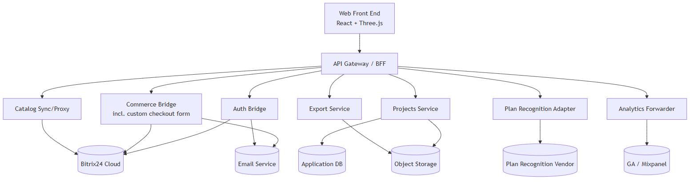
Figure: Component Diagram

Data Flow
For the primary loop (design-to-purchase), the front end loads catalog data from the Catalog Sync/Proxy's local cache (kept current via Bitrix24 webhooks + periodic reconciliation, not per-request Bitrix24 calls). Users place items into a project managed by the Projects Service, persisted to the Application DB/Object Storage. At checkout, the front end renders Commerce Bridge's custom checkout form; on submission, tokenized payment details (never raw card data — see security note below) are sent to the Commerce Bridge, which calls Bitrix24 Payment APIs directly and creates/updates the corresponding CRM deal. Order status and history are read live from Bitrix24 CRM via the Commerce Bridge for the "My Orders" page — no separate order database is maintained. A favorited item's displayed status (pending / used-in-project / ordered) is derived at read time by cross-referencing the favorites record in the Application DB against Bitrix24 CRM order data via the Commerce Bridge (to detect "ordered") and Projects Service data (to detect "used-in-project"). The check order is explicit and takes strict priority: ordered → used-in-project → pending — the system checks "ordered" first, falls back to "used-in-project" only if not ordered, and defaults to "pending" if neither match is found.

Key Flow Sequence Diagrams

UC-1: Register and log in
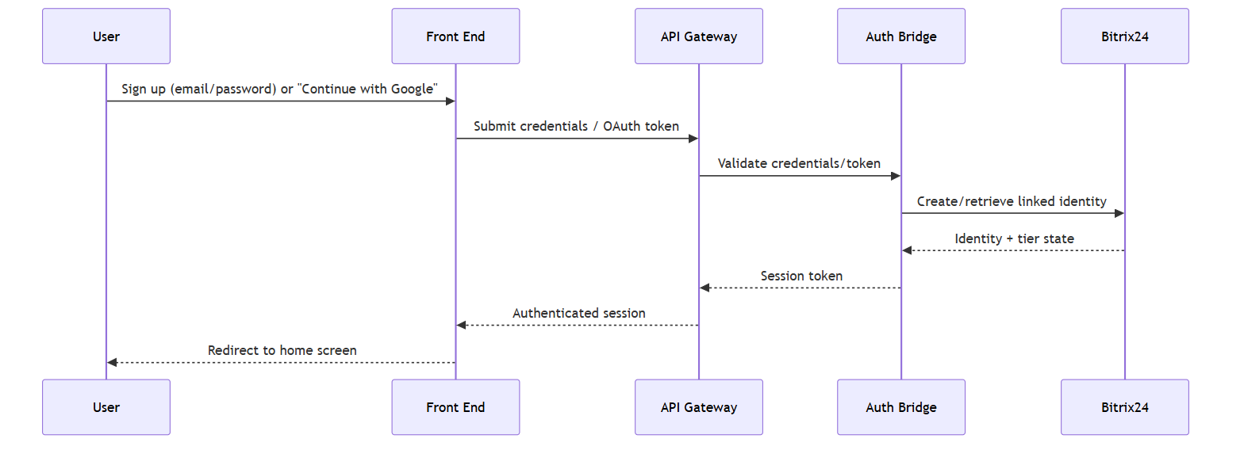
Figure: UC-1: Register and log in

UC-2: Create a design from an uploaded floor plan
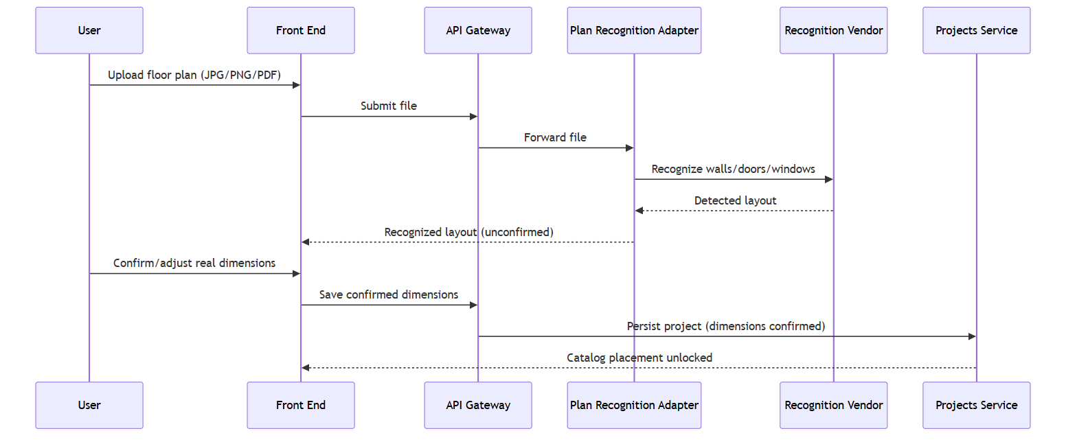
Figure: UC-2: Create a design from an uploaded floor plan

UC-3: Start a design from a gallery template or public design
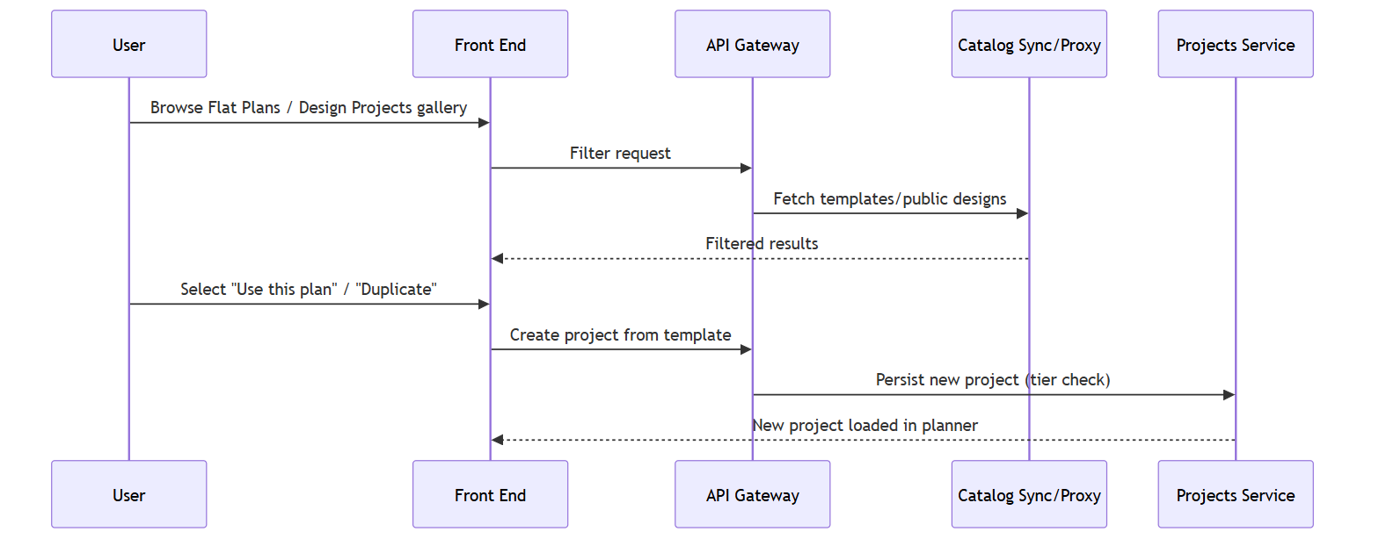
Figure: UC-3: Start a design from a gallery template or public design

UC-4: Furnish a design with catalog products
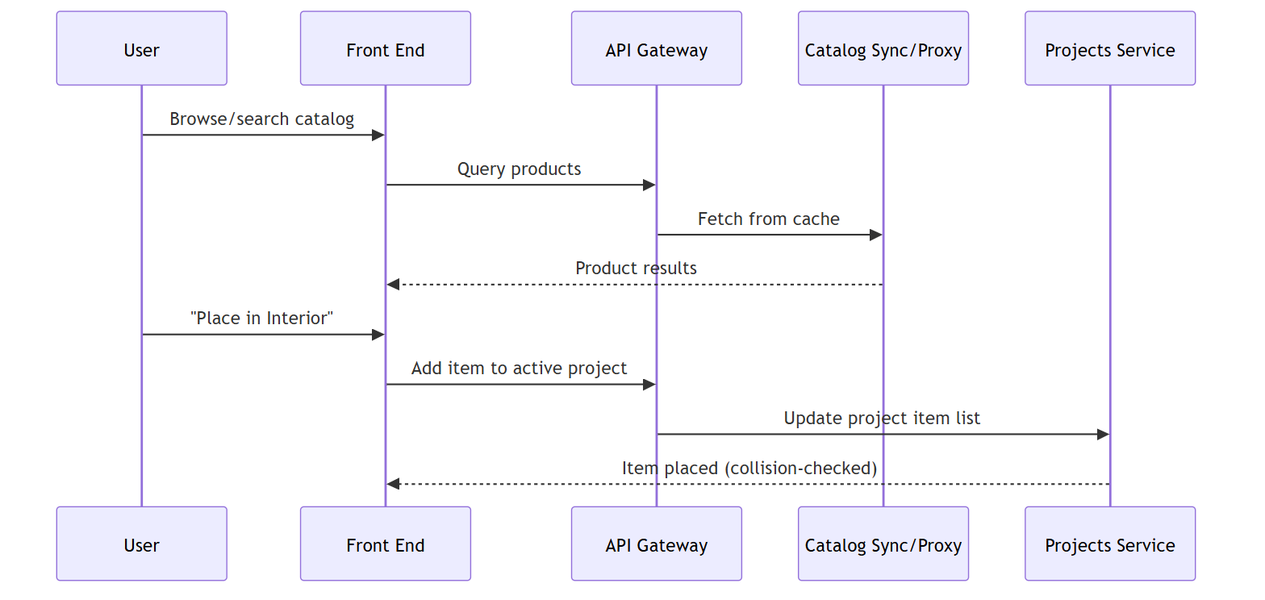
Figure: UC-4: Furnish a design with catalog products

UC-5: Save, duplicate, share, and publish a project
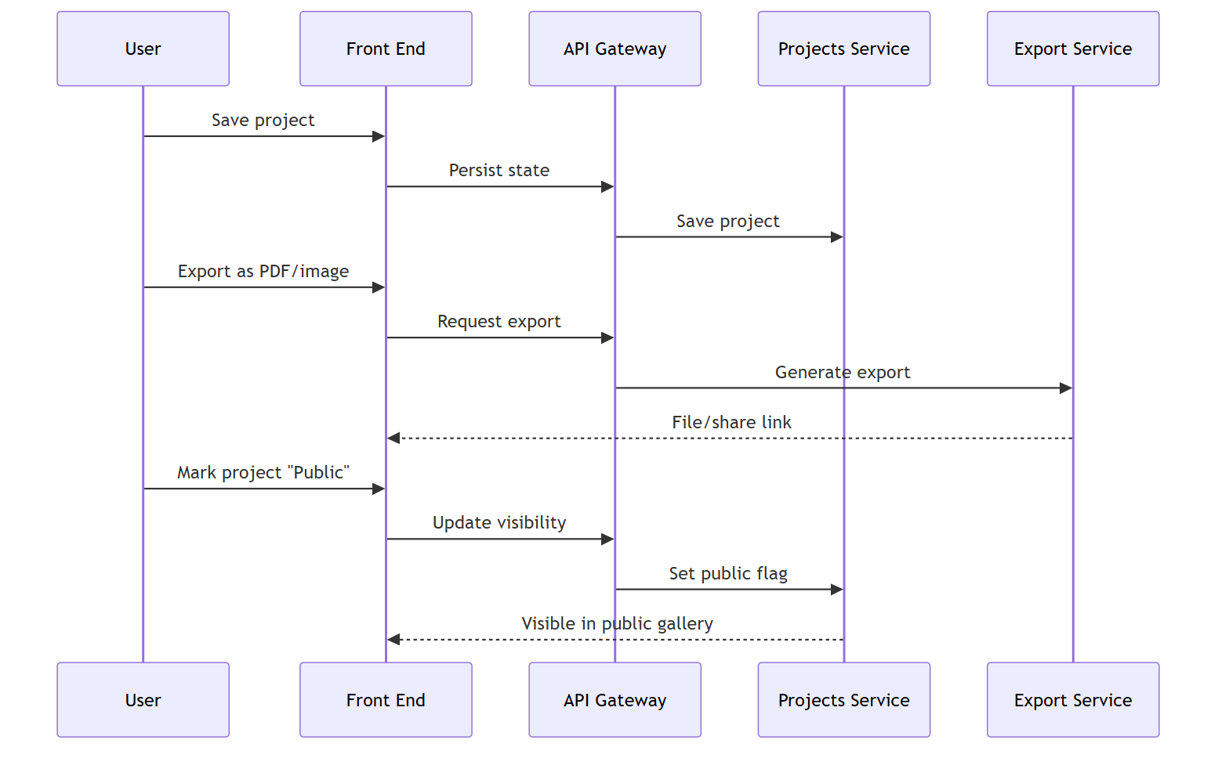
Figure: UC-5: Save, duplicate, share, and publish a project

UC-6: Purchase products/design packs (cart and checkout)
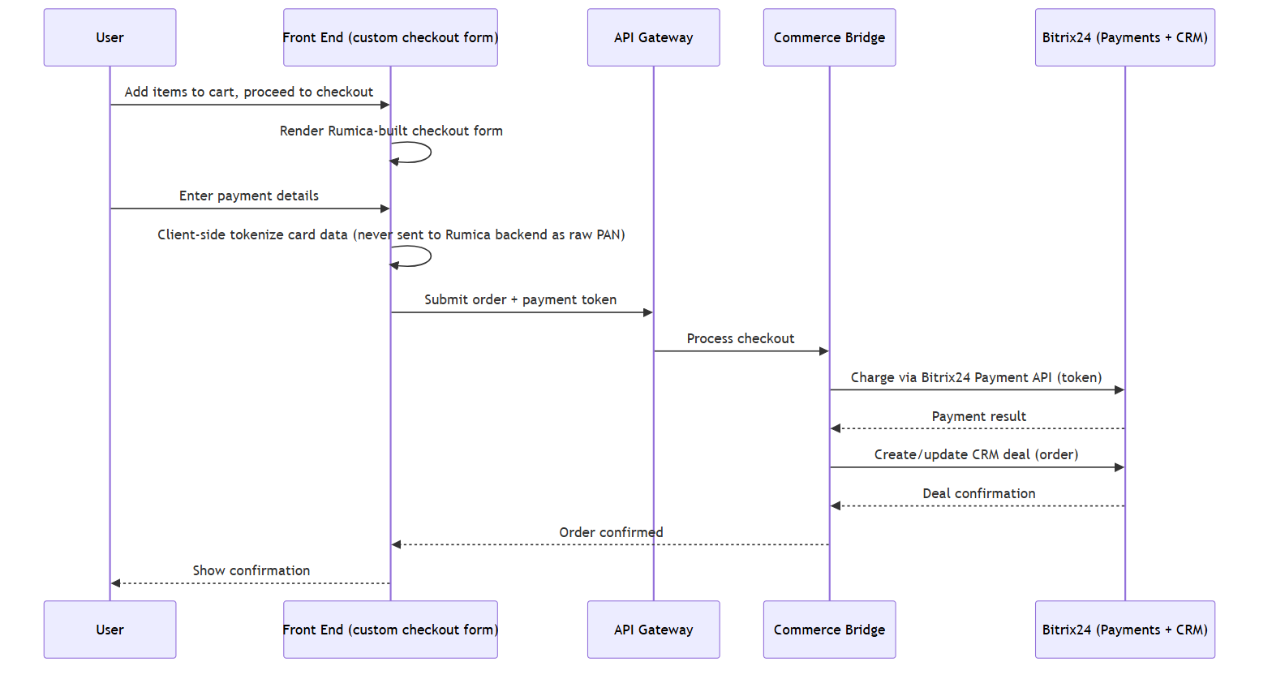
Figure: UC-6: Purchase products/design packs (cart and checkout)
Note on this flow: because Rumica's own front end renders the checkout form (rather than redirecting to a Bitrix24-hosted payment page), the payment card fields must use client-side tokenization (e.g., via the tokenization SDK of whichever payment provider is registered under Bitrix24's Payment module) so that raw card numbers never transit or persist in Rumica-owned code or infrastructure. This is a security/compliance consideration for the implementation team, not something to assume is automatically true of a custom form — it must be an explicit build requirement.

UC-7: View order history ("My Orders")
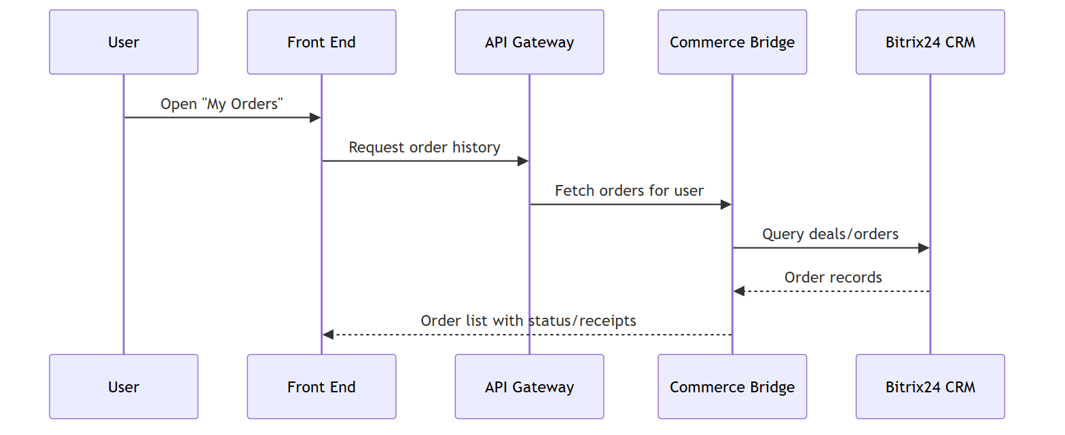
Figure: UC-7: View order history ("My Orders")

UC-8: Subscribe to a paid tier
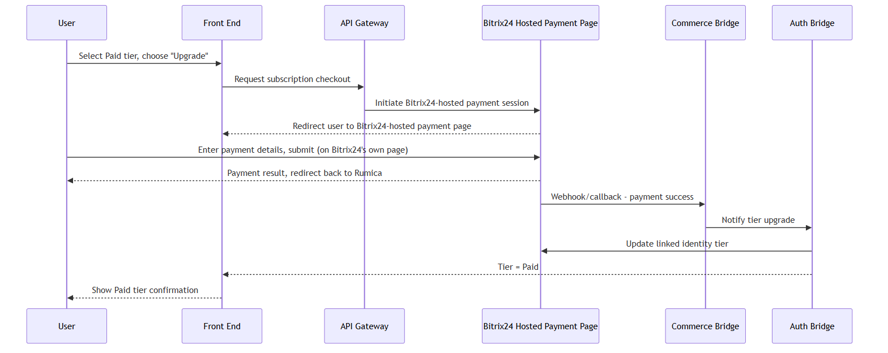
Figure: UC-8: Subscribe to a paid tier
Note on this flow: unlike UC-6 (client-side tokenization + direct Commerce Bridge → Bitrix24 Payment API call), subscription payment is a genuinely separate path — the user is handed off to Bitrix24's own hosted payment page, and Bitrix24 calls back to the Commerce Bridge via webhook once payment succeeds. Rumica's front end and Commerce Bridge never handle raw or tokenized card data for this flow at all, since Bitrix24 owns the entire payment page.

UC-9: Manage catalog and users (Admin)
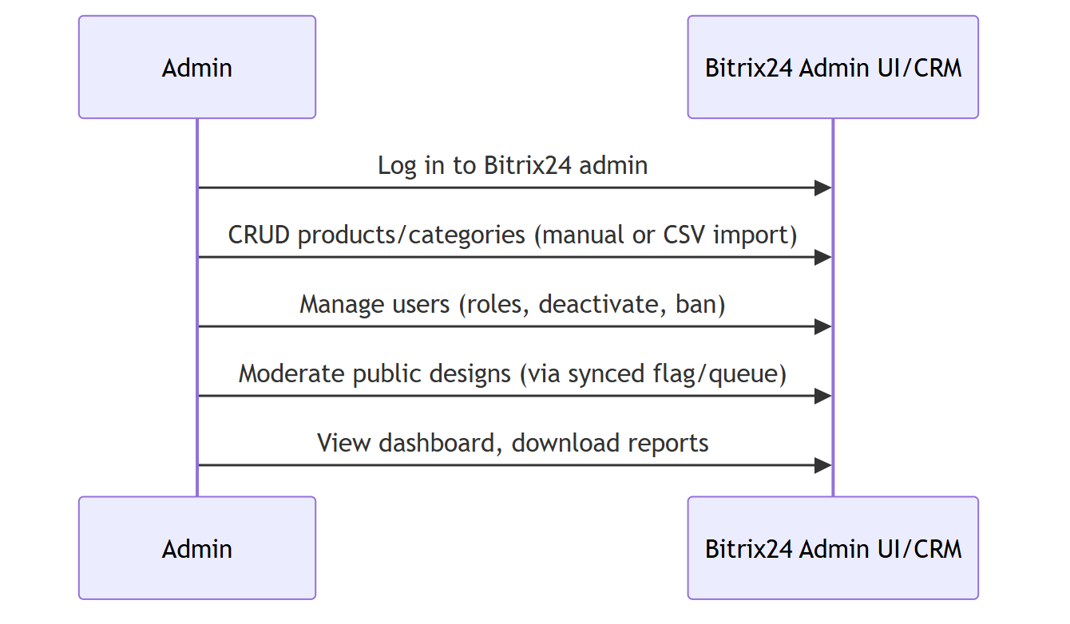
Figure: UC-9: Manage catalog and users (Admin)
(Admin actions occur primarily within Bitrix24 itself; the Catalog Sync/Proxy and Projects Service pick up resulting changes via webhook/reconciliation for the front end to reflect. No separate custom admin UI is built where Bitrix24's native admin covers the requirement.)

Integrations
System | Protocol/Method | Data Exchanged | Notes
Bitrix24 Cloud (Standard Plan) | REST API + Webhooks, OAuth 2.0 | Identity, catalog, CRM deals/orders, payments | Final: Cloud, standard commercial plan. Moderate REST API rate limits — satisfied by webhook-driven catalog sync + periodic reconciliation, not live-proxying. No on-premise deployment is assumed anywhere in this architecture.
Bitrix24 Payment APIs / Hosted Payment Page | REST, direct server-to-server call from Commerce Bridge (cart/product checkout); Bitrix24-hosted payment page + webhook/callback (subscriptions) | Payment authorization/capture requests, tokenized payment method (cart); hosted-page redirect + payment-success webhook (subscriptions) | Final: two genuinely distinct payment paths. Cart/product checkout (UC-6/FR-20) calls Bitrix24 Payment APIs directly from Rumica's own custom checkout form; the Bitrix24-hosted widget is NOT used for this path. Subscription payment (UC-8/FR-21) instead uses Bitrix24's own hosted payment page, with Bitrix24 calling back via webhook to the Commerce Bridge for tier update.
Floor-plan recognition vendor (working assumption: CubiCasa) | REST API | Uploaded plan file → detected walls/doors/windows | Adapter-isolated pending vendor PoC per Vision & Scope
Google OAuth | OAuth 2.0 | Identity token | Sole social login provider in MVP
Google Analytics / Mixpanel | Client-side SDK and/or server-side event API | Usage events (project creation, item usage, planner engagement) | No PII beyond what these vendors' standard SDKs already collect
Email service (e.g., SendGrid/Mailgun-class provider) | REST/SMTP API | Registration, password recovery, order confirmation emails | Provider not yet named in Vision & Scope; treated as a standard transactional email integration

Non-Functional Requirements Mapping
The Vision & Scope document specifies no project-specific compliance, data-residency, or scale targets — only general best-practice placeholders (NFR-1 through NFR-5). This architecture satisfies them as follows:
- NFR-1 (uptime, 99.5%+ target): Achieved by relying on Bitrix24 Cloud's own SLA for CRM/catalog/payments, and standard cloud hosting with health checks/auto-restart for the thin custom services layer. No multi-region/active-active setup is warranted given no stated availability requirement beyond "standard."
- NFR-2 (reasonable responsiveness): The Catalog Sync/Proxy's local cache (rather than live-proxying every catalog read through Bitrix24) is the primary lever here — it keeps catalog page loads independent of Bitrix24 API latency/limits.
- NFR-3 (standard security practices): Encrypted transport (HTTPS) end to end; OAuth-based identity (Google + Bitrix24) rather than custom credential storage where possible; role-based access enforced natively by Bitrix24 for Admin functions. Additionally, because checkout is now a custom-built form (client-confirmed decision), client-side payment tokenization is called out explicitly as a required implementation practice so that raw card data never reaches Rumica-owned code — this is a superset addition to NFR-3 driven directly by the checkout decision, not a new requirement.
- NFR-4 (backup/recovery): Application DB and Object Storage use standard managed-service backup/retention (e.g., automated snapshots); Bitrix24-held data (catalog, CRM, payments) is backed up under Bitrix24's own operational practices, outside Rumica's responsibility.
- NFR-5 (single-currency, single-language): No architectural component introduces multi-currency or i18n infrastructure; this keeps the checkout, catalog, and CRM integration simpler than a localized build would require.
- Scale assumption (explicit, per default-routing guidance): No load/concurrency targets were given. This architecture defaults to a straightforward, non-distributed deployment of the bridge services (a small number of instances behind a load balancer) rather than a microservices/event-streaming buildout — sufficient for MVP traffic and straightforward to scale horizontally later if real usage data warrants it.

Deployment View
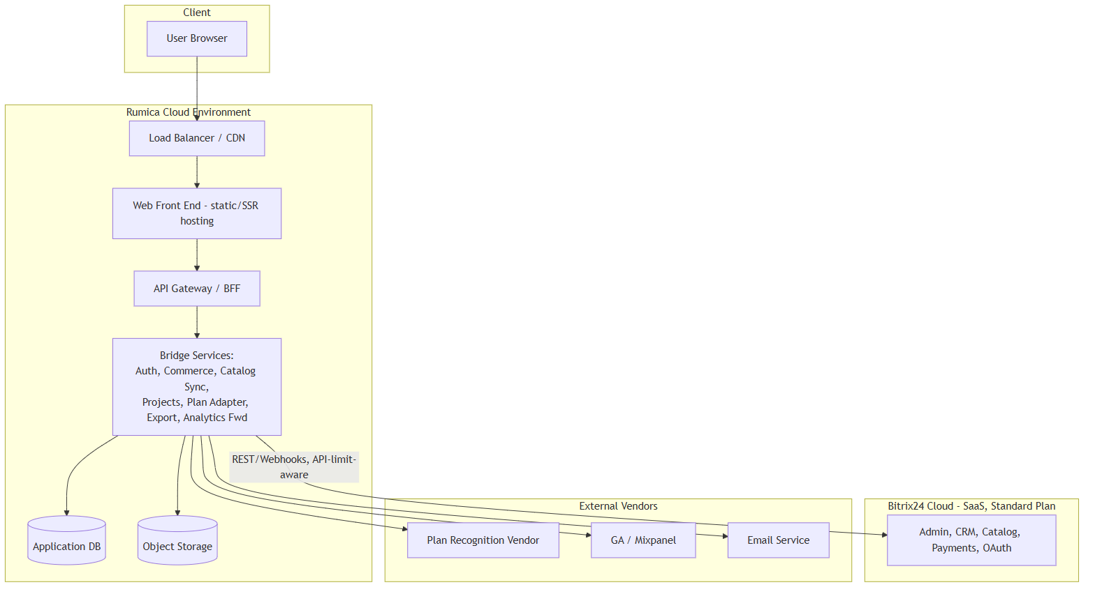
Figure: Deployment View
Bitrix24 is consumed exclusively as a Cloud SaaS service (standard commercial plan, client-confirmed) — there is no on-premise Bitrix24 deployment in scope, and none of the sync/cache design assumes one. Rumica's own custom services are deployed as a small, horizontally-scalable set of stateless instances behind a load balancer; this is intentionally simple given no stated scale requirement.

Key Architectural Decisions & Tradeoffs
- Bitrix24-centric backend: Admin, catalog, CRM, and payments live in Bitrix24 rather than being custom-built — gives up some flexibility/customization depth in exchange for materially lower build and maintenance cost (BR-4). The earlier Java/Spring Boot microservices exploration is confirmed superseded, not a parallel track.
- Webhook + periodic reconciliation catalog sync (not live-proxying): Chosen over calling Bitrix24 on every catalog read — trades near-real-time freshness (catalog updates land within the reconciliation window, not instantly) for materially lower Bitrix24 API load, which matters directly given the confirmed standard-plan API limits.
- Custom Rumica-built checkout form (final, client-confirmed) — cart/product purchases only (UC-6/FR-20): Chosen over the Bitrix24-hosted payment widget for cart/product checkout, to give full UX/branding control end to end — trades a simpler, vendor-hosted redirect flow for additional custom-code surface (form validation, client-side tokenization, more careful security review) that the team must budget for explicitly. Subscription payment (UC-8/FR-21) intentionally does NOT use this mechanism: it is a genuinely separate path through Bitrix24's own hosted payment flow, with Bitrix24 calling back to the Commerce Bridge via webhook — the two checkout mechanisms are deliberately distinct, not a shared implementation.
- No separate order database: "My Orders" and order state are read live from Bitrix24 CRM rather than mirrored into Rumica's own DB — avoids a dual-write consistency problem, at the cost of order-history read latency being bounded by Bitrix24 API responsiveness (acceptable given no stated latency NFR).
- Adapter boundary around floor-plan recognition: Isolates the vendor choice (CubiCasa is a working assumption, not yet finalized per Vision & Scope) so a vendor swap after the PoC doesn't ripple into the rest of the system.
- Relational Application DB (not NoSQL): Projects/user-mapping/webhook-receipt data is structured and relationally shaped; no requirement points toward a document store or need for schema flexibility at this stage.
- No microservices split for the bridge layer: A small number of cohesive services behind a shared gateway is sufficient; splitting further would add operational overhead (service discovery, distributed tracing, more deployment units) with no stated scale/team driver to justify it.

Cost & Complexity Notes
This remains a materially cheaper build than a fully custom backend (avoiding a parallel CRM/catalog/payment/admin implementation), which is the primary cost rationale for the Bitrix24-centric direction. One specific line item does need revisiting, however: the original commercial proposal's estimate table sizes E-Commerce Features at Front-end 2520 / Back-end 1440 / Testing 352 (USD), which reads as scoped for a simpler checkout integration (e.g., delegating to a Bitrix24-hosted payment page). The now-final decision to build a custom Rumica checkout form — including form validation, client-side payment tokenization, and the associated security review — is a larger build than a hosted-widget redirect and should prompt a re-estimate of that line item before the number is treated as final budget. This is flagged here as a cost/scope implication for the estimate owner, not resolved by this architecture document.

Clarifying Questions
None. Both architecture-level questions from the prior round (Bitrix24 edition/plan; checkout implementation approach) are now resolved and reflected above as final decisions. No new architecture-level ambiguity was identified while incorporating them.

