RAIL: Indigenous Weather Forecasting Challenge – 4th Place Solution

1. Overview and Objectives

Purpose
This document describes a winning solution for the RAIL: Indigenous Weather Forecasting Challenge on Zindi. The goal is to build a classification model that predicts the type of rainfall (HEAVYRAIN, MEDIUMRAIN, SMALLRAIN, or NORAIN) expected in the next 12 to 24 hours, based solely on indigenous ecological indicators submitted by trained farmers in Ghana. The solution leverages robust preprocessing, feature engineering, ensemble modeling, and hyperparameter optimization to achieve high accuracy despite class imbalances and missing data.

Objectives and Expected Outcomes
- Accurate Rainfall Predictions: Achieve high Macro F1 scores for classifying rainfall intensity.
- Feature and Data Integration: Effectively incorporate ecological indicators, confidence levels, and community/district specifics.
- Robustness: Handle missing values, categorical features, and potential class imbalances.
- Efficient Inference Pipeline: Provide a streamlined approach from data loading to final predictions and submissions.

2. Architecture Diagram
Below is a concise representation of how data loading, preprocessing, modeling, and inference steps interact:
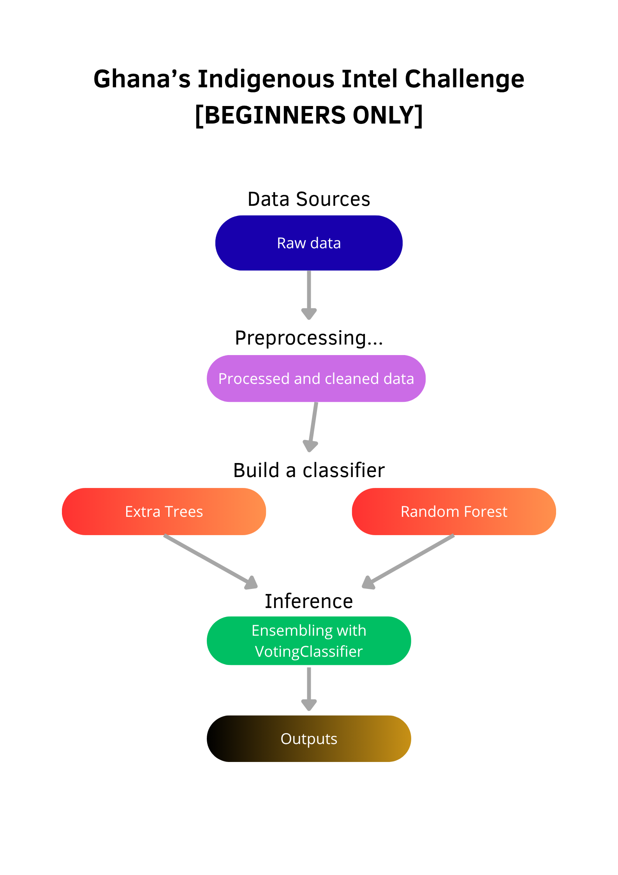

3. ETL Process

3.1 Extract
- Data Sources: Train dataset (ecological indicators, confidence, predicted intensity, and targets), Test dataset (similar features without targets), Sample submission file (for ID alignment and prediction format).
- Data Formats: CSV for all datasets.
- Extraction Considerations: Parse IDs to extract forecast_length (12 or 24 hours). Handle potentially sparse indicators and missing values during loading.

3.2 Transform
- Data Cleaning: Extract forecast_length from IDs as a numeric feature; identify and impute missing values (median for numerics, most frequent for categoricals).
- Aggregation: No temporal aggregation needed; focus on per-observation features.
- Feature Engineering: Define numeric and categorical features, visualize class balance, apply OneHotEncoding and cyclical/time-based transformations if extended.

3.3 Load
- Output Files: class_balance.png (target distribution), submission.csv (final predictions).
- Prepared X/y splits serve as inputs to the modeling step.

4. Data Modeling

4.1 Strategic Data Segmentation
- Full Dataset: Used the entire train set for a global model capturing all indicator-driven behaviors.
- Stratified Splitting: Employed StratifiedKFold to maintain class distributions during cross-validation.

4.2 Model Training
- Two main classifier configurations in an ensemble:
- ExtraTreesClassifier: Tuned with n_estimators=248, focused on robust feature handling.
- RandomForestClassifier: Tuned with n_estimators=300, balanced for bias-variance tradeoff.
- Evaluation & Optimization: 5-Fold Stratified CV for Macro F1 and accuracy, Optuna hyperparameter optimization for tuning.

5. Inference
- Preprocessing: Apply the same pipeline (imputation + OneHotEncoding) to test data.
- Model Prediction: Use the fitted ensemble (VotingClassifier with soft voting) to generate predictions.
- Submission Alignment: Conform predictions to the sample submission format.
- Updates & Versioning: Extendable with new indicators or models.

6. Run Time
- Notebook Execution: ~5–10 minutes end-to-end (CPU environment, including Optuna trials).
- Model Training: Majority of time spent on 5-fold CV and hyperparameter optimization.

7. Performance Metrics
- Primary Metric: Macro F1 Score
- CV Macro F1: ~0.9798
- CV Accuracy: ~0.9951
- Public Leaderboard F1: 0.968444344
- Final Rank: 4th Place
- Ensemble Improvement: ~0.5% gain in F1 from voting vs. single models.

8. Error Handling and Logging
- Logging: Basic INFO-level logging configured for data loading and CV.
- Error Handling: Robust handling of unknown categories and NaNs; assertions check file paths and submission alignment.

9. Maintenance and Monitoring
- Monitoring: Re-evaluate class balance if rainfall patterns change; verify feature importance.
- Scaling: Potential for device/user-specific sub-models if dataset grows.
- Lifecycle Management: Retraining for new regions or indicators; possible integration with XGBoost, LightGBM, or time-series features.

10. Conclusion and Performance Summary

Highlights
- Pipeline Efficiency: Integrated preprocessing handles diverse features seamlessly.
- Ensemble Diversity: Combining ExtraTrees and RandomForest enhances generalization.
- Optimization Focus: Optuna tuning and stratified CV ensure peak performance.
- Reproducibility: Seeding and modular code for consistent results.

Key Results
- CV Macro F1: ~0.9798
Final Rank: 4th

Future Improvements
- Advanced Features: Derive time-based elements from prediction_time or indicator interactions.
- Expanded Modeling: Add XGBoost/LightGBM; incorporate SMOTE for imbalance.
- Handling Sparse Data: Implement nuanced imputation or feature selection.
- Deployment: Develop a real-time app for farmers using Streamlit or similar.
Overall, this approach—emphasizing robust pipelines and optimized ensembles—delivers accurate, reliable predictions for indigenous rainfall forecasting in Ghana.
Notebook Name: 4TH_PLACE_SOLUTION
Training Time: ~5–10 minutes (full run).

