

**PROJEKTNI ZADATAK**

*WEB SAJT Simple House*

Učenik : **Đorđe Jovanović**

Broj indeksa : **11/21**

Predmet : **Web Programiranje 2**

**SADRŽAJ**

UVOD 3

1. Korišćeni programski jezici 3

2. Funkcionalnosti 3

3. Template 5

ORGANIZACIJA 6

1. Organizaciona šema 6

2. Mapa sajta 6

3. Opis funkcionalnosti 7

KODOVI 17

Index.html 17

About.html 20

Contact.html 23

Author.html 28

Style.css 30

Custom.js 41

Products.json 62

Staff.json 73

Navigation.json 75

Food_categories.json 75

Dish_types.json 76

Sort.json 76

RSS.xml 77

Robots.txt 77

# UVOD

## 1. Korišćeni programski jezici

Jezici korišćeni prilikom kreiranja sajta su : **HTML, CSS, JavaScript, jQuery**

Radno okruženje : **Visual Studio Code**

## 2. Funkcionalnosti

**Funkcionalnosti** stranice :

1. **Strelica Pocetak** (vraća korisnika na početak strane)
2. **Prikaz navigacionih linkova** (dinamičko čitanje informacija iz JavaScript-a)
3. **Zadavanje klase .active navigacionim linkovima prilikom menjanja strane**
4. **Dinamicko ispisivanje proizvoda na index stranici citanjem iz JSON fajla,kao i ispisivanje zaposlenih citanjem iz JSON fajla na about stranici**
5. **Filtriranje po tipu hrane,tipu jela i veganskoj hrani**
6. **Sortiranje po ceni,nazivu i popularnosti**
7. **Uskladjeno sortiranje i filtriranje**
8. **Klikom na tri tacke kod teksta proizvoda otvara se modal koji blize opisuje proizvod**
9. **Klikom na order now dugme se taj artikal stavlja u korpu ako vec nije tamo, a ako jeste povecava se kolicina za jedan**
10. **Dinamicki se kreira footer**
11. **Validacija forme za korpu i za kontakt stranicu**
12. **Obrada forme na klik tastera kao I na promenu opcije iz input type time(dozvoljava samo da se zakaze u toku radnog vremena) I input type date(dozvoljava samo zakazivanje pocevsi od sutra), kao I pri izlaskom (blur) iz inputa**
13. **Klikom na korpu se otvara sidebar sa proizvodima koji su naruceni, kao I njihovom kolicinom koja se moze menjati**
14. **Dinamicko izracunavanje ukupne cene u odnosu na to koji su proizvodi izabrani, u kojim kolicinama I porcijama.**
15. **Dinamicko ispisivanje drustvenih mreza zaposlenih u odnosu na JSON fajl svojstva**
16. **Klikom na order dugme se otvara forma za narucivanje, gde ima validacije forme na klik tastera I na blur**
17. **Input type number u korpi se stampaju u odnosu na to da li taj proizvod ima porciju.. Npr ako proizvod ima malu I srednju porciju imace samo dva input number-a, dok ce neki imati samo 1 ili sva 3.**
18. **Ispisivanje cene proizvodima u odnosu na to koje porcije za njih postoje.**
19. **Ispisivanje veganskih proizvoda I vrsta jela.**
20. **Dinamicko popunjavanje tabele na order modalu, ako za neki proizvod ima izabrano 0 za sve kolicine koje taj proizvod ima nece biti ubacen u krajnju tabelu racuna.**
21. **Dinamicko izracunavanje koliko proizvoda ima u korpi sa njihovom kolicinom.**
22. **Klikom van modala I klikom na X se modali zatvaraju**
23. **Izdavanje obavestenja u odnosu na to da li je forma dobro popunjena, I izdavanje obavestenja prilikom klika na taster za ubacivanje u korpu.**
24. **Prilikom slanja porudzbine, nakon 3 sekunde zatvaraju se sidebar korpe I modal za narucivanje**
25. **Preloader (loading screen) koji nakon 1.5s prikazuje sajt**
26. **Dinamicko popunjavanje drop down listi pomocu JSON-a**

## 3. Template

Za izradu sajta je korišćen template: https://www.free-css.com/free-css-templates/page263/simple-house

Većina slika su iz templejta i besplatne su za korisnika,ostale slike sam skinuo sa sajta Pexels.

Ubacivao sam delove HTML i CSS koda, nisam koristio ništa od tuđeg JavaScript koda.

Dodao sam robots.txt,dodao sam sitemap.xml ,dodao sam rss i dodao sam custom.js sa mojim JavaScript I jQuery kodom.

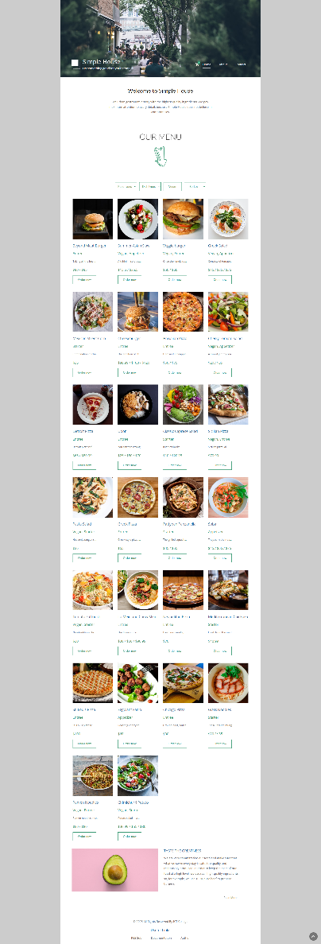

# ORGANIZACIJA

## 1. Organizaciona šema

Korišćen je mrežni model zato što se sa svake stranice može pristupiti ostalima.

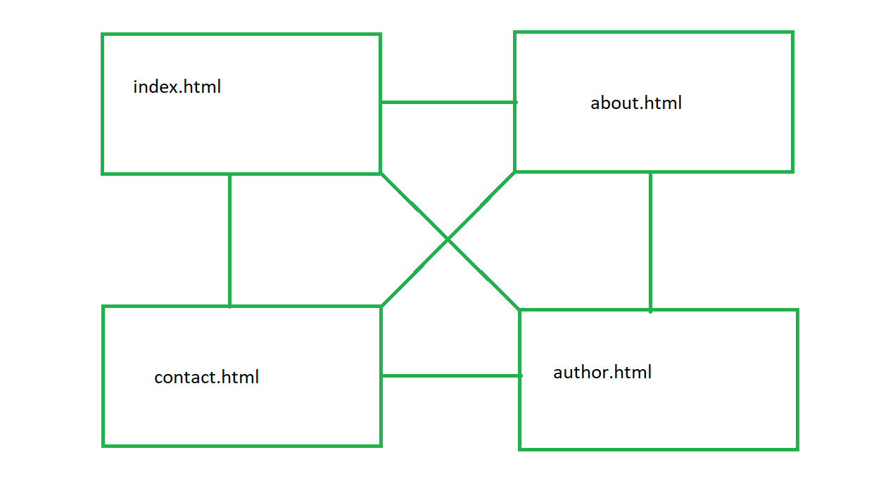

## 2. Mapa sajta

Sitemap kod :

<?xml *version*="1.0" *encoding*="UTF-8"?>

<urlset

*xmlns*="http://www.sitemaps.org/schemas/sitemap/0.9"

*xmlns:xsi*="http://www.w3.org/2001/XMLSchema-instance"

*xsi:schemaLocation*="http://www.sitemaps.org/schemas/sitemap/0.9

            http://www.sitemaps.org/schemas/sitemap/0.9/sitemap.xsd">

<url>

  <loc>https://dzokara.github.io/SimpleHouse/index.html</loc>

  <lastmod>2023-03-05T17:27:04+00:00</lastmod>

  <changefreq>daily</changefreq>

  <priority>1</priority>

</url>

<url>

  <loc>https://dzokara.github.io/SimpleHouse/about.html</loc>

  <lastmod>2023-03-05T17:27:04+00:00</lastmod>

  <changefreq>monthly</changefreq>

  <priority>0.9</priority>

</url>

<url>

  <loc>https://dzokara.github.io/SimpleHouse/contact.html</loc>

  <lastmod>2023-03-05T17:27:04+00:00</lastmod>

  <changefreq>monthly</changefreq>

  <priority>0.85</priority>

</url>

<url>

  <loc>https://dzokara.github.io/SimpleHouse/author.html</loc>

  <lastmod>2023-03-05T17:27:04+00:00</lastmod>

  <changefreq>yearly</changefreq>

  <priority>0.75</priority>

</url>

</urlset>

## 3. Opis funkcionalnosti

**Loading screen (nestaje nakon 1.5s)**



**Dinamicko ispisivanje navigacionih linkova iz JSON fajla i dinamicko setovanje .active klase u odnosu na to na kojoj strani se nalazite**

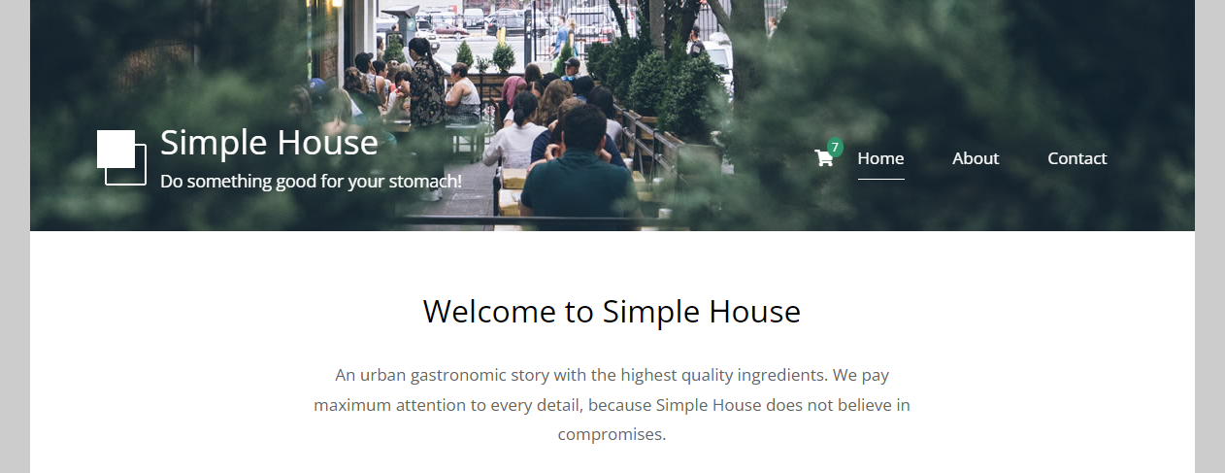

**Dinamicko popunjavanje drop down listi sa podacima iz JSON-a, menjanjem vrednosti drop down listi vrsi se filtriranje i sortiranje, klikom na dugme vegan njemu se menja boja i prikazuju se samo veganski proizvodi, ponovnim klikom sklanja mu se boja i prikazuju se svi proizvodi.**



**Dinamicko ispisivanje proizvoda sa podacima iz JSON-a, dinamicko ispisivanje njihovih cena u odnosu na njihova svojstva, dinamicko ispisivanje vrste jela i da li su veganska.**

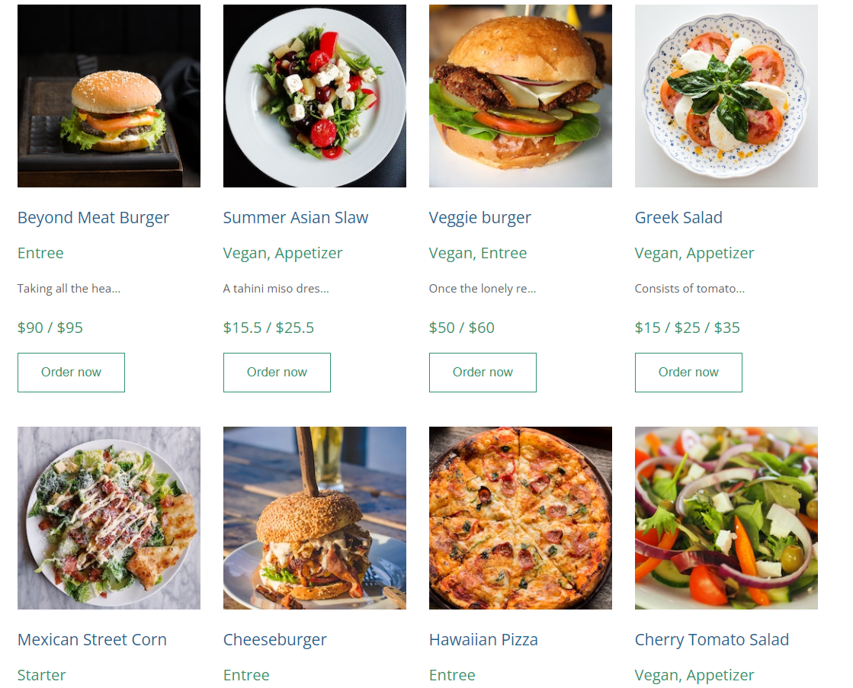

**Klikom na „...“ otvara se modal koji blize opisuje taj proizvod.**

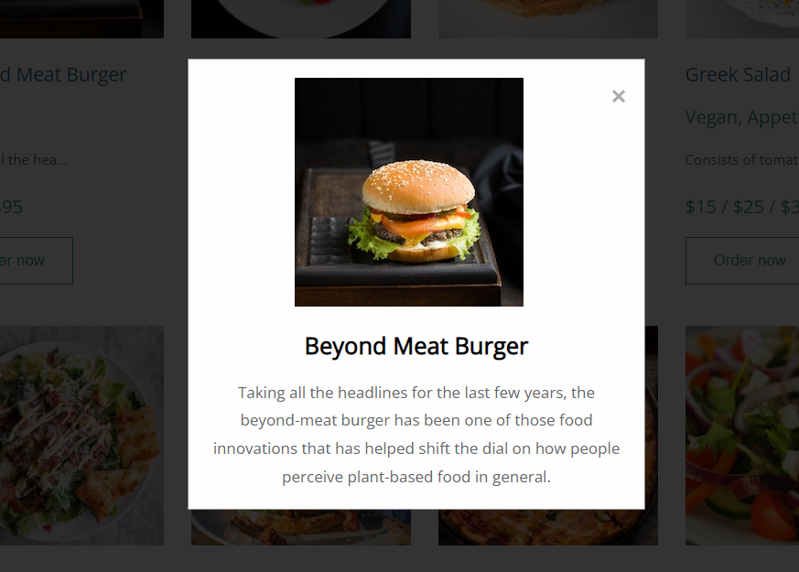

**Modal se zatvara klikom van njega i klikom na „x“**

**Klikom na „order now“ dugme iskace notifikacija, i proizvod se stavlja u korpu.**

**Dinamicki kreiran futer na svakoj strani.**



**Dinamicki kreiran staff blok citanjem iz JSON-a , i takodje dinamicki postavljenje drustvene mreze u zavisnosti od svojstava objekata.**

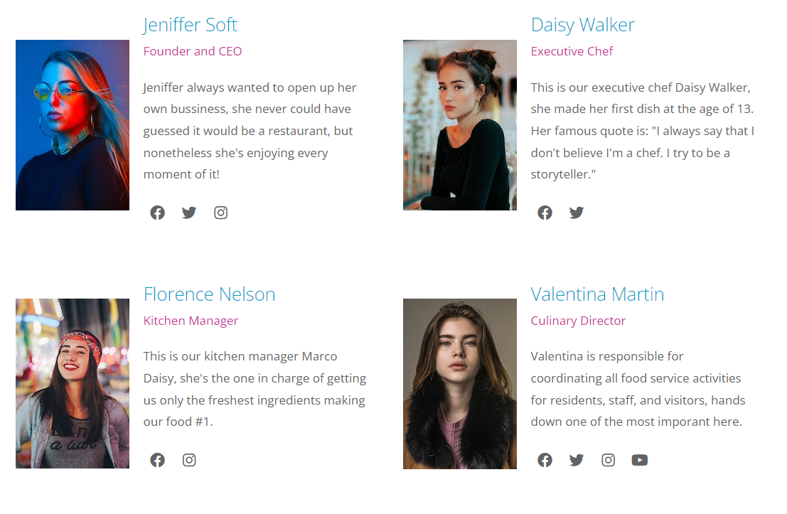

**Validacija forme klikom na taster, izlaskom iz tekstualnih polja, i promenom vrednosti date,time i checkbox**

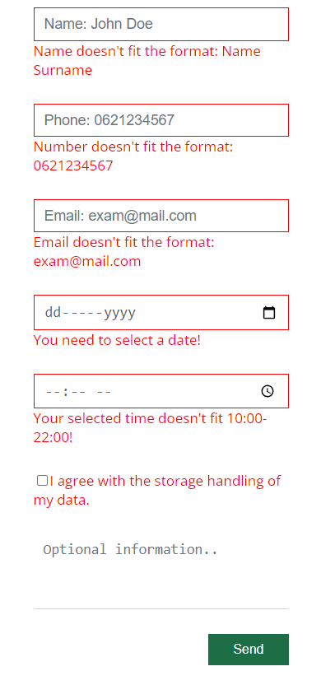

**Ukoliko se forma dobro popuni, forma se resetuje i prikazuje obavestenje korisniku koje nestaje posle 3 sekunde**

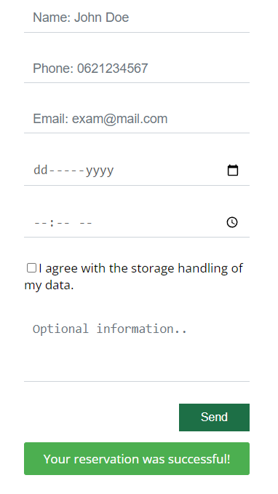

**Klikom na strelicu vraca na vrh stranice**

**Klikom na ikonicu korpe otvara se sidebar, broj iznad ikonice se dinamicki izracuvana u odnosu na kolicinu i broj proizvoda u korpi**



**Ukoliko je korpa prazna prikazace se:**

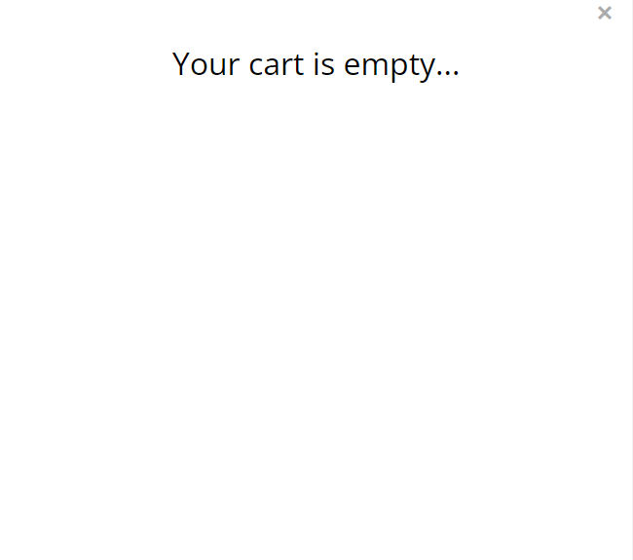

**Klikom na „x“ se zatvara korpa ili klikom van sidebar-a**

**Ukoliko korpa nije prazna prikazace se proizvodi:**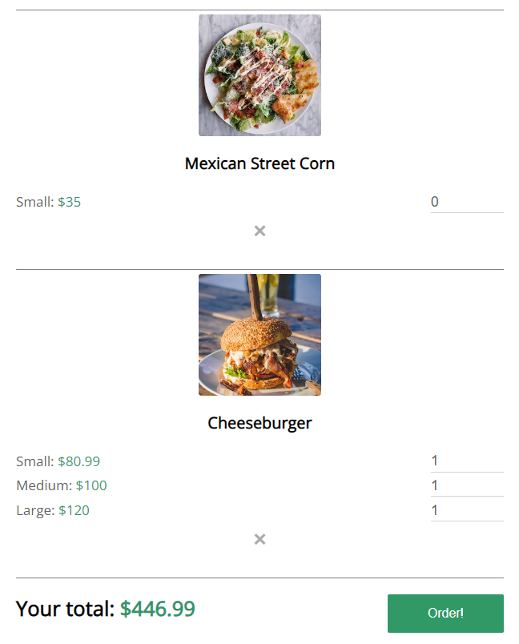

**Inputi se razlikuju jer se dinamicki kreiraju sa svojstvima iz JSON-a, dinamicki se izracunava ukupna cena menjanjem inputa, klikom na „x“ se proizvod brise iz korpe, ukoliko klikom na „order“ postoji proizvod koji za sva njegova input polja ima vrednost 0 on nece biti ubacen u krajnji racun.**

**Klikom na „order!“ otvara se modal za narucivanje:**

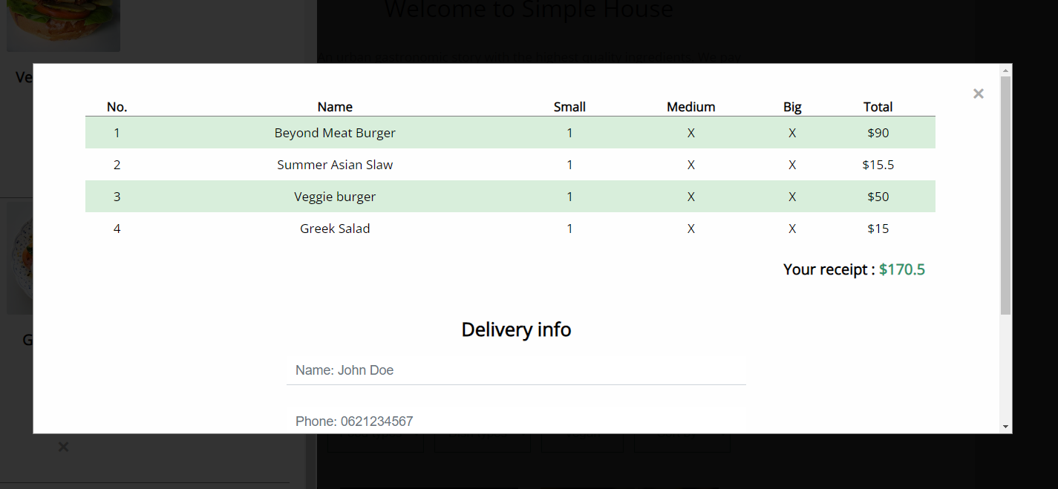

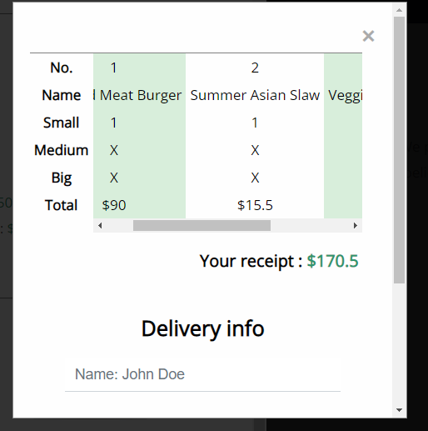

**Klikom na „x“ se zatvara modal. Dinamicki se izracunava ukupna cena racuna.**

**Forma sadrzi provere klikom na taster i izlaskom iz tekstualnih polja.**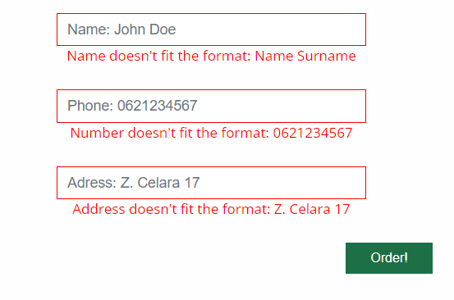

**Ukoliko se forma dobro popuni dobija se obavestenje, korpa se cisti i nakon 3 sekunde zatvara modal i sidebar**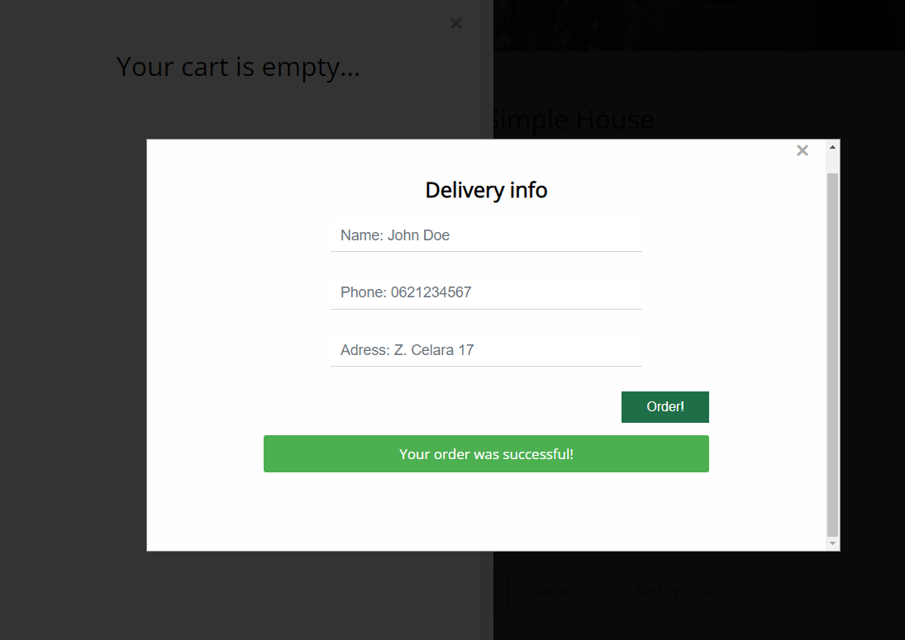

# KODOVI

## Index.html

<!DOCTYPE *html*>

<html>

<head>

    <meta *charset*="UTF-8" />

    <meta *name*="viewport" *content*="width=device-width, initial-scale=1.0" />

    <meta *http-equiv*="X-UA-Compatible" *content*="ie=edge" />

    <meta *name*="author" *content*="mailto:djordje.jovanovic.11.21@ict.edu.rs">

    <meta *name*="keywords" *content*="Simple House, TASTE, Food, Pizza, Burger" />

    <meta *name*="description" *content*="Simple House, an urban gastronomic story with the highest quality ingredients." />

    <meta *name*="copyright" *content*="Simple House Djordje Jovanovic 2023">

    <meta *name*="language" *content*="english">

    <title>Simple House</title>

    <link *rel*="icon" *href*="img/favicon.ico" *type*="image/x-icon">

    <link *href*="https://fonts.googleapis.com/css?family=Open+Sans:400" *rel*="stylesheet" />

    <link *href*="css/all.min.css" *rel*="stylesheet" />

    <link *href*="css/templatemo-style.css" *rel*="stylesheet" />

    <link *rel*="stylesheet" *href*="css/style.css"/>

</head>

<body>

    <div *id*="preloader">

        <img *src*="img/preloader.png" *alt*="loading..." />

    </div>

    <div *id*="sidebar-container" *class*="d-none">

        <div *id*="sidebar">

            <span *class*="close-sidebar">&times;</span>

            <div *id*="ordered-items">

            </div>

            <div *id*="total">

            </div>

        </div>

    </div>

    <div *id*="modal-order-container" *class*="d-none">

        <div *id*="modal-order" *class*="modal">

        </div>

    </div>

      <div *id*="notification">Your order has been added to cart!</div>

      <div *id*="modal-container">

        <div *id*="modal" *class*="modal">

        </div>

      </div>

    <a *href*="#" *id*="return-to-top"><i *class*="fa fa-chevron-up"></i></a>

    <div *class*="container">

    <!-- Top box -->

        <!-- Logo & Site Name -->

        <div *class*="placeholder">

            <div *class*="parallax-window" *data-parallax*="scroll" *data-image-src*="img/simple-house-01.jpg">

                <div *class*="tm-header">

                    <div *class*="row tm-header-inner">

                        <div *class*="col-md-6 col-12">

                            <img *src*="img/simple-house-logo.png" *alt*="Logo" *class*="tm-site-logo" />

                            <div *class*="tm-site-text-box">

                                <h1 *class*="tm-site-title">Simple House</h1>

                                <h6 *class*="tm-site-description">Do something good for your stomach!</h6>

                            </div>

                        </div>

                        <nav *id*="navlinks" *class*="col-md-6 col-12 tm-nav">

                        </nav>

                    </div>

                </div>

            </div>

        </div>

        <main>

            <header *class*="row tm-welcome-section tm-mb-45">

                <h2 *class*="col-12 text-center tm-section-title">Welcome to Simple House</h2>

                <p *class*="col-12 text-center">An urban gastronomic story with the highest quality ingredients. We pay maximum attention to every detail, because Simple House does not believe in compromises.</p>

            </header>

            <div *id*="our-menu"*class*="justify-content-center tm-mb-45">

                <img *src*="img/menu-arrow.png" *alt*="Down arrow" *class*="img-fluid" />

            </div>

            <div *id*="filters" *class*="tm-paging-links justify-content-center">

                <div *id*="foods">

                </div>

                <div *id*="dishes">

                </div>

                <input *type*="button" *class*="tm-paging-link" *value*="Vegan" *id*="veganBtn" />

                <div *id*="sort">

                </div>

            </div>

            <!-- Gallery -->

            <div *class*="row tm-gallery">

                <!-- gallery page 1 -->

                <div *id*="tm-gallery-page-pizza" *class*="tm-gallery-page justify-content-center">

                </div>

                <div *class*="tm-section tm-container-inner">

                    <div *class*="row">

                        <div *class*="col-md-6">

                            <figure *class*="tm-description-figure">

                                <img *src*="img/img-01.jpg" *alt*="Image" *class*="img-fluid" />

                            </figure>

                        </div>

                        <div *class*="col-md-6">

                            <div *class*="tm-description-box">

                                <h4 *class*="tm-gallery-title">TASTE THE GREATNESS</h4>

                                <p *class*="tm-mb-45">We are very committed to our food and make sure that what we serve every day is safe, top quality and responsibly produced. In order to keep the taste of our food at a high level, we use real, high-quality ingredients, so, for example, we use 100% pure beef to prepare burgers.</p>

                                <a *href*="about.html" *class*="tm-btn tm-btn-default tm-right">Read More</a>

                            </div>

                        </div>

                    </div>

                </div>

            </div>

        </main>

        <footer *class*="tm-footer text-center">

        </footer>

    </div>

    <script *src*="js/jquery.min.js"></script>

    <script *src*="js/parallax.min.js"></script>

    <script *src*="js/custom.js"></script>

</body>

</html>

## About.html

<!DOCTYPE *html*>

<html>

<head>

    <meta *charset*="UTF-8" />

    <meta *name*="viewport" *content*="width=device-width, initial-scale=1.0" />

    <meta *http-equiv*="X-UA-Compatible" *content*="ie=edge" />

    <meta *name*="author" *content*="mailto:djordje.jovanovic.11.21@ict.edu.rs">

    <meta *name*="keywords" *content*="Simple House, About, History,TASTE, Food, Pizza, Burger" />

    <meta *name*="description" *content*="Simple House, about our restaurant and how it came to be" />

    <meta *name*="copyright" *content*="Simple House Djordje Jovanovic 2023">

    <meta *name*="language" *content*="english">

    <title>Simple House - About Page</title>

    <link *rel*="icon" *href*="img/favicon.ico" *type*="image/x-icon">

    <link *href*="https://fonts.googleapis.com/css?family=Open+Sans:300,400" *rel*="stylesheet" />

    <link *href*="css/all.min.css" *rel*="stylesheet" />

    <link *href*="css/templatemo-style.css" *rel*="stylesheet" />

    <link *rel*="stylesheet" *href*="css/style.css"/>

</head>

<body>

    <div *id*="preloader">

        <img *src*="img/preloader.png" *alt*="loading..." />

    </div>

    <div *id*="sidebar-container" *class*="d-none">

        <div *id*="sidebar">

            <span *class*="close-sidebar">&times;</span>

            <div *id*="ordered-items">

            </div>

            <div *id*="total">

            </div>

        </div>

    </div>

    <div *id*="modal-order-container" *class*="d-none">

        <div *id*="modal-order" *class*="modal">

        </div>

    </div>

    <a *href*="#" *id*="return-to-top"><i *class*="fa fa-chevron-up"></i></a>

    <div *class*="container">

    <!-- Top box -->

        <!-- Logo & Site Name -->

        <div *class*="placeholder">

            <div *class*="parallax-window" *data-parallax*="scroll" *data-image-src*="img/simple-house-01.jpg">

                <div *class*="tm-header">

                    <div *class*="row tm-header-inner">

                        <div *class*="col-md-6 col-12">

                            <img *src*="img/simple-house-logo.png" *alt*="Logo" *class*="tm-site-logo" />

                            <div *class*="tm-site-text-box">

                                <h1 *class*="tm-site-title">Simple House</h1>

                                <h6 *class*="tm-site-description">Do something good for your stomach!</h6>

                            </div>

                        </div>

                        <nav *id*="navlinks" *class*="col-md-6 col-12 tm-nav">

                        </nav>

                    </div>

                </div>

            </div>

        </div>

        <main>

            <header *class*="row tm-welcome-section">

                <h2 *class*="col-12 text-center tm-section-title">About Simple House</h2>

                <p *class*="col-12 text-center">Here you can learn more about us, why and how we do what we do. Also you can meet our wonderful staff!</p>

            </header>

            <div *class*="tm-container-inner tm-persons">

                <div *id*="staff" *class*="row">

                </div>

            </div>

            <div *class*="tm-container-inner tm-featured-image">

                <div *class*="row">

                    <div *class*="col-12">

                        <img *id*="woman-eating" *src*="img/about-05.jpg" *alt*="Woman eating" />

                    </div>

                </div>

            </div>

            <div *class*="tm-container-inner tm-features">

                <div *class*="row">

                    <div *class*="col-lg-4">

                        <div *class*="tm-feature">

                            <i *class*="fas fa-4x fa-pepper-hot tm-feature-icon"></i>

                            <p *class*="tm-feature-description"> We offer unique and creative flavor combinations that are hard to find elsewhere. We use unusual ingredients to create dishes that are completely new and exciting.</p>

                            <a *href*="index.html#tm-gallery-page-pizza" *class*="tm-btn tm-btn-primary">Order now!</a>

                        </div>

                    </div>

                    <div *class*="col-lg-4">

                        <div *class*="tm-feature">

                            <i *class*="fas fa-4x fa-seedling tm-feature-icon"></i>

                            <p *class*="tm-feature-description">We use high-quality, fresh ingredients that are locally sourced and organic which makes our food healthier!</p>

                            <a *href*="index.html#tm-gallery-page-pizza" *class*="tm-btn tm-btn-success">Order now!</a>

                        </div>

                    </div>

                    <div *class*="col-lg-4">

                        <div *class*="tm-feature">

                            <i *class*="fas fa-4x fa-cocktail tm-feature-icon"></i>

                            <p *class*="tm-feature-description">Our food is easy to order and delivered quickly, making our food ideal for people who are really busy and have little / no time.</p>

                            <a *href*="index.html#tm-gallery-page-pizza" *class*="tm-btn tm-btn-danger">Order now!</a>

                        </div>

                    </div>

                </div>

            </div>

            <div *class*="tm-container-inner tm-history">

                <div *class*="row">

                    <div *class*="col-12">

                        <div *class*="tm-history-inner">

                            <img *src*="img/about-06.jpg" *alt*="Image" *class*="img-fluid tm-history-img" />

                            <div *class*="tm-history-text">

                                <h4 *class*="tm-history-title">History of our restaurant</h4>

                                <p *class*="tm-mb-p">In 2010, four college friends - Jeniffer, Daisy, Florence, and Valentina - were studying in a big city on the West Coast. They were always busy with classes and extracurricular activities, and often found themselves craving fast food late at night.</p>

                                <p>One night, they decided to start their own fast food delivery service, called "Simple House" to bring their favorite fast food to hungry college students like themselves. They pooled their savings, bought a used van, and started making deliveries around campus.</p>

                            </div>

                        </div>

                    </div>

                </div>

            </div>

        </main>

        <footer *class*="tm-footer text-center">

        </footer>

    </div>

    <script *src*="js/jquery.min.js"></script>

    <script *src*="js/custom.js"></script>

    <script *src*="js/parallax.min.js"></script>

</body>

</html>

## Contact.html

<!DOCTYPE *html*>

<html>

<head>

    <meta *charset*="UTF-8" />

    <meta *name*="viewport" *content*="width=device-width, initial-scale=1.0" />

    <meta *http-equiv*="X-UA-Compatible" *content*="ie=edge" />

    <meta *name*="author" *content*="mailto:djordje.jovanovic.11.21@ict.edu.rs">

    <meta *name*="keywords" *content*="Simple House, Contact, Reservation, TASTE, Food, Pizza, Burger" />

    <meta *name*="description" *content*="Simple House, get your reservation now." />

    <meta *name*="copyright" *content*="Simple House Djordje Jovanovic 2023">

    <meta *name*="language" *content*="english">

    <title>Simple House - Contact Page</title>

    <link *rel*="icon" *href*="img/favicon.ico" *type*="image/x-icon">

    <link *href*="https://fonts.googleapis.com/css?family=Open+Sans:300,400" *rel*="stylesheet" />

    <link *href*="css/all.min.css" *rel*="stylesheet" />

    <link *href*="css/templatemo-style.css" *rel*="stylesheet" />

    <link *rel*="stylesheet" *href*="css/style.css"/>

</head>

<body>

    <div *id*="preloader">

        <img *src*="img/preloader.png" *alt*="loading..." />

    </div>

    <div *id*="sidebar-container" *class*="d-none">

        <div *id*="sidebar">

            <span *class*="close-sidebar">&times;</span>

            <div *id*="ordered-items">

            </div>

            <div *id*="total">

            </div>

        </div>

    </div>

    <div *id*="modal-order-container" *class*="d-none">

        <div *id*="modal-order" *class*="modal">

        </div>

    </div>

    <a *href*="#" *id*="return-to-top"><i *class*="fa fa-chevron-up"></i></a>

    <div *class*="container">

    <!-- Top box -->

        <!-- Logo & Site Name -->

        <div *class*="placeholder">

            <div *class*="parallax-window" *data-parallax*="scroll" *data-image-src*="img/simple-house-01.jpg">

                <div *class*="tm-header">

                    <div *class*="row tm-header-inner">

                        <div *class*="col-md-6 col-12">

                            <img *src*="img/simple-house-logo.png" *alt*="Logo" *class*="tm-site-logo" />

                            <div *class*="tm-site-text-box">

                                <h1 *class*="tm-site-title">Simple House</h1>

                                <h6 *class*="tm-site-description">Do something good for your stomach!</h6>

                            </div>

                        </div>

                        <nav *id*="navlinks" *class*="col-md-6 col-12 tm-nav">

                        </nav>

                    </div>

                </div>

            </div>

        </div>

        <main>

            <header *class*="row tm-welcome-section">

                <h2 *class*="col-12 text-center tm-section-title">Contact Page</h2>

                <p *class*="col-12 text-center">Here you can get your reservation, or contact us. We are happy to help you with all of your questions! </p>

            </header>

            <div *class*="tm-container-inner-2 tm-contact-section">

                <div *class*="row">

                    <div *class*="col-md-6">

                        <form *action*="" *method*="POST" *id*="contactForm" *class*="tm-contact-form">

                            <div *class*="form-group">

                              <input *type*="text" *id*="tbName" *name*="name" *class*="form-control" *placeholder*="Name: John Doe"/>

                              <span *class*="alert d-none">Name doesn't fit the format: Name Surname</span>

                            </div>

                            <div *class*="form-group">

                                <input *type*="text" *id*="tbPhone" *name*="phone" *class*="form-control" *placeholder*="Phone: 0621234567"/>

                                <span *class*="alert d-none">Number doesn't fit the format: 0621234567</span>

                              </div>

                            <div *class*="form-group">

                              <input *type*="email" *id*="tbEmail" *name*="email" *class*="form-control" *placeholder*="Email: exam@mail.com"/>

                              <span *class*="alert d-none">Email doesn't fit the format: exam@mail.com</span>

                            </div>

                            <div *class*="form-group">

                                <input *type*="date" *class*="form-control" *id*="reservationDate" *name*="reservationDate">

                                <span *class*="alert d-none">You need to select a date!</span>

                            </div>

                            <div *class*="form-group">

                                <input *type*="time" *step*="any" *class*="form-control" *id*="reservationTime" *name*="reservationTime">

                                <span *class*="alert d-none">Your selected time doesn't fit 10:00-22:00!</span>

                            </div>

                            <div *class*="form-group">

                                <input *type*="checkbox" *id*="agreement"><span *id*="agreementText">I agree with the storage handling of my data.</span>

                            </div>

                            <div *class*="form-group">

                              <textarea *rows*="3" *name*="message" *id*="information" *class*="form-control" *placeholder*="Optional information.."></textarea>

                            </div>

                            <div *class*="form-group tm-d-flex">

                              <button *type*="button" *id*="btnSubmit" *class*="tm-btn tm-btn-success tm-btn-right">

                                Send

                              </button>

                              <span *id*="success" *class*="d-none tm-text-success">Your reservation was successful!</span>

                            </div>

                        </form>

                    </div>

                    <div *class*="col-md-6">

                        <div *class*="tm-address-box">

                            <h4 *class*="tm-info-title tm-text-success">Our Address</h4>

                            <address>

                                Our restaurant is located in Zdravka Čelara 16, Belgrade 11000

                            </address>

                            <h4 *class*="tm-info-title tm-text-success">Open Hours</h4>

                            <p *class*="tm-mb-45 tm-gallery-title">10:00 - 22:00</p>

                            <h4 *class*="tm-info-title tm-text-success">Contact us</h4>

                            <a *href*="tel:0621234567" *class*="tm-contact-link">

                                <i *class*="fas fa-phone tm-contact-icon"></i>0621234567

                            </a>

                            <a *href*="mailto:djordje.jovanovic.11.21@ict.edu.rs" *class*="tm-contact-link">

                                <i *class*="fas fa-envelope tm-contact-icon"></i>djordje.jovanovic.11.21@ict.edu.rs

                            </a>

                            <div *class*="tm-contact-social">

                                <a *href*="https://fb.com/" *class*="tm-social-link"><i *class*="fab fa-facebook tm-social-icon"></i></a>

                                <a *href*="https://twitter.com/" *class*="tm-social-link"><i *class*="fab fa-twitter tm-social-icon"></i></a>

                                <a *href*="https://www.instagram.com/" *class*="tm-social-link"><i *class*="fab fa-instagram tm-social-icon"></i></a>

                            </div>

                        </div>

                    </div>

                </div>

            </div>

            <div *class*="tm-container-inner-2 tm-map-section">

                <div *class*="row">

                    <div *class*="col-12">

                        <div *class*="tm-map">

                            <iframe *src*="https://www.google.com/maps/embed?pb=!1m14!1m8!1m3!1d11321.435429847032!2d20.4844148!3d44.8142534!3m2!1i1024!2i768!4f13.1!3m3!1m2!1s0x0%3A0xc17ed71f59ac4725!2sICT%20College!5e0!3m2!1sen!2srs!4v1676733780015!5m2!1sen!2srs" *frameborder*="0" *style*="border:0;" *allowfullscreen*=""></iframe>

                        </div>

                    </div>

                </div>

            </div>

        </main>

        <footer *class*="tm-footer text-center">

        </footer>

    </div>

    <script *src*="js/jquery.min.js"></script>

    <script *src*="js/custom.js"></script>

    <script *src*="js/parallax.min.js"></script>

</body>

</html>

## Author.html

<!DOCTYPE *html*>

<html>

<head>

    <meta *charset*="UTF-8" />

    <meta *name*="viewport" *content*="width=device-width, initial-scale=1.0" />

    <meta *http-equiv*="X-UA-Compatible" *content*="ie=edge" />

    <meta *name*="author" *content*="mailto:djordje.jovanovic.11.21@ict.edu.rs">

    <meta *name*="keywords" *content*="Simple House, Author, Creator, TASTE, Food, Pizza, Burger" />

    <meta *name*="description" *content*="Simple House, author of the site" />

    <meta *name*="copyright" *content*="Simple House Djordje Jovanovic 2023">

    <meta *name*="language" *content*="english">

    <title>Simple House - Author Page</title>

    <link *rel*="icon" *href*="img/favicon.ico" *type*="image/x-icon">

    <link *href*="https://fonts.googleapis.com/css?family=Open+Sans:400" *rel*="stylesheet" />

    <link *href*="css/all.min.css" *rel*="stylesheet" />

    <link *href*="css/templatemo-style.css" *rel*="stylesheet" />

    <link *rel*="stylesheet" *href*="css/style.css"/>

</head>

<body>

    <div *id*="preloader">

        <img *src*="img/preloader.png" *alt*="loading..." />

    </div>

    <a *href*="#" *id*="return-to-top"><i *class*="fa fa-chevron-up"></i></a>

    <div *id*="sidebar-container" *class*="d-none">

        <div *id*="sidebar">

            <span *class*="close-sidebar">&times;</span>

            <div *id*="ordered-items">

            </div>

            <div *id*="total">

            </div>

        </div>

    </div>

    <div *id*="modal-order-container" *class*="d-none">

        <div *id*="modal-order" *class*="modal">

        </div>

    </div>

    <div *class*="container">

    <!-- Top box -->

        <!-- Logo & Site Name -->

        <div *class*="placeholder">

            <div *class*="parallax-window" *data-parallax*="scroll" *data-image-src*="img/simple-house-01.jpg">

                <div *class*="tm-header">

                    <div *class*="row tm-header-inner">

                        <div *class*="col-md-6 col-12">

                            <img *src*="img/simple-house-logo.png" *alt*="Logo" *class*="tm-site-logo" />

                            <div *class*="tm-site-text-box">

                                <h1 *class*="tm-site-title">Author</h1>

                            </div>

                        </div>

                        <nav *id*="navlinks" *class*="col-md-6 col-12 tm-nav">

                        </nav>

                    </div>

                </div>

            </div>

        </div>

        <main>

            <div *class*="tm-container-inner tm-history">

                <div *class*="row">

                    <div *class*="col-12">

                        <div *id*="author" *class*="tm-history-inner">

                            <img *src*="img/author.jpg" *alt*="Image" *class*="img-fluid tm-history-img" />

                            <div *class*="tm-history-text">

                                <h4 *class*="tm-history-title">Đorđe Jovanović 11/21</h4>

                                <p>I was born in Belgrade. I am currently a student at the ICT College. I am a front end developer that is constantly working on his craft. I mostly dable in front-end programming for now, but I'm also having tons of fun learning new stuff! </p>

                            </div>

                        </div>

                    </div>

                </div>

            </div>

        </main>

        <footer *class*="tm-footer text-center">

        </footer>

    </div>

    <script *src*="js/jquery.min.js"></script>

    <script *src*="js/parallax.min.js"></script>

    <script *src*="js/custom.js"></script>

</body>

</html>

## Style.css

/* PRELOADER */

*#preloader* {

  position: fixed;

  top: 0;

  left: 0;

  width: 100%;

  height: 100%;

  background-color: #f5f5f5;

  z-index: 9999;

}

*#preloader* img{

  position: absolute;

  top: 50%;

  left: 50%;

  transform: translate(-50%, -50%);

  animation: spin 1s linear infinite;

}

@keyframes *spin* {

  0% { transform: translate(-50%, -50%) rotate(0deg); }

  100% { transform: translate(-50%, -50%) rotate(360deg); }

}

/* shopping cart */

*.cart-icon* {

  position: relative;

  display: inline-block;

}

*#cart-icon*{

  cursor: pointer;

}

*#notification* {

  display:none;

  position:fixed;

  background-color: #4CAF50;

  color: white;

  font-size: 16px;

  padding: 12px;

  bottom: 20px;

  right: 80px;

  z-index:999999;

  border-radius:10px;

}

*.cart-count* {

  position: absolute;

  top: -10px;

  right: -10px;

  background-color: #2F956D;

  color: white;

  font-size: 12px;

  padding: 2px 5px;

  border-radius: 50%;

}

*#sidebar*{

  position: fixed;

  top: 0;

  left: 0;

  bottom: 0;

  width: 35%;

  background-color: white;

  z-index: 999;

  padding: 20px;

  overflow-y: scroll;

}

*#sidebar-container*{

  position:fixed;

  z-index: 1500;

  width: 100%;

  height: 100%;

  background-color: rgba(0,0,0,0.8);

}

*#author* img{

  width:40%;

  border-radius: 5px;

}

select{

  border:1px solid #2F956D;

  font-size:17px;

  color:#2F956D;

  text-align: center;

  height:52px;

  cursor: pointer;

  width:130px;

}

option{

  font-size:18px;

}

*.tm-paging-link*{

  font-size:17px;

  border:1px solid #2F956D;

}

*.tm-paging-link:hover*{

  transition:0.5s;

  cursor:pointer;

}

*#veganBtn*{

  margin:7px;

}

*.clicked*{

  background-color: #2F956D;

  color: white;

}

/* return to top arrow*/

*#return-to-top* {

    position: fixed;

    bottom: 20px;

    right: 20px;

    display: none;

    height:50px;

    width:50px;

    z-index:9999;

    border-radius: 35px;

    background: rgb(0, 0, 0);

    background: rgba(0, 0, 0, 0.7);

}

*#return-to-top* i {

    font-size: 24px;

    color:white;

    position: relative;

    left: 13px;

    top: 12px;

}

*.justify-content-center*{

  justify-content: center;

}

*.align-center*{

  align-items:center;

}

label[*for*=agreement]{

  color:#6c757d;

  font-size:15px;

}

footer hr{

  width:50%;

  border:1px solid #2F956D;

  border-radius:100px;

}

*#our-menu*,*#woman-eating*{

  width:100%;

  display:flex;

}

*.tm-gallery-item*{

  text-overflow: ellipsis;

  white-space: nowrap;

  overflow: hidden;

}

*.read-more*{

  text-decoration: none;

  color:#2F956D;

}

*.json-error*{

  padding:50px 0px;

  text-align: center;

  color:red;

}

*.modal* {

  display: none;

  text-align: center;

  position: fixed;

  z-index: 1501;

  left: 0;

  top: 0;

  width: 100%;

  height: 100%;

  overflow: auto;

  background-color: rgba(0,0,0,0.8);

}

*#modal-order.modal*{

  display:block;

}

*#modal* h2{

  margin:20px 0px;

}

*.modal-content* {

  background-color: #fefefe;

  margin: 15% auto;

  padding: 20px;

  border: 1px solid #888;

  max-width: 500px;

}

*#modal-order* *.modal-content*{

  overflow-y: scroll;

  height:500px;

  width:70%;

  max-width: none;

}

*#table-row*{

  padding:0px 50px;

}

*.close-sidebar*,*.close-modal*,*.remove-order*,*.close-modal-order* {

  color: #aaa;

  float: right;

  font-size: 28px;

  font-weight: bold;

}

*.close-sidebar:hover*,*.close-modal:hover*,*.remove-order:hover*,*.close-modal-order:hover*,

*.close-sidebar:focus*,*.close-modal:focus*,*.remove-order:focus*,*.close-modal-order:focus*{

  color: black;

  text-decoration: none;

  cursor: pointer;

}

*.alert*{

  color:red;

}

*.d-none*{

  display:none!important;

}

*.d-block*{

  display:block;

}

*.border-danger*{

  border:1px solid red;

}

*.sidebar-content*{

  display:flex;

  flex-direction: column;

  height:100%;

  align-items: center;

  justify-content: space-around;

  margin-bottom:30px;

  padding-top:5px;

  border-top:1px solid gray;

}

*.sidebar-content* img{

  width:25%;

  border-radius:3px;

}

*#empty-cart*{

  margin-top:50px;

}

*.cart-qty*{

  display: flex;

  align-items: center;

  justify-content: space-between;

  width:100%;

}

*.cart-qty* input[*type*=number]{

  width: 15%;

  padding:0px;

}

*.cart-qty* p{

  width:35%;

}

*.green*{

  color:#2F956D;

}

*#total*{

  border-top:1px solid gray;

  padding-top:20px;

  display:flex;

  width:100%;

  justify-content: space-between;

}

*#orderButton*{

  padding:15px 50px;

  border-radius: 2px;

}

*#success*{

  margin:15px 0px;

  padding:10px 0px;

  color:white;

  border:1px solid #4CAF50;

  background-color: #4CAF50;

  text-align: center;

  border-radius: 3px;

}

*#information*{

  resize: none;

}

*#usefull-link*{

  display:flex;

  width:30%;

  margin:0px auto;

  justify-content: space-between;

}

*#order-form-container* *.form-control*{

  width:70%;

  margin:0px auto;

}

*#receipt*{

  margin-bottom:50px;

  text-align: right;

  margin-right:80px;

}

*#orderForm*{

  width:80%;

  margin:0px auto;

}

*#delivery*{

  width:100%;

  margin-bottom:20px;

}

*#order-table*{

  width:100%;

  border-collapse: collapse;

  margin-top:25px;

}

*#order-table* tbody{

  border-top:1px solid gray;

}

*#order-table* td{

  padding:10px 5px;

  border:none;

}

*#order-table* tbody tr*:nth-child*(odd){

  background-color:rgba(204, 233, 208, 0.767);

}

@media(max-width:1350px){

*#sidebar*{

    width:50%;

  }

}

@media(max-width:1100px){

*#order-form-container* *.form-control*{

    width:100%;

  }

}

@media(max-width:851px){

*.tm-header-inner*{

    flex-direction: column;

  }

*#usefull-link*{

    width:60%;

  }

*#sidebar*{

    width:60%;

  }

}

@media(max-width:811px){

*#orderForm* span{

    font-size:15px;

  }

}

@media(max-width:767px){

*#author*{

    flex-direction: column-reverse;

  }

*#author* img{

    margin-top:20px;

    width:50%;

   }

*#order-form-container*{

    margin:0px auto;

    padding:0px;

    width:80%;

   }

*#orderForm*{

    width:100%;

   }

}

@media(max-width:746px){

*#woman-eating*{

    display:none;

  }

*.sidebar-content* img{

    width:40%;

  }

}

@media(max-width:711px){

*#table-row*{

    padding:0px;

  }

*#order-table*{

    display:block;

    margin-top:40px;

    border-top:1px solid gray;

  }

*#order-table* thead{

    display:block;

    float:left;

  }

*#order-table* tbody{

    overflow-x: scroll;

    display:block;

    white-space: nowrap;

    width:auto;

    border-top:none;

  }

*#order-table* tr{

    display: inline-block;

  }

*#order-table* th, *#order-table* td{

    display: block;

    padding: 5px;

  }

*#receipt*{

    margin-right:20px;

  }

}

@media(max-width:654px){

*#total*{

    flex-direction: column;

    align-items: center;

  }

*#orderButton*{

    margin-top:10px;

  }

}

@media(max-width:630px){

*.cart-qty* p{

    width:50%;

  }

}

@media(max-width:617px){

*#order-form-container*{

    width:90%;

  }

}

@media(max-width:600px){

*#sidebar*{

    width:70%;

  }

}

@media(max-width:540px){

*#order-form-container*{

    width:100%;

  }

}

@media (min-width: 459px) {

  img*.parallax-slider*{

    width:100%;

  }

}

@media(max-width:459px){

*#usefull-link*{

    width:80%;

  }

*#author* img{

    width:70%;

   }

*#sidebar*{

    width:80%;

  }

*.sidebar-content* img{

    width:50%;

  }

}

@media(max-width:420px){

*#receipt*{

    margin-right:0px;

  }

}

@media (max-width: 355px){

*#navlinks*{

    padding:0px;

    width:100%;

  }

*#usefull-link*{

    width:100%;

  }

*#author* img{

    width:80%;

   }

*.cart-qty* p{

    width:60%;

  }

*#receipt*{

    font-size:17px;

  }

}

@media(max-width:330px){

*.tm-header-inner*{

    padding:20px 0px;

  }

}

## Custom.js

window.onload=function(){

    getData("navigation",function(*data*){

        makeNav(data);

        updateProductNumber();

    });

    makeFooter();

    //-- cart sidebar

    var sidebar=document.getElementById("sidebar-container");

    $(document).on("click","#cart-icon",function(){

        if(sidebar.classList.contains("d-none")){

            fillSidebar();

            sidebar.classList.remove("d-none");

        }

        else{

            sidebar.classList.add("d-none");

        }

    });

    window.addEventListener("click",function(*event*){

        if (event.target==sidebar) {

            sidebar.classList.add("d-none");

        }

    });

    $(document).on("click",".remove-order",function(){

        id=$(*this*).data('id');

        removeItem(id);

        calculateTotal("cart");

        updateProductNumber();

        fillSidebar();

    });

    $(document).on("click",".close-sidebar",function(){

        sidebar.classList.add("d-none");

    });

    $(document).on("change",`.sidebar-content input[type="number"]`,function(){

        calculateTotal("cart");

        let cartArray=getLS("cart");

        let input=(*this*).getAttribute("name");

        let id=(*this*).dataset.id;

        let val=parseInt((*this*).value);

        cartArray.forEach((*el*)=>{

            if(el.id==id){

                if(input=="md-qty"){

                    el.mdQty=val;

                }

                if(input=="lg-qty"){

                    el.lgQty=val;

                }

                if(input=="sm-qty"){

                    el.qty=val;

                }

            }

        });

        saveLS("cart",cartArray);

        updateProductNumber();

    });

    //------ cart order form

    var orderModal=document.getElementById("modal-order-container");

    $(document).on("click","#orderButton",function(){

        orderModal.classList.remove("d-none");

        fillOrderModal();

    })

    $(document).on("click",".close-modal-order",function(){

        orderModal.classList.add("d-none");

    });

    $(document).on("blur","#tbOrderName",function(){

        reCheck(reName,$(*this*));

    });

    $(document).on("blur","#tbOrderPhone",function(){

        reCheck(rePhone,$(*this*));

    });

    $(document).on("blur","#tbOrderAddress",function(){

        reCheck(reAdress,$(*this*));

    });

    $(document).on("click","#btnOrderSubmit",function(){

        let valid=validateForm("order");

        if(valid){

            localStorage.removeItem("cart");

            fillSidebar();

            updateProductNumber();

            $("#table-row").html("");

            $("#receipt").html("");

            setTimeout(function timer(){

                orderModal.classList.add("d-none");

                sidebar.classList.add("d-none");

            },3000);

        }

    });

    //--index page

    if(window.location.href.indexOf("index.html")>-1|| window.location.href.endsWith("/")){

        getData("dish_types",function(*data*){

            makeDdl(data,"dishesSelect","filter","Dish types","dishes");

            saveLS("dish_types",data);

        });

        getData("products",function(*data*){

            setTimeout(function timer(){

                makeShop(data);

            },0);

            saveLS("products",data);

        });

        getData("food_categories",function(*data*){

            makeDdl(*data*,"foodsSelect","filter","Food types","foods");

            saveLS("categories",*data*);

        });

        getData("sort",function(*data*){

            makeDdl(*data*,"sortSelect","sort","Sort by","sort");

        });

        $(document).on("change", "#foodsSelect", filterSync);

        $(document).on("change", "#dishesSelect", filterSync);

        $(document).on("change", "#sortSelect", filterSync);

        $(document).on("click", "#veganBtn",function(){

            isButtonClicked();

            filterSync();

        });

        $(document).on("click", ".addToCartButtons",function(){

            showNotification();

            addToCart((*this*).getAttribute("data-id"));

            updateProductNumber();

        });

    };

    //--about page

    if(window.location.href.indexOf("about.html")>-1){

        getData("staff",function(*data*){

            makeStaffDiv(*data*);

        });

    };

    //--contact page

    if(window.location.href.indexOf("contact.html")>-1){

        let date=document.getElementById("reservationDate");

        let now=**new** *Date*();

        let year = now.getFullYear();

        let month = (now.getMonth() + 1).toString().padStart(2, "0");

        let day = (now.getDate()+1).toString().padStart(2, "0");

        let currentDate = `${year}-${month}-${day}`;

        date.min=currentDate;

        $(document).on("change","#reservationTime",function(){

            checkTime($(*this*).val(),$(*this*));

        })

        $(document).on("blur", "#tbName",function(){

            reCheck(reName,$(*this*));

        });

        $(document).on("blur", "#tbPhone",function(){

            reCheck(rePhone,$(*this*));

        });

        $(document).on("blur", "#tbEmail",function(){

            reCheck(reEmail,$(*this*));

        });

        $(document).on("change", "#reservationDate",function(){

            checkDate($(*this*));

        });

        $(document).on("change", "#agreement",function(){

            agreementCheck($(*this*),$("#agreementText"));

        });

        $(document).on("click","#btnSubmit",function(){

            validateForm("contact");

        });

    };

};

window.addEventListener("load", function() {

    const loader = document.getElementById("preloader");

    setTimeout(() => {

        loader.style.display = "none";

        document.getElementById("preloader").style.display = "none";

    }, 1500);

    });

$(document).ready(function() {

  $(window).scroll(function() {

      if ($(*this*).scrollTop() > 250) {

          $('#return-to-top').fadeIn();

      } else {

          $('#return-to-top').fadeOut();

      }

  });

  $('#return-to-top').click(function() {

      $('html, body').animate({scrollTop : 0},800);

      return false;

  });

      var modal = document.getElementById("modal");

      $(document).on("click",".read-more",function(*e*){

*e*.preventDefault();

        let id=$(*this*).data('id');

        fillModal(id);

        modal.style.display = "block";

      });

      $(document).on("click",".close-modal",function(){

        modal.style.display = "none";

      });

      window.onclick = function(*event*) {

        if (*event*.target == modal) {

          modal.style.display = "none";

        }

      }

});

// -- functions

function getData(*file*,*callback*){

    $.ajax({

        url:"data/"+*file*+".json",

        method:"get",

        dataType:"json",

        success:*callback*,

        error:function(*jqXHR*, *exception*){

            var msg = '';

            if (*jqXHR*.status === 0) {

            msg = 'Not connecteded.\n Verify Network.';

            } else if (*jqXHR*.status == 404) {

            msg = 'Requested page not found. [404]';

            } else if (*jqXHR*.status == 500) {

            msg = 'Internal Server Error [500].';

            } else if (*exception* === 'parsererror') {

            msg = 'Requested JSON parse failed.';

            } else if (*exception* === 'timeout') {

            msg = 'Time out error.';

            } else if (*exception* === 'abort') {

            msg = 'Ajax request aborted.';

            } else {

            msg = 'Uncaught Error.\n' + *jqXHR*.responseText;

            }

            $("main").addClass("json-error");

            $("main").html(msg);

        }

    });

}

function isButtonClicked(){

    btn=document.getElementById("veganBtn");

    if (btn.classList.contains("clicked")) {

        btn.classList.remove("clicked");

    }

    else{

        btn.classList.add("clicked");

    }

}

function saveLS(*name*, *value*){

    localStorage.setItem(*name*, JSON.stringify(*value*));

}

function getLS(*name*){

    return JSON.parse(localStorage.getItem(*name*));

}

function makeFooter(){

    let html="";

    html+=`<p>&copy; 2023 All Rights Reserved By ICT College</p>

            <hr/>

            <p class="tm-gallery-title">Useful Links</p>

            <div id="usefull-link">

            <a href="rss.xml">RSS Sub</a>

            <a href="documentation.pdf">Documentation</a>

            <a href="author.html">Author</a>

            </div>`;

    $("footer").html(html);

}

function makeNav(*data*){

    let html=`<ul class="tm-nav-ul">

                <div id="cart-icon" class="cart-icon">

                    <i class="fa fa-shopping-cart"></i>

                    <span class="cart-count">0</span>

                </div>`;

    for (let it of *data*) {

        html+=`<li class="tm-nav-li"><a href="${it.href}" class="tm-nav-link">${it.title}</a></li>`

    }

    html+=`</ul>`;

    $("#navlinks").html(html);

    let currentPage=0;

    if(window.location.href.endsWith("/")){

        document.querySelectorAll("#navlinks .tm-nav-li a")[currentPage].classList.add("active");

    }

    else{

        for (let it of *data*) {

            if (window.location.href.indexOf(it.href) > -1) {

                document.querySelectorAll("#navlinks .tm-nav-li a")[currentPage].classList.add("active");

            }

            else{

                currentPage++;

            }

        }

    }

}

function makeShop(*data*){

    let html="";

    if (*data*.length==0) {

        document.getElementById("tm-gallery-page-pizza").classList.add("justify-content-center");

        html+=`<h3 class="tm-mb-45">Oops, seems like none of our food matches your selection, send us your suggestions!</h3>

        `

    }

    else{

    document.getElementById("tm-gallery-page-pizza").classList.remove("justify-content-center");

    for (let it of *data*) {

        html+=`  <article class="col-lg-3 col-md-4 col-sm-6 col-12 tm-gallery-item">

                    <figure>

                        <img src="img/gallery/${it.image_url.href}" alt="${it.alt}" class="img-fluid tm-gallery-img" />

                        <figcaption>

                            <h4 class="tm-gallery-title">${it.name}</h4>

                            <p class=tm-gallery-price>`;

        html+=it.vegan ? "Vegan, " : "";

        html+=getDishType(it.typeid,"dish_types");

        html+=`</p>

        <p class="tm-gallery-description">${it.description.substr(0,18)}<a href="#" class="read-more" data-id="${it.id}">...</a></p>

        <p class="tm-gallery-price">$`

        html+=`${it.price.sm_price} `;

        html+=it.price.md_price==undefined ? "</p>" : `/ $${it.price.md_price} ` ;

        html+=it.price.lg_price==undefined ? "</p>" : `/ $${it.price.lg_price} </p> `;

        html+=`  </figcaption>

                <input type="button" value="Order now" class="tm-paging-link tm-mb-45 addToCartButtons" data-id="${it.id}">

                </figure>

            </article>`;

    }

}

  $("#tm-gallery-page-pizza").html(html);

}

function getDishType(*id*,*data*){

    let html="";

    dataLS=getLS(data);

    for (let it of dataLS) {

        if(it.id==id){

            html=it.name;

            break;

        }

    }

    return html;

}

function makeDdl(*data*,*id*,*type*,*defaultVal*,*divId*){

    let html = `

    <select class="tm-paging-item" id="${id}">

        <option value="0">${defaultVal}</option>`;

        for(let it of data){

            if(type == "sort"){

                html += `<option value="${it.value}">${it.text}</option>`

            }

            else{

                html += `<option value="${it.id}">${it.name}</option>`

            }

        }

    html += `</select>`;

    if(document.querySelector(`#${divId}`)){

        document.querySelector(`#${divId}`).innerHTML = html;

    }

}

function socialsCheck(*social*,*className*,*link*){

    let html="";

    html+=social ? `<a href="${link}" class="tm-social-link"><i class="fab fa-${className} tm-social-icon"></i></a>` : "";

    return html;

}

function makeStaffDiv(*data*){

    let html="";

    for (let it of data) {

        html+=`

        <article class="col-lg-6">

        <figure class="tm-person">

            <img src="img/${it.image.src}" alt="${it.image.alt}" class="img-fluid tm-person-img" />

            <figcaption class="tm-person-description">

                <h4 class="tm-person-name">${it.name.fName} ${it.name.lName}</h4>

                <p class="tm-person-title">${it.function}</p>

                <p class="tm-person-about">${it.about}</p>

                <div>

                ${socialsCheck(it.socials.facebook,"facebook","https://fb.com")}

                ${socialsCheck(it.socials.twitter,"twitter","https://twitter.com/")}

                ${socialsCheck(it.socials.instagram,"instagram","https://www.instagram.com/")}

                ${socialsCheck(it.socials.youtube,"youtube","https://www.youtube.com/")}

                </div>

                </figcaption>

                </figure>

                </article>

                `

    }

    $("#staff").html(html);

}

function fillModal(*id*){

    let html="";

    let products=getLS("products");

    let i=id-1;

    html+=` <div class="modal-content">

                <span class="close-modal">&times;</span>

                <img src="img/gallery/${products[i].image_url.href}" alt="${products[i].image_url.alt}"/>

                <h2>${products[i].name}</h2>

                <p>${products[i].description}</p>

            </div> `;

    $("#modal").html(html);

}

function fillSidebar(){

    let ordered=getLS("cart");

    let html="";

    var empty=false;

    if(ordered==null || ordered.length==0){

        html=`<h2 id="empty-cart" class="text-center tm-section-title">Your cart is empty...</h2>`;

        empty=true;

    }

    else{

        ordered=getProductsForCart();

        html+=`<h2 class="tm-mb-45">Your orders </h2>

                `

        for (let p of ordered) {

            html+=`

            <div class="sidebar-content">

                <img class="img-fluid" src="img/gallery/${p.image_url.href}" alt="${p.image_url.alt}"/>

                <h3>${p.name}</h3>

                <div class="cart-qty"><p>Small: <span class="green">$${p.price.sm_price}</span></p><input name="sm-qty" class="form-control" min="0" type="number" value="${p.qty}" data-id="${p.id}"></div>`

            html+=checkIfPriceExists(p.id,"md_price") ? `<div class="cart-qty"><p>Medium: <span class="green">$${p.price.md_price}</span></p><input name="md-qty" class="form-control" type="number" min="0" value="${p.mdQty}" data-id="${p.id}"></div>` : "";

            html+= checkIfPriceExists(p.id,"lg_price") ? `<div class="cart-qty"><p>Large: <span class="green">$${p.price.lg_price}</span></p><input name="lg-qty" class="form-control" type="number" min="0" value="${p.lgQty}" data-id="${p.id}"></div>` : "";

            html+=`<span class="remove-order" data-id="${p.id}">&times;</span>

            </div>

                    `;

        }

    }

    $("#ordered-items").html(html);

    if(!empty)

    {

        $("#total").removeClass("d-none");

        calculateTotal("cart");

    }

    else{

        $("#total").addClass("d-none");

    }

}

function showNotification() {

    var notification = document.getElementById("notification");

    notification.style.display = "block";

    setTimeout(function() {

      notification.style.display = "none";

    }, 3000);

  }

function addToCart(*id*){

    var ordered=[];

    if(getLS("cart")!=null){

        ordered=getLS("cart");

        updateProductNumber();

        if(alreadyInCart()){

            updateQty();

        }

        else{

            ordered.push({

                id:id,

                qty:1,

                mdQty:0,

                lgQty:0

            });

            updateProductNumber();

        }

    }

    else{

        ordered.push({

            id:id,

            qty:1,

            mdQty:0,

            lgQty:0

        });

        updateProductNumber();

    }

    function alreadyInCart(){

        return ordered.find(*el*=>el.id==id);

    }

    function updateQty(){

        for (let p of ordered) {

            if(p.id==id){

                p.qty++;

                break;

            }

        }

    }

    saveLS("cart",ordered);

}

function updateProductNumber(){

    let count=0;

    var ordered=getLS("cart");

    if(ordered==null){

        count=0;

    }

    else{

        for(let p of ordered)

    {

        if(checkIfPriceExists(p.id,"md_price")){

            count+=p.mdQty;

        }

        if(checkIfPriceExists(p.id,"lg_price")){

            count+=p.lgQty;

        }

        count+=p.qty;

    }

    }

    document.getElementsByClassName("cart-count")[0].innerHTML= count;

}

function removeItem(*id*){

    let ordered=getLS("cart");

    let newArray=ordered.filter(*el*=>el.id!=id);

    saveLS("cart",newArray);

}

function getProductsForCart(){

    let ordered=getLS("cart");

    let products=getLS("products");

    if(ordered==null || ordered.length == 0 ){

        return [];

    }

    let orderedProducts = products.filter(*el* => {

        for(let o of ordered){

            if(el.id == o.id){

                el.qty = o.qty;

                el.mdQty=o.mdQty;

                el.lgQty=o.lgQty;

                return true;

            }

        }

        return false;

    })

    return orderedProducts;

}

function calculateTotal(*type*){

    let ordered=getProductsForCart();

    let total=0;

    let is=0;

    let im=0;

    let il=0;

    let inputSm=document.getElementsByName("sm-qty");

    let inputMd=document.getElementsByName("md-qty");

    let inputLg=document.getElementsByName("lg-qty");

    for(let p of ordered){

        if(checkIfPriceExists(p.id,"md_price")){

            total+=p.price.md_price*inputMd[im].value;

            im++;

        }

        if(checkIfPriceExists(p.id,"lg_price")){

            total+=p.price.lg_price*inputLg[il].value;

            il++;

        }

        total+=p.price.sm_price*inputSm[is].value;

        is++;

    }

    if(type=="cart"){

        html=`<h2>Your total: <span class="green">$${parseFloat(total.toFixed(2))}</span></h2><input type="button" id="orderButton" class="tm-btn tm-btn-success" value="Order!"/>`;

        $("#total").html(html);

        return;

    }

    if(type=="order"){

        return total;

    }

}

function checkIfPriceExists(*id*,*propName*){

    let ordered=getProductsForCart();

    let p=ordered.find(*el*=>el.id==id);

    if(propName=="lg_price"){

        if (p.price.lg_price) {

            return true;

        }

        else{

            return false;

        }

    }

    if(propName="md_price"){

        if (p.price.md_price) {

            return true;

        }

        else{

            return false;

        }

    }

}

function fillOrderModal(){

    let html="";

        let products=getProductsForCart();

        let okProducts=products.filter(*el*=>{

            return el.qty + el.mdQty + el.lgQty !=0;

        });

        let no=1;

        html+=` <div class="modal-content">

                    <span class="close-modal-order">&times;</span>

                <div id="table-row" class="row">

                    <table id="order-table">

                        <thead>

                            <tr>

                                <th>No.</th>

                                <th>Name</th>

                                <th>Small</th>

                                <th>Medium</th>

                                <th>Big</th>

                                <th>Total</th>

                            </tr>

                        </thead>

                        <tbody>

                `;

                for (let p of okProducts) {

                    html+= `<tr>

                    <td>${no++}</td>

                    <td>${p.name}</td>

                    <td>${p.qty == 0 ? "X" : p.qty}</td>

                    <td>${p.mdQty == 0 ? "X" : p.mdQty}</td>

                    <td>${p.lgQty == 0 ? "X" : p.lgQty}</td>

                    <td>$${totalForOneProduct(p.id)}</td>

                </tr>`

                }

                html+=`

                        </tbody>

                    </table>

                </div>

                <h3 id="receipt">Your receipt : <span class="green">$${calculateTotal("order")}</span></h3>

                <div class="row">

                <h2 id="delivery">Delivery info</h2>

                <div id="order-form-container" class="tm-container-inner-2 tm-contact-section">

                        <form action="" method="POST" id="orderForm">

                            <div class="form-group">

                                <input type="text" id="tbOrderName" name="name" class="form-control" placeholder="Name: John Doe"/>

                                <span class="alert d-none">Name doesn't fit the format: Name Surname</span>

                            </div>

                            <div class="form-group">

                                <input type="text" id="tbOrderPhone" name="phone" class="form-control" placeholder="Phone: 0621234567"/>

                                <span class="alert d-none">Number doesn't fit the format: 0621234567</span>

                            </div>

                            <div class="form-group">

                                <input type="text" id="tbOrderAddress" name="address" class="form-control" placeholder="Adress: Z. Celara 17"/>

                                <span class="alert d-none">Address doesn't fit the format: Z. Celara 17 </span>

                            </div>

                            <div class="form-group tm-d-flex">

                                <button type="button" id="btnOrderSubmit" class="tm-btn tm-btn-success tm-btn-right">

                                Order!

                                </button>

                                <span id="success" class="d-none tm-text-success">Your order was successful!</span>

                            </div>

                        </form>

                </div>

            </div>

            </div> `;

    $("#modal-order").html(html);

}

function totalForOneProduct(*id*){

    let total=0;

    let products=getProductsForCart();

    let product=products.find(*el*=>el.id==id);

    checkIfPriceExists(id,"md_price") ? total+=product.mdQty*product.price.md_price : "";

    checkIfPriceExists(id,"lg_price") ? total+=product.lgQty*product.price.lg_price : "";

    total += product.qty*product.price.sm_price;

    return total;

}

function sort(*data*){

    value=document.getElementById("sortSelect").value;

    if (value==0) {

        return data;

    }

    else{

        data.sort((*a*,*b*)=>{

            if(value=="price-asc")

                return a.price.sm_price - b.price.sm_price;

            if (value=="price-desc") {

                return b.price.sm_price - a.price.sm_price;

            }

            if(value=="name-asc"){

                if(a.name < b.name){

                    return -1;

                }

                else if(a.name > b.name){

                    return 1;

                }

                else{

                    return 0;

                }

            }

            if(value=="name-desc"){

                if(a.name > b.name){

                    return -1;

                }

                else if(a.name < b.name){

                    return 1;

                }

                else{

                    return 0;

                }

            }

            if(value=="popularity"){

                return b.popularity - a.popularity;

            }

        })

    return data;

    }

}

function filterFood(*data*,*type*){

    var filterProperty;

    if (type=="foods") {

        filterProperty="categoryid"

        currentValue=document.getElementById("foodsSelect").value;

    }

    else

    {

        filterProperty="typeid"

        currentValue=document.getElementById("dishesSelect").value;

    }

    if(currentValue!=0){

        return data.filter(*x*=> x[filterProperty] == currentValue);

    }

    else{

        return data;

    }

}

function filterVegan(*data*){

   if(document.getElementById("veganBtn").classList.contains("clicked"))

        return data.filter(*x*=>x.vegan==true);

    else  return data;

}

function filterSync(){

    let products=getLS("products");

    products=filterFood(products,"foods");

    products=filterFood(products,"dish");

    products=filterVegan(products);

    sort(products);

    makeShop(products);

}

reName=/^[A-ZŠĐŽČĆ][a-zšđčćž]{2,14}(\s[A-ZŠĐŽČĆ][a-zšđčćž]{2,14})+$/;

reEmail=/^[a-z0-9\.]+@[a-z]+\.[a-z]{2,3}$/;

rePhone=/^06\d{7,8}$/;

reAdress=/^[A-Za-zČĆŽĐŠčćžđš'\.\-\s\,0-9]{3,}$/;

function addBorder(*obj*){

    obj.next('span').removeClass("d-none");

    obj.addClass("border-danger");

    return false;

}

function removeBorder(*obj*){

    obj.next('span').addClass("d-none");

    obj.removeClass("border-danger");

    return true;

}

function reCheck(*re*,*obj*){

    if(!re.test(obj.val())){

      return addBorder(obj)

  }

    else{

        return removeBorder(obj);

    }

}

function checkTime(*value*,*obj*){

    let min="10:00";

    let max="22:00";

    if(value>min && value<max){

        return removeBorder(obj);

    }

    else{

        return addBorder(obj);

    }

}

function agreementCheck(*obj*,*label*){

    if(obj.is(":checked")){

        label.removeClass("alert");

        return true;

    }

    else{

        label.addClass("alert");

        return false;

    }

}

function checkDate(*obj*){

    if(obj.val()==""){

        return addBorder(obj);

    }

    else{

        return removeBorder(obj);

    }

}

function validateForm(*type*){

    let brGresaka=0;

    if(type=="contact"){

        let tbName=$("#tbName");

        let tbPhone=$("#tbPhone");

        let tbEmail=$("#tbEmail");

        let date=$("#reservationDate");

        let time=$("#reservationTime");

        let chb=$("#agreement");

        !reCheck(reName,tbName) ? brGresaka++ : "";

        !reCheck(rePhone,tbPhone) ? brGresaka++ : "";

        !reCheck(reEmail,tbEmail) ? brGresaka++ : "";

        !checkTime($(time).val(),time) ? brGresaka++ : "";

        !checkDate(date) ? brGresaka++ : "";

        !agreementCheck(chb,$("#agreementText")) ? brGresaka++ : "";

    }

    if(type=="order"){

        let tbName=$("#tbOrderName");

        let tbPhone=$("#tbOrderPhone");

        let tbAddress=$("#tbOrderAddress");

        !reCheck(reName,tbName) ? brGresaka++ : "";

        !reCheck(rePhone,tbPhone) ? brGresaka++ : "";

        !reCheck(reAdress,tbAddress) ? brGresaka++ : "";

    }

    if(brGresaka==0){

        if(type=="contact"){

            document.getElementById("contactForm").reset();

        }

        if(type=="order"){

            document.getElementById("orderForm").reset();

        }

        document.getElementById("success").classList.remove("d-none");

        setTimeout(function timer(){

            document.getElementById("success").classList.add("d-none");

        },3000);

    return true;

    }

}

## Products.json

[

      {

        "id":1,

        "name": "Beyond Meat Burger",

        "categoryid": 2,

        "typeid":3,

        "vegan":false,

        "popularity":80,

        "price": {

          "sm_price": 90,

          "md_price": 95

        },

        "description": "Taking all the headlines for the last few years, the beyond-meat burger has been one of those food innovations that has helped shift the dial on how people perceive plant-based food in general.",

        "image_url": {

          "href":"Beyond meat burger.jpg",

          "alt":"Beyond meat burger"

        }

      },

      {

        "id":2,

        "name": "Summer Asian Slaw",

        "categoryid": 4,

        "typeid":1,

        "vegan":true,

        "popularity":54,

        "price": {

          "sm_price": 15.50,

          "md_price": 25.50

        },

        "description": "A tahini miso dressing gives it a creamy umami coating, while peaches add juicy pops of sweetness. ",

        "image_url": {

          "href":"Summer Asian Slaw.jpg",

          "alt":"Summer Asian Slaw"

        }

      },

      {

        "id":3,

        "name": "Veggie burger",

        "categoryid": 2,

        "typeid":3,

        "vegan":true,

        "popularity":65,

        "price": {

          "sm_price": 50,

          "md_price": 60

        },

        "description": "Once the lonely refuge of the only vegetarian in your group, the veggie burger now threatens to knock the beef burger off its perch.",

        "image_url": {

          "href":"Veggie burger.jpg",

          "alt":"Veggie burger"

        }

      },

      {

        "id":4,

        "name": "Greek Salad",

        "categoryid": 4,

        "typeid":1,

        "vegan":true,

        "popularity":45,

        "price": {

          "sm_price": 15,

          "md_price": 25,

          "lg_price": 35

        },

        "description": "Consists of tomatoes, cucumbers, olives, feta, and onions. It's lightly dressed with olive oil, salt, pepper, and oregano.",

        "image_url": {

          "href":"Greek Salad.jpg",

          "alt":"Greek Salad"

        }

      },

      {

        "id":5,

        "name": "Mexican Street Corn",

        "categoryid": 4,

        "typeid":2,

        "vegan":false,

        "popularity":21,

        "price": {

          "sm_price": 35

        },

        "description": "Combination of charred corn, crumbly Cotija, creamy mayo, and cilantro is a hard one to beat.",

        "image_url": {

          "href":"Mexican Street Corn Salad.jpg",

          "alt":"Mexican Street Corn Salad"

        }

      },

      {

        "id":6,

        "name": "Cheeseburger",

        "categoryid": 2,

        "typeid":3,

        "vegan":false,

        "popularity":96,

        "price": {

          "sm_price": 80.99,

          "md_price": 100,

          "lg_price": 120

        },

        "description": "The addition of cheese transforms a burger... into a cheeseburger.",

        "image_url": {

          "href":"Cheeseburger.jpg",

          "alt":"Cheeseburger"

        }

      },

      {

        "id":7,

        "name": "Hawaiian Pizza",

        "categoryid": 1,

        "typeid":3,

        "vegan":false,

        "popularity":82,

        "price": {

          "sm_price": 60,

          "md_price": 75

        },

        "description": "Ham and Pineapple on a base of mozzarella and tomato sauce.",

        "image_url": {

          "href":"Hawaiian Pizza.jpg",

          "alt":"Hawaiian Pizza"

        }

      },

      {

        "id":8,

        "name": "Cherry Tomato Salad",

        "categoryid": 4,

        "typeid":1,

        "vegan":true,

        "popularity":39,

        "price": {

          "sm_price": 20,

          "md_price": 35

        },

        "description": "A mix of jammy roasted cherry tomatoes and juicy fresh ones. With spiced roasted chickpeas, tangy feta, and big pearls of couscous, it's hearty enough to be a meal on its own.",

        "image_url": {

          "href":"Cherry Tomato Couscous Salad.jpg",

          "alt":"Cherry Tomato Couscous Salad"

        }

      },

      {

        "id":9,

        "name": "Detroit Pizza",

        "categoryid": 1,

        "typeid":3,

        "vegan":false,

        "popularity":96,

        "price": {

          "sm_price": 65,

          "md_price":80.99

        },

        "description": "Detroit pizza is first topped with pepperoni, followed by brick cheese which is spread to the very edges of the pan.",

        "image_url": {

          "href":"Detroit Pizza.jpg",

          "alt":"Detroit Pizza"

        }

      },

      {

        "id":10,

        "name": "Udon",

        "categoryid": 3,

        "typeid":3,

        "vegan":false,

        "popularity":86,

        "price": {

          "sm_price": 25,

          "md_price": 50,

          "lg_price": 70

        },

        "description": "You can’t go wrong with yaki udon for a mouthwatering Japanese dinner dish!",

        "image_url": {

          "href":"Udon.jpg",

          "alt":"Udon Noodles"

        }

      },

      {

        "id":11,

        "name": "Classic Caprese Salad",

        "categoryid": 4,

        "typeid":2,

        "vegan":false,

        "popularity":75,

        "price": {

          "sm_price": 10,

          "md_price": 20.15

        },

        "description": "If it ain't broke, don't fix it, or however the saying goes... You get the point.",

        "image_url": {

          "href":"Classic Caprese Salad.jpg",

          "alt":"Classic Caprese Salad"

        }

      },

      {

        "id":12,

        "name": "Sicilian Pizza",

        "categoryid": 1,

        "typeid":3,

        "vegan":true,

        "popularity":100,

        "price": {

          "sm_price": 70.99

        },

        "description": "Sicilian pizza, also known as sfincione, provides a thick cut of pizza with pillowy dough, a crunchy crust, and robust tomato sauce. This square-cut pizza is served with or without cheese.",

        "image_url": {

          "href":"Sicilian Pizza.jpg",

          "alt":"Sicilian Pizza"

        }

      },

      {

        "id":13,

        "name": "Pasta Salad",

        "categoryid": 4,

        "typeid":2,

        "vegan":true,

        "popularity":91,

        "price": {

          "sm_price": 25

        },

        "description": "Heavenly tangy / creamy / crunchy / fresh summer combo.",

        "image_url": {

          "href":"Pasta Salad.jpg",

          "alt":"Pasta Salad"

        }

      },

      {

        "id":14,

        "name": "Greek Pizza",

        "typeid":3,

        "vegan":false,

        "categoryid": 1,

        "popularity":80,

        "price": {

          "sm_price": 55

        },

        "description": "Greek-style pizza, especially popular in the New England states, features a thick and chewy crust cooked in shallow, oiled pans, resulting in a nearly deep-fried bottom.",

        "image_url": {

          "href":"Greek Pizza.jpg",

          "alt":"Greek Pizza"

        }

      },

      {

        "id":15,

        "name": "Pattypan Panzanella",

        "categoryid": 4,

        "typeid":2,

        "vegan":false,

        "popularity":56,

        "price": {

          "sm_price": 45,

          "md_price": 55

        },

        "description": "The grilled squash is a great jammy contrast to crisp cucumbers and bursty cherry tomatoes.",

        "image_url": {

          "href":"Pattypan Panzanella.jpg",

          "alt":"Pattypan Panzanella"

        }

      },

      {

        "id":16,

        "name": "Soba",

        "categoryid": 3,

        "typeid":1,

        "vegan":false,

        "popularity":24,

        "price": {

          "sm_price": 45,

          "md_price": 55,

          "lg_price": 75

        },

        "description": "They earn their dark coloring from buckwheat flour. It has more protein and fiber than your average pasta.",

        "image_url": {

          "href":"Soba.jpg",

          "alt":"Soba Noodles"

        }

      },

      {

        "id":17,

        "name": "Tomato Fattoush",

        "categoryid": 4,

        "typeid":2,

        "vegan":true,

        "popularity":15,

        "price": {

          "sm_price": 30

        },

        "description": "Non-traditional take on fattoush, a bread salad made with toasted pita. This one has a layer of lemony yogurt and is topped with crispy chickpeas",

        "image_url": {

          "href":"Heirloom Tomato Fattoush.jpg",

          "alt":"Heirloom Tomato Fattoush"

        }

      },

      {

        "id":18,

        "name": "Lo Mein and Chow Mein",

        "categoryid": 3,

        "typeid":3,

        "vegan":false,

        "popularity":42,

        "price": {

          "sm_price": 30,

          "md_price": 60,

          "lg_price": 90.99

        },

        "description": "The flavors of lo mein and chow mein noodles are perfect for hot stir-fries with garlic, sesame, and ginger. ",

        "image_url": {

          "href":"Lo Mein and Chow Mein.jpg",

          "alt":"Lo Mein and Chow Mein"

        }

      },

      {

        "id":19,

        "name": "Neapolitan Pizza",

        "categoryid": 1,

        "typeid":3,

        "vegan":false,

        "popularity":92,

        "price": {

          "sm_price": 70

        },

        "description": "Fresh mozzarella, tomatoes, basil leaves, oregano, and olive oil.",

        "image_url": {

          "href":"Neapolitan Pizza.jpg",

          "alt":"Neapolitan Pizza"

        }

      },

      {

        "id":20,

        "name": "Mediterranean Chickpea",

        "categoryid": 4,

        "typeid":2,

        "vegan":false,

        "popularity":32,

        "price": {

          "sm_price": 40.99

        },

        "description": "Fresh from the mediterranean! Only the best for our customers.",

        "image_url": {

          "href":"Mediterranean Chickpea Salad.jpg",

          "alt":"Mediterranean Chickpea Salad"

        }

      },

      {

        "id":21,

        "name": "St. Louis Pizza",

        "categoryid": 1,

        "typeid":3,

        "vegan":false,

        "popularity":95,

        "price": {

          "sm_price": 100

        },

        "description": "St. Louis pizza features a thin crust with a cracker-like consistency that is made without yeast.",

        "image_url": {

          "href":"St. Louis Pizza.jpg",

          "alt":"St. Louis Pizza"

        }

      },

      {

        "id":22,

        "name": "Eggplant Farro",

        "categoryid": 4,

        "typeid":1,

        "vegan":false,

        "popularity":40,

        "price": {

          "sm_price": 60

        },

        "description": "Roasting cherry tomatoes gives them an intense sweet & savory flavor that’s fantastic alongside eggplant, arugula, and nutty farro.",

        "image_url": {

          "href":"Eggplant & Roasted Tomato Farro Salad.jpg",

          "alt":"Eggplant & Roasted Tomato Farro Salad"

        }

      },

      {

        "id":23,

        "name": "Chicago Pizza",

        "categoryid": 1,

        "typeid":3,

        "vegan":false,

        "popularity":90,

        "price": {

          "sm_price": 90

        },

        "description": "Ground beef, sausage, pepperoni, onion, mushrooms, and green peppers, placed underneath the tomato sauce.",

        "image_url": {

          "href":"Chicago Pizza.jpg",

          "alt":"Chicago Pizza"

        }

      },

      {

        "id":24,

        "name": "Glass Noodles",

        "categoryid": 3,

        "typeid":2,

        "vegan":false,

        "popularity":65,

        "price": {

          "sm_price": 20,

          "md_price": 35

        },

        "description": "These include mung bean, peas, or sweet potato, although mung bean is the most common.",

        "image_url": {

          "href":"Glass Noodles.jpg",

          "alt":"Glass Noodles"

        }

      },

      {

        "id":25,

        "name": "Ramen Noodles",

        "categoryid": 3,

        "typeid":3,

        "vegan":true,

        "popularity":69,

        "price": {

          "sm_price": 60,

          "md_price": 80

        },

        "description": "Ramen noodles incorporate wheat flour, vegetable oils, and in some instances, extra flavoring.",

        "image_url": {

          "href":"Ramen Noodles.jpg",

          "alt":"Ramen Noodles"

        }

      },

      {

        "id":26,

        "name": "Chimichurri Potato",

        "categoryid": 4,

        "typeid":2,

        "vegan":true,

        "popularity":36,

        "price": {

          "sm_price": 30.99,

          "md_price": 55,

          "lg_price":80

        },

        "description": "Potato salad in a tangy, herbaceous chimichurri instead of a creamy dressing. ",

        "image_url": {

          "href":"Chimichurri Potato Salad.jpg",

          "alt":"Chimichurri Potato Salad"

        }

      }

]

## Staff.json

[

    {

        "name":{

            "fName":"Jeniffer",

            "lName":"Soft"

            },

        "image":{

            "src":"Jeniffer Soft.jpg",

            "alt":"Jennifer Soft"

        },

        "function":"Founder and CEO",

        "about":"Jeniffer always wanted to open up her own bussiness, she never could have guessed it would be a restaurant, but nonetheless she's enjoying every moment of it!",

        "socials":{

            "facebook":true,

            "twitter":true,

            "instagram":true,

            "youtube":false

        }

    },

    {

        "name":{

            "fName":"Daisy",

            "lName":"Walker"

            },

        "image":{

                "src":"Daisy Walker.jpg",

                "alt":"Daisy Walker"

        },

        "function":"Executive Chef",

        "about":"This is our executive chef Daisy Walker, she made her first dish at the age of 13. Her famous quote is: &#34;I always say that I don't believe I'm a chef. I try to be a storyteller.&#34;",

        "socials":{

            "facebook":true,

            "twitter":true,

            "instagram":false,

            "youtube":false

        }

    },

    {

        "name":{

            "fName":"Florence",

            "lName":"Nelson"

            },

        "image":{

                "src":"Florence Nelson.jpg",

                "alt":"Florence Nelson"

        },

        "function":"Kitchen Manager",

        "about":"This is our kitchen manager Marco Daisy, she's the one in charge of getting us only the freshest ingredients making our food #1.",

        "socials":{

            "facebook":true,

            "twitter":false,

            "instagram":true,

            "youtube":false

        }

    },

    {

        "name":{

            "fName":"Valentina",

            "lName":"Martin"

            },

        "image":{

                "src":"Valentina Martin.jpg",

                "alt":"Valentina Martin"

        },

        "function":"Culinary Director",

        "about":"Valentina is responsible for coordinating all food service activities for residents, staff, and visitors, hands down one of the most imporant here.",

        "socials":{

            "facebook":true,

            "twitter":true,

            "instagram":true,

            "youtube":true

        }

    }

]

## Navigation.json

[

    {

        "href": "index.html",

        "title": "Home"

    },

    {

        "href": "about.html",

        "title": "About"

    },

    {

        "href": "contact.html",

        "title": "Contact"

    }

]

## Food_categories.json

[

    {

        "id": 1,

        "name": "Pizza"

    },

    {

        "id": 2,

        "name": "Burger"

    },

    {

        "id": 3,

        "name": "Noodles"

    },

    {

        "id":4,

        "name":"Salad"

    }

]

## Dish_types.json

[

    {

        "id":1,

        "name":"Appetizer"

    },

    {

        "id":2,

        "name":"Starter"

    },

    {

        "id":3,

        "name":"Entree"

    }

]

## Sort.json

[

    {

        "value": "price-asc",

        "text": "Lowest price"

    },

    {

        "value": "price-desc",

        "text": "Highest price"

    },

    {

        "value":"popularity",

        "text":"Popularity"

    },

    {

        "value": "name-asc",

        "text": "Name A-Z"

    },

    {

        "value": "name-desc",

        "text": "Name Z-A"

    }

]

## RSS.xml

<rss *version*="2.0">

    <channel>

        <title>Simple House - Fast Food Shop</title>

        <link>https://dzokara.github.io/SimpleHouse/index.html</link>

        <description>Informations about the best delivery in the city.</description>

        <item>

            <title>About</title>

            <link>https://dzokara.github.io/SimpleHouse/about.html</link>

            <description>Informations about us, and our restaurant.</description>

        </item>

        <item>

            <title>Reservations</title>

            <link>https://dzokara.github.io/SimpleHouse/contact.html</link>

            <description>Informations about the restaurant reservations.</description>

        </item>

    </channel>

</rss>

## Robots.txt

User-agent:*

Disallow: img/