ISO/IEC JTC 1/SC 29/WG 1 N2360
Date: 2001 November 12

ISO/IEC JTC 1/SC 29/WG 1
(ITU-T SG16)

Coding of Still Pictures

JBIG JPEG
Joint Bi-level Image Joint Photographic
Experts Group Experts Group

TITLE: FPDAM Text of Amendment-1 to JPEG2000 Part-2 (15444-2)

SOURCE: Editor: Michael Marcellin, SAIC/University of Arizona
Co-Editor: Janet Rountree, SAIC

PROJECT: JPEG 2000

STATUS: Proposed Amendment

REQUESTED
ACTION: Discussion and approval for ballot

DISTRIBUTION: WG 1

Contact:
ISO/IEC JTC 1/SC 29/WG 1 Convener - Dr. Daniel T. Lee
Yahoo!, Rm 2802, Sunning Plaza, 10 Hysan Avenue, Causeway Bay, Hong Kong
Tel: +1 408 992 7051/+852 2882 3898, Fax: +1 253 830 0372, E-mail: dlee@yahoo-inc.com

INTERNATIONAL STANDARD

ITU-T RECOMMENDATION

INFORMATION TECHNOLOGY – JPEG 2000 IMAGE CODING SYSTEM:
EXTENSIONS

AMENDMENT 1
Enhancement to quantization method

Background
Remote sensing applications require a low-memory, high-throughput implementation of JPEG 2000 for use on board spacecraft and aircraft. This implementation, known as the scan-based mode, has already been demonstrated for JPEG 2000 Part 1. Images are processed as collections of a small number of lines, known as scan elements. In tests of the scan-based mode, it has been shown that the use of precincts rather than tiles as scan elements gives better image quality, because small tiles tend to produce boundary artifacts.

For high-quality lossy compression, it is desirable to add Part 2 quantization methods to the scan-based mode. In order to maintain high throughput, the quantization must be performed with single-pass rate control (no iteration). But effective single-pass rate control over the image as a whole can be achieved only if trellis-coded quantization (or explicit scalar quantization) is performed on a precinct-by-precinct basis, with different step sizes for each precinct.

In order to enable this procedure, a change to Part 2 syntax is required to signal the step sizes on a precinct-by-precinct basis. Since a long image divided into short precincts may contain many tile parts, it is also desirable to increase the maximum value of the tile part index (currently 254).

Changes to Annex A.1
Table A-1 from ITU-T T.801 | ISO/IEC 15444-2 should be replaced with Table 1 below.

Table A-1 – Syntax support for extensions
Extension | Extended ITU-T T.800 | ISO/IEC 15444-1 marker segments | New marker segments
All extensions | SIZ, SOT | —
Variable DC offset | — | DCO
Variable scalar quantization | QCD, QCC | QPD, QPC
Trellis coded quantization | QCD, QCC | QPD, QPC
Visual masking | — | VMS
Single sample offset transform | SIZ, COD, COC | —
Arbitrary decomposition styles | COD, COC | DFS, ADS
Arbitrary transformation kernels | COD, COC | ATK
Multiple component transform | COD | CBD, MCT, MCC, MIC
Non-linearity point transformation | — | CBD, NLT
Arbitrary shaped region of interest | RGN | —

Table A-2 from ITU-T T.801 | ISO/IEC 15444-2 (Rsiz marker) should have an added line:

11xx xxxx xxxx xxxx Precinct-dependent quantization is required to decode this code stream

Changes to Annex A.2.3, Annex C and Annex D
General references to QCD/QCC or qcd/qcc should be replaced with QCD/QCC/QPD/QPC or qcd/qcc/qpd/qpc respectively.

New Annex A.2.5 should be added as follows
A.2.5 Start of tile-part (SOT) extended

Function: Marks the beginning of a tile-part, the index of its tile, and the index of its tile-part. The tile-parts of a given tile shall appear in order (see TPsot) in the codestream. However, tile-parts from other tiles may be interleaved in the codestream. Therefore, the tile-parts from a given tile may not appear contiguously in the codestream.

Usage: Every tile-part header. Shall be the first marker segment in a tile-part header. There shall be at least one SOT in a codestream. There shall be only one SOT per tile-part.

Length: Variable depending on the maximum number of tile-parts in the tile.
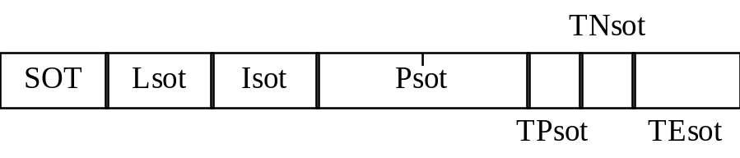
Figure 1 – Start of tile-part syntax

SOT: Marker code. Table 3 shows the sizes and values of the symbol and parameters for start of tile-part marker segment.

Lsot: Length of marker segment in bytes (not including the marker).

Isot: Tile index. This number refers to the tiles in raster order starting at the number 0.

Psot: Length, in bytes, from the beginning of the first byte of this SOT marker segment of the tile-part to the end of the data of that tile-part. Figure A-16 from ITU-T T.800 | ISO/IEC 15444-1 shows this alignment. Only the last tile-part in the codestream may contain a 0 for Psot. If the Psot is 0, this tile-part is assumed to contain all data until the EOC marker.

TPsot: Tile-part index. There is a specific order required for decoding tile-parts; this index denotes the order from 0. If there is only one tile-part for a tile then this value is zero. If this value is 255 then the TEsot marker segment contains the tile-part index. The tile-parts of this tile shall appear in the codestream in this order, although not necessarily consecutively.

TNsot: Number of tile-parts of a tile in the codestream. Two values are allowed: the correct number of tile-parts for that tile and zero. A zero value indicates that the number of tile-parts of this tile is not specified in this tile-part. If any TPsot marker segments for this tile are 255, this value must be 0.

TEsot: Tile-part index when TPsot is 255. The length of this marker segment parameter will be 16 bits when TPsot is 255, but 0 when TPsot<255.

Table 2 – Start of tile-part parameter values
Parameter | Size (bits) | Values
SOT | 16 | 0xFF90
Lsot | 16 | 10 OR 12
Isot | 16 | 0 – 65 534
Psot | 32 | 12 – (2³² – 1)
TPsot | 8 | 0 – 255
TNsot | 8 | Table A-6 from ITU-T T.800 | ISO/IEC 15444-1
TEsot | 0  16 | NA; if TPsot < 255  0 – 65 534; if TPsot = 255

Changes to Annex A.3
Table A-17 from ITU-T T.801 | ISO/IEC 15444-2 should be replaced with Table 3 below.

Table A-17 – List of markers and marker segments
 | Symbol | Code | Main headerª | Tile-part headerª
Default quantization for precinct | QPD | 0xFF5A | optional | optional
Component quantization for precinct | QPC | 0xFF5B | optional | optional
Variable DC offset | DCO | 0xFF70 | optional | optional
Visual masking | VMS | 0xFF71 | optional | optional
Downsampling factor style | DFS | 0xFF72 | optional | optional
Arbitrary decomposition style | ADS | 0xFF73 | optional | optional
Arbitrary transformation kernels | ATK | 0xFF72 | optional | optional
Component bit depth | CBD | 0xFF78 | optional | optional
Multiple component transformation definition | MCT | 0xFF74 | optional | optional
Multiple component collection | MCC | 0xFF75 | optional | optional
Multiple component intermediate collection | MIC | 0xFF77 | optional | optional
Non-linearity point transformation | NLT | 0xFF76 | optional | optional
- Optional means it may be used in the header if this extension is used.

New Annex A.11 should be added as follows
A.11 Default Quantization for Precinct (QPD)

Function: Describes the quantization default used for compressing all components of a particular (resolution level, precinct) pair. The parameter values can be overridden for an individual (component, resolution level, precinct) triplet by a QPC marker segment which must appear in a tile-part header prior to any packets for that triplet.

Usage: Main and any tile-part header. Several QPD marker segments may appear in any tile-part header, but only one for each (resolution level, precinct) pair. If a QPD is used in a tile-part header it overrides the quantization characteristics defined by either QCD or QCC marker segments for all components of the (resolution level, precinct) pair indexed by the QPD within the scope of the particular tile. Thus, the quantization characteristics of a particular (resolution level, precinct) pair is determined by the presence of QCD, QCC, QPD or QPC markers in the following order of precedence:

Any tile-part QPC > Any tile-part QPD > First tile-part QCC > First tile-part QCD >
Main QPC > Main QPD > Main QCC > Main QCD

When QPD marker segments are used, they must appear in tile-part headers before any packets are found for the indexed (resolution level, precinct) pair.

Length: Variable depending on the number of quantized subbands within the resolution level indexed.

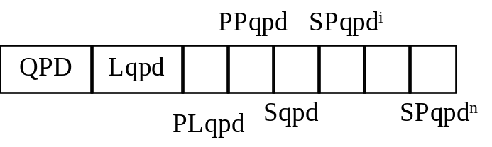
Figure 2 - Default quantization for precinct syntax

QPD: Marker code. Table 4 shows the size and parameter values for the QPD marker segment.

Lqpd: Length of marker segment in bytes (not including the marker). The value of this parameter is determined by the following equation:

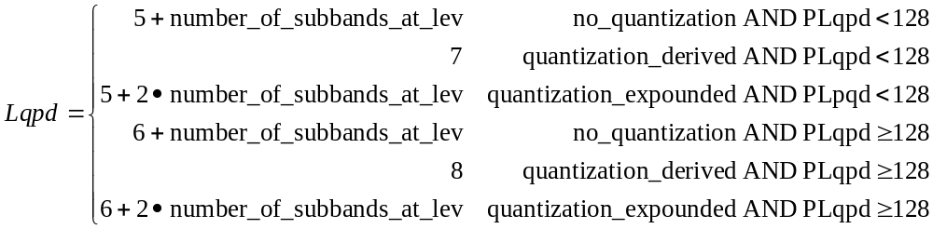 (1)

where number_of_subbands_at_lev is defined in Annex F.2.4 of ITU-T T.801 | ISO/IEC 15444-2 for each resolution level, and no_quantization, quantization_derived, or quantization_expounded is signalled in the Sqpd parameter.

Note: The Lqpd can be used to determine how many quantization step sizes are present in the marker segment. However, there is not necessarily a correspondence with the number of subbands present because the subbands can be truncated with no requirement to correct this marker segment.

PLqpd: The resolution level index for the pair signaled. Equation 2 shows how this marker segment is constructed based on the resolution level index lev as well as the precinct index prec for the pair.

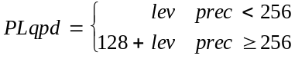 (2)

As in ITU-T T.800 | ISO/IEC 15444-1, the resolution level index lev can range from 0 to N_{L}, where N_{L} is the number of decomposition levels defined in ITU-T T.800 | ISO/IEC 15444-1.

PPqpd: The precinct index for the pair signaled. The size of this marker segment parameter will be one byte when the PLqpd parameter is less than 128, but two bytes when PLqpd is greater than or equal to 128. This parameter will then just hold the precinct index prec. The precinct index prec can range from 0 to numprecincts-1, where numprecincts is the number of precincts at resolution level lev and is also defined in ITU-T T.800 | ISO/IEC 15444-1.

Sqpd: Quantization style for all components of the (resolution level, precinct) pair.

SPqpd^{i}: Quantization step size value for the i-th subband at resolution level lev in the order defined for lev in Annex F.2.4 of ITU-T T.801 | ISO/IEC 15444-2. The number of parameters is the same as the number of subbands in the resolution level lev.

Table 4: Default quantization for precinct parameter values
Parameter | Size (bits) | Values
QPD | 16 | 0xFF5A
Lqpd | 16 | 6 — 101
PLqpd | 8 | 0 — 32 OR 128 — 160
PPqpd | 8  16 | 0 — 255 if PLqpd < 128  0 — 65 535 if PLqpd
Sqpd | 8 | Table A-10 from ITU-T T.801 | ISO/IEC 15444-2
SPqpdi | variable | Table A-10 from ITU-T T.801 | ISO/IEC 15444-2

New Annex A.12 should be added as follows
A.12 Component Quantization for Precinct (QPC)

Function: Describes the quantization used for compressing a particular (component, resolution level, precinct) triplet.

Usage: Main and any tile-part header. Several QPC marker segments may appear in any tile-part header, but only one for each (component, resolution level, precinct) triplet. If a QPC is used in a tile-part header it overrides the quantization characteristics defined by QCD, QCC, or QPD marker segments for the triplet indexed by the QPC within the scope of the particular tile. Thus, the quantization characteristics of a particular (component, resolution level, precinct) triplet is determined by the presence of QCD, QCC, QPD or QPC markers in the following order of precedence:

Any tile-part QPC > Any tile-part QPD > First tile-part QCC > First tile-part QCD >
Main QPC > Main QPD > Main QCC > Main QCD

When QPC marker segments are used, they must appear in tile-part headers before any packets are found for the indexed (component, resolution level, precinct) triplet.

Length: Variable depending on the number of quantized subbands within the resolution level indexed.

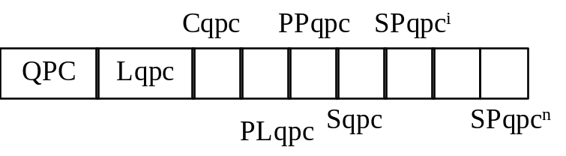
Figure 3 - Component quantization for precinct syntax

QPC: Marker code. Table 5 shows the size and parameter values for QPC marker segment.

Lqpc: Length of marker segment in bytes (not including the marker). The value of this parameter is determined by the following equation:

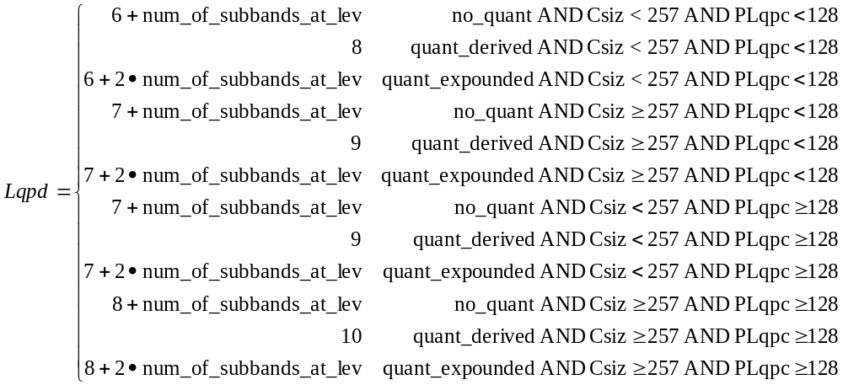 (3)

where number_of_subbands_at_lev is defined in Annex F.2.4 of ITU-T T.801 | ISO/IEC 15444-2 for each resolution level, Csiz is signaled according to ITU-T T.800 | ISO/IEC 15444-1, and no_quantization, quantization_derived, or quantization_expounded is signalled in the Sqpc parameter.

Note: The Lqpc can be used to determine how many quantization step sizes are present in the marker segment. However, there is not necessarily a correspondence with the number of subbands present because the subbands can be truncated with no requirement to correct this marker segment.

Cqpc: The index of the component to which this marker segment relates. The components are indexed 0, 1, 2, etc. (Either 8 or 16 bits depending on Csiz value).

PLqpc: The resolution level index for the pair signaled. Equation 4 shows how this marker segment is constructed based on the resolution level index lev as well as the precinct index prec for the pair.

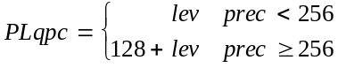 (4)

As in ITU-T T.800 | ISO/IEC 15444-1, the resolution level index lev can range from 0 to N_{L}, where N_{L} is the number of decomposition levels defined in ITU-T T.800 | ISO/IEC 15444-1.

PPqpc: The precinct index for the pair signaled. The size of this marker segment parameter will be one byte when the PLqpc marker segment parameter is less than 128, but two bytes when PLqpc is greater than or equal to 128. This parameter will then just hold the precinct index prec. The precinct index prec can range from 0 to numprecincts-1, where numprecincts is the number of precincts at resolution level lev and is also defined in ITU-T T.800 | ISO/IEC 15444-1.

Sqpc: Quantization style for all components of the (component, resolution level, precinct) triplet.

SPqpc^{i}: Quantization step size value for the i-th subband at resolution level lev in the order defined for lev in Annex F.2.4 of ITU-T T.801 | ISO/IEC 15444-2. The number of parameters is the same as the number of subbands in the resolution level lev.

Table 5: Default quantization for precinct parameter values
Parameter | Size (bits) | Values
QPC | 16 | 0xFF5B
Lqpc | 16 | 7 — 103
Cqpc | 8  16 | 0 —255; if Csiz < 257  0 — 16 383; if Csiz
PLqpc | 8 | 0 — 32 OR 128 — 160
PPqpc | 8  16 | 0 — 255; if PLqpc < 128  0 — 65 535; if PLqpc
Sqpc | 8 | Table A-10 from ITU-T T.801 | ISO/IEC 15444-2
SPqpc^{i} | variable | Table A-10 from ITU-T T.801 | ISO/IEC 15444-2

