ABEILLE Gwenaëlle



Guide for developers of Tango devices

Tango Device in Java

Design guidelines

Table of contents

1. Introduction 3

2. A first device 4

3. Device 6

4. Command 7

5. Attribute 8

6. Init 10

7. Delete 11

8. State 12

9. Status 12

10. Device property 13

11. Device properties 13

12. Class property 14

13. Around Invoke 14

14. State machine 15

15. Device Manager 15

16. Dynamic API 16

a. Dynamic Command 16

i. Configuration 16

ii. StateMachine 17

iii. Execution 17

b. Dynamic Attribute 17

i. Configuration 17

i. StateMachine 18

ii. Read attribute 18

iii. Write attribute 18

iv. Update write part 19

17. JTangoServerLang library 19

18. Error management 19

19. Logging 19

20. Start up: DB/NO DB 21

a. Server with Tango Database 21

b. Device without Tango database 22

21. Annexes 23

a. Full sample device code 23

b. Command with ICommandBehavior 24

c. Attribute with IAttributeBehavior 24

d. Extended example 26

e. Logging configuration with logback 29

f. Properties file for a device without Tango Database 29

# Introduction

This paper is a documentation intended for developers. It described how to build a Java Tango Device. A background in the Java language is strongly recommended. The pre-requisites are:

* The Tango concepts: attribute, command, device property… Please read at least the first 3 chapters of the Tango reference manual : <http://www.tango-controls.org/>, <http://www.tango-controls.org/Documents/tango-kernel/>
* The Java language Standard Edition : <http://www.oracle.com/technetwork/java/javase/documentation/index.html>
* The concept of annotations introduced in Java version 5: <http://docs.oracle.com/javase/tutorial/java/javaOO/annotations.html>
* Java beans : <http://en.wikipedia.org/wiki/JavaBeans>

# A first device

Here is the code of simple device with one Tango command and one attribute (see annexes for full code):

@Device

**public** **class** TestDevice {

**private** **final** Logger logger = LoggerFactory.*getLogger*(TestDevice.**class**);

/**

* Attribute myAttribute READ WRITE, type DevDouble.

*/

@Attribute

**public** **double** myAttribute;

/**

* Starts the server.

*/

**public** **static** **void** main(**final** String[] args) {

ServerManager.*getInstance*().start(args, TestDevice.**class**);

}

/**

* init device

*/

@Init

**public** **void** init() {

logger.debug("init");

}

/**

* delete device

*/

@Delete

**public** **void** delete() {

logger.debug("delete");

}

/**

* Execute command start. Type VOID-VOID

*/

@Command

**public** **void** start() {

logger.debug("start");

}

/**

* Read attribute myAttribute.

*

* **@return**

*/

**public** **double** getMyAttribute() {

logger.debug("getMyAttribute {}", myAttribute);

**return** myAttribute;

}

/**

* Write attribute myAttribute

*

* **@param** myAttribute

*/

**public** **void** setMyAttribute(**final** **double** myAttribute) {

logger.debug("setMyAttribute {}", myAttribute);

**this**.myAttribute = myAttribute;

}

}

Before starting it, the device has to be declared in the Tango database with Jive with menu “Create server” (cf. chapter Jive for details…). Hereafter, a server “TestDevice/1” with one device “tmp/test/device.1” is created:

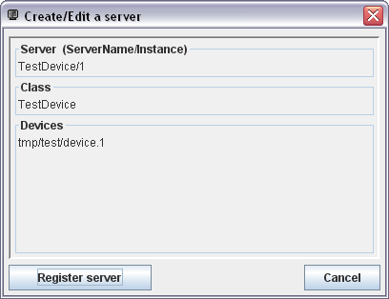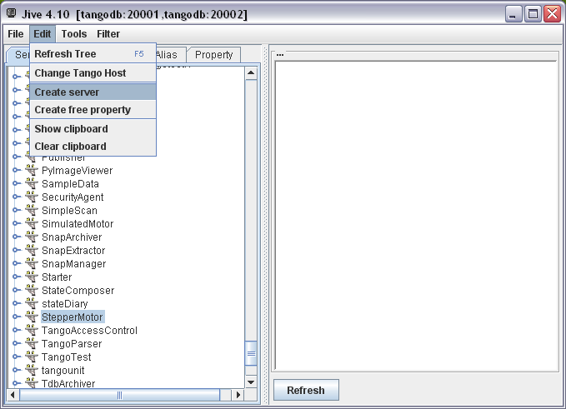

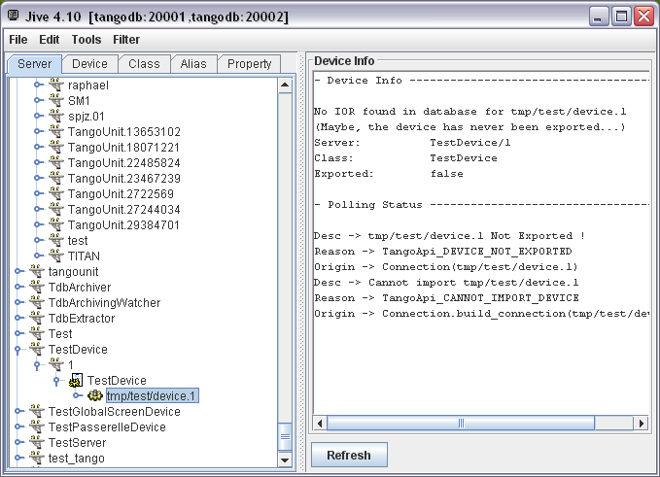

As the TestDevice class of this device has a main method, it has to be started as a standard Java program:

1. A Java system property “TANGO_HOST” must be defined. For instance “tangodb:20001,tangodb:20002” , like in the Jive screenshot above.
2. The mandatory program argument is the instance name (1 in above example).

Once started, the device can be tested. Here is an example of the ATKPanel generic client (Tango concept reminder: The commands *Init*, *State*, *Status* and the attributes *State*, *Status* are created by default for any device):

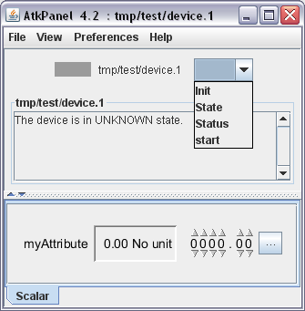

A first code explanation:

* The “@Device” annotation on the class defines this class as a Tango Device.
* The “@Attribute” annotation defines a field as a Tango attribute.
  + The attribute type is defined by the field type.
  + If this field has a getter, it is a READ attribute;
  + if it has a setter, it is a WRITE attribute;
  + if both getter and setter, it is a READ/WRITE attribute.
* The annotation “@Command” defines a method as a Tango command:
  + The parameter type defines the input type
  + The return type defines the output type
* The “@Init” annotation defines a method called at server startup and when “Init” command is called.
* The “@Delete” annotation defines a method called at server shutdown, and at “Init” command, before “@Init”.
* Main method: to start the server
* The logger field is to log. It is based on slf4j (<http://www.slf4j.org/>). See annexes for example of configuration.

The following chapters will describes all this in details.

# Device

A Tango device is created with the Java annotation on a class:

org.tango.server.annotation.Device

@Device

**public** **class** TestDevice {

}

This class must have a no-arguments constructor.

This annotation has an option to configure how the server will manage client transactions. Default value is “NONE”. Here is an example for one client request at a time per device:

@Device(transactionType = TransactionType.*DEVICE*)

All transaction values are:

* TransactionType.*DEVICE*: One client request per device.
* TransactionType.*CLASS*: One client request per device class (that may contain several devices).
* TransactionType.*SERVER*: One client request per server (that may contain several classes).
* TransactionType.*ATTRIBUTE*: One client request per attribute.
* TransactionType.*COMMAND*: One client request per command.
* TransactionType.*ATTRIBUTE_COMMAND*: One client request per attribute or command.
* TransactionType.*NONE*: Default value. All client requests can be done at the same time.

NB: A good choice has to be made between performance and thread-safety of the device depending of the use-cases:

* Using TransactionType.NONE means that several clients can modify values, states in the device at the same time. In this case, the developer has to implement the thread-safety by himself if necessary. A good use case for this configuration is a “stateless” device where each request is an independent transaction that is unrelated to any previous request.
* Using TransactionType.DEVICE means that only one client can do a request on the device at a time. So, if a lot of clients are connected to the device, their performance can be drastically reduced while waiting for other clients. The main use case for this configuration is a “statefull” device that contains a conversation state that is retains across transactions.

# Command

A tango command is created with the Java annotation on a method:

org.tango.server.annotation.Command

Example code:

@Command

**public** **int** testCmd(**final** **double**[] in) {

**return** 0;

}

The command name is by default the method name. The Command annotation has some parameters to change its name, its description, its polling configuration… See javadoc for details.

The method has to be public.

The input and output types are defined by the method definition. Here are the tango types for each Java type:

|  |  |
| --- | --- |
| Java type | Tango type |
| void | DEVVOID |
| boolean | DEVBOOLEAN |
| long | DEVLONG64 |
| long[] | DEVVARLONG64ARRAY |
| short | DEVSHORT |
| short[] | DEVVARSHORTARRAY |
| float | DEVFLOAT |
| float[] | DEVVARFLOATARRAY |
| double | DEVDOUBLE |
| double[] | DEVVARDOUBLEARRAY |
| String | DEVSTRING |
| String[] | DEVVARSTRINGARRAY |
| int | DEVLONG |
| Int[] | DEVVARLONGARRAY |
| DevState or DeviceState | DEVSTATE |
| byte | DEVUCHAR |
| byte[] | DEVVARCHARARRAY |
| DevEncoded | DEVENCONDED |
| DevVarLongStringArray | DEVVARLONGSTRINGARRAY |
| DevVarDoubleStringArray | DEVVARDOUBLESTRINGARRAY |

NB: Full class names of tango commands:

fr.esrf.Tango.DevState

fr.esrf.Tango.DevEncoded

fr.esrf.Tango.DevVarLongStringArray

fr.esrf.Tango.DevVarDoubleStringArray

org.tango.DeviceState

Tango provides also other types that do not have equivalent in Java types: DEVULONG, DEVULONG64, DEVUSHORT, DEVVARULONGARRAY, DEVVARULONG64ARRAY, DEVVARUSHORTARRAY. It is possible to define these types with a dynamic command (Cf chapter dynamic API for details).

NB: The wrappers objects of primitives (Integer, Double…) can also be used, but it could lead to performance issues.

# Attribute

A tango attribute is created with the Java annotation on a method or a field:

org.tango.server.annotation.Attribute

Example code:

@Attribute

**private** **double** testAttribute;

**public** **double** getTestAttribute() {

**return** testAttribute;

}

**public** **void** setTestAttribute(**double** testAttribute) {

**this**.testAttribute = testAttribute;

}

As defined by the Java bean convention, the setter and getter must contain the name of the field and manage the same type as the field (reminder: a getter for a boolean start by “is”). The getter and setter have to be public while the field is private.

* If this field as a getter, it is a READ attribute;
* If it as a setter, it is a WRITE attribute;
* If both, it is a READ/WRITE attribute.

It is also possible to place the annotation on the getter.

The attribute name is by default the field name. The annotation has some parameters to change its name, its polling configuration, its memorization configuration… See javadoc for details.

Here are the Tango types for each Java type:

|  |  |  |
| --- | --- | --- |
| Java type | Tango type | Tango format |
| boolean | DEVBOOLEAN | SCALAR |
| boolean[] | DEVBOOLEAN | SPECTRUM |
| boolean[][] | DEVBOOLEAN | IMAGE |
| long | DEVLONG64 | SCALAR |
| long[] | DEVLONG64 | SPECTRUM |
| long[][] | DEVLONG64 | IMAGE |
| short | DEVSHORT | SCALAR |
| short[] | DEVSHORT | SPECTRUM |
| short[][] | DEVSHORT | IMAGE |
| float | DEVFLOAT | SCALAR |
| float[] | DEVFLOAT | SPECTRUM |
| float[][] | DEVFLOAT | IMAGE |
| double | DEVDOUBLE | SCALAR |
| double[] | DEVDOUBLE | SPECTRUM |
| double[][] | DEVDOUBLE | IMAGE |
| String | DEVSTRING | SCALAR |
| String[] | DEVSTRING | SPECTRUM |
| String[][] | DEVSTRING | IMAGE |
| int | DEVLONG | SCALAR |
| int[] | DEVLONG | SPECTRUM |
| int[][] | DEVLONG | IMAGE |
| DevState or DeviceState | DEVSTATE | SCALAR |
| DevState[] or DeviceState[] | DEVSTATE | SPECTRUM |
| DevState[][] or DeviceState[][] | DEVSTATE | IMAGE |
| byte | DEVUCHAR | SCALAR |
| byte[] | DEVUCHAR | SPECTRUM |
| byte[][] | DEVUCHAR | IMAGE |
| DevEncoded | DEVENCONDED | SCALAR |

NB: Full class names of tango attributes:

fr.esrf.Tango.DevState

fr.esrf.Tango.DevEncoded

fr.esrf.Tango.DevVarLongStringArray

fr.esrf.Tango.DevVarDoubleStringArray

org.tango.DeviceState

Tango provides also other types that do not have equivalent in Java types: DEVULONG, DEVULONG64, DEVUSHORT. It is possible to define these types with a dynamic command. Cf chapter dynamic API for details. Please also refer to this section if the write part of the attribute has to be changed from the device.

NB: The wrappers objects of primitives (Integer, Double…) can also be used, but it could lead to performance issues.

A Tango attribute has also a quality and a timestamp. By default, it is not accessible. The default behavior is a valid quality, and the timestamp is the read time. To access these properties, the getter method can return a container for the attribute value, quality and timestamp. The container is: org.tango.server.attribute.AttributeValue. It contains method to set the value, quality and timestamp. Please refer to its javadoc for details.

@Attribute

**private** **double** myAttribute;

**public** AttributeValue getMyAttribute() **throws** DevFailed {

AttributeValue value = **new** AttributeValue(myAttribute);

value.setQuality(AttrQuality.*ATTR_CHANGING*);

value.setTime(System.*currentTimeMillis*());

**return** value;

}

Default attribute properties are configurable with annotation:

org.tango.server.annotation.AttributeProperties

Please refer to javadoc for details. Example:

@Attribute

@AttributeProperties(format = "%6.4f", description = "a test attribute")

**private** **double** testAttribute;

# Init

org.tango.server.annotation.Init

@Init

**public** **void** init() {

}

Method must be public with no parameters. It is called at server startup and when “Init” command is called. If this method throws an exception, the device will automatically switch to the “FAULT” state and the status will provide the stack trace.

Annotation option: “lazyLoading”. Default value is false. If the init method takes a lot a time, its execution can be detached with this option set to true. The device will automatically switch in state “INIT” during its execution. This option avoids timeouts when executing the “Init” command as well as a rapid device startup and consequently a rapid control system startup.

# Delete

org.tango.server.annotation.Delete

@Delete

**public** **void** delete() {

}

Method must be public with no parameters. It is called when “Init” command is called before @Init method and at server shutdown. The delete method is generally used to close resources.

# State

org.tango.server.annotation.State

@State

**private** DeviceState state;

**public** DeviceState getState() {

**return** state;

}

**public** **void** setState(**final** DeviceState state) {

**this**.state = state;

}

The state annotation defines the state of the device, which will appear in the default command and attribute “State”.

The field can be fr.esrf.Tango.DevState or org.tango.DeviceState:

* DevState is the Tango standard type defined by its IDL.
* DeviceState is java Enum that provides easiness to manage a State.

Getter and setter are mandatory.

The device property “StateCheckAttrAlarm” is defined for all Java devices. If set to true, each times a client request the state or the status of the device, all attributes are read to check if some attributes are in ALARM or WARNING quality. If alarms are detected, the state and the status will be updated consequently. The default value of this property is false. WARNING: if some attributes requests are slow, it could lead to performance issues.

# Status

org.tango.server.annotation.Status

@Status

**private** String status;

**public** String getStatus() {

**return** status;

}

**public** **void** setStatus(String status) {

**this**.status = status;

}

The status annotation defines the status of the device, which will appear in the default command and attribute “Status”.

The status field must be a String, getter and setter are mandatory.

# Device property

org.tango.server.annotation.DeviceProperty

*NB: Tango reminder: order of loading a device property:*

* *Value defined at device level*
* *If does not exists; value defined at class level*
* *If does not exists; default value*

@DeviceProperty (defaultValue = "", description = "an example")

**private** String devicePropTest;

**public** **void** setDevicePropTest(String devicePropTest) {

**this**.devicePropTest = devicePropTest;

}

The field can be of any standard java type (int, double …), as scalar or array.

The property has some parameters, details are in javadoc.

A setter is mandatory, so that the value can be injected at device initialization.

# Device properties

org.tango.server.annotation.DeviceProperties

It is possible to retrieve all device properties at once. Can be useful if some device properties are not known in advance (Example: some dynamic attributes that has their names as a device property name).

@DeviceProperties

**private** Map<String, String[]> devicePropTest;

**public** **void** setDevicePropTest(**final** Map<String, String[]> devicePropTest) {

**this**.devicePropTest = devicePropTest;

}

The field has to be a java.util.Map with a “String” key and a “String[]” value.

A setter is mandatory, so that the value can be injected at device initialization.

# Class property

org.tango.server.annotation.ClassProperty

@ClassProperty

**private** **double**[] classPropTest = **new** **double**[] {1,2};

**public** **void** setClassPropTest(**double**[] classPropTest) {

**this**.classPropTest = classPropTest;

}

The field can be of any standard java type (int, double …), as scalar or array.

The property has some parameters, details are in javadoc.

A setter is mandatory, so that the value can be injected at device initialization.

# Around Invoke

org.tango.server.annotation.AroundInvoke

It defines a public void method with a single parameter of class org.tango.server.InvocationContext that is called before and after every command and attributes execution. This functionality is known as “always executed hook” in C++.

@AroundInvoke

**public** **void** aroundInvoke(**final** InvocationContext ctxt) {

System.*out*.println("called at " + ctxt.getContext());

System.*out*.println("called command or attributes " +

Arrays.*toString*(ctxt.getNames()));

}

# State machine

org.tango.server.annotation.StateMachine

The StateMachine annotation allows to define some denied state, and some state changes:

* For an “@Init”, it is possible to define the state at the end of its execution
* For a command, its execution can be disallowed for some states and the state at the end of its execution can be defined.
* For an attribute, it can be disallowed to write it for some states and the state at the end of its execution.

@Attribute

@StateMachine

**private** **double** value;

@Init

@StateMachine(endState = DeviceState.*OFF*)

**public** **void** init() {

}

@Command

@StateMachine(deniedStates = { DeviceState.*FAULT*, DeviceState.*UNKNOWN* }, endState = DeviceState.*ON*)

**public** **int** on() {

**return** 0;

}

# Device Manager

org.tango.server.annotation.DeviceManagement

DeviceManager contains commons to for a device. For example, it provides its name, the admin device name, the way to change attribute properties…

@DeviceManagement

**private** DeviceManager deviceManager;

@Init

**public** **void** init() {

System.*out*.println(deviceManager.getName());

}

**public** **void** setDeviceManager(**final** DeviceManager deviceManager) {

**this**.deviceManager = deviceManager;

}

# Dynamic API

Attributes and commands can be created dynamically with the class org.tango.server.dynamic.DynamicManager that will be injected by the annotation org.tango.server.annotation.DynamicManagement. It provides methods to add or remove attributes and commands. Typically, the add methods will be called in the @Init method and remove will be called in @Delete method:

@DynamicManagement

**private** DynamicManager dynamicManagement;

**public** **void** setDynamicManagement(DynamicManager dynamicManagement) {

**this**.dynamicManagement = dynamicManagement;

}

@Init

**public** **void** init() **throws** DevFailed {

dynamicManager.addAttribute(**new** TestDynamicAttribute());

dynamicManager.addCommand(**new** TestDynamicCommand());

}

@Delete

**public** **void** delete() **throws** DevFailed {

dynamicManager.clearAll();

}

NB: If a server is running with several devices in the same process, the dynamic commands or attributes can be different for each device.

The following paragraphs explain in details how to create attribute and commands.

## Dynamic Command

A dynamic command is a class that must implements org.tango.server.command.ICommandBehavior. See annexes for a full sample code.

### Configuration

**public** CommandConfiguration getConfiguration() **throws** DevFailed {

**final** CommandConfiguration config = **new** CommandConfiguration();

config.setName("testDynCmd");

config.setInType(**void**.**class**);

config.setOutType(**double**.**class**);

**return** config;

}

### StateMachine

Not mandatory, can return “null”. It works like the StateMachine annotation. See its chapter for details

**public** StateMachineBehavior getStateMachine() **throws** DevFailed {

**final** StateMachineBehavior stateMachine = **new** StateMachineBehavior();

stateMachine.setDeniedStates(DeviceState.*FAULT*);

stateMachine.setEndState(DeviceState.*ON*);

**return** stateMachine;

}

### Execution

The input and output types of the execute method is define by the configuration above. If the type is void, the parameter or returned value may be null.

**public** Object execute(**final** Object arg) **throws** DevFailed {

**return** 10.0;

}

NB: the command types may be declared in two different ways:

* setInType(Class<?> type) or setOutType: as table in chapter “Command”, the java class defines the command type and format.
* setTangoInType(int tangoType) or setTangoOutType: defines the type with a integer (constant are defined in class fr.esrf.TangoConst). This method is more flexible as some Tango types do not have equivalent in Java classes: DEVULONG, DEVULONG64, DEVUSHORT, DEVVARULONGARRAY, DEVVARULONG64ARRAY, DEVVARUSHORTARRAY.

## Dynamic Attribute

A dynamic attribute is a class that must implements org.tango.server.attribute. IAttributeBehavior. See annexes for a full sample code.

### Configuration

Firstly, the method “getConfiguration” returns the full configuration of the attribute (see javadoc for org.tango.server.attribute.AttributeConfiguration for details). Here is an example for a scalar, DevDouble, READ_WRITE attribute:

**public** AttributeConfiguration getConfiguration() **throws** DevFailed {

**final** AttributeConfiguration config = **new** AttributeConfiguration();

config.setName("testDynAttr");

// attribute testDynAttr is a DevDouble

config.setType(**double**.**class**);

// attribute testDynAttr is READ_WRITE

config.setWritable(AttrWriteType.*READ_WRITE*);

**return** config;

}

NB: the attribute type and format may be declared in two different ways:

* setType(Class<?> type): as table in chapter “Attribute”, the java class defines the attribute type and format.
* setTangoType(int tangoType, AttrDataFormat format): defines the type with a integer (constant are defined in class fr.esrf.TangoConst). The format is defined by the class fr.esrf.AttrDataFormat. This method is more flexible as some Tango types do not have equivalent in Java classes: DEVULONG, DEVULONG64, DEVUSHORT.

### StateMachine

Not mandatory, can return “null”. It works like the StateMachine annotation. See its chapter for details

**public** StateMachineBehavior getStateMachine() **throws** DevFailed {

**final** StateMachineBehavior stateMachine = **new** StateMachineBehavior();

stateMachine.setDeniedStates(DeviceState.*FAULT*);

stateMachine.setEndState(DeviceState.*ON*);

**return** stateMachine;

}

### Read attribute

The getValue method is used to read the attribute. It must return an org.tango.server.attribute.AttributeValue (see javadoc for details). Of course, the inserted value must be of the same type as the attribute type (defined in getConfiguration)

**private** **double** readValue = 0;

**private** **double** writeValue = 0;

**public** AttributeValue getValue() **throws** DevFailed {

readValue = readValue + writeValue;

**return** **new** AttributeValue(readValue);

}

### Write attribute

The method setValue will be called only if the attribute has been defined as writable in getConfiguration.

**public** **void** setValue(**final** AttributeValue value) **throws** DevFailed {

writeValue = (Double) value.getValue();

}

### Update write part

For some specific cases, the write part has to be updated from the device, i.e. the last set point of an equipment. This is possible by implementing the interface org.tango.server.attribute.ISetValueUpdater which has one method:

**public** AttributeValue getSetValue() **throws** DevFailed {

**return** **new** AttributeValue(writeValue);

}

# JTangoServerLang library

Some default dynamic attributes and commands are already in the library JTangoServerLang, i.e.:

* Attribute and command proxies
* Group command
* …

Example: org.tango.server.dynamic.command.ProxyCommand will create a Command that is connected to another command. The input and output types will be calculated automatically.

# Error management

The standard exception in Tango is fr.esrf.DevFailed. The class org.tango.DevFailedUtils is useful to throw it. It will, for instance, fill the origin field. See javadoc for details

@Command

**public** **int** off() **throws** DevFailed {

**throw** DevFailedUtils.*newDevFailed*("DEVICE_ERROR", "an example error");

}

# **Loggin**g

The Java Tango server API uses SLF4J (<http://www.slf4j.org/>). The underlying libraries use also SLF4J (i.e. jacorb, ehcache…). Here is a declaration example of a logger class:

**import** org.slf4j.Logger;

**import** org.slf4j.LoggerFactory;

…

**private** **final** Logger logger = LoggerFactory.*getLogger*(TestDevice.**class**);

For details about logging, please refer to its documentation: <http://www.slf4j.org/docs.html>

As SLF4J is an abstraction layer for various logging framework, a framework must be chosen by the developer (ie. logback, log4j, java.util.logging…). It allows the end user to choose the logging framework at deployment time. Nevertheless, the logging configuration is framework dependent. See annexes for an example of a logback configuration file.

LIMITATION: JTangoServer depends directly on logback (<http://logback.qos.ch/> ), because it has to implement some particularities to configure it:

* Configuration of the logging level
* Configuration of logging into file or into another device (for logviewer application).

So logback may be used to benefit from the above configuration topics (accessible through the administration device).

# Start up: DB/NO DB

## Server with Tango Database

A device may also contain a main method where it is started. It should contain a call to start of org.tango.server.ServerManager.

**public** **static** **void** main(**final** String[] args) {

ServerManager.*getInstance*().start(args, TestDevice.**class**);

}

When using the Tango database, the java system property or environment variable TANGO_HOST must be defined to indicate the host and port of the database. The string array passed in the start method must contain at least the instance name as it has been previously defined in the Tango database. The other options are:

* The "-h" option display the list of instances declared in the tango database for the given server.
* The “–v x“ option allow to override the default logging level (also called root level) of the logging configuration file where x is a integer value (possible values are OFF=0, FATAL = 1, ERROR = 2, WARN = 3, INFO = 4, DEBUG = 5, TRACE = 6)

It is possible to have several classes in a single server. Here is an example of a server started with several classes (org.tango.Motor and org.tango.PowerSupply):

// add class org.tango.Motor to the server (to be declared as “Motor” in the tango db)

ServerManager.getInstance().addClass(org.tango.Motor.**class**.getSimpleName(), org.tango.Motor.**class**);

// add class org.tango.PowerSupply to the server (to be declared as “PowerSupply” in the tango db)

ServerManager.getInstance().addClass(org.tango.PowerSupply.**class**.getSimpleName(),org.tango. PowerSupply.**class**);

// start the server “Insertion/test”

ServerManager.getInstance().start(**new** String[] {"test"}, "Insertion");

The following screenshot shows an example declaration of the server “Insertion/test” in the tango db; it contains 4 devices, 2 of class Motor and 2 of class PowerSupply:

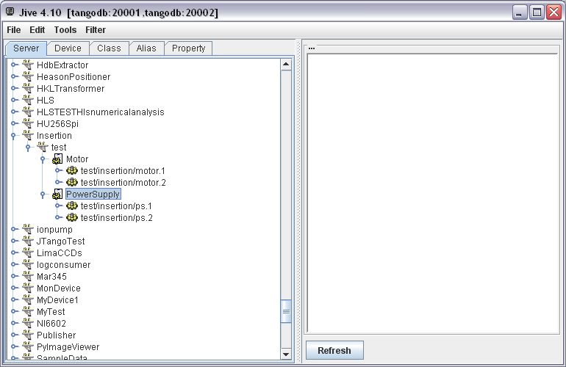

## Device without Tango database

A device may also be started without a Tango database, for example perform do unit tests. The system property OAPort (used by JacORB) must specify the port on which the server is started. The following code starts a device “1/1/1” on the port 12354 (NB: a client will connect to it with an address like "tango://localhost:12354/1/1/1#dbase=no")

**public** **static** **final** String *NO_DB_DEVICE_NAME* = "1/1/1";

**public** **static** **final** String *NO_DB_GIOP_PORT* = "12354";

**public** **static** **final** String *NO_DB_INSTANCE_NAME* = "1";

**public** **static** **void** main(**final** String[] args) {

System.*setProperty*("OAPort", *NO_DB_GIOP_PORT*);

ServerManager.*getInstance*().start(**new** String[] { *NO_DB_INSTANCE_NAME*, "-nodb", "-dlist", *NO_DB_DEVICE_NAME* },

TestDevice.**class**);

}

The start options are for a no db server:

* -nodb to indicate a server without database
* -dlist the list of devices in the server
* -file= the properties file. As the device and class properties are normally defined in the Tango DB, a file can be specified to replace it. (Refer to annexes for an example). If the device started without database is also defined in tango db, it is possible to generate its file with jive. The “Save server data” menu accessible by right-clicking on the instance name:

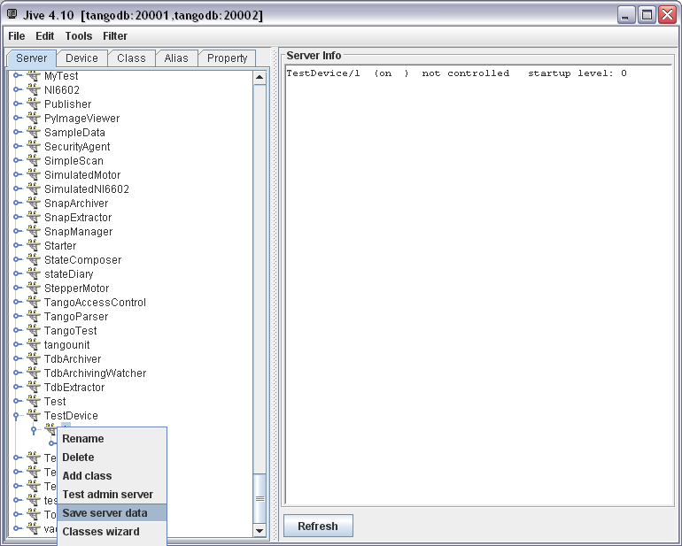

Example:

**public** **static** **void** main(**final** String[] args) {

System.*setProperty*("OAPort", *NO_DB_GIOP_PORT*);

ServerManager.*getInstance*().start(

**new** String[] { *NO_DB_INSTANCE_NAME*, "-nodb", "-dlist", *NO_DB_DEVICE_NAME*,

"-file=" + TestDevice.**class**.getResource("/noDbproperties.txt").getPath() }, TestDevice.**class**);

}

# Annexes

## Full sample device code

**package** org.tango.test;

**import** org.slf4j.Logger;

**import** org.slf4j.LoggerFactory;

**import** org.tango.server.ServerManager;

**import** org.tango.server.annotation.Attribute;

**import** org.tango.server.annotation.Command;

**import** org.tango.server.annotation.Delete;

**import** org.tango.server.annotation.Device;

**import** org.tango.server.annotation.Init;

@Device

**public** **class** TestDevice {

**private** **final** Logger logger = LoggerFactory.*getLogger*(TestDevice.**class**);

/**

* Attribute myAttribute READ WRITE, type DevDouble.

*/

@Attribute

**public** **double** myAttribute;

/**

* Starts the server.

*/

**public** **static** **void** main(**final** String[] args) {

ServerManager.*getInstance*().start(args, TestDevice.**class**);

}

/**

* init device

*/

@Init

**public** **void** init() {

logger.debug("init");

}

/**

* delete device

*/

@Delete

**public** **void** delete() {

logger.debug("delete");

}

/**

* Execute command start. Type VOID-VOID

*/

@Command

**public** **void** start() {

logger.debug("start");

}

/**

* Read attribute myAttribute. *

* **@return**

*/

**public** **double** getMyAttribute() {

logger.debug("getMyAttribute {}", myAttribute);

**return** myAttribute;

}

/**

* Write attribute myAttribute

*

* **@param** myAttribute

*/

**public** **void** setMyAttribute(**final** **double** myAttribute) {

logger.debug("setMyAttribute {}", myAttribute);

**this**.myAttribute = myAttribute;

}

}

## Command with ICommandBehavior

**package** org.tango.test;

**import** org.tango.server.StateMachineBehavior;

**import** org.tango.server.command.CommandConfiguration;

**import** org.tango.server.command.ICommandBehavior;

**import** fr.esrf.Tango.DevFailed;

**public** **class** TestDynamicCommand **implements** ICommandBehavior {

@Override

**public** CommandConfiguration getConfiguration() **throws** DevFailed {

**final** CommandConfiguration config = **new** CommandConfiguration();

config.setName("testDynCmd");

config.setInType(**void**.**class**);

config.setOutType(**double**.**class**);

**return** config;

}

@Override

**public** Object execute(**final** Object arg) **throws** DevFailed {

**return** 10.0;

}

@Override

**public** StateMachineBehavior getStateMachine() **throws** DevFailed {

**return** **null**;

}

}

## Attribute with IAttributeBehavior

**package** org.tango.test;

**import** org.tango.server.StateMachineBehavior;

**import** org.tango.server.attribute.AttributeConfiguration;

**import** org.tango.server.attribute.AttributeValue;

**import** org.tango.server.attribute.IAttributeBehavior;

**import** fr.esrf.Tango.AttrWriteType;

**import** fr.esrf.Tango.DevFailed;

/**

* A sample attribute

*

*

*/

**public** **class** TestDynamicAttribute **implements** IAttributeBehavior {

**private** **double** readValue = 0;

**private** **double** writeValue = 0;

/**

* Configure the attribute

*/

@Override

**public** AttributeConfiguration getConfiguration() **throws** DevFailed {

**final** AttributeConfiguration config = **new** AttributeConfiguration();

config.setName("testDynAttr");

// attribute testDynAttr is a DevDouble

config.setType(**double**.**class**);

// attribute testDynAttr is READ_WRITE

config.setWritable(AttrWriteType.*READ_WRITE*);

**return** config;

}

/**

* Read the attribute

*/

@Override

**public** AttributeValue getValue() **throws** DevFailed {

readValue = readValue + writeValue;

**return** **new** AttributeValue(readValue);

}

/**

* Write the attribute

*/

@Override

**public** **void** setValue(**final** AttributeValue value) **throws** DevFailed {

writeValue = (Double) value.getValue();

}

/**

* Configure state machine if needed

*/

@Override

**public** StateMachineBehavior getStateMachine() **throws** DevFailed {

**final** StateMachineBehavior stateMachine = **new** StateMachineBehavior();

stateMachine.setDeniedStates(DeviceState.*FAULT*);

stateMachine.setEndState(DeviceState.*ON*);

**return** stateMachine;

}

@Override

**public** AttributeValue getSetValue() **throws** DevFailed {

**return** **new** AttributeValue(writeValue);

}

}

## Extended example

**package** org.tango.test;

**import** java.util.Map;

**import** org.slf4j.Logger;

**import** org.slf4j.LoggerFactory;

**import** org.tango.DeviceState;

**import** org.tango.server.ServerManager;

**import** org.tango.server.annotation.Attribute;

**import** org.tango.server.annotation.ClassProperty;

**import** org.tango.server.annotation.Command;

**import** org.tango.server.annotation.Delete;

**import** org.tango.server.annotation.Device;

**import** org.tango.server.annotation.DeviceProperties;

**import** org.tango.server.annotation.DeviceProperty;

**import** org.tango.server.annotation.DynamicManagement;

**import** org.tango.server.annotation.Init;

**import** org.tango.server.annotation.State;

**import** org.tango.server.annotation.StateMachine;

**import** org.tango.server.dynamic.DynamicManager;

**import** org.tango.server.testserver.JTangoTest;

**import** fr.esrf.Tango.DevFailed;

@Device

**public** **class** TestDevice {

**private** **final** Logger logger = LoggerFactory.*getLogger*(TestDevice.**class**);

/**

* A device property

*/

@DeviceProperty(defaultValue = "", description = "an example device property")

**private** String myProp;

@ClassProperty(defaultValue = "0", description = "an example class property")

**private** **int** myClassProp;

@DeviceProperties

**private** Map<String, String[]> deviceProperties;

/**

* Attribute myAttribute READ WRITE, type DevDouble.

*/

@Attribute

**public** **double** myAttribute;

/**

* Manage dynamic attributes and commands

*/

@DynamicManagement

**public** DynamicManager dynamicManager;

/**

* Manage state of the device

*/

@State

**private** DeviceState state = DeviceState.*OFF*;

/**

* Starts the server.

*/

**public** **static** **void** main(**final** String[] args) {

ServerManager.*getInstance*().start(args, TestDevice.**class**);

}

**public** **static** **final** String *NO_DB_DEVICE_NAME* = "1/1/1";

**public** **static** **final** String *NO_DB_GIOP_PORT* = "12354";

**public** **static** **final** String *NO_DB_INSTANCE_NAME* = "1";

/**

* Starts the server in nodb mode.

*

* **@throws** DevFailed

*/

**public** **static** **void** startNoDb() {

System.*setProperty*("OAPort", *NO_DB_GIOP_PORT*);

ServerManager.*getInstance*().start(**new** String[] { *NO_DB_INSTANCE_NAME*, "-nodb", "-dlist", *NO_DB_DEVICE_NAME* },

TestDevice.**class**);

}

/**

* Starts the server in nodb mode with a file for device and class properties

*

* **@throws** DevFailed

*/

**public** **static** **void** startNoDbFile() **throws** DevFailed {

System.*setProperty*("OAPort", *NO_DB_GIOP_PORT*);

ServerManager.*getInstance*().start(

**new** String[] { *NO_DB_INSTANCE_NAME*, "-nodb", "-dlist", *NO_DB_DEVICE_NAME*,

"-file=" + JTangoTest.**class**.getResource("/noDbproperties.txt").getPath() }, TestDevice.**class**);

}

/**

* init device

*

* **@throws** DevFailed

*/

@Init

@StateMachine(endState = DeviceState.*ON*)

**public** **void** init() **throws** DevFailed {

logger.debug("myProp value = {}", myProp);

logger.debug("myClassProp value = {}", myClassProp);

logger.debug("deviceProperties value = {}", deviceProperties);

// create a new dynamic attribute

dynamicManager.addAttribute(**new** TestDynamicAttribute());

// create a new dynamic command

dynamicManager.addCommand(**new** TestDynamicCommand());

logger.debug("init done");

}

/**

* delete device

*

* **@throws** DevFailed

*/

@Delete

**public** **void** delete() **throws** DevFailed {

logger.debug("delete");

// remove all dynamic commands and attributes

dynamicManager.clearAll();

}

/**

* Execute command start.

*/

@Command

@StateMachine(endState = DeviceState.*RUNNING*, deniedStates = DeviceState.*FAULT*)

**public** **void** start() {

logger.debug("start");

}

/**

* Read attribute myAttribute.

*

* **@return**

*/

**public** **double** getMyAttribute() {

logger.debug("getMyAttribute {}", myAttribute);

**return** myAttribute;

}

/**

* Write attribute myAttribute

*

* **@param** myAttribute

*/

**public** **void** setMyAttribute(**final** **double** myAttribute) {

logger.debug("setMyAttribute {}", myAttribute);

**this**.myAttribute = myAttribute;

}

**public** **void** setMyProp(**final** String myProp) {

**this**.myProp = myProp;

}

**public** **void** setMyClassProp(**final** **int** myClassProp) {

**this**.myClassProp = myClassProp;

}

**public** Map<String, String[]> getDeviceProperties() {

**return** deviceProperties;

}

**public** DeviceState getState() {

**return** state;

}

**public** **void** setState(**final** DeviceState state) {

**this**.state = state;

}

}

See tango-controls.org/… to download code.

## Logging configuration with logback

<?xml version=*"1.0"* encoding=*"UTF-8"* ?>

<configuration>

<jmxConfigurator />

<appender name=*"CONSOLE"* class=*"ch.qos.logback.core.ConsoleAppender"*>

<layout class=*"ch.qos.logback.classic.PatternLayout"*>

<pattern>%-5level %d{HH:mm:ss.SSS} [%thread - %X{deviceName}] %logger{36}.%M:%L - %msg%n</pattern>

</layout>

</appender>

<logger name=*"jacorb"* level=*"ERROR"* />

<logger name=*"net.sf.ehcache"* level=*"ERROR"* />

<logger name=*"org.tango"* level=*"ERROR"* />

<logger name=*"or.tango.test"* level=*"DEBUG"* />

<root level=*"DEBUG"*>

<appender-ref ref=*"CONSOLE"* />

</root>

</configuration>

## Properties file for a device without Tango Database

# --- 1/1/1 properties

1/1/1->myProp:titi

CLASS/TestDevice->myClassProp: 10