| |  | | --- | |  | |  | |  | |
| --- | --- | --- | --- | --- |

| *Prepared for* |  |
| --- | --- |
|  |  |

| **Valuation Date:** | 1st January 1970 |  |
| --- | --- | --- |
| **Our Ref:** |  |
| **Client Ref:** |  |

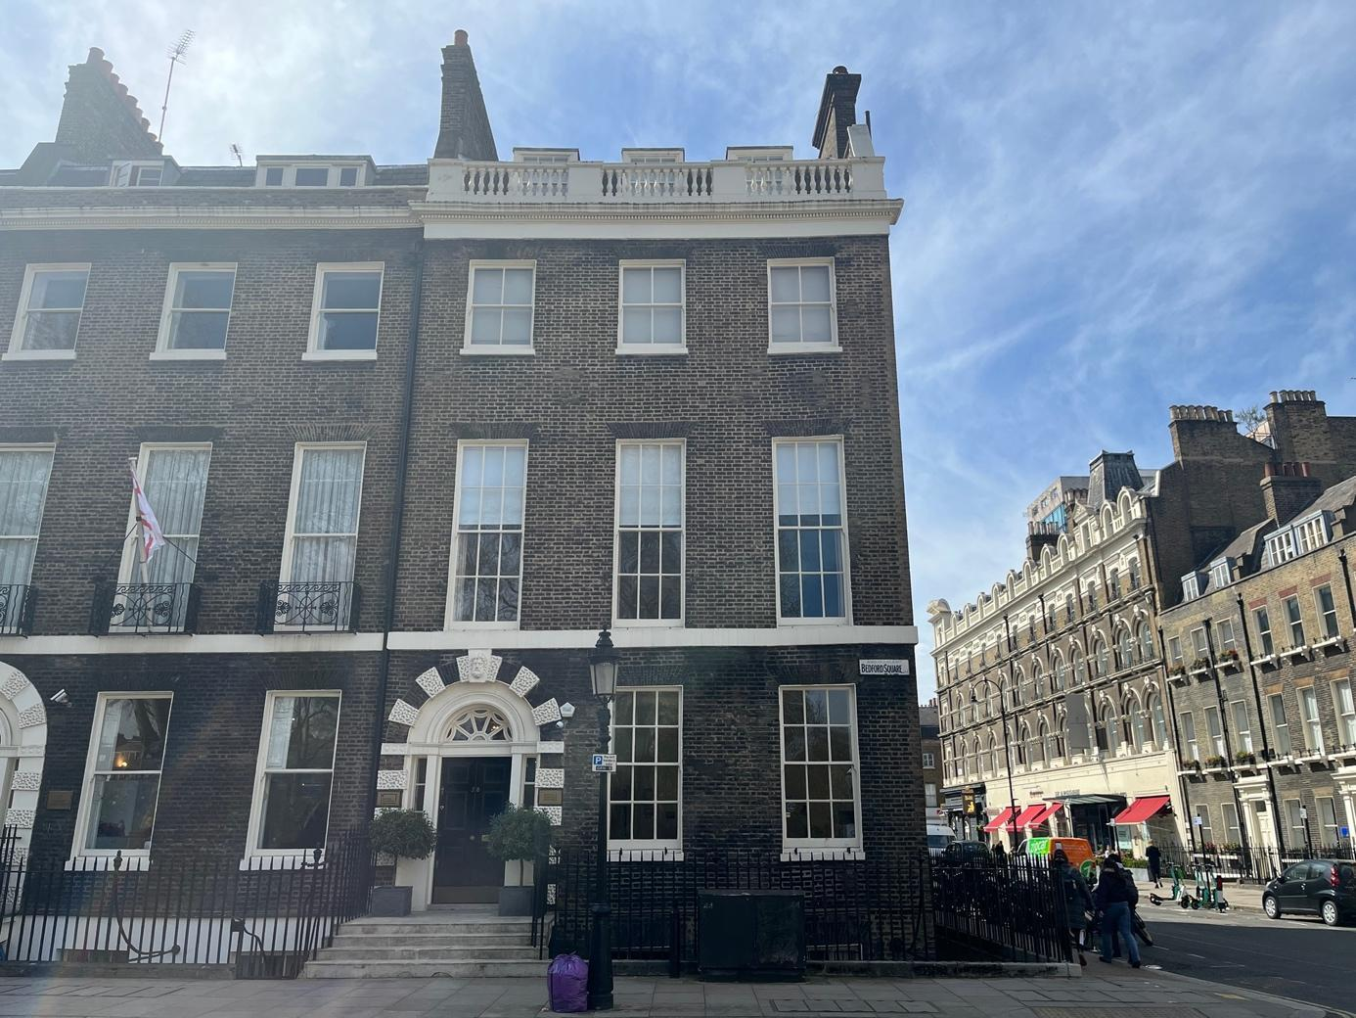

**EXECUTIVE SUMMARY**

| **Property:** | |  | | --- | |  | |  | |  | |
| --- | --- | --- | --- | --- | --- |
| **Client:** |  |

| **Tenure:** |  |
| --- | --- |
| **Tenancies:** | xxxxx |
| **User:** | xxxxx |
| **Location:** | in and postal district |
| **Description:** | xxxxx |
| **Total Floor Area:** | m2 ( ft2) |
| **Valuation Date:** | 1st January 1970 |
| **Market Value:** | £xxxxx |
| **Market Value:**  **(special assumption vacant possession)** | £xxxxx |
| **Market Value:**  **(special assumption 180 days)** | £xxxxxx |
| **Market Rent:** | £xxxx per annum |
| **Reinstatement Value:** | £xxxx - for guidance purposes only, net of VAT |

| **SWOT Analysis:** | **Strengths** | * xxx | **Opportunities** | * xxxx |
| --- | --- | --- | --- | --- |
| **Weaknesses** | * xxx | **Threats** | * xxxx |

| **THIS SUMMARY IS PROVIDED FOR THE PURPOSES OF QUICK REFERENCE**  **BUT IS SUBJECT TO AND MUST NOT BE RELIED UPON OUT OF THE**  **CONTEXT OF THE FULL VALUATION REPORT** |
| --- |

**CONTENTS**

**1.0** **INTRODUCTION 5**

1.1 Property 5

1.2 Instructions 5

1.3 Valuation Date 5

1.4 Valuation Basis 6

1.5 Valuation Definitions 6

**2.0** **INSPECTION 6**

2.1 Circumstances of Inspection 6

2.2 Restrictions to Inspection 6

2.3 Physical Constraints 7

**3.0** **LOCATION 7**

3.1 Situation 7

**4.0** **DESCRIPTION 8**

4.1 Property Description 8

4.2 Accommodation 9

4.3 Condition 10

4.4 Services 11

**5.0** **ENVIRONMENTAL CONSIDERATIONS 11**

5.1 Contamination 11

5.2 Deleterious Materials 11

5.3 Flooding 12

5.4 Energy Performance Certificates 12

5.5 Radon Gas 12

5.6 Invasive Species 12

5.7 Fire Regulations 13

**6.0** **TOWN PLANNING MATTERS 13**

6.1 Highways 13

6.2 Conservation 13

6.3 Planning Consents 13

**7.0** **LOCAL TAXATION 14**

7.1 Business Rates 14

**8.0** **TENURE 14**

**9.0** **TENANCIES 14**

9.1 Commercial 14

**10.0** **VALUATION COMMENTARY 15**

10.1 Key Considerations 15

**11.0** **COMPARABLE EVIDENCE 15**

11.1 Sales: 15

11.2 Lettings: 17

11.2 Marketing History 17

**12.0** **METHODOLOGY 17**

**13.0** **LOAN SECURITY 18**

**14.0** **VALUATION 19**

**15.0** **VALUATION STIPULATIONS 20**

**16.0** **GENERALLY 24**

**APPENDICES**

# 1.0 INTRODUCTION

## 1.1 Property

This report is for the valuation of the property known as:-

| |  | | --- | |  | |  | |  | |
| --- | --- | --- | --- | --- |

## 1.2 Instructions

We have been instructed by to prepare a report and valuation in respect of the subject property for Array purposes.

In accordance with the recommendations of the RICS, we would state that this report is provided solely for the purpose stated above. It is confidential to and for the use only of the party to whom it is addressed only, and no responsibility is accepted to any third party for the whole or any part of its contents. Any such parties rely upon this report at their own risk. Neither the whole nor any part of this report or any reference to it may be included now, or at any time in the future, in any published document, circular or statement, nor published, referred to or used in any way without our written approval of the form and context in which it may appear.

This report has been carried out in accordance with the **RICS Valuation – Global Standards effective 31 January 2022, incorporating the IVSC (International Valuation Standards updated and effective 31 January 2022)**, produced by The Royal Institution of Chartered Surveyors and known as “The Red Book” and should be read in conjunction with the terms of business and general principles. It is also in accordance with the UK national supplement - January 2019.

The measurement of the premises has been carried out in accordance with the RICS Property Measurement Second Edition and the International Property Measurement Standards (where applicable) and the RICS Code of Measuring Practice 6th Edition, both issued by The Royal Institution of Chartered Surveyors.

## 1.3 Valuation Date

The date of valuation is **1st January 1970.**

## 1.4 Valuation Basis

We will specifically provide our opinion of the following:-

The **Market Value** of the property.

The **Market Value** of the property on a special assumption of vacant possession.

The **Market Value** of the property on a special assumption of 180 day marketing period.

The **Market Value** of the property on a special assumption of 90 day marketing period.

The **Market Value** **(1)** of the property as a fully equipped operational entity, having regard to trading potential (trading valuation)

The **Market Value** **(2)** of the property as a fully equipped operational entity, having regard to trading potential, subject to the following special assumptions:-

1. That exchange will take place within 6 months
2. Accounts or records of trade would not be available to a prospective purchaser
3. The business is open for trade

The **Market Value (3)** of the property as a fully equipped operational entity, having regard to trading potential, subject to the following special assumptions:-

1. That exchange will take place within 6 months
2. Accounts or records of trade would not be available to a prospective purchaser
3. The business is closed and the registration/licences removed (include commentary on likelihood of being reinstated either in if current or amended format)
4. The trading Inventory has been removed

The **Gross Development Value** of the of the subject property on a special assumption of development completion.

The **EUV-SH** of the subject property on a special assumptionof development completion.

The **Aggregate** **Market Value** **(MV-VP)** of the subject proeprty on a special assumption of development completion and that each unit is sold individually subject to a full vacant possession.

The **Market Rent** of the subject property.

The **Reinstatement Value** of the subject properties for insurance purposes (guide only)

## 1.5 Valuation Definitions

Our valuation has been carried out in accordance with the **RICS Valuation Global Standards 2022 incorporating the IVSC (International Valuation Standards Council) effective 31 January 2022** produced by The Royal Institution of Chartered Surveyors. It is also in accordance with the UK national supplement - January 2019.

**VPS4 and IVS104** of the standards defines Market Value as; the estimated amount for which an asset or liability should exchange on the valuation date between a willing buyer and a willing seller in an arm's length transaction after proper marketing and where the parties had each acted knowledgeably, prudently and without compulsion.

**VPS4 and IVS104** defines the Market Rent as the estimated amount for which an interest in real property should be leased on the valuation date between a willing lessor and a willing lessee on appropriate lease terms in an arm’s length transaction after proper marketing, and where the parties had each acted knowledgeably, prudently, and without compulsion.

# 2.0 INSPECTION

## 2.1 Circumstances of Inspection

The property was inspected by on **1st January 1970;** weather conditions were xxxxx.

## 2.2 Restrictions to Inspection

We have inspected the building externally from ground level and have not been able to obtain clear views of the roof. Our inspection has been limited to the visible internal and external parts. Our inspection was also limited by the presence of furniture, fixtures and floor coverings.

## 2.3 Physical Constraints

The Disability Discrimination Act 1995 & 2005 and the Equality Act 2010 provide duties on property owners and managing agents to ensure that reasonable measures are undertaken to ensure that there are no physical/accessibility constraints to a property, including fire escape routes that would be discriminatory. Our own inspection did not identify any such constraints that would require reasonable alterations to be carried out. We therefore assume that the property complies with the above legislation.

# 3.0 LOCATION

## 3.1 Situation

The subject property is situated on in and postal district. The property is situated close to the following amenities:-

GOOGLE API?

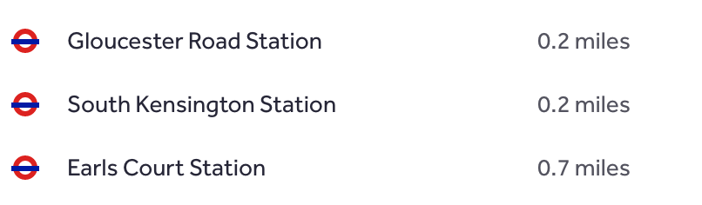

The location map is as follows:-

GOOGLE API?

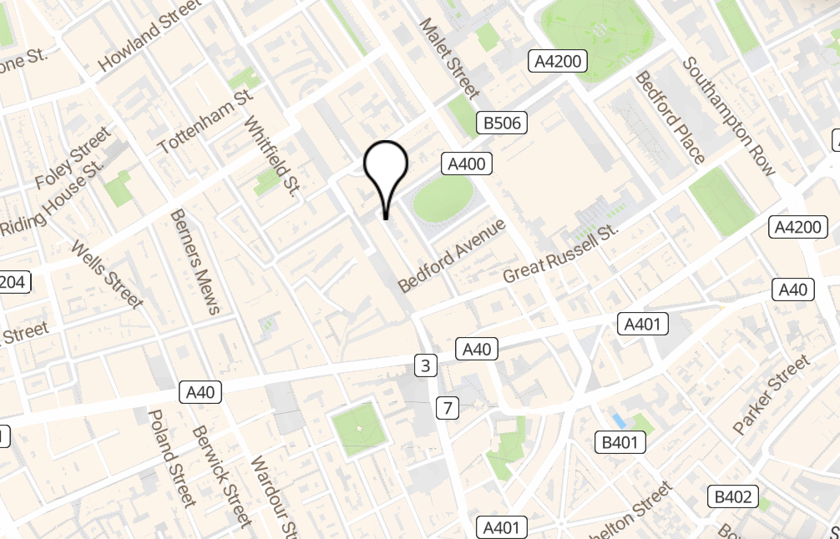

# 4.0 DESCRIPTION

## 4.1 Property Description

The subject property is….

The photographic record is as follows:-

|  |  |
| --- | --- |
| **qwe.jpg** | **asd.jpg** |
|  |  |
|  |  |
|  |  |
| **dfg.jpg** | **photo may be here** |
|  |  |
|  |  |
|  |  |
|  |  |
|  |  |
|  |  |
|  |  |
|  |  |
|  |  |
|  |  |

## 4.2 Accommodation

The subject property has been measured in accordance with the Code of Measuring Practice (6th edition) incorporating the International Property Measurements Standards (IPMS Offices and Residential).

The approximate floor areas are summarised in the table below:-

| **Floor** | **Description** | **Floor Area** |
| --- | --- | --- |
| Xxx Floor | xxxx | m² ( ft²) |
| **TOTAL NET/GROSS INTERNAL FLOOR AREA:** | | **m² ( ft²)** |

## 4.3 Condition

We have not been instructed to undertake a structural survey and our non-invasive inspection has only identified areas of disrepair, which unless stated, are unlikely to have a significant effect upon the Market Value.

Subject to the limitations of our inspection, we are able to confirm that the property is/is not in a reasonable structural condition commensurate with the property’s age and use.

The property is finished to a xxxx

We had limited views of the main roof and rear elevation due to the height and configuration of the building. We have assumed that these areas are clear from any major defects which would significantly affect marketability.

Externally surfaces have weathered commensurate with age and ongoing maintenance to the general fabric of the building should be anticipated. There is evidence, however, that the property has suffered from slight movement as evidenced by fracturing to external and internal finishes. The movement appears long standing in nature. We recommend however that the Bank’s solicitors confirm that ongoing building insurance is available along standard terms, and that the property is adequately covered in its current use and layout.

The subject property has a useful economic life in excess of 25 years, subject to regular maintenance and repair when necessary. We assume such repair and maintenance will be undertaken.

## 4.4 Services

We understand that mains services are connected to the subject property. However, we have not undertaken any tests to ascertain the condition and capacity of these services and we have assumed for the purposes of this valuation that all plant and services are in good order.

# 5.0 ENVIRONMENTAL CONSIDERATIONS

## 5.1 Contamination

We have not carried out any investigation into past or present uses, either of the property or of any neighbouring land, to establish whether or not there is any potential for contamination to the property. In the absence of an environmental audit or other environmental investigation or soil survey, we will assume that no contamination, or the possibility of contamination, exists.

On the basis of a visual inspection and the information available to us in the public domain, we are of the opinion that purchasers are likely to conclude that there are no significant environmental risks associated with this property. As such, we have assumed there would be no adverse effect on value of the property or on its marketability.

However, should it be established that contamination exists at the property or on any neighbouring land, or that the premises have been or are being put to a contaminative use, then this might adversely impact on our opinions of value and we would need to review the valuation advice contained within this report.

## 5.2 Deleterious Materials

We have not seen a copy of an Asbestos Survey Report or Asbestos Management Plan relating to the subject property. However, the existing building is/ is not of an age where it could contain deleterious materials such as asbestos and assume that asbestos is not present in any material quantity that would affect the values now reported.

We assume that prior to any works being carried out within the property an appropriate survey, by a suitably qualified person, will be undertaken to reveal the nature and location of such materials which can be disposed of safely in accordance with current guidelines.

The Control of Asbestos Regulations 2012 requires that all non-domestic premises and those common areas of blocks of flats to have a written Asbestos Management Plan, which is reviewed at regular intervals (where non domestic only and blocks with communal areas / domestic does not require any plan).

We have not been provided with a copy of the Asbestos Management Plan, but in preparing our valuation have assumed that all necessary measures are in place and that no additional costs would be incurred in order to comply.

## 5.3 Flooding

We have carried out a search on the Environment Agency website, which indicates that the property is within a ‘very low risk’ area prone to flooding from surface water, rivers and seas. Very low risk means that each year this area has a chance of flooding of less than 0.1%. (<https://www.ukradon.org/information/ukmaps>)

**We recommend your legal advisors confirm that adequate flood risk insurance is in place if necessary.**

## 5.4 Energy Performance Certificates

The Energy Efficiency (Private Rented Sector) (England and Wales) Regulations 2015 make it unlawful to let residential or commercial properties with an Energy Performance Certificate (EPC) rating of ‘F’ or ‘G’ (i.e. the lowest 2 grades of energy efficiency), unless there is an applicable exemption. The regulations apply to all new lettings, sub-lettings or renewals from 1 April 2018. From 1 April 2020 (for domestic property) and 1 April 2023 (non-domestic property) all existing tenancies with an EPC will need to meet the minimum requirements.

The subject property falls withing the following EPC Band:-

Band A-E (<https://find-energy-certificate.digital.communities.gov.uk/find-a-certificate/type-of-property>)

If E or above: - The above rating is at or above the prescribed level of an E which is acceptable for this type of property. We have no further recommendations and the rating has no impact upon our valuation. The benchmarks may have changed since the date this assessment was carried out and as such it is advisable to obtain an expert’s opinion to advise whether an EPC should be commissioned and if the building is likely to meet the minimum requirements.

If below an E: - The above rating is below the prescribed level of E which is the legal minimum requirement. We are not qualified to assess the likely cost of improving the EPC rating. We recommend specialist advice is sought in this regard. We strongly recommend the bank stipulate as part of the loan agreement that the borrower carries out the necessary improvement(s) to the property to provide an EPC rating of E or above. Our valuation is provided on the assumption the property will be improved by the borrower and a rating or E or above will be provided and therefore there is no impact on valuation.

No EPC:- We have not been provided with an up to date EPC rating for this property. This property is/is not exempt and therefore it is a legal requirement to provide an EPC. If an EPC is not provided, Landlords may face substantial penalties. Our valuation is based on the assumption that the subject property will meet the minimum requirement of an E or above and that there will be no impact on valuation. We strongly recommend the bank stipulate as part of the loan agreement that the borrower obtains an EPC showing a rating of E or above.

## 5.5 Radon Gas

Our enquiries appear to confirm that the property is not within an area significantly affected by Radon Gas and assume that protection measures are not required.

## 5.6 Invasive Species

Japanese Knotweed is a rampant non-native species which can cause physical damage to buildings and hard surfaces. By quantifying the likely cost of treatment and any necessary repairs, the impact of Japanese Knotweed can be taken into account in the valuation process and reflected in the same way as any other defect or item of disrepair.

As valuers, we are not in a position to comment on the costs of any potential treatment as this is a specialist area but can be advised as to whether there was the existence of the plant. How invasive this has become may not be readily identified by a single visual inspection.

While this invasive, non-native plant can be difficult to control, it should be recognised that timely and persistent treatment programmes can minimise its impact and in time can be eradicated.

There was / was no obvious Japanese Knotweed or other contaminative species noted during the course of our inspection.

## 5.7 Fire Regulations

We have not seen a copy of a Fire Risk Assessment, but assume that all relevant legislation has been complied with.

# 6.0 TOWN PLANNING MATTERS

Where we have been unable to make verbal enquires, online enquiries of the Local Authority have been undertaken to confirm town planning matters, which may affect our valuation. We believe that the information that we have obtained is correct, but we cannot accept liability for either incorrect or for material omissions in the information gleaned, including statutory notices or contraventions of statutory requirements.

## 6.1 Highways

We assume that the street the property is situated on is an adopted road, as there are no indications to suggest otherwise. Your solicitor’s searches should be able to confirm this assumption and recommend we are notified if the road is not adopted.

## 6.2 Conservation

Our enquiries reveal that the subject property is [neither a Listed Building, nor situated within a Conservation Area].

## 6.3 Planning Consents

Our investigations of the xxxCouncilxxx reveal the following relevant material planning history:-

| **Application No.** | **Details** | **Decision Date** | **Decision** |
| --- | --- | --- | --- |
|  |  |  |  |

(<https://opendatacommunities.org/data/planning/decisions/major-and-minor-development-type/all>)

Based on the above it is reasonable to assume that the property as constructed and used fully complies with the requisite planning and building regulations.

**We recommend that your legal advisors confirm the above information is accurate before being relied upon.**

# 7.0 LOCAL TAXATION

## 7.1 Business Rates

Rateable Values have now been reassessed under the 2017 Rating Revaluation. The revaluation for this property is £….. (<https://www.tax.service.gov.uk/business-rates-find/search>)which is effective from 1 April 2017. The actual rates payable may be affected by various reliefs or discounts that are available. The revaluation can also be appealed. We have not investigated whether or not this is a fair assessment.

## 7.2 Council Tax

The subject property is listed as being within Council Tax Band [ ? ] (<https://www.tax.service.gov.uk/check-council-tax-band/search>)

The above information has been obtained from the Valuation Office Agency and Directgov.uk websites. We have not investigated whether or not this is a fair assessment and may be subject to alteration. The actual rates or council tax payable may be affected by various reliefs or discounts that are available.

# 8.0 TENURE

We are instructed that this property is held with a title.

We have not been provided with a Report on Title and Copping Joyce therefore assume that the property is not subject to any defect in title, any adverse covenant, or subject to any unusual or other onerous restrictions, rights or outgoings, and that good title can be shown.

For the purposes of this valuation report, it is assumed that there are no outstanding disputes with the neighbouring occupiers. Moreover, it is also assumed that there are no wayleaves or easements granted in favour of the subject property, or, indeed, any neighbouring property or properties.

We recommend your legal advisors confirm the above assumptions and that the above information is accurate before being relied upon.

We have not been furnished with a copy of the relevant lease but assume that the property is held for a term in excess of XX years unexpired subject to a ground rent of no more than £XX per annum, which is subject to review every 25 years, and that there is a service charge liability in respect of the maintenance and repair of the building’s structure and common parts. We also assume this service charge is and will remain reasonable with no significant expenditures expected within the foreseeable future. We lastly assume that this lease is drafted upon standard modern terms and conditions with no onerous terms or conditions applying.

We have not been provided with a Report on Title and Copping Joyce therefore assume that the property is not subject to any defect in title, any adverse covenant, or subject to any unusual or other onerous restrictions, rights or outgoings, and that good title can be shown.

For the purposes of this valuation report, it is assumed that there are no outstanding disputes with the neighbouring occupiers. Moreover, it is also assumed that there are no wayleaves or easements granted in favour of the subject property, or, indeed, any neighbouring property or properties.

No property is being valued. Please see clause 9.0 Tenancies.

**We recommend your legal advisors confirm the above assumptions and that the above information is accurate before being relied upon.**

# 9.0 TENANCIES

## 9.1 Commercial

We have been provided with a copy of a lease for [which part of the property?] held between [landlord] (Landlord) and [tenant] (Tenant). The main salient points are as follows:-

| **Demise:** |  |
| --- | --- |
| **Term:** |  |
| **Rent:** |  |
| **Repair:** |  |
| **User:** |  |
| **Alterations:** |  |
| **Alienation:** |  |
| **Rent Review:** |  |
| **Service Charge:** |  |
| **General Comments:** |  |

## 9.2 Residential

We understand the property is let subject to a standard Assured Shorthold Tenancy Agreement for an initial fixed term of 6-12 months at a rent of [£ ].

We have/have not seen a copy of the lease and assume this is drafted upon standard, non-onerous, terms and conditions where vacant possession can be obtained within a period of six months.

Your legal advisors should confirm the above rents and assumptions before being relied upon.

# 10.0 VALUATION COMMENTARY

## 10.1 Sector Overview

## 10.2 Key Considerations

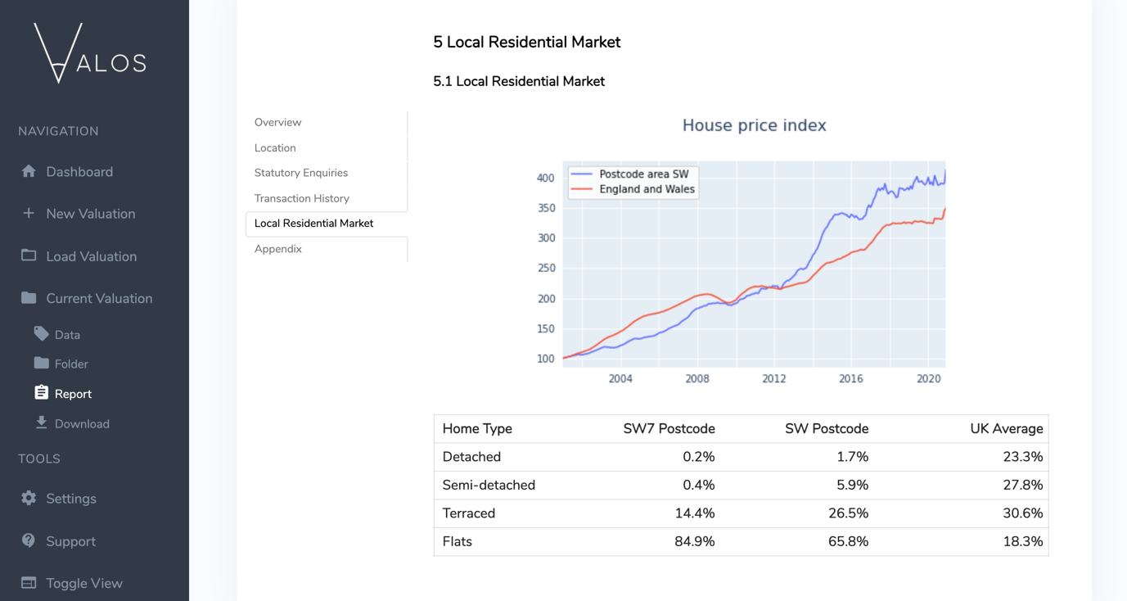

Demographics

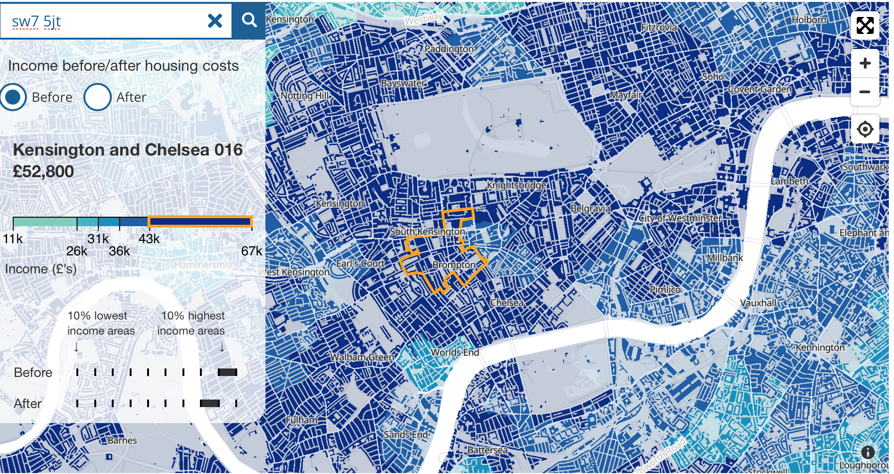

(<https://www.ons.gov.uk/peoplepopulationandcommunity/personalandhouseholdfinances/incomeandwealth/bulletins/smallareamodelbasedincomeestimates/financialyearending2018>)

# 11.0 COMPARABLE EVIDENCE

## 11.1 Sales:

Xxxxxx

## 11.2 Lettings:

Xxxxxx

## 11.2 Marketing History

The subject property sold in xxxx for xxxx.

(No API. <https://www.gov.uk/government/statistical-data-sets/price-paid-data-downloads>)

**Solicitors to verify in this regard.**

# 12.0 METHODOLOGY

???

# 14.0 VALUATION

We submit the following opinions of value as at **1st January 1970**:-

| 1. The **Market Value** of the property is **£ (Pounds).** 2. The **Market Value** of the property on a special assumption of vacant possession, is **£ (Pounds).** 3. The **Market Value** of the property on a special assumption of 180 days marketing, is **£ (Pounds).** 4. The **Market Rent** of the property, is **£ (Pounds) per annum.** |
| --- |
| 1. The **Reinstatement Value** of the subject property for insurance purposes, as a guide only, is a figure in the region of **£ ( Pounds).**   ***Valuation Note:***  *The above is provided for guidance without any liability.  We assume clearance and reinstatement using modern methods and materials.  The figure is not reflective of any extra costs relating to conservation area status or listed buildings (or indeed proximity to listed buildings). It does not include VAT.*  *The above figure should not be relied upon, prior to building surveyor or other professional with replacement costs experience, undertaking a formal reinstatement valuation to confirm the above is accurate.* |

# 15.0 VALUATION STIPULATIONS

Valuation Basis

Where Copping Joyce are instructed to provide valuations on the basis of limited marketing/disposal periods, we draw your attention to the guidance provided by the **RICS Valuation – Global Standards effective 31 January 2020, incorporating the IVSC (International Valuation Standards updated and effective 31 January 2022)**, that an opinion under such circumstances is only valid at the valuation date and may not be relied upon in the event of a future default when market conditions and sale circumstances may be different.

Disposal Costs Taxation and Other Liabilities

No allowances are made for any expenses of realisation, or for taxation, which might arise in the event of a disposal. All property is considered as if free and clear of all mortgages or other charges, which may be secured thereon. Furthermore, no allowance is made to reflect any liability to repay any government or other grants or taxation allowance that may arise on disposal.

Unless otherwise stated, no allowance is made for the possible impact of potential legislation which is under consideration and valuations are prepared and expressed exclusive of VAT payments.

Documentation

We do not normally read documents of title and rarely have access to full lease documentation. We assume, unless informed to the contrary, that each property has a good and marketable title, that all documentation is satisfactorily drawn and that there are no encumbrances, restrictions, easements or other outgoings of an onerous nature, which would have a material effect on the value of the interest under consideration, nor material litigation pending. Where we have been provided with documentation we recommend that reliance should not be placed on our interpretation without verification by your lawyers.

Tenants

Although we reflect our general understanding of a tenant’s status in our valuations, enquiries as to the financial standing of actual or prospective tenants are not normally made unless specifically requested. Where properties are valued with the benefit of lettings, it is therefore assumed, unless we are informed otherwise, that the tenants are capable of meeting their financial obligations under the lease and that there are no arrears of rent or undisclosed breaches of covenant.

Measurements

All measurements are carried out in accordance with the RICS Property Measurement, 2nd Edition January 2018, effective 1 May 2018 (where applicable) and the RICS Code of Measuring Practice (6th Edition), both issued by the Royal Institution of Chartered Surveyors, except where specifically state that we have relied on another source.  The areas adopted are purely for the purpose of assisting us in forming an opinion of rental or capital value.  They should not be relied upon for other purposes nor used by other parties without our written authorisation.

Estimated Rental Value

Our opinion of rental value is formed purely for the purposes of assisting in the formation of an opinion of capital value. It does not necessarily represent the amount that might be agreed by negotiation, or determined by an Expert, Arbitrator or Court, at rent review or lease renewal. This statement does not apply to our opinion of Market Value.

Town Planning and Other Statutory Regulations:

Information on town planning is, wherever possible, obtained either verbally from local planning authority officers or publicly available electronic or other sources. It is obtained purely to assist us in forming an opinion of capital value and should not be relied upon for other purposes.

It is assumed that the property has been constructed in full compliance with valid Town Planning and Building Regulation approval and it is not subject to any outstanding statutory notice as to its construction, use or occupation. Unless our enquiries have revealed the contrary, it is further assumed that the existing use of the subject premises is duly authorised or established and that no adverse planning conditions apply.

If reliance is required we recommend that verification be obtained from lawyers that:-

I. the position is correctly stated in our report;

II. the property is not adversely affected by any other decisions made, or conditions prescribed, by public authorities;

1. that there are no outstanding statutory notices.

Our valuations are prepared on the basis that the premises (and any works thereto) comply with all relevant statutory and EC regulations, including fire regulations, access and use by disabled persons and control and remedial measures for asbestos in the workplace.

Structural Surveys

We have not been instructed to carry out a structural survey and have not inspected woodwork or other parts of the property that are covered, unexposed or inaccessible and such parts will be assumed to be in good repair and condition. We do not test the services and we therefore do not give any assurance that any property is free from defect. We seek to reflect in our valuations any readily apparent defects or items of disrepair, which we note during our inspection, or costs of repair which are brought to our attention. Unless stated otherwise in our reports we assume any tenants are fully responsible for the repair of their demise either directly or through a service charge.

This valuation does not purport to express an opinion about or to advise upon the condition of un-inspected parts and should not be taken as making any implied representation or statement about such parts.

Deleterious Materials

We do not normally carry out investigations on site to ascertain whether any building was constructed or altered using deleterious materials or techniques (including, by way of example high alumina cement concrete, woodwool as permanent shuttering, calcium chloride or asbestos). Unless we are otherwise informed, our valuations are on the basis that no such materials or techniques have been used.

Cladding

There is current Government Guidance in respect of cladding. This is contained in ADVICE NOTE 14 MHCLG/BSP/18/12/2018. Full retentions must be imposed pending the results of any cladding tests. In the aftermath of Grenfell, Government advice and guidance has evolved and indeed will continue to do so, specifically around the use of combustible materials in high-rise blocks. Building Regulations have also been subject to review and updating. In December 2018, the Government banned the use of combustible materials in high rise buildings and based on numerous studies into cladding (not exclusively fire related), issued Advice Note 14 which addressed cladding materials other than ACM. It requires the ‘responsible person’, to assess the ‘cladding system’ generally in relation to combustibility, but specifically to assess whether the ‘system’ had been correctly installed and subsequently maintained in accordance with manufacturers recommendations. This advice note threw doubt on the adequacy of cladding fixings and the existence/adequacy of fire stops and cavity barriers all of which form an integral part of the ‘system’ and help ensure fire safety.

If cladding is located then we will require a cladding expert report to assess and we reserve the right to amend our valuation if necessary and /or to offer suitable recommendations regarding loan security.

In arriving at the valuation for mortgage purposes, we will rely on the EWS1 form in good faith as completed by a professionally qualified third party. There is, however, no liability on us for any losses or potential losses arising directly and solely from the valuation being provided in reliance upon the EWS1 form. If you require further information, then please seek independent advice prior to providing any lending on the property.

Site Conditions

We do not normally carry out investigations on site in order to determine the suitability of ground conditions and services for the purposes for which they are, or are intended to be, put; nor do we undertake archaeological, ecological or environmental surveys. Unless we are otherwise informed, our valuations are on the basis that these aspects are satisfactory and that, where development is contemplated, no extraordinary expenses, delays or restrictions will be incurred during the construction period due to these matters. However, should our site inspection and further reasonable enquiries during the preparation of the valuation lead us to believe that the land is likely to be contaminated we will discuss our concerns with you.

Insurance

Unless expressly advised to the contrary we assume that appropriate cover is and will continue to be available on commercially acceptable terms, for example in regard to Composite Panels, Terrorism, Flood and Rising Water Table.

NHBC (Applicable to New Build projects or buildings erected in the last ten years)

The 2013 edition of the NHBC Standards came into effect for every NHBC registered home where works were started on or after 1 January 2013. This is an essential part of risk management to ensure buildings are constructed to the correct standards. This keeps potential problems to a minimum, benefitting both homeowners and builders. We assume that the subject property benefits from the required certification and we recommend your legal advisers confirm this is correct prior to capital advance. This could potentially impact on any resale and the valuation provided herein. We have assumed that the property has the necessary warranties and we reserve the right to review our valuation if this is not the case.

Outstanding Debts

In the case of property where construction works are in hand, or have recently been completed, we do not normally make allowance for any liability already incurred, but not yet discharged, in respect of completed works, or obligations in favour of contractors, subcontractors or any members of the professional or design team.

# 16.0 GENERALLY

inspected the property. The valuation has been undertaken by . We confirm that both the above-named and Copping Joyce, the firm, are independent valuers as defined by PS 2 of the, *‘The Red Book’*.  has the relevant experience in valuing the type of property concerned in the particular location and is an RICS Registered Valuer.

Our Valuations and Reports are confidential to the party to whom they are addressed and for the specific purpose to which they refer, and no responsibility whatsoever is accepted to any third parties.

Neither the whole, nor any part, nor reference thereto, may be published in any document, statement or circular, nor in any communication with third parties, without our prior written approval of the form and context in which it will appear.

|  |  |
| --- | --- |
|  | |

| **..………………………………………**  **RICS Registered Valuer** | **..………………………………………**  **RICS Registered Valuer** |
| --- | --- |

**For and on behalf of**

**COPPING JOYCE SURVEYORS LIMITED**

**Report Date: 1st January 1970**