 | NORZAGARAY COLLEGE  SYSTEM DOCUMENTATION |  | 
GRADTRACK / 2026 EDITION
USER MANUAL
A Web-Based Graduate Tracer System with Alumni Job Support System for Norzagaray College
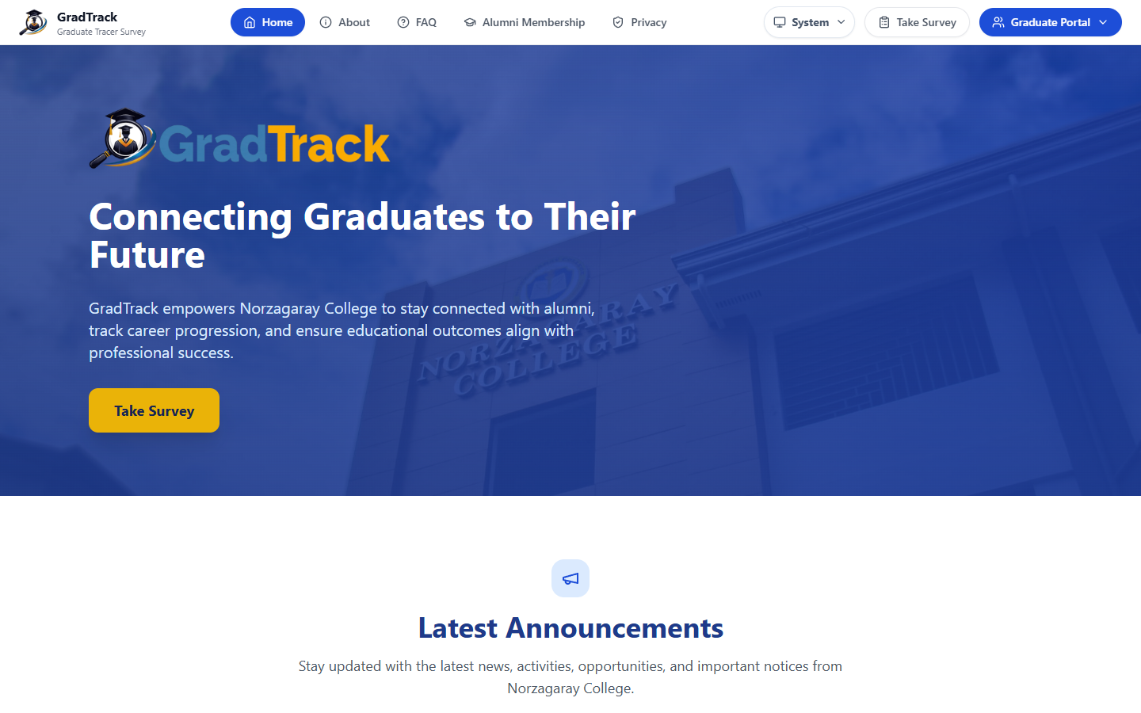 | FROM  GRADUATE  DATA TO  CAREER  CONNECTION  TRACE • CONNECT  SUPPORT • GROW  
DOCUMENT  GRADTRACK UPDATED USER MANUAL | EDITION  2026

05  RESEARCHERS | PREPARED BY  Manansala, John Paul U. • Medico, Kyla Mae J. • Medina, Gleiza B.  Meneses, Edricson I. • Rodriguez, Rhom Moises M.
NORZAGARAY COLLEGE • BULACAN, PHILIPPINES

Table of Contents
Table of Contents 1
List of Figures 4
How to Use This Manual 6
1 Introduction 7
1.1 Purpose of the Manual 7
1.2 Source of Truth 7
1.3 Safety and Data Privacy 7
2 Software Requirements 8
2.1 End-User Requirements 8
2.2 Deployment Components 8
3 User Roles and Access 9
4 Public Site, Survey, and Account Access 10
4.1 Public Home Page 10
4.2 Public Announcements 10
4.3 About GradTrack 11
4.4 Frequently Asked Questions 12
4.5 Privacy Policy 13
4.6 Alumni Membership Information 14
4.7 Proceed to Alumni Registration 15
4.8 Personnel Sign In 16
4.9 Graduate Portal Login 17
4.10 Graduate Identity Verification 18
4.11 Data Privacy Consent 19
4.12 Complete the Graduate Tracer Survey 20
4.13 Review Survey Answers 21
4.14 Survey Submission Result 22
4.15 Create a Graduate Portal Account 23
5 Graduate / Alumni Portal 25
5.1 Community Forum 25
5.2 Create a Community Post 25
5.3 Graduate Announcements 26
5.4 Direct and Group Messaging 27
5.5 Browse Job Opportunities 28
5.6 View and Apply for a Job 29
5.7 Saved Jobs 30
5.8 Manage Graduate Job Posts 31
5.9 Create a Graduate Job Post 32
5.10 Graduate Profile and Credentials 33
5.11 Add a Professional Credential 34
5.12 Graduate Profile Settings 35
5.13 Graduate Notifications 36
6 Research Coordinator User Manual 38
6.1 Research Coordinator Dashboard 38
6.2 Graduate Records and Participation 38
6.3 Survey Management 39
6.4 Edit Survey Information 40
6.5 Response Monitoring 41
6.6 Reports Overview 42
6.7 Descriptive Survey Analytics 43
6.8 Inferential Analysis 44
6.9 Research Coordinator Job Postings 45
6.10 Research Coordinator AI Assistant 46
7 Dean User Manual 48
7.1 Department-Scoped Dean Dashboard 48
7.2 Dean Survey Participation 48
7.3 Dean Reports and Analytics 49
7.4 Dean Job Postings 50
7.5 Dean Profile 51
7.6 Dean AI Assistant 52
8 Registrar User Manual 54
8.1 Manage Graduate Records 54
8.2 Search and Filter Graduate Records 54
8.3 Add a Graduate Record 55
8.4 Import Graduate Records from Excel 56
8.5 Archive Graduate Records 57
8.6 Registrar Profile 58
9 Alumni President User Manual 60
9.1 Review Graduate Portal Account Requests 60
9.2 View Graduate Account Details 60
9.3 Manage Alumni Membership Information 61
9.4 Manage Announcements 62
9.5 Create an Announcement 63
9.6 Moderate Reported Forum Content 64
9.7 Alumni President Job Postings 65
9.8 Approve Graduate Job Posts 66
10 Administrator User Manual 68
10.1 User Management 68
10.2 Add a Personnel User 68
10.3 Automated Email Reminders 69
10.4 Audit Trail 70
10.5 Database Backup 71
10.6 General System Settings 72
10.7 Branding Settings 73
10.8 Administrator Profile 74
10.9 Administrator AI Assistant 75
11 MIS Staff User Manual 77
11.1 MIS Staff Dashboard 77
11.2 MIS Staff Profile 77
12 Job Support Features 79
12.1 Job-Posting Rules 79
13 Common Account, Security, and Troubleshooting Guidance 80
13.1 Sign Out 80
13.2 Password Safety 80
13.3 Common Problems 80
Appendix A — Verification and Screenshot Notes 81

List of Figures
Figure 1. GradTrack Public Home Page 10
Figure 2. Public Announcements Page 11
Figure 3. About GradTrack Page 12
Figure 4. Frequently Asked Questions 13
Figure 5. GradTrack Privacy Policy 14
Figure 6. Alumni Membership Information 15
Figure 7. Alumni Membership Registration Link 16
Figure 8. Personnel Sign In Page 17
Figure 9. Graduate Portal Login 18
Figure 10. Graduate Identity Verification 19
Figure 11. Data Privacy Notice and Informed Consent 20
Figure 12. Graduate Tracer Survey Form 21
Figure 13. Survey Review Screen 22
Figure 14. Survey Completion and Next Actions 23
Figure 15. Graduate Portal Account Registration 24
Figure 16. Graduate Community Forum 25
Figure 17. Community Post Composer 26
Figure 18. Graduate Announcements 27
Figure 19. Direct and Group Messaging 28
Figure 20. Browse Jobs 29
Figure 21. Job Opportunity Details 30
Figure 22. Saved Job Opportunities 31
Figure 23. Graduate Job Posts 32
Figure 24. Create Job Post Form 33
Figure 25. Graduate Profile and Credentials 34
Figure 26. Add Professional Credential 35
Figure 27. Graduate Profile Settings 36
Figure 28. Graduate Notifications Panel 37
Figure 29. Research Coordinator Dashboard 38
Figure 30. Graduate Survey Participation 39
Figure 31. Survey Management 40
Figure 32. Edit Survey 41
Figure 33. Survey Response Monitoring 42
Figure 34. Reports and Analytics Overview 43
Figure 35. Descriptive Survey Analytics 44
Figure 36. Inferential Analysis 45
Figure 37. Research Coordinator Job Postings 46
Figure 38. Research Coordinator AI Assistant 47
Figure 39. Dean Department Dashboard 48
Figure 40. Dean Survey Participation 49
Figure 41. Dean Reports and Analytics 50
Figure 42. Dean Job Postings 51
Figure 43. Dean Personnel Profile 52
Figure 44. Dean AI Assistant 53
Figure 45. Registrar Manage Graduates 54
Figure 46. Registrar Search and Filters 55
Figure 47. Registrar Add Graduate Form 56
Figure 48. Registrar Excel Import Control 57
Figure 49. Registrar Archive 58
Figure 50. Registrar Personnel Profile 59
Figure 51. Alumni Verification with Updated View Details Action 60
Figure 52. Alumni Account Details 61
Figure 53. Alumni Membership Management 62
Figure 54. Alumni President Announcement Manager 63
Figure 55. Create Announcement Form 64
Figure 56. Forum Moderation 65
Figure 57. Alumni President Job Postings 66
Figure 58. Graduate Job Approval Queue 67
Figure 59. Administrator User Management 68
Figure 60. Add Personnel User 69
Figure 61. Automated Email Reminders 70
Figure 62. Administrator Audit Trail 71
Figure 63. Database Backup 72
Figure 64. General System Settings 73
Figure 65. GradTrack Branding Settings 74
Figure 66. Administrator Profile 75
Figure 67. Administrator AI Assistant 76
Figure 68. MIS Staff Dashboard 77
Figure 69. MIS Staff Profile 78

How to Use This Manual
This manual is organized by user role. Follow only the procedures assigned to your account. Button names and navigation labels are written exactly as displayed in the verified November 2026 system build.
- Screenshots use anonymized documentation data captured from an isolated local copy of the latest source code.
- Actions that send notifications, publish content, archive records, or permanently delete data require authorization and careful confirmation.
- The Administrator and MIS Staff are separate roles in the current system.
- The current Registrar interface has no row-level Edit or View Details actions and no restore command.

1 Introduction
GradTrack is a web-based graduate tracer and alumni job-support system for Norzagaray College. It combines graduate identity verification, tracer surveys, role-based monitoring and analytics, alumni community features, and approved job opportunities.

1.1 Purpose of the Manual
This manual provides current, step-by-step instructions for public visitors, graduates, Research Coordinators, Deans, the Registrar, the Alumni President, the Administrator, and MIS Staff.

1.2 Source of Truth
The procedures and figures in this edition were verified against the latest application routes, role configuration, source code, and a running local environment. The previous 61-page manual was used only as a structural and academic-style reference.

1.3 Safety and Data Privacy
Use authorized accounts only. Do not share passwords, expose graduate personal data, send reminders without confirming recipients, or perform archive, delete, publish, approval, or backup actions outside institutional policy.

2 Software Requirements

2.1 End-User Requirements
- A desktop or laptop computer with a current version of Microsoft Edge, Google Chrome, or Mozilla Firefox.
- A stable network connection to the authorized GradTrack environment.
- A screen resolution of at least 1366 × 768; 1440 × 900 or higher is recommended.
- An authorized personnel account or an approved Graduate Portal account for restricted modules.
- A PDF reader and Microsoft Word or a compatible office application for exported reports and this manual.

2.2 Deployment Components
The current project uses a React/Vite frontend, PHP API, MySQL or MariaDB data storage, and a real-time messaging service. These components are maintained by authorized technical staff and are not required for ordinary end-user procedures.

3 User Roles and Access
The current source code defines the following separate roles and access scopes.
Role | Verified Current Access
Graduate / Alumni | Community Forum, announcements, messaging, jobs, job submissions, saved jobs, profile, credentials, settings, notifications
Research Coordinator | Institution dashboard, graduate participation, survey management, responses, reports and analytics, job postings, AI Assistant
Dean | Department-scoped dashboard, survey participation, reports and analytics, job postings, profile, AI Assistant
Registrar | Graduate search and filters, add, Excel/CSV import, bulk archive, Registrar Archive, profile; no row-level edit/view/restore actions
Alumni President | Graduate account approvals, registered alumni, membership content, announcements, forum moderation, job postings and approvals
Administrator | Personnel users, automated reminders, audit trail, database backup, system settings, branding, profile, AI Assistant
MIS Staff | Institution dashboard and own profile only in the current navigation

4 Public Site, Survey, and Account Access

4.1 Public Home Page
Purpose: Introduce GradTrack and provide entry points to the survey, Graduate Portal, public information, and personnel system.
Procedure
Step 1. Open the GradTrack web address in a supported browser.
Step 2. Use the top navigation to open Home, About, FAQ, Alumni Membership, or Privacy.
Step 3. Select Take Survey, Graduate Portal, or System for the required task.
Expected Result: The selected public page or access portal opens.
Figure 1. GradTrack Public Home Page
Figure description: The current public landing page displays the latest GradTrack branding and navigation.

4.2 Public Announcements
Purpose: Allow visitors to read published college and alumni announcements without signing in.
Procedure
Step 1. From the public site, open Announcements when it is presented from the home page or portal.
Step 2. Review the announcement cards.
Step 3. Select Read More to open the complete announcement.
Expected Result: The chosen published announcement is displayed.
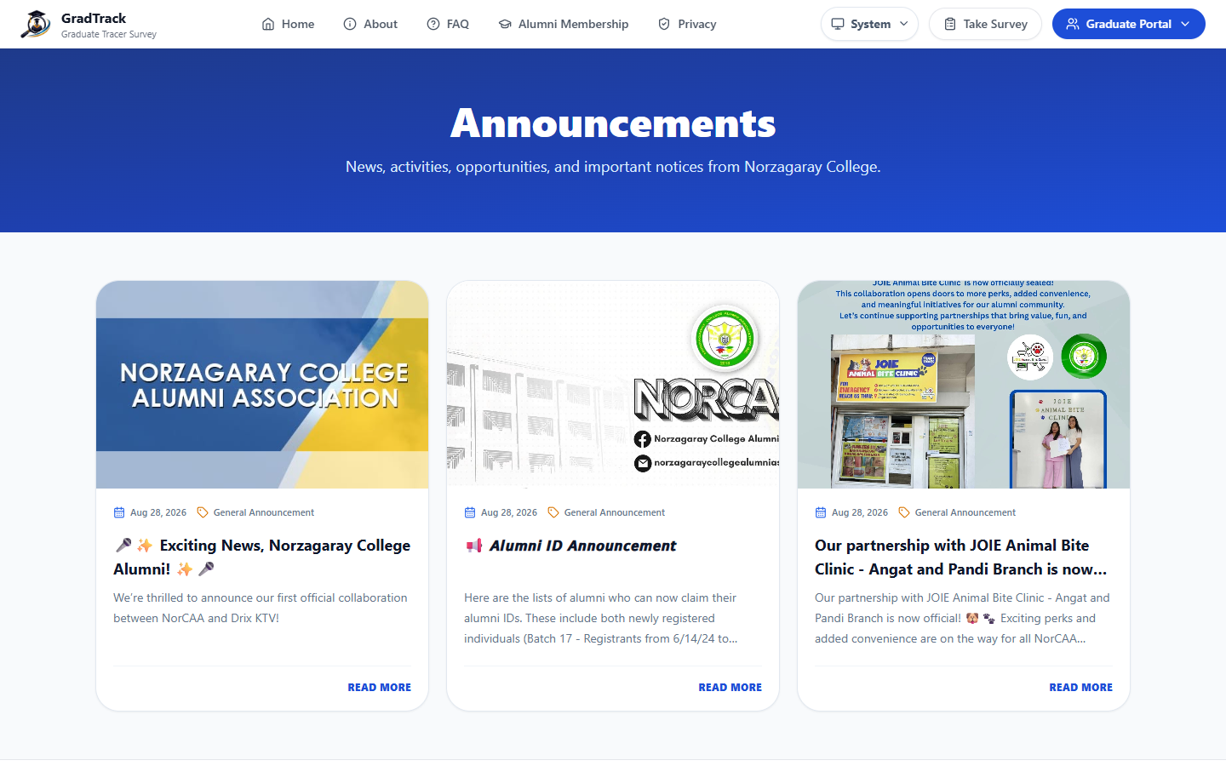
Figure 2. Public Announcements Page
Figure description: Published announcements appear as image cards with their dates, categories, and summaries.

4.3 About GradTrack
Purpose: Explain the system mission and the graduate-tracing problem addressed by GradTrack.
Procedure
Step 1. Select About on the public navigation bar.
Step 2. Read the mission and system overview.
Step 3. Scroll to review the remaining informational sections.
Expected Result: The About page presents the current system description.
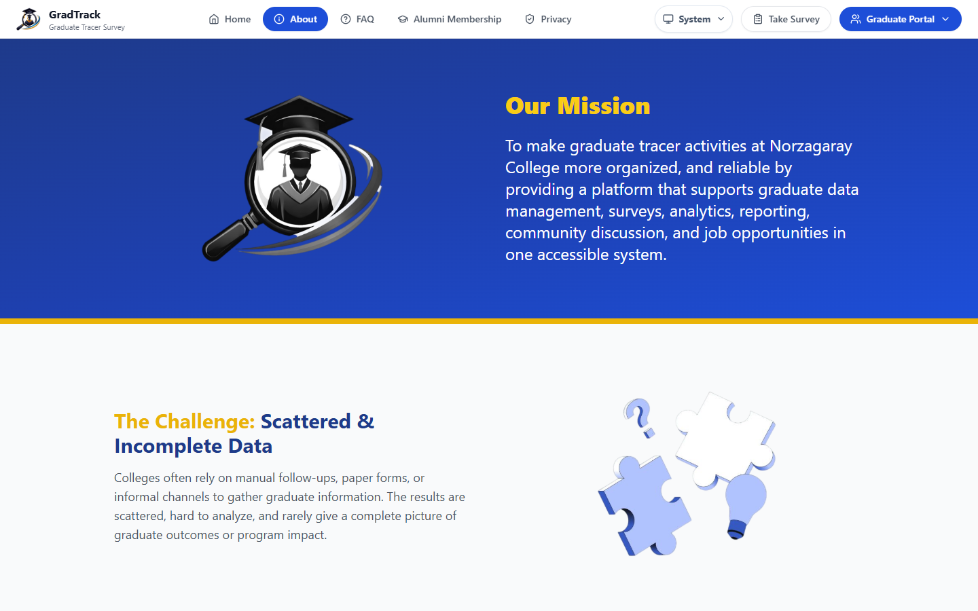
Figure 3. About GradTrack Page
Figure description: The About page describes GradTrack's purpose using current system branding.

4.4 Frequently Asked Questions
Purpose: Provide quick answers about surveys, access, accounts, and common system concerns.
Procedure
Step 1. Select FAQ on the public navigation bar.
Step 2. Locate the relevant category.
Step 3. Select a question to expand its answer.
Expected Result: The selected answer expands on the same page.
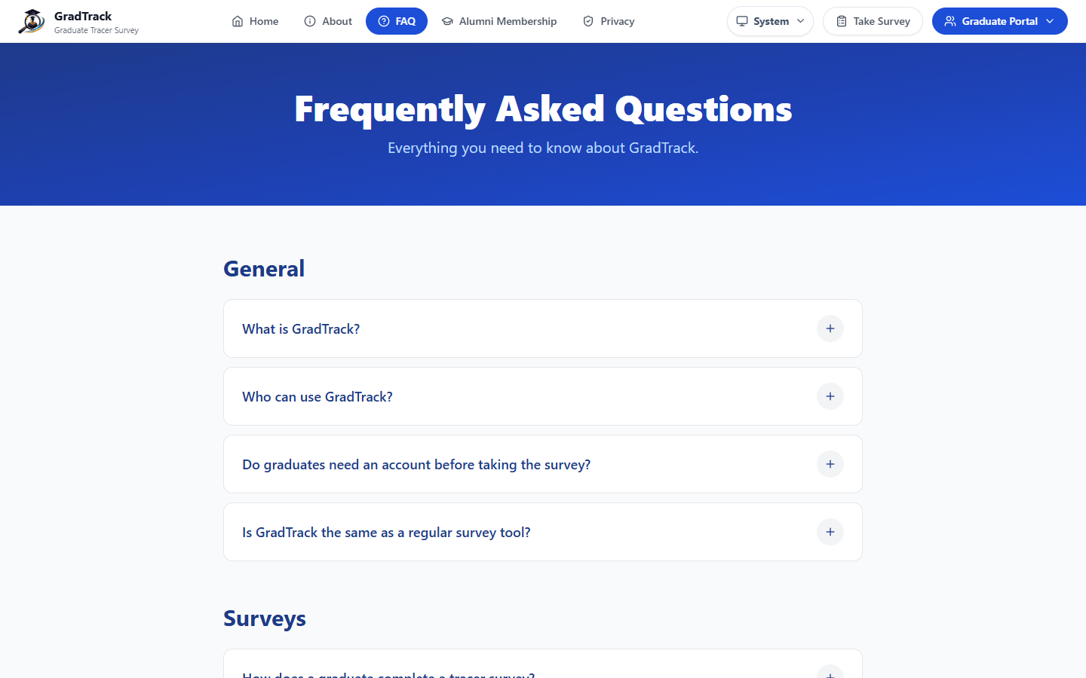
Figure 4. Frequently Asked Questions
Figure description: The FAQ page organizes common questions into expandable items.

4.5 Privacy Policy
Purpose: Inform users how GradTrack collects, uses, and protects personal information.
Procedure
Step 1. Select Privacy on the public navigation bar.
Step 2. Read the policy before supplying personal or survey information.
Step 3. Scroll to review the information categories and user responsibilities.
Expected Result: The current privacy policy is displayed.
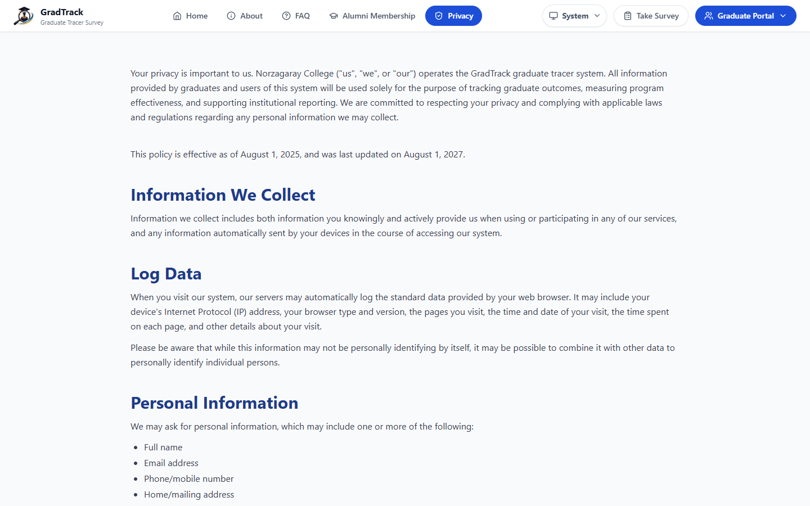
Figure 5. GradTrack Privacy Policy
Figure description: The public privacy page presents the current notice and categories of collected information.

4.6 Alumni Membership Information
Purpose: Present the current Norzagaray College Alumni Association benefits, fees, and identification-card information.
Procedure
Step 1. Select Alumni Membership on the public navigation bar.
Step 2. Review the membership benefits and fee breakdown.
Step 3. Review the sample alumni identification card and important membership information.
Expected Result: The visitor can review the published membership information before proceeding.
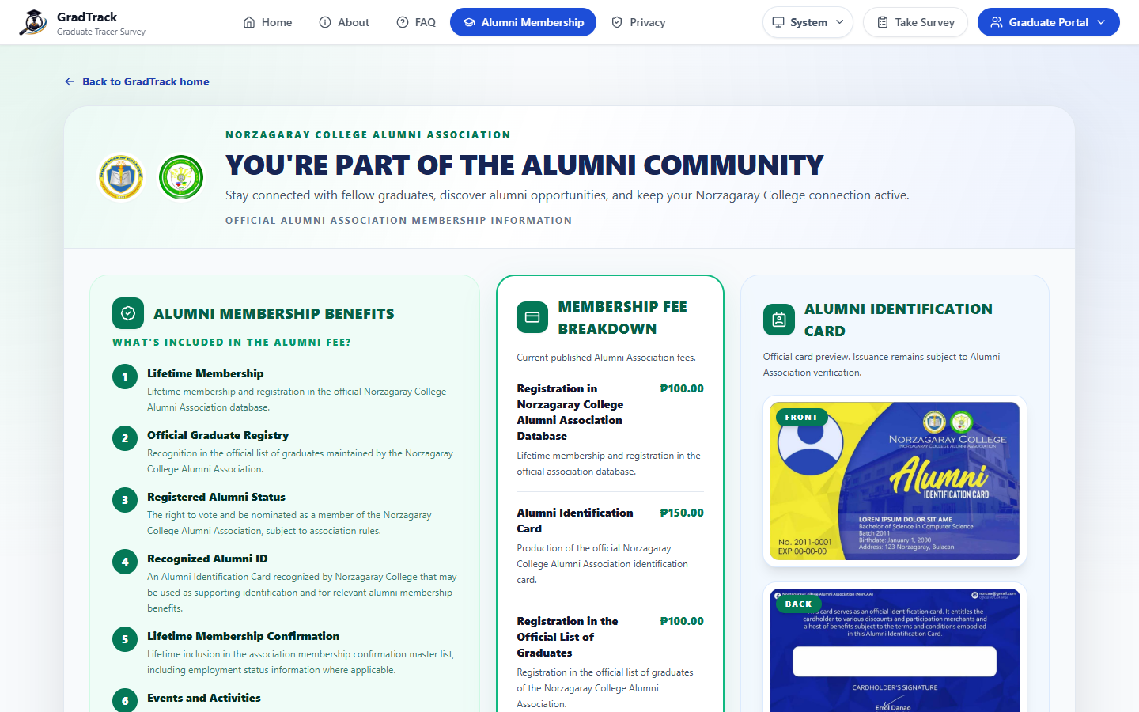
Figure 6. Alumni Membership Information
Figure description: The membership page shows the current college and Alumni Association logos, benefits, fees, and ID-card preview.

4.7 Proceed to Alumni Registration
Purpose: Direct qualified graduates to the official Alumni Association registration process.
Procedure
Step 1. Open Alumni Membership from the public site.
Step 2. Scroll to Official Registration — How to Proceed.
Step 3. Read the eligibility and payment notes.
Step 4. Select Proceed to Alumni Registration; the official form opens in a new browser tab when enabled.
Expected Result: The official Alumni Association registration page opens separately from GradTrack.
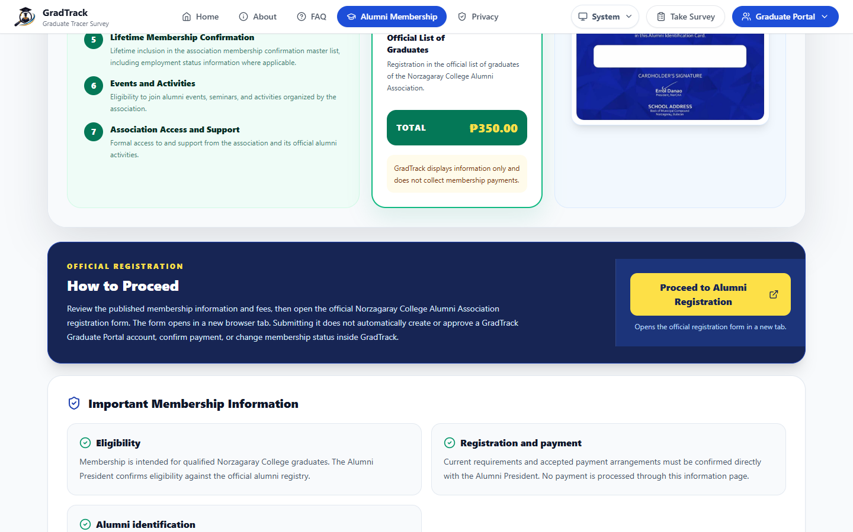
Figure 7. Alumni Membership Registration Link
Figure description: The registration call-to-action explains that GradTrack displays information only and does not collect membership payments.

4.8 Personnel Sign In
Purpose: Authenticate authorized college personnel according to their assigned role.
Procedure
Step 1. From the public site, select System, or open the personnel sign-in page.
Step 2. Enter the authorized email address and password.
Step 3. Select Sign In.
Expected Result: GradTrack opens the modules allowed for the authenticated personnel role.
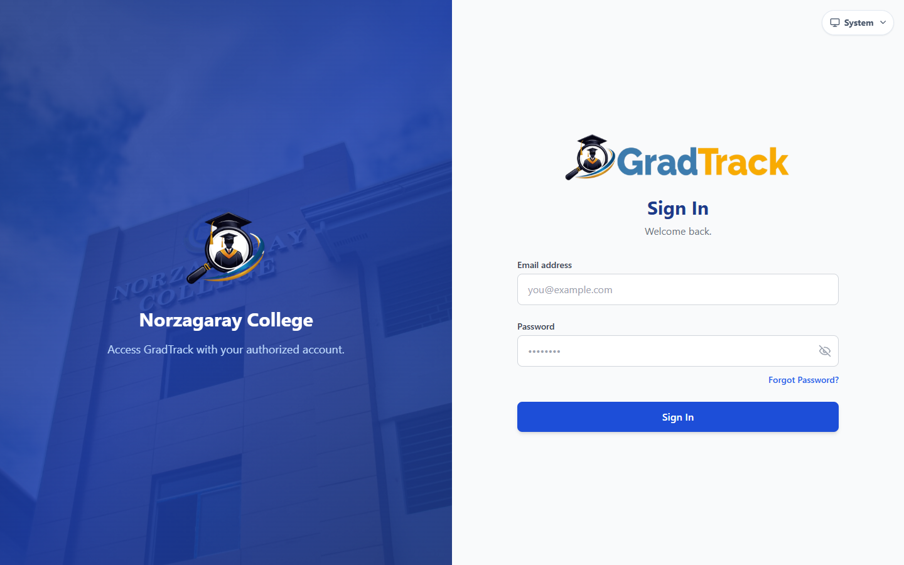
Figure 8. Personnel Sign In Page
Figure description: The personnel sign-in page uses the current GradTrack and Norzagaray College branding.

4.9 Graduate Portal Login
Purpose: Allow approved graduates to access community, job, profile, and messaging features.
Procedure
Step 1. Open Graduate Portal from the public navigation.
Step 2. Enter the registered email address and password.
Step 3. Select Log In.
Expected Result: An approved and active account opens the Graduate Community portal.
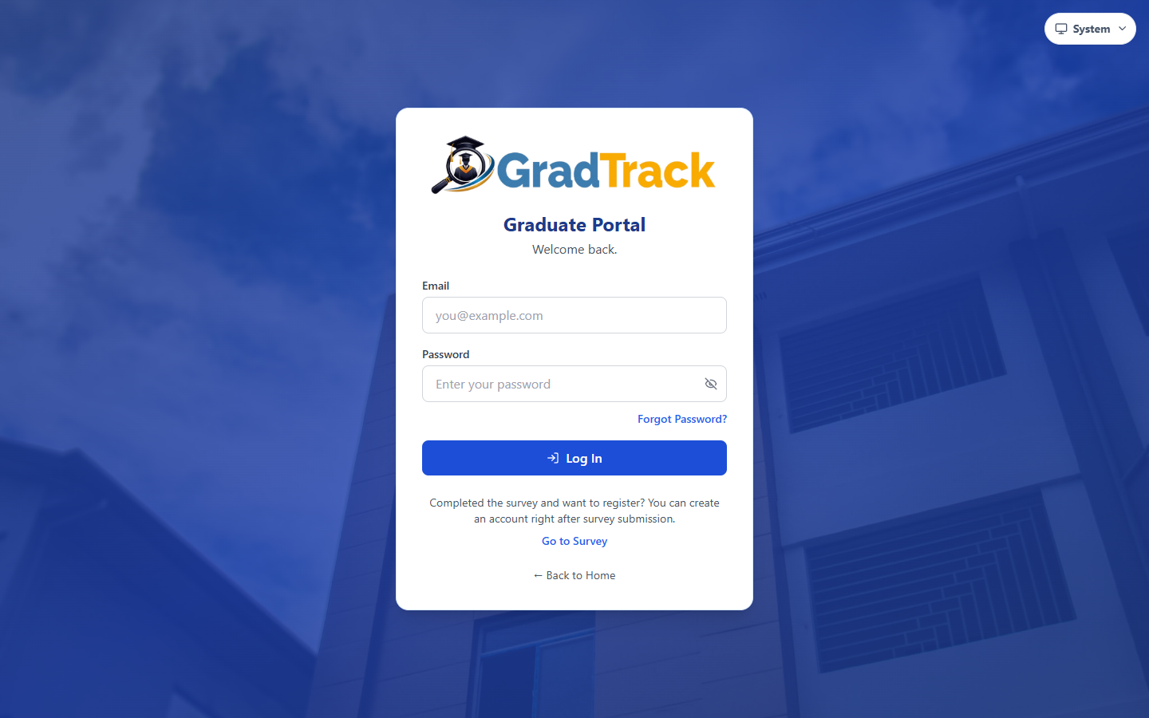
Figure 9. Graduate Portal Login
Figure description: The Graduate Portal login page includes links for password recovery and survey access.

4.10 Graduate Identity Verification
Purpose: Match a graduate to the official registrar record before survey access or account creation.
Procedure
Step 1. Select Take Survey or Go to Survey.
Step 2. Choose Student Number or Email as the verification method.
Step 3. Enter the requested identifier, last name, and program exactly as recorded.
Step 4. Select Verify & Continue.
Expected Result: A verified graduate proceeds to the assigned survey or eligible account-creation flow.
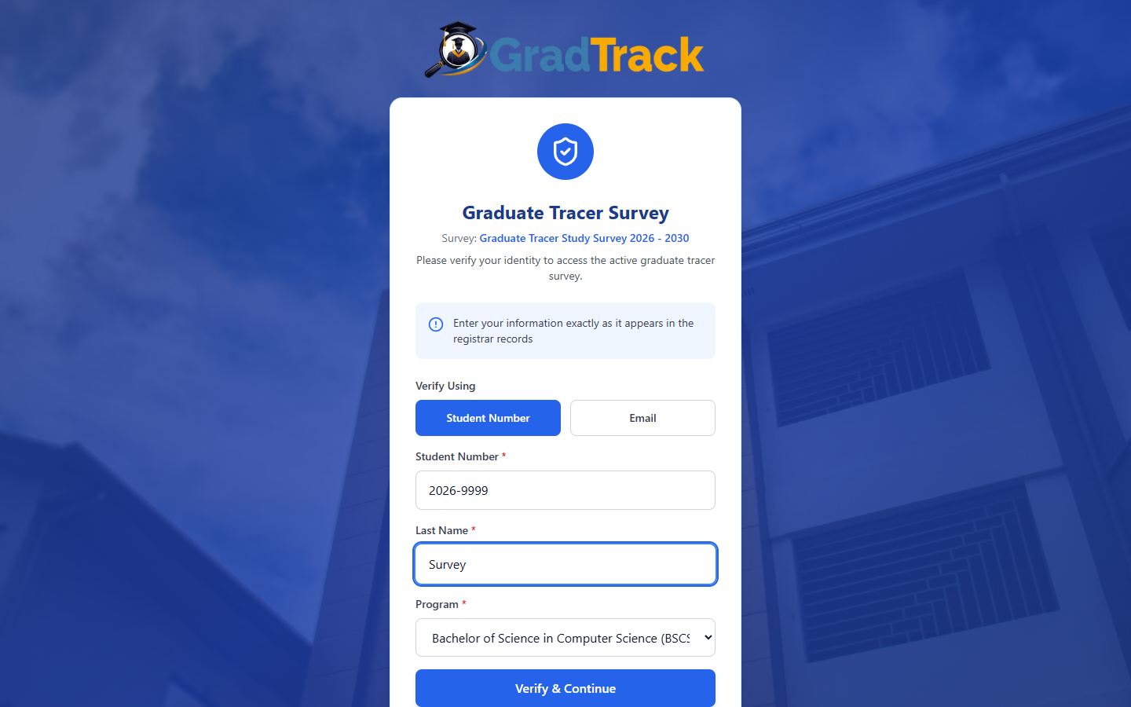
Figure 10. Graduate Identity Verification
Figure description: The verification form validates identity against the registrar's graduate records.

4.11 Data Privacy Consent
Purpose: Obtain informed consent before collecting tracer-survey responses.
Procedure
Step 1. Read the complete Data Privacy Notice & Informed Consent.
Step 2. Select the acknowledgement checkbox when you agree.
Step 3. Select I Agree & Proceed; select Decline & Go Back if you do not consent.
Expected Result: Consent opens the survey; declining returns the user without submitting responses.
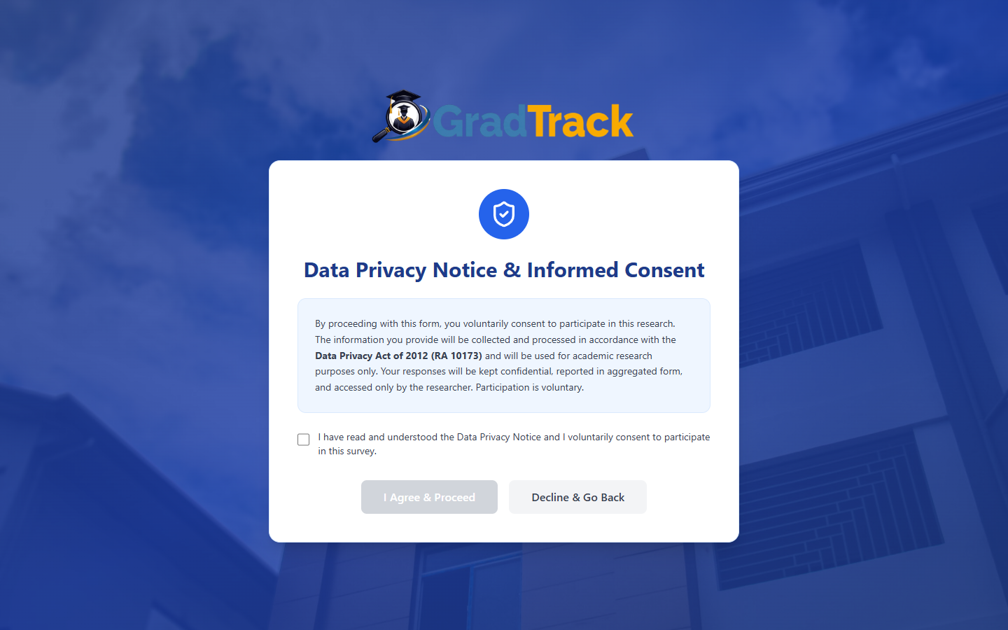
Figure 11. Data Privacy Notice and Informed Consent
Figure description: The consent screen must be acknowledged before the survey form becomes available.

4.12 Complete the Graduate Tracer Survey
Purpose: Collect the graduate's personal, educational, training, further-study, and employment information.
Procedure
Step 1. Complete every field marked with an asterisk.
Step 2. Use the address selectors and choose answers that accurately describe the graduate.
Step 3. Select Next to continue through each section; use Previous to revise an earlier section.
Step 4. Observe the Draft saved indicator before leaving the page.
Expected Result: Valid answers are saved as a draft and the next survey section opens.
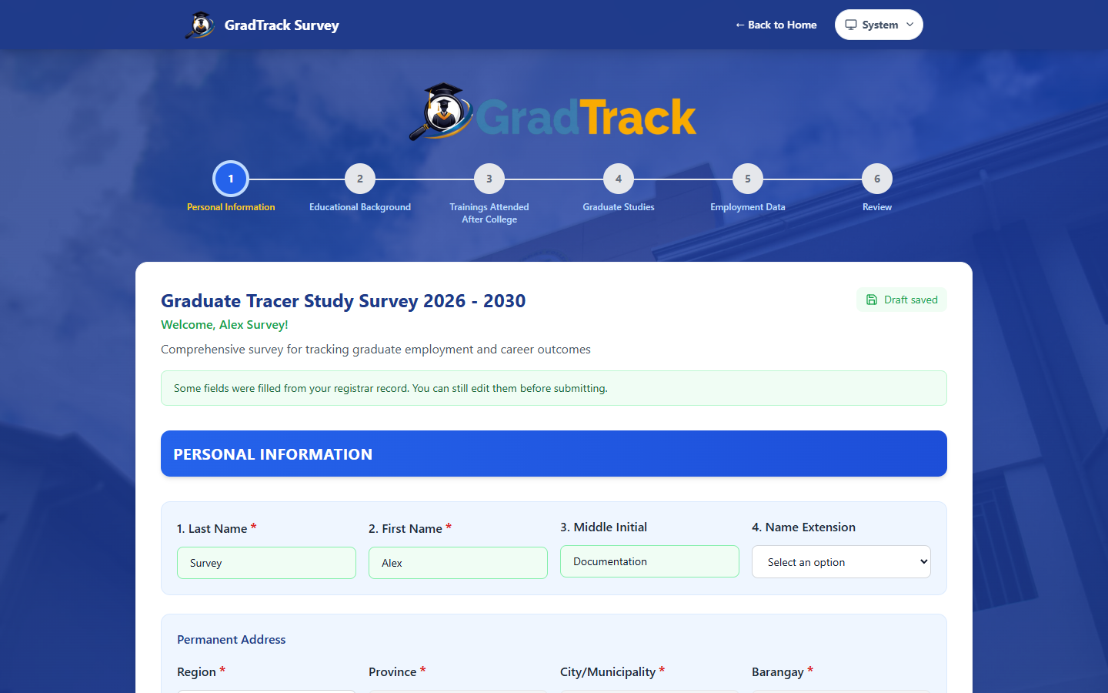
Figure 12. Graduate Tracer Survey Form
Figure description: The multi-section tracer survey shows progress, required fields, and draft status.

4.13 Review Survey Answers
Purpose: Let the graduate verify all answers before final submission.
Procedure
Step 1. On the last survey section, select Review Answers.
Step 2. Review each answer by section.
Step 3. Select Edit this section when a correction is required.
Step 4. Return to Review and select Confirm & Submit Survey only when the information is accurate.
Expected Result: The survey is ready for a single final submission.
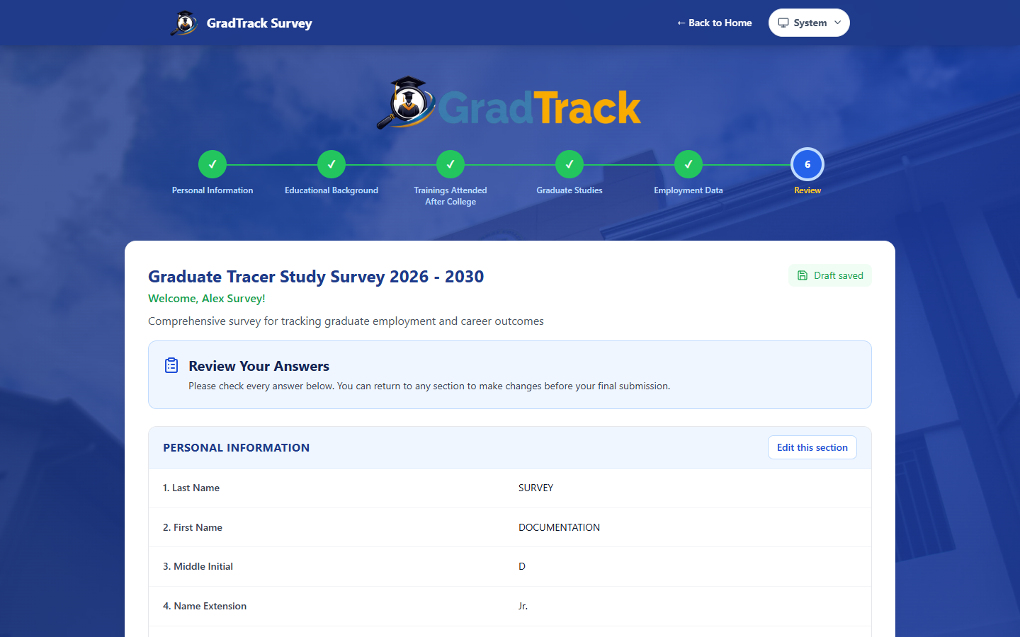
Figure 13. Survey Review Screen
Figure description: The review screen groups all answers and provides an edit link for each section.

4.14 Survey Submission Result
Purpose: Confirm successful submission and present the graduate's next available actions.
Procedure
Step 1. After reviewing the answers, select Confirm & Submit Survey.
Step 2. Wait for the Survey Completed confirmation.
Step 3. Choose Register as Alumni Member for association information, or Create My GradTrack Account for portal registration.
Expected Result: The final response is recorded and the post-survey choices are displayed.
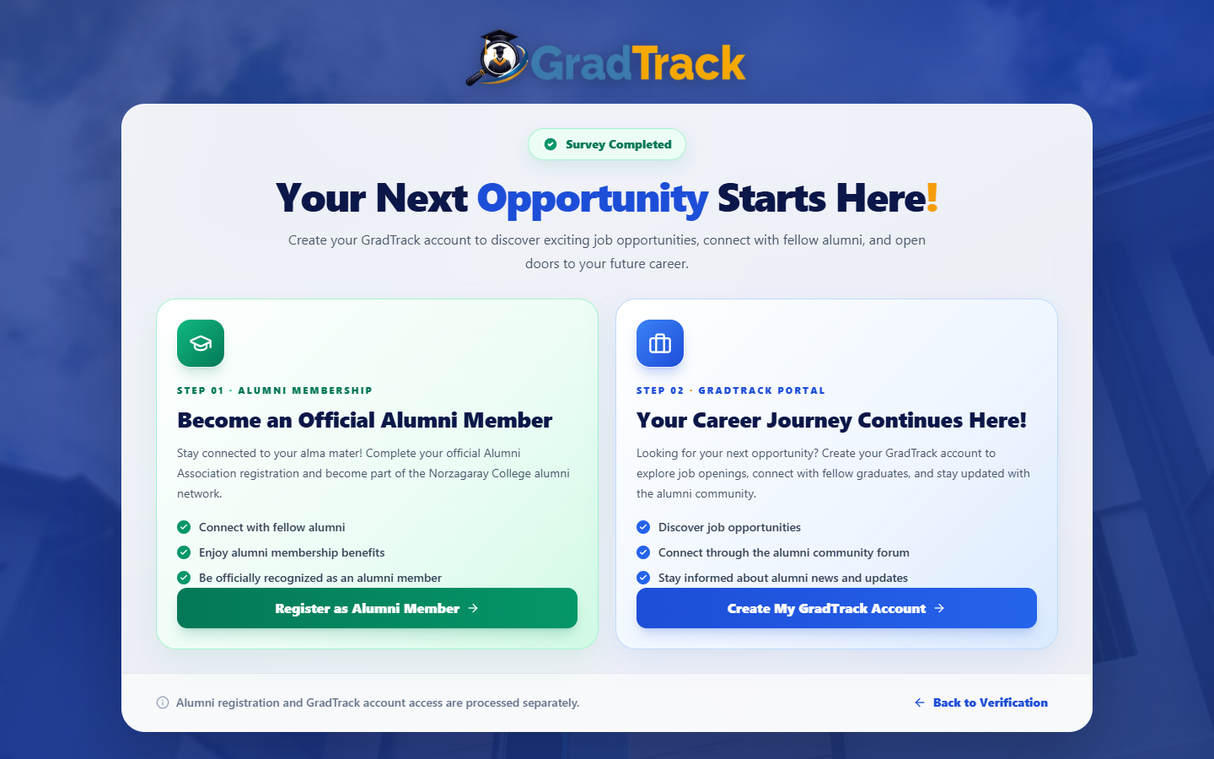
Figure 14. Survey Completion and Next Actions
Figure description: The completion screen separates Alumni Association membership from Graduate Portal account creation.

4.15 Create a Graduate Portal Account
Purpose: Create a portal account after a qualifying survey response has been submitted.
Procedure
Step 1. From the completion screen, select Create My GradTrack Account.
Step 2. Review the verified name, program, graduation year, and contact number.
Step 3. Enter a valid email address.
Step 4. Create and confirm a password containing uppercase, lowercase, number, and symbol characters.
Step 5. Select Create Account.
Expected Result: The account is submitted for Alumni President verification; access begins only after approval and activation.
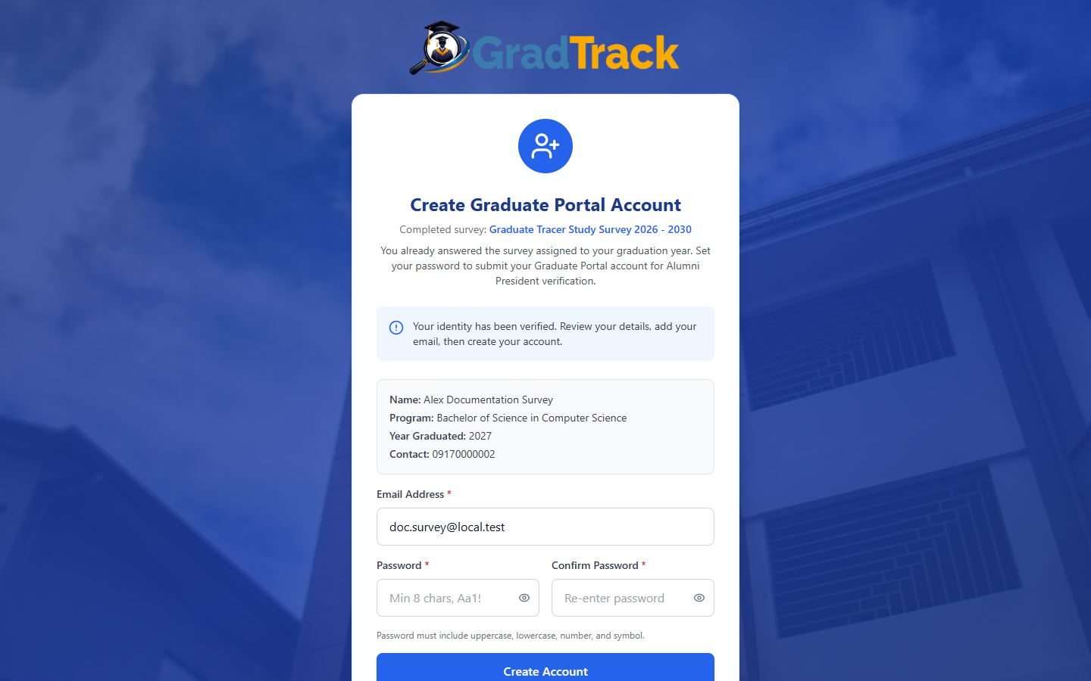
Figure 15. Graduate Portal Account Registration
Figure description: The account form uses verified survey details and explains the pending Alumni President approval step.

5 Graduate / Alumni Portal

5.1 Community Forum
Purpose: Enable approved graduates to share updates and interact with the alumni community.
Procedure
Step 1. Sign in to the Graduate Portal.
Step 2. Select the Home or Community Forum icon.
Step 3. Use search and category, program, or year filters to locate posts.
Step 4. Use Like, Comment, Report, or Message only as appropriate.
Expected Result: The forum displays posts allowed for the signed-in graduate.
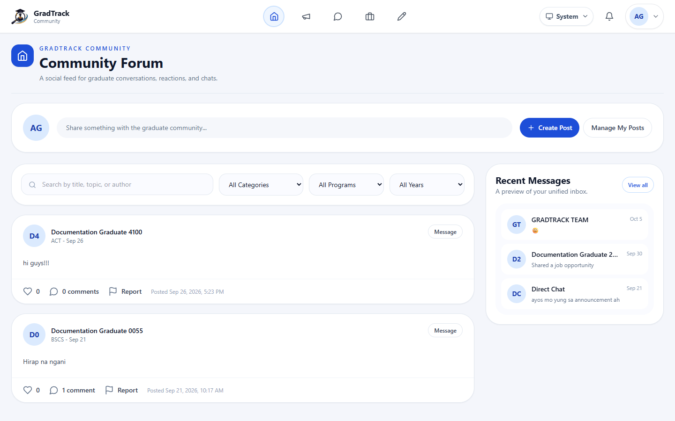
Figure 16. Graduate Community Forum
Figure description: The forum combines posts, filters, and recent-message shortcuts.

5.2 Create a Community Post
Purpose: Publish a text or media update to the graduate community.
Procedure
Step 1. On Community Forum, select Create Post.
Step 2. Enter the post text.
Step 3. Optionally select Add Media and choose a supported file.
Step 4. Select Post.
Expected Result: The post is submitted and appears according to the forum's current moderation rules.
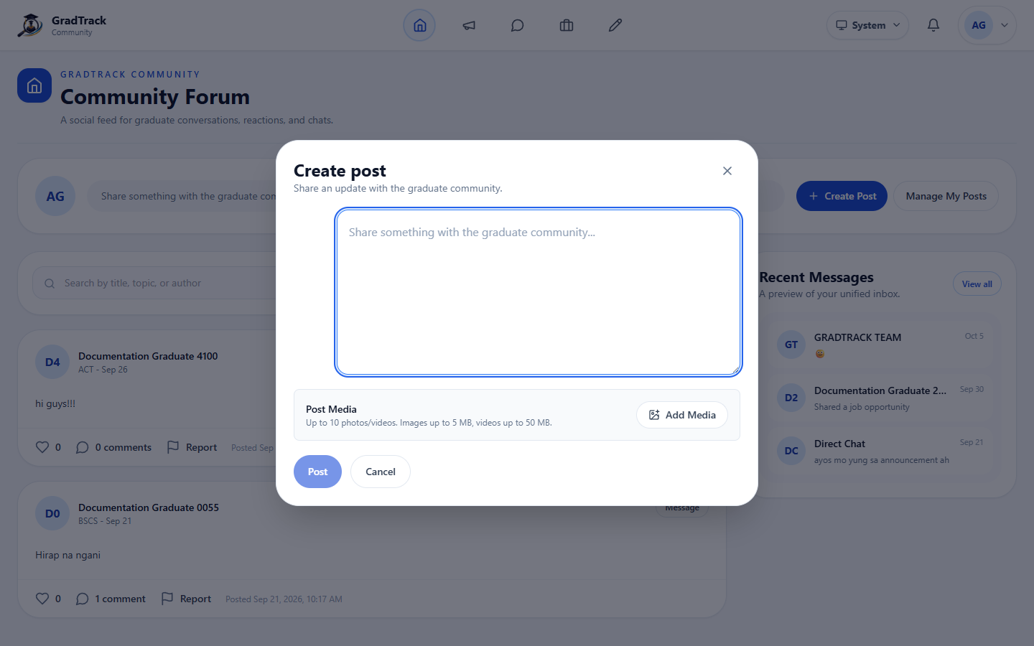
Figure 17. Community Post Composer
Figure description: The composer accepts post text and optional supported media.

5.3 Graduate Announcements
Purpose: Show published college and alumni notices inside the Graduate Portal.
Procedure
Step 1. Select the Announcements icon.
Step 2. Browse the published announcement cards.
Step 3. Select Read More to view a complete notice.
Expected Result: The graduate can read the current published notice.
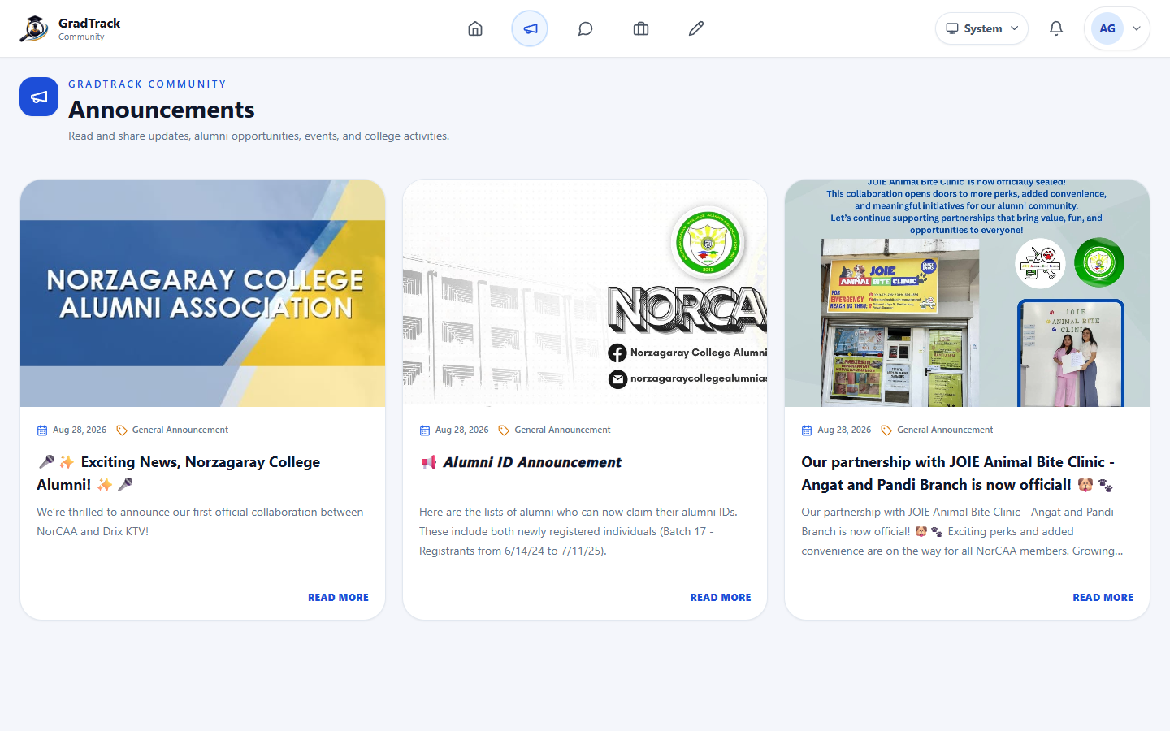
Figure 18. Graduate Announcements
Figure description: Portal announcements display current images, categories, summaries, and dates.

5.4 Direct and Group Messaging
Purpose: Support private and group communication among authorized graduates.
Procedure
Step 1. Select Messages.
Step 2. Choose an existing conversation or select New Message.
Step 3. Select a recipient or eligible group.
Step 4. Enter the message and send it.
Expected Result: The message appears in the selected conversation.
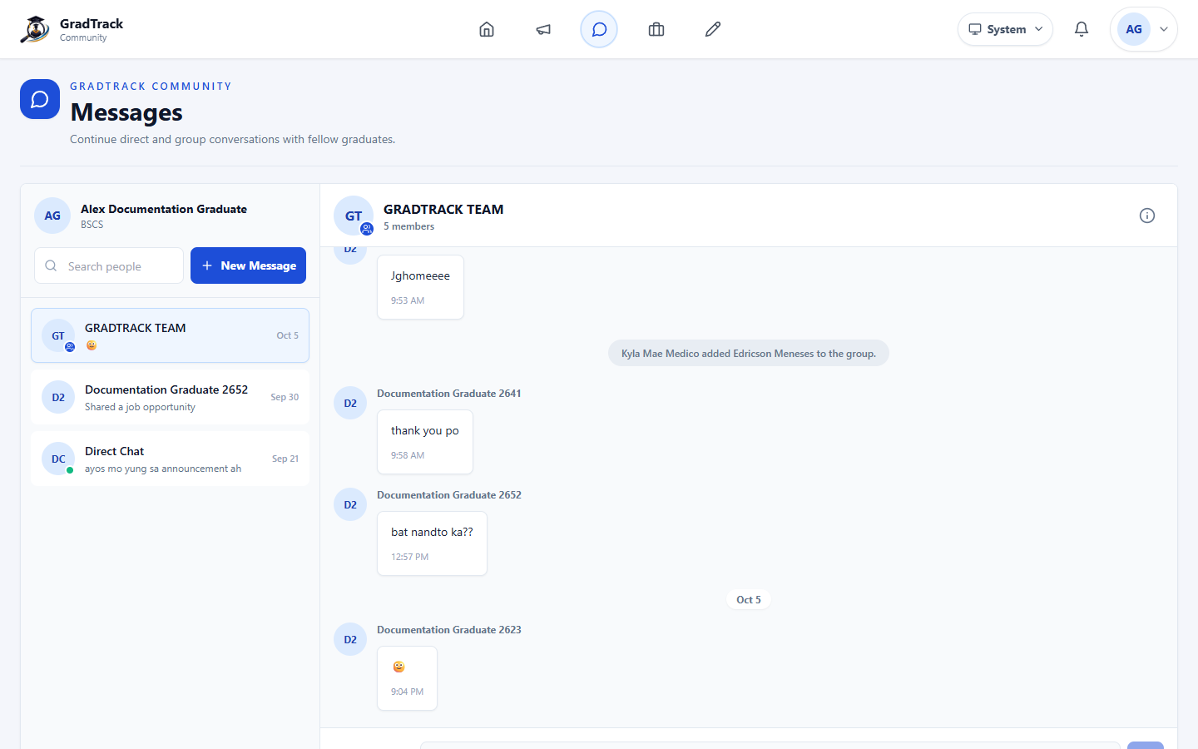
Figure 19. Direct and Group Messaging
Figure description: The messaging workspace lists conversations and the selected chat thread.

5.5 Browse Job Opportunities
Purpose: Help graduates find approved job opportunities relevant to their program and interests.
Procedure
Step 1. Select Browse Jobs.
Step 2. Use keyword, location, job-type, and program-fit filters.
Step 3. Use the sort list when needed.
Step 4. Select View Details on a job card.
Expected Result: The selected job opportunity opens with its full details.
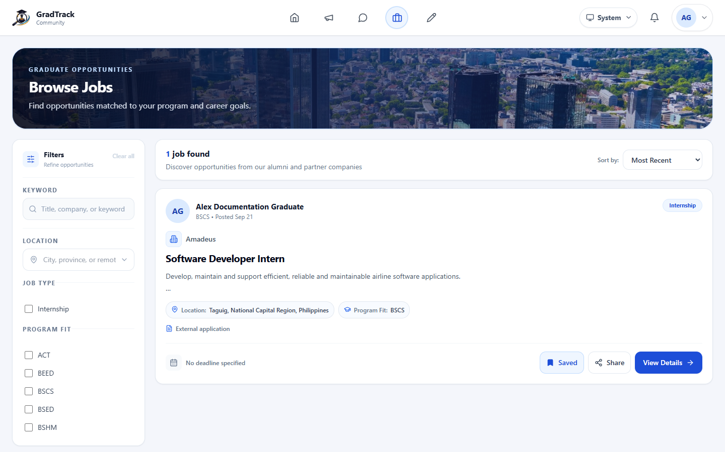
Figure 20. Browse Jobs
Figure description: The job browser presents filters, program fit, save, share, and View Details controls.

5.6 View and Apply for a Job
Purpose: Display the complete opportunity and direct the graduate to the employer's application method.
Procedure
Step 1. Open a job using View Details.
Step 2. Review the description, location, type, deadline, and program fit.
Step 3. Select Save or Share when needed.
Step 4. Follow Apply Now or the displayed employer instructions; external applications open outside GradTrack.
Expected Result: The graduate is directed to the configured application channel.
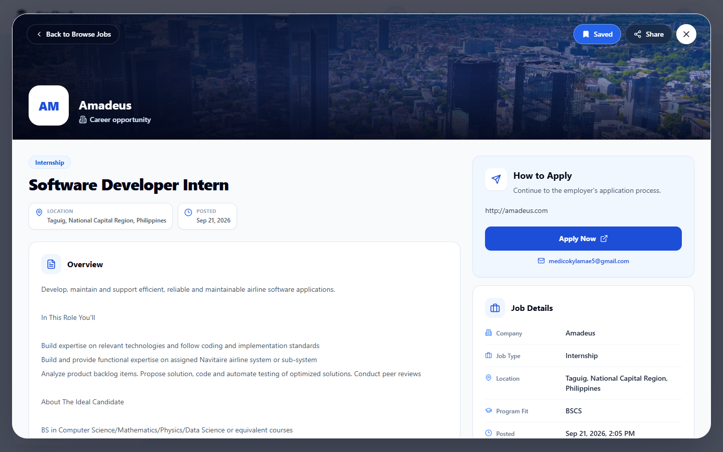
Figure 21. Job Opportunity Details
Figure description: The detail view separates the opportunity description, application guidance, and job metadata.

5.7 Saved Jobs
Purpose: Keep selected active opportunities for later review.
Procedure
Step 1. Select Saved on a job card or detail page.
Step 2. Open Saved Jobs from the job navigation.
Step 3. Select View Details to revisit an opportunity, or select Saved again to remove it.
Expected Result: The saved-jobs list reflects the graduate's current bookmarks.
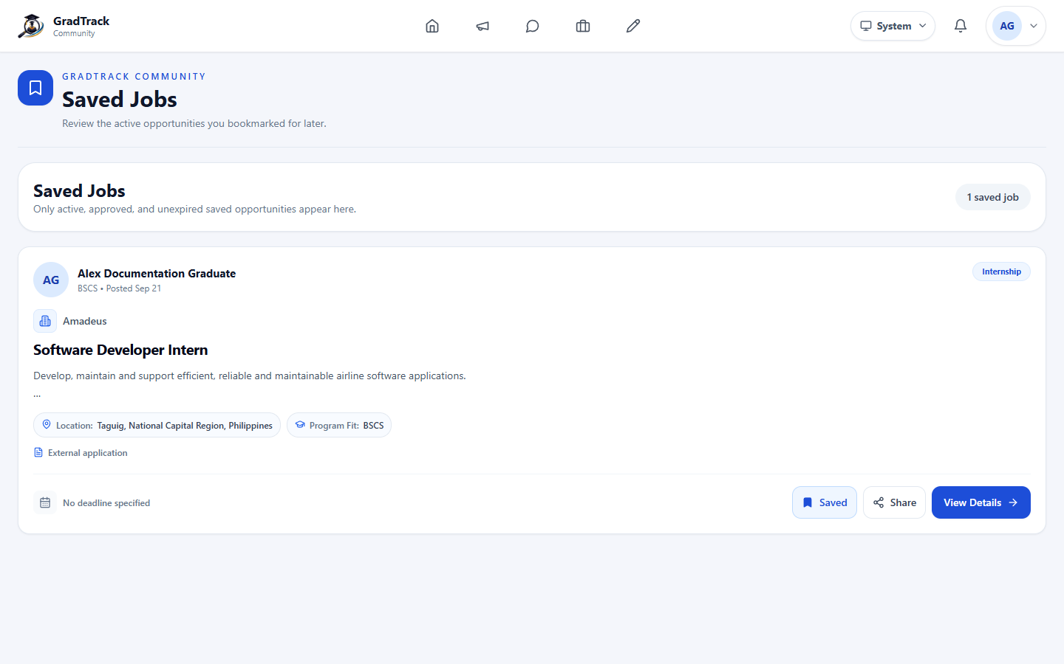
Figure 22. Saved Job Opportunities
Figure description: The Saved Jobs page lists bookmarked active opportunities.

5.8 Manage Graduate Job Posts
Purpose: Allow graduates to review job opportunities they submitted for approval.
Procedure
Step 1. Select Job Posting.
Step 2. Review each post and its status.
Step 3. Use Edit or Delete only on posts for which the buttons are available.
Step 4. Select Create Job Post to submit another opportunity.
Expected Result: The page shows the graduate's current job submissions and approval status.
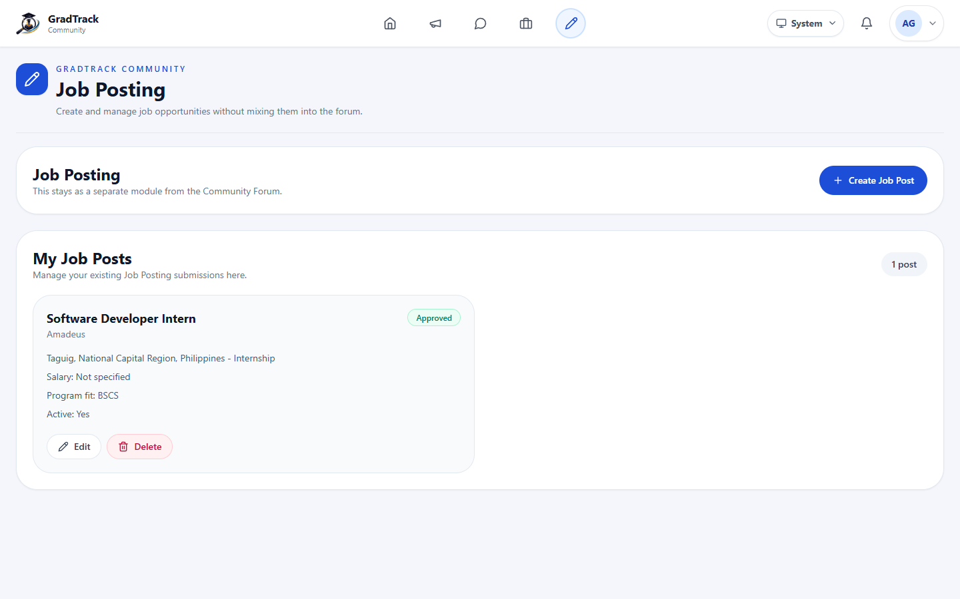
Figure 23. Graduate Job Posts
Figure description: My Job Posts separates graduate submissions from the community forum.

5.9 Create a Graduate Job Post
Purpose: Submit an employment opportunity for Alumni President review.
Procedure
Step 1. On Job Posting, select Create Job Post.
Step 2. Enter the job title, company, location, salary range, employment type, description, and required skills.
Step 3. Select the appropriate course or program fit.
Step 4. Submit the form for review.
Expected Result: The opportunity enters the job-approval workflow and is not public until approved.
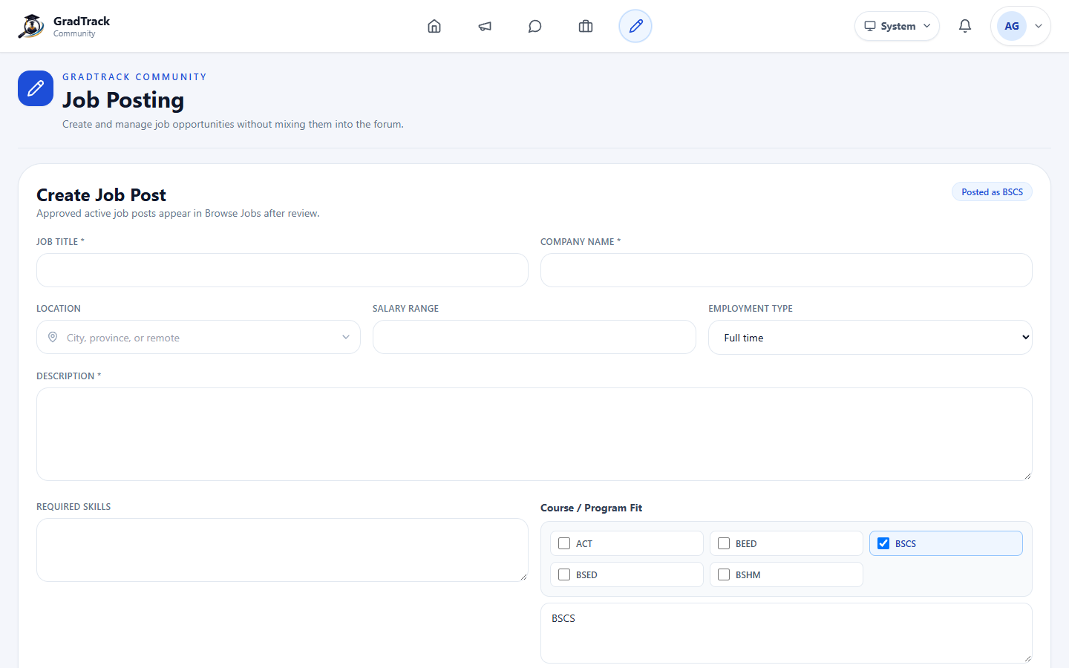
Figure 24. Create Job Post Form
Figure description: The form records employer details, job information, skills, and program fit.

5.10 Graduate Profile and Credentials
Purpose: Maintain the graduate's portal profile and professional credential records.
Procedure
Step 1. Open the profile menu and select My Profile.
Step 2. Review personal, education, employment, and credential information.
Step 3. Use the available profile controls to update portal information or add a credential.
Expected Result: The profile displays the latest portal information and credential list.
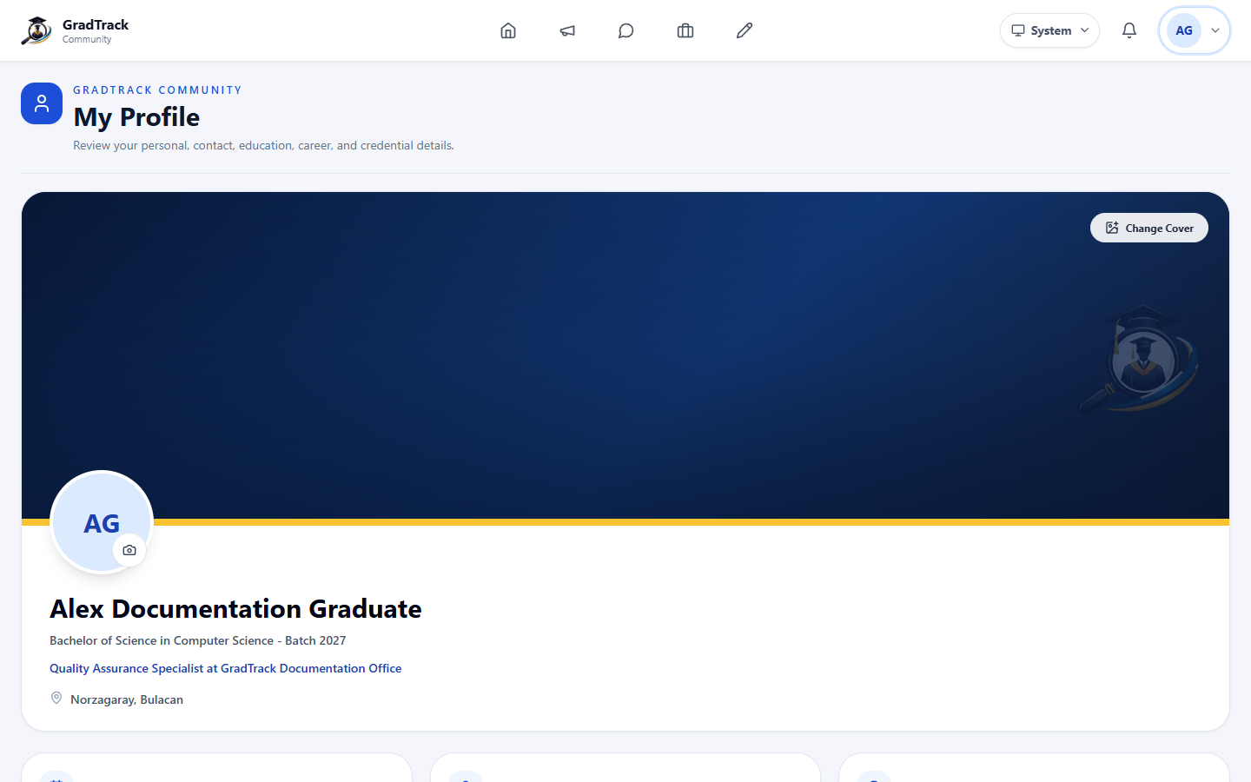
Figure 25. Graduate Profile and Credentials
Figure description: The current profile combines a cover, identity summary, career details, and professional credentials.

5.11 Add a Professional Credential
Purpose: Store a professional certificate with issuing and verification details.
Procedure
Step 1. In My Profile, select Add Credential.
Step 2. Upload a supported certificate file.
Step 3. Enter the credential name, issuing organization, dates, ID, and verification link when applicable.
Step 4. Select Save Credential.
Expected Result: The credential is added to the graduate profile.
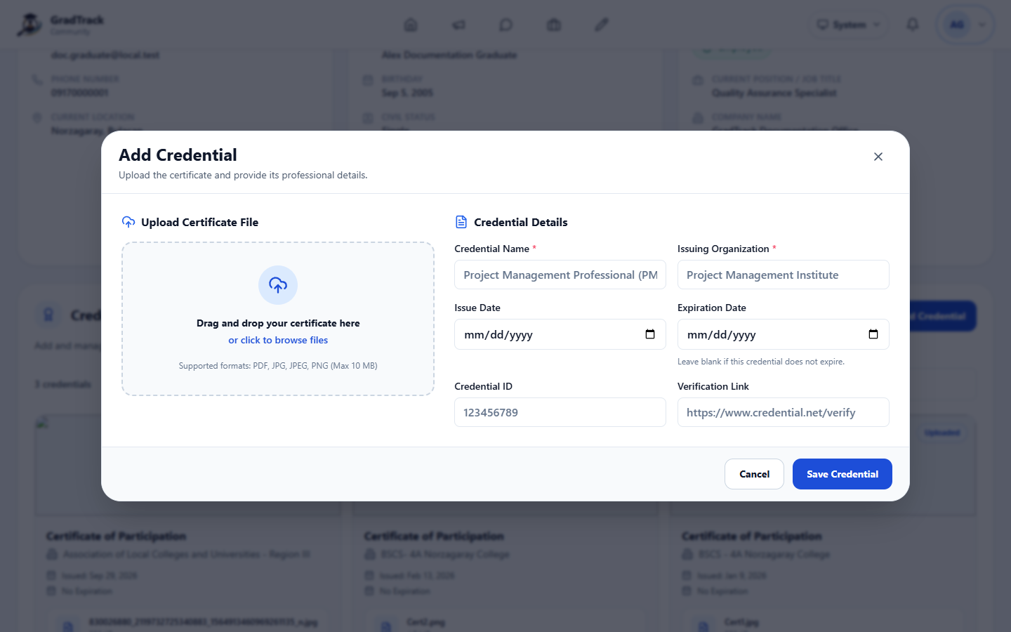
Figure 26. Add Professional Credential
Figure description: The credential dialog accepts a certificate file and structured professional details.

5.12 Graduate Profile Settings
Purpose: Update portal profile information, employment, education, photos, and password.
Procedure
Step 1. From My Profile, open Settings.
Step 2. Choose the relevant settings category.
Step 3. Update only the fields that have changed.
Step 4. Save the changes.
Expected Result: The Graduate Portal profile is updated; the submitted tracer-survey response remains unchanged.
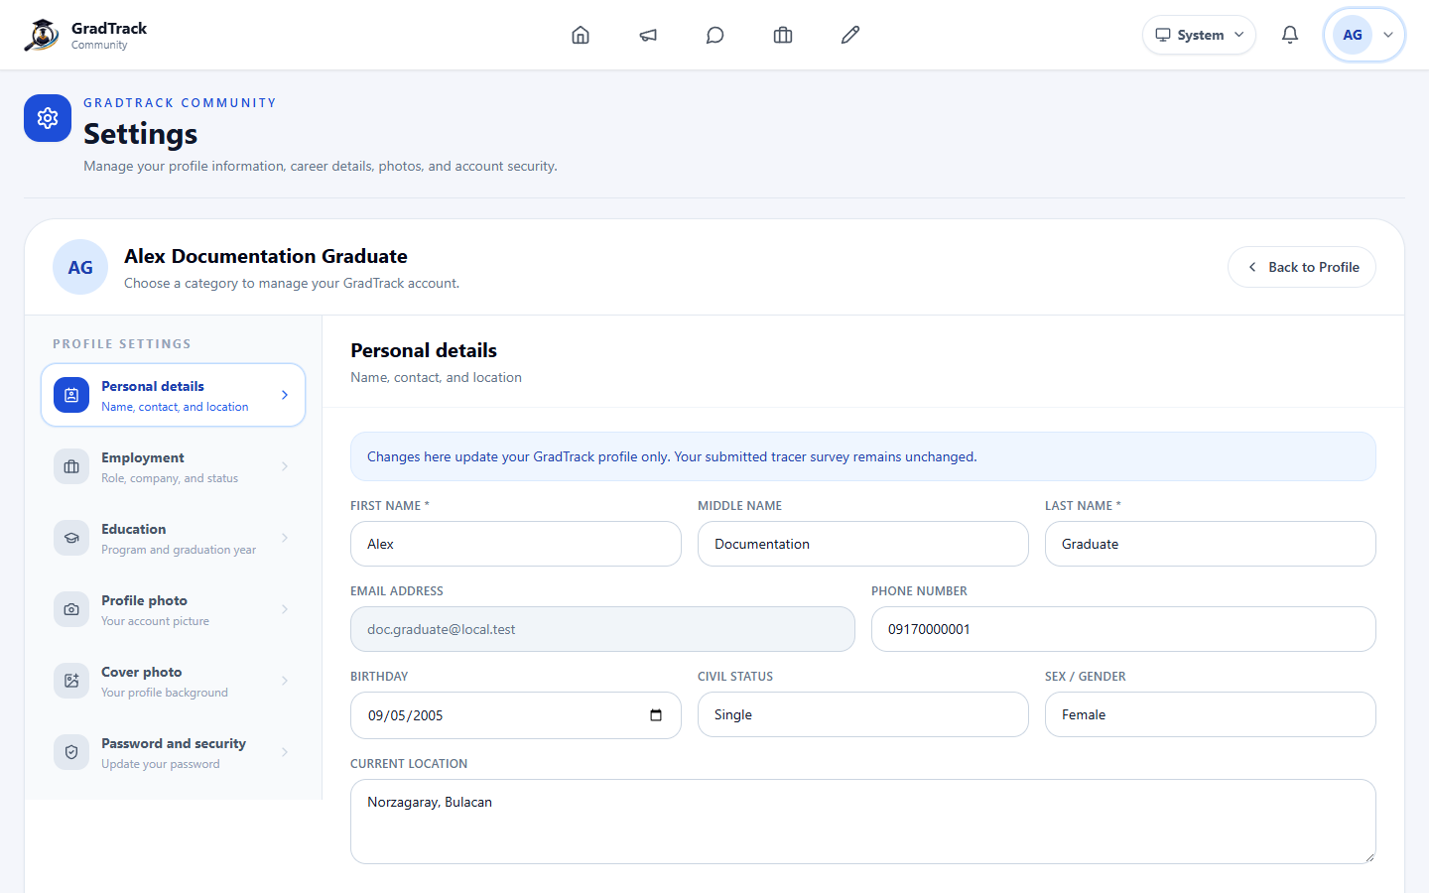
Figure 27. Graduate Profile Settings
Figure description: Settings explicitly separate portal profile edits from the submitted survey record.

5.13 Graduate Notifications
Purpose: Show job, announcement, message, and account activity alerts.
Procedure
Step 1. Select the notification bell.
Step 2. Review unread and recent notifications.
Step 3. Select a notification to open its related module when available.
Step 4. Use Mark read or Mark all read as needed.
Expected Result: Notification status is updated and the related content opens when selected.
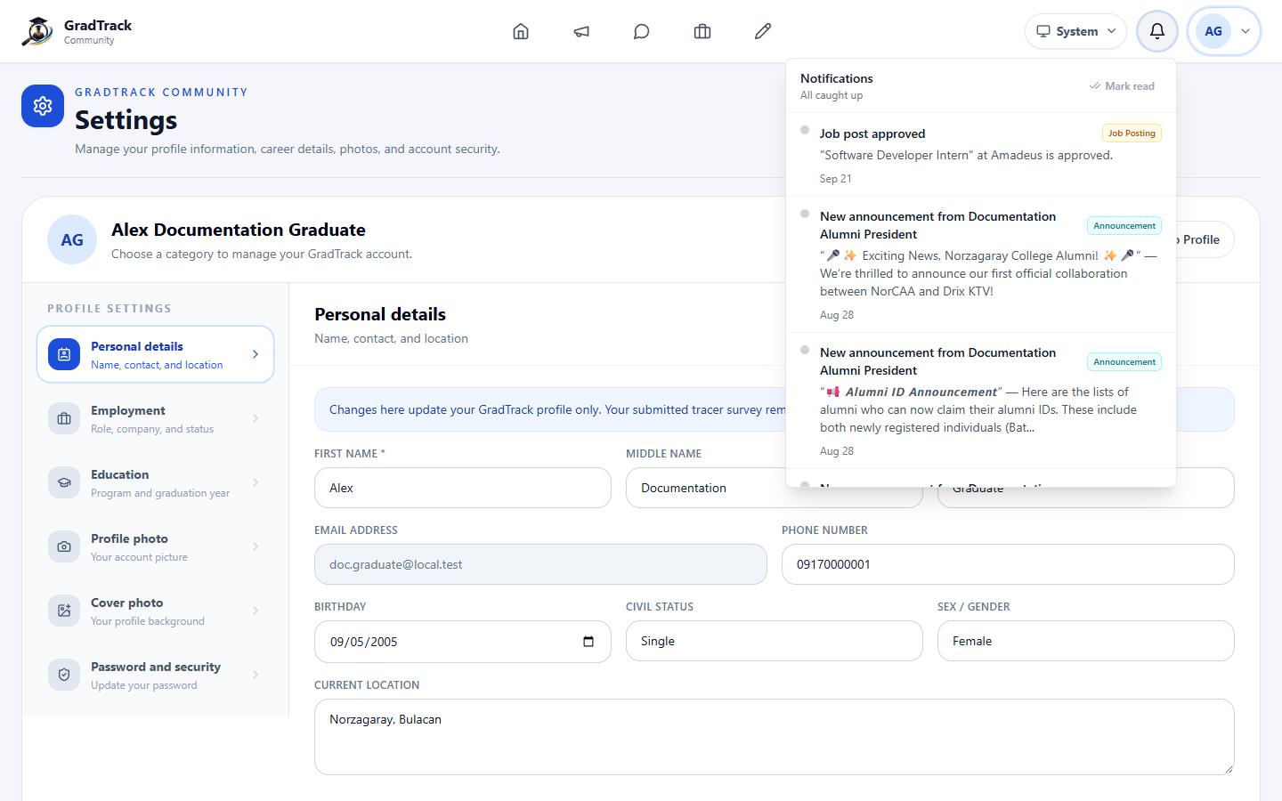
Figure 28. Graduate Notifications Panel
Figure description: The notification panel groups current portal alerts and their module labels.

6 Research Coordinator User Manual

6.1 Research Coordinator Dashboard
Purpose: Present institution-wide employment, alignment, survey-coverage, and trend indicators.
Procedure
Step 1. Sign in as Research Coordinator.
Step 2. Open Dashboard.
Step 3. Choose a survey from the Survey list.
Step 4. Review the summary cards and charts; use the program breakdown controls where provided.
Expected Result: The dashboard displays analytics for the selected survey and permitted scope.
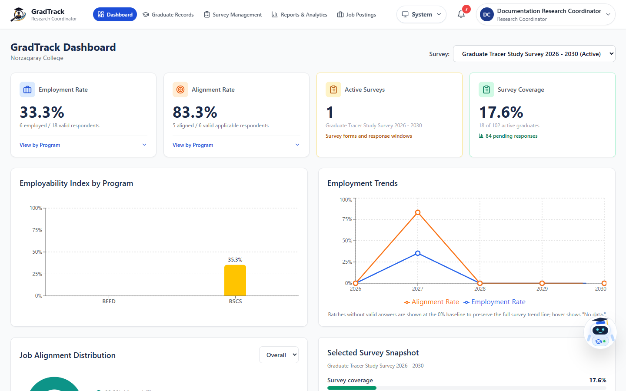
Figure 29. Research Coordinator Dashboard
Figure description: The dashboard shows employment rate, alignment, active survey, coverage, and program trends.

6.2 Graduate Records and Participation
Purpose: Monitor survey participation and prepare reminders for graduates who have not answered.
Procedure
Step 1. Open Graduate Records.
Step 2. Choose the survey and use status, program, year, and search filters.
Step 3. Select eligible non-respondents when a reminder is required.
Step 4. Review the message and select Notify Selected only after confirming the recipients.
Expected Result: The filtered participation list is displayed; approved reminder actions are logged.
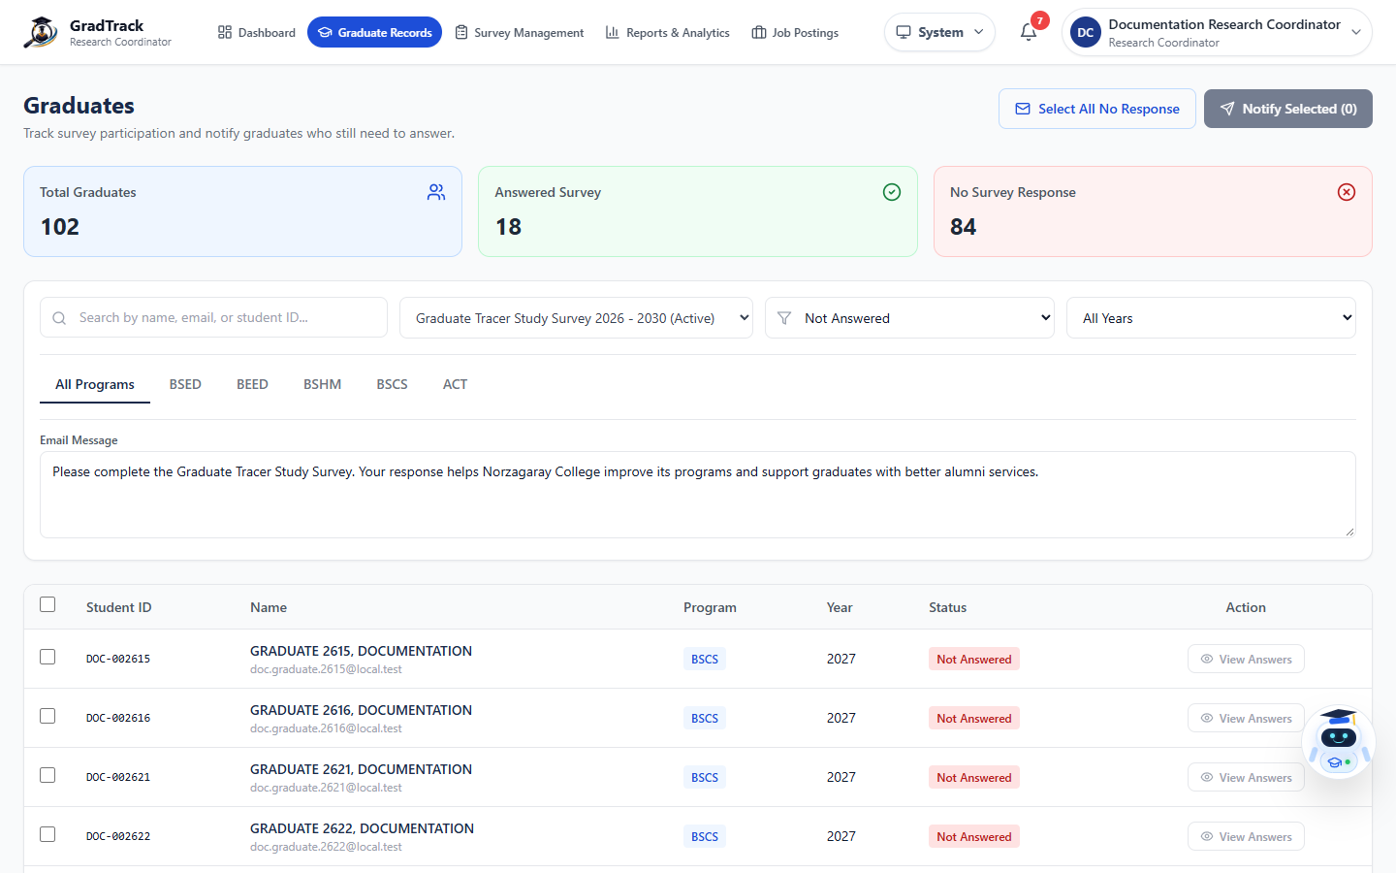
Figure 30. Graduate Survey Participation
Figure description: The page shows answered and unanswered totals, filters, selection controls, and reminder text.

6.3 Survey Management
Purpose: Create, review, activate, complete, and archive tracer surveys according to authorized workflow.
Procedure
Step 1. Open Survey Management.
Step 2. Review active and saved survey cards and response counts.
Step 3. Use the card icons to view details, analytics, edit, or archive when the action is available.
Step 4. Do not create another survey while the interface indicates that an active survey must first be completed or archived.
Expected Result: The survey list reflects the current lifecycle status and authorized actions.
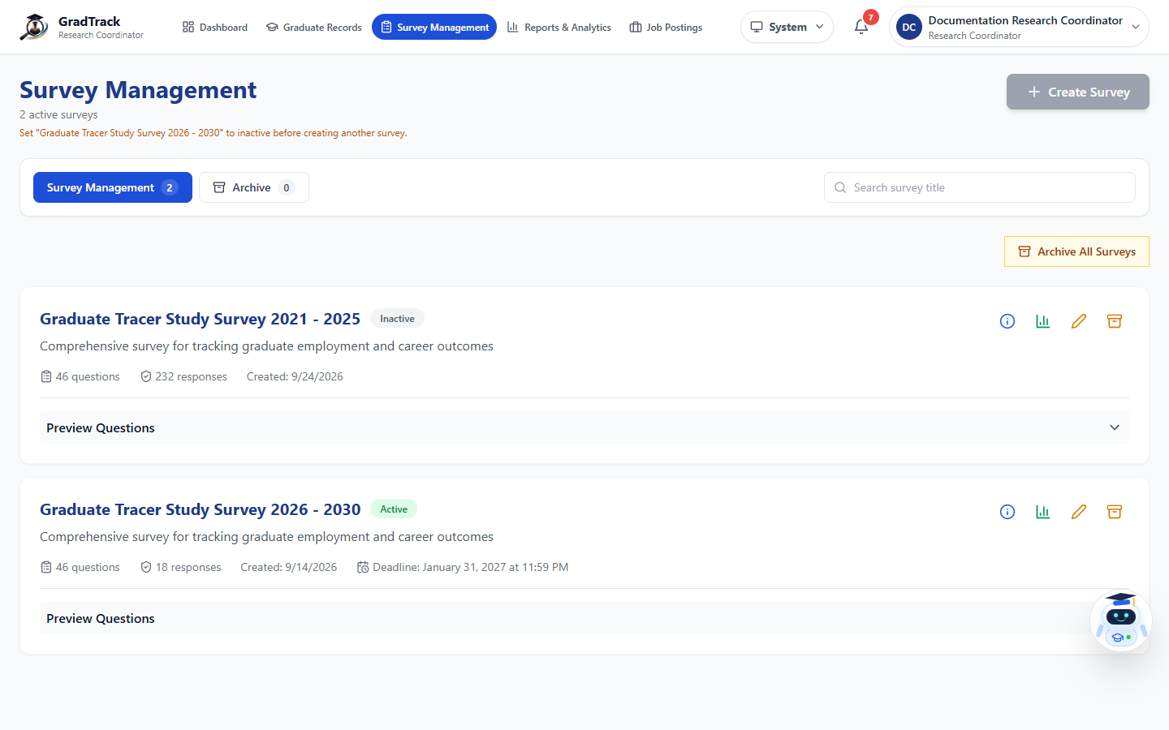
Figure 31. Survey Management
Figure description: Survey cards show status, questions, responses, dates, preview, and current actions.

6.4 Edit Survey Information
Purpose: Update the permitted survey information and respondent targets before use.
Procedure
Step 1. On Survey Management, select the Edit icon for an editable survey.
Step 2. Review the title, description, status, dates, and respondent targets.
Step 3. Make only authorized changes.
Step 4. Save the survey.
Expected Result: The survey information is updated and retained in Survey Management.
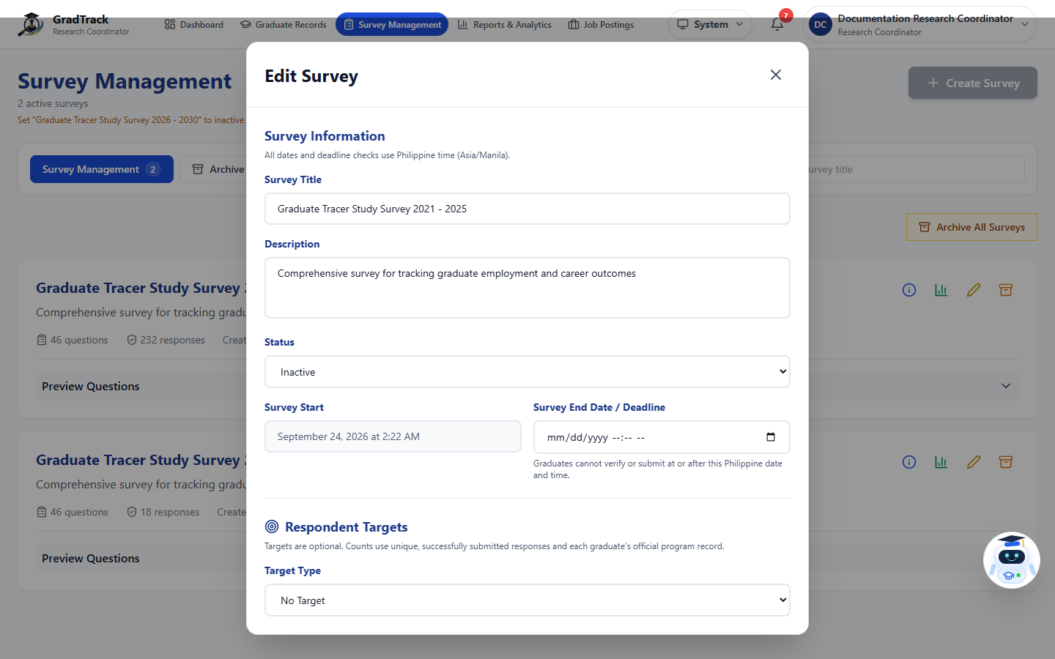
Figure 32. Edit Survey
Figure description: The current edit dialog includes survey information, status, schedule, and respondent targets.

6.5 Response Monitoring
Purpose: Review summarized, question-level, and individual survey responses.
Procedure
Step 1. Open Survey Management and select the response or details control for a survey.
Step 2. Use program, batch, employment-status, and date filters.
Step 3. Review Summary, Questions, or Individual tabs.
Step 4. Use the search controls to locate a specific response when authorized.
Expected Result: The selected response view displays the filtered survey data.
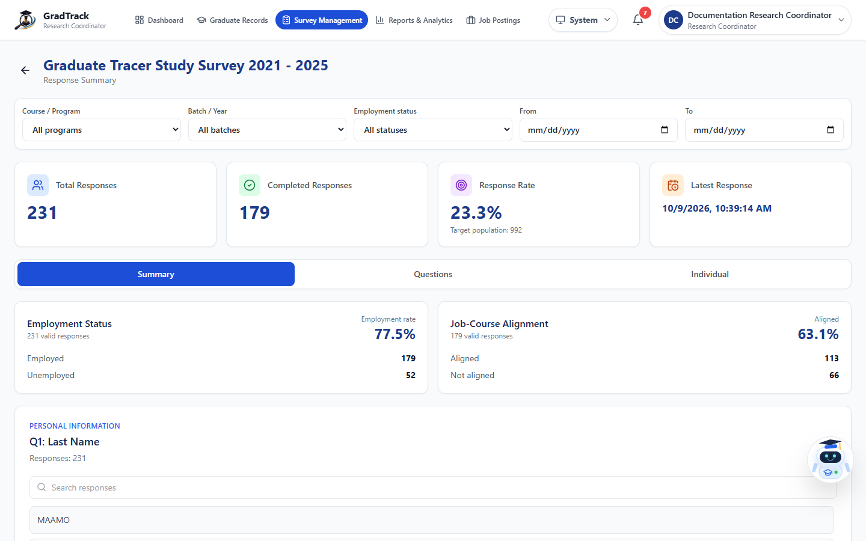
Figure 33. Survey Response Monitoring
Figure description: The response page presents totals, response rate, filters, and multiple analysis tabs.

6.6 Reports Overview
Purpose: Review and export aggregate graduate-tracer indicators.
Procedure
Step 1. Open Reports & Analytics.
Step 2. Choose the survey and set report filters.
Step 3. Select Apply Filters.
Step 4. Review the overview cards and charts; use Export PDF, Export Word, or Export Excel when an official output is required.
Expected Result: The report updates to the selected filters or downloads in the chosen format.
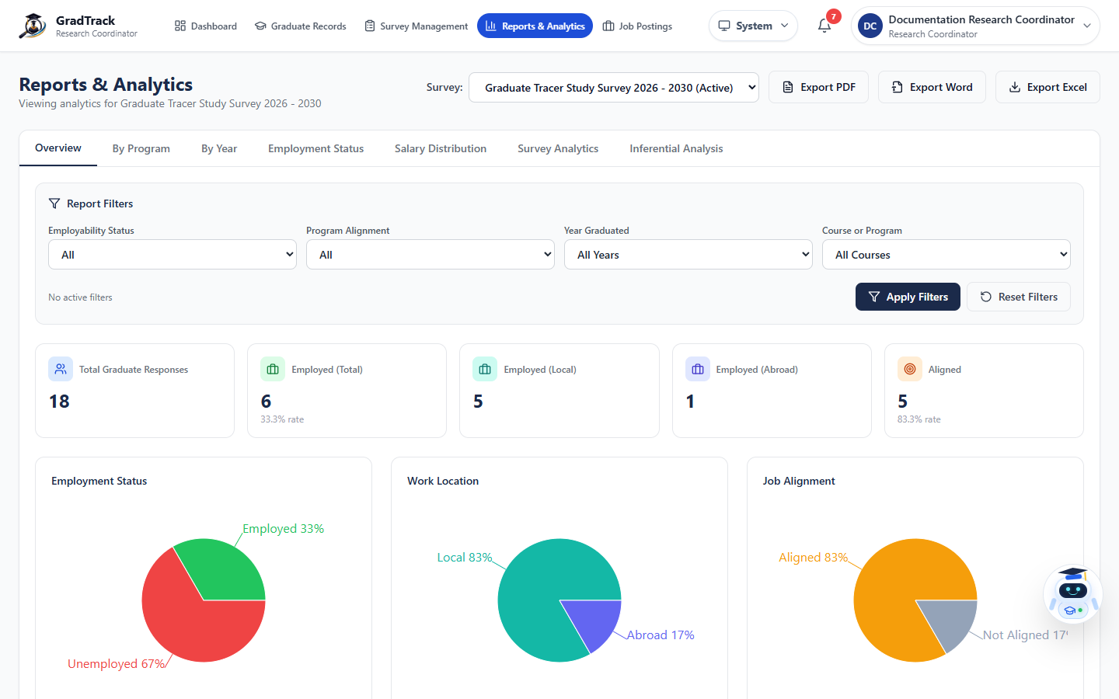
Figure 34. Reports and Analytics Overview
Figure description: The overview combines report filters, totals, and employment, location, and alignment charts.

6.7 Descriptive Survey Analytics
Purpose: View detailed tabular and graphical distributions of tracer-survey answers.
Procedure
Step 1. In Reports & Analytics, select Survey Analytics.
Step 2. Choose the survey.
Step 3. Choose the required table from the Table list.
Step 4. Select Show Graph when a chart is needed, or use the export controls.
Expected Result: The selected descriptive table and available visualization are displayed.
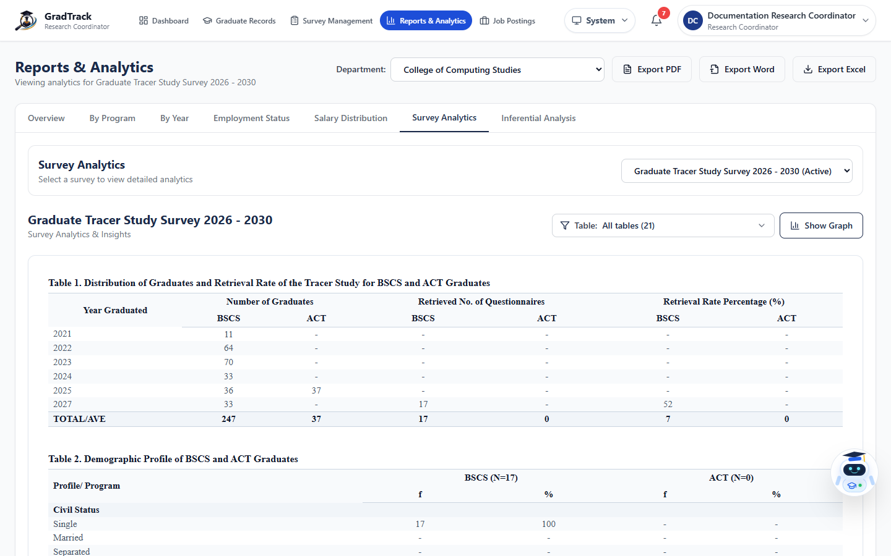
Figure 35. Descriptive Survey Analytics
Figure description: Survey Analytics provides thesis-ready demographic and response tables.

6.8 Inferential Analysis
Purpose: Test the statistical association between two supported tracer variables.
Procedure
Step 1. In Reports & Analytics, select Inferential Analysis.
Step 2. Choose Variable 1 and Variable 2.
Step 3. Set year and program filters when available.
Step 4. Select Run Analysis and review the chi-square output and interpretation.
Expected Result: GradTrack displays the computed association results for the chosen variables and filters.
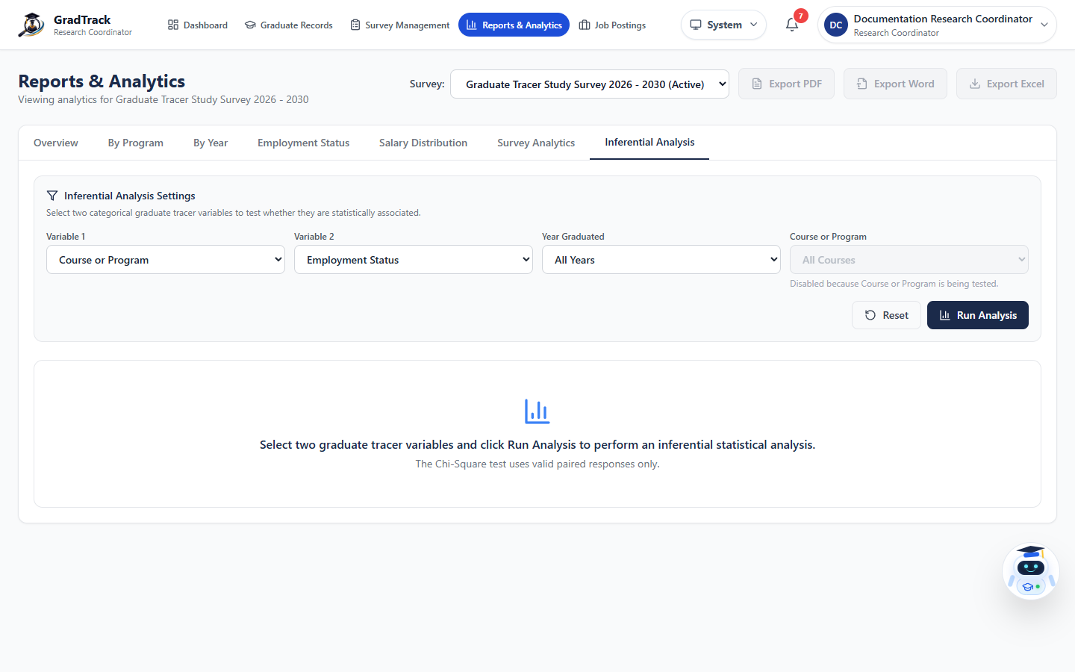
Figure 36. Inferential Analysis
Figure description: The inferential panel configures variables and filters before running a chi-square analysis.

6.9 Research Coordinator Job Postings
Purpose: Create and manage staff-originated opportunities for the Graduate Portal.
Procedure
Step 1. Open Job Postings.
Step 2. Use search to locate an existing managed post.
Step 3. Select Create Job to add an opportunity, or use Edit, Archive, or Delete only when appropriate.
Step 4. Confirm publication status before expecting the post to appear to graduates.
Expected Result: The managed job list reflects the completed action.
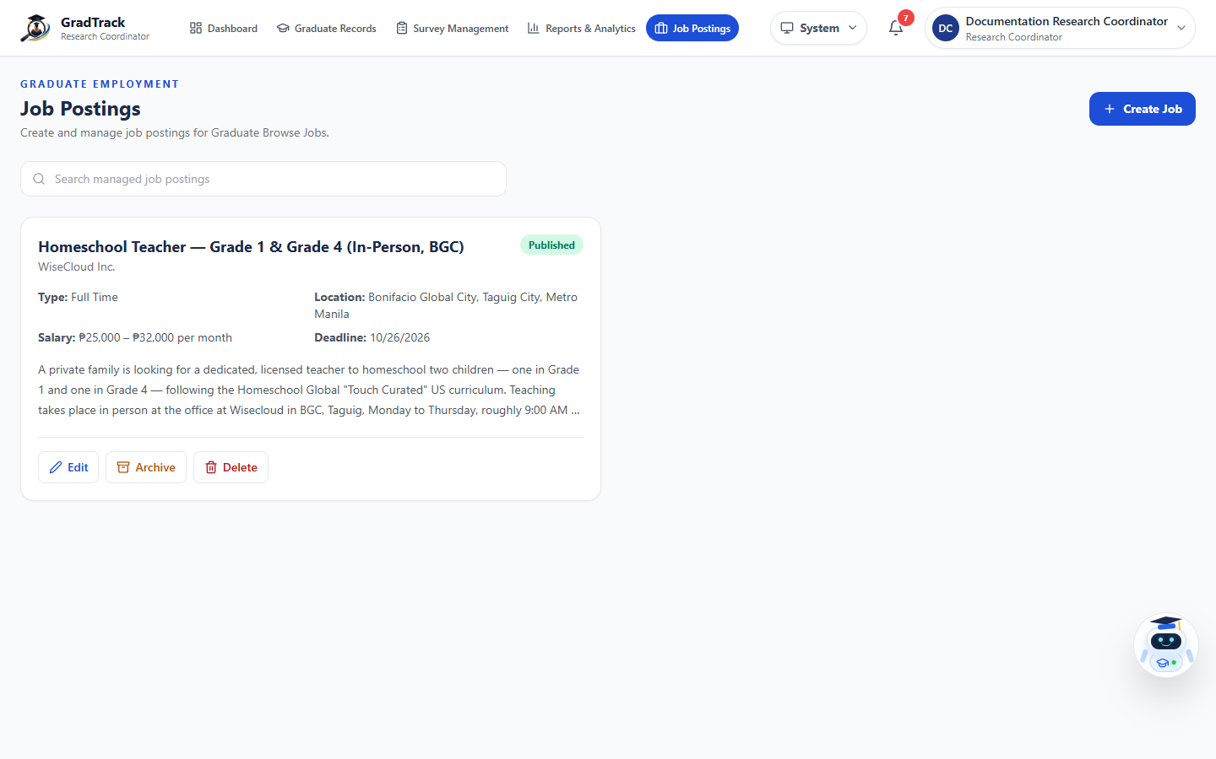
Figure 37. Research Coordinator Job Postings
Figure description: The job manager displays current staff posts and their publication status.

6.10 Research Coordinator AI Assistant
Purpose: Provide role-scoped assistance using GradTrack data and permitted modules.
Procedure
Step 1. Select Ask GradTrack AI Assistant.
Step 2. Open a previous conversation or select New conversation.
Step 3. Enter a clear question related to authorized GradTrack data.
Step 4. Verify important results against the corresponding module or report before use.
Expected Result: The assistant returns a role-scoped response and retains the conversation when supported.
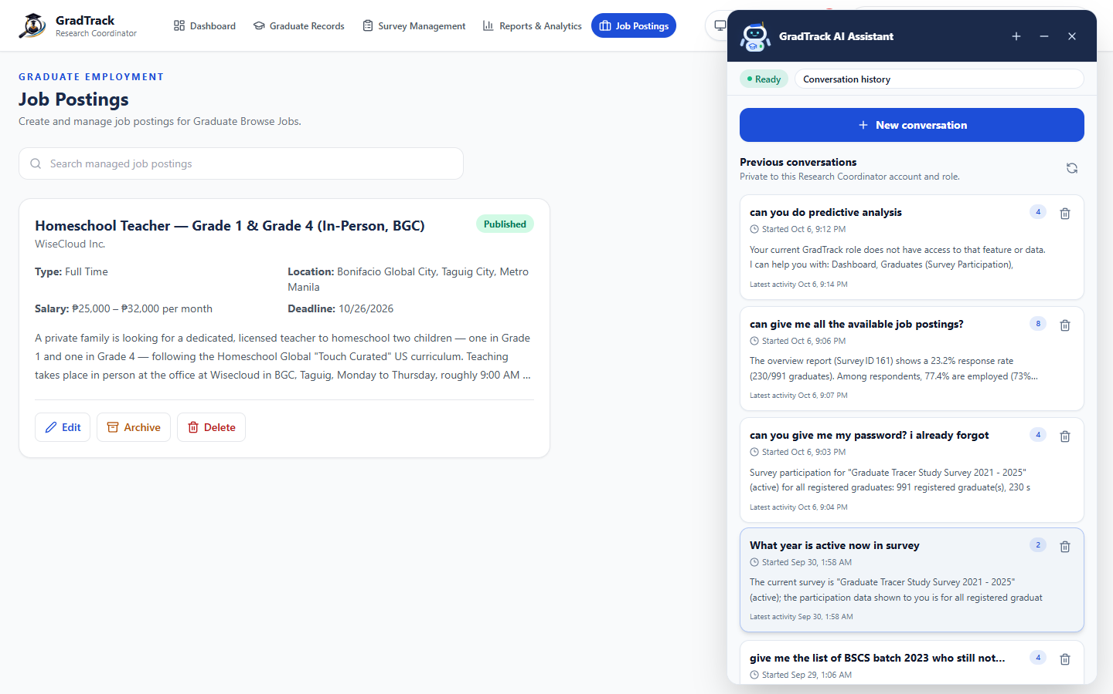
Figure 38. Research Coordinator AI Assistant
Figure description: The assistant panel shows conversation history and responses limited to the signed-in role.

7 Dean User Manual

7.1 Department-Scoped Dean Dashboard
Purpose: Show graduate outcomes only for the dean's assigned department and programs.
Procedure
Step 1. Sign in as Dean.
Step 2. Open Dashboard.
Step 3. Choose the relevant survey.
Step 4. Review department employment, alignment, coverage, and trend indicators.
Expected Result: The dashboard displays only the dean's authorized academic scope.
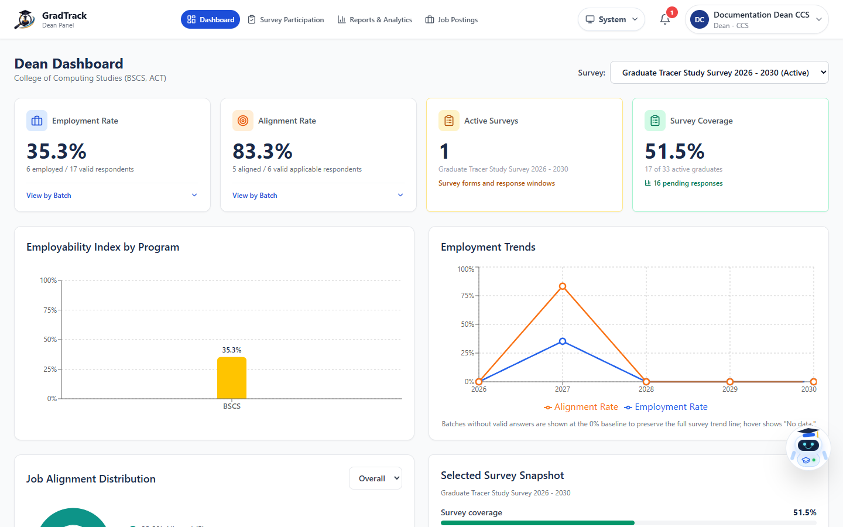
Figure 39. Dean Department Dashboard
Figure description: The Dean Dashboard identifies the assigned college and restricts metrics to its programs.

7.2 Dean Survey Participation
Purpose: Monitor survey completion for graduates in the dean's assigned programs.
Procedure
Step 1. Open Survey Participation.
Step 2. Choose the survey and apply search, status, and year filters.
Step 3. Review answered and unanswered totals.
Step 4. Use reminder controls only for eligible selected graduates.
Expected Result: The scoped participation list and totals are displayed.
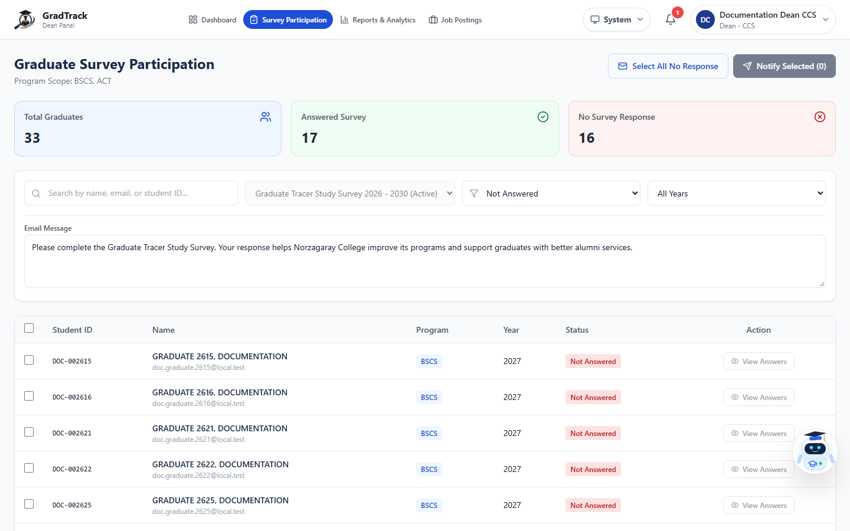
Figure 40. Dean Survey Participation
Figure description: The participation page identifies the dean's program scope and response status.

7.3 Dean Reports and Analytics
Purpose: Analyze department-specific graduate outcomes and export authorized reports.
Procedure
Step 1. Open Reports & Analytics.
Step 2. Choose a survey and batch or year.
Step 3. Apply the available employment and program-alignment filters.
Step 4. Review the charts or select an export format.
Expected Result: The report displays or exports data within the dean's department scope.
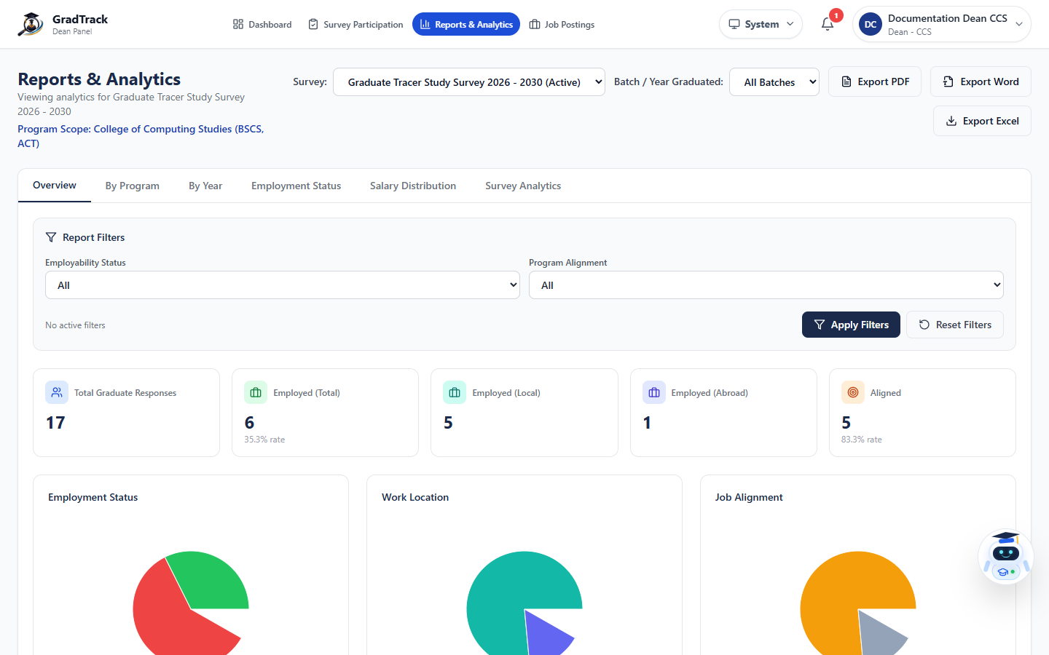
Figure 41. Dean Reports and Analytics
Figure description: The Dean report displays the restricted program scope above the analytic tabs.

7.4 Dean Job Postings
Purpose: Create and manage job opportunities for Graduate Portal publication.
Procedure
Step 1. Open Job Postings.
Step 2. Select Create Job to add an opportunity.
Step 3. Complete the current job form and publish or save it as allowed.
Step 4. Use search and available management actions for existing posts.
Expected Result: The opportunity appears in the dean's managed job list with its current status.
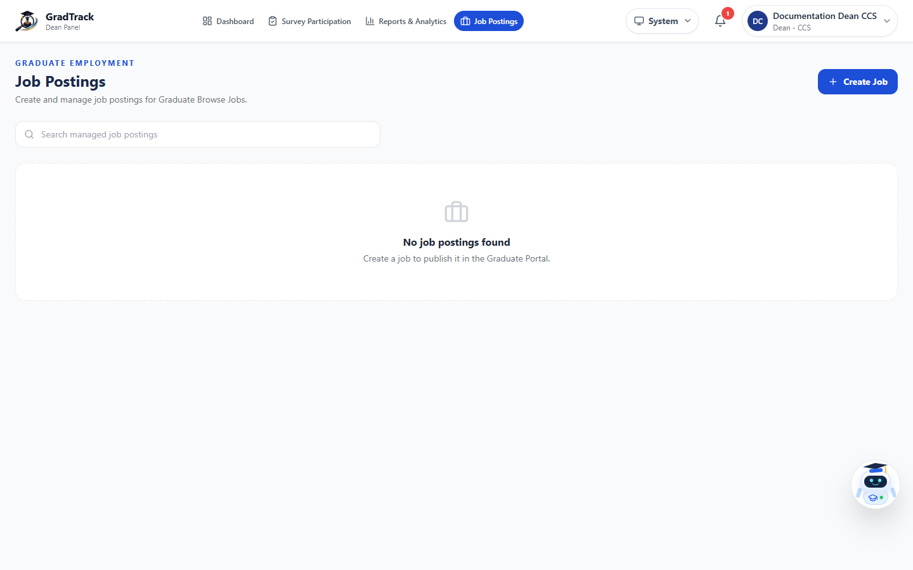
Figure 42. Dean Job Postings
Figure description: The Dean job page provides a scoped managed-post list and Create Job action.

7.5 Dean Profile
Purpose: Maintain the dean's personnel name, profile image, and password.
Procedure
Step 1. Open the account menu and select My Profile.
Step 2. Select Edit Profile when a profile change is required.
Step 3. Update permitted account details or password fields.
Step 4. Select Save Changes.
Expected Result: The personnel profile is updated.
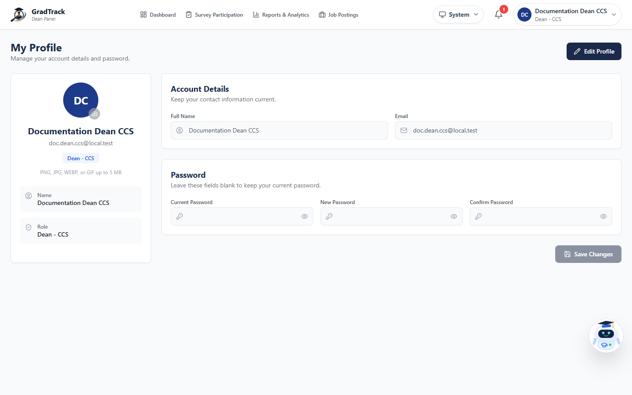
Figure 43. Dean Personnel Profile
Figure description: The profile page separates account details from password changes.

7.6 Dean AI Assistant
Purpose: Answer questions using only data and functions available to the signed-in dean.
Procedure
Step 1. Select Ask GradTrack AI Assistant.
Step 2. Start or reopen a conversation.
Step 3. Ask a question about the assigned department, survey participation, reports, or permitted job data.
Step 4. Confirm critical results using the corresponding GradTrack page.
Expected Result: The assistant responds within the dean's role and department scope.
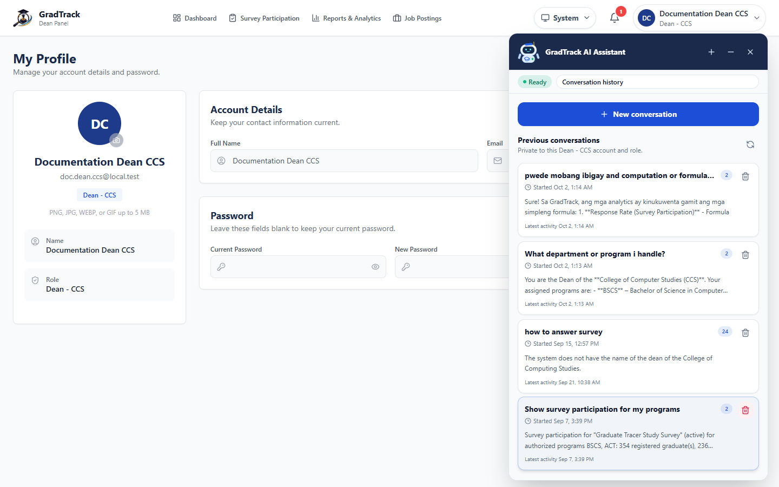
Figure 44. Dean AI Assistant
Figure description: The Dean assistant panel shows role-scoped conversation history.

8 Registrar User Manual

8.1 Manage Graduate Records
Purpose: View, select, add, import, filter, and archive registrar graduate records.
Procedure
Step 1. Sign in as Registrar.
Step 2. Review the Manage Graduates table.
Step 3. Use the checkboxes only when a bulk archive operation is required.
Step 4. Use Add Graduate or Import Excel for authorized new records.
Expected Result: The current graduate list is displayed without row-level Edit or View Details actions.
Important: Current-version rule: Registrar users cannot edit existing graduate information from this page. The former row-level Edit and View Details actions were removed.
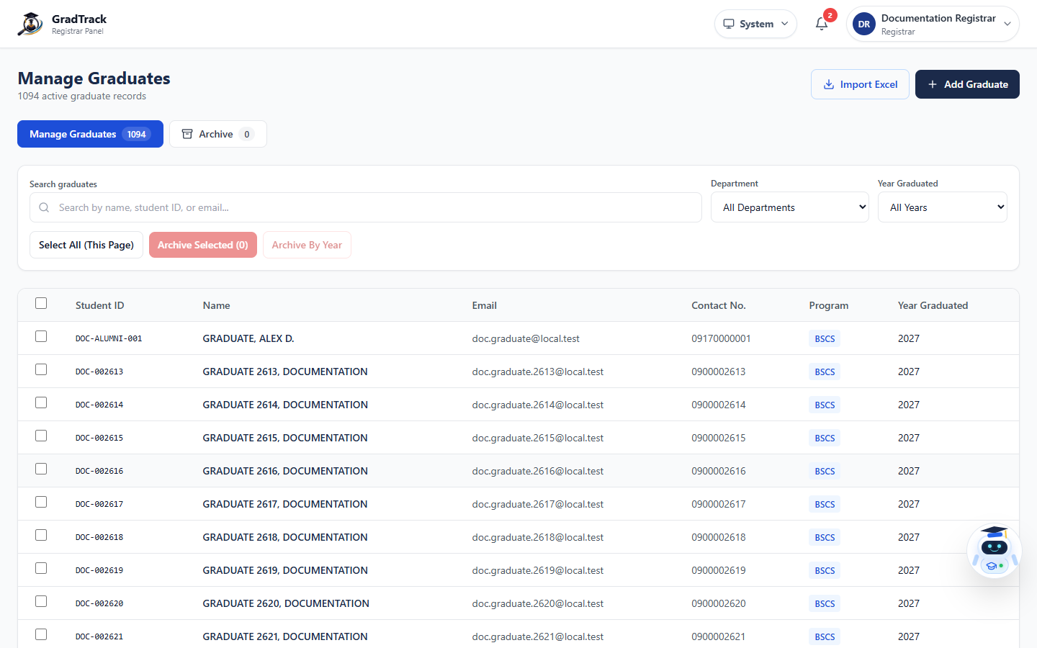
Figure 45. Registrar Manage Graduates
Figure description: The current table ends at Year Graduated and intentionally has no Actions column.

8.2 Search and Filter Graduate Records
Purpose: Locate graduate records by identifier, name, email, department, and graduation year.
Procedure
Step 1. Open Manage Graduates.
Step 2. Enter a name, student ID, or email in Search graduates.
Step 3. Choose a Department.
Step 4. Choose a Year Graduated when required.
Expected Result: The table updates to matching records; it remains a read-only row display.
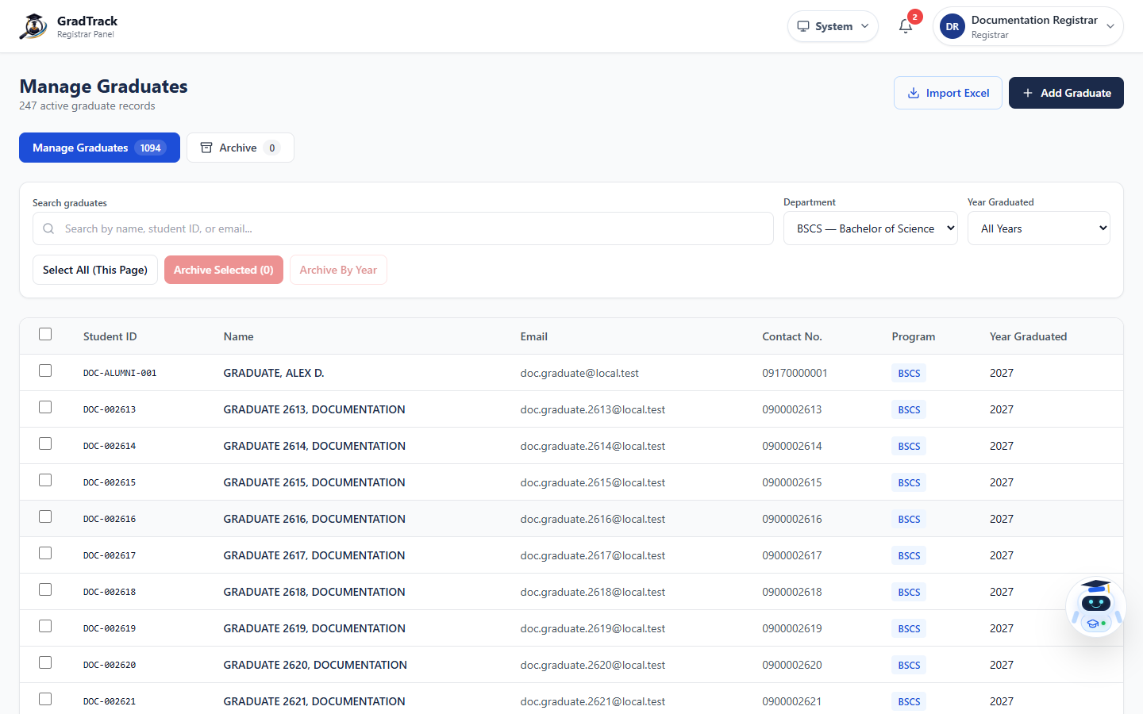
Figure 46. Registrar Search and Filters
Figure description: Department and graduation-year filters narrow the read-only graduate table.

8.3 Add a Graduate Record
Purpose: Create a new official graduate record for later identity verification and survey assignment.
Procedure
Step 1. Select Add Graduate.
Step 2. Enter the student number, first name, optional middle name, last name, and name extension.
Step 3. Enter optional email and contact number when available.
Step 4. Select the program and enter the year graduated.
Step 5. Select Add Graduate.
Expected Result: A valid new graduate record is added to Manage Graduates.
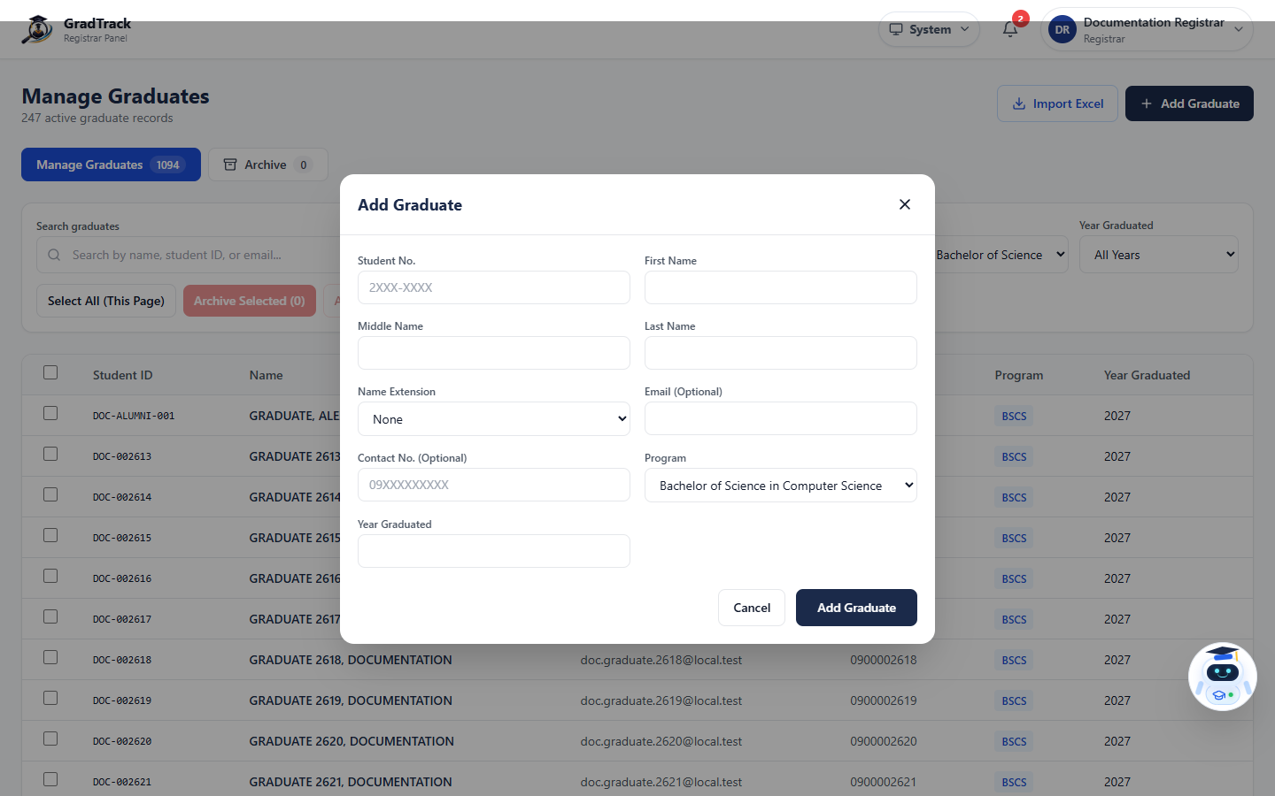
Figure 47. Registrar Add Graduate Form
Figure description: The add form contains identity, contact, program, and graduation-year fields.

8.4 Import Graduate Records from Excel
Purpose: Add multiple graduate records using the current spreadsheet-import workflow.
Procedure
Step 1. Prepare the spreadsheet using the expected registrar columns.
Step 2. Select Import Excel.
Step 3. Choose the authorized Excel or CSV file.
Step 4. Review validation results and correct invalid or duplicate rows before confirming the import.
Step 5. Return to Manage Graduates and verify the imported records.
Expected Result: Valid rows are added and the table refreshes; invalid rows are reported for correction.
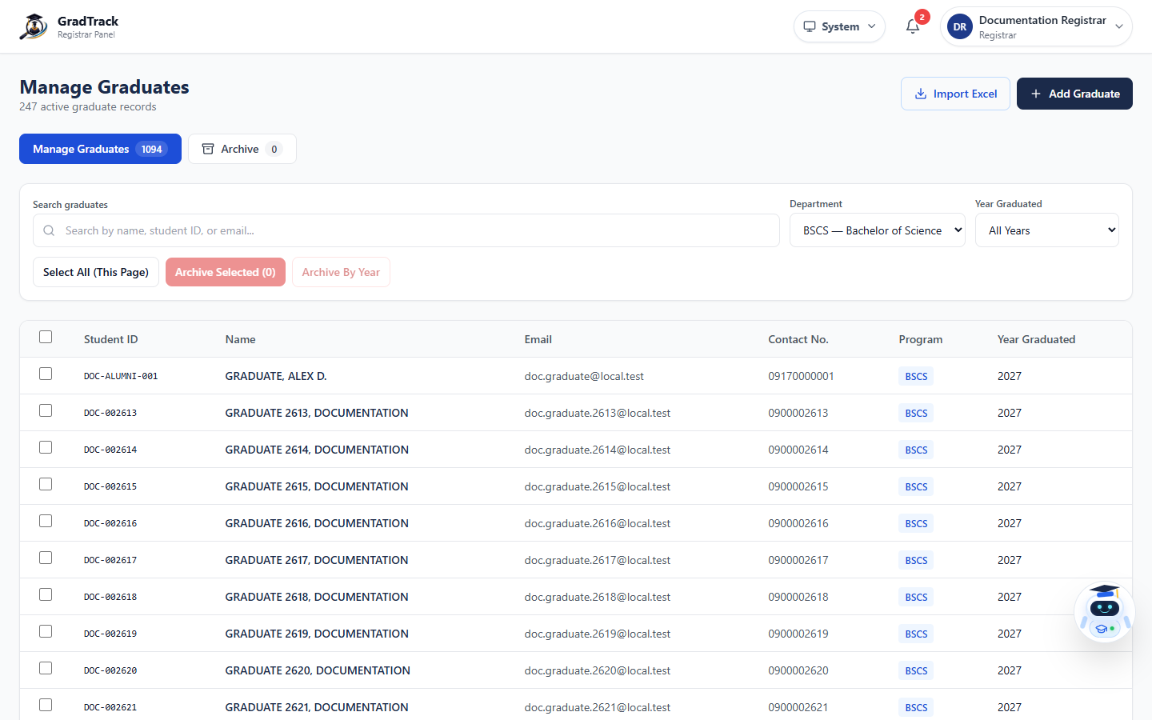
Figure 48. Registrar Excel Import Control
Figure description: The Import Excel control is available above the current read-only record table.

8.5 Archive Graduate Records
Purpose: Move selected active records out of Manage Graduates while preserving related historical data, or permanently remove archived records when explicitly authorized.
Procedure
Step 1. On Manage Graduates, select records and choose Archive Selected, or select a department and year before Archive By Year.
Step 2. Confirm the archive operation after reviewing its scope.
Step 3. Select Archive to review archived records.
Step 4. Use permanent-delete controls only when explicitly authorized and after confirming that the action cannot be undone.
Expected Result: Archived records appear in Registrar Archive; the current interface does not provide Edit, View Details, or Restore actions.
Important: There is no Restore procedure in the current Registrar interface. Do not follow restore steps from an older manual.
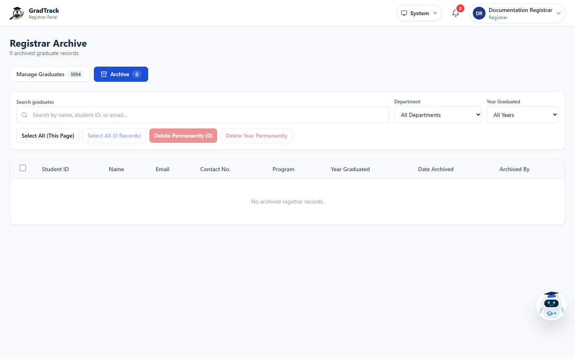
Figure 49. Registrar Archive
Figure description: Registrar Archive provides selection and permanent-deletion controls but no row-level actions or restore command.

8.6 Registrar Profile
Purpose: Maintain the Registrar's personnel profile and password.
Procedure
Step 1. Open the account menu and select My Profile.
Step 2. Select Edit Profile when required.
Step 3. Update permitted details or password fields.
Step 4. Select Save Changes.
Expected Result: The Registrar personnel profile is updated; graduate records are unaffected.
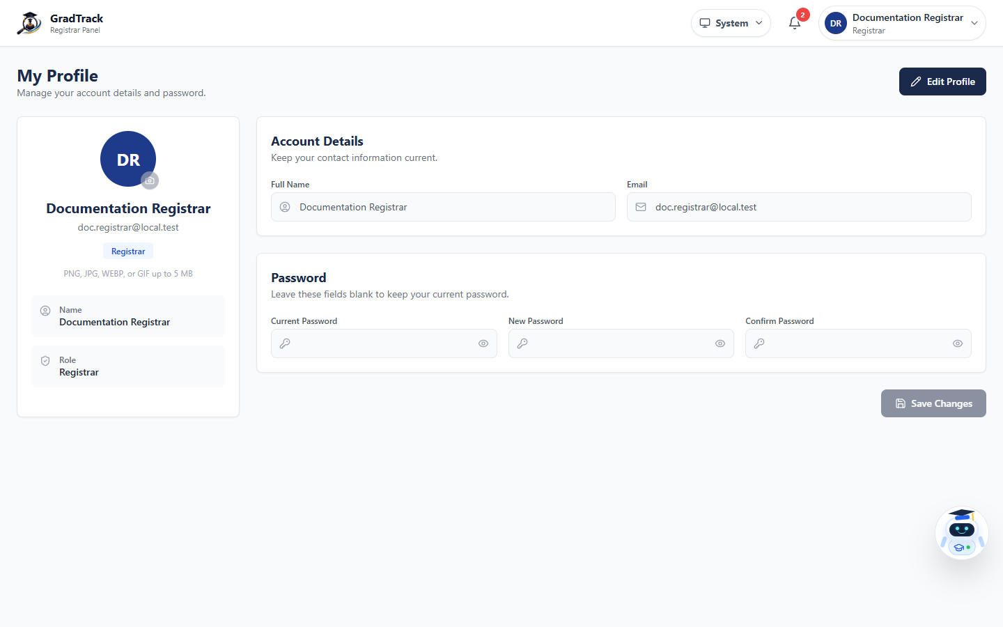
Figure 50. Registrar Personnel Profile
Figure description: The Registrar profile page is separate from graduate-record management.

9 Alumni President User Manual

9.1 Review Graduate Portal Account Requests
Purpose: Approve or reject Graduate Portal accounts after reviewing the submitted graduate information.
Procedure
Step 1. Sign in as Alumni President and open Alumni Verification.
Step 2. Use Pending, Approved, or Rejected to select the review queue.
Step 3. Select the blue eye View button in the Actions column.
Step 4. After review, select Approve or Reject; provide a reason when rejecting.
Expected Result: The verification status changes and controls the graduate's portal eligibility.
Important: This figure documents the latest View Details icon requested for the updated manual.
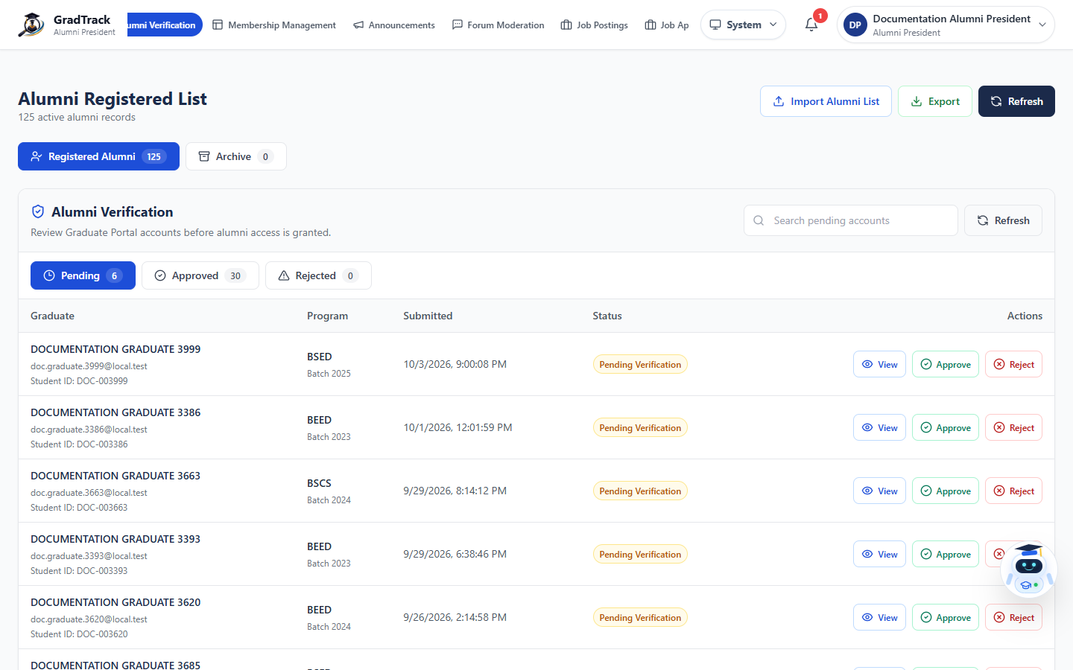
Figure 51. Alumni Verification with Updated View Details Action
Figure description: The current Actions column uses the updated blue eye icon with the View label beside Approve and Reject.

9.2 View Graduate Account Details
Purpose: Inspect verified survey and account information before deciding an account request.
Procedure
Step 1. Select View on a graduate request.
Step 2. Review verification status, portal status, email, student ID, program, year, phone, address, and submission timestamps.
Step 3. Select Approve or Reject from the dialog when ready, or select Close without changing status.
Expected Result: The selected approval action is recorded, or the dialog closes without a change.
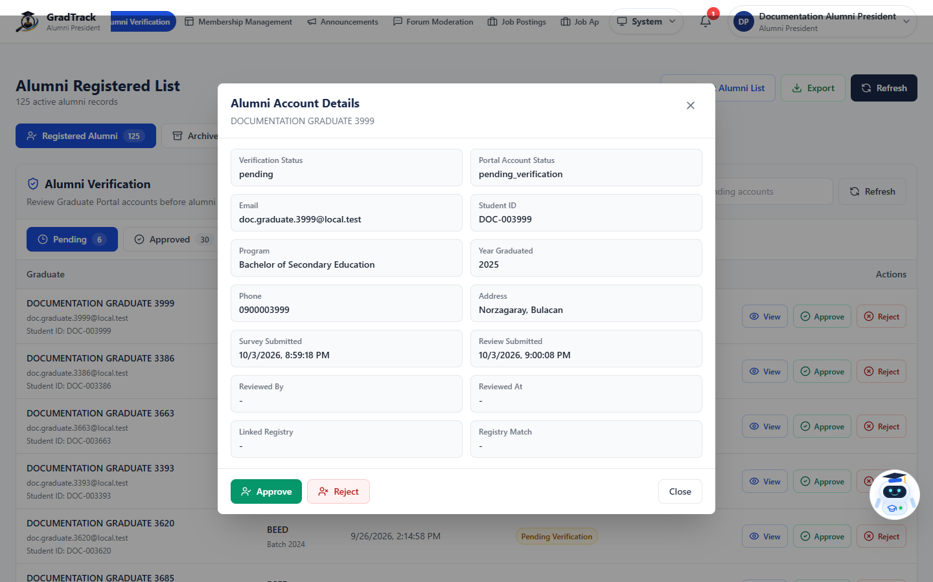
Figure 52. Alumni Account Details
Figure description: The details dialog presents the information required for Alumni President account review.

9.3 Manage Alumni Membership Information
Purpose: Maintain the public membership branding, page copy, benefits, fees, ID previews, instructions, and publication state.
Procedure
Step 1. Open Membership Management.
Step 2. Review the branding and page-copy fields.
Step 3. Update only confirmed Alumni Association information and assets.
Step 4. Use Preview draft before Save draft or Publish.
Step 5. Select Publish only after the content has been verified.
Expected Result: The draft is saved or the approved membership content becomes public.
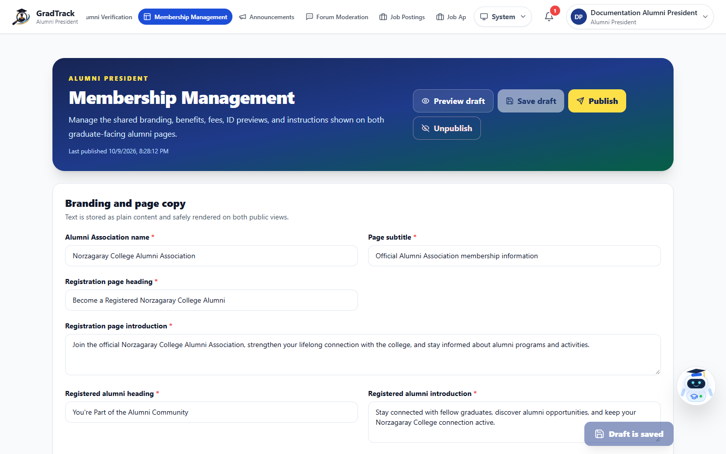
Figure 53. Alumni Membership Management
Figure description: The management page controls the two public membership views and their current branding.

9.4 Manage Announcements
Purpose: Create and maintain notices shown on public and Graduate Portal announcement pages.
Procedure
Step 1. Open Announcements.
Step 2. Use All, Published, Draft, or Archived to filter the list.
Step 3. Select Edit or Delete only for the intended announcement.
Step 4. Select New Announcement to create a notice.
Expected Result: The announcement list reflects the completed action and current status.
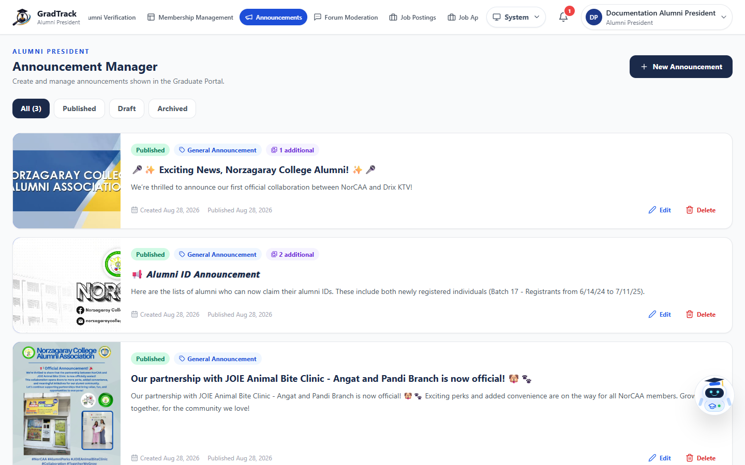
Figure 54. Alumni President Announcement Manager
Figure description: The Announcement Manager lists published content and available management actions.

9.5 Create an Announcement
Purpose: Publish or save an official notice with complete content and optional media.
Procedure
Step 1. Select New Announcement.
Step 2. Enter the title, category, event date when applicable, status, short description, and full content.
Step 3. Add supported media using the available controls.
Step 4. Select Create Announcement.
Expected Result: The announcement is created with the selected publication status.
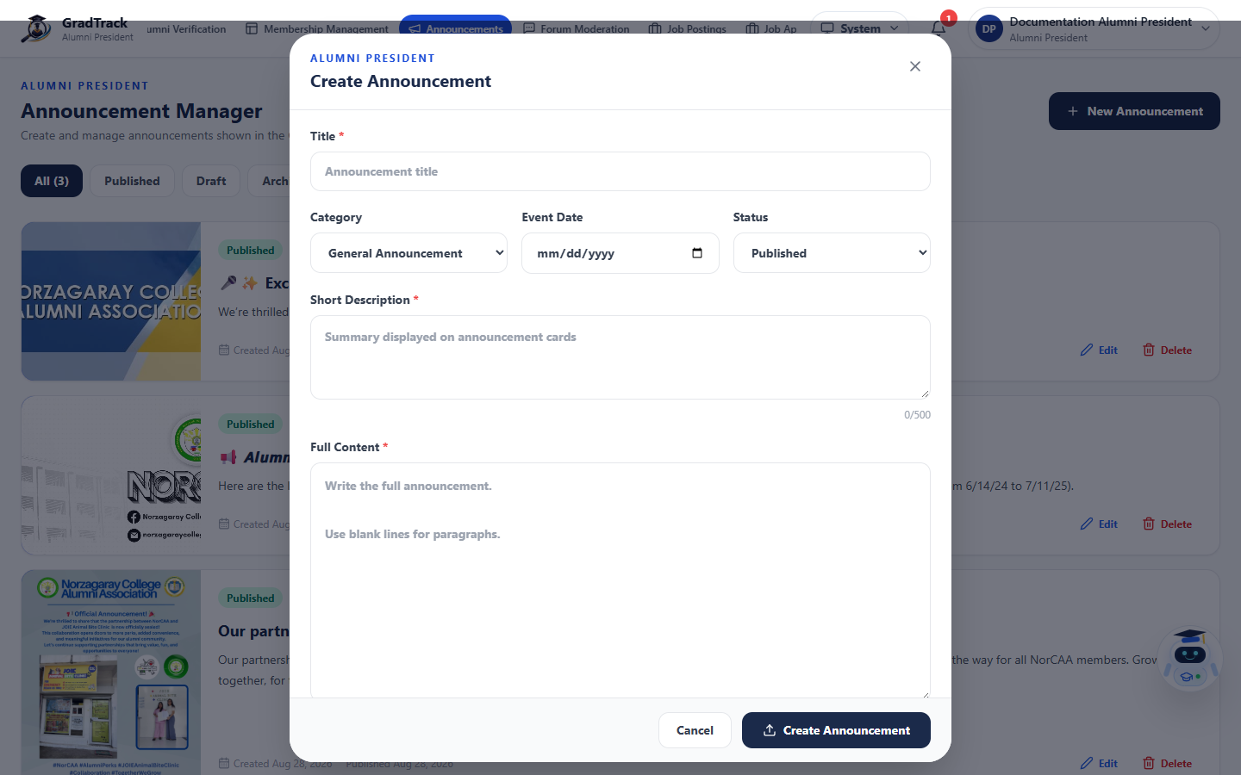
Figure 55. Create Announcement Form
Figure description: The current form includes title, category, event date, status, summary, and full content.

9.6 Moderate Reported Forum Content
Purpose: Review and resolve graduate reports without altering unrelated community content.
Procedure
Step 1. Open Forum Moderation.
Step 2. Use report type, reason, status, and search filters.
Step 3. Select View Content before deciding.
Step 4. Choose Hide Content, Resolve Report, or Dismiss Report according to the verified case.
Expected Result: The report and content status update according to the selected moderation decision.
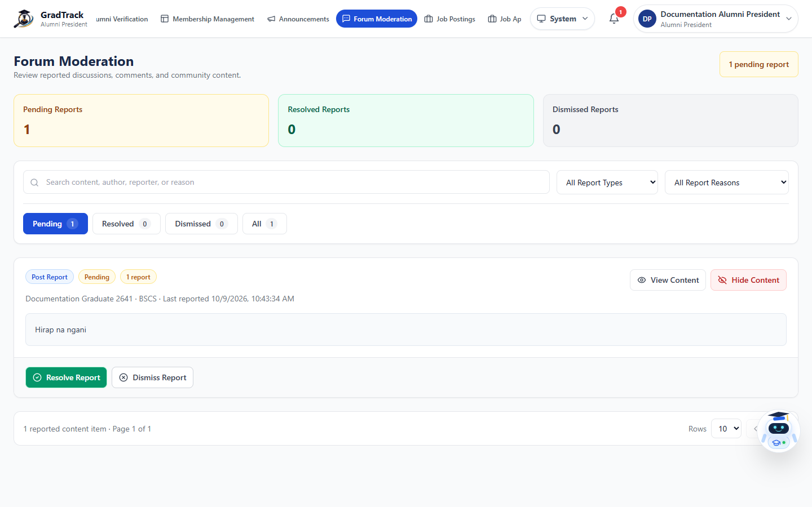
Figure 56. Forum Moderation
Figure description: The moderation queue displays report counts, filters, content preview, and resolution controls.

9.7 Alumni President Job Postings
Purpose: Create and manage staff-originated opportunities displayed to graduates.
Procedure
Step 1. Open Job Postings.
Step 2. Select Create Job to add an official opportunity.
Step 3. Use search to locate an existing post.
Step 4. Use Edit, Archive, or Delete only after confirming the intended job and status.
Expected Result: The staff job list reflects the completed action.
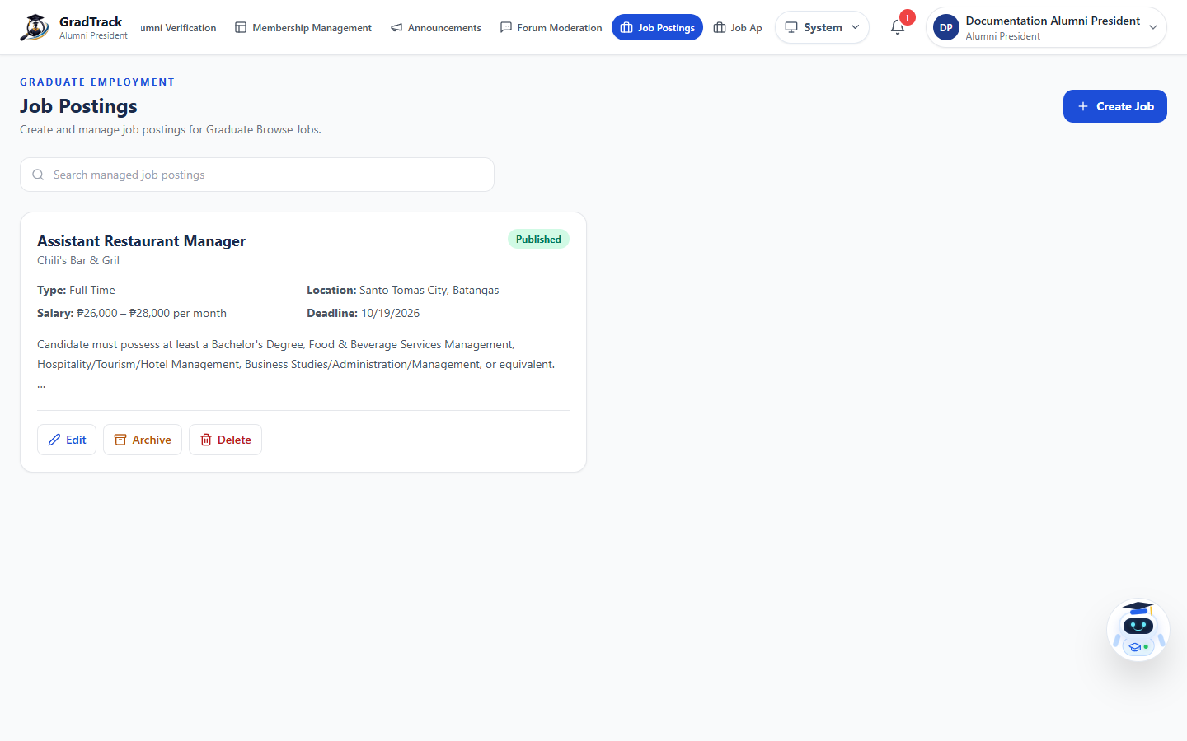
Figure 57. Alumni President Job Postings
Figure description: The staff job manager shows publication status and authorized management controls.

9.8 Approve Graduate Job Posts
Purpose: Review job opportunities submitted by graduates before publication.
Procedure
Step 1. Open Job Approval.
Step 2. Use status tabs and search to locate a submission.
Step 3. Review the job information and program scope.
Step 4. Approve, decline, or archive the submission using the available control and provide a reason when required.
Expected Result: The job submission moves to the selected approval status; only approved active posts appear in Browse Jobs.
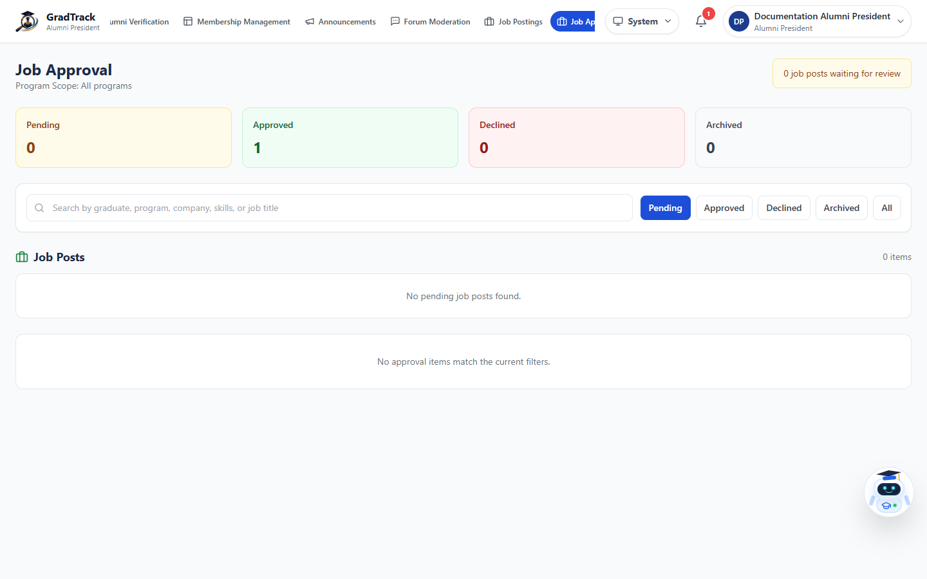
Figure 58. Graduate Job Approval Queue
Figure description: The approval page summarizes pending, approved, declined, and archived graduate job posts.

10 Administrator User Manual

10.1 User Management
Purpose: Maintain authorized personnel accounts, roles, and active status.
Procedure
Step 1. Sign in as Administrator and open User Management.
Step 2. Use search, role, and status filters.
Step 3. Select the edit or account-status action for the intended personnel record.
Step 4. Confirm role and status changes before saving.
Expected Result: The personnel account list reflects the authorized update.
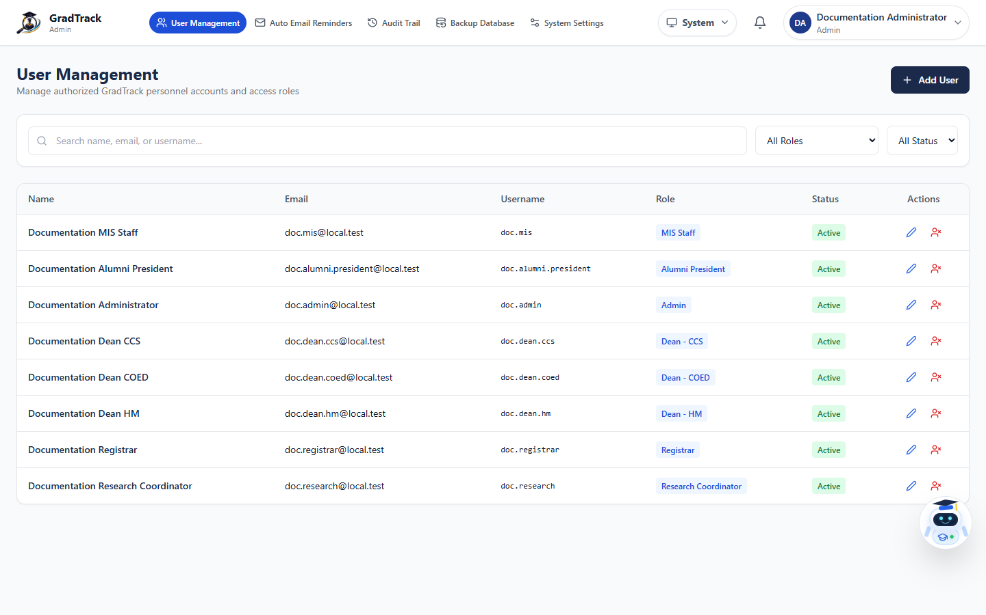
Figure 59. Administrator User Management
Figure description: User Management lists distinct Admin, MIS Staff, Research Coordinator, Registrar, Alumni President, and Dean roles.

10.2 Add a Personnel User
Purpose: Create a new authorized personnel account with a specific system role.
Procedure
Step 1. In User Management, select Add User.
Step 2. Enter the full name, username, email, and temporary password.
Step 3. Select the exact role and account status.
Step 4. Select Create User and communicate credentials through an approved channel.
Expected Result: The new personnel account appears in User Management.
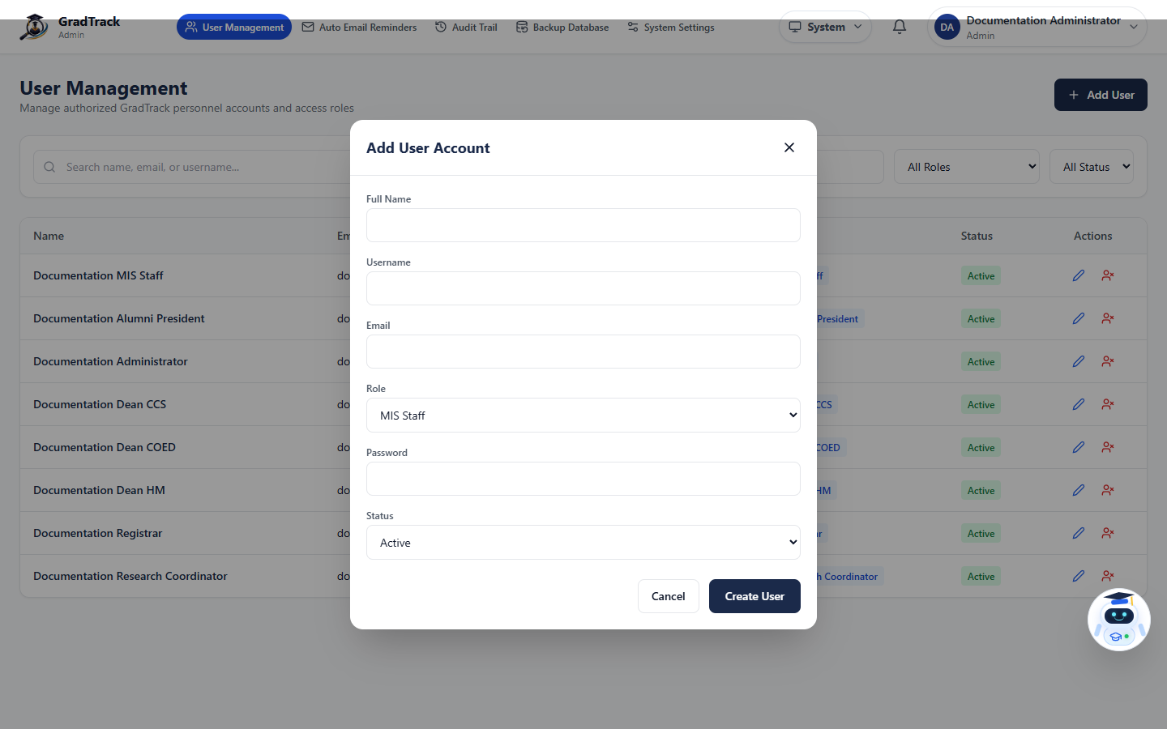
Figure 60. Add Personnel User
Figure description: The Add User form includes identity, login, role, password, and status fields.

10.3 Automated Email Reminders
Purpose: Configure and monitor survey reminders for eligible graduates who have not answered.
Procedure
Step 1. Open Auto Email Reminders.
Step 2. Review the active survey, eligible graduate count, frequency, and delivery totals.
Step 3. Use the Frequency, Send Reminders, or History tabs for the required task.
Step 4. Confirm recipients and settings before any manual send.
Expected Result: The reminder configuration or delivery history is displayed and authorized sends are logged.
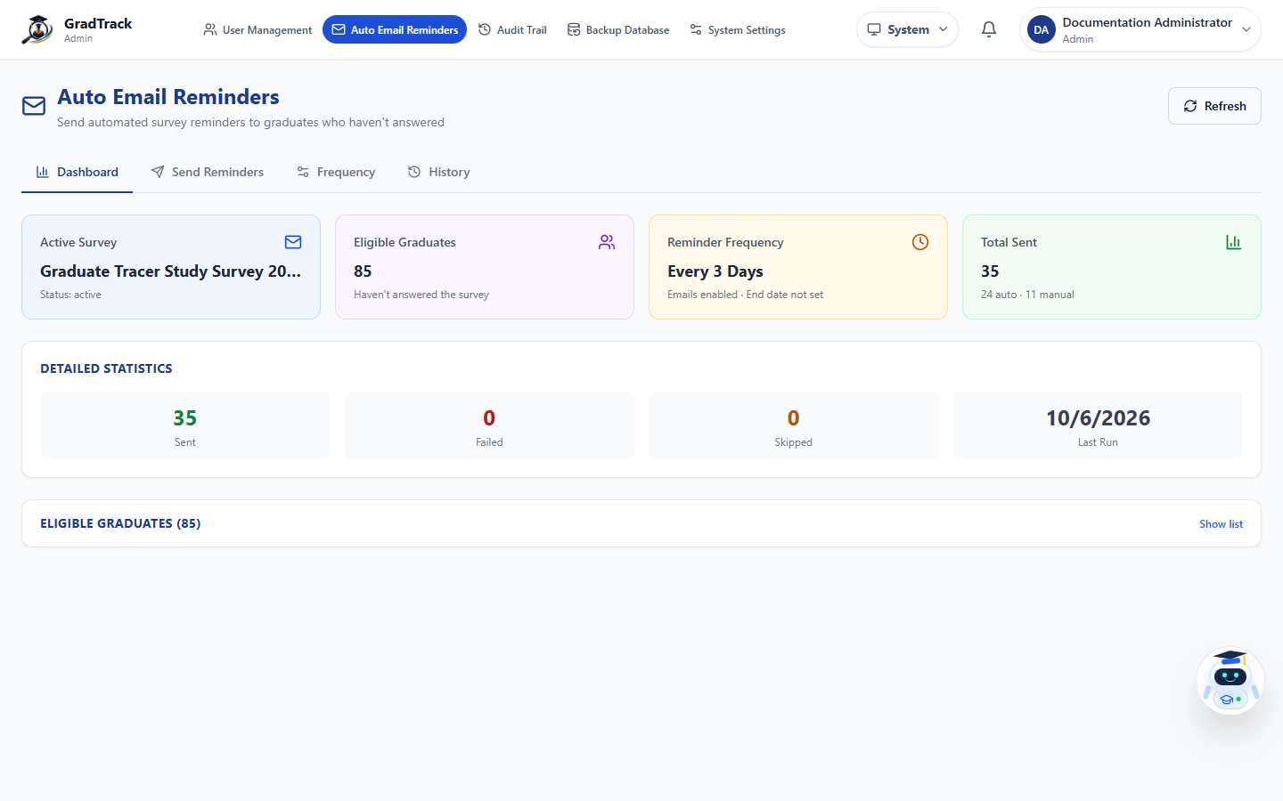
Figure 61. Automated Email Reminders
Figure description: The reminder dashboard summarizes eligible graduates, frequency, totals, and recent run data.

10.4 Audit Trail
Purpose: Review read-only records of personnel authentication and administrative actions.
Procedure
Step 1. Open Audit Trail.
Step 2. Use search, role, department, action, module, and date filters.
Step 3. Select View Details for an event when needed.
Step 4. Select Export only when an authorized audit copy is required.
Expected Result: The filtered audit events or selected event details are displayed.
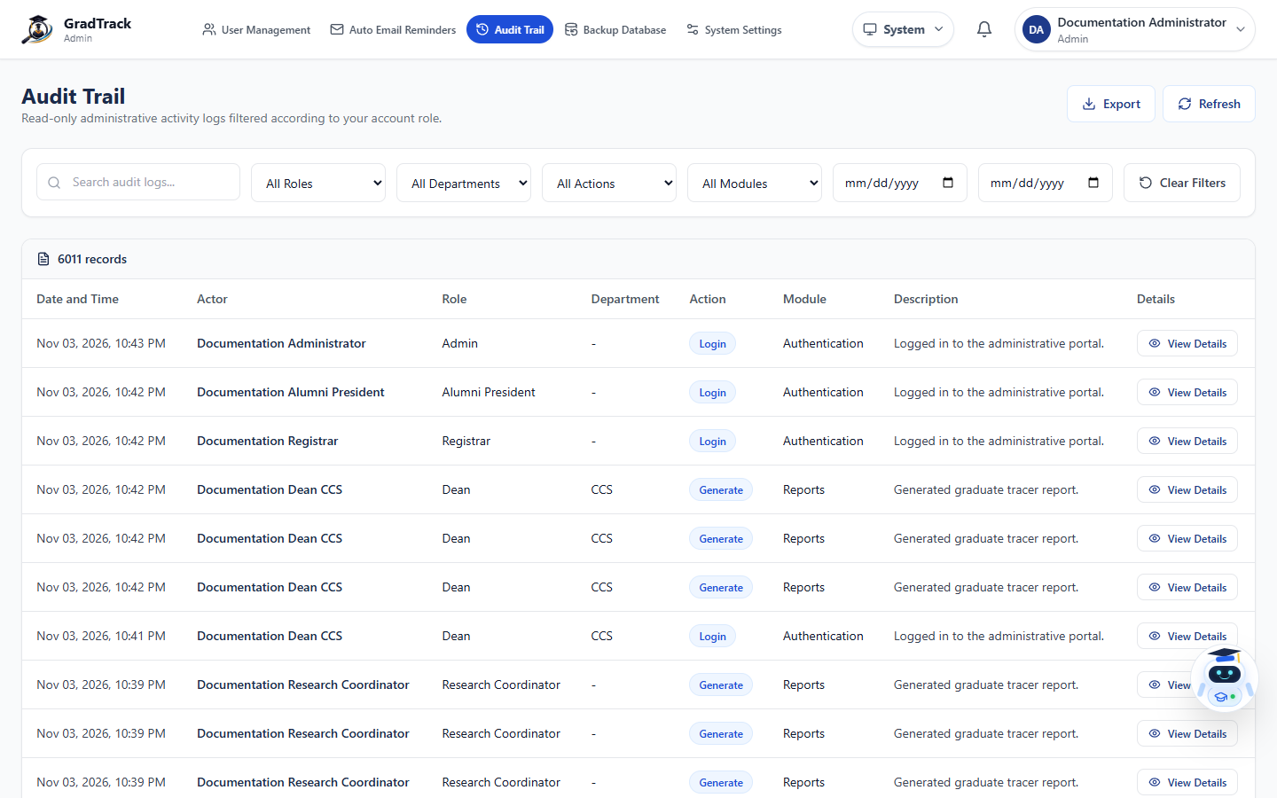
Figure 62. Administrator Audit Trail
Figure description: The audit trail records actor, role, department, action, module, description, and time.

10.5 Database Backup
Purpose: Download a restorable SQL backup of the current GradTrack database.
Procedure
Step 1. Open Backup Database.
Step 2. Review the database name, table count, record count, estimated size, and checklist.
Step 3. Select Download Backup.
Step 4. Store the downloaded SQL file in a secure, access-controlled location and verify it using the institution's recovery procedure.
Expected Result: A database backup file downloads without changing current records.
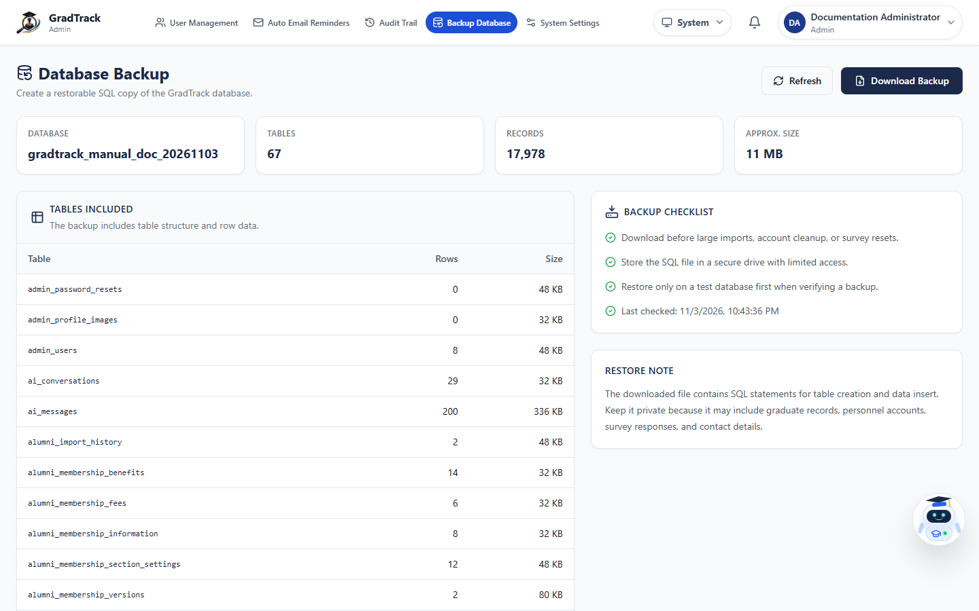
Figure 63. Database Backup
Figure description: The backup page identifies included tables, counts, size, checklist, and restore note.

10.6 General System Settings
Purpose: Maintain approved system identity, contact, feature, survey, community, maintenance, and public-content configuration.
Procedure
Step 1. Open System Settings.
Step 2. Choose the relevant settings tab.
Step 3. Review the current values before editing.
Step 4. Select Save Changes only after confirming the full effect; use Cancel to discard unsaved changes.
Expected Result: The approved configuration is saved and applied to its affected interface.
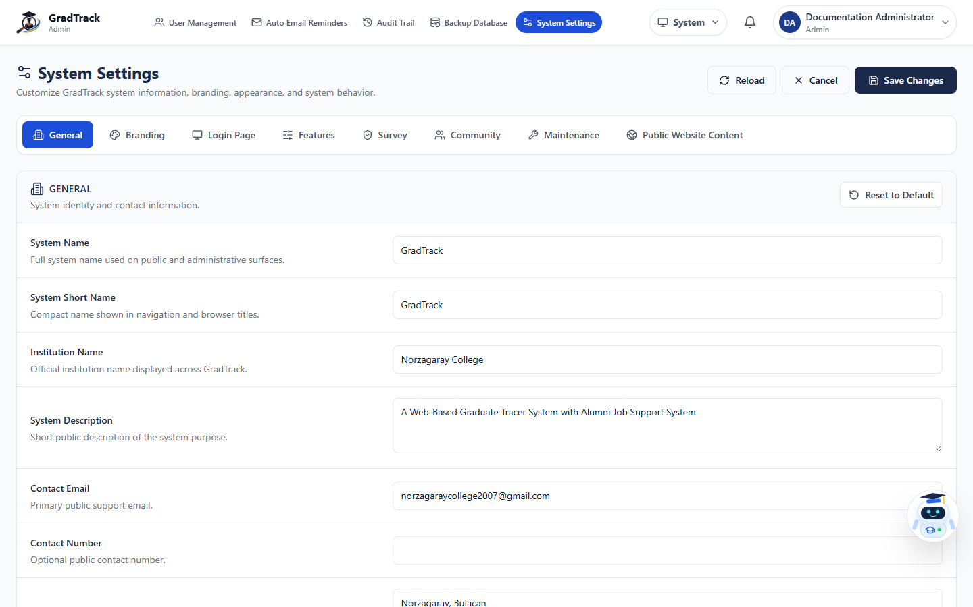
Figure 64. General System Settings
Figure description: System Settings groups general, branding, login, feature, survey, community, maintenance, and public-content options.

10.7 Branding Settings
Purpose: Use the official current logos, favicon, and theme colors throughout GradTrack.
Procedure
Step 1. In System Settings, select Branding.
Step 2. Review the current System Logo, Login Logo, Favicon, and theme colors.
Step 3. Select Upload only for an approved official asset.
Step 4. Preview the interface and select Save Changes.
Expected Result: The approved branding is applied to the configured system surfaces.
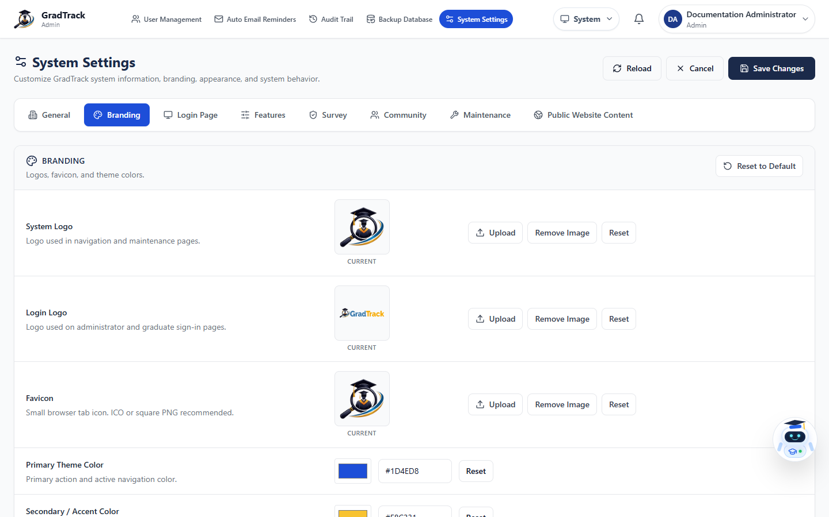
Figure 65. GradTrack Branding Settings
Figure description: The branding tab displays the current official GradTrack assets and theme colors.

10.8 Administrator Profile
Purpose: Maintain the Administrator's own personnel information, profile image, and password.
Procedure
Step 1. Open the account menu and select My Profile.
Step 2. Select Edit Profile.
Step 3. Update permitted details or password fields.
Step 4. Select Save Changes.
Expected Result: The Administrator's personnel profile is updated.
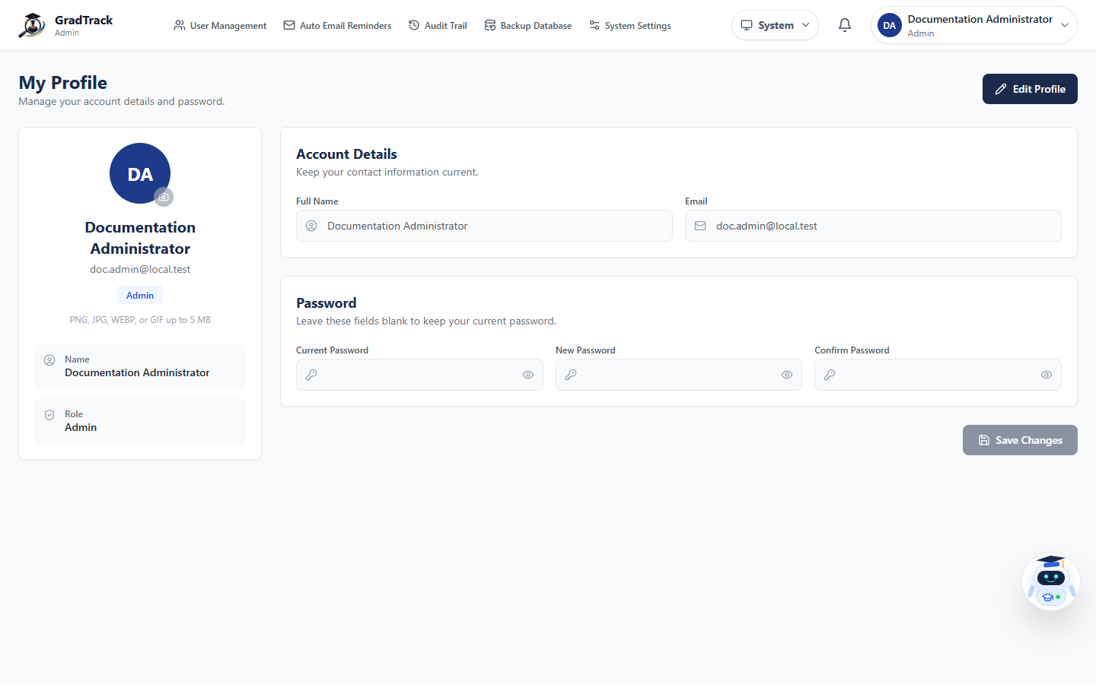
Figure 66. Administrator Profile
Figure description: The profile page separates account details from password changes.

10.9 Administrator AI Assistant
Purpose: Provide assistance using data and modules permitted to the Administrator role.
Procedure
Step 1. Select Ask GradTrack AI Assistant.
Step 2. Start a new conversation or open an existing one.
Step 3. Enter a clear system-related question.
Step 4. Verify operational or security-sensitive information using the relevant administrative module.
Expected Result: The assistant returns a role-scoped response without performing unconfirmed destructive actions.
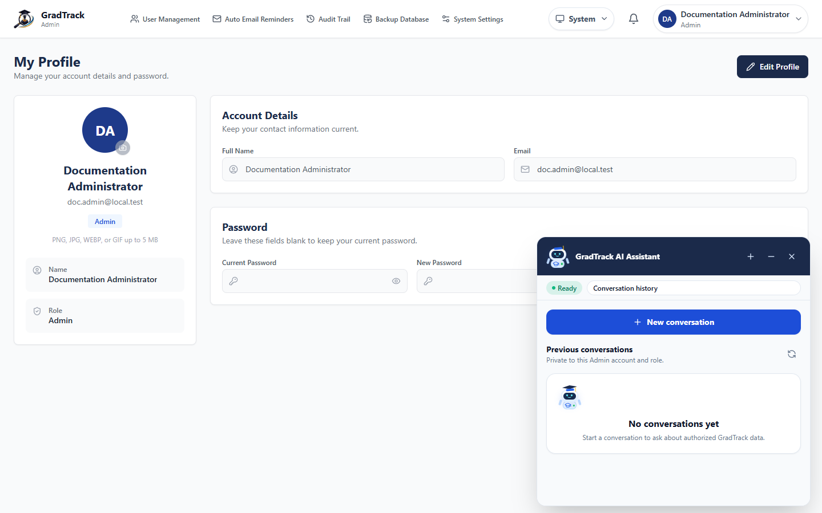
Figure 67. Administrator AI Assistant
Figure description: The Administrator assistant panel is available from personnel pages and maintains conversation history.

11 MIS Staff User Manual

11.1 MIS Staff Dashboard
Purpose: Provide MIS Staff with the current institution-wide graduate-outcome dashboard.
Procedure
Step 1. Sign in as MIS Staff.
Step 2. Open Dashboard.
Step 3. Choose the relevant survey.
Step 4. Review employment, alignment, coverage, and trend indicators.
Expected Result: The selected survey's institution-wide dashboard is displayed.
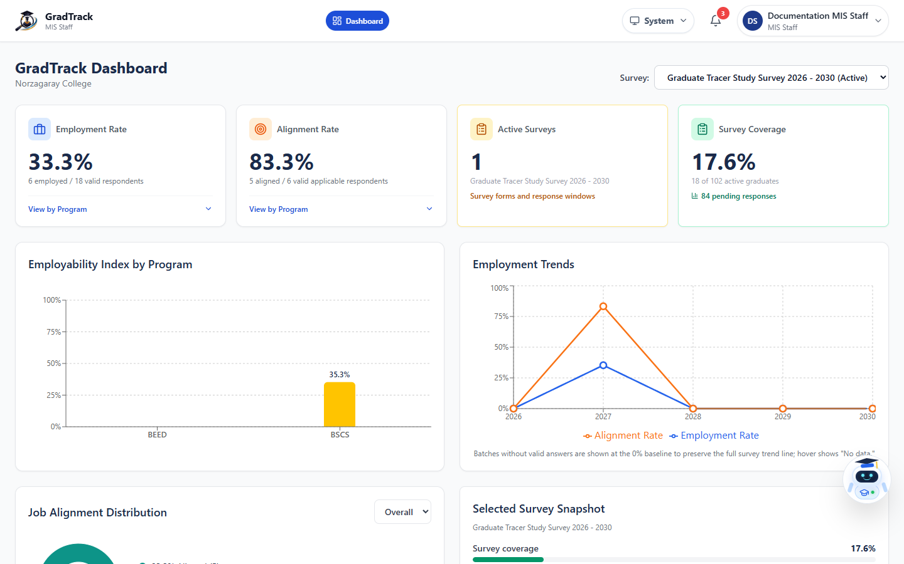
Figure 68. MIS Staff Dashboard
Figure description: The current MIS Staff role has dashboard access without the Administrator's management modules.

11.2 MIS Staff Profile
Purpose: Maintain the MIS Staff user's own profile and password.
Procedure
Step 1. Open the account menu and select My Profile.
Step 2. Select Edit Profile.
Step 3. Update permitted details or password fields.
Step 4. Select Save Changes.
Expected Result: The MIS Staff profile is updated.
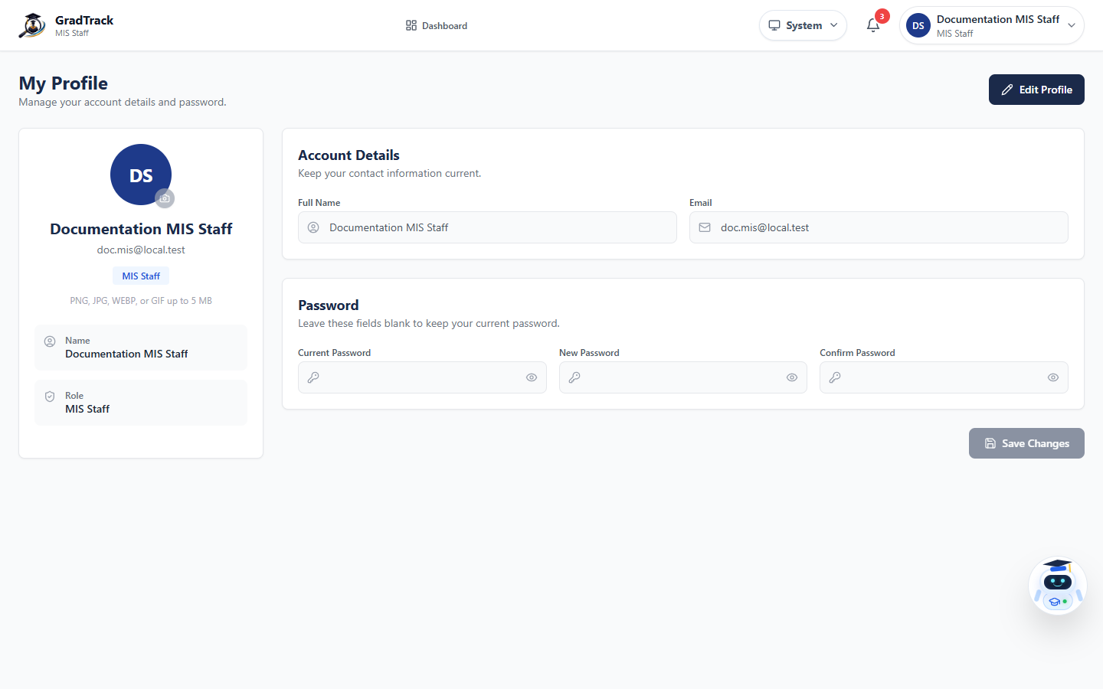
Figure 69. MIS Staff Profile
Figure description: MIS Staff is a separate current role with profile access and no Admin configuration menu.

12 Job Support Features
GradTrack uses a controlled job-posting lifecycle so graduates see approved opportunities and can follow the employer's configured application method.
Stage | Responsible User | Current Action | Related Figures
Create | Graduate | Submit a complete job post for review | Figures 23–24
Review | Alumni President | Approve, decline, or archive graduate submissions | Figure 58
Publish and maintain | Research Coordinator, Dean, or Alumni President | Create and manage authorized staff posts | Figures 37, 42, and 57
Discover | Graduate | Filter, open, save, and share active jobs | Figures 20–22
Apply | Graduate | Follow Apply Now or the employer's displayed instructions | Figure 21

12.1 Job-Posting Rules
- Graduate-submitted jobs are not public until approved.
- External application links and employer contact methods open or operate outside GradTrack.
- Saved Jobs are personal bookmarks and do not constitute an application.
- Archive or delete actions must be used only on the intended post and with authorization.

13 Common Account, Security, and Troubleshooting Guidance

13.1 Sign Out
Open the account menu and select Sign Out. Confirm that the sign-in page appears before leaving a shared computer.

13.2 Password Safety
- Use a unique password and never send it through an unsecured channel.
- Graduate Portal registration requires uppercase, lowercase, number, and symbol characters.
- Use the appropriate Forgot Password link instead of creating a duplicate account.

13.3 Common Problems
Problem | Current Guidance
A page keeps loading | Wait for the active request to finish, refresh once, and verify the authorized environment and network connection.
A menu is missing | Confirm the signed-in role. Menus are intentionally role-based.
A graduate cannot verify identity | Check that student number or email, last name, program, and registrar record match exactly.
A graduate cannot sign in | Confirm that the account was created, approved by the Alumni President, and remains active.
A job is not visible | Confirm that it is approved, published, active, and not past its availability rules.
A Registrar edit action is missing | This is expected in the current version. Existing graduate rows have no Edit or View Details action.

Appendix A — Verification and Screenshot Notes
- All figures were captured at 1440 × 900 from the latest running application.
- The screenshot environment used an isolated local clone and anonymized names, emails, student identifiers, phone numbers, and addresses.
- No production record was edited, archived, approved, deleted, or emailed during documentation work.
- The local survey was temporarily placed in an active documentation state so consent, completion, review, submission, and account-registration screens could be verified.
- The original 61-page PDF and existing editable Word file were references only; current source code and working interfaces were treated as authoritative.

