

GRADTRACK
Web-Based Graduate Tracer System
with Alumni Job Support System
USER MANUAL
NORZAGARAY COLLEGE
Prepared from the current live GradTrack implementation
October 2026
Version 1.0 • Current-interface documentation

TABLE OF CONTENTS
1. INTRODUCTION 1
1.1 About GradTrack 1
1.2 Purpose of This Manual 1
1.3 Intended Users 1
1.4 Scope 1
2. SYSTEM REQUIREMENTS 2
3. USER ROLES 3
3.1 Dean Program Scope 3
4. LOGIN AND ACCOUNT ACCESS 4
4.1 Open GradTrack 4
4.2 Personnel Sign In 4
4.3 Graduate Portal Login 4
4.4 Invalid Credentials 5
5. GRADUATE USER MANUAL 7
5.1 Verify the Graduate Record 7
5.2 Accept the Privacy Notice 7
5.3 Complete the Tracer Survey 8
5.4 Review and Submit the Survey 9
5.5 Create a Graduate Portal Account 10
5.6 Use the Community Forum 11
5.7 Read Announcements 12
5.8 Use Messaging 13
5.9 View and Update the Profile 14
5.10 Add a Professional Credential 14
5.11 Manage Account Settings 16
5.12 Review Notifications 17
6. RESEARCH COORDINATOR USER MANUAL 18
6.1 Review the Research Dashboard 18
6.2 Monitor Graduate Survey Participation 18
6.3 Manage Surveys 19
6.4 Monitor Responses 20
6.5 Use Reports and Export Data 21
6.6 Review Descriptive Survey Analytics 22
6.7 Run Inferential Analysis 23
6.8 Publish a Staff Job Post 24
7. DEAN USER MANUAL 26
7.1 Review the Dean Dashboard 26
7.2 Review Survey Participation 26
7.3 Analyze and Export Reports 27
7.4 Manage Job Postings 28
8. REGISTRAR USER MANUAL 30
8.1 View and Search Graduate Records 30
8.2 Filter by Program and Graduation Year 30
8.3 Add a Graduate Manually 31
8.4 Edit a Graduate Record 32
8.5 Import Graduate Records 33
8.6 Archive and Restore Records 34
9. ALUMNI PRESIDENT USER MANUAL 35
9.1 Approve or Reject Graduate Accounts 35
9.2 Manage Announcements 36
9.3 Moderate Reported Forum Content 37
9.4 Review Graduate Job Posts 38
9.5 Manage Staff Job Postings 39
10. ADMIN / MIS STAFF USER MANUAL 40
10.1 Admin – Manage Personnel Accounts 40
10.2 Admin – Configure Survey Reminders 41
10.3 Admin – Review the Audit Trail 42
10.4 Admin – Create a Database Backup 42
10.5 Admin – Update System Settings 43
10.6 Personnel Profile 44
10.7 MIS Staff Dashboard 44
11. NOTIFICATIONS, MESSAGES, AND COMMUNITY FEATURES 46
11.1 Recommended Use 46
12. JOB SUPPORT FEATURES 47
12.1 Graduate – Browse Job Opportunities 47
12.2 Graduate – Submit a Job Post 48
12.3 Authorized Staff – Manage Job Posts 49
12.4 Alumni President – Approve Graduate Posts 49
13. ANALYTICS AND REPORTS 50
13.1 Apply Report Filters 50
13.2 Interpret Results Carefully 50
13.3 Generate a Formal Report 50
14. ERROR HANDLING / COMMON ISSUES 51
15. LOGOUT 52
15.1 Graduate Logout 52
15.2 Personnel Logout 52
16. TROUBLESHOOTING 54
16.1 Information to Provide When Reporting a Problem 54
16.2 Manual Validation Basis 54

Open this document in Microsoft Word and update the table if page numbers do not refresh automatically.

1. INTRODUCTION

1.1 About GradTrack
GradTrack is Norzagaray College’s web-based graduate tracer system with alumni job support. It combines graduate survey collection, alumni community services, employment opportunities, graduate records, analytics, reporting, and controlled administrative functions in one role-based application.

1.2 Purpose of This Manual
This manual explains the current GradTrack interface as verified in the running application on October 7, 2026. It gives first-time users direct procedures, expected results, and screenshots from the implemented system.

1.3 Intended Users
- Graduates and alumni
- Research Coordinators
- College Deans
- Registrar personnel
- Alumni President
- Administrators and MIS Staff

1.4 Scope
The manual covers account access, the Graduate Tracer Survey, Graduate Portal, role-specific personnel modules, notifications and communication, job support, analytics, reports, errors, logout, and troubleshooting. Features are included only when confirmed in the source code and current running interface.
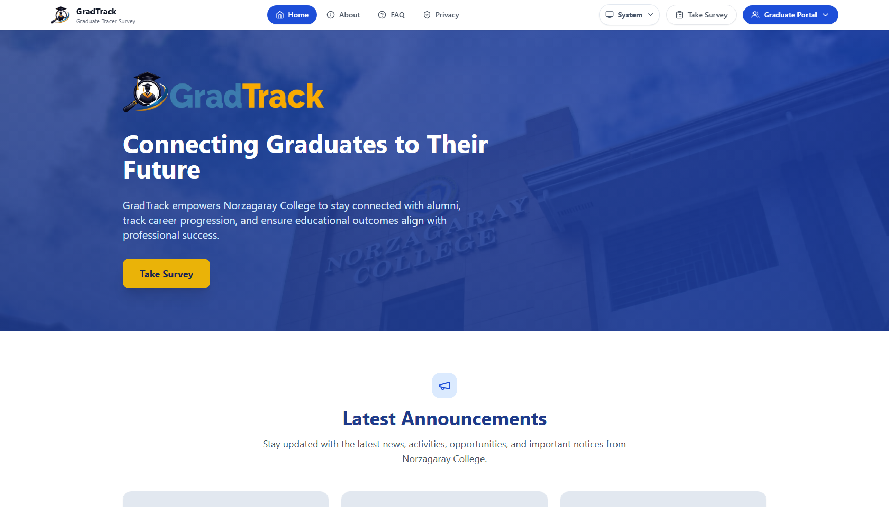
Figure 1. GradTrack public home page

2. SYSTEM REQUIREMENTS
GradTrack is a web application. No separate desktop installation is required for ordinary users.
Requirement |  | Verified guidance
Browser |  | Use a current desktop web browser with JavaScript, cookies, and file downloads enabled. The documented session was tested in Google Chrome.
Connection |  | Use a stable network connection to the server that hosts GradTrack.
Account |  | Personnel require an active role account. Graduate Portal access requires an approved Graduate account. The public tracer survey begins with graduate-record verification.
Display |  | A desktop or laptop display is recommended for wide tables, charts, record management, and report exports.
Registrar import |  | The current import control accepts .xlsx and .csv graduate lists.
Graduate credentials |  | Certificate files may be PDF, JPG, JPEG, or PNG, with a maximum size of 10 MB.
Job requirements |  | The job-post form accepts the formats stated in the live form, including PDF, DOCX, PNG, JPG, and JPEG.
 | Access and security: The application address is deployment-specific. Obtain the correct GradTrack link and account details from the authorized system administrator; this manual does not publish private development credentials.

3. USER ROLES
GradTrack applies route-level and module-level role permissions. The current implementation exposes the following responsibilities.
Role | Implemented access and responsibility
Graduate | Completes the tracer survey; uses the forum, announcements, messages, jobs, job posting, profile, credentials, notifications, and settings after approval.
Research Coordinator | Views the institutional dashboard and survey participation; manages surveys; monitors responses; runs analytics and inferential analysis; exports reports; manages staff job postings.
Dean | Views department-scoped dashboard, graduate participation, reports, analytics, exports, and job postings. Survey management and inferential analysis are not exposed to this role.
Registrar | Maintains graduate records through search, program/year filters, manual entry, editing, import, and archival controls.
Alumni President | Approves or rejects Graduate Portal accounts; manages announcements; moderates reported forum content; reviews graduate-submitted jobs; manages job postings.
Admin | Manages personnel accounts, reminders, audit records, database backup, system settings, and own profile. The current Admin landing page is User Management.
MIS Staff | Views the general GradTrack dashboard and own profile. The current sidebar does not expose Admin system-management pages to MIS Staff.

3.1 Dean Program Scope
Dean role |  | Department | Programs in the current implementation
Dean – CS |  | CCS | BSCS and ACT
Dean – COED |  | COED | BSED and BEED
Dean – HM |  | HM | BSHM
 | Role restriction: Permissions are determined by the signed-in role. A user should not attempt to reach a module that is absent from the role’s sidebar or route set.

4. LOGIN AND ACCOUNT ACCESS

4.1 Open GradTrack
Purpose: Reach the system’s public entry page.
Step 1. Open the GradTrack address provided by the institution.
Step 2. Choose the appropriate entry: Graduate Portal or Personnel Sign In. Graduates may also begin the tracer survey from the public page.
Expected Result: The selected sign-in page or public survey-verification page is displayed.

4.2 Personnel Sign In
Purpose: Authenticate a Research Coordinator, Dean, Registrar, Alumni President, Admin, or MIS Staff.
Step 1. Open Personnel Sign In.
Step 2. Enter the registered email address.
Step 3. Enter the account password.
Step 4. Click “Sign In.”
Expected Result: GradTrack opens the first page authorized for the account’s role.
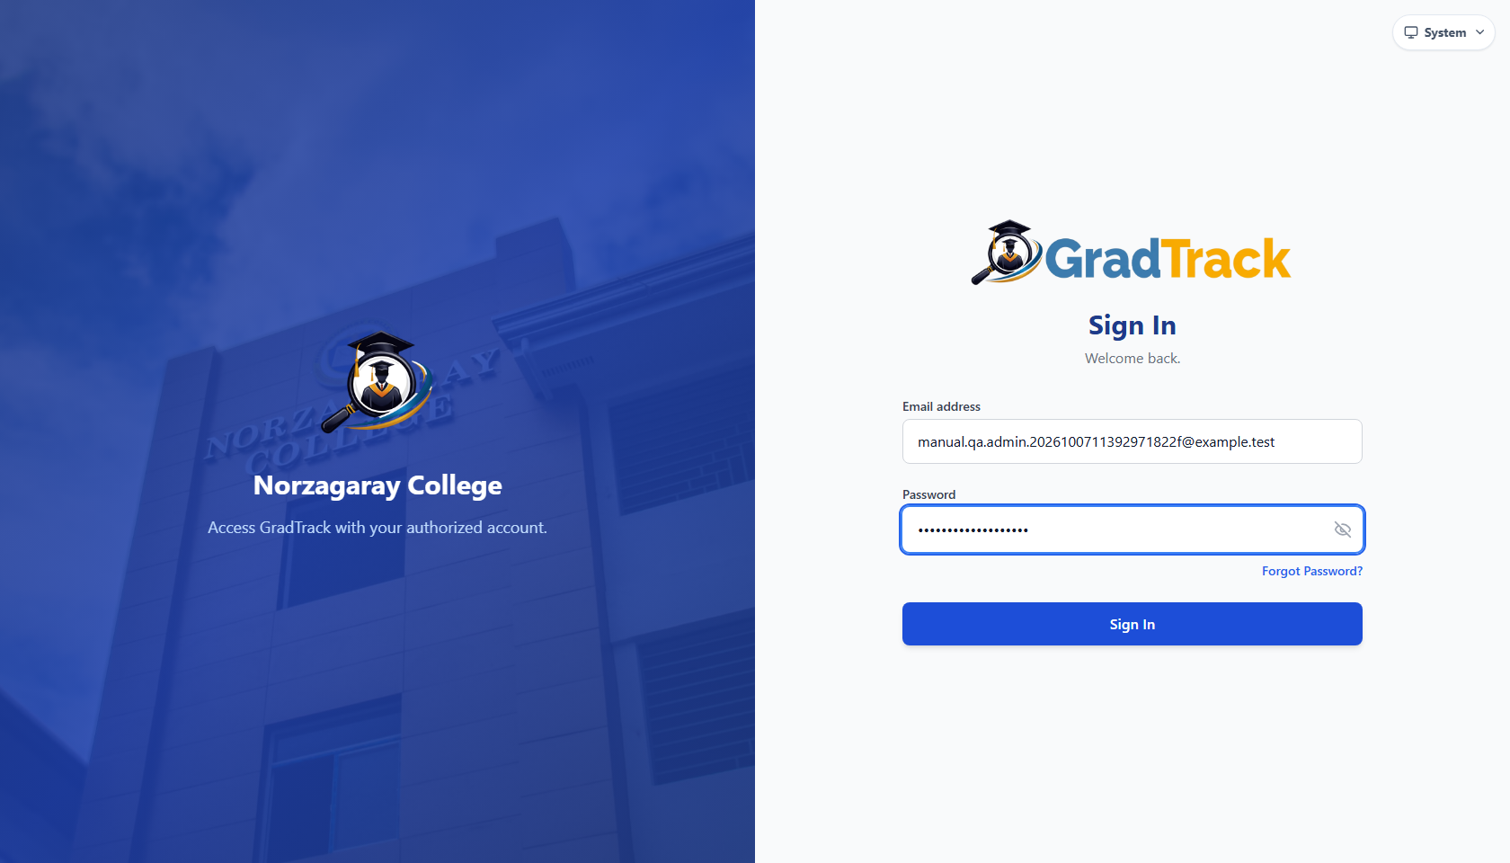
Figure 2. Personnel Sign In page

4.3 Graduate Portal Login
Purpose: Authenticate an approved Graduate Portal account.
Step 1. Open Graduate Portal.
Step 2. Enter the registered email address.
Step 3. Enter the password.
Step 4. Click “Log In.”
Expected Result: The Graduate Community Forum opens after successful authentication.
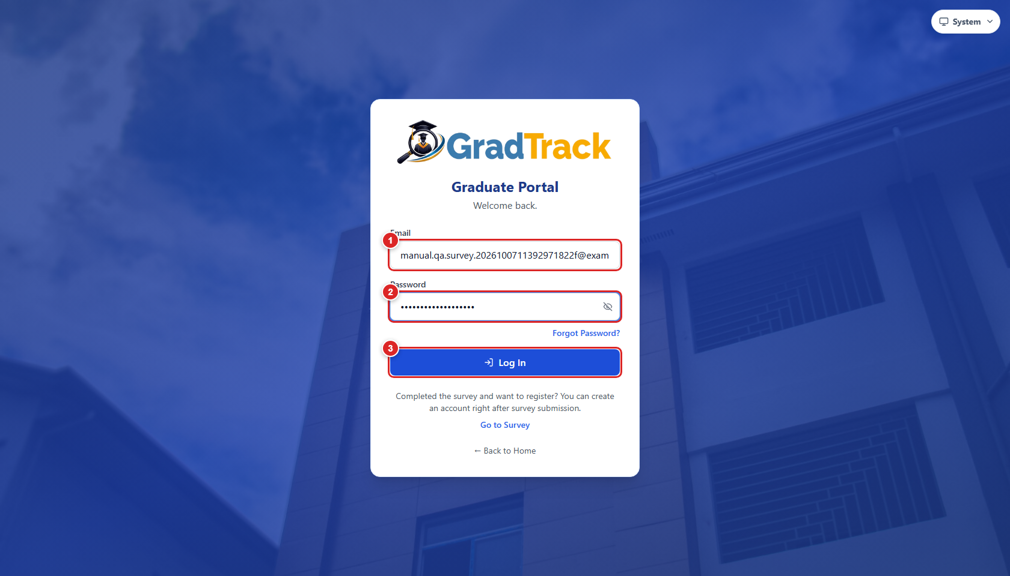
Figure 3. Graduate Portal login page with numbered controls

4.4 Invalid Credentials
Purpose: Recognize the system response when an email/password combination is incorrect.
Step 1. Submit a sign-in form using invalid credentials.
Step 2. Read the displayed message.
Step 3. Close the message when applicable, correct both fields, and try again.
Expected Result: Personnel Sign In displays “Invalid email or password.” Graduate Portal displays a “Log In Failed” dialog with the same reason.
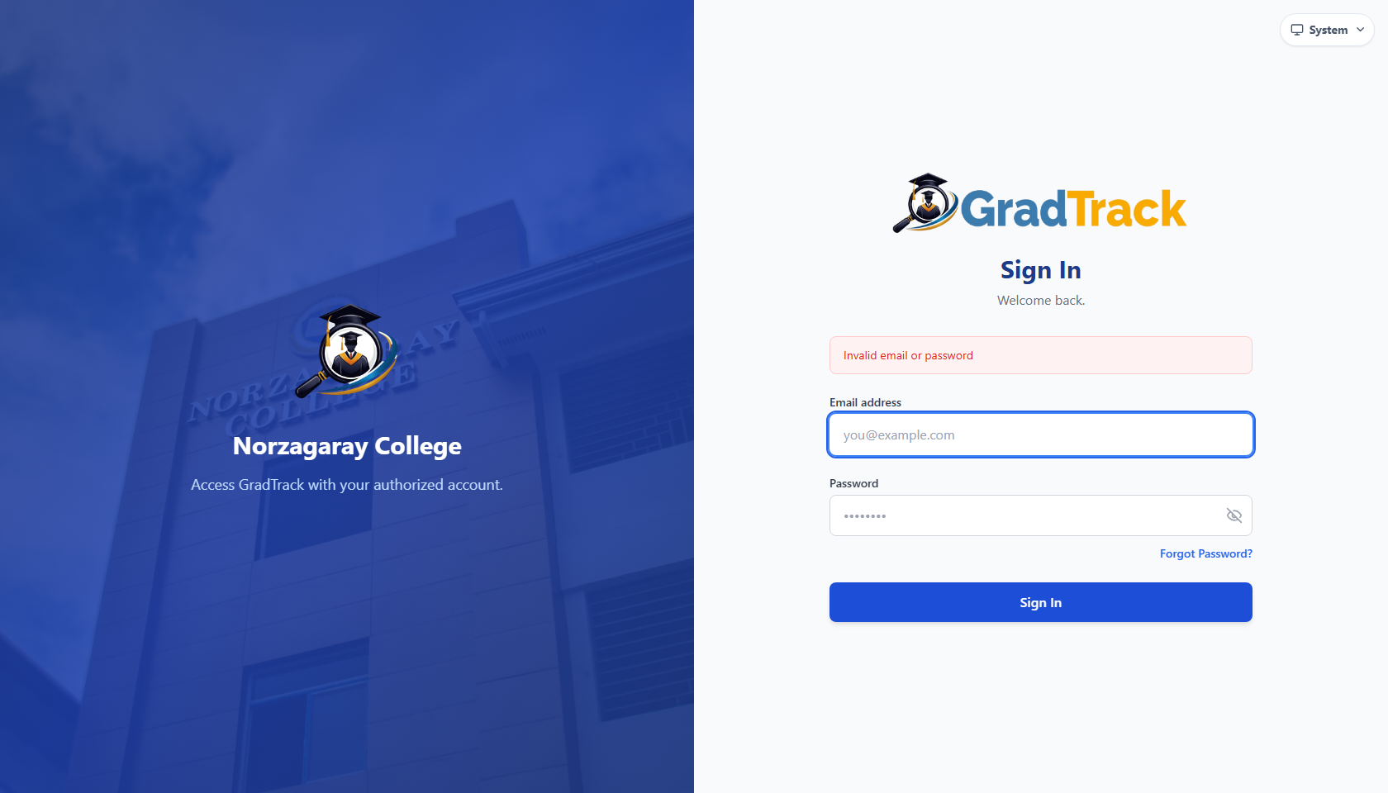
Figure 4. Personnel invalid-login message
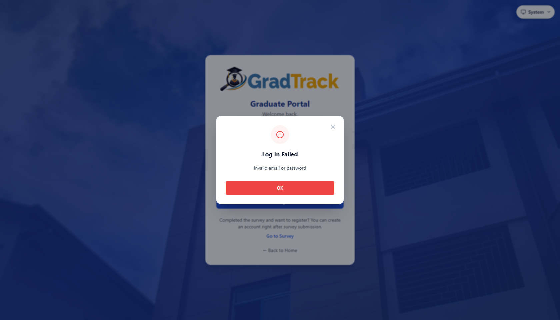
Figure 5. Graduate Portal invalid-login dialog
Credential safety: Passwords are intentionally omitted from this manual and are not visible in screenshots.

5. GRADUATE USER MANUAL
A graduate may complete the public tracer survey before creating a Graduate Portal account. The account created after submission remains pending until the Alumni President verifies it.

5.1 Verify the Graduate Record
Purpose: Match the survey participant to an existing graduate record.
Step 1. Open the Graduate Tracer Survey.
Step 2. Enter the Student ID.
Step 3. Enter the last name.
Step 4. Select the program/course.
Step 5. Click “Verify & Continue.”
Expected Result: A matched graduate is taken to the survey’s privacy and consent screen.
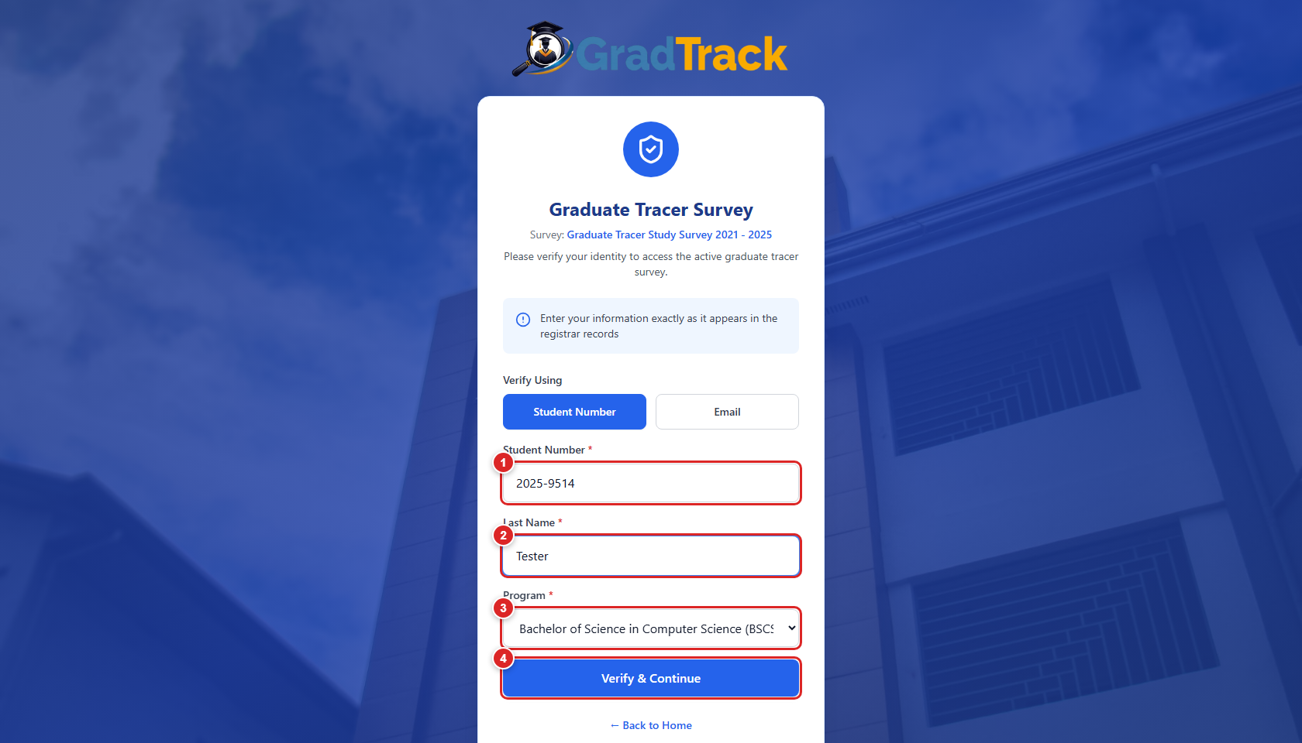
Figure 6. Graduate tracer survey identity verification

5.2 Accept the Privacy Notice
Purpose: Record informed consent before survey responses are collected.
Step 1. Read the Data Privacy Notice and Informed Consent.
Step 2. Select the consent checkbox.
Step 3. Click “I Agree & Proceed.”
Expected Result: The first survey section becomes available.
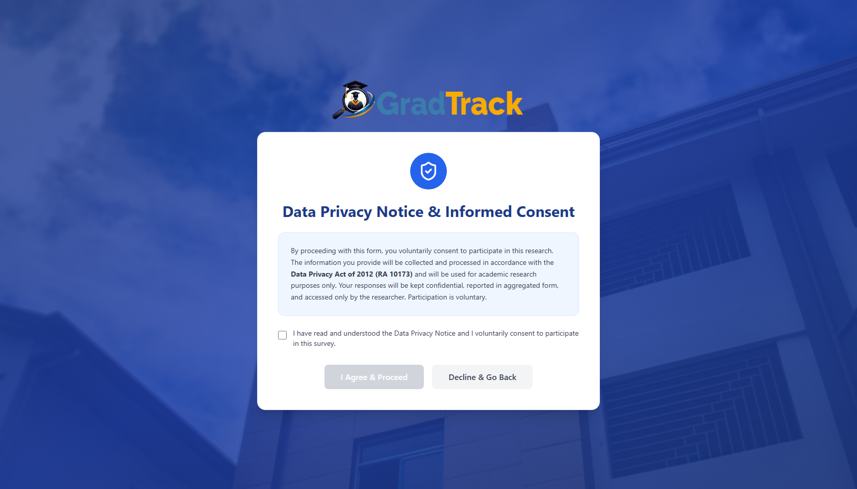
Figure 7. Data Privacy Notice and informed-consent screen

5.3 Complete the Tracer Survey
Purpose: Provide current graduate, education, training, graduate-study, and employment information.
Step 1. Complete every required item in the current section.
Step 2. Use “Next” to proceed through the staged form.
Step 3. Review conditional questions that appear from earlier answers.
Step 4. Use “Previous” when a response must be corrected.
Expected Result: Each valid section advances to the next section and the progress indicator updates.
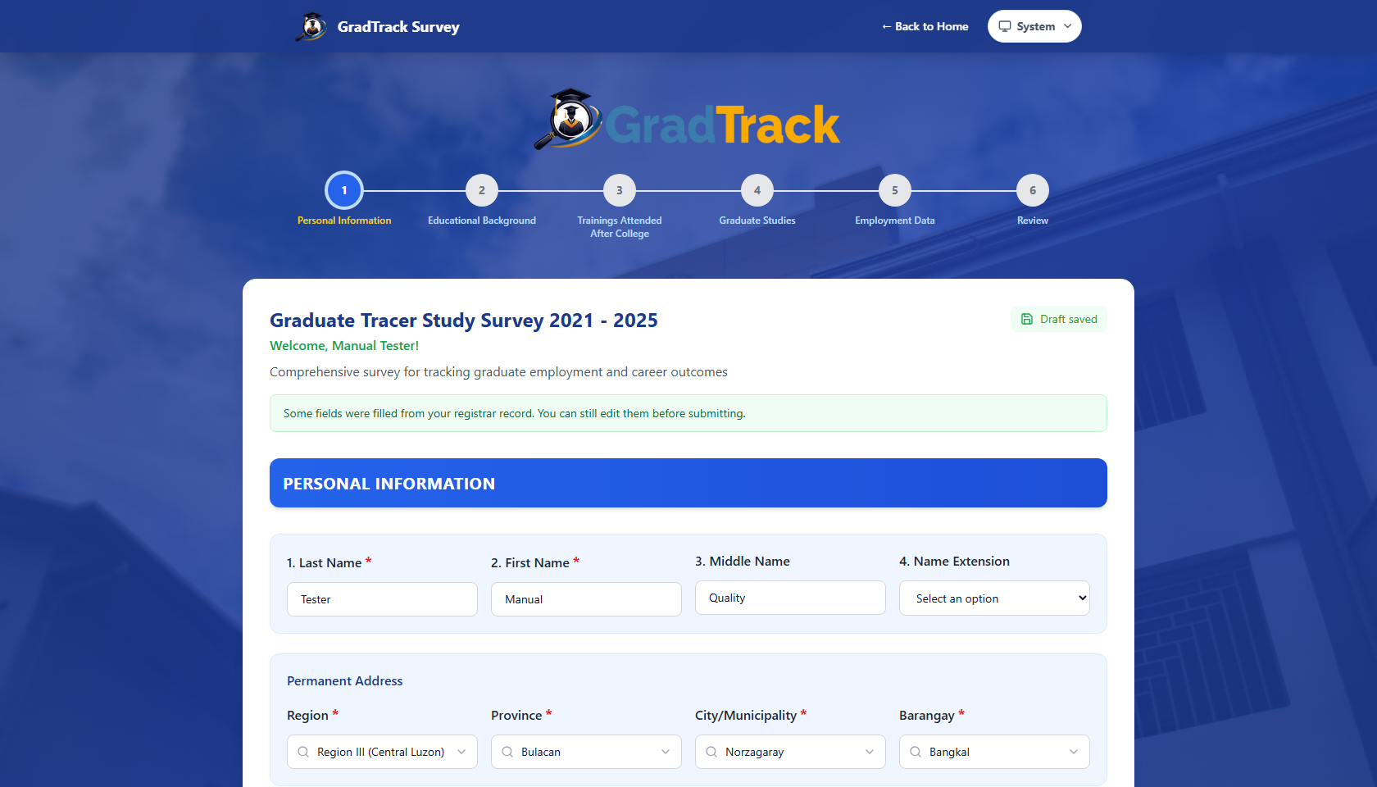
Figure 8. Tracer Survey – Personal Information section
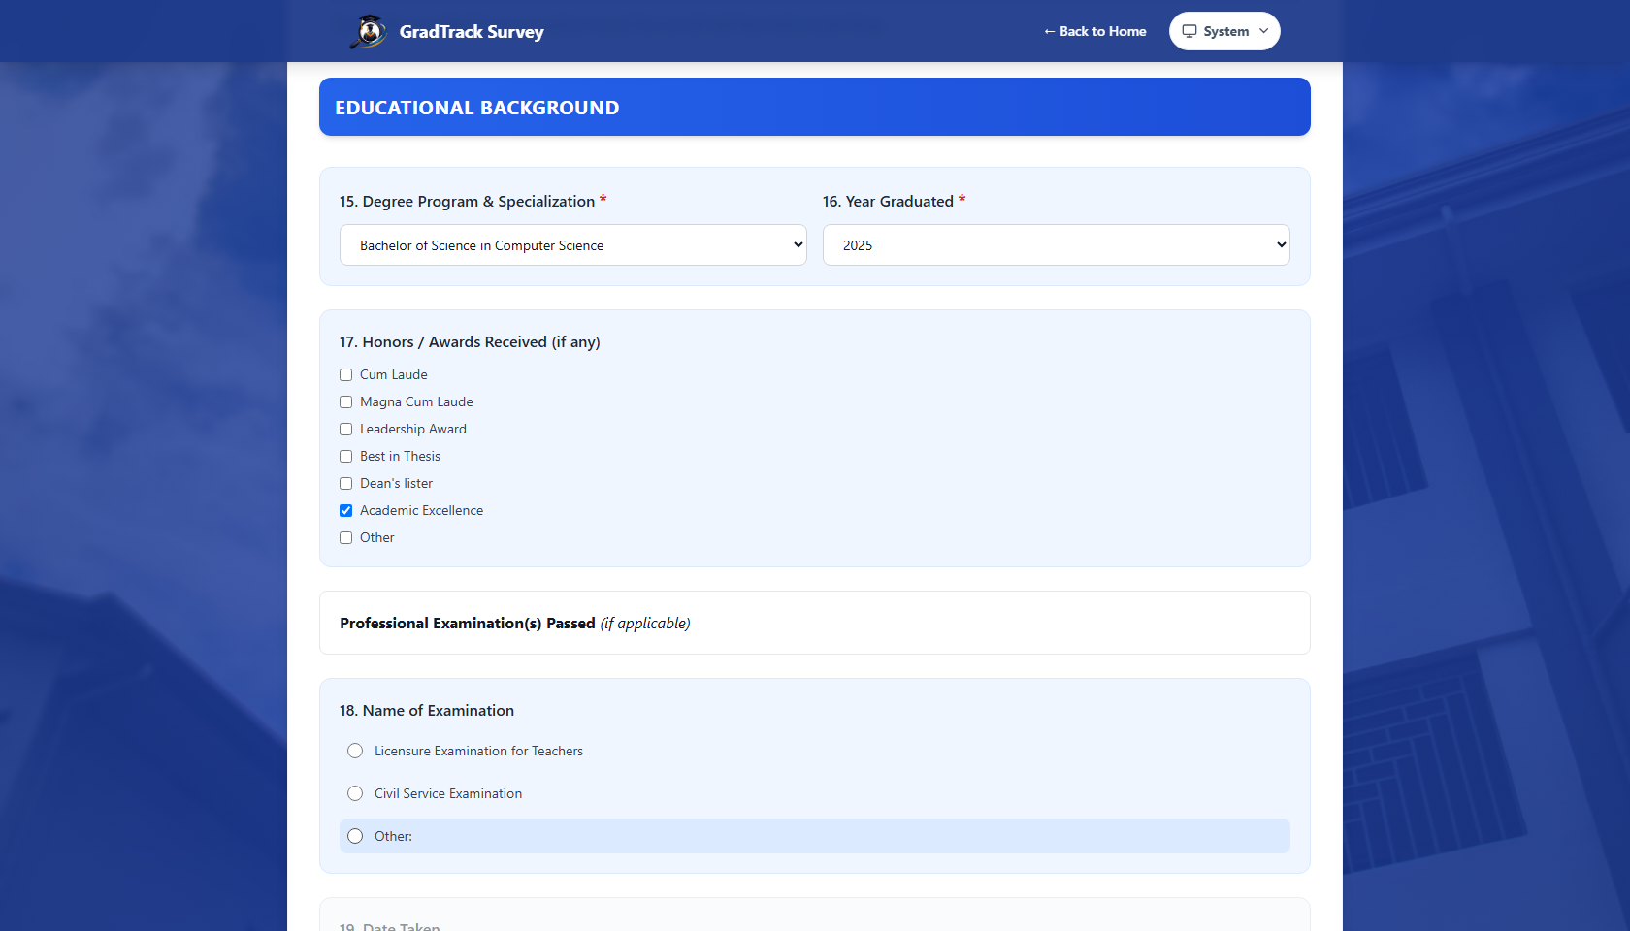
Figure 9. Tracer Survey – Educational Background section
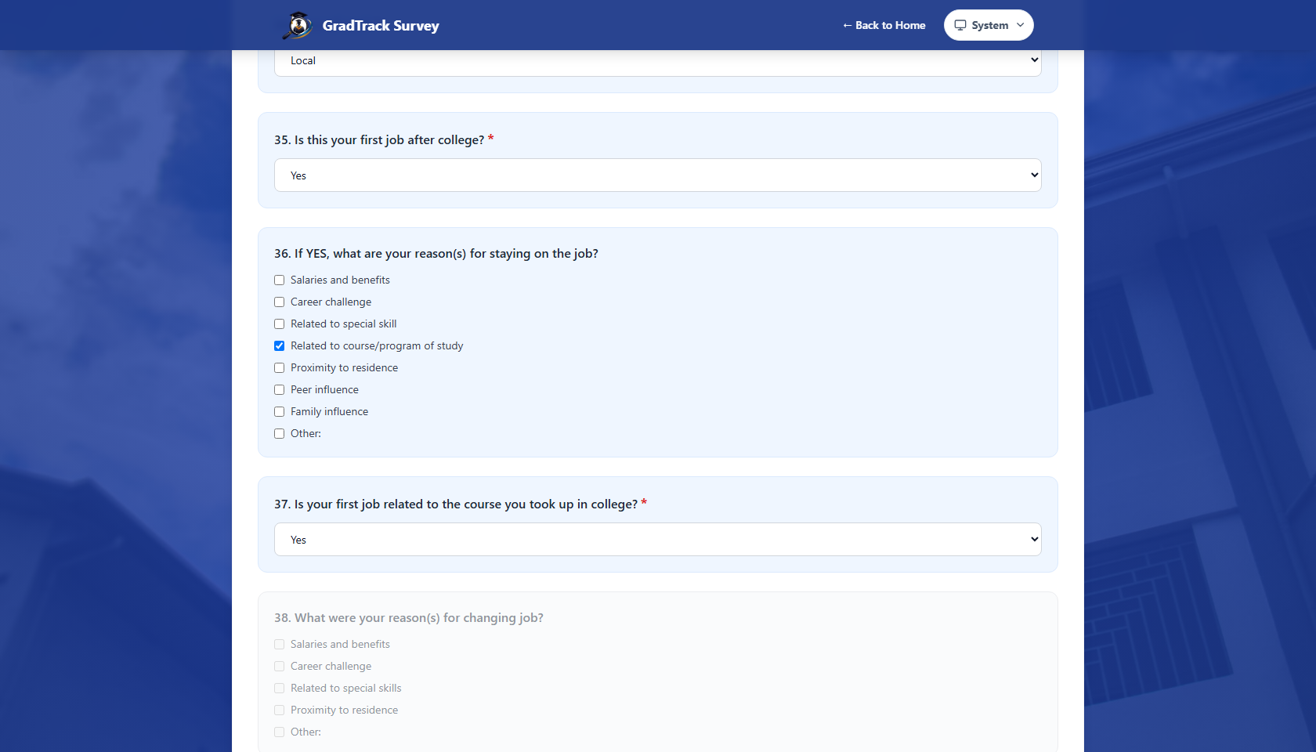
Figure 10. Tracer Survey – Employment Data section

5.4 Review and Submit the Survey
Purpose: Confirm the complete response before final submission.
Step 1. At the final survey stage, click “Review Answers.”
Step 2. Review the answers grouped by section.
Step 3. Return to a section if a correction is needed.
Step 4. Click “Confirm & Submit Survey” when the response is complete.
Expected Result: GradTrack confirms successful submission and offers Graduate Portal account creation.
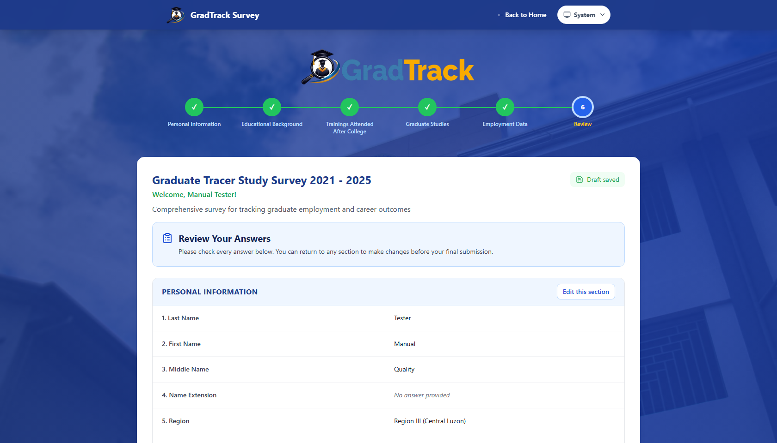
Figure 11. Survey review and confirmation screen
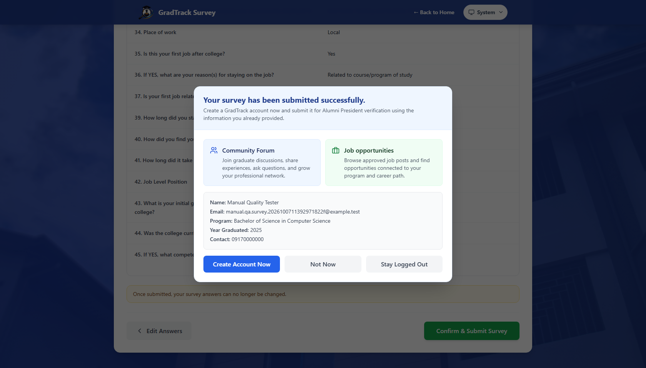
Figure 12. Successful survey submission

5.5 Create a Graduate Portal Account
Purpose: Request access to the alumni community after survey submission.
Step 1. Select “Create Account Now” on the successful-submission page.
Step 2. Enter a password that satisfies the form guidance.
Step 3. Re-enter the password.
Step 4. Click “Create Account.”
Expected Result: The account is created with pending alumni verification. Access is available only after Alumni President approval.
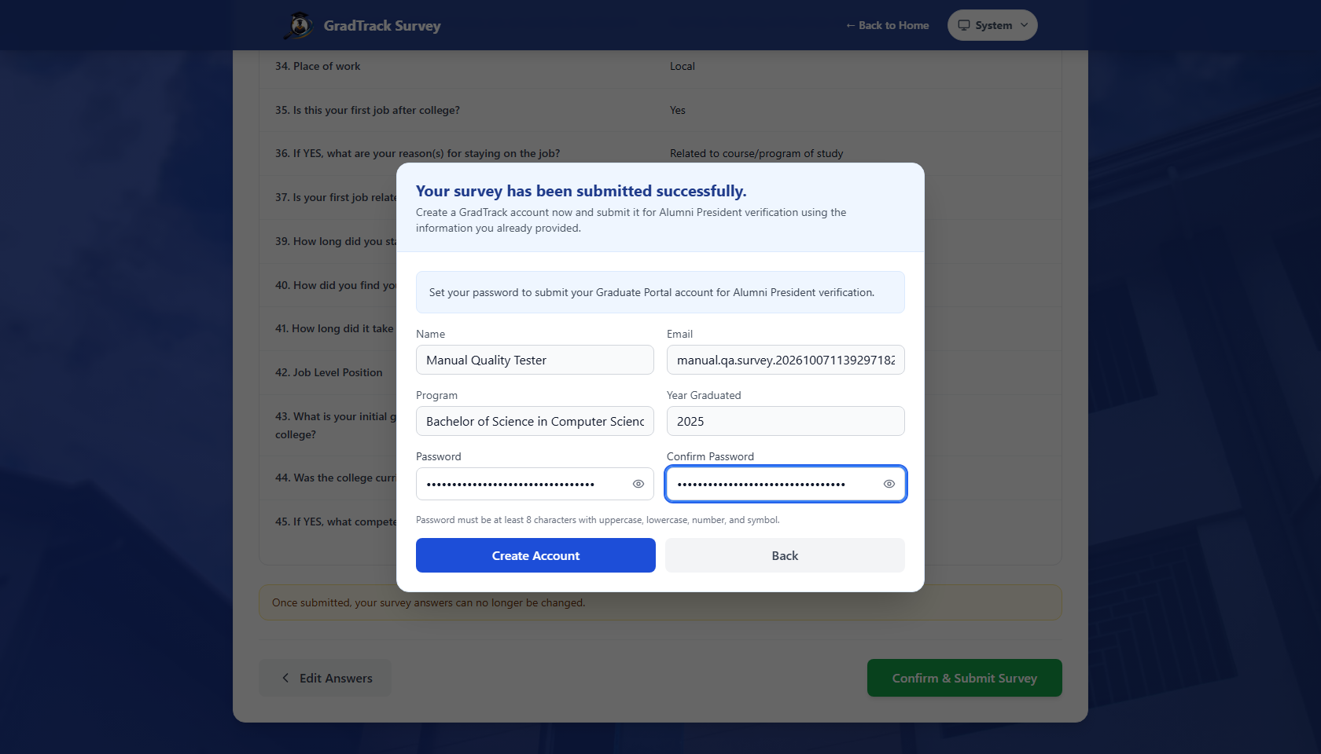
Figure 13. Graduate Portal account-creation form
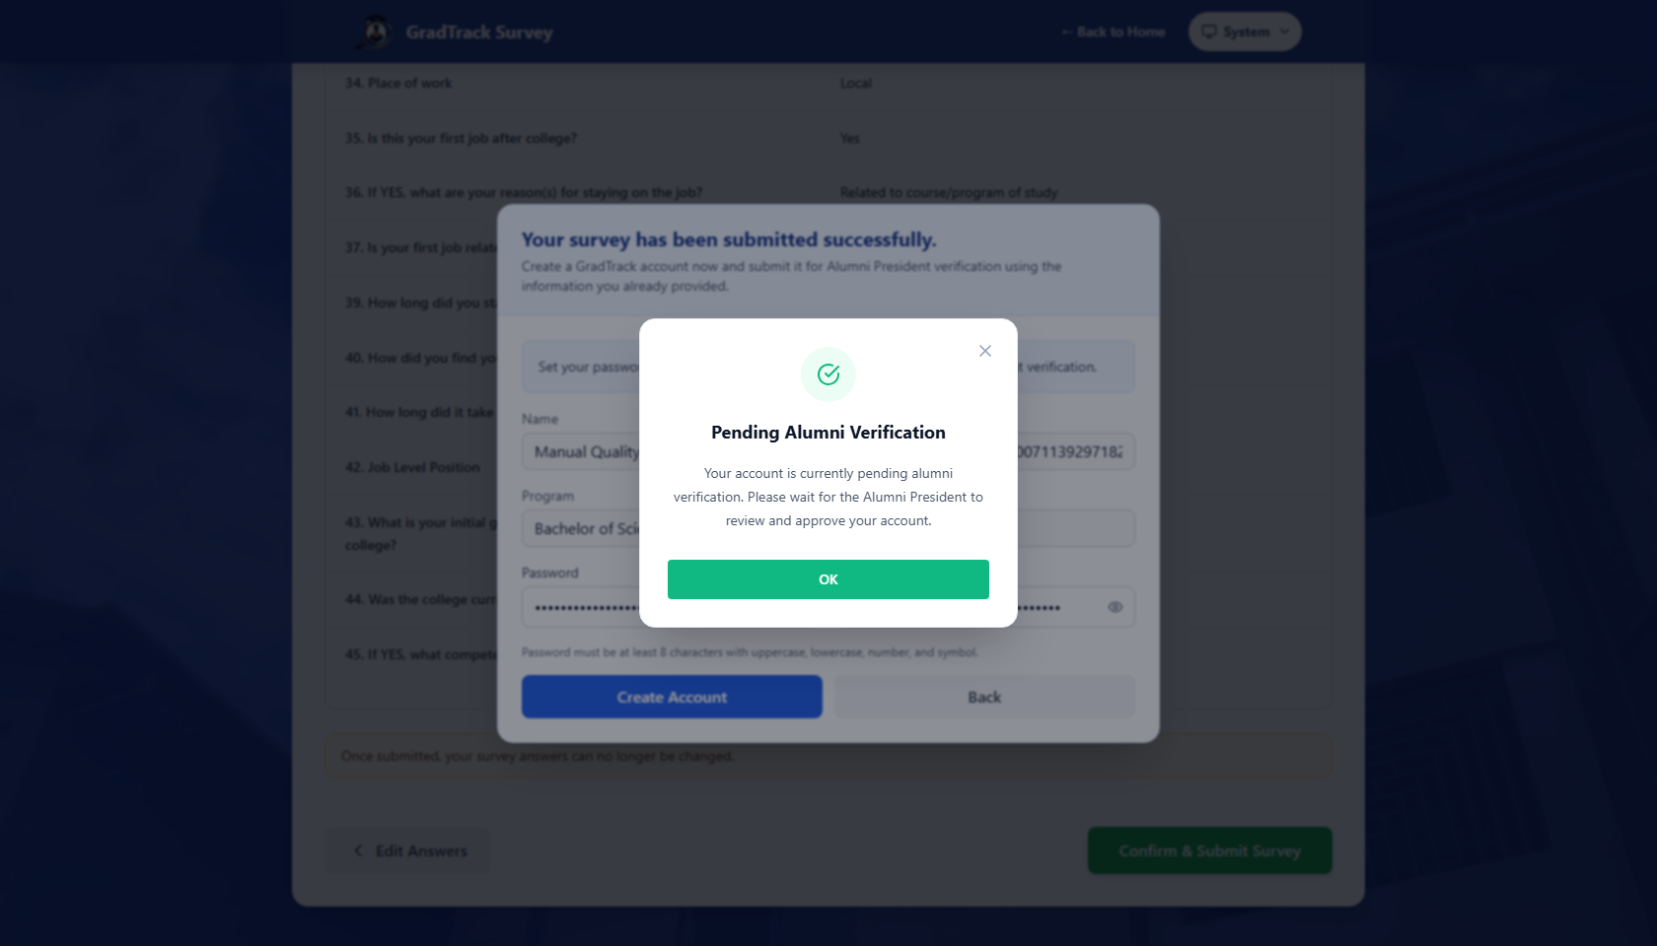
Figure 14. Graduate account pending Alumni President verification

5.6 Use the Community Forum
Purpose: Read alumni discussions and create a community post.
Step 1. Sign in to Graduate Portal.
Step 2. Select the Community Forum icon if another module is open.
Step 3. Browse the available feed and categories.
Step 4. Click “Create Post” to open the composer.
Step 5. Complete the visible post fields and submit when ready.
Expected Result: The forum feed is displayed; a submitted post follows the forum’s current publishing/moderation behavior.
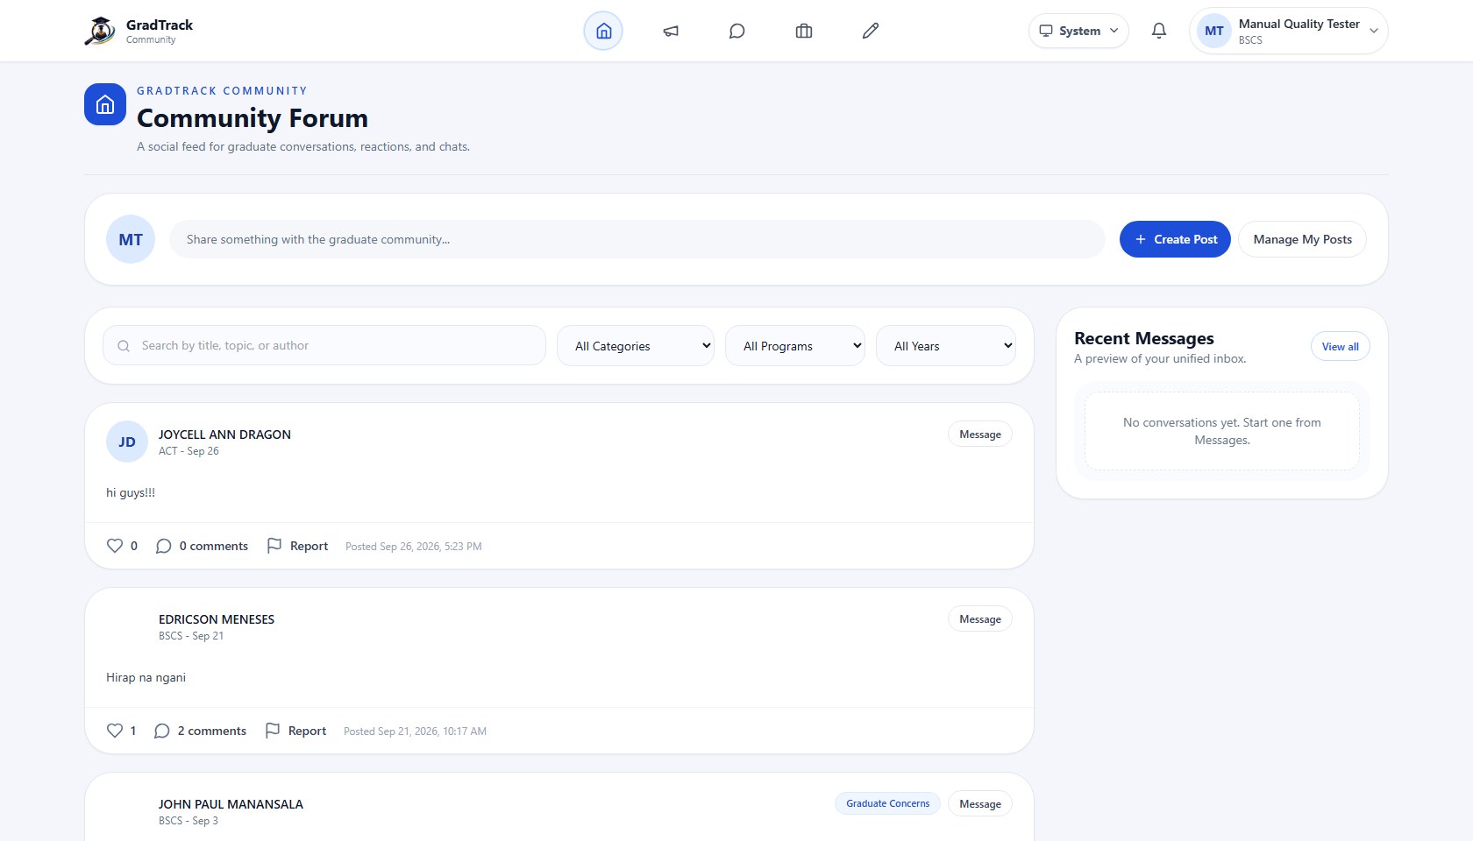
Figure 15. Graduate Community Forum home
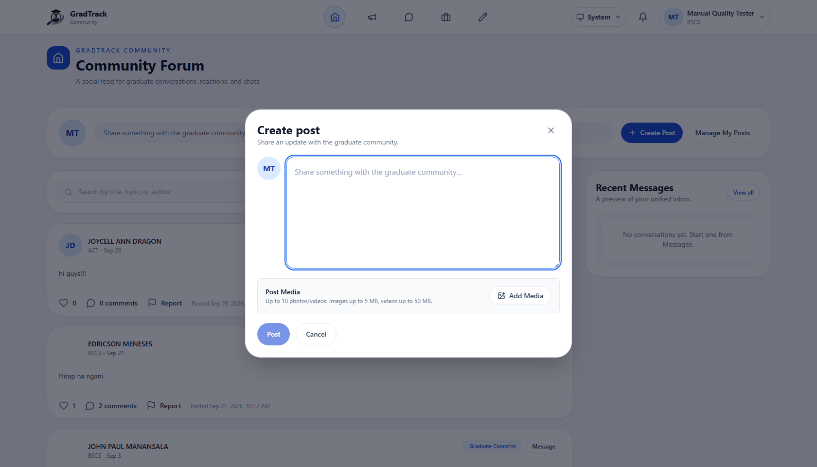
Figure 16. Community Forum post composer

5.7 Read Announcements
Purpose: View information published for graduates.
Step 1. Select the Announcements icon in the Graduate Portal header.
Step 2. Browse the announcement cards.
Step 3. Open an announcement when more detail is available.
Expected Result: Published announcements are shown in the Graduate Portal.
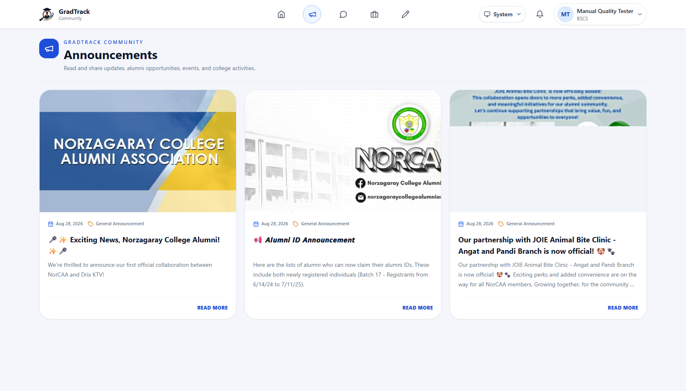
Figure 17. Graduate announcements page

5.8 Use Messaging
Purpose: Open direct or group conversations with alumni users.
Step 1. Select the Messages icon.
Step 2. Choose an existing conversation or click “New Message.”
Step 3. Select the recipient or group controls shown by the interface.
Step 4. Enter and send the message.
Expected Result: The message appears in the selected conversation after successful delivery.
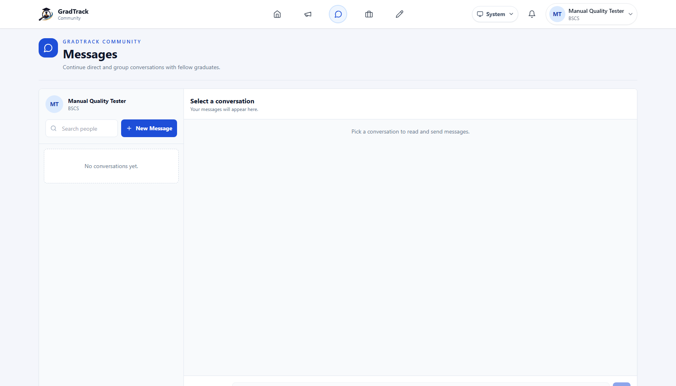
Figure 18. Graduate direct and group messaging workspace

5.9 View and Update the Profile
Purpose: Review graduate, education, and employment information displayed by the portal.
Step 1. Select the profile/edit icon.
Step 2. Review the profile cards and available edit controls.
Step 3. Update only fields enabled by the interface.
Step 4. Save the form when changes are complete.
Expected Result: Saved profile information is displayed in the Graduate profile.
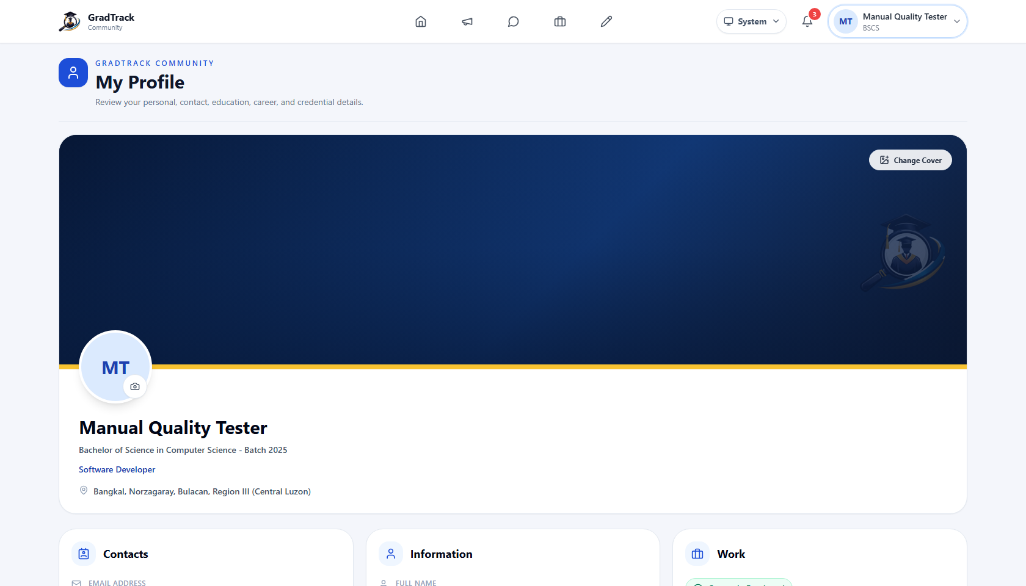
Figure 19. Graduate profile and information cards

5.10 Add a Professional Credential
Purpose: Upload and record a certificate, license, or other professional credential.
Step 1. Open “My Profile” and scroll to Credentials.
Step 2. Click “Add Credential.”
Step 3. Choose a PDF, JPG, JPEG, or PNG certificate file not exceeding 10 MB.
Step 4. Enter the required Credential Name and Issuing Organization.
Step 5. Optionally provide issue/expiration dates, credential ID, and verification link.
Step 6. Click “Save Credential.”
Expected Result: A success message appears and the new credential card is shown in the profile.
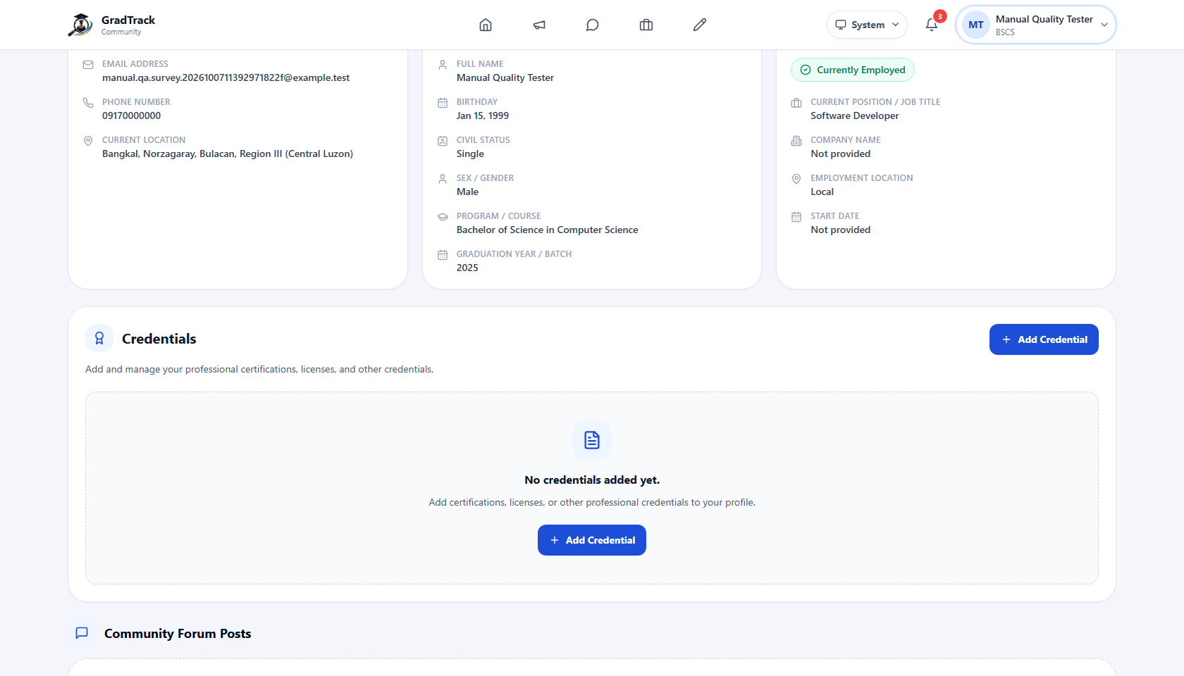
Figure 20. Graduate Credentials section before upload
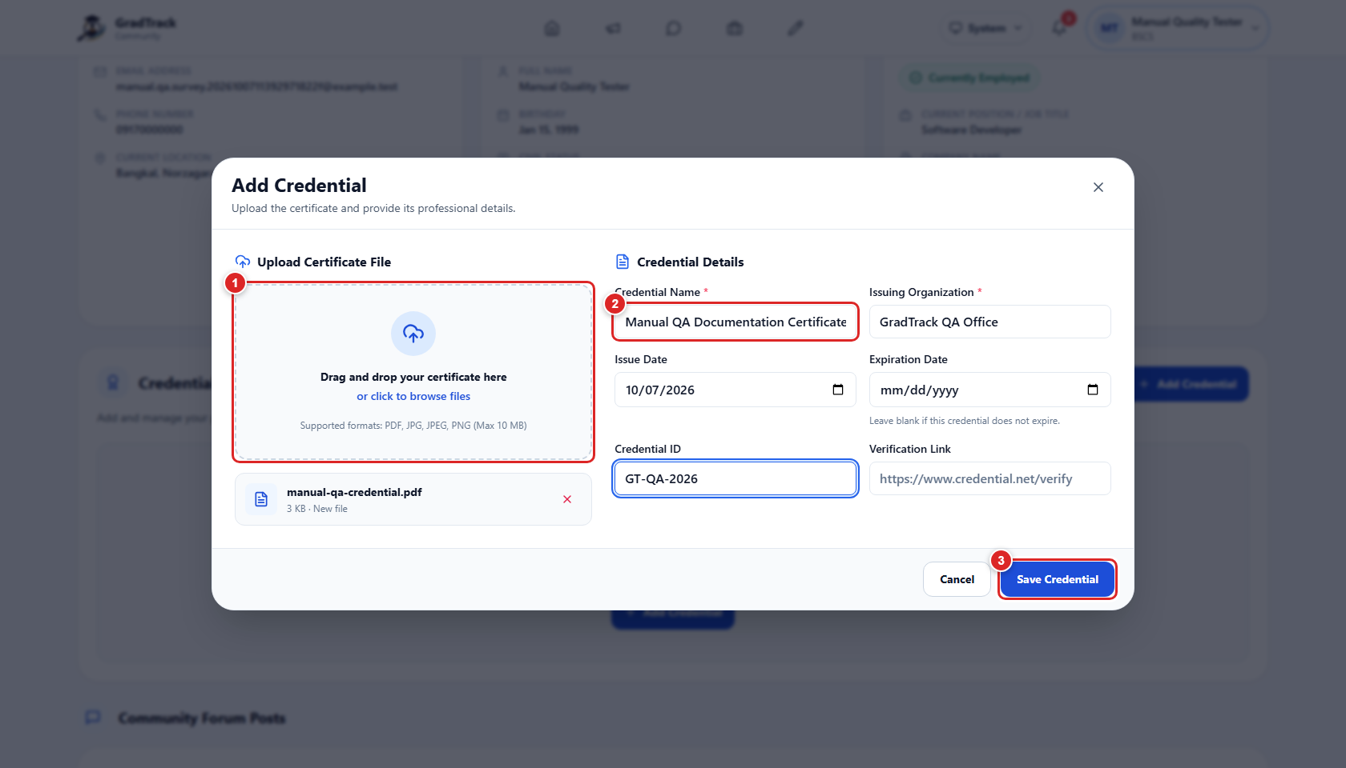
Figure 21. Completed credential-upload form with numbered actions
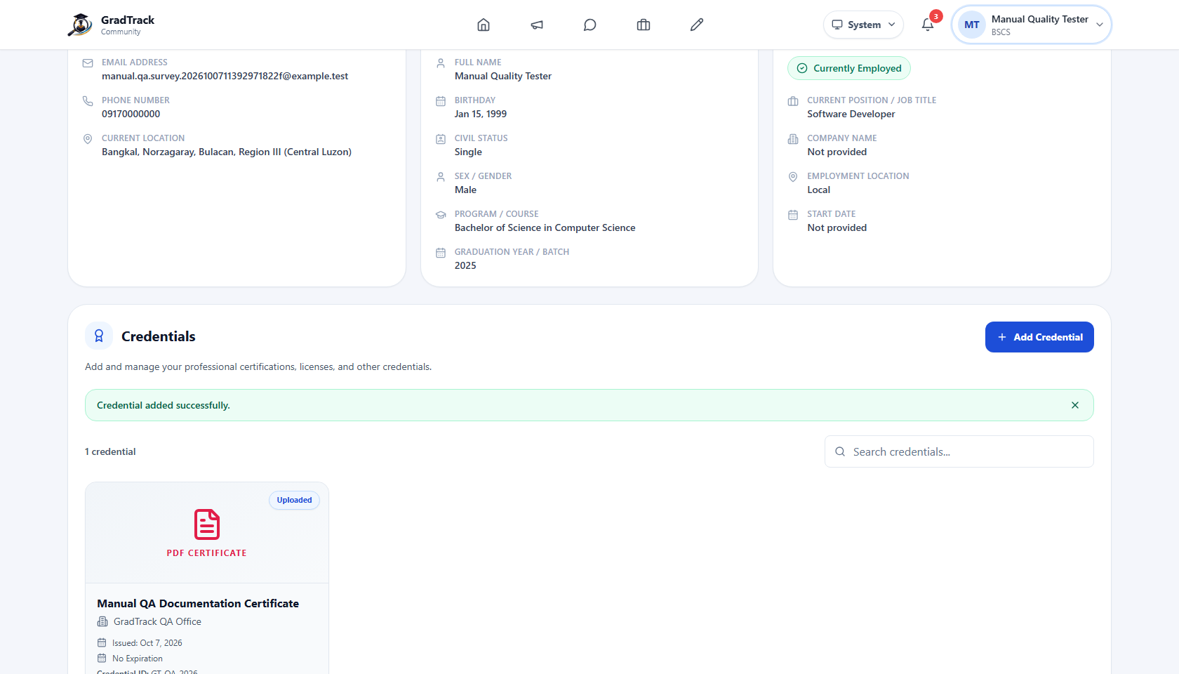
Figure 22. Successfully uploaded Graduate credential

5.11 Manage Account Settings
Purpose: Update the Graduate Portal profile and security settings available to the user.
Step 1. Open the account menu at the upper right.
Step 2. Select the settings/profile option shown by the menu.
Step 3. Review the editable profile and password controls.
Step 4. Save only after verifying the entered information.
Expected Result: GradTrack stores valid changes and keeps the account signed in.
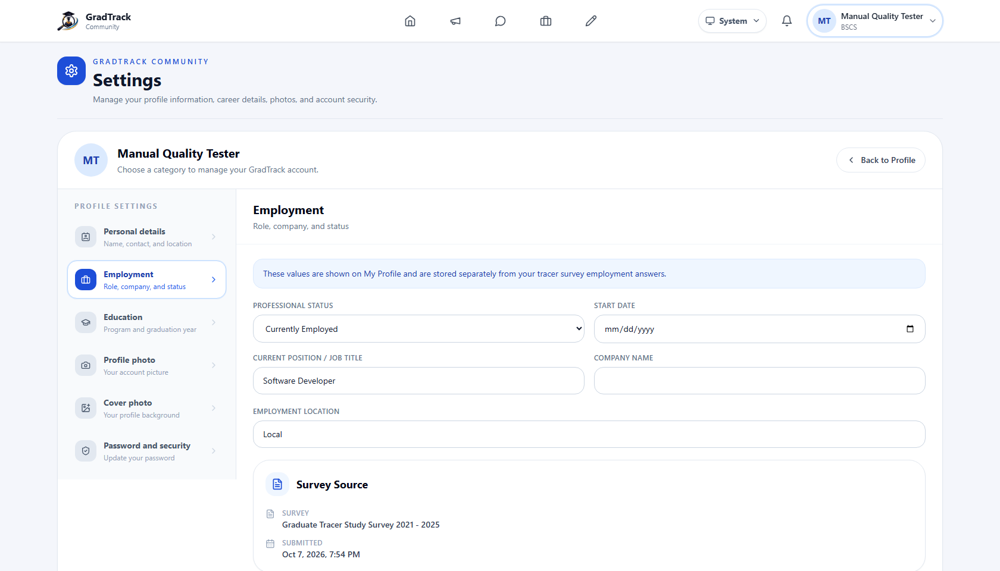
Figure 23. Graduate profile and account settings

5.12 Review Notifications
Purpose: See current Graduate Portal alerts and activity.
Step 1. Click the notification-bell icon in the header.
Step 2. Review unread and earlier notifications.
Step 3. Open a notification to follow its available destination.
Expected Result: The notification panel lists the account’s current notifications.
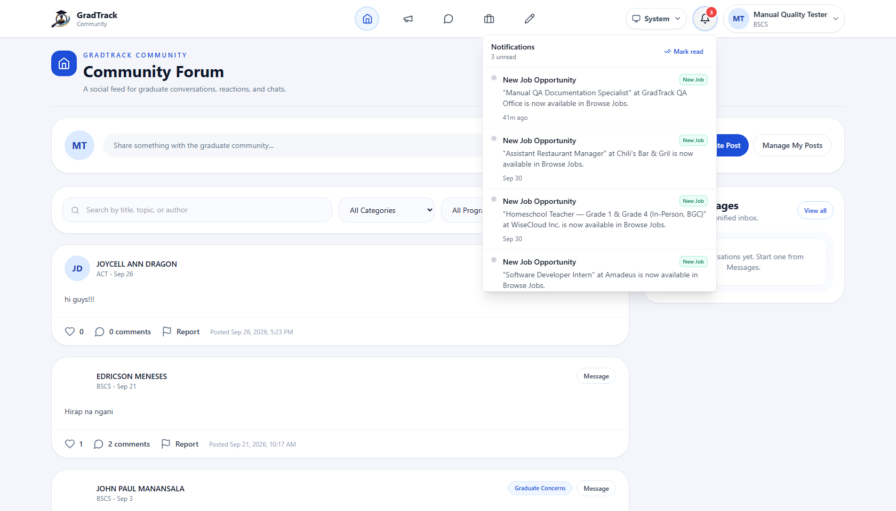
Figure 24. Graduate notifications panel

6. RESEARCH COORDINATOR USER MANUAL

6.1 Review the Research Dashboard
Purpose: See institution-wide graduate and tracer-survey indicators.
Step 1. Sign in with a Research Coordinator account.
Step 2. Open Dashboard from the sidebar.
Step 3. Review the summary cards and chart controls.
Step 4. Use the visible year/program controls when analysis must be narrowed.
Expected Result: The Research Coordinator dashboard displays available institution-level statistics and charts.
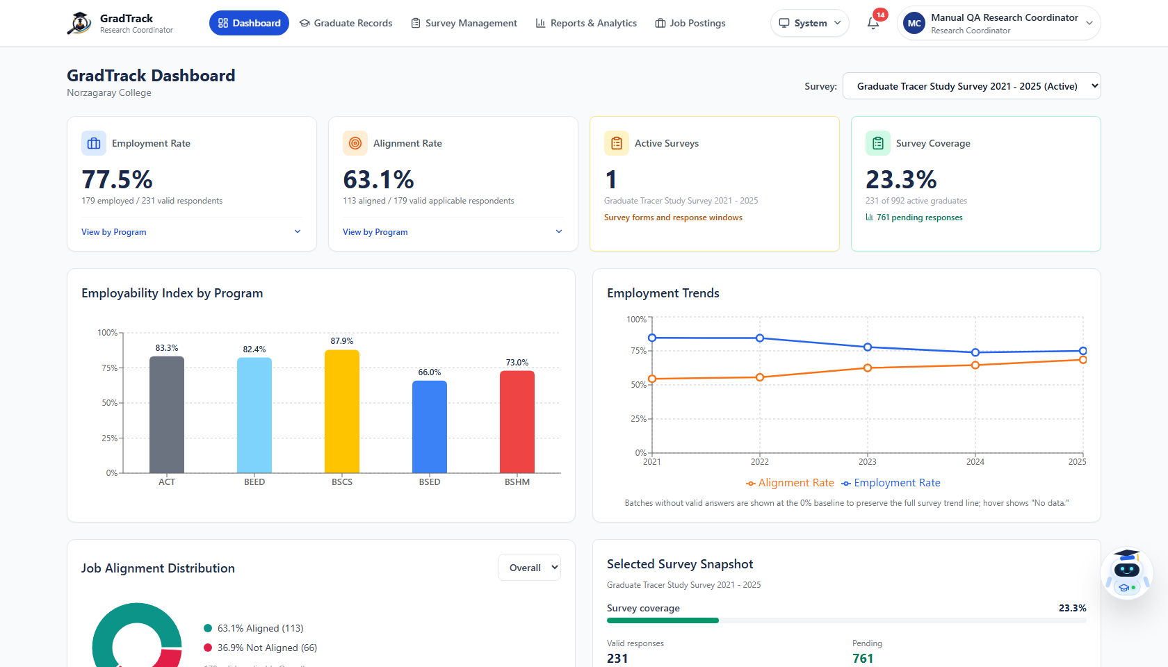
Figure 25. Research Coordinator dashboard

6.2 Monitor Graduate Survey Participation
Purpose: Identify graduates with completed or incomplete tracer-survey participation.
Step 1. Select “Graduate Survey Participation.”
Step 2. Use search and available filters to narrow the table.
Step 3. Review status and survey information for each record.
Step 4. Use the row reminder action where the interface makes it available.
Expected Result: The filtered participation list and relevant reminder controls are displayed.
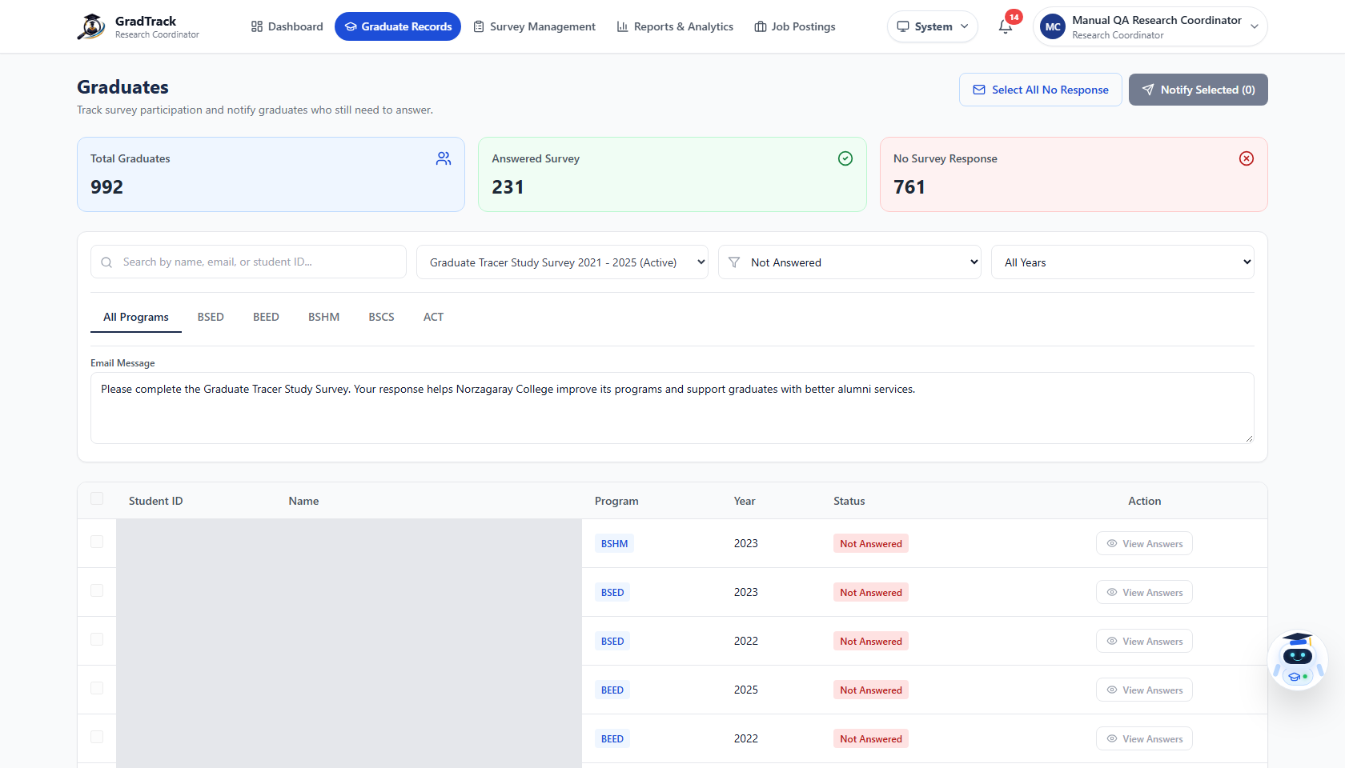
Figure 26. Research Coordinator graduate survey participation

6.3 Manage Surveys
Purpose: Review, activate, edit, or otherwise manage tracer surveys within the coordinator’s permissions.
Step 1. Open “Survey Management.”
Step 2. Review the current survey cards and status.
Step 3. Use a survey’s action menu for the operations available in its current state.
Step 4. Open “Edit Survey” to inspect or change fields that remain editable.
Step 5. Save valid changes when required.
Expected Result: GradTrack applies the selected permitted survey action and refreshes the survey status.
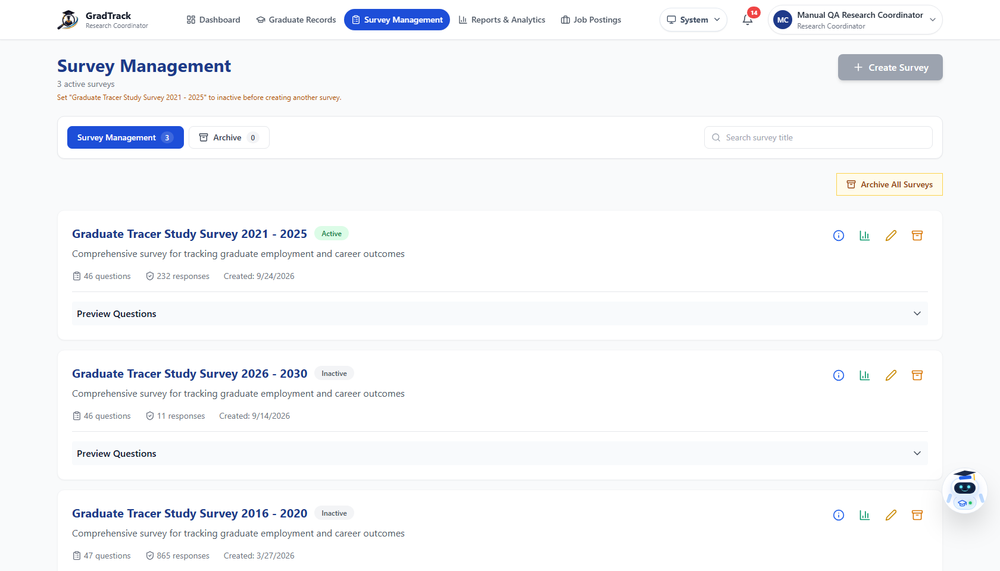
Figure 27. Research Coordinator Survey Management
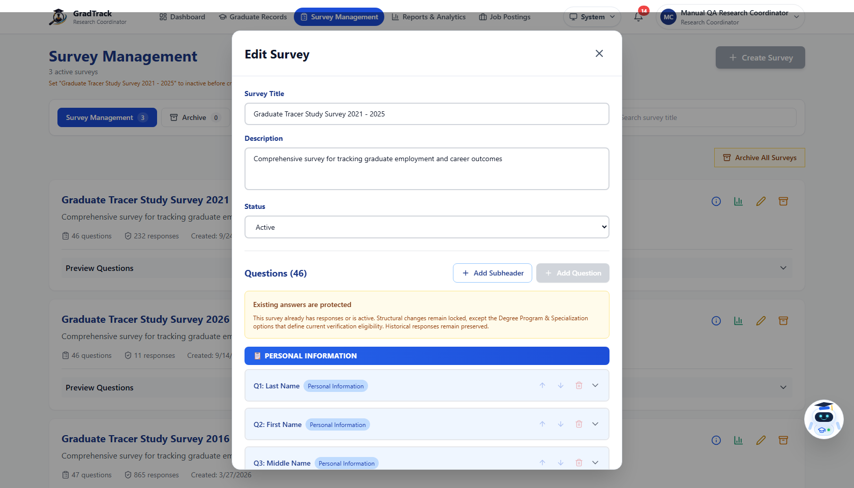
Figure 28. Editing the current survey and scope options
Verified current-state constraint: During validation, an active survey already existed. The “Create Survey” action was disabled until the current survey is made inactive. Structural changes to a survey with responses are also protected by the interface. The manual therefore does not claim that a second live survey was created.

6.4 Monitor Responses
Purpose: Open survey-level response totals and analytics.
Step 1. From Survey Management, choose the current survey’s response/analytics action.
Step 2. Review participation totals, response status, and available charts.
Step 3. Apply the filters offered by the screen.
Expected Result: The Survey Analytics page displays current response information for the selected survey.
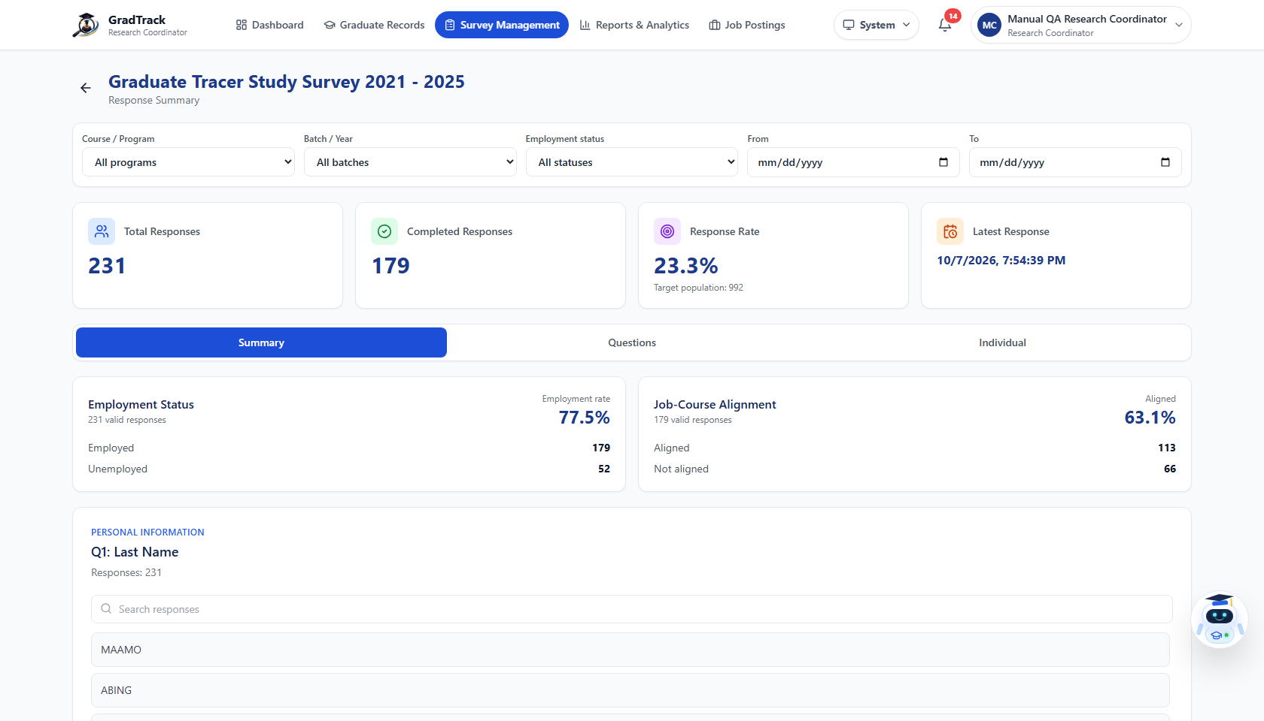
Figure 29. Survey response monitoring and analytics

6.5 Use Reports and Export Data
Purpose: Analyze graduate outcomes and produce report files.
Step 1. Open “Reports & Analytics.”
Step 2. Choose a report tab.
Step 3. Apply year, department/program, or survey controls that are visible for the selected tab.
Step 4. Review the resulting cards, tables, and charts.
Step 5. Click “Export PDF,” “Export Word,” or “Export Excel.”
Step 6. Wait for the generated file to download.
Expected Result: A report matching the selected scope is displayed and the chosen export is downloaded.
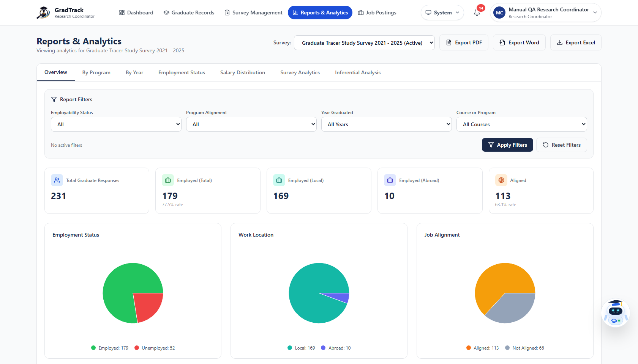
Figure 30. Research Coordinator reports overview and export controls
Export validation: The PDF, Word, and Excel exports were each generated and validated during this manual’s live-system test.

6.6 Review Descriptive Survey Analytics
Purpose: Inspect question-level counts, percentages, and visual summaries.
Step 1. Open Reports & Analytics.
Step 2. Select “Survey Analytics.”
Step 3. Choose the survey and department scope shown on the page.
Step 4. Review the response summaries and question charts.
Expected Result: GradTrack displays descriptive summaries derived from the selected survey responses.
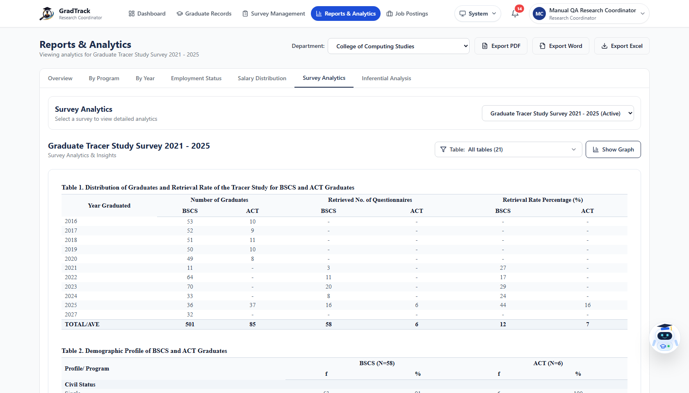
Figure 31. Survey Analytics charts and descriptive summaries

6.7 Run Inferential Analysis
Purpose: Evaluate the relationship between two supported survey variables.
Step 1. Open “Inferential Analysis.”
Step 2. Select the two variables offered by the analysis controls.
Step 3. Set the available scope or filters.
Step 4. Click “Run Analysis.”
Step 5. Review the test statistic, strength/interpretation, evidence statement, compared-answer count, and chart.
Expected Result: A completed inferential result is displayed when enough compatible data is available.
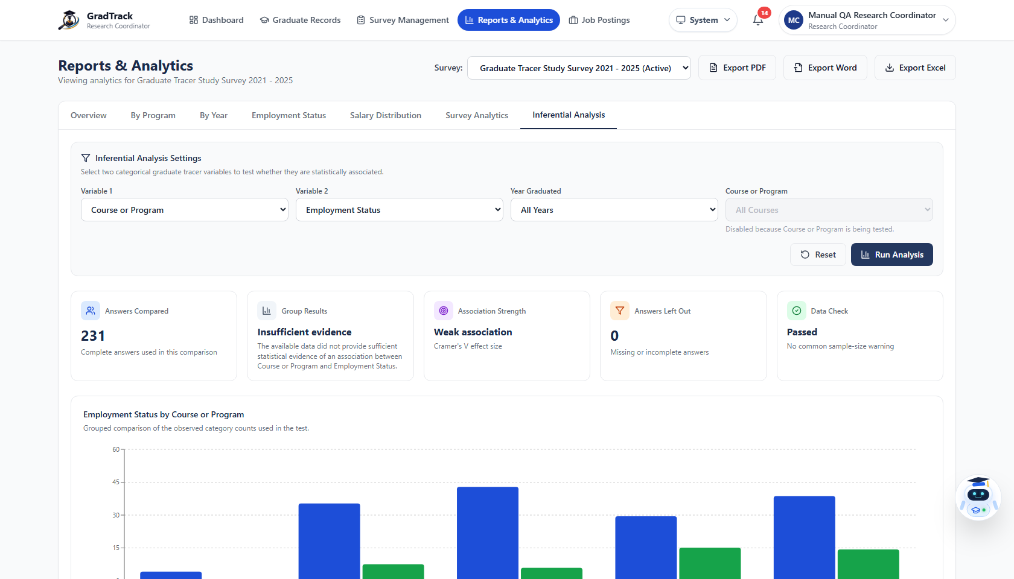
Figure 32. Completed Chi-Square inferential analysis result

6.8 Publish a Staff Job Post
Purpose: Create a job opportunity as an authorized personnel user.
Step 1. Open “Job Postings.”
Step 2. Click “Create Job.”
Step 3. Complete the required job title, company, description, deadline, contact/application, and other visible fields.
Step 4. Review optional fit, skills, qualifications, and requirements-file controls.
Step 5. Click “Publish Job.”
Expected Result: The job is published and appears in the job-posting list. Current staff-authorized roles publish directly.
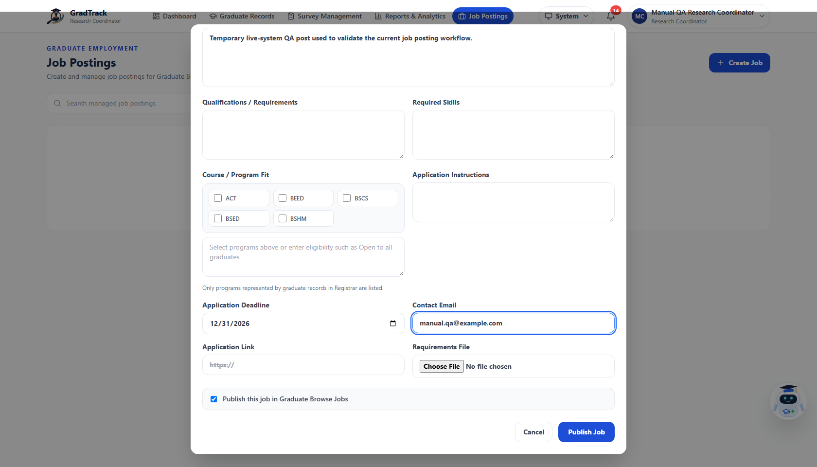
Figure 33. Authorized staff job-post creation form
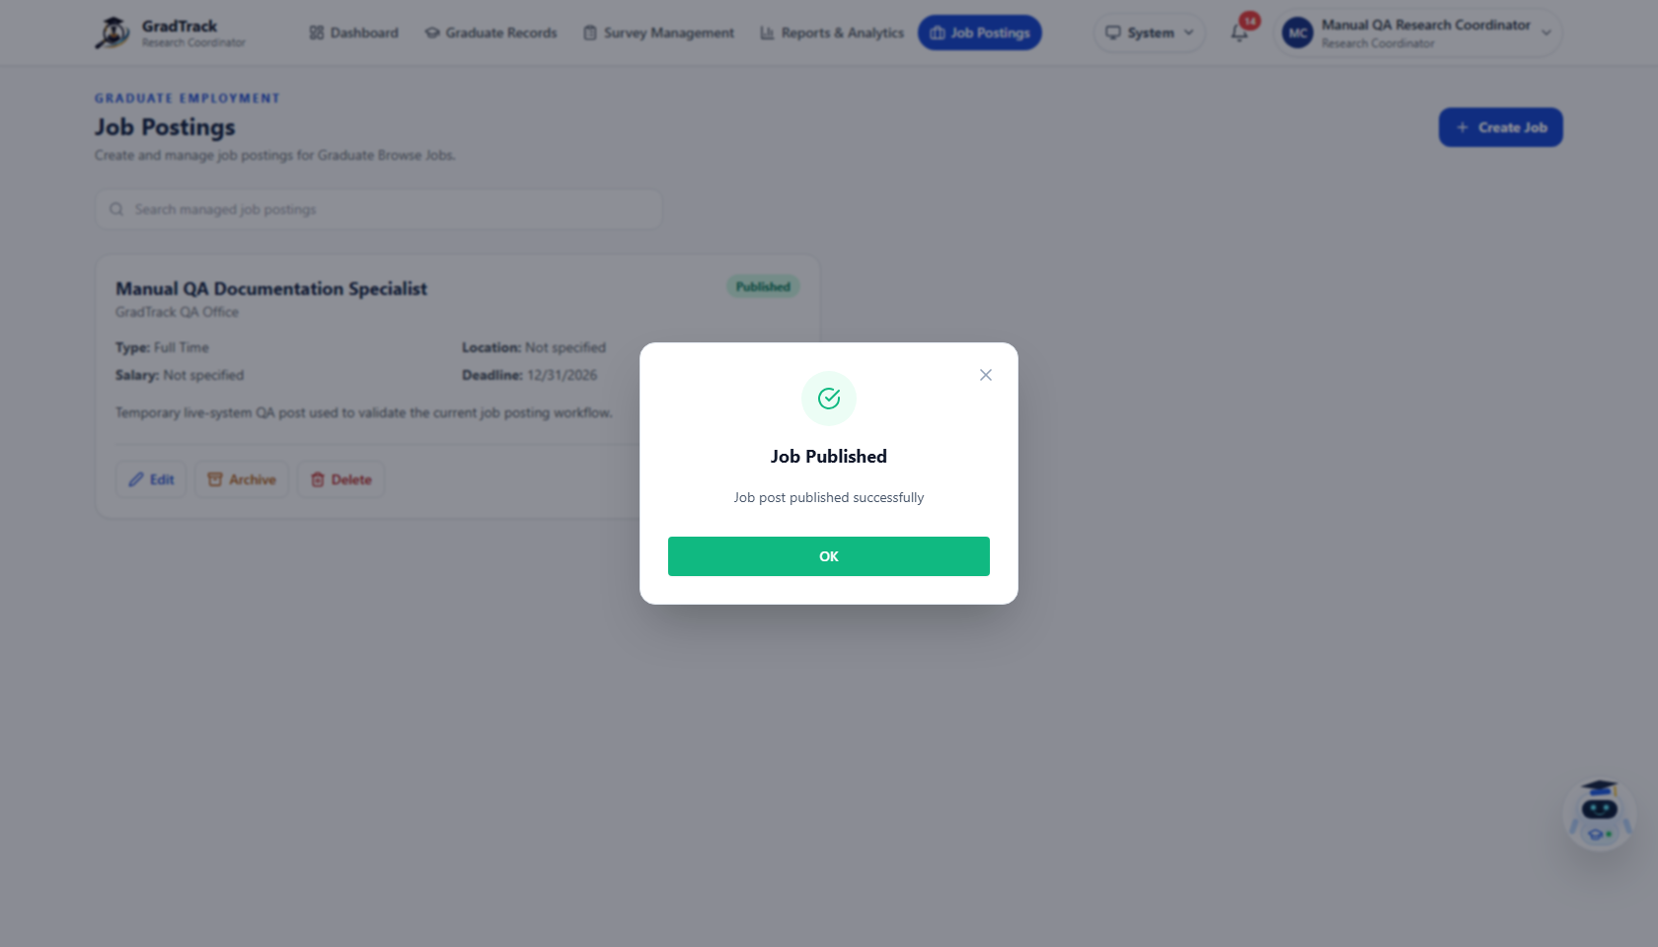
Figure 34. Successful staff job-post publication

7. DEAN USER MANUAL
A Dean sees data only for the programs mapped to that Dean role. The examples below show the CCS Dean scope.

7.1 Review the Dean Dashboard
Purpose: View graduate and tracer information for the assigned department.
Step 1. Sign in with the Dean account.
Step 2. Open Dashboard.
Step 3. Review summary cards, charts, and scope labels.
Step 4. Use the available year/program controls without leaving the authorized department scope.
Expected Result: The department-scoped Dean Dashboard is displayed.
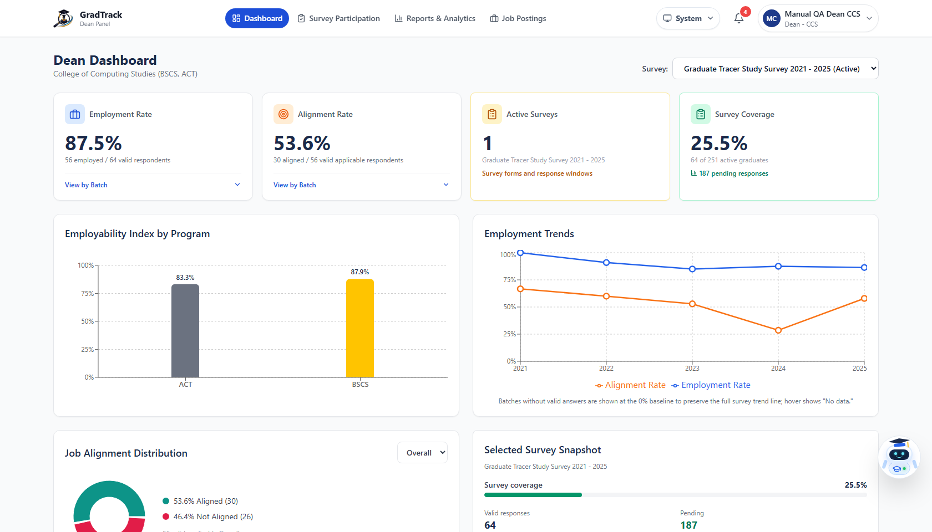
Figure 35. CCS Dean dashboard with department-scoped data

7.2 Review Survey Participation
Purpose: Monitor tracer participation for graduates in the Dean’s assigned programs.
Step 1. Open “Graduate Survey Participation.”
Step 2. Search or filter the permitted records.
Step 3. Review the displayed response status.
Step 4. Use available reminder controls when follow-up is appropriate.
Expected Result: Only records within the Dean’s configured program scope are displayed.
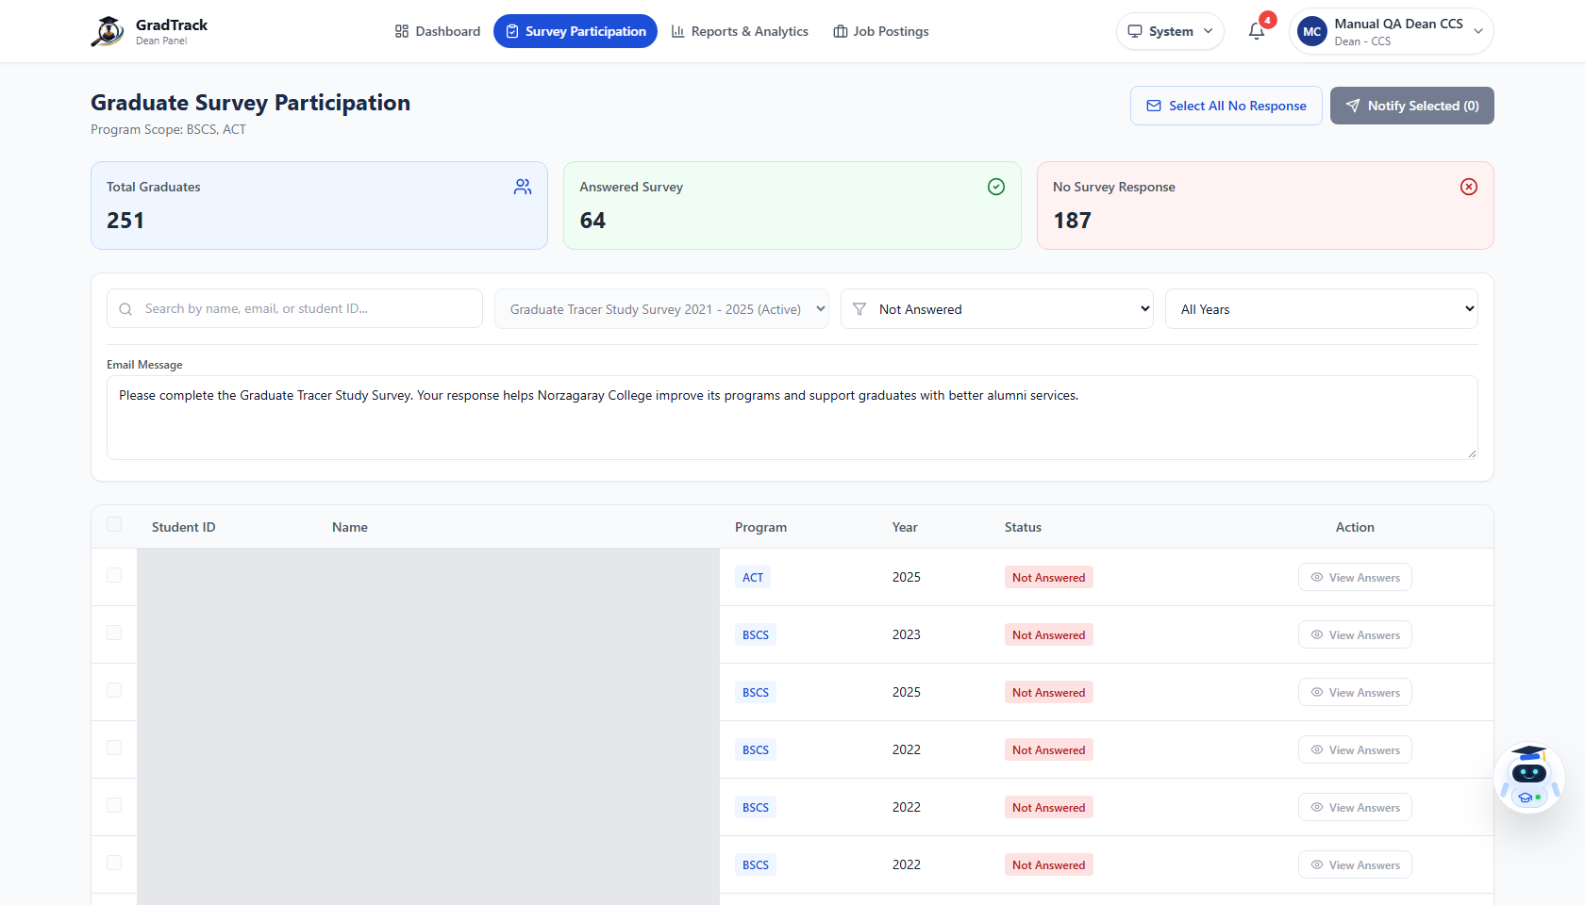
Figure 36. Dean survey participation within assigned programs

7.3 Analyze and Export Reports
Purpose: Review department-scoped graduate outcomes and download formal reports.
Step 1. Open “Reports & Analytics.”
Step 2. Choose an available report tab.
Step 3. Apply the available year/program filters.
Step 4. Review the cards, tables, and charts.
Step 5. Select PDF, Word, or Excel export when a file is required.
Expected Result: The report remains restricted to the Dean’s mapped programs and the chosen export downloads.
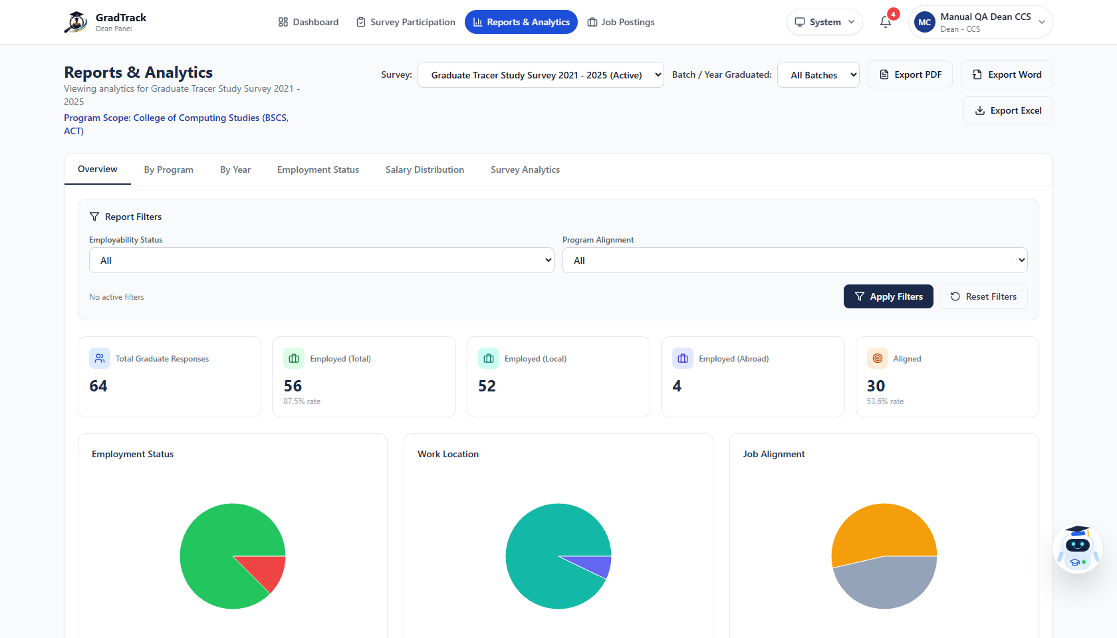
Figure 37. Dean reports and analytics with restricted program scope

7.4 Manage Job Postings
Purpose: Publish and maintain authorized staff job opportunities.
Step 1. Open “Job Postings.”
Step 2. Review current postings.
Step 3. Use “Create Job” to enter a new opportunity.
Step 4. Use the available edit/archive controls for postings the role may manage.
Expected Result: The current job list reflects successful permitted actions.
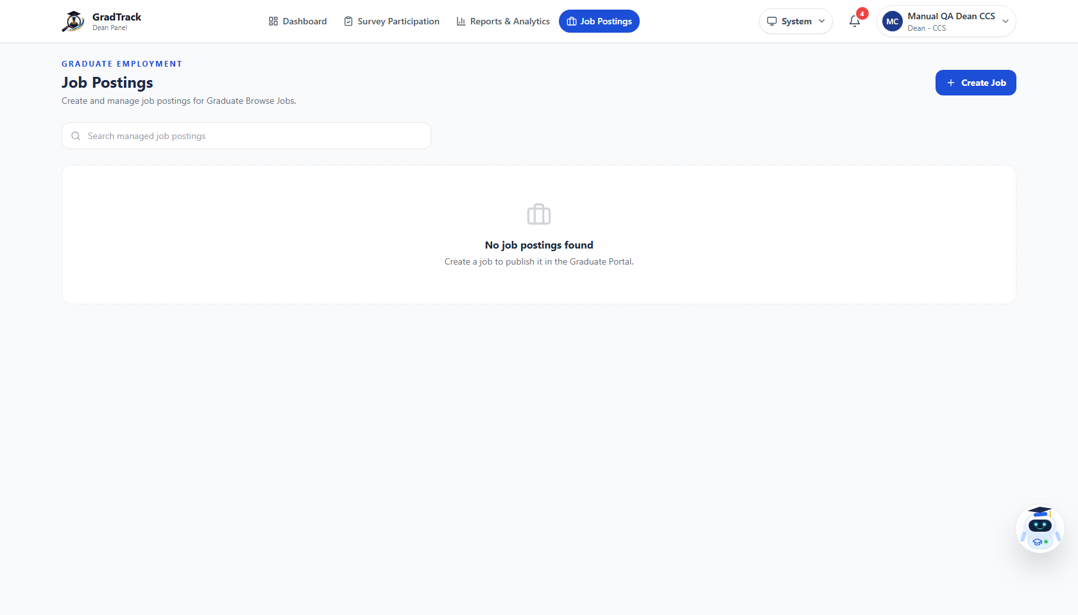
Figure 38. Dean job-posting management
Restriction: The current Dean navigation does not expose Survey Management or Inferential Analysis. Those functions are not documented as Dean permissions.

8. REGISTRAR USER MANUAL

8.1 View and Search Graduate Records
Purpose: Locate graduate master records maintained by the Registrar.
Step 1. Sign in with the Registrar account.
Step 2. Open “Manage Graduates.”
Step 3. Enter a name, student ID, or other supported term in “Search graduates.”
Step 4. Review the matching rows and available row actions.
Expected Result: The graduate table displays records matching the search and current filters.
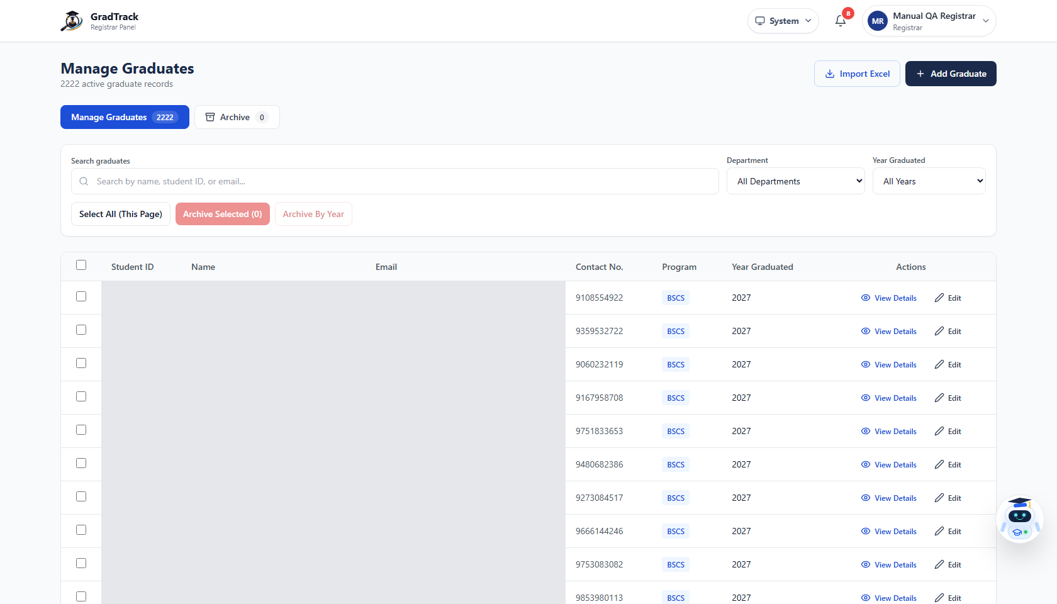
Figure 39. Registrar graduate-records table

8.2 Filter by Program and Graduation Year
Purpose: Narrow graduate records to a course/program and year.
Step 1. Open Manage Graduates.
Step 2. Open the control labeled “Department.”
Step 3. Select a program entry, such as “BSCS — Bachelor of Science in Computer Science.”
Step 4. Select the graduation year.
Step 5. Review the filtered total and rows.
Expected Result: Only records matching both the chosen program and graduation year are displayed.
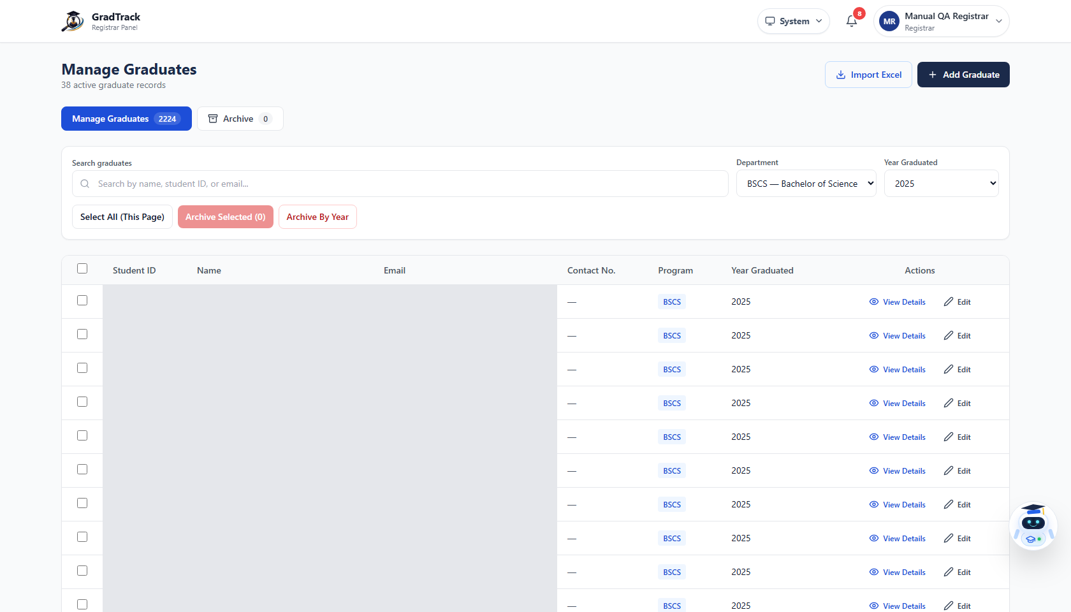
Figure 40. Verified Registrar program and graduation-year filtering
Actual filter behavior: Although the live control is labeled “Department,” its options are individual course/program records. In the verified test, selecting BSCS and 2025 returned only BSCS graduates from 2025.

8.3 Add a Graduate Manually
Purpose: Create one graduate master record without a bulk import.
Step 1. Click “Add Graduate.”
Step 2. Enter the Student ID and graduate name.
Step 3. Enter the email and contact number where required by the form.
Step 4. Select the Department and then the Course/Program provided by the form.
Step 5. Enter the graduation year.
Step 6. Click “Add Graduate.”
Expected Result: GradTrack displays “Graduate Added,” and the new record appears in the table.
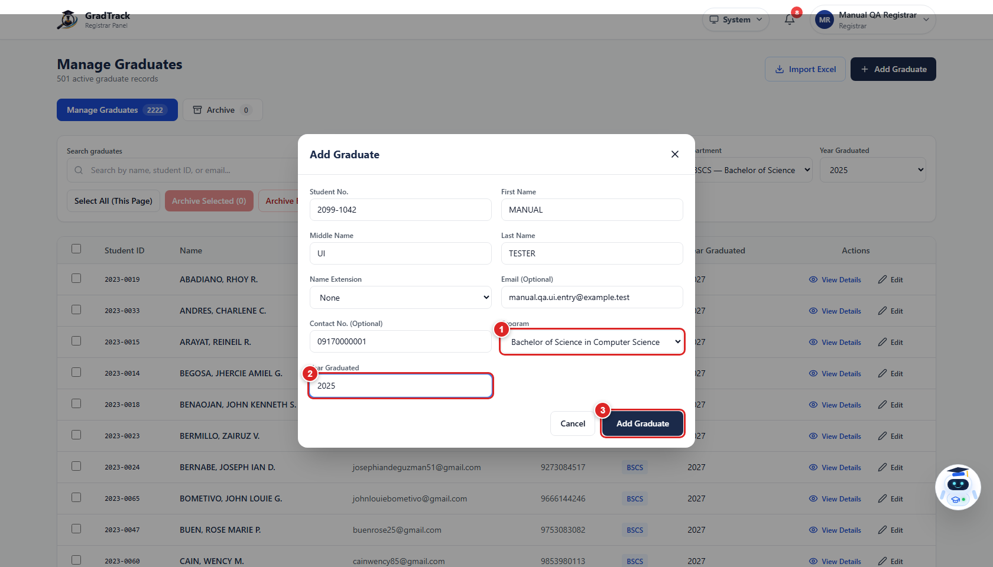
Figure 41. Registrar manual graduate-entry form
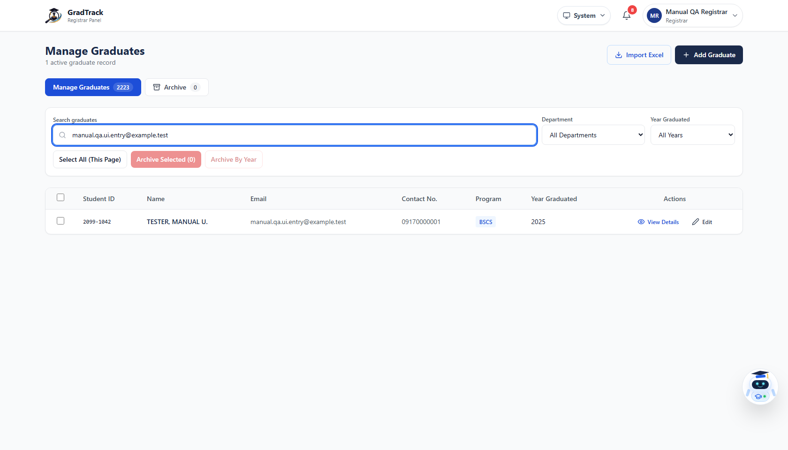
Figure 42. Newly added graduate record

8.4 Edit a Graduate Record
Purpose: Correct or update an existing graduate master record.
Step 1. Find the graduate through search or filters.
Step 2. Click the row’s “Edit” action.
Step 3. Change the necessary fields.
Step 4. Click “Save Changes.”
Expected Result: GradTrack displays “Graduate Updated,” and the table shows the saved values.
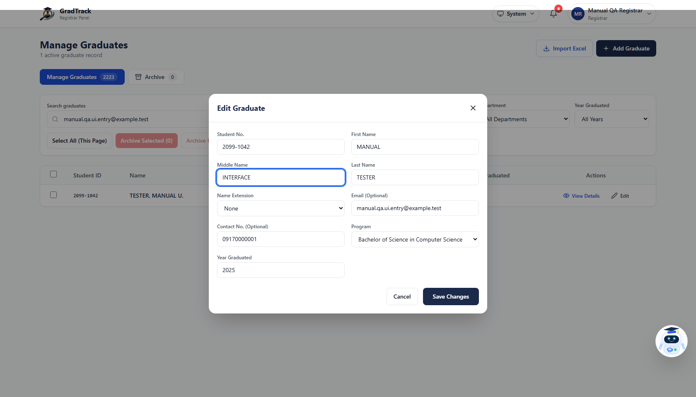
Figure 43. Registrar edit-graduate form

8.5 Import Graduate Records
Purpose: Add graduate master records from a supported spreadsheet.
Step 1. Prepare an .xlsx or .csv file using the fields/template expected by the import area.
Step 2. Use the import/file control on Manage Graduates.
Step 3. Select the file.
Step 4. Wait while GradTrack validates and imports the rows.
Step 5. Review inserted, skipped, duplicate, and error information in the result dialog.
Step 6. Click “Done.”
Expected Result: A result dialog reports the import outcome. Valid new rows are added to the graduate records.
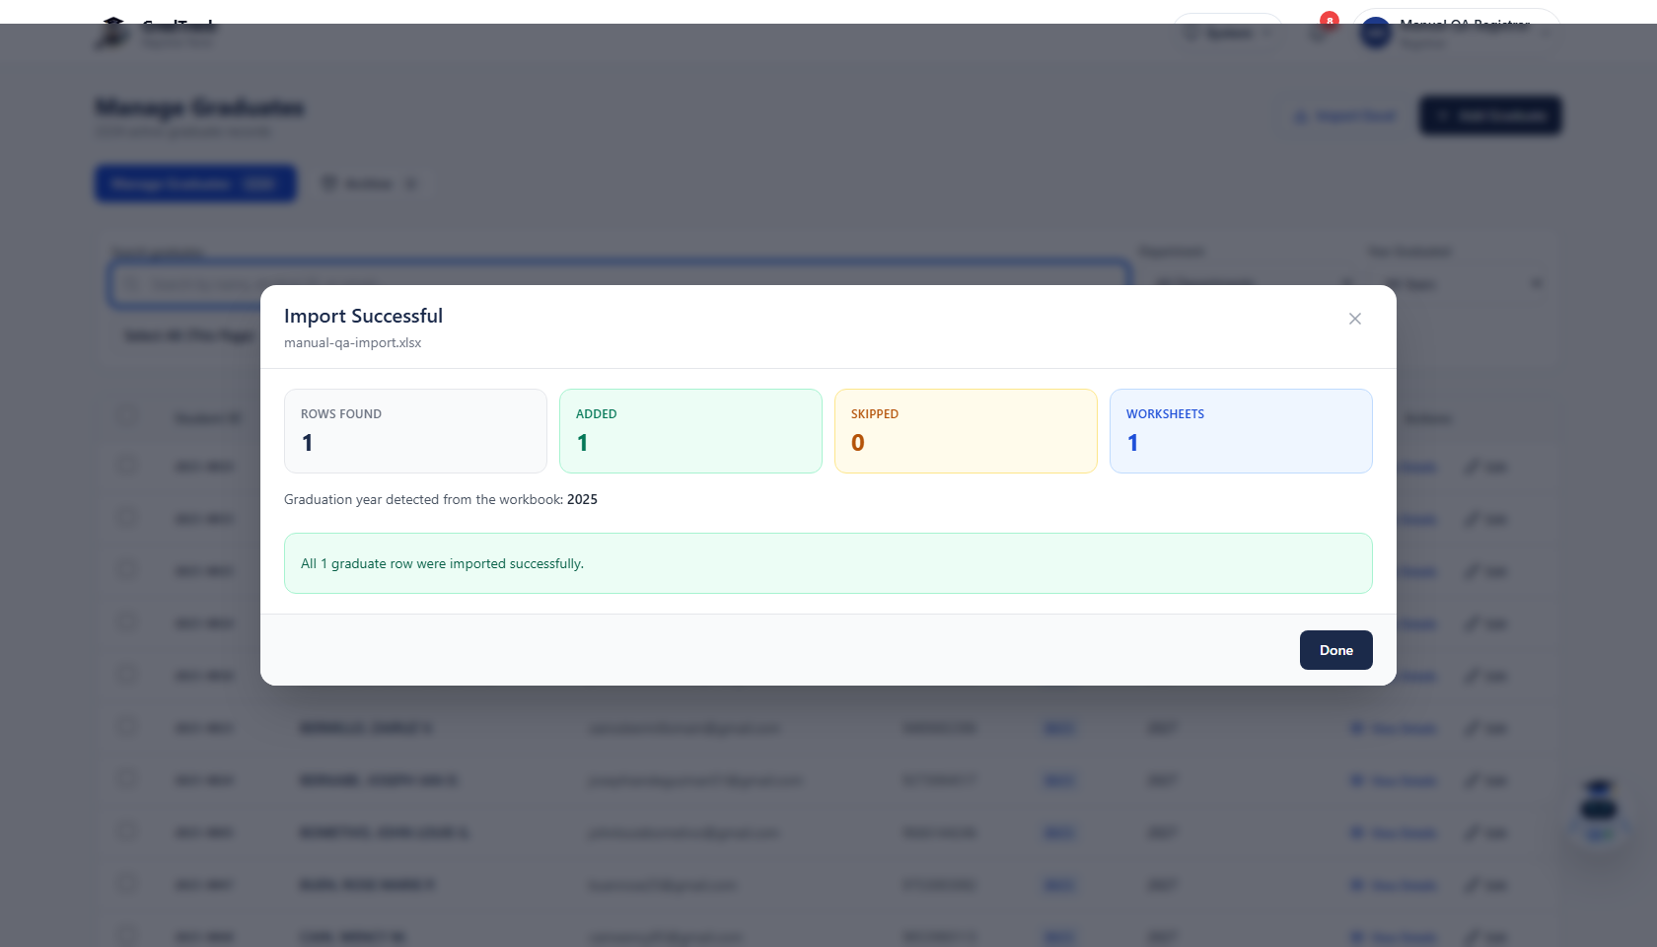
Figure 44. Registrar Excel import validation and result

8.6 Archive and Restore Records
Purpose: Control whether an obsolete or incorrectly active graduate record remains in the main list.
Step 1. Find the required record.
Step 2. Use the archive action exposed for that row.
Step 3. Confirm the action when prompted.
Step 4. Use the archived-record view and restore action when a record must return to the active list.
Expected Result: The record moves between active and archived views according to the confirmed action.
Records control: Archive/restore changes record visibility. Follow institutional records policy and verify the target record before confirming.

9. ALUMNI PRESIDENT USER MANUAL

9.1 Approve or Reject Graduate Accounts
Purpose: Verify that a pending account belongs to the matched graduate before granting portal access.
Step 1. Open “Alumni Registered List.”
Step 2. Use “Search pending accounts” to find the graduate.
Step 3. Click “View details” and compare the displayed graduate information.
Step 4. Choose “Approve account” or “Reject account.”
Step 5. Read the confirmation message and confirm the intended action.
Expected Result: An approved account can use Graduate Portal. A rejected account remains unable to sign in as an approved graduate.
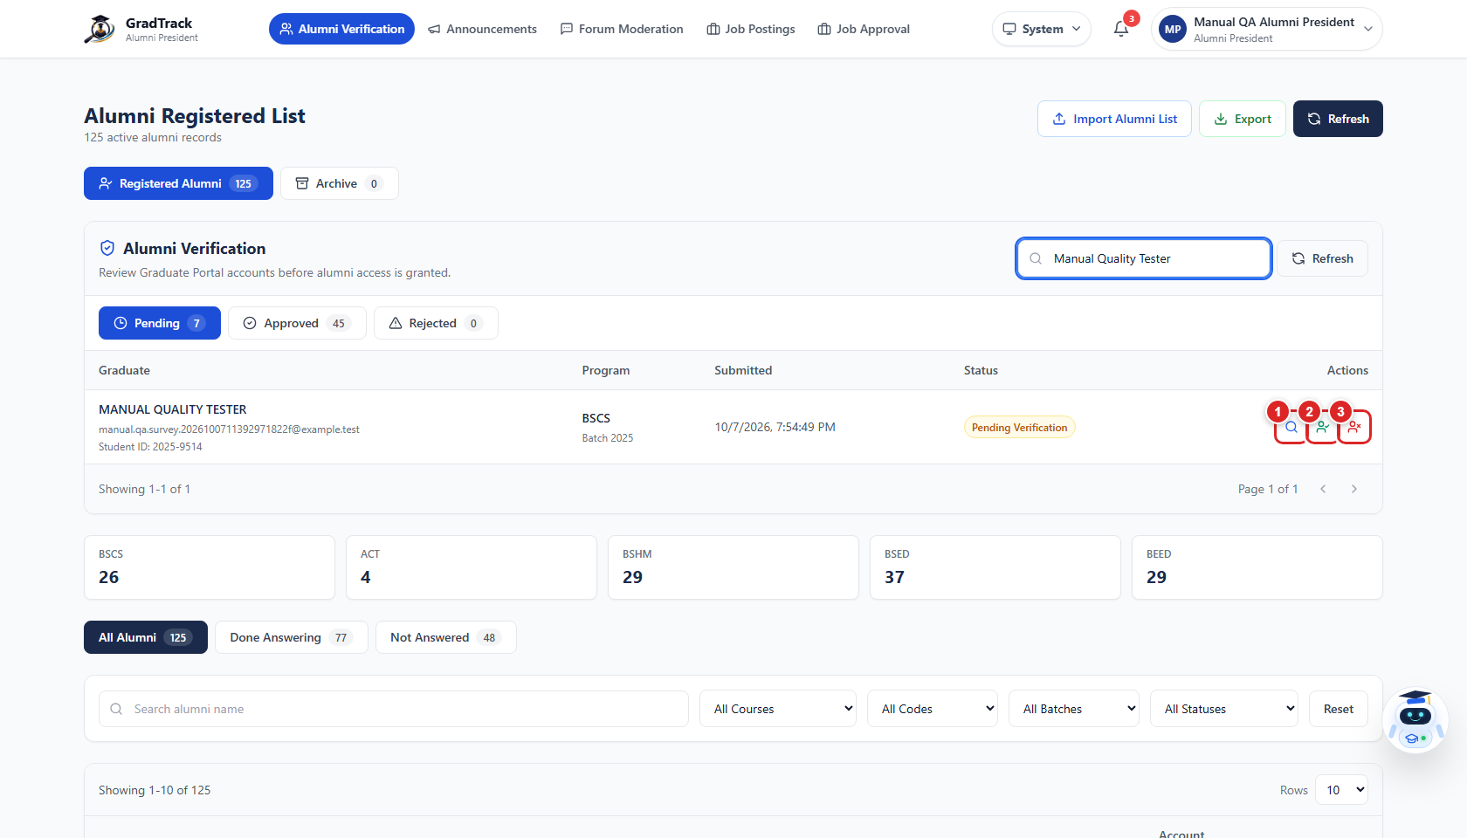
Figure 45. Alumni President account-verification queue
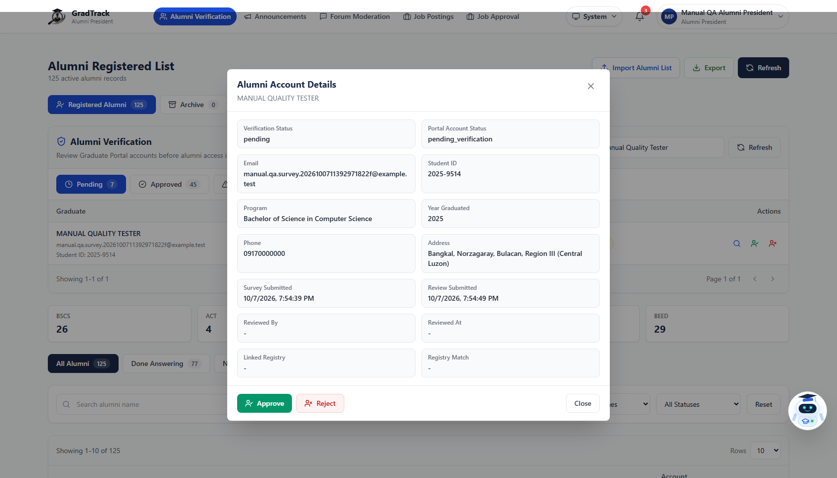
Figure 46. Graduate account details for verification
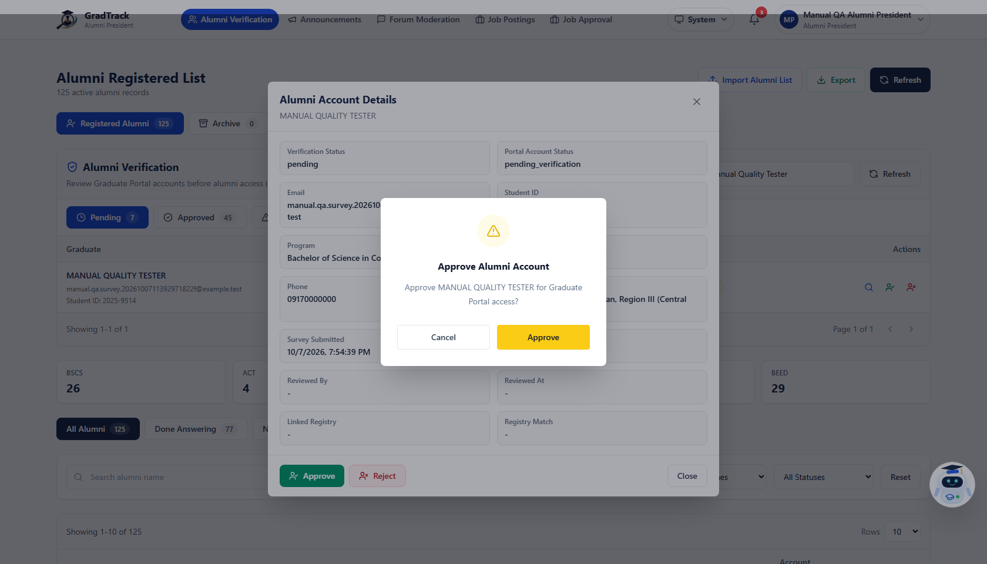
Figure 47. Graduate account approval confirmation

9.2 Manage Announcements
Purpose: Publish information for Graduate Portal users.
Step 1. Open “Announcements.”
Step 2. Review existing announcements and their statuses.
Step 3. Click “New Announcement.”
Step 4. Complete the title, content, audience/status, date, or other visible fields.
Step 5. Save or publish using the control shown in the form.
Expected Result: The announcement is stored with the selected status and appears to its intended audience when published.
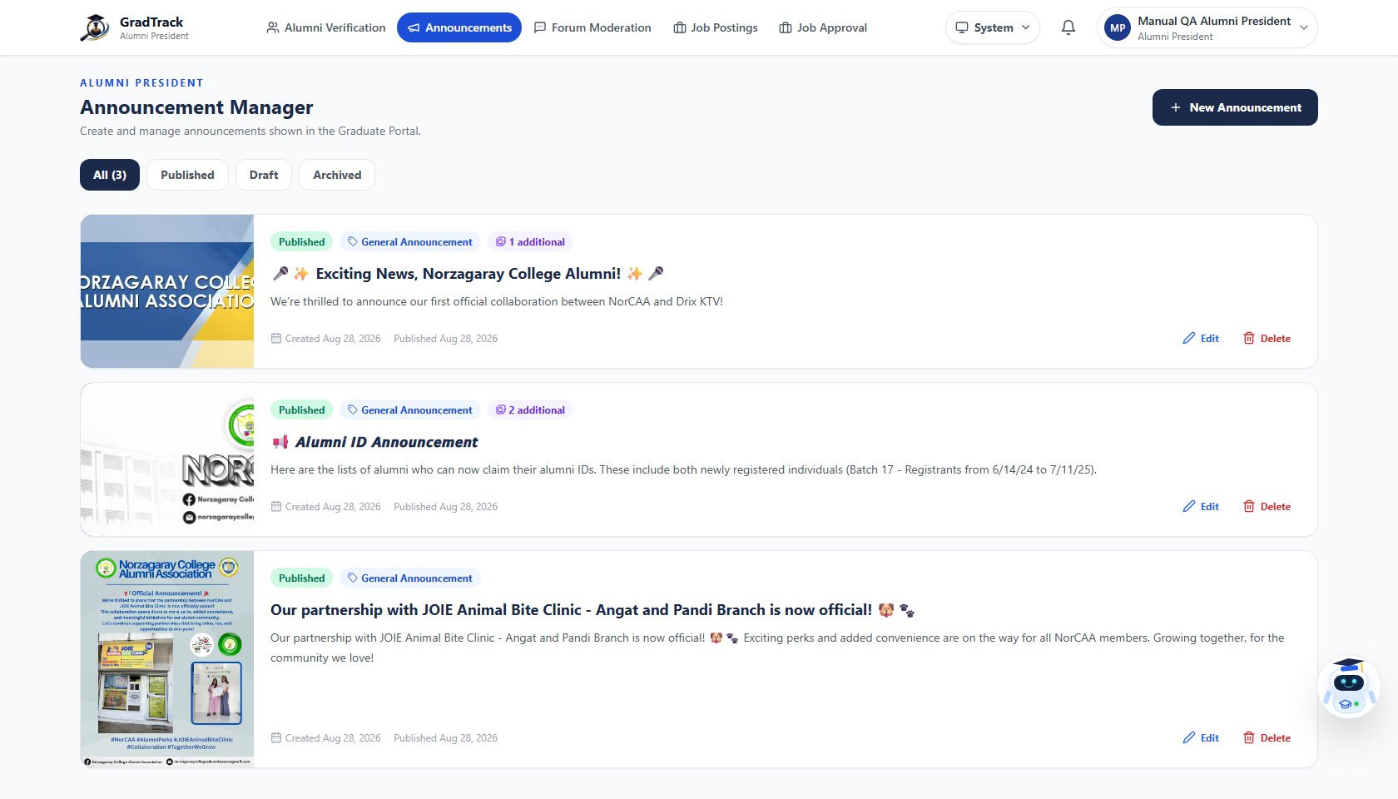
Figure 48. Alumni President Announcement Manager
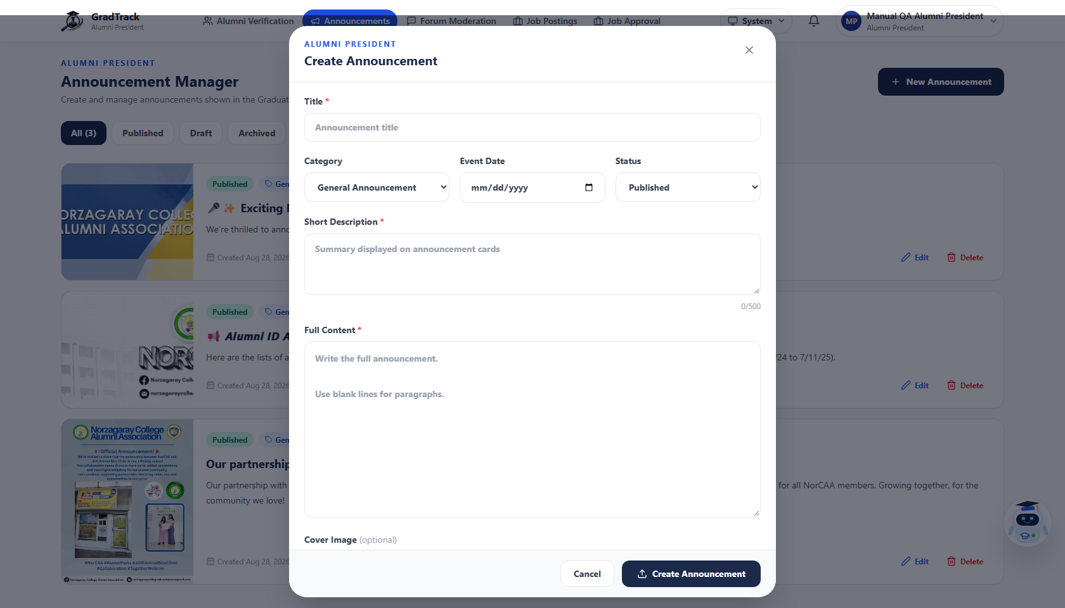
Figure 49. Create Announcement form

9.3 Moderate Reported Forum Content
Purpose: Review community posts or comments reported for moderation.
Step 1. Open “Forum Moderation.”
Step 2. Review the pending report queue.
Step 3. Open a reported item when available.
Step 4. Apply only the moderation action supported by the current item and policy.
Expected Result: The report status updates after the selected moderation action. When no reports exist, the page displays its empty state.
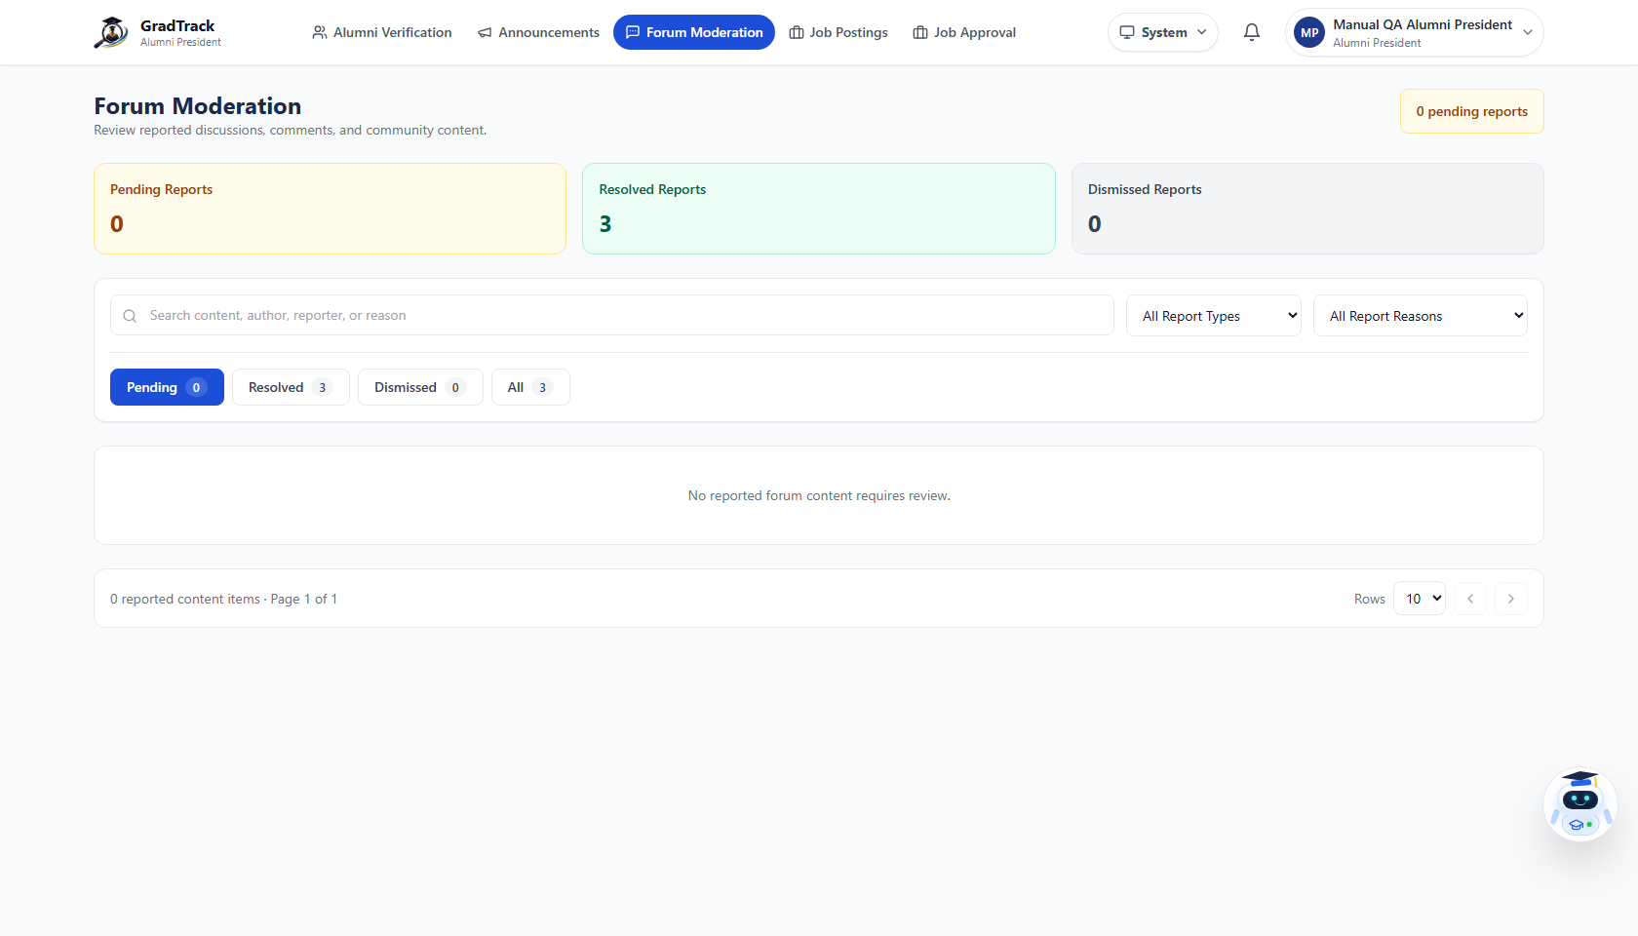
Figure 50. Alumni President Forum Moderation empty state

9.4 Review Graduate Job Posts
Purpose: Approve or reject employment opportunities submitted by Graduate Portal users.
Step 1. Open “Job Approval.”
Step 2. Review the pending job queue.
Step 3. Open a submitted job when available.
Step 4. Check its title, company, description, contact/application information, and supporting details.
Step 5. Approve or reject the post using the available action.
Expected Result: Approved graduate posts become eligible for publication; rejected posts do not appear as approved opportunities.
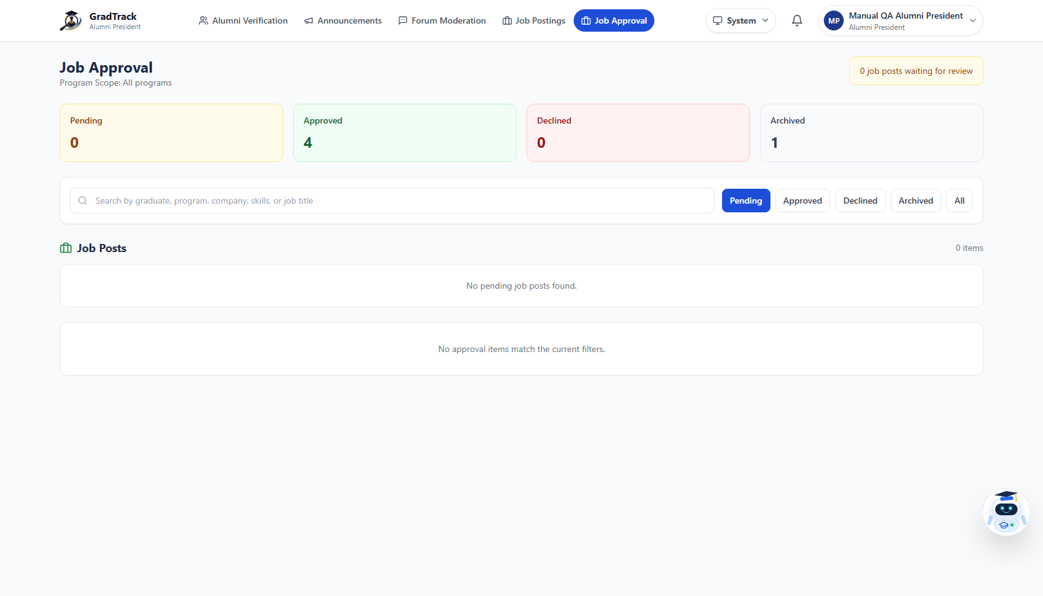
Figure 51. Alumni President graduate job-post approval queue

9.5 Manage Staff Job Postings
Purpose: Create and maintain job opportunities as an authorized personnel publisher.
Step 1. Open “Job Postings.”
Step 2. Create, edit, archive, or restore postings with the controls shown for the account.
Step 3. Verify the job’s deadline and application method before publication.
Expected Result: Valid staff-created job posts are published directly and appear in the jobs module.

10. ADMIN / MIS STAFF USER MANUAL

10.1 Admin – Manage Personnel Accounts
Purpose: Create and maintain non-graduate system accounts and assigned roles.
Step 1. Sign in with an Admin account.
Step 2. Open “User Management.”
Step 3. Search or review the personnel list.
Step 4. Click “Add User” to create an account.
Step 5. Enter the required identity and sign-in fields, then select the intended role.
Step 6. Save the account; use row controls for later edits or status changes.
Expected Result: The personnel account appears in User Management with the selected role and status.
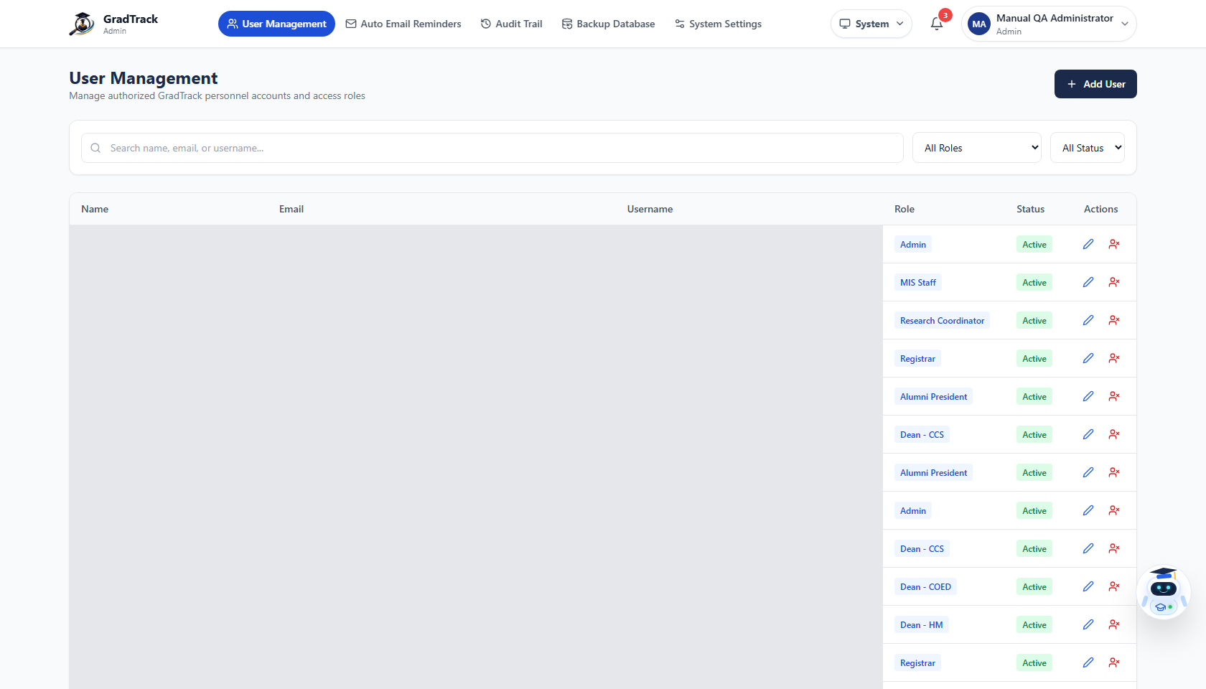
Figure 52. Admin user and personnel account management
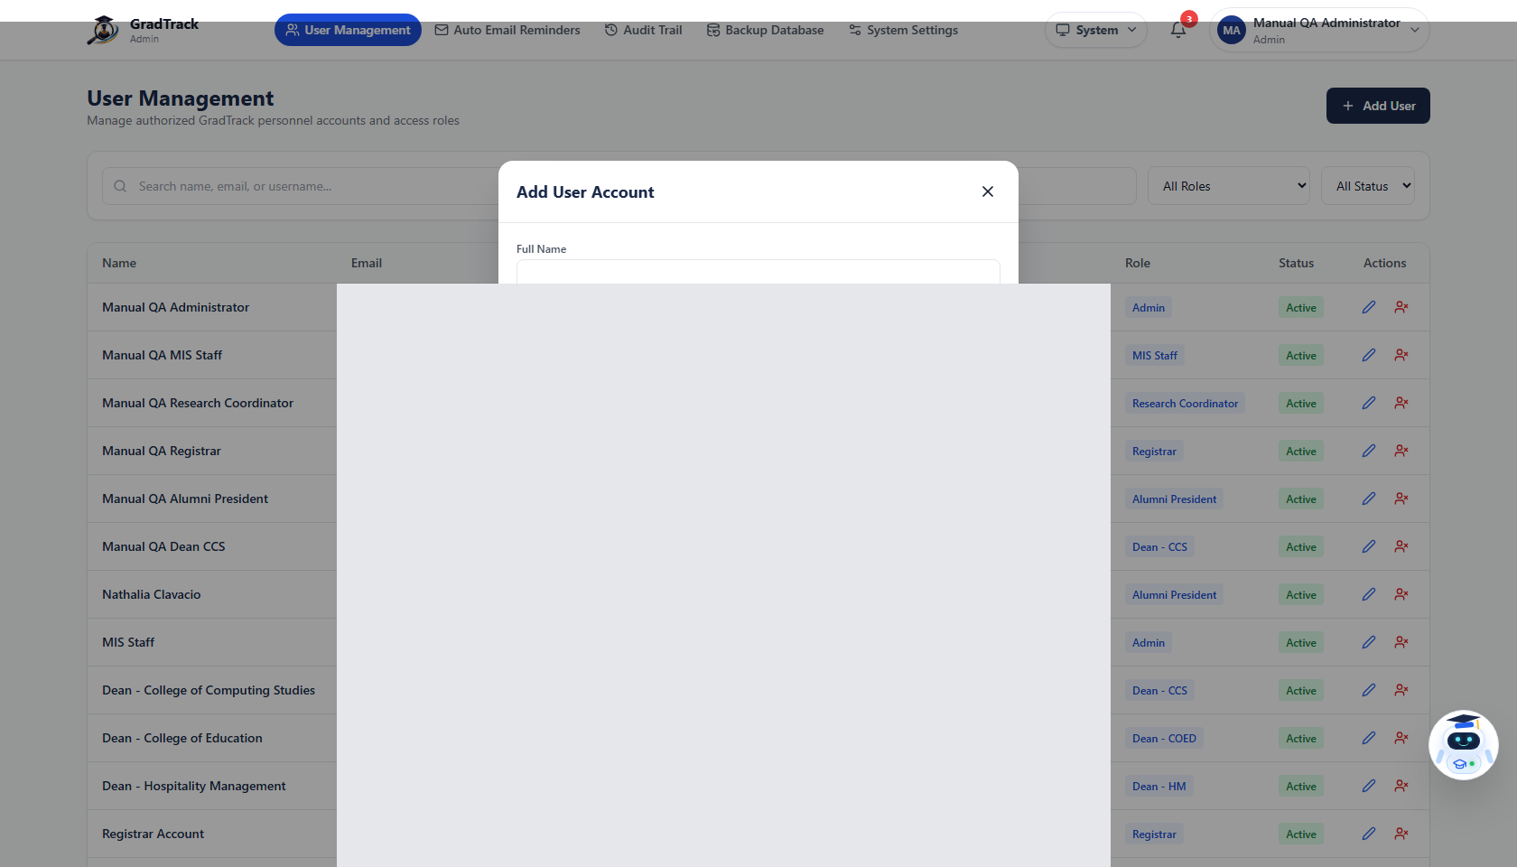
Figure 53. Admin Add User form and role selection

10.2 Admin – Configure Survey Reminders
Purpose: Manage automated and manual reminder activity for survey participation.
Step 1. Open “Auto Email Reminders.”
Step 2. Review the current reminder configuration and status.
Step 3. Change only the fields required by the institution’s reminder schedule.
Step 4. Use the visible save/manual-send controls as appropriate.
Expected Result: The reminder configuration or manual action is recorded by GradTrack.
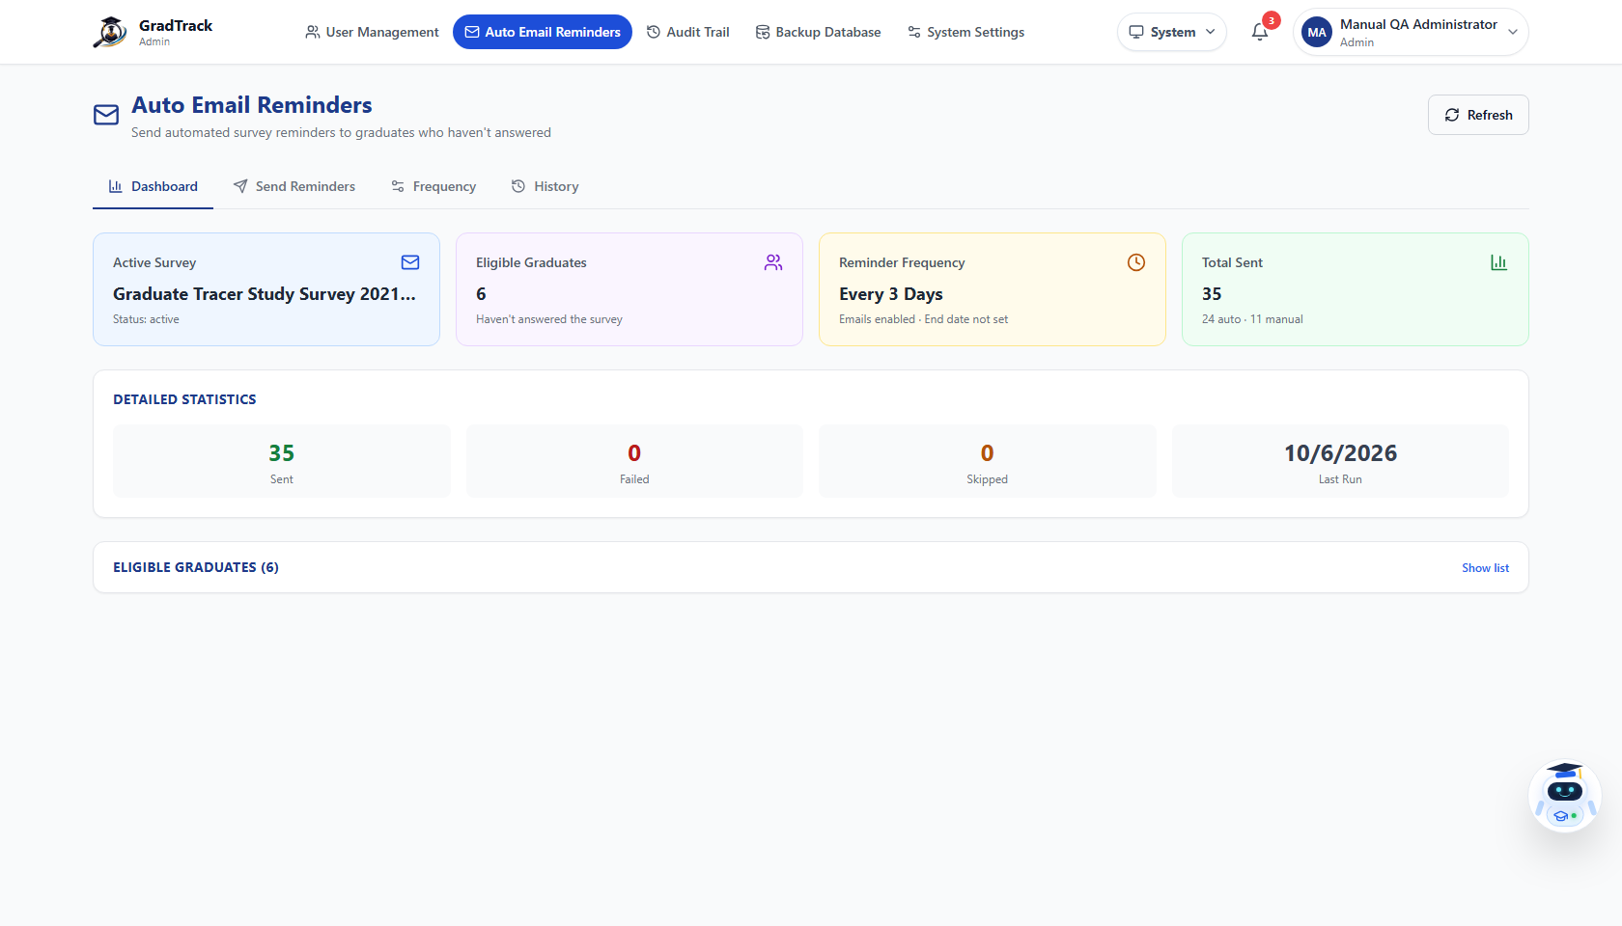
Figure 54. Admin automated and manual survey reminders

10.3 Admin – Review the Audit Trail
Purpose: Trace recorded personnel and system actions.
Step 1. Open “Audit Trail.”
Step 2. Apply the visible date, user, action, or search filters.
Step 3. Review the event details and timestamps.
Step 4. Use available pagination to move through results.
Expected Result: The table shows audit entries matching the selected filters.
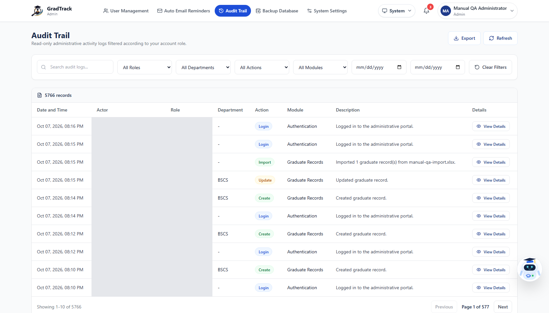
Figure 55. Admin audit trail and filters

10.4 Admin – Create a Database Backup
Purpose: Generate a database backup through the provided administrative control.
Step 1. Open “Database Backup.”
Step 2. Read the page guidance and backup status.
Step 3. Click the backup/download control when an authorized backup is required.
Step 4. Store the downloaded file according to institutional security policy.
Expected Result: GradTrack creates and downloads the database backup or displays a verified error.
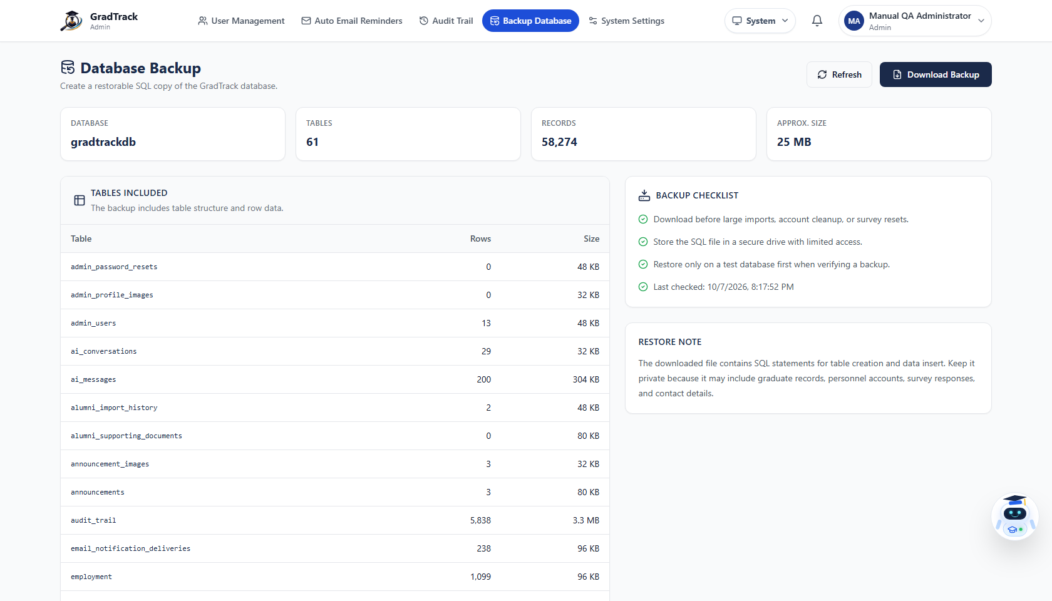
Figure 56. Admin database-backup controls

10.5 Admin – Update System Settings
Purpose: Maintain institution and application configuration exposed in the current Admin interface.
Step 1. Open “System Settings.”
Step 2. Review the current institution/system values.
Step 3. Edit only approved settings.
Step 4. Save the changes and verify the confirmation.
Expected Result: Valid settings are stored and used by the application where applicable.
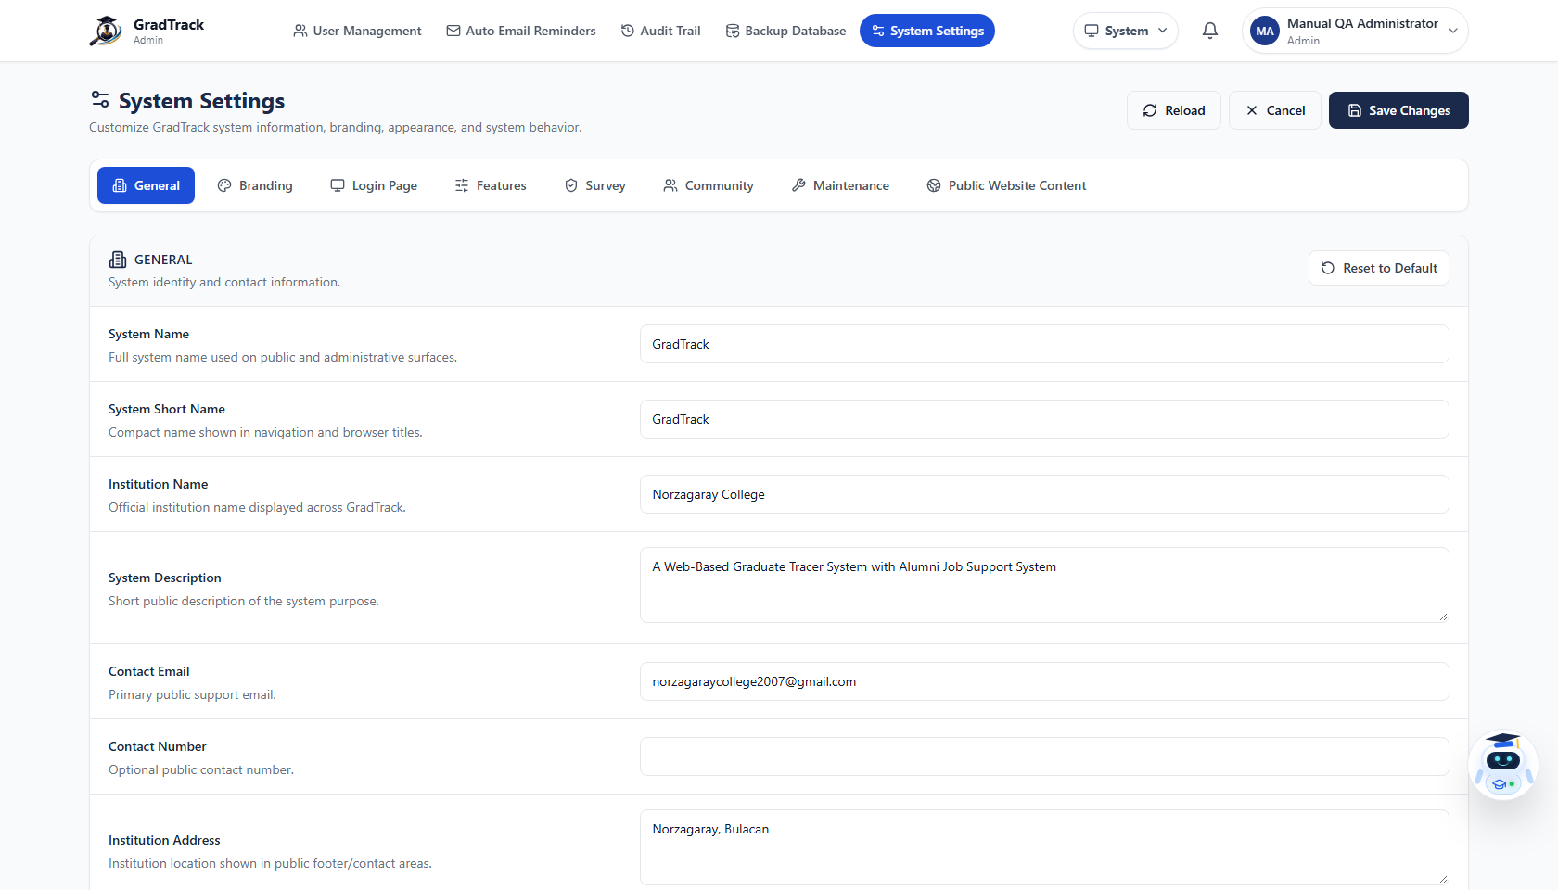
Figure 57. Admin system settings

10.6 Personnel Profile
Purpose: Review the signed-in personnel identity and update available profile/password fields.
Step 1. Open the account menu.
Step 2. Select “My Profile.”
Step 3. Review or edit the fields enabled for the account.
Step 4. Save the changes.
Expected Result: Valid changes are stored for the signed-in personnel account.
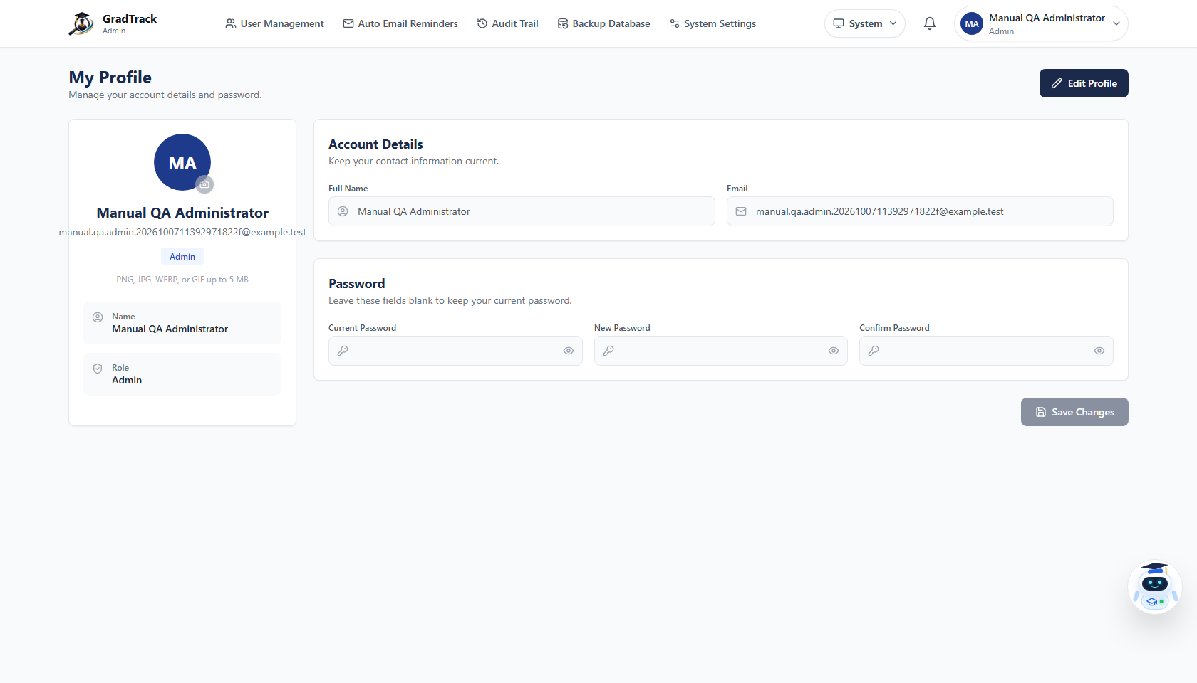
Figure 58. Personnel profile and password settings

10.7 MIS Staff Dashboard
Purpose: Review the general dashboard available to the MIS Staff role.
Step 1. Sign in with an MIS Staff account.
Step 2. Open Dashboard when necessary.
Step 3. Review the displayed summary cards and charts.
Step 4. Use My Profile for the account’s own profile settings.
Expected Result: The general GradTrack Dashboard is displayed with the limited MIS Staff navigation.
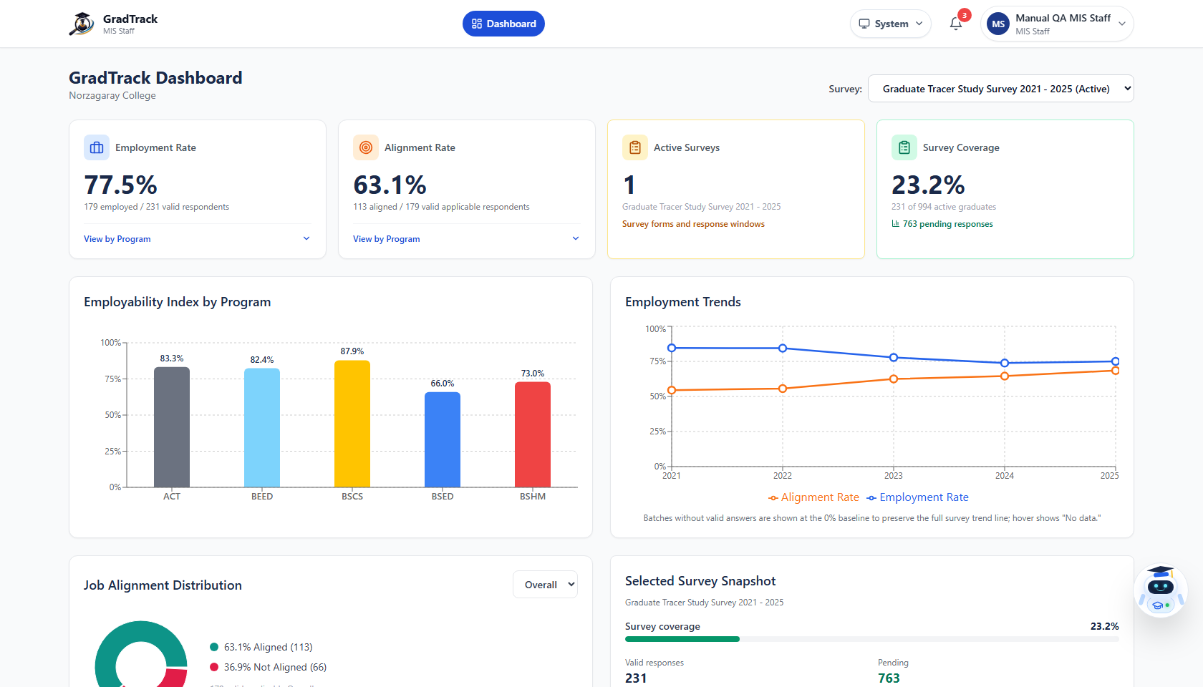
Figure 59. MIS Staff dashboard and limited navigation
Verified restriction: In the current interface, MIS Staff does not receive Admin User Management, Audit Trail, Database Backup, Auto Reminders, or System Settings navigation.

11. NOTIFICATIONS, MESSAGES, AND COMMUNITY FEATURES
The Graduate Portal groups community features in its header navigation. Personnel also receive a notification control in the application header when applicable.
Feature | Graduate action | Management or restriction
Notifications | Open the bell, review alerts, and follow an available destination. | Notification contents depend on current account activity and role.
Messaging | Open conversations, start a new direct/group message, and send text. | Only authenticated Graduate Portal users and available recipients are shown.
Community Forum | Browse, create posts, and interact using controls shown on each item. | The Alumni President handles reported-content moderation.
Announcements | Read published announcements. | The Alumni President creates and manages announcement records.

11.1 Recommended Use
- Keep messages and forum posts relevant to alumni, graduate, and professional activities.
- Verify recipients before sending a direct or group message.
- Review notifications regularly because account approval, community activity, or system actions may create new alerts.
- Report inappropriate content through the controls provided by the live interface.
Related screens: See Figures in Sections 5 and 9 for the live notification panel, message workspace, forum composer, announcement page, and moderation queue.

12. JOB SUPPORT FEATURES

12.1 Graduate – Browse Job Opportunities
Purpose: Find published employment opportunities.
Step 1. Open the Jobs icon in Graduate Portal.
Step 2. Use the search and visible filters to narrow the job cards.
Step 3. Click “View Details” on a job.
Step 4. Review the description, qualifications, deadline, contact, and application method.
Expected Result: The selected job’s complete details and “How to Apply” information are displayed.
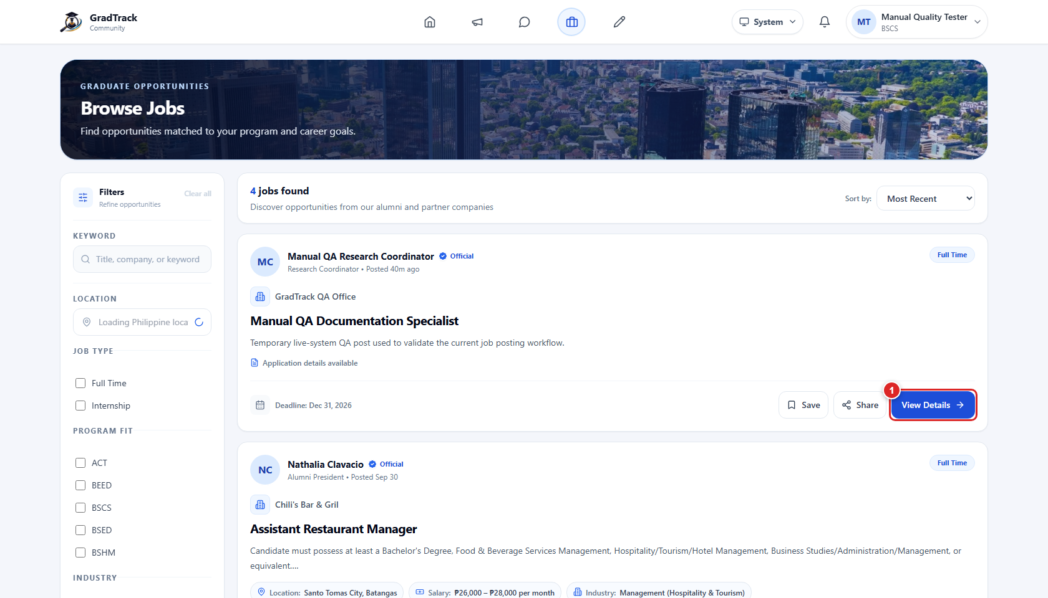
Figure 60. Graduate Browse Jobs page
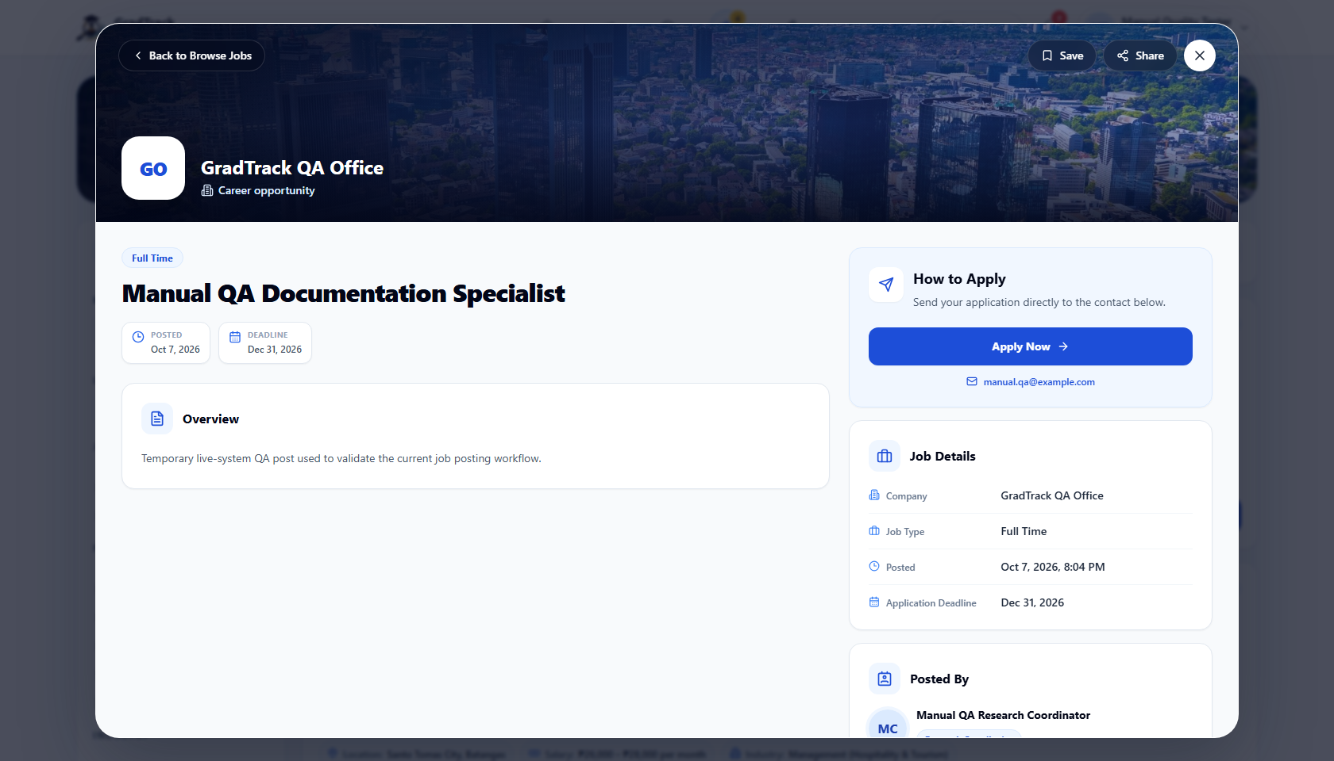
Figure 61. Graduate job-opportunity details and application guidance
Application behavior: The verified current job-detail screen directs the user through the employer’s contact email or external application link. An internal applicant-tracking submission was not presented in this tested flow.

12.2 Graduate – Submit a Job Post
Purpose: Recommend an employment opportunity to the alumni community.
Step 1. Open “Job Posting.”
Step 2. Click “Create Job Post.”
Step 3. Complete the visible job, company, description, requirements, deadline, and application fields.
Step 4. Submit the post.
Expected Result: The graduate-submitted post enters Alumni President review before it can be approved for publication.
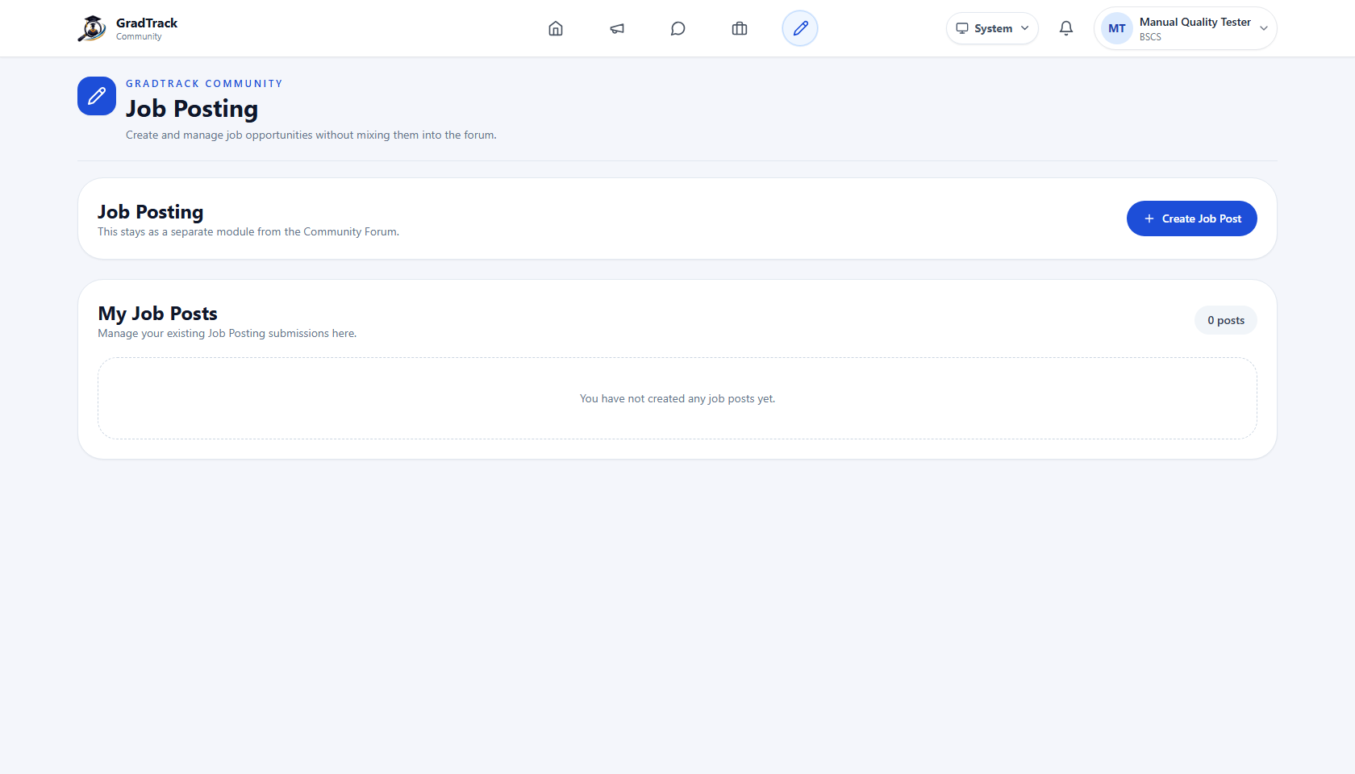
Figure 62. Graduate Job Posting page
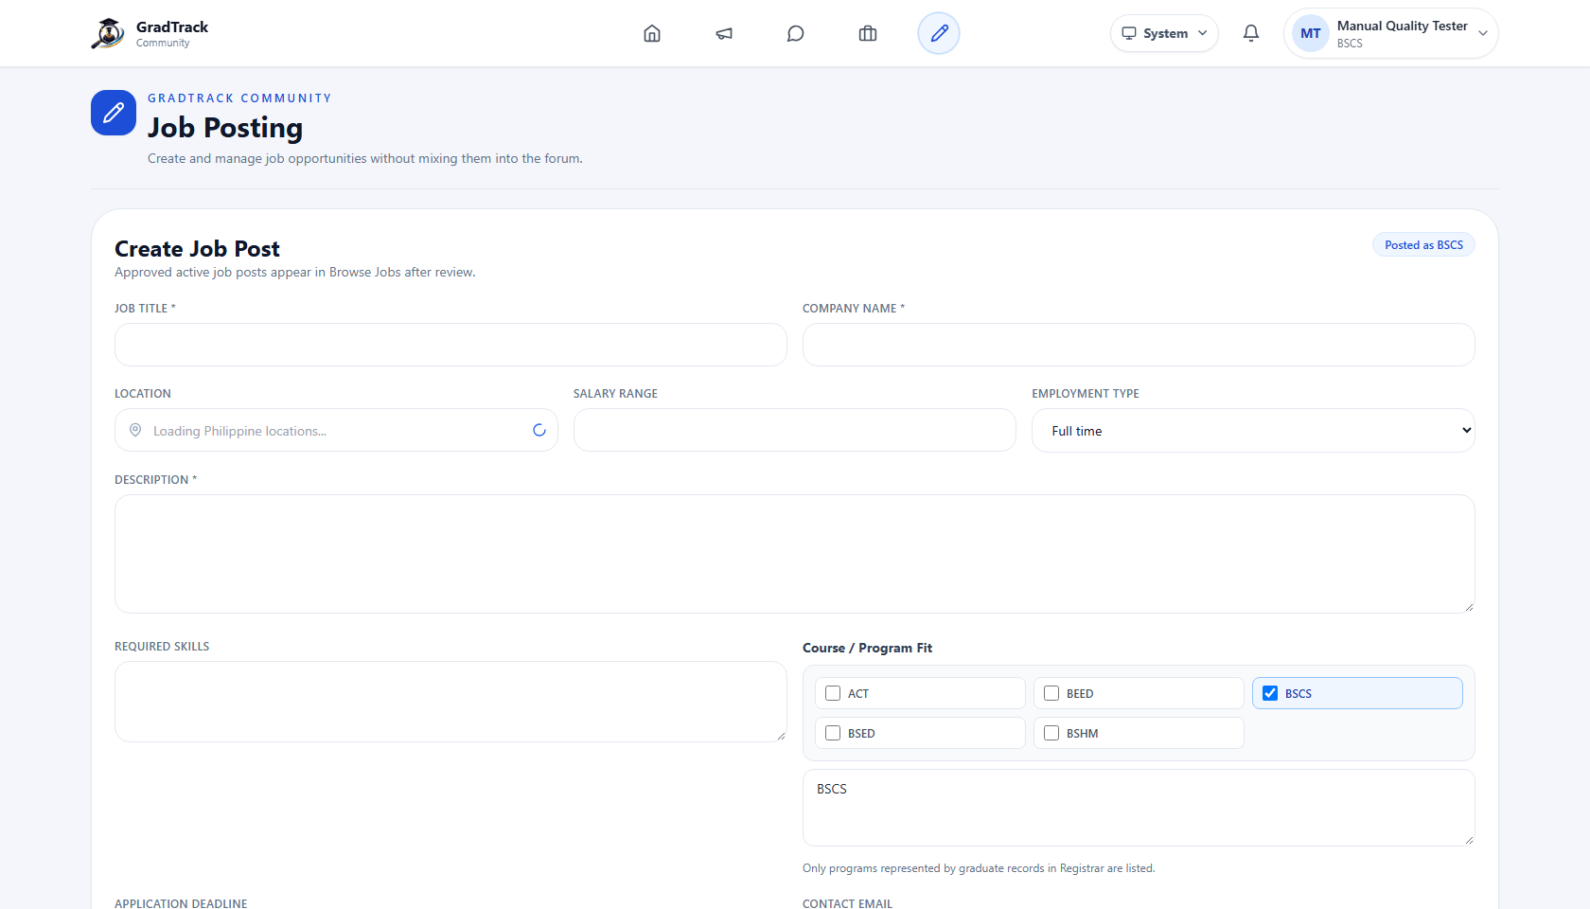
Figure 63. Graduate job-post creation form

12.3 Authorized Staff – Manage Job Posts
Purpose: Publish and maintain employment opportunities as Research Coordinator, Dean, or Alumni President.
Step 1. Open “Job Postings.”
Step 2. Click “Create Job.”
Step 3. Complete the required and applicable optional fields.
Step 4. Publish the posting.
Step 5. Use edit, archive, or restore controls made available for the role’s postings.
Expected Result: A valid staff-created posting is published directly and becomes visible to graduates.

12.4 Alumni President – Approve Graduate Posts
Purpose: Protect the jobs feed by reviewing graduate-submitted opportunities.
Step 1. Open “Job Approval.”
Step 2. Review each pending submission.
Step 3. Approve a suitable post or reject an unsuitable/incomplete post.
Expected Result: Only approved graduate submissions become approved job opportunities.

13. ANALYTICS AND REPORTS
The current Reports & Analytics module combines scope filters, dashboard summaries, charts, tables, descriptive survey analytics, formal exports, and Research Coordinator inferential analysis.
Area | What the current system provides | Authorized roles
Dashboard statistics | Graduate and participation totals plus role-appropriate visual summaries. | Research Coordinator, Dean, MIS Staff (general dashboard)
Graduate/employment analysis | Outcome cards, charts, employment information, and program/year/department scope controls. | Research Coordinator and Dean
Survey analytics | Question-level response counts, percentages, and charted summaries. | Research Coordinator and Dean within role scope
Inferential analysis | Variable selection and Chi-Square result with evidence/association interpretation when data permits. | Research Coordinator only
Formal exports | PDF, Word, and Excel report generation from the selected report scope. | Research Coordinator and Dean

13.1 Apply Report Filters
Step 1. Open Reports & Analytics.
Step 2. Select the appropriate report tab.
Step 3. Choose the year, department/program, or survey controls displayed for that tab.
Step 4. Wait for the “Loading filtered data” state to finish.
Step 5. Read the scope labels before interpreting or exporting results.
Expected Result: Cards, tables, and charts refresh for the selected scope.

13.2 Interpret Results Carefully
- Use the visible response/sample count together with percentages and charts.
- Treat “no data” or insufficient-evidence results as a limitation, not as a positive finding.
- For Dean reports, confirm that the screen remains within the assigned department/program scope.
- For inferential analysis, report the selected variables, test result, evidence statement, association strength, and answers compared.

13.3 Generate a Formal Report
Step 1. Set the final report tab and filters.
Step 2. Click Export PDF, Export Word, or Export Excel.
Step 3. Wait for generation to finish.
Step 4. Open the downloaded file and verify its title, scope, tables, and charts before distribution.
Expected Result: A non-empty export file is downloaded in the selected format.
Validated behavior: All three formal report formats were produced successfully from the running application during validation. The screenshots in Figures from Section 6 show the exact export controls, descriptive analytics, and completed inferential result.

14. ERROR HANDLING / COMMON ISSUES
Observed situation |  | Actual system response | User action
Incorrect personnel credentials |  | “Invalid email or password.” appears on Personnel Sign In. | Re-enter the registered email and password. Contact an administrator if the account is inactive or unknown.
Incorrect Graduate credentials |  | A “Log In Failed” dialog states “Invalid email or password.” | Close the dialog, correct both fields, and retry.
Graduate account pending |  | The post-survey account screen states that alumni verification is pending. | Wait for Alumni President approval before Graduate Portal login.
Active survey already exists |  | Survey Management disables creation and directs the coordinator to make the current survey inactive first. | Review the current survey and institutional plan before changing its status.
Survey has responses |  | The edit interface protects response-sensitive structural changes. | Limit edits to fields the interface permits; do not expect destructive restructuring.
No forum reports |  | Forum Moderation shows an empty state. | No moderation action is required until a report arrives.
No pending graduate jobs |  | Job Approval shows an empty state. | No approval action is required until a graduate submits a post.
Credential file missing/unsupported/too large |  | The credential form keeps the submission invalid and shows the relevant file guidance/error. | Choose a PDF/JPG/JPEG/PNG file no larger than 10 MB.
Empty report/filter result |  | Cards, tables, or charts may show no available records for that scope. | Clear or broaden filters and confirm that source records exist.
Permission restriction |  | The module is absent from navigation or an unauthorized route is blocked. | Use only features assigned to the signed-in role.
 | Avoid duplicate actions: Do not repeatedly submit a form while its button shows a loading/generating state. Wait for the final success or error message.

15. LOGOUT

15.1 Graduate Logout
Purpose: End the authenticated Graduate Portal session on a shared or personal device.
Step 1. Open the account menu at the upper right.
Step 2. Choose “Logout” or “Sign Out.”
Step 3. Review the confirmation dialog.
Step 4. Confirm logout.
Expected Result: The Graduate session ends and the Graduate Portal login page is displayed.
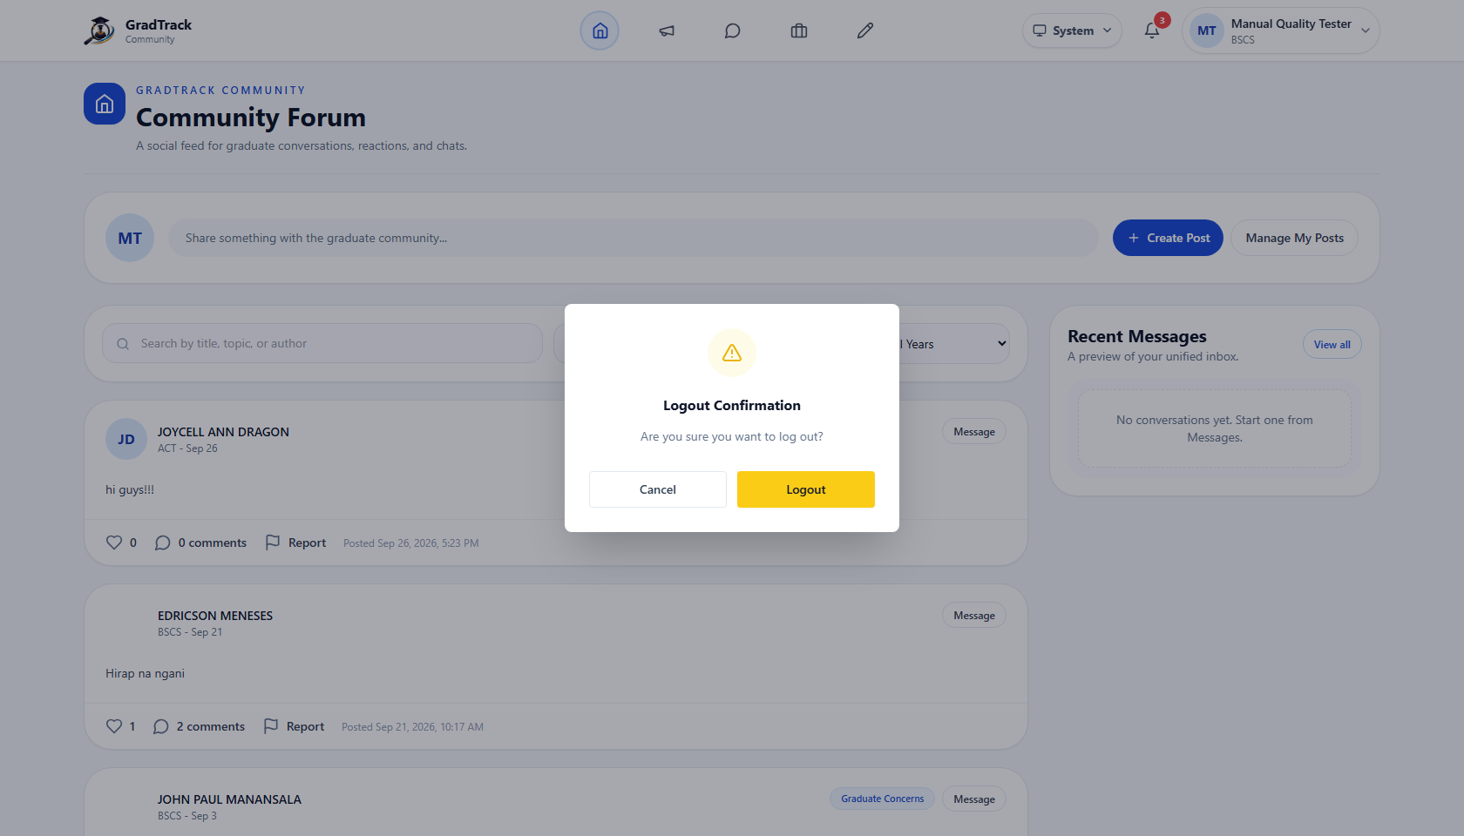
Figure 64. Graduate logout confirmation

15.2 Personnel Logout
Purpose: End the authenticated personnel session.
Step 1. Open the personnel profile menu.
Step 2. Click “Sign Out.”
Step 3. Review the Logout Confirmation dialog.
Step 4. Confirm the action.
Expected Result: The personnel session ends and Personnel Sign In is displayed.
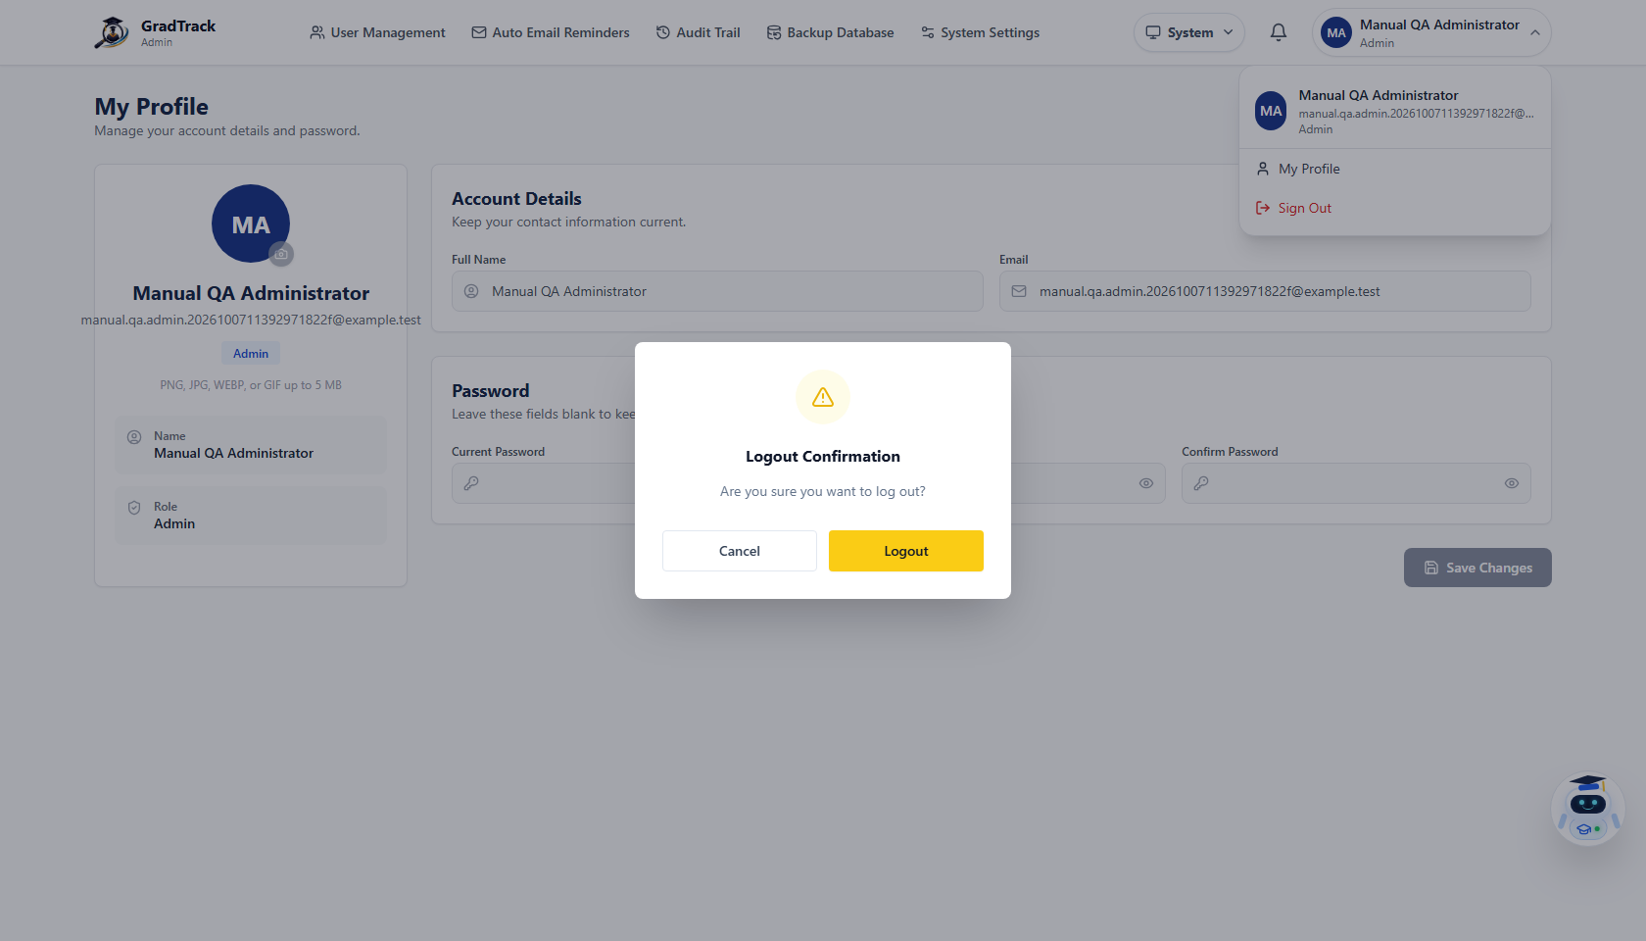
Figure 65. Personnel logout confirmation
Security practice: Always log out before leaving a shared workstation. Closing a tab is not a substitute for the application’s logout action.

16. TROUBLESHOOTING
Problem | Practical resolution
The page stays on a loading state. | Check the network connection, wait briefly, then refresh once. If the problem remains, record the page name and time for the administrator.
Login still fails after correcting the password. | Confirm that the correct Graduate or Personnel sign-in page is being used and that the account is active/approved.
A Graduate cannot enter the portal after creating an account. | Check whether the account is still pending Alumni President verification.
Survey verification does not continue. | Recheck Student ID, last name, and selected program against the Registrar-maintained graduate record.
A required survey/form field prevents continuation. | Review the current section for a highlighted required field or conditional question, correct it, then submit again.
Registrar import reports skipped/error rows. | Use the result dialog to identify the affected rows; correct identifiers, program codes, years, or duplicate data and re-import only the corrected records.
Report export does not download. | Wait for generation to finish, confirm browser downloads are allowed, then retry once with a stable connection.
A report contains no data. | Clear restrictive filters, confirm the survey/year/program scope, and verify that source responses exist.
A menu item described for another role is missing. | This is expected role-based access. Sign in with the authorized role or request access through the institution.
A credential will not upload. | Use PDF/JPG/JPEG/PNG, remain within 10 MB, and complete Credential Name and Issuing Organization.

16.1 Information to Provide When Reporting a Problem
- Role and page/module name (never send the password).
- Approximate date and time of the problem.
- The exact visible error message.
- The action taken immediately before the problem.
- A screenshot that excludes passwords, private tokens, and unrelated personal data.

16.2 Manual Validation Basis
This manual was produced from the current local GradTrack implementation and browser-rendered interface. Validation included role-based sign-in, invalid-login behavior, survey completion and review, Graduate account approval, credential upload, graduate-record add/edit/import, combined program/year filtering, staff job publication, inferential analysis, and PDF/Word/Excel report exports.
Document control: Interface labels, available records, and dashboard values can change as GradTrack data and configuration evolve. Use the current running interface as the operational source of truth.

