Clemente
genetically modified organism (GMO)
organism whose genome has been engineered in the laboratory in order to favour the expression of desired physiological traits or the generation of desired biological products. In conventional livestock production, crop farming, and even pet breeding, it has long been the practice to breed select individuals of a species in order to produce offspring that have desirable traits. In genetic modification, however, recombinant genetic technologies are employed to produce organisms whose genomes have been precisely altered at the molecular level, usually by the inclusion of genes from unrelated species of organisms that code for traits that would not be obtained easily through conventional selective breeding.

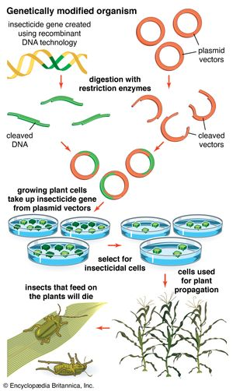
Genetically modified organisms
Scientific methods that include recombinant DNA technology are used to produce genetically modified organisms.
Genetically modified organisms (GMOs) are produced using scientific methods that include recombinant DNA technology and reproductive cloning. In reproductive cloning, a nucleus is extracted from a cell of the individual to be cloned and is inserted into the enucleated cytoplasm of a host egg (an enucleated egg is an egg cell that has had its own nucleus removed). The process results in the generation of an offspring that is genetically identical to the donor individual. The first animal produced by means of this cloning technique with a nucleus from an adult donor cell (as opposed to a donor embryo) was a sheep named Dolly, born in 1996. Since then a number of other animals, including pigs, horses, and dogs, have been generated by reproductive cloning technology. Recombinant DNA technology, on the other hand, involves the insertion of one or more individual genes from an organism of one species into the DNA (deoxyribonucleic acid) of another. Whole-genome replacement, involving the transplantation of one bacterial genome into the “cell body,” or cytoplasm, of another microorganism, has been reported, although this technology is still limited to basic scientific applications.
GMOs produced through genetic technologies have become a part of everyday life, entering into society through agriculture, medicine, research, and environmental management. However, while GMOs have benefited human society in many ways, some disadvantages exist; therefore, the production of GMOs remains a highly controversial topic in many parts of the world.
MONICA
GMOs in agriculture

Genetically engineered corn (maize)A field of genetically engineered corn (maize).
Genetically modified (GM) foods were first approved for human consumption in the United States in 1994, and by 2014–15 about 90 percent of the corn, cotton, and soybeans planted in the United States were GM. By the end of 2014, GM crops covered nearly 1.8 million square kilometres (695,000 square miles) of land in more than two dozen countries worldwide. The majority of GM crops were grown in the Americas.
Engineered crops can dramatically increase per area crop yields and, in some cases, reduce the use of chemical insecticides. For example, the application of wide-spectrum insecticides declined in many areas growing plants, such as potatoes, cotton, and corn, that were endowed with a gene from the bacterium Bacillus thuringiensis, which produces a natural insecticide called Bt toxin. Field studies conducted in India in which Bt cotton was compared with non-Bt cotton demonstrated a 30–80 percent increase in yield from the GM crop. This increase was attributed to marked improvement in the GM plants’ ability to overcome bollworm infestation, which was otherwise common. Studies of Bt cotton production in Arizona, U.S., demonstrated only small gains in yield—about 5 percent—with an estimated cost reduction of $25–$65 (USD) per acre owing to decreased pesticide applications. In China, where farmers first gained access to Bt cotton in 1997, the GM crop was initially successful. Farmers who had planted Bt cotton reduced their pesticide use by 50–80 percent and increased their earnings by as much as 36 percent. By 2004, however, farmers who had been growing Bt cotton for several years found that the benefits of the crop eroded as populations of secondary insect pests, such as mirids, increased. Farmers once again were forced to spray broad-spectrum pesticides throughout the growing season, such that the average revenue for Bt growers was 8 percent lower than that of farmers who grew conventional cotton. Meanwhile, Bt resistance had also evolved in field populations of major cotton pests, including both the cotton bollworm (Helicoverpa armigera) and the pink bollworm (Pectinophora gossypiella).
Other GM plants were engineered for resistance to a specific chemical herbicide, rather than resistance to a natural predator or pest. Herbicide-resistant crops (HRC) have been available since the mid-1980s; these crops enable effective chemical control of weeds, since only the HRC plants can survive in fields treated with the corresponding herbicide. Many HRCs are resistant to glyphosate (Roundup), enabling liberal application of the chemical, which is highly effective against weeds. Such crops have been especially valuable for no-till farming, which helps prevent soil erosion. However, because HRCs encourage increased application of chemicals to the soil, rather than decreased application, they remain controversial with regard to their environmental impact. In addition, in order to reduce the risk of selecting for herbicide-resistant weeds, farmers must use multiple diverse weed-management strategies.

golden rice
Genetically modified golden rice plants in cultivation.
Another example of a GM crop is golden rice, which originally was intended for Asia and was genetically modified to produce almost 20 times the beta-carotene of previous varieties. Golden rice was created by modifying the rice genome to include a gene from the daffodil Narcissus pseudonarcissus that produces an enzyme known as phyotene synthase and a gene from the bacterium Erwinia uredovora that produces an enzyme called phyotene desaturase. The introduction of these genes enabled beta-carotene, which is converted to vitamin A in the human liver, to accumulate in the rice endosperm—the edible part of the rice plant—thereby increasing the amount of beta-carotene available for vitamin A synthesis in the body. In 2004 the same researchers who developed the original golden rice plant improved upon the model, generating golden rice 2, which showed a 23-fold increase in carotenoid production.
Another form of modified rice was generated to help combat iron deficiency, which impacts close to 30 percent of the world population. This GM crop was engineered by introducing into the rice genome a ferritin gene from the common bean, Phaseolus vulgaris, that produces a protein capable of binding iron, as well as a gene from the fungus Aspergillus fumigatus that produces an enzyme capable of digesting compounds that increase iron bioavailability via digestion of phytate (an inhibitor of iron absorption). The iron-fortified GM rice was engineered to overexpress an existing rice gene that produces a cysteine-rich metallothioneinlike (metal-binding) protein that enhances iron absorption.
A variety of other crops modified to endure the weather extremes common in other parts of the globe are also in production.
ESCOPALAO
GMOs in medicine and research
GMOs have emerged as one of the mainstays of biomedical research since the 1980s. For example, GM animal models of human genetic diseases enabled researchers to test novel therapies and to explore the roles of candidate risk factors and modifiers of disease outcome. GM microbes, plants, and animals also revolutionized the production of complex pharmaceuticals by enabling the generation of safer and cheaper vaccines and therapeutics. Pharmaceutical products range from recombinant hepatitis B vaccine produced by GM baker’s yeast to injectable insulin (for diabetics) produced in GM Escherichia coli bacteria and to factor VIII (for hemophiliacs) and tissue plasminogen activator (tPA, for heart attack or stroke patients), both of which are produced in GM mammalian cells grown in laboratory culture. Furthermore, GM plants that produce “edible vaccines” are under development. An edible vaccine is an antigenic protein that is produced in the consumable parts of a plant (e.g., fruit) and absorbed into the bloodstream when the parts are eaten. Once absorbed into the body, the protein stimulates the immune system to produce antibodies against the pathogen from which the antigen was derived. Such vaccines could offer a safe, inexpensive, and painless way to provide vaccines, particularly in less-developed regions of the world, where the limited availability of refrigeration and sterile needles has been problematic for some traditional vaccines. Novel DNA vaccines may be useful in the struggle to prevent diseases that have proved resistant to traditional vaccination approaches, including HIV/AIDS, tuberculosis, and cancer.
Genetic modification of insects has become an important area of research, especially in the struggle to prevent parasitic diseases. For example, GM mosquitoes have been developed that express a small protein called SM1, which blocks entry of the malaria parasite, Plasmodium, into the mosquito’s gut. This results in the disruption of the parasite’s life cycle and renders the mosquito malaria-resistant. Introduction of these GM mosquitoes into the wild could help reduce transmission of the malaria parasite. In another example, male Aedes aegypti mosquitoes engineered with a method known as the sterile insect technique transmit a gene to their offspring that causes the offspring to die before becoming sexually mature. In field trials in a Brazil suburb, A. aegypti populations declined by 95 percent following the sustained release of sterile GM males.
Finally, genetic modification of humans via gene therapy is becoming a treatment option for diseases ranging from rare metabolic disorders to cancer. Coupling stem cell technology with recombinant DNA methods allows stem cells derived from a patient to be modified in the laboratory to introduce a desired gene. For example, a normal beta-globin gene may be introduced into the DNA of bone marrow-derived hematopoietic stem cells from a patient with sickle cell anemia; introduction of these GM cells into the patient could cure the disease without the need for a matched donor.
TORALBA
Role of GMOs in environmental management
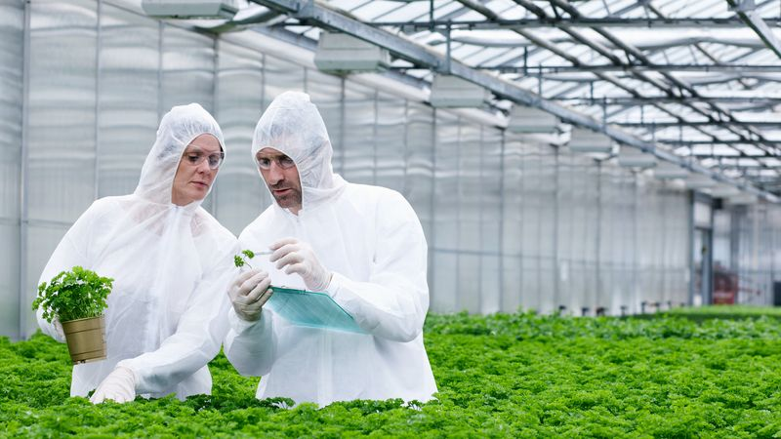

Are genetically modified organisms safe?Questions and answers about genetically modified organisms.
See all videos for this article
Another application of GMOs is in the management of environmental issues. For example, some bacteria can produce biodegradable plastics, and the transfer of that ability to microbes that can be easily grown in the laboratory may enable the wide-scale “greening” of the plastics industry. In the early 1990s, Zeneca, a British company, developed a microbially produced biodegradable plastic called Biopol (polyhydroxyalkanoate, or PHA). The plastic was made with the use of a GM bacterium, Ralstonia eutropha, to convert glucose and a variety of organic acids into a flexible polymer. GMOs endowed with the bacterially encoded ability to metabolize oil and heavy metals may provide efficient bioremediation strategies.
BENAOJAN
Sociopolitical relevance of GMOs
While GMOs offer many potential benefits to society, the potential risks associated with them have fueled controversy, especially in the food industry. Many skeptics warn about the dangers that GM crops may pose to human health. For example, genetic manipulation may potentially alter the allergenic properties of crops. Whether some GM crops, such as golden rice, deliver on the promise of improved health benefits is also unclear. The release of GM mosquitoes and other GMOs into the environment also raised concerns. More-established risks were associated with the potential spread of engineered crop genes to native flora and the possible evolution of insecticide-resistant “superbugs.”
From the late 1990s, the European Union (EU) addressed such concerns by implementing strict GMO labeling laws. In the early 2000s, all GM foods and GM animal feeds in the EU were required to be labeled if they consisted of or contained GM products in a proportion greater than 0.9 percent. By contrast, in the United States, foods containing GM ingredients did not require special labeling, though the issue was hotly debated at national and state levels. Many opponents of GM products focused their arguments on unknown risks to food safety. However, despite the concerns of some consumer and health groups, especially in Europe, numerous scientific panels, including the U.S. Food and Drug Administration, concluded that consumption of GM foods was safe, even in cases involving GM foods with genetic material from very distantly related organisms.
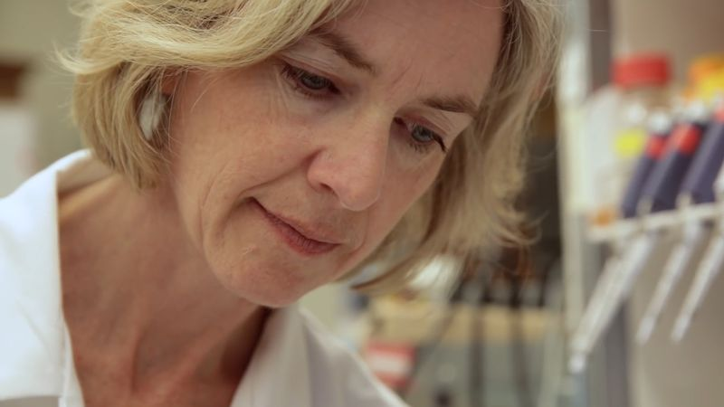

The strict regulations on GM products in the EU have been a source of tension in agricultural trade. In the late 1990s, the EU declared a moratorium on the import and use of GM crops. However, the ban—which led to trade disputes with other countries, particularly the United States, where GM foods had been accepted openly—was considered unjustified by the World Trade Organization. In consequence, the EU implemented regulatory changes that allowed for the import of certain GM crops. Within Europe, however, only one GM crop, a type of insect-resistant corn (maize), was cultivated. Some countries, including certain African states, had likewise rejected GM products. Still other countries, such as Canada, China, Argentina, and Australia, had open policies on GM foods.
The use of GMOs in medicine and research has produced a debate that is more philosophical in nature. For example, while genetic researchers believe they are working to cure disease and ameliorate suffering, many people worry that current gene therapy approaches may one day be applied to produce “designer” children or to lengthen the natural human life span. Similar to many other technologies, gene therapy and the production and application of GMOs can be used to address and resolve complicated scientific, medical, and environmental issues, but they must be used wisely.

COMMERCIAL OR PALARO

CLEMENTE
Biotechnology
biotechnology, the use of biology to solve problems and make useful products. The most prominent area of biotechnology is the production of therapeutic proteins and other drugs through genetic engineering.

History of biotechnology
People have been harnessing biological processes to improve their quality of life for some 10,000 years, beginning with the first agricultural communities. Approximately 6,000 years ago, humans began to tap the biological processes of microorganisms in order to make bread, alcoholic beverages, and cheese and to preserve dairy products. But such processes are not what is meant today by biotechnology, a term first widely applied to the molecular and cellular technologies that began to emerge in the 1960s and ’70s. A fledgling “biotech” industry began to coalesce in the mid- to late 1970s, led by Genentech, a pharmaceutical company established in 1976 by Robert A. Swanson and Herbert W. Boyer to commercialize the recombinant DNA technology pioneered by Boyer, Paul Berg, and Stanley N. Cohen. Early companies such as Genentech, Amgen, Biogen, Cetus, and Genex began by manufacturing genetically engineered substances primarily for medical and environmental uses.

biotechnologyA researcher processing biological samples in a laboratory to purify molecules for the production of therapeutic proteins.(more)
For more than a decade, the biotechnology industry was dominated by recombinant DNA technology, or genetic engineering. This technique consists of splicing the gene for a useful protein (often a human protein) into production cells—such as yeast, bacteria, or mammalian cells in culture—which then begin to produce the protein in volume. In the process of splicing a gene into a production cell, a new organism is created. At first, biotechnology investors and researchers were uncertain about whether the courts would permit them to acquire patents on organisms; after all, patents were not allowed on new organisms that happened to be discovered and identified in nature. But, in 1980, the U.S. Supreme Court, in the case of Diamond v. Chakrabarty, resolved the matter by ruling that “a live human-made microorganism is patentable subject matter.” This decision spawned a wave of new biotechnology firms and the infant industry’s first investment boom. In 1982 recombinant insulin became the first product made through genetic engineering to secure approval from the U.S. Food and Drug Administration (FDA). Since then, dozens of genetically engineered protein medications have been commercialized around the world, including recombinant versions of growth hormone, clotting factors, proteins for stimulating the production of red and white blood cells, interferons, and clot-dissolving agents.
BENAOJAN
Approaches and tools
In the early years, the main achievement of biotechnology was the ability to produce naturally occurring therapeutic molecules in larger quantities than could be derived from conventional sources such as plasma, animal organs, and human cadavers. Recombinant proteins are also less likely to be contaminated with pathogens or to provoke allergic reactions. Today, biotechnology researchers seek to discover the root molecular causes of disease and to intervene precisely at that level. Sometimes this means producing therapeutic proteins that augment the body’s own supplies or that make up for genetic deficiencies, as in the first generation of biotech medications. (Gene therapy—insertion of genes encoding a needed protein into a patient’s body or cells—is a related approach.)
The biotechnology industry has also expanded its research into the development of traditional pharmaceuticals and monoclonal antibodies that stop the progress of a disease. Successful production of monoclonal antibodies was one of the most important techniques of biotechnology to emerge during the last quarter of the 20th century. The specificity of monoclonal antibodies and their availability in quantity have made it possible to devise sensitive assays for an enormous range of biologically important substances and to distinguish cells from one another by identifying previously unknown marker molecules on their surfaces. Such advances were made possible through the study of genes (genomics), the proteins that they encode (proteomics), and the larger biological pathways in which they act.
TORALBA
Applications of biotechnology
Biotechnology has numerous applications, particularly in medicine and agriculture. Examples include the use of biotechnology in merging biological information with computer technology (bioinformatics), exploring the use of microscopic equipment that can enter the human body (nanotechnology), and possibly applying techniques of stem cell research and cloning to replace dead or defective cells and tissues (regenerative medicine). Companies and academic laboratories integrate these disparate technologies in an effort to analyze downward into molecules and also to synthesize upward from molecular biology toward chemical pathways, tissues, and organs.
In addition to being used in health care, biotechnology has proved helpful in refining industrial processes through the discovery and production of biological enzymes that spark chemical reactions (catalysts); for environmental cleanup, with enzymes that digest contaminants into harmless chemicals and then die after consuming the available “food supply”; and in agricultural production through genetic engineering.

Genetically modified organismsScientific methods that include recombinant DNA technology are used to produce genetically modified organisms.(more)
Agricultural applications of biotechnology have proved the most controversial. Some activists and consumer groups have called for bans on genetically modified organisms (GMOs) or for labeling laws to inform consumers of the growing presence of GMOs in the food supply. In the United States, the introduction of GMOs into agriculture began in 1993, when the FDA approved bovine somatotropin (BST), a growth hormone that boosts milk production in dairy cows. The next year, the FDA approved the first genetically modified whole food, a tomato engineered for a longer shelf life. Since then, regulatory approval in the United States, Europe, and elsewhere has been won by dozens of agricultural GMOs, including crops that produce their own pesticides and crops that survive the application of specific herbicides used to kill weeds.
Studies by the United Nations, the U.S. National Academy of Sciences, the European Union, the American Medical Association, U.S. regulatory agencies, and other organizations have found GMO foods to be safe, but skeptics contend that it is still too early to judge the long-term health and ecological effects of such crops. In the late 20th and early 21st centuries, the land area planted in genetically modified crops increased dramatically, from 1.7 million hectares (4.2 million acres) in 1996 to 180 million hectares (445 million acres) by 2014. By 2014–15 about 90 percent of the corn, cotton, and soybeans planted in the United States were genetically modified. The majority of genetically modified crops were grown in the Americas.
Overall, the revenues of U.S. and European biotechnology industries roughly doubled over the five-year period from 1996 through 2000. Rapid growth continued into the 21st century, fueled by the introduction of new products, particularly in health care. By 2020 the biotechnology market size was estimated at $752.88 billion globally, with new opportunities for growth emerging in particular from government- and industry-driven efforts to accelerate drug development and product-approval processes.
MONICA
genetic engineering
genetic engineering, the artificial manipulation, modification, and recombination of DNA or other nucleic acid molecules in order to modify an organism or population of organisms. The term genetic engineering is generally used to refer to methods of recombinant DNA technology, which emerged from basic research in microbial genetics. The techniques employed in genetic engineering have led to the production of medically important products, including human insulin, human growth hormone, and hepatitis B vaccine, as well as to the development of genetically modified organisms such as disease-resistant plants.

Historical developments


genetically modified humansCRISPR and genetically modified humans.
The term genetic engineering initially referred to various techniques used for the modification or manipulation of organisms through the processes of heredity and reproduction. As such, the term embraced both artificial selection and all the interventions of biomedical techniques, among them artificial insemination, in vitro fertilization (e.g., “test-tube” babies), cloning, and gene manipulation. In the latter part of the 20th century, however, the term came to refer more specifically to methods of recombinant DNA technology (or gene cloning), in which DNA molecules from two or more sources are combined either within cells or in vitro and are then inserted into host organisms in which they are able to propagate.
The possibility for recombinant DNA technology emerged with the discovery of restriction enzymes in 1968 by Swiss microbiologist Werner Arber. The following year American microbiologist Hamilton O. Smith purified so-called type II restriction enzymes, which were found to be essential to genetic engineering for their ability to cleave a specific site within the DNA (as opposed to type I restriction enzymes, which cleave DNA at random sites). Drawing on Smith’s work, American molecular biologist Daniel Nathans helped advance the technique of DNA recombination in 1970–71 and demonstrated that type II enzymes could be useful in genetic studies. Genetic engineering based on recombination was pioneered in 1973 by American biochemists Stanley N. Cohen and Herbert W. Boyer, who were among the first to cut DNA into fragments, rejoin different fragments, and insert the new genes into E. coli bacteria, which then reproduced.

CLEMENTE
Process and techniques

Vaccine developmentThe generation of vaccines relies heavily on techniques in genetic engineering.
Most recombinant DNA technology involves the insertion of foreign genes into the plasmids of common laboratory strains of bacteria. Plasmids are small rings of DNA; they are not part of the bacterium’s chromosome (the main repository of the organism’s genetic information). Nonetheless, they are capable of directing protein synthesis, and, like chromosomal DNA, they are reproduced and passed on to the bacterium’s progeny. Thus, by incorporating foreign DNA (for example, a mammalian gene) into a bacterium, researchers can obtain an almost limitless number of copies of the inserted gene. Furthermore, if the inserted gene is operative (i.e., if it directs protein synthesis), the modified bacterium will produce the protein specified by the foreign DNA.
A subsequent generation of genetic engineering techniques that emerged in the early 21st century centred on gene editing. Gene editing, based on a technology known as CRISPR-Cas9, allows researchers to customize a living organism’s genetic sequence by making very specific changes to its DNA. Gene editing has a wide array of applications, being used for the genetic modification of crop plants and livestock and of laboratory model organisms (e.g., mice).
The correction of genetic errors associated with disease in animals suggests that gene editing has potential applications in gene therapy for humans. Gene therapy is the introduction of a normal gene into an individual’s genome in order to repair a mutation that causes a genetic disease. When a normal gene is inserted into a mutant nucleus, it most likely will integrate into a chromosomal site different from the defective allele; although this may repair the mutation, a new mutation may result if the normal gene integrates into another functional gene. If the normal gene replaces the mutant allele, there is a chance that the transformed cells will proliferate and produce enough normal gene product for the entire body to be restored to the undiseased phenotype.

TORALBA
Applications

Genetically engineered corn (maize)A field of genetically engineered corn (maize).
Genetic engineering has advanced the understanding of many theoretical and practical aspects of gene function and organization. Through recombinant DNA techniques, bacteria have been created that are capable of synthesizing human insulin, human growth hormone, alpha interferon, a hepatitis B vaccine, and other medically useful substances. Plants may be genetically adjusted to enable them to fix nitrogen, and genetic diseases can possibly be corrected by replacing dysfunctional genes with normally functioning genes.
Genes for toxins that kill insects have been introduced in several species of plants, including corn and cotton. Bacterial genes that confer resistance to herbicides also have been introduced into crop plants. Other attempts at the genetic engineering of plants have aimed at improving the nutritional value of the plant.
MONICA
Controversy and ethical issues
In 1980 the “new” microorganisms created by recombinant DNA research were deemed patentable, and in 1986 the U.S. Department of Agriculture approved the sale of the first living genetically altered organism—a virus, used as a pseudorabies vaccine, from which a single gene had been cut. Since then several hundred patents have been awarded for genetically altered bacteria and plants. Patents on genetically engineered and genetically modified organisms, particularly crops and other foods, however, were a contentious issue, and they remained so into the first part of the 21st century.

golden rice
Grains of golden rice, a genetically modified rice (Oryza sativa) that contains beta-carotene.
Special concern has been focused on genetic engineering for fear that it might result in the introduction of unfavourable and possibly dangerous traits into microorganisms that were previously free of them—e.g., resistance to antibiotics, production of toxins, or a tendency to cause disease. Indeed, possibilities for misuse of genetic engineering were vast. In particular, there was significant concern about genetically modified organisms, especially modified crops, and their impacts on human and environmental health. For example, genetic manipulation may potentially alter the allergenic properties of crops. In addition, whether some genetically modified crops, such as golden rice, deliver on the promise of improved health benefits was also unclear. The release of genetically modified mosquitoes and other modified organisms into the environment also raised concerns.
In the 21st century, significant progress in the development of gene-editing tools brought new urgency to long-standing discussions about the ethical and social implications surrounding the genetic engineering of humans. The application of gene editing in humans raised significant ethical concerns, particularly regarding its potential use to alter traits such as intelligence and beauty. More practically, some researchers attempted to use gene editing to alter genes in human sperm, which would enable the edited genes to be passed on to subsequent generations, while others sought to alter genes that increase the risk of certain types of cancer, with the aim of reducing cancer risk in offspring. The impacts of gene editing on human genetics, however, were unknown, and regulations to guide its use were largely lacking.

