**NORZAGARAY COLLEGE**

**COLLEGE OF COMPUTING STUDIES**

Municipal Compound

Brgy. Poblacion, Norzagaray, Bulacan

Tel. No. 044-694-2192

Email: norzagaraycollege2007@gmail.com

**ChillPoint: A Tailored Point of Sale System for Adam's Ice Cream**

Department of Computing Studies

In Partial Fulfillment for the Subject

Information Management

(CSC5)

**Proponents:**

Bermillo, Zairus V.  
Arayat, Reineil R.  
Begosa, Jhercie Amiel G.  
Nacua, Crizzylaine S.  
Toralba, Revelyn O.

**Instructor:**

Mr. Jerimy Lumibao

**November 2024**

**Chapter 1**

**THE PROBLEM AND THE BACKGROUND**

**Introduction**

Businesses utilize modern technologies in today's rapidly evolving world. Both clients and staff find the traditional ways of ordering, keeping track of transactions, and managing inventory to be extremely time-consuming and ineffective. The existing management system requires improvement to effectively oversee firms in a more suitable and fulfilling way.

This research titled " ChillPoint: A Tailored Point of Sale System for Adam's Ice Cream” will present an innovative method to address the issues that the traditional approach faces. The deployment of this ordering and inventory management system will facilitate faster and easier order placement and tracking, easier stock tracking, real-time updates, sales monitoring, and error reduction all of which will improve the overall customer experience. Because it offers a more sophisticated and customer-friendly approach, this will benefit not just the business but also the users. Proponents anticipate further success, satisfied consumers, and efficient operations with this new system. Process simplification, increased requirement prediction accuracy, and improved business planning are all possible with this system.

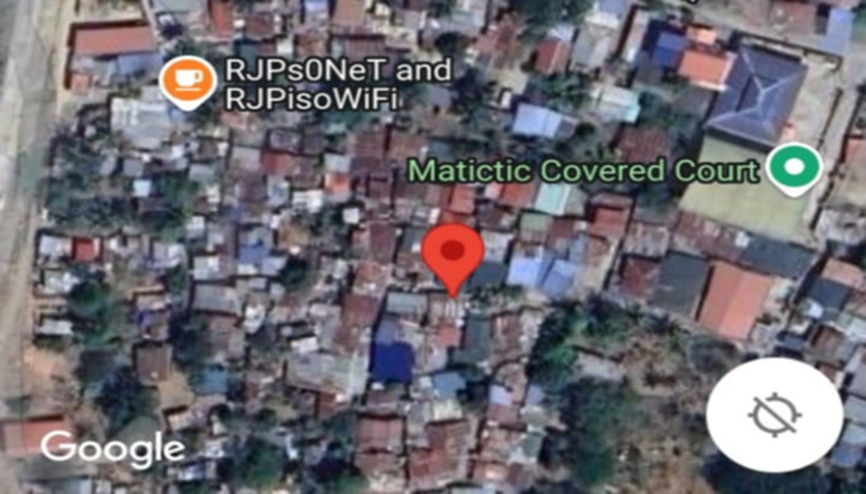**Research Locale**

This study aims to create a system designing about point of sales for Adam’s Ice Cream business for efficiency to help expand and upgrade their billing and inventory system. Computerized systems are the new currently used by modern businesses to help improve their transactions, security, and efficiency. A point of sales system is effective on small or medium businesses since it is used to accept orders or purchases from customers and keep track of sales in a particular business.

This Adam’s ice cream is located to Matictic, Norzagaray, Bulacan. Adam's Ice Cream is a local ice cream shop dedicated in crafting delicious, high-quality frozen treats that bring joy to every bite. With a focus on using fresh, locally sourced ingredient. This also offers a wide variety of flavors, ranging from classic favorites to unique, seasonal creations. Each batch is made with care, ensuring a smooth, creamy texture and unforgettable taste. Adam’s Ice Cream is strong committed to excellence in service. The proposed system will help the business to achieve efficiency and productivity in operations. It can be fully integrated into the entire business, which in turn can minimize inventory costs and maximize sales and profits. This research aims to identify the critical features and innovations needed in a specialized ice cream POS system that can enhance operational efficiency and improve customer satisfaction.

**Statement of the Problem**

The Adams Ice Cream business encounters difficulties in maintaining the precision and dependability of its conventional point-of-sale (POS) system and inventory management procedures. These problems affect the business's capacity to monitor inventory and sales efficiently, possibly resulting in discrepancies, inefficiencies, and decreased customer satisfaction.

**General Problem**

How can Adams Ice Cream efficiently and accurately monitor its inventory and sales operations to improve business performance?

**Specific Problems**

1. How to improve the accuracy and reliability of the sales report?
2. How to enhance the convenience of the user during the ordering process?
3. How to enhance sales monitoring and inventory management while ensuring data integrity and operation transparency?

**General Objective**

To implement a digital point-of-sale (POS) system and inventory management to accurately and efficiently monitor the sales and the current inventory that available.

**Specific Objective**

1. To improve the accuracy and reliability of the sales report
2. To enhance the user convenience in the ordering process
3. To enhance the sales monitoring ang inventory management while ensuring the data integrity and operation transparency.

**Significance of the Study**

The following key and important information and knowledge about the selected issues and their expected significance to individuals are provided by the research aims:

**Business Owner**. The digital solution for the traditional manual sales monitoring is more convenient which will improve the sales and also the inventory of the business where the digital will conveniently save more time to check the business.

**Customers**. By optimizing the ordering process, the digital solution will contribute to a smoother and more efficient customer experience.

**Community**. The successful implementation of this system will give impact to not just the business but also to the community it can cause that other business will adapt this digital solution to their business or system.

**Future Researcher**. This will add to the body of knowledge in the field of sales and inventory management and solutions for small and medium-sized business.

**Scope and Limitation**

Adams Ice Cream, which is situated in Matictic, Norzagaray, Bulacan, is the main subject of the study. It seeks to create and put into use an inventory management and digital point-of-sale system that is customized to the particular requirements of the company. From placing orders and recording transactions to producing sales statistics, the suggested system aims to optimize every step of the transaction process and may be used as a template by other companies thinking about implementing digital management solutions. This study evaluates how the digital system affects data processing, operational efficiency, and the possibility of errors in sales and inventory records.

However, user flexibility, which might differ among personnel and impact the system's success, is a major factor in the new system's effectiveness. Furthermore, other variables that are outside the purview of this study, like shifts in supplier dependability and market demand, may have an effect on inventory levels and sales patterns.

In conclusion. The technology used in the entire transaction process, from placing orders to reporting sales, boosting efficiency and reducing mistakes in inventory and sales tracking. While the success of the new system depends on how well users adapt to it, external factors like supplier reliability and changes in customer demand may also have an impact on its efficacy. All things considered, this analysis provides Adams Ice Cream with a feasible plan for modernizing its business processes and increasing sales of the business.

**Hypothesis**

The replacement of the traditional pen and paper in listing the sales and managing the inventory will be replaced with a more appropriate and technological advanced approach will significantly enhance the efficient and dependability of the sales tracking for Adams Ice cream business. The adaption of digital sales and inventory management system is expected to reduced the time consumes on recording and computing the transaction, where it eliminates the potential errors and improving the overall integrity of the sales reports. This action is likely to lead to increased operation efficiency, that could contribute to more success of the business.

These changes will lead to reduced transaction time, minimized errors, accurate sales data, and inventory management within the business.

**Definition of Terms**

**System** - A system is a group of interacting or interrelated elements that act according to a set of rules to form a unified whole.

**Point of sale** - A point of sale (POS) is the hardware and software merchants use to process payments and complete customer purchases. A POS transaction may occur in person or online, with receipts generated in print or electronically.

**Inventory system** - Inventory systems provide detailed records of new and returned products as they're entering or leaving the warehouse to help companies organize and account for their stock.

**Real time updates** - Real-time updates refer to the swift and instantaneous distribution of information as it occurs or is generated, ensuring that end-users receive the most recent data without noticeable delays.

**Sales monitoring** - A sales monitoring system is a software program or connected series of programs that tracks and manages a company's sales information. It can gather and compile information from multiple sources and store sales data about your customers and products.

**Error reduction** - Error reduction techniques and strategies aimed at minimizing the discrepancies between computed results and the exact values in numerical analysis.