Smart EduBuddy
System Workflow & Circuit Diagram
Complete Technical Documentation
Contents:
1. System Workflow: How It Works
2. Circuit Diagram (NodeMCU / ESP32)
3. Power Supply
4. Software Architecture
5. MQTT Communication Protocol
6. Testing & Troubleshooting
7. Safety Guidelines

1. System Workflow: How It Works

Step 1: Teacher Sets Question
- Teacher opens "Teacher Panel" on their laptop.
- Teacher types a question (e.g., "What color is the sky?")
- Teacher selects the Correct Answer from the dropdown (e.g., "Color Blue").
- Teacher clicks "Send Question".
- Result:
- The question appears on the Dashboard Screen (Projector/TV).
- The system silently stores the "Correct Answer ID" (e.g., 02BLUE).

Step 2: Student Responds
- Student looks at the question on the big screen.
- Student finds the physical card that matches their answer (e.g., The Blue Card).
- Student taps the card on the Smart EduBuddy Device (RFID Reader).

Step 3: Device Processing
- RFID Reader detects the card.
- NodeMCU/ESP32 reads the unique ID from the card (e.g., UID: E3 4A B2).
- Code converts that detected ID into a readable Answer ID (e.g., 02BLUE).
- Device sends this message: "02BLUE" to the MQTT Cloud.

Step 4: System Verification
- Web Dashboard receives the message "02BLUE".
- It checks: Is 02BLUE == Correct Answer ID?
- YES (Correct):
- Screen flashes GREEN.
- Audio plays: "Correct! Great Job!"
- +1 Score is added to the "Correct" scoreboard.
- NO (Wrong):
- Screen flashes RED.
- Audio plays: "Oops! Try Again!"
- +1 Score is added to the "Wrong" scoreboard.

2. Circuit Diagram (NodeMCU / ESP32)
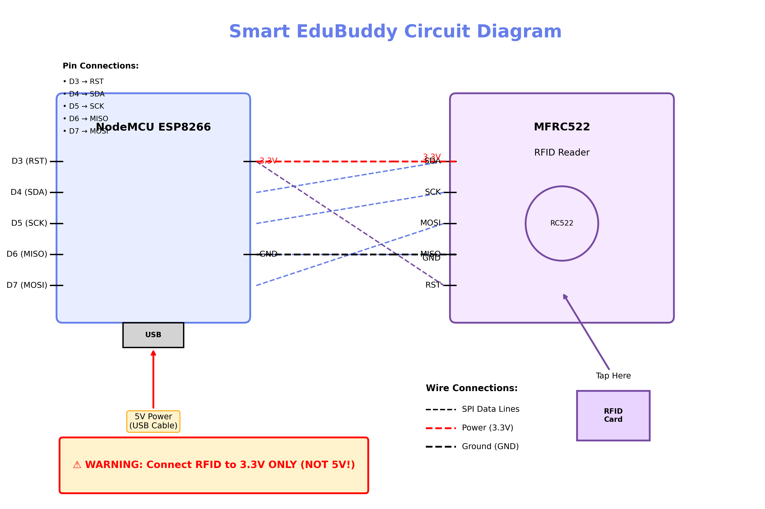
Figure 1: Complete Circuit Schematic Diagram

Components Needed:
- Microcontroller: NodeMCU (ESP8266) OR ESP32 Dev Module
- RFID Reader: MFRC522 (RC522)
- Buttons (Optional): 2x Push Buttons (for testing without cards)
- LED (Optional): Built-in LED is used for status.

Wiring Connections:

A. RFID Reader (RC522) to Microcontroller
RC522 Pin | NodeMCU (ESP8266) | ESP32
SDA (SS) | D4 (GPIO 2) | GPIO 5
SCK | D5 (GPIO 14) | GPIO 18
MOSI | D7 (GPIO 13) | GPIO 23
MISO | D6 (GPIO 12) | GPIO 19
IRQ | Not Connected | Not Connected
GND | GND | GND
RST | D3 (GPIO 0) | GPIO 22
3.3V | 3.3V (3V3) | 3.3V (3V3)
⚠️ WARNING: Do NOT connect RC522 to 5V (Vin). It will damage the reader! Always use 3.3V.

3. Power Supply
Connect the NodeMCU / ESP32 to your laptop or a USB charger using a Micro-USB cable.

Power Requirements:
- Input Voltage: 5V DC (via USB)
- Current Draw: ~200mA (typical), ~500mA (max)
- Power Consumption: ~1W average
- Power Source Options: USB wall adapter, laptop USB port, power bank

Recommended Power Sources:
- Phone charger (5V, 1A minimum)
- Laptop USB port (for testing)
- Power bank (for portable operation)

4. Software Architecture

System Components:

NodeMCU Firmware
- Language: Arduino C++
- Libraries: MFRC522, PubSubClient, ESP8266WiFi
- Functions: WiFi connection, RFID reading, MQTT publishing

Web Dashboard
- Technology: HTML5, CSS3, JavaScript
- MQTT Library: MQTT.js (WebSocket)
- Functions: Display questions, show feedback, track scores

Teacher Control Panel
- Interface: Web-based (responsive design)
- Features: Question creation, preset options, game controls

5. MQTT Communication Protocol
The system uses MQTT (Message Queuing Telemetry Transport) for real-time communication between all components.

MQTT Topics:
Topic | Purpose
edubuddy/question | Teacher sends questions to dashboard
edubuddy/answer | NodeMCU sends student answers
edubuddy/status | Device online/offline notifications
edubuddy/control | System control commands (reset, clear)

Message Format Example:
Question Message: QUESTION|02BLUE|Find the Color Blue
Answer Message: A1B2C3D4

6. Testing & Troubleshooting

Initial Testing Steps:
- Power On Test: Check if NodeMCU power LED lights up
- WiFi Connection: Verify connection via Serial Monitor
- RFID Test: Place card on reader, check Serial Monitor for UID
- MQTT Test: Verify "Connected" status on dashboard

Common Issues & Solutions:

Issue 1: RFID Not Reading Cards
- Verify 3.3V power connection (NOT 5V!)
- Check all SPI wire connections
- Try different RFID cards

Issue 2: WiFi Won't Connect
- Double-check WiFi SSID and password
- Ensure using 2.4GHz network (ESP8266 doesn't support 5GHz)
- Move NodeMCU closer to router

Issue 3: Dashboard Shows Offline
- Refresh browser page
- Check internet connection
- Verify MQTT broker is accessible

7. Safety Guidelines

Electrical Safety:
- Always use 5V USB power only
- Never connect RFID reader to 5V - use 3.3V only!
- Avoid touching components while powered on
- Use insulated enclosure for classroom use

Physical Safety:
- No exposed sharp components
- Secure all wire connections
- Keep device away from water and liquids
- Supervise children during use

Data Safety:
- No personal student data is stored
- System only tracks anonymous scores
- All communication is on local network or encrypted MQTT
Smart EduBuddy - IoT Educational System
Version 1.0 | Complete Technical Documentation
For more information, see the complete documentation package

