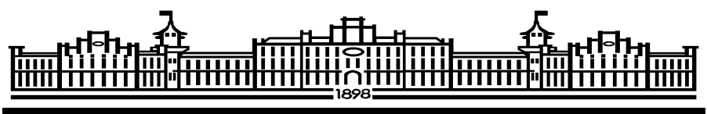
МІНІСТЕРСТВО ОСВІТИ І НАУКИ УКРАЇНИ
НАЦІОНАЛЬНИЙ ТЕХНІЧНИЙ УНІВЕРСИТЕТ УКРАЇНИ
«КИЇВСЬКИЙ ПОЛІТЕХНІЧНИЙ ІНСТИТУТ»

ФАКУЛЬТЕТ ІНФОРМАТИКИ ТА ОБЧИСЛЮВАЛЬНОЇ ТЕХНІКИ
КАФЕДРА ОБЧИСЛЮВАЛЬНОЇ ТЕХНІКИ

ЛАБОРАТОРНА РОБОТА №7
з дисципліни «Паралельні та розподілені обчислення
Паралельне програмування-2»
Тема: «Ada. Рандеву»

Виконав:
студент 3-го курсу
групи ІП-42
з номер заліковки 4206
Дзюба Влад

Київ – 2017
Завдання
Мета роботи: розробка програми для ПКС з ЛП
Мова програмування: Ada
Засоби організації взаємодії процесів: механізм рандеву.
Варіант
T, d, MO
1
E, MK
2
3
A, Z
4
5
6
7
8

Математичний паралельний алгоритм:

Алгоритм для кожного процесу:
nextsMap — множина індексів потоків, з яких надходять
- Ввести T, d MO.  - Отримати .  - Обчислити  - Передати  - Отримати .  - Передати .  - Отримати  - Обчислити  - Передати |  | - Ввести Z.  - Передати .  - Обчислити  - Отримати .  - Обчислити  - Передати  - Отримати .  - Отримати  - Обчислити  - Отримати  - Вивести
- Ввести E, MK.  - Отримати .  - Обчислити  - Передати  - Отримати  - Отримати .  - Передати  - Обчислити  - Передати |  | - Отримати.  - Обчислити  - Отримати .  - Обчислити  - Передати  - Отримати  - Отримати .  - Отримати  - Обчислити  - Передати

Структурна схема взаємодії процесів
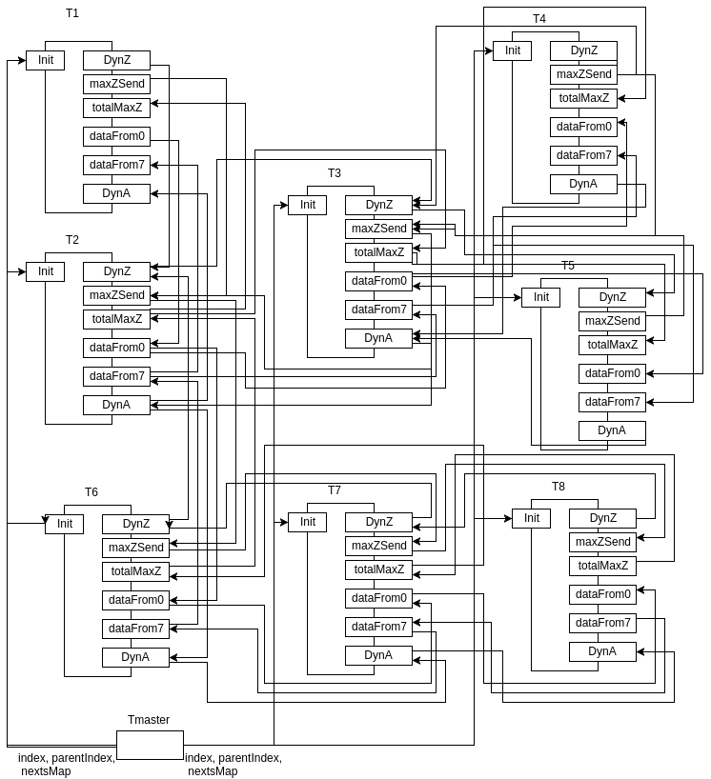

Лістінг програми:
Main.adb
--------------------------------------------------------------------------------
-- main
-- Author:
-- Dzyuba Vlad, IP-42
-- Purpose:
-- Parallel calculating of operations with numbers, vectors and matricies.
--------------------------------------------------------------------------------
with Ada.Text_IO; use Ada.Text_IO;
with Ada.Containers.Hashed_Maps;
with Ada.Containers.Vectors;
use Ada.Containers;

procedure main2 is
N: constant Integer := 280;
P: constant Integer := 8;
H: constant Integer := N / P;
subtype Index is Integer range 0..N-1;
subtype PartIndex is Integer range 0..H-1;
subtype ThreadIndex is Integer range 0..P-1;
type Vector is array (Index) of Integer;
type VectorPart is array (PartIndex) of Integer;
type Matrix is array (Index) of Vector;
type MatrixPart is array (PartIndex) of Vector;

function IntHash(id: Integer) return Hash_Type is
begin
return Hash_Type(id);
end;

package Vectors is new Ada.Containers.Hashed_Maps
(Key_Type => Integer,
Element_Type => VectorPart,
Hash => IntHash,
Equivalent_Keys => "=");

package Matrixes is new Ada.Containers.Hashed_Maps
(Key_Type => Integer,
Element_Type => MatrixPart,
Hash => IntHash,
Equivalent_Keys => "=");

type DynArray is Array (Integer range <>) of ThreadIndex;
type PDynArray is access DynArray;

package Nexts is new Ada.Containers.Hashed_Maps
(Key_type => ThreadIndex,
Element_Type => PDynArray,
Hash => IntHash,
Equivalent_keys => "=");

function initVector return Vector is
res: Vector;
begin
for i in Vector'Range loop
res(i) := 1;
end loop;
return res;
end;

function initMatrix return Matrix is
res: Matrix;
begin
for i in Matrix'Range loop
res(i) := initVector;
end loop;
return res;
end;

task type Calculation is
entry Init(index, parentIndex: ThreadIndex; nextsMap: Nexts.Map);
entry DynZ(from: ThreadIndex; vecParts: Vectors.Map);
entry maxZSend(anotherMaxZ: Integer);
entry totalMaxZ(totalMaxZ: Integer);
entry dataFrom0(from: ThreadIndex; T: Vector; d: Integer; MO: Matrix);
entry dataFrom7(from: ThreadIndex; vecParts: Vectors.Map; matParts: Matrixes.Map);
entry DynA(from: ThreadIndex; vecParts: Vectors.Map);
end Calculation;

calc1, calc2, calc3, calc4, calc5, calc6, calc7, calc8: Calculation;

function toVectorsMap(vec: Vector) return Vectors.Map is
res: Vectors.Map;
begin
for i in ThreadIndex loop
declare
part: VectorPart;
begin
for j in PartIndex loop
part(j) := vec(i*H+j);
end loop;
Vectors.Insert(res, i, part);
end;
end loop;
return res;
end;

function fromVectorsMap(vecParts: Vectors.Map) return Vector is
res: Vector;
procedure addPart(position: Vectors.Cursor) is
procedure addPart(key: Integer; vecPart: VectorPart) is
begin
for i in vecPart'Range loop
res(key * H + i) := vecPart(i);
end loop;
end;
begin
Vectors.Query_Element(position, addPart'Access);
end;
begin
Vectors.Iterate(vecParts, addPart'Access);
return res;
end;

function toMatrixesMap(mat: Matrix) return Matrixes.Map is
res: Matrixes.Map;
begin
for i in ThreadIndex loop
declare
part: MatrixPart;
begin
for j in PartIndex loop
part(j) := mat(i*H+j);
end loop;
Matrixes.Insert(res, i, part);
end;
end loop;
return res;
end;

function remove(vecParts: in out Vectors.Map; index: Integer) return VectorPart is
res: VectorPart;
begin
res := Vectors.Element(vecParts, index);
Vectors.Delete(vecParts, index);
return res;
end;

function remove(matParts: in out Matrixes.Map; index: Integer) return MatrixPart is
res: MatrixPart;
begin
res := Matrixes.Element(matParts, index);
Matrixes.Delete(matParts, index);
return res;
end;

task body Calculation is
index, parentIndex: ThreadIndex;
nextsMap: Nexts.Map;

T, Z, E: Vector;
d, maxZ: Integer;
MO, MK: Matrix;
Eh, Zh, Ah: VectorPart;
MKh: MatrixPart;

begin
accept Init(index, parentIndex: ThreadIndex; nextsMap: Nexts.Map) do
Calculation.index := index;
Calculation.parentIndex := parentIndex;
Calculation.nextsMap := nextsMap;

case index is
when 0 =>
T := initVector;
d := 1;
MO := initMatrix;

when 4 =>
Z := initVector;

when 7 =>
E := initVector;
MK := initMatrix;
when others => null;
end case;
end Init;

if index = 4 then
declare
ZParts: Vectors.Map;
begin
ZParts := toVectorsMap(Z);
Zh := remove(ZParts, index);
calc3.DynZ(index, ZParts);
end;
else declare
fromCopy: Integer;
vecPartsCopy: Vectors.Map;
elem: VectorPart;

procedure sendZhTo(position: Nexts.Cursor) is
procedure sendZhTo(key: ThreadIndex; neededKeys: PDynArray) is
cutZh: Vectors.Map;
begin
if fromCopy = key then
return;
end if;
for i in neededKeys'Range loop
elem := Vectors.Element(vecPartsCopy, neededKeys(i));
Vectors.Insert(cutZh, neededKeys(i), elem);
end loop;
case key is
when 0 => calc1.DynZ(index, cutZh);
when 1 => calc2.DynZ(index, cutZh);
when 2 => calc3.DynZ(index, cutZh);
when 3 => calc4.DynZ(index, cutZh);
when 4 => calc5.DynZ(index, cutZh);
when 5 => calc6.DynZ(index, cutZh);
when 6 => calc7.DynZ(index, cutZh);
when 7 => calc8.DynZ(index, cutZh);
end case;
end;
begin
Nexts.Query_Element(position, sendZhTo'Access);
end;
begin
accept DynZ(from: ThreadIndex; vecParts: Vectors.Map) do
fromCopy := from;
vecPartsCopy:= vecParts;
end;
Zh := remove(vecPartsCopy, index);
Nexts.Iterate(nextsMap, sendZhTo'Access);
end;
end if;
maxZ := Integer'First;
for i in Zh'Range loop
maxZ := Integer'Max(maxZ, Zh(i));
end loop;

declare
len: ThreadIndex := Integer(Nexts.Length(nextsMap))-1;
begin
if parentIndex = index then
len := len + 1;
end if;
for i in 1..len loop
accept maxZSend(anotherMaxZ: Integer) do
maxZ := Integer'Max(maxZ, anotherMaxZ);
end;
end loop;
end;

if index /= parentIndex then
case parentIndex is
when 0 => calc1.maxZSend(maxZ);
when 1 => calc2.maxZSend(maxZ);
when 2 => calc3.maxZSend(maxZ);
when 3 => calc4.maxZSend(maxZ);
when 4 => calc5.maxZSend(maxZ);
when 5 => calc6.maxZSend(maxZ);
when 6 => calc7.maxZSend(maxZ);
when 7 => calc8.maxZSend(maxZ);
end case;
declare
procedure sendTotalMaxZTo(position: Nexts.Cursor) is
procedure sendTotalMaxZTo(key: ThreadIndex; neededKeys: PDynArray) is
begin
if parentIndex = key then
return;
end if;
case key is
when 0 => calc1.totalMaxZ(maxZ);
when 1 => calc2.totalMaxZ(maxZ);
when 2 => calc3.totalMaxZ(maxZ);
when 3 => calc4.totalMaxZ(maxZ);
when 4 => calc5.totalMaxZ(maxZ);
when 5 => calc6.totalMaxZ(maxZ);
when 6 => calc7.totalMaxZ(maxZ);
when 7 => calc8.totalMaxZ(maxZ);
end case;
end;
begin
Nexts.Query_Element(position, sendTotalMaxZTo'Access);
end;
begin
accept totalMaxZ(totalMaxZ: Integer) do
maxZ := totalMaxZ;
end;
Nexts.Iterate(nextsMap, sendTotalMaxZTo'Access);
end;
else
calc3.totalMaxZ(maxZ);
end if;

if index = 0 then
calc2.dataFrom0(index, T, d, MO);
else
declare
fromIndex: ThreadIndex;
procedure sendDataFrom0To(position: Nexts.Cursor) is
procedure sendDataFrom0To(key: ThreadIndex; neededKeys: PDynArray) is
begin
if fromIndex = key then
return;
end if;
case key is
when 0 => calc1.dataFrom0(index, T, d, MO);
when 1 => calc2.dataFrom0(index, T, d, MO);
when 2 => calc3.dataFrom0(index, T, d, MO);
when 3 => calc4.dataFrom0(index, T, d, MO);
when 4 => calc5.dataFrom0(index, T, d, MO);
when 5 => calc6.dataFrom0(index, T, d, MO);
when 6 => calc7.dataFrom0(index, T, d, MO);
when 7 => calc8.dataFrom0(index, T, d, MO);
end case;
end;
begin
Nexts.Query_Element(position, sendDataFrom0To'Access);
end;
begin
accept dataFrom0(from: ThreadIndex; T: Vector; d: Integer; MO: Matrix) do
Calculation.T := T;
Calculation.d := d;
Calculation.MO := MO;
fromIndex := from;
end;
Nexts.Iterate(nextsMap, sendDataFrom0To'Access);
end;
end if;

if index = 7 then
declare
EParts: Vectors.Map;
MKParts: Matrixes.Map;
begin
EParts := toVectorsMap(E);
Eh := remove(EParts, index);
MKParts := toMatrixesMap(MK);
MKh := remove(MKParts, index);
calc7.dataFrom7(index, EParts, MKParts);
end;
else
declare
fromIndex: ThreadIndex;
vecPartsCopy: Vectors.Map;
matPartsCopy: Matrixes.Map;
elem: VectorPart;
elemMat: MatrixPart;
procedure sendDataFrom7To(position: Nexts.Cursor) is
procedure sendDataFrom7To(key: ThreadIndex; neededKeys: PDynArray) is
cutEh: Vectors.Map;
cutMKh: Matrixes.Map;
begin
if fromIndex = key then
return;
end if;
for i in neededKeys'Range loop
elem := Vectors.Element(vecPartsCopy, neededKeys(i));
Vectors.Insert(cutEh, neededKeys(i), elem);
elemMat := Matrixes.Element(matPartsCopy, neededKeys(i));
Matrixes.Insert(cutMKh, neededKeys(i), elemMat);
end loop;
case key is
when 0 => calc1.dataFrom7(index, cutEh, cutMKh);
when 1 => calc2.dataFrom7(index, cutEh, cutMKh);
when 2 => calc3.dataFrom7(index, cutEh, cutMKh);
when 3 => calc4.dataFrom7(index, cutEh, cutMKh);
when 4 => calc5.dataFrom7(index, cutEh, cutMKh);
when 5 => calc6.dataFrom7(index, cutEh, cutMKh);
when 6 => calc7.dataFrom7(index, cutEh, cutMKh);
when 7 => calc8.dataFrom7(index, cutEh, cutMKh);
end case;
end;
begin
Nexts.Query_Element(position, sendDataFrom7To'Access);
end;
begin
accept dataFrom7(from: ThreadIndex; vecParts: Vectors.Map; matParts: Matrixes.Map) do
fromIndex := from;
vecPartsCopy := vecParts;
matPartsCopy := matParts;
end;
Eh := remove(vecPartsCopy, index);
MKh := remove(matPartsCopy, index);
Nexts.Iterate(nextsMap, sendDataFrom7To'Access);
end;
end if;

for i in Ah'Range loop
declare
mok: Integer;
begin
Ah(i) := maxZ * Eh(i);
for j in T'Range loop
mok := 0;
for k in MO'Range loop
mok := mok + MO(k)(j) * MKh(i)(k);
end loop;
Ah(i) := Ah(i) + d * T(j) * mok;
end loop;
end;
end loop;

declare
gVecParts: Vectors.Map;
procedure mixin(position: Vectors.Cursor) is
procedure mixin(key: Integer; vecPart: VectorPart) is
begin
Vectors.Insert(gVecParts, key, vecPart);
end;
begin
Vectors.Query_Element(position, mixin'Access);
end;
len: Integer := Integer(Nexts.Length(nextsMap))-1;
begin
Vectors.Insert(gVecParts, index, Ah);
if index = parentIndex then
len := len + 1;
end if;
for i in 1..len loop
accept dynA(from: ThreadIndex; vecParts: Vectors.Map) do
Vectors.Iterate(vecParts, mixin'Access);
end;
end loop;
if index /= parentIndex then
case parentIndex is
when 0 => calc1.dynA(index, gVecParts);
when 1 => calc2.dynA(index, gVecParts);
when 2 => calc3.dynA(index, gVecParts);
when 3 => calc4.dynA(index, gVecParts);
when 4 => calc5.dynA(index, gVecParts);
when 5 => calc6.dynA(index, gVecParts);
when 6 => calc7.dynA(index, gVecParts);
when 7 => calc8.dynA(index, gVecParts);
end case;
else
declare
A: Vector := fromVectorsMap(gVecParts);
begin
if N < 20 then
for i in A'Range loop
put(Integer'Image(A(i)));
end loop;
put_line("");
end if;
end;
end if;
end;

end Calculation;

begin
declare
nextsMap: Nexts.Map;
keys1: PDynArray;
begin
keys1 := new DynArray(0..6);
for i in keys1'Range loop
keys1(i) := i + 1;
end loop;
Nexts.Insert(nextsMap, 1, keys1);
calc1.Init(0, 1, nextsMap);
end;
declare
nextsMap: Nexts.Map;
keys0: PDynArray;
keys2: PDynArray;
keys5: PDynArray;
begin
keys0 := new DynArray(0..0);
keys0(0) := 0;
keys2 := new DynArray(0..2);
keys2(0) := 2; keys2(1) := 3; keys2(2) := 4;
keys5 := new DynArray(0..2);
keys5(0) := 5; keys5(1) := 6; keys5(2) := 7;

Nexts.Insert(nextsMap, 0, keys0);
Nexts.Insert(nextsMap, 2, keys2);
Nexts.Insert(nextsMap, 5, keys5);

calc2.Init(1, 2, nextsMap);
end;
declare
nextsMap: Nexts.Map;
keys1: PDynArray;
keys3: PDynArray;
keys4: PDynArray;
begin
keys1 := new DynArray(0..4);
keys1(0) := 0; keys1(1) := 1; keys1(2) := 5; keys1(3) := 6; keys1(4) := 7;
keys3 := new DynArray(0..0);
keys3(0) := 3;
keys4 := new DynArray(0..0);
keys4(0) := 4;

Nexts.Insert(nextsMap, 1, keys1);
Nexts.Insert(nextsMap, 3, keys3);
Nexts.Insert(nextsMap, 4, keys4);

calc3.Init(2, 4, nextsMap);
end;
declare
nextsMap: Nexts.Map;
keys2: PDynArray;
begin
keys2 := new DynArray(0..6);
keys2(0) := 0; keys2(1) := 1; keys2(2) := 2;
keys2(3) := 4; keys2(4) := 5; keys2(5) := 6; keys2(6) := 7;

Nexts.Insert(nextsMap, 2, keys2);

calc4.Init(3, 2, nextsMap);
end;
declare
nextsMap: Nexts.Map;
keys2: PDynArray;
begin
keys2 := new DynArray(0..6);
keys2(0) := 0; keys2(1) := 1; keys2(2) := 2; keys2(3) := 3;
keys2(4) := 5; keys2(5) := 6; keys2(6) := 7;

Nexts.Insert(nextsMap, 2, keys2);

calc5.Init(4, 4, nextsMap);
end;
declare
nextsMap: Nexts.Map;
keys1: PDynArray;
keys6: PDynArray;
begin
keys1 := new DynArray(0..4);
keys1(0) := 0; keys1(1) := 1; keys1(2) := 2; keys1(3) := 3; keys1(4) := 4;
keys6 := new DynArray(0..1);
keys6(0) := 6; keys6(1) := 7;

Nexts.Insert(nextsMap, 1, keys1);
Nexts.Insert(nextsMap, 6, keys6);

calc6.Init(5, 1, nextsMap);
end;
declare
nextsMap: Nexts.Map;
keys5: PDynArray;
keys7: PDynArray;
begin
keys5 := new DynArray(0..5);
keys5(0) := 0; keys5(1) := 1; keys5(2) := 2; keys5(3) := 3; keys5(4) := 4; keys5(5) := 5;
keys7 := new DynArray(0..0);
keys7(0) := 7;

Nexts.Insert(nextsMap, 5, keys5);
Nexts.Insert(nextsMap, 7, keys7);

calc7.Init(6, 5, nextsMap);
end;
declare
nextsMap: Nexts.Map;
keys6: PDynArray;
begin
keys6 := new DynArray(0..6);
for i in keys6'Range loop
keys6(i) := i;
end loop;

Nexts.Insert(nextsMap, 6, keys6);

calc8.Init(7, 6, nextsMap);
end;
end;

