In prior iterations, you have framed your design by providing a list of structural business rules as well as a conceptual ERD. You have also received additional feedback from your facilitator, and have continued augmenting your database skills with additional course material and experience. Your design is well on its way! You are ready to create a logical ERD for your project. Recall that logical ERDs are tied to relational model, and contain primary and foreign key constraints. Further recall that entities are normalized in logical ERDs.

To make sure your logical ERD works both in theory and in practice, now would be a good time to begin implementing the SQL for Aspect 1. Recall that the aspect has four components – the tables and constraints, a reusable stored procedure, example usages of the procedure, and a query. As you begin writing the SQL for this aspect, you may realize that your design must be altered or enhanced in order to support the data and relationships needed, which is perfectly reasonable. You will just want to ensure that changes to the design are reflected consistently in the business rules, conceptual ERD, and logical ERD.

This work is summarized in the steps below.

1. Make any enhancements and corrections to your business rules and provide the updated list below.

- A SELLER sells one or many PRODUCT(S)
- A PRODUCT is sold by one or many SELLERS
- A WAREHOUSE stores many PRODUCT(S)
- A PRODUCT is stored at one or more WAREHOUSE
- A CUSTOMER buys zero to many PRODUCT(S)
- A PRODUCT is brought by one or more CUSTOMER
- An ORDER may contain one or many PRODUCT(S)
- One ORDER may have one or more SHIPMENTS
- A SHIPMENT is sent from one or many WAREHOUSE
- A WAREHOUSE ship zero to many SHIPMENTS
- A CUSTOMER may get one zero or many SHIPMENTS
- One SHIPMENT is sent to a CUSTOMER.

Entity List
SELLER
PRODUCT
WAREHOUSE
ADDRESS
ORDER
SHIPMENT
CUSTOMER
INVENTORY

2. Make any enhancements and corrections to your conceptual ERD and provide the updated ERD below.

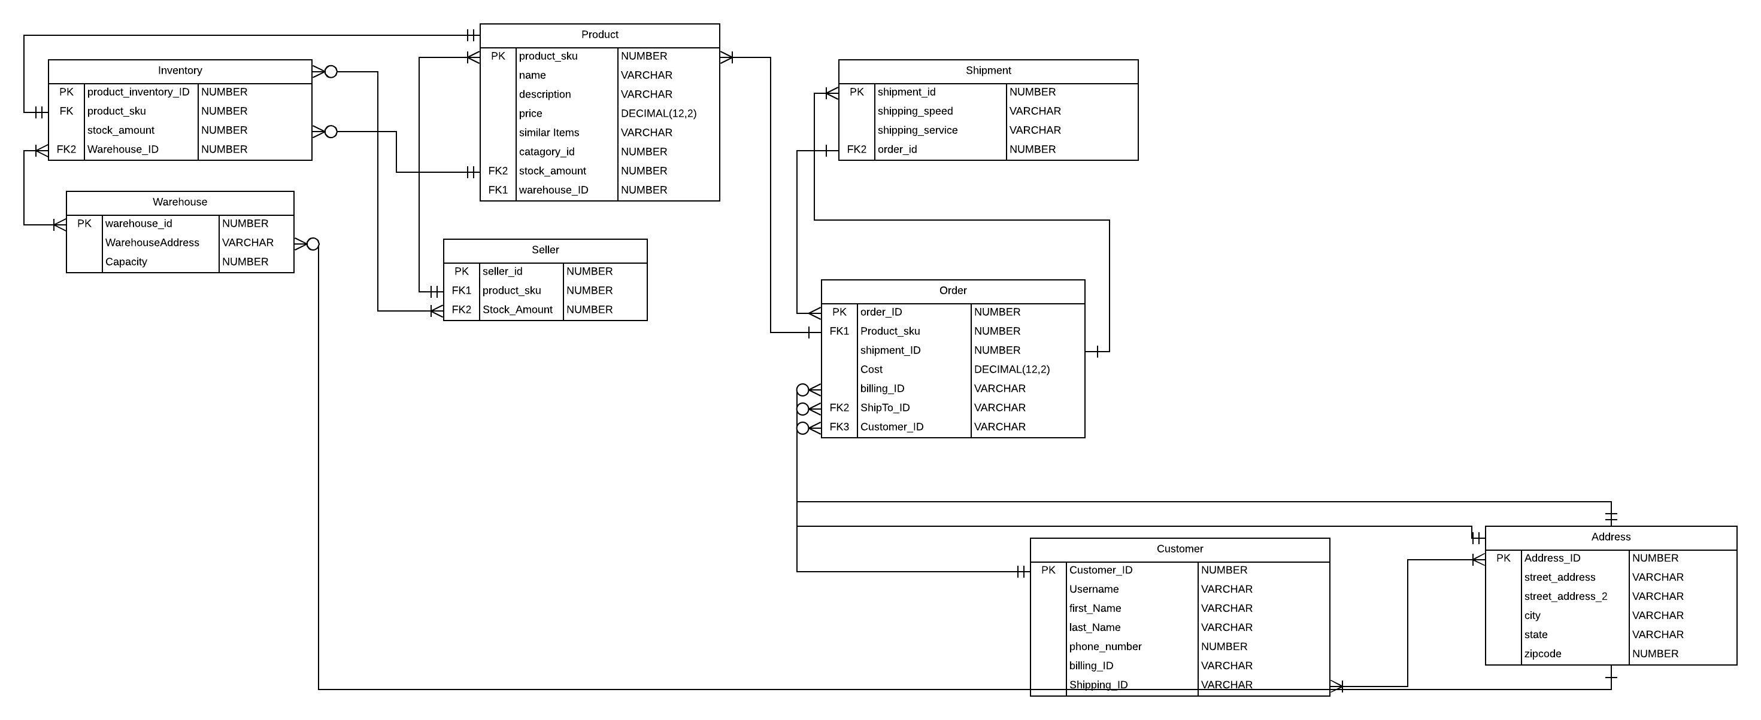

https://www.lucidchart.com/invitations/accept/c9d4b5da-6648-4384-a8ee-c51b59eae219

3. Submit a logical entity-relationship diagram for your term project database below.

4. Create and execute the SQL for Aspect 1. Provide screenshots.
- Tables and constraints.

CREATE TABLE amzShipment (
shipment_id DECIMAL(10),
shipping_speed VARCHAR2(255),
shipping_service VARCHAR2(255),
order_id DECIMAL(10),
PRIMARY KEY (shipment_id)
);

CREATE TABLE amzWarehouse (
warehouse_id DECIMAL(10),
WarehouseAddress VARCHAR2(255),
Capacity DECIMAL(10),
PRIMARY KEY (warehouse_id)
);

CREATE TABLE amzProduct (
product_sku DECIMAL(10),
name VARCHAR2(255),
description VARCHAR2(255),
price DECIMAL(12,2),
similar_items VARCHAR2(255),
catagory_id DECIMAL(10),
stock_amount DECIMAL(10),
warehouse_ID DECIMAL(10),
PRIMARY KEY (product_sku)
);

CREATE TABLE amzSeller (
seller_id DECIMAL(10),
slr_product_sku DECIMAL(10),
Stock_Amount DECIMAL(10),
PRIMARY KEY (seller_id)
);

CREATE TABLE amzOrder (
order_ID DECIMAL(10),
ord_Product_sku DECIMAL(10),
ord_shipment_ID DECIMAL(10),
Cost DECIMAL(12,2),
ord_billing_ID VARCHAR2(255),
ord_ShipTo_ID VARCHAR2(255),
ord_Customer_ID VARCHAR2(255),
PRIMARY KEY (order_ID)
);

CREATE TABLE amzAddress (
Address_ID DECIMAL(10),
street_address VARCHAR2(255),
street_address_2 VARCHAR2(255),
city VARCHAR2(255),
state VARCHAR2(255),
zipcode DECIMAL(10),
PRIMARY KEY (Address_ID)
);

CREATE TABLE amzCustomer (
Customer_ID DECIMAL(10),
Username VARCHAR2(255),
first_Name VARCHAR2(255),
last_Name VARCHAR2(255),
phone_number DECIMAL(10),
cus_billing_ID VARCHAR2(255),
cus_Shipping_ID VARCHAR2(255),
PRIMARY KEY (Customer_ID)
);

CREATE TABLE amzInventory (
product_inventory_ID DECIMAL(10),
inv_product_sku DECIMAL(10),
inv_stock_amount DECIMAL(10),
inv_Warehouse_ID DECIMAL(10),
PRIMARY KEY (product_inventory_ID)
);
EXECUTION SCREENSHOT

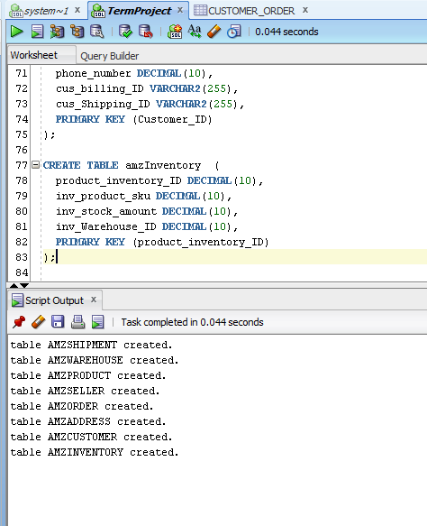

- Reusable stored procedure.
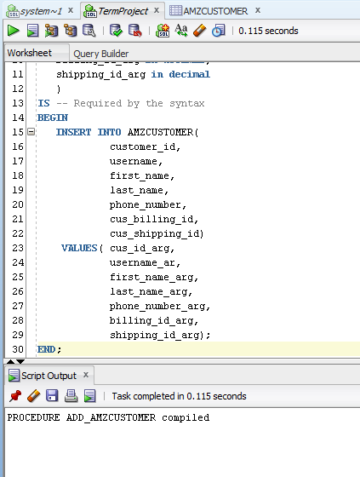

- Use of the stored procedure.
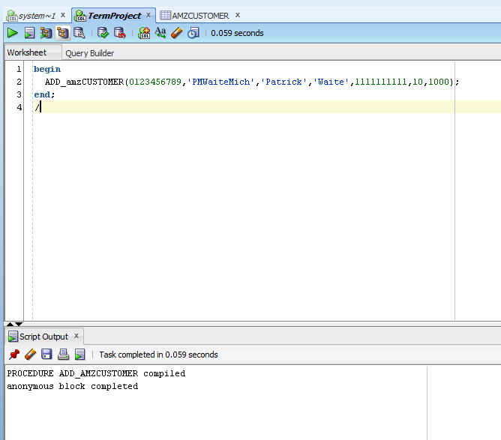

- SQL query.
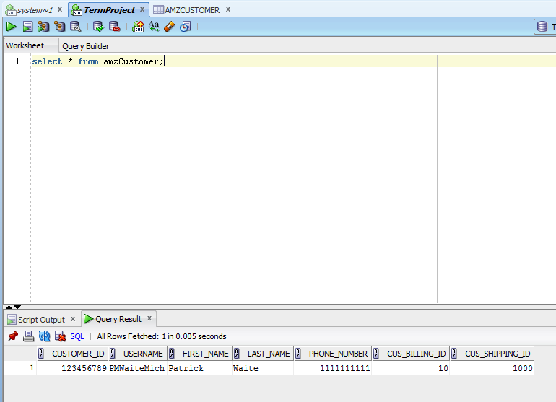

This iteration is not your final term project submission. You have the opportunity to modify all sections of your term project before the final submission at the end of the course.

Use the Ask the Facilitators Discussion Forum if you have any questions regarding the how to approach this assignment.

Save your assignment as lastnameFirstname_iteration4.doc and submit it in the Assignments section of the course.

For help uploading files please refer to the Technical Support page in the syllabus.

