Structural Business rules
New product use case
- A SELLER sells zero or many PRODUCT(S)
- A PRODUCT is sold by one or many SELLERS
- Each PRODUCT has a CATEGORY

CONCEPTUAL ERD
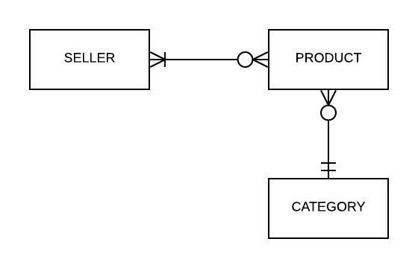

Product delivery use case
- A WAREHOUSE stores many PRODUCT(S)
- A PRODUCT is stored at one or more WAREHOUSE
CONCEPTUAL ERD
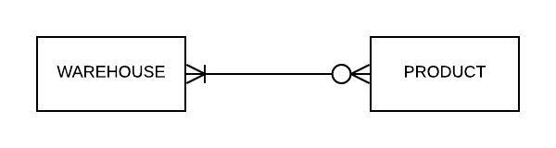

New customer account use case
- A CUSTOMER has an address, phone number, username, and email address
CONCEPTUAL ERD
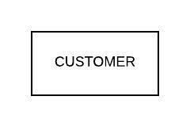

Product purchases use case
- A CUSTOMER buys zero to many PRODUCT(S)
- A PRODUCT is brought by one or more CUSTOMER
- An ORDER may contain one or many PRODUCT(S)
CONCEPTUAL ERD
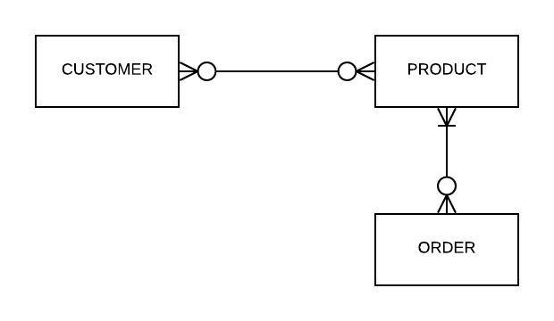

Product shipment use case
- One ORDER may have one or more SHIPMENTS
- A SHIPMENT is sent from one or many WAREHOUSE
- A WAREHOUSE ship zero to many SHIPMENTS
- A CUSTOMER may get one zero or many SHIPMENTS
- One SHIPMENT is sent to a CUSTOMER.
CONCEPTUAL ERD
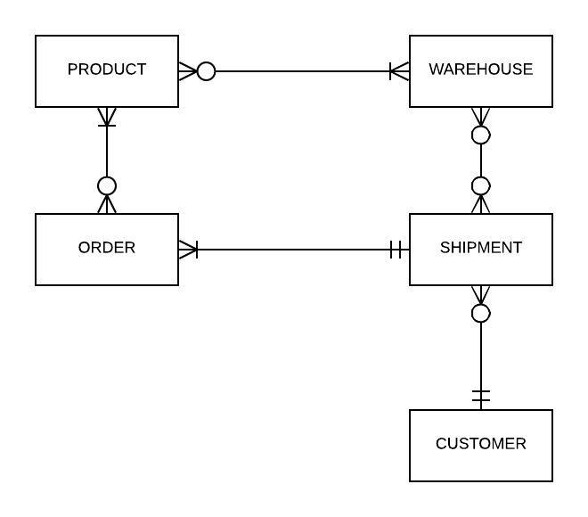

All parts combined we’d get a Conseptual ERD such as
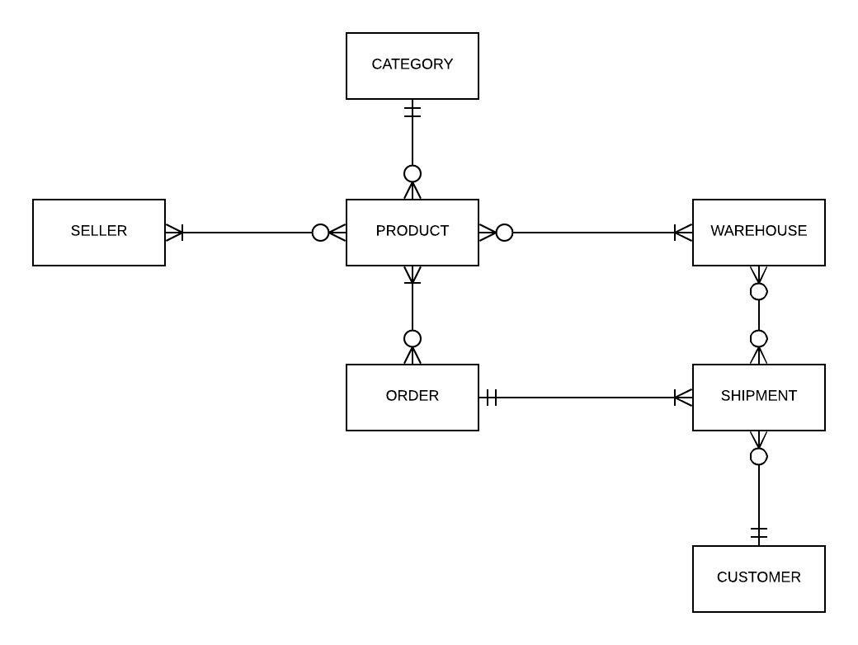
At a low concept level we can focus on 2 persons entities and the products and how they interact with one another.
Under my logical Entity relational diagram I’ve expanded out from the conceptual and added much of the underlying table structures and data types.
For a better view please find diagram at lucidchard ((https://www.lucidchart.com/invitations/accept/8646dcfe-c93c-4139-8580-e6454b55419b ))
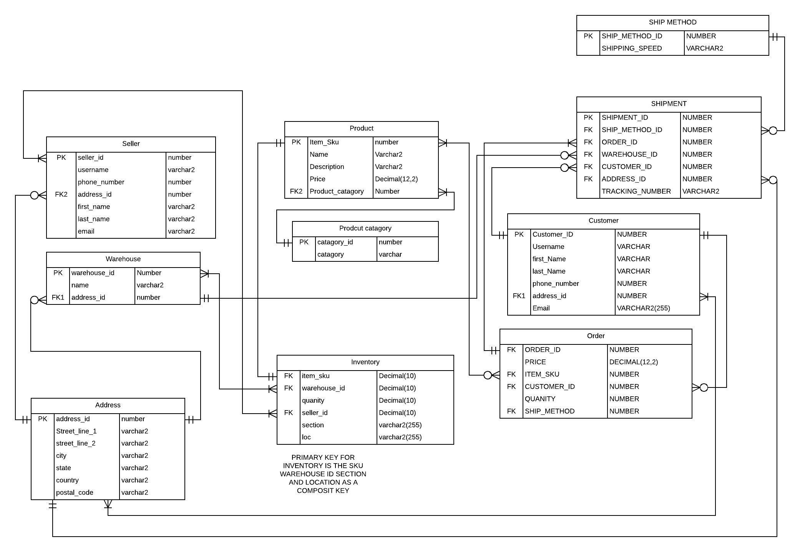
A few things to note about this diagram my inventory and order entities require a composite primary key as more than one product can be the same sku, and the order table is used to compile orders, each item of an order would have the same ID as such that column would not be unique.
To begin with breaking down the ERD for this database we should look at the reasoning behind each entity. We have seller, product, warehouse, address, inventory, product category, ship method, shipment, customer, and order as our entities or tables. The goal of my design would be to keep data of similar nature together. The address and product tables are good examples of this, as seller, customer, and warehouse all have addresses associated with them, the use of a table for just this data is the correct choice instead of tacking on street address data to those three entities. Product operates in a similar way for order and shipment as well as inventory.
Inventory is intended to operate as a bridge table between product and warehouse as well as hold the physical location of the product within the warehouse. Order and shipment also serve as bridge tables between product and customer.

Section 2
Aspect 1: New Products – This aspect is based upon the New Product Use Case in Section 1.
b. Develop a parameterized stored procedure that is used when a seller needs to add any new
product.
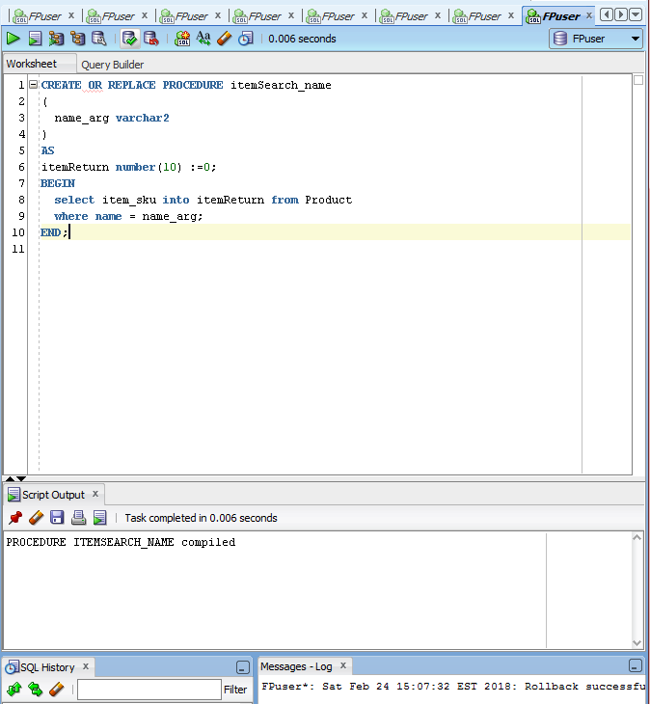
The use case specifies searching for an item before a new item is added this stored procedure aids in that

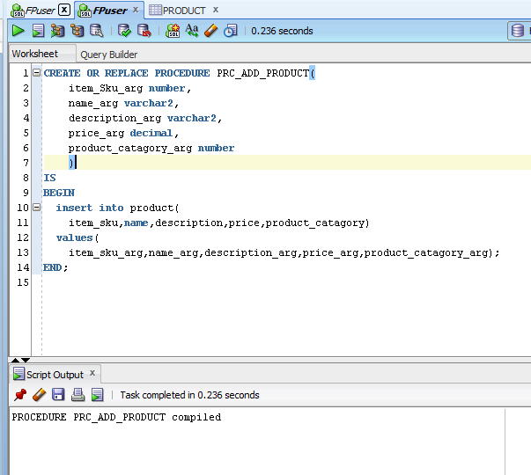

The stored procedure for adding a new item

c. A seller adds two new products. The first is a floating lamp which floats in air rather than resting
on a base. The second is a throwable camera that allows a photographer to throw the camera
into the air and take pictures in flight. Invoke the stored procedure twice to add these products,
keeping in mind that products have at a minimum a name, description, price, and category.

Item search for the new items
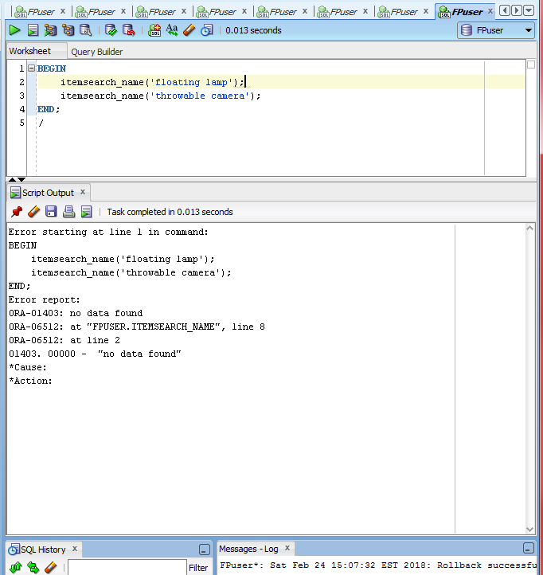

Returned a no data found,
As such executed new item stored procedure
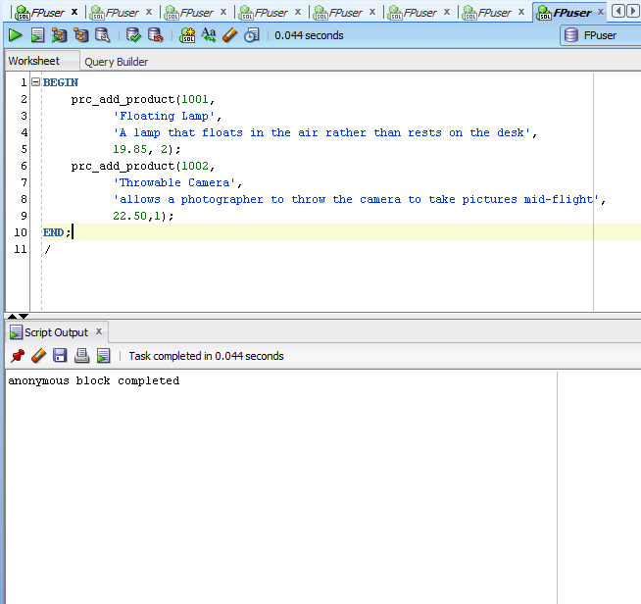

Proof of add
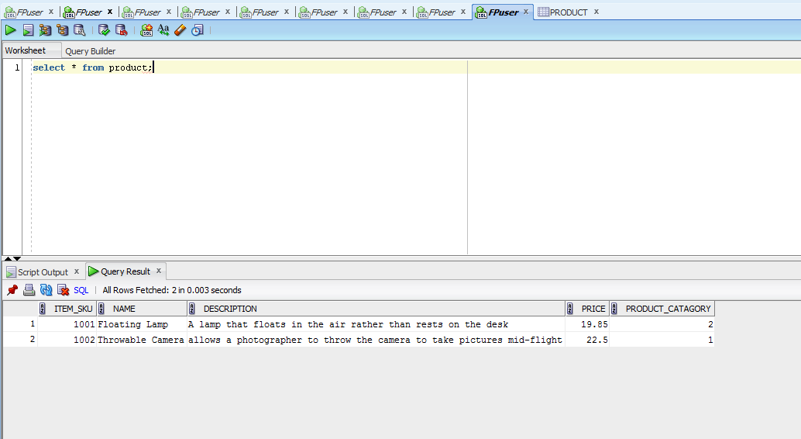

d. A seller is considering developing a new electronic product, and requests a list of existing
products in the “Computers” or “Electronics” categories that cost $25 or less. Develop and
execute a single query that provides this information.
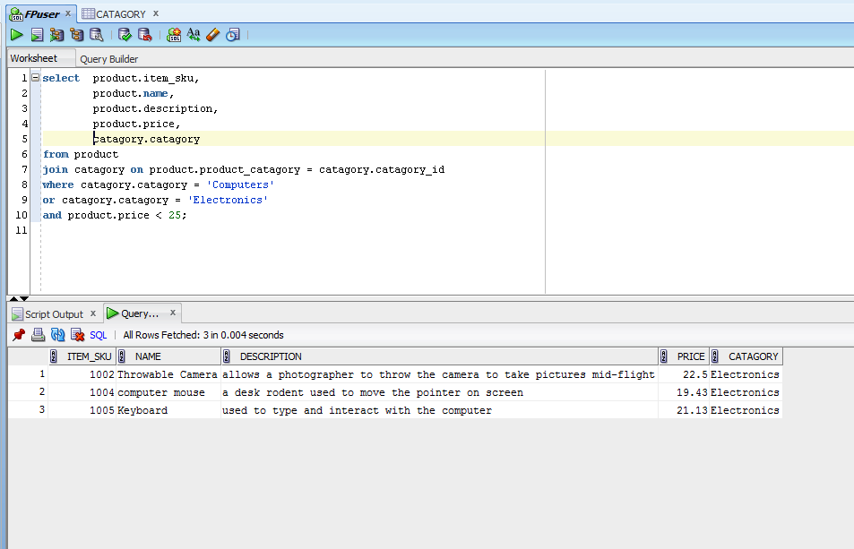
Aspect 2: Product Delivery – This aspect is based upon the Product Delivery Use Case in Section 1.
b. Develop a parameterized stored procedure that is used when any seller delivers any product toAmazon’s warehouse.
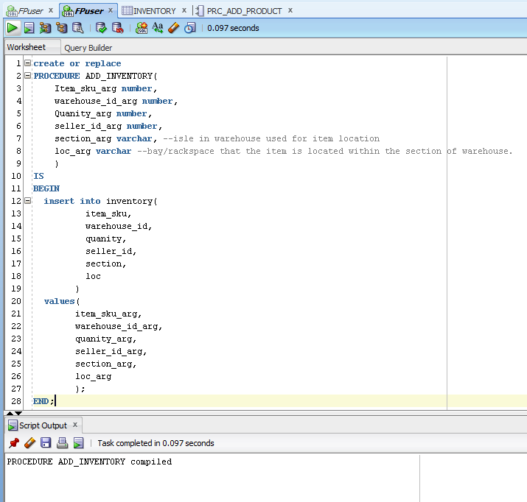

c. A seller delivers ten each of the two new products added in Aspect 1 (the floating lamp and
throwable camera). Invoke the stored procedure twice to update the inventory of these
products for a seller of your choosing.

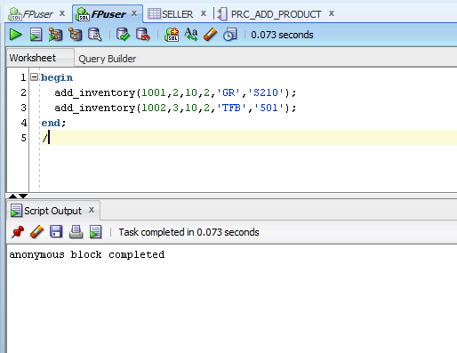

Select * from proof of addition
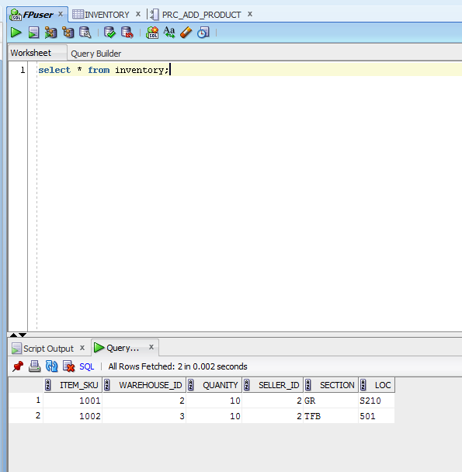

d. The seller from b above requests a listing of all of its products that have an inventory of 12 or
less. Develop and execute a single query that provides this information (the floating lamp and
throwable camera should be among those listed).
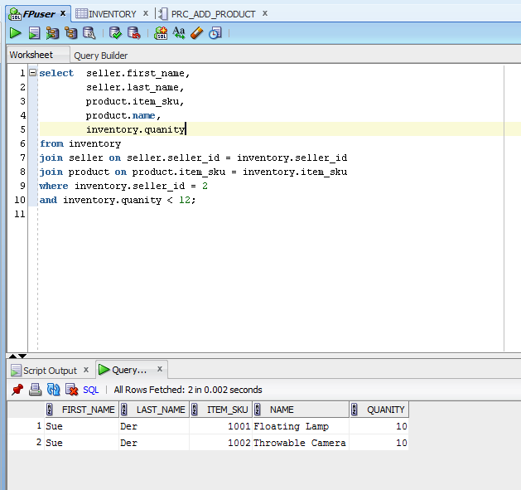

Aspect 3: New Customer Accounts – This aspect is based upon the New Customer Account Use Case inSection 1.
b. Develop a parameterized stored procedure that is used when any new customer signs up for a new account on Amazon.
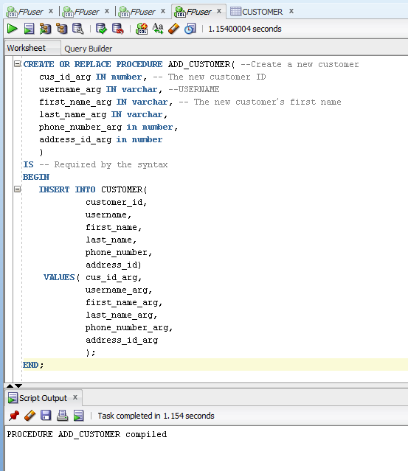
A quick note I forgot to add in a email address to the procedure and added them in after the fact.

c. People named Carter Channing and Delaney Emerson sign up for new accounts on Amazon.
Invoke the stored procedure twice to add these customers.
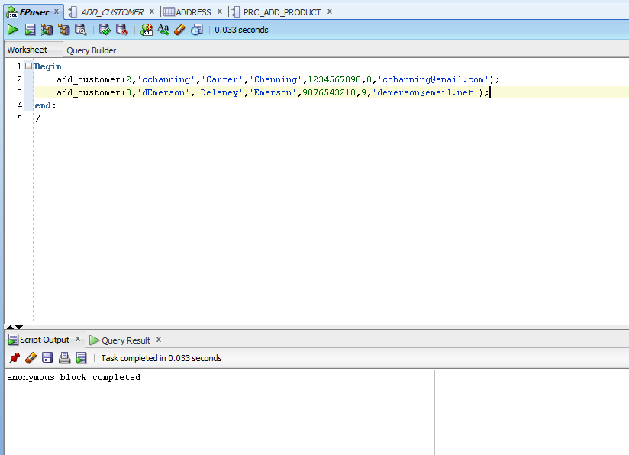

d. For research purposes, Amazon requests the last names of customers where there are least 3
accounts associated with the last name. Amazon would like to see the actual number of
accounts associated with those last names. Develop and execute a single query that provides
this information.
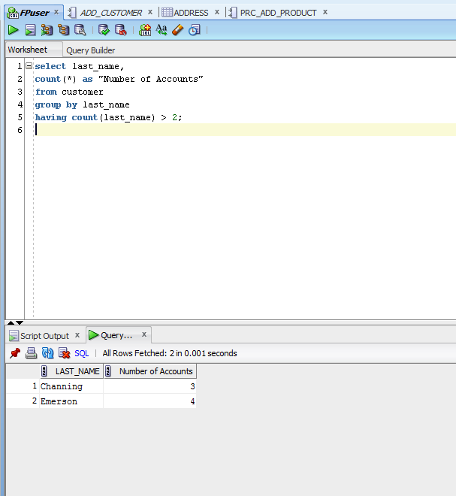

Aspect 4: Product Purchases – This aspect is based upon the Product Purchase Use Case in Section 1.
b. Develop a parameterized stored procedure that is used when any customer purchases any
product.

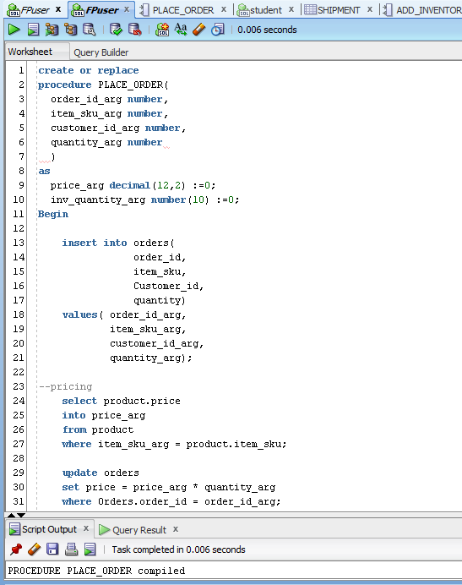

The entire procedure is as follows as the screen shot got cut off a bit but I put the decrement to the inventory and also a price calculation in the procedure as well as adding a line to ‘orders’

Sql stored procedure :
create or replace
procedure PLACE_ORDER(
order_id_arg number,
item_sku_arg number,
customer_id_arg number,
quantity_arg number,
ship_method_arg number
)
as
price_arg decimal(12,2) :=0;
inv_quantity_arg number(10) :=0;
Begin

insert into orders(
order_id,
item_sku,
Customer_id,
quantity,
ship_method)
values( order_id_arg,
item_sku_arg,
customer_id_arg,
quantity_arg,
ship_method_arg);

--pricing
select product.price
into price_arg
from product
where item_sku_arg = product.item_sku;

update orders
set price = price_arg * quantity_arg
where Orders.order_id = order_id_arg;

--inventory control
select inventory.quanity
into inv_quantity_arg
from inventory
where item_sku_arg = inventory.item_sku;

update inventory
set inventory.quanity = inv_quantity_arg - quantity_arg
where inventory.item_sku = item_sku_arg;

end;

c. Carter (from Aspect 3) purchases two floating lamps (from Aspect 1), and Delaney purchases
one throwable camera. Invoke the stored procedure twice, once for each purchase.
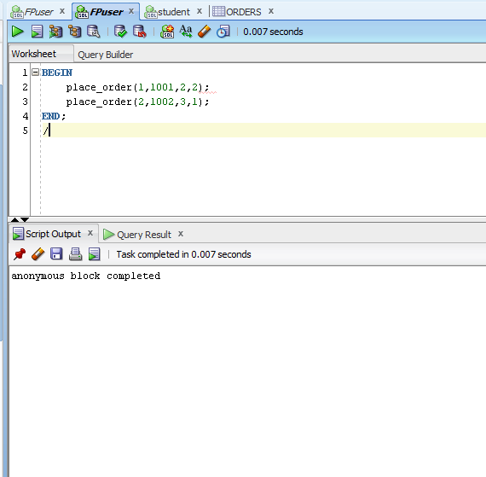

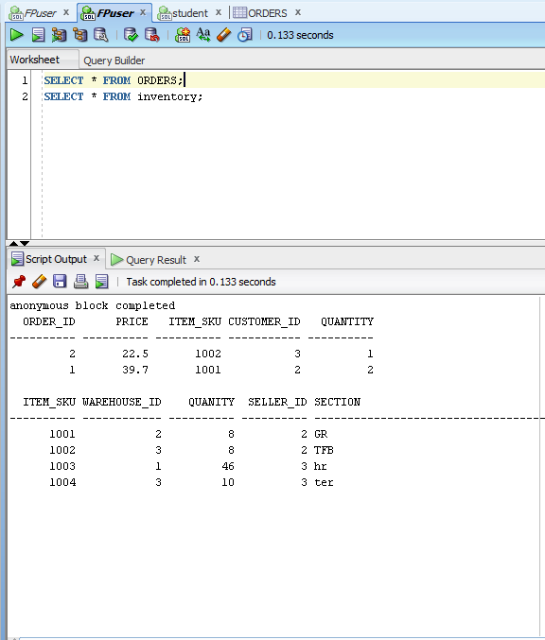

d. The marketing department at Amazon wants to reach out to customers who buy popular
products. The department requests the names and addresses of all customers who bought any
product that was purchased by at least four people. Develop and execute a single query that
provides this information.
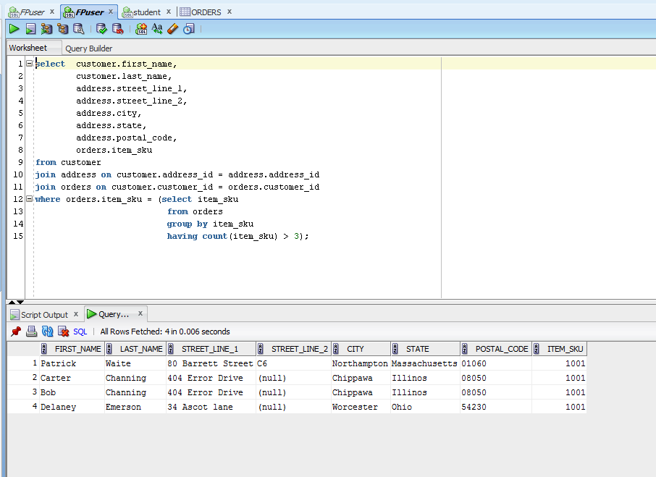

Aspect 5: Product Shipment – This aspect is based upon the Product Shipment Use Case in Section 1.
b. Develop a parameterized stored procedure that is used when Amazon ships any order.
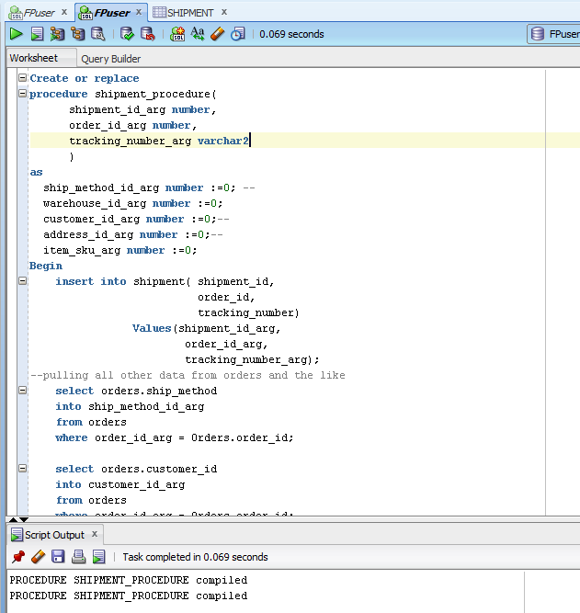

Again the screen shot got cut off so here’s the sql, the shipment table uses a lot of data from other tables and as such rather than entering it in manually every time it is called I’ve created basic select commands to pull the data over and place it in the correct field of the table.

create or replace
procedure shipment_procedure(
shipment_id_arg number,
order_id_arg number,
tracking_number_arg varchar2
)
as
ship_method_id_arg number :=0; --
warehouse_id_arg number :=0;
customer_id_arg number :=0;--
address_id_arg number :=0;--
item_sku_arg number :=0;
Begin
insert into shipment( shipment_id,
order_id,
tracking_number)
Values(shipment_id_arg,
order_id_arg,
tracking_number_arg);
--pulling all other data from orders and the like
select orders.ship_method
into ship_method_id_arg
from orders
where order_id_arg = Orders.order_id;

select orders.customer_id
into customer_id_arg
from orders
where order_id_arg = Orders.order_id;

select customer.address_id
into address_id_arg
from customer
where customer_id_arg = Customer.customer_id;

select orders.item_sku
into item_sku_arg
from orders
where order_id_arg = Orders.order_id;

select inventory.warehouse_id
into warehouse_id_arg
from inventory
where item_sku_arg = inventory.item_sku;

update shipment
set shipment.ship_method_id = ship_method_id_arg,
shipment.warehouse_id = warehouse_id_arg,
shipment.customer_id = customer_id_arg,
shipment.address_id = address_id_arg
where order_id_arg = shipment.order_id;

end;

c. Amazon ships the orders listed in Aspect 4, one to Carter and the other to Delaney. Invoke the stored procedure twice, once for each order.

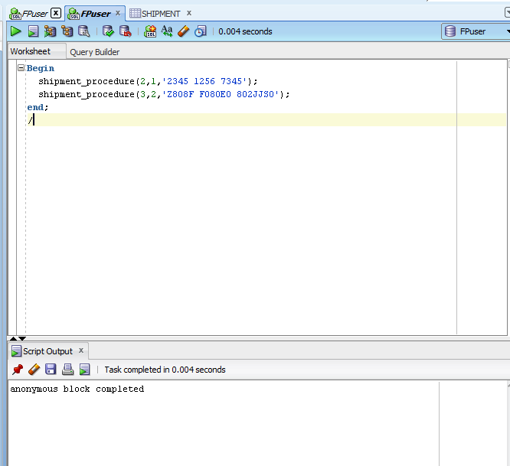

d. Here you define you own query. Define a request for information for this aspect that is
implemented with either aggregation or with a subquery. Then develop and execute a single
query that provides this information.
For this question my request for information was to get a record of tracking numbers from a warehouse having more than three shipments on record. I programmed it to display the tracking number that was entered when the package was shipped and also the first and last name city and state and order number. Below are the results
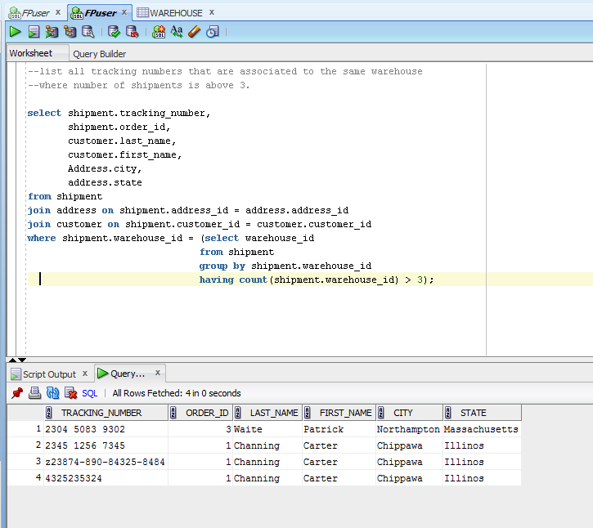

Index request
Create and justify an index that is beneficial to at least one query in your implementation. Include
screenshots illustrating the creation of the index, along with an explanation as to why the index is
beneficial (be specific).
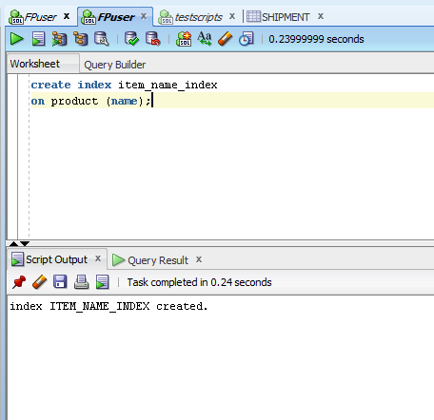
For the request to create an index I chose to place an index on the name field in my product table, this is advantageous for my search query because all the way back to use case of adding a new item the first step is to search for the item in the system. With the number of items I created for this project it may not make much of a difference but if we consider having thousands of product records like amazon does to search by name, as my stored procedure does, would be greatly improved by use of an index on this field.

