CI PIPELINE
SAST Setup using SonarQube
🔷 1. Objective
- This documenation explains how to install and configure SonarQube for performing Static Application Security Testing (SAST) in the CI pipeline. SonarQube is used to analyze source code for bugs, vulnerabilities, and code quality issues.
- It checks for readability,maintainablity,code coverage

🔷 2. Prerequisites
- Linux-based system (Ubuntu recommended)
- Root or sudo access
- Minimum:
  - 2 GB RAM
  - Java 17+ (here we use Java 21)
🔷 3. Java Installation
SonarQube requires Java to run.
sudo apt update
sudo apt install -y openjdk-21-jdk
Verify Java Path
readlink -f $(which java)
Example output:
/usr/lib/jvm/java-21-openjdk-amd64/bin/java
🔷 4. Set JAVA_HOME
Create environment configuration:
sudo nano /etc/profile.d/java.sh
Add:
export JAVA_HOME=/usr/lib/jvm/java-21-openjdk-amd64
export PATH=$JAVA_HOME/bin:$PATH
Apply changes:
source /etc/profile.d/java.sh

🔷 5. Install SonarQube
Navigate to installation directory:
cd /opt
Download latest version:
sudo wget https://binaries.sonarsource.com/Distribution/sonarqube/sonarqube-26.3.0.120487.zip
Extract and rename:
sudo unzip sonarqube-26.3.0.120487.zip
sudo mv sonarqube-26.3.0.120487 sonarqube

🔷 6. Create SonarQube User
For security, SonarQube should not run as root.
sudo useradd -r -m sonar
sudo chown -R sonar:sonar /opt/sonarqube

🔷 7. System Configuration
Edit kernel parameters:
sudo nano /etc/sysctl.conf
Add:
vm.max_map_count=262144
fs.file-max=65536
Apply configuration:
sudo sysctl -p

🔷 8. Configure SonarQube as a Service
Create systemd service file:
sudo nano /etc/systemd/system/sonarqube.service
Add the following configuration:
[Unit]
Description=SonarQube service
After=network.target
[Service]
Type=forking
User=sonar
Group=sonar
ExecStart=/opt/sonarqube/bin/linux-x86-64/sonar.sh start
ExecStop=/opt/sonarqube/bin/linux-x86-64/sonar.sh stop
LimitNOFILE=65536
LimitNPROC=4096
Restart=always
[Install]
WantedBy=multi-user.target

🔷 9. Start SonarQube Service
Reload systemd:
sudo systemctl daemon-reload
Enable service on boot:
sudo systemctl enable sonarqube
Start SonarQube:
sudo systemctl start sonarqube

🔷 10. Verify Service Status
Check if SonarQube is running:
sudo systemctl status sonarqube
Expected:
- Status: active (running)

🔷 11. Access SonarQube UI
Open browser:
http://<server-ip>:9000
Default credentials:
- Username: admin
- Password: admin

CI Pipeline – SonarQube (SAST) Integration, Workflow and Quality Gate Enforcement
- The CI pipeline is implemented using GitHub Actions and integrates SonarQube to perform Static Application Security Testing (SAST).
- It ensures code quality by analyzing source code and enforcing Quality Gates during the CI process.
🔷 Branch Strategy
The repository uses:
- feature/ci-pipeline → CI testing
- main → production-ready code
SonarQube runs on both branches to validate code early and before production.

🔷 Pipeline Trigger Configuration
📁 .github/workflows/ci.yml
✔ Trigger Definition
on:
push:
branches:
- main
- feature/ci-pipeline
pull_request:
branches:
- main
workflow_dispatch:

🔷 How Pipeline is Triggered
Trigger Flow
- Developer commits code
- Code is pushed to:
  - feature/ci-pipeline OR
  - main
- GitHub detects the event
- GitHub Actions starts the pipeline

🔷 SonarQube Integration (Pipeline Level)
✔ YAML Configuration
sonarqube:
name: SonarQube Scan (${{ matrix.service }})
needs: prepare
runs-on: ubuntu-latest
steps:
- uses: actions/checkout@v4
with:
fetch-depth: 0
- name: SonarQube Scan
uses: SonarSource/sonarqube-scan-action@v2
with:
args: >
-Dsonar.projectKey=${{ matrix.service }}
-Dsonar.projectName=${{ matrix.service }}
-Dsonar.sources=ecommerce-microservices/${{ matrix.service }}
env:
SONAR_TOKEN: ${{ secrets.SONAR_TOKEN }}
SONAR_HOST_URL: ${{ secrets.SONAR_HOST_URL }}

🔷 SonarQube Setup (Server Side)
✔ Step 1: Access SonarQube
http://<server-ip>:9000
✔ Step 2: Login
- admin / admin
✔ Step 3: Create Project
- Projects → Create Project
- Provide:
  - Project Key
  - Project Name
✔ Step 4: Generate Token
- My Account → Security → Generate Token
✔ Step 5: Configure Quality Gate
- Define:
  - No critical vulnerabilities
  - Code coverage threshold
  - Maintainability rating

🔷 GitHub Secrets Configuration
📁 GitHub → Settings → Secrets
Add:
- SONAR_TOKEN
- SONAR_HOST_URL

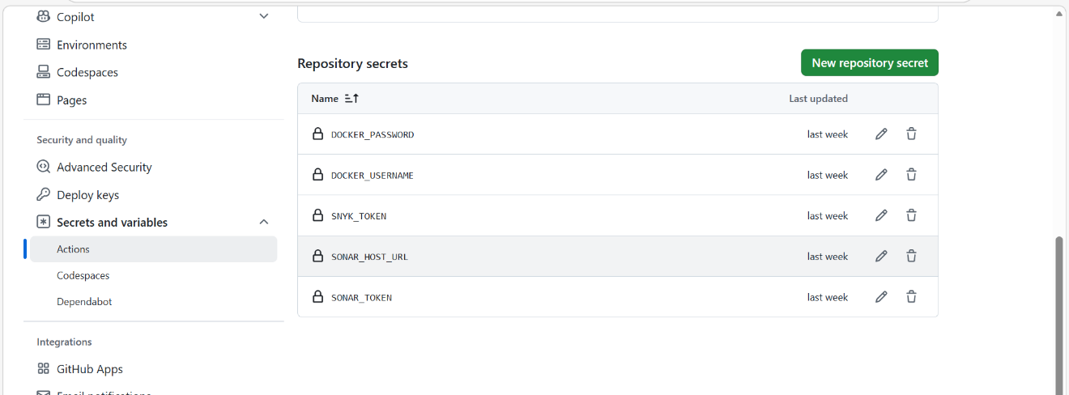

🔷 How SonarQube Works (Execution Flow)
- Pipeline starts
- Code is checked out
- SonarQube scan runs
- Code is analyzed for:
  - Bugs
  - Vulnerabilities
  - Code smells
- Results sent to SonarQube server
- Dashboard updated

🔷 Quality Gate Evaluation
After analysis:
- SonarQube applies Quality Gate rules
- Checks include:
  - Security issues
  - Code quality
  - Coverage
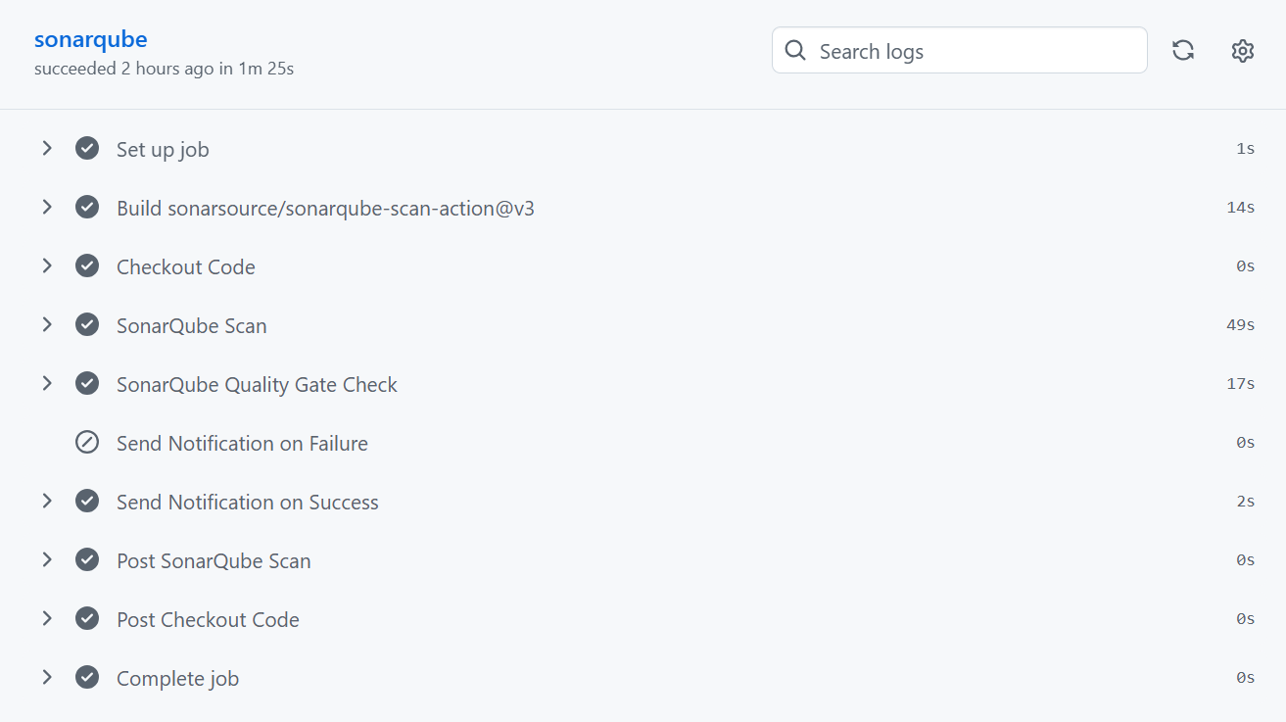

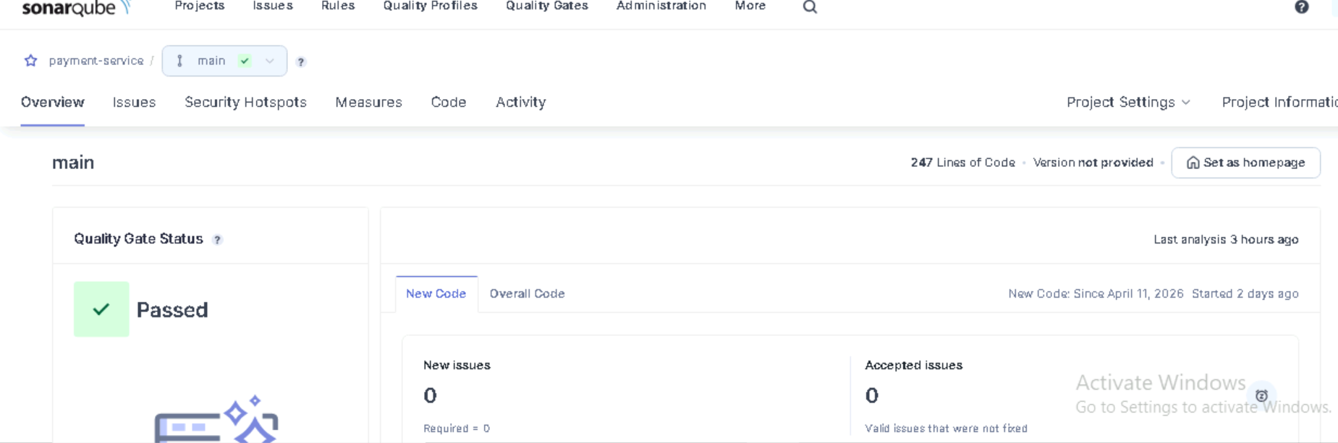

🔷 ✔ Enforcing Pipeline Failure
Add Quality Gate Step
- name: SonarQube Quality Gate Check
uses: SonarSource/sonarqube-quality-gate-action@v1
env:
SONAR_TOKEN: ${{ secrets.SONAR_TOKEN }}

🔷 Pipeline Failure Flow
Execution Logic
- SonarQube scan completes
- Quality Gate check runs
Decision:
- PASS → pipeline continues
- FAIL → pipeline stops
🔷 Dependency Control
needs: sonarqube
Ensures:
- If SonarQube fails:
  - Next jobs will NOT execute
  - Pipeline stops early

🔷 Failure Notification
- name: Send email on failure
if: failure()
uses: dawidd6/action-send-mail@v3
- If SonarQube fails:
  - Email is triggered
  - Contains:
    - Service name
    - Failure reason
Email Notification for Sonarcube Quality Gate Passed
- 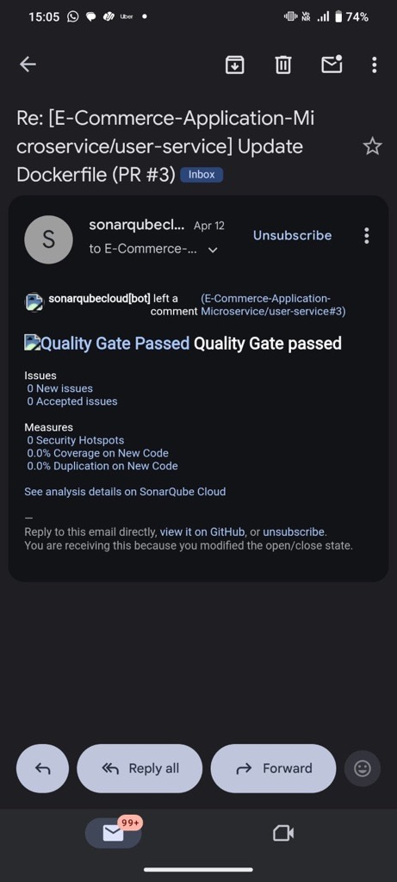

Email Notification for Sonarqube Quality Gate Failed

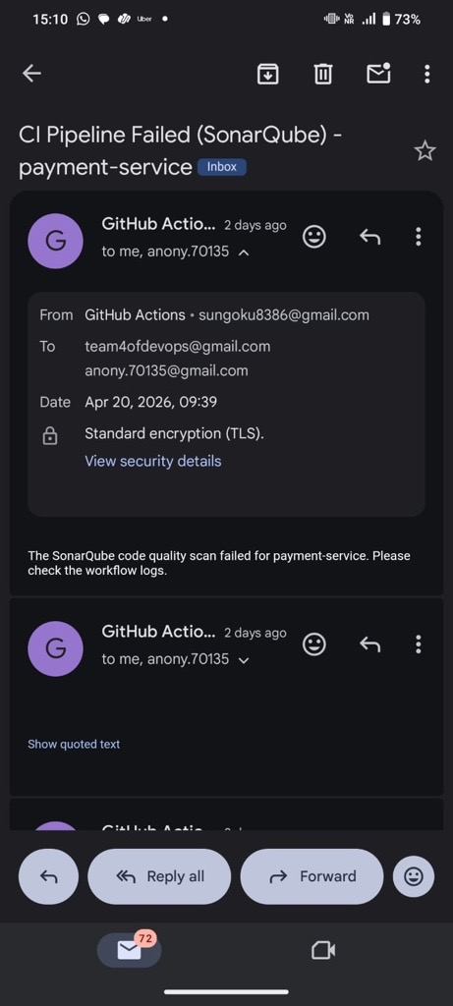

Email Notification for CI Pipeline Successful

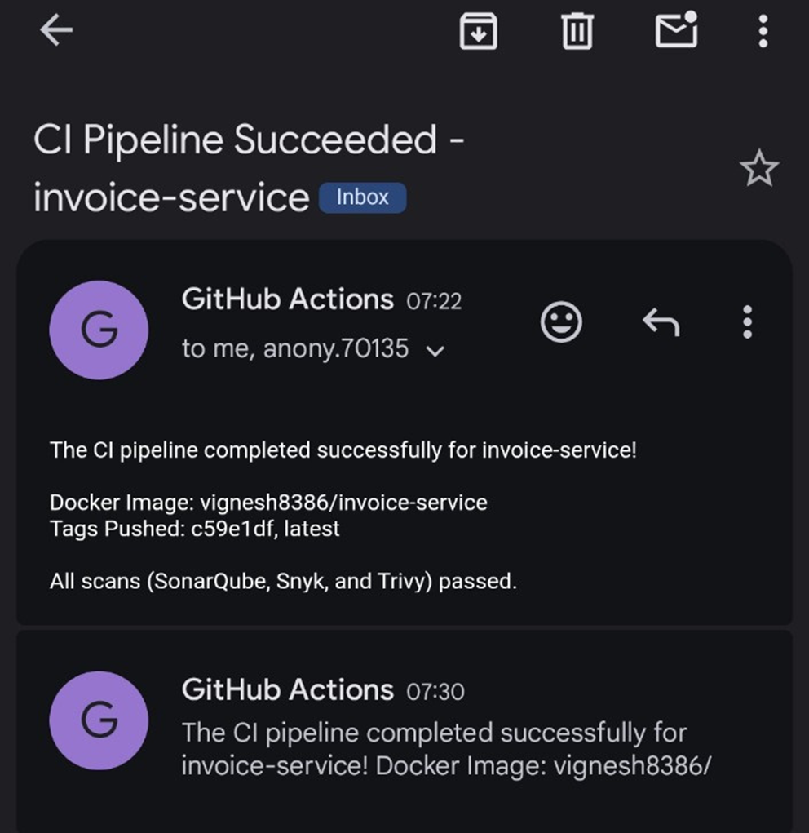

SCA Setup using Snyk

🔷 Objective
This documentation explains how to integrate and configure Snyk for performing Software Composition Analysis (SCA) in the CI pipeline.
Snyk is used to scan project dependencies and identify:
- Known vulnerabilities (CVEs)
- License issues
- Outdated or insecure packages
It ensures:
- Secure dependency management
- Early detection of third-party risks
- Continuous monitoring of vulnerabilities

🔷 Prerequisites
• GitHub repository with CI pipeline
• Node.js installed
• Snyk account (free or enterprise)
• Access to GitHub Actions
Minimum:
- Node.js 18+ (for Node-based services)
- Internet access for vulnerability database

🔷 3. Create Snyk Account & Generate Token
✔ Step 1: Login to Snyk
- Visit: https://snyk.io
- Sign in using GitHub
✔ Step 2: Generate API Token
- Go to Account Settings → API Token
- Copy the token
🔷 GitHub Secrets Configuration
📁 GitHub → Settings → Secrets → Actions
Add:
- SNYK_TOKEN → (from Snyk account)
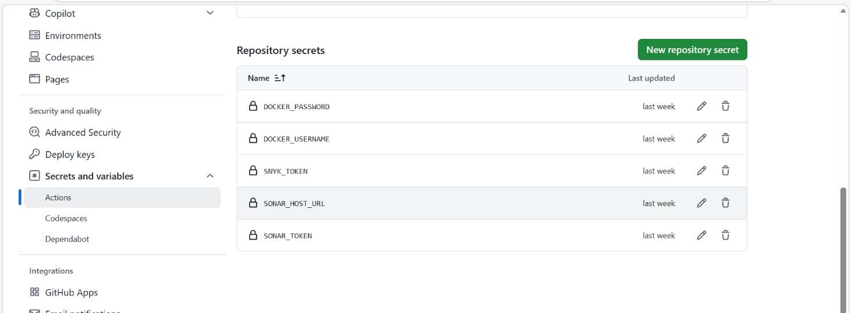

🔷 5. Snyk Integration (Pipeline Level)**
✔ YAML Configuration
snyk:
name: "Snyk Scan (${{ matrix.service }})"
needs: [prepare, sonarqube]
runs-on: ubuntu-latest
strategy:
fail-fast: false
matrix: ${{ fromJson(needs.prepare.outputs.matrix) }}
steps:
- uses: actions/checkout@v4
- name: Setup Node.js
uses: actions/setup-node@v4
with:
node-version: "20"
- name: Install dependencies
run: |
cd ecommerce-microservices/${{ matrix.service }}
npm install --no-audit --no-fund
- name: Run Snyk Scan
uses: snyk/actions/node@master
env:
SNYK_TOKEN: ${{ secrets.SNYK_TOKEN }}
with:
args: --file=ecommerce-microservices/${{ matrix.service }}/package.json --severity-threshold=high
command: test

🔷 How Pipeline is Triggered
Trigger Flow
- Developer commits code
- Code is pushed to:
  - feature/ci-pipeline OR
  - main
- GitHub detects the event
- GitHub Actions starts the pipeline
- Snyk scan runs after SonarQube

🔷 How Snyk Works
- Pipeline starts
- Code is checked out
- Dependencies are installed
- Snyk scans:
  - package.json / dependency files
- Compares dependencies against vulnerability database
- Generates report

🔷 Vulnerability Analysis
Snyk identifies:
- 🔴 Critical vulnerabilities
- 🟠 High severity
- 🟡 Medium
- 🟢 Low
It also provides:
- Fix recommendations
- Upgrade versions
- Patch suggestions

🔷 Severity Threshold Enforcement
In our pipeline:
--severity-threshold=high
✔ Behavior:
- If High or Critical vulnerabilities found → Pipeline fails
- If only Medium/Low → Pipeline continues with warning

🔷 Report Generation
✔ Upload Report Step
- name: Upload Snyk report
if: always()
uses: actions/upload-artifact@v4
with:
name: snyk-results-${{ matrix.service }}
path: snyk-*.json
This stores scan results for auditing and debugging

🔷 Pipeline Failure Flow
Execution Logic
- Snyk scan completes
- Vulnerability threshold evaluated
Decision:
- PASS → pipeline continues
- FAIL → pipeline stops

🔷 Dependency Control
needs: sonarqube
Ensures:
- Snyk runs only after SAST passes
- If SonarQube fails → Snyk will NOT execute

🔷 Failure Notification
- name: Send email on failure
if: failure()
uses: dawidd6/action-send-mail@v3
✔ Behavior:
If Snyk fails:
- Email is triggered
- Contains:
  - Service name
  - Vulnerability severity
  - Failure reason

Email Notification for Synk vulnerabilities
