# **LapStore Project**

# **Project Proposal**

* **Overview**: LapStore is an e-commerce platform offering a wide range of laptops at competitive prices, providing comprehensive product information, an excellent user experience, and outstanding customer support.
* **Objectives**: Deliver a seamless user experience, increase sales, and improve customer satisfaction.
* **Scope**: Develop a website with an easy-to-use interface, product management system, and shopping cart functionality.

### **Project Plan**

* **Timeline**: Gantt chart covering the period from March 9 to May 9.

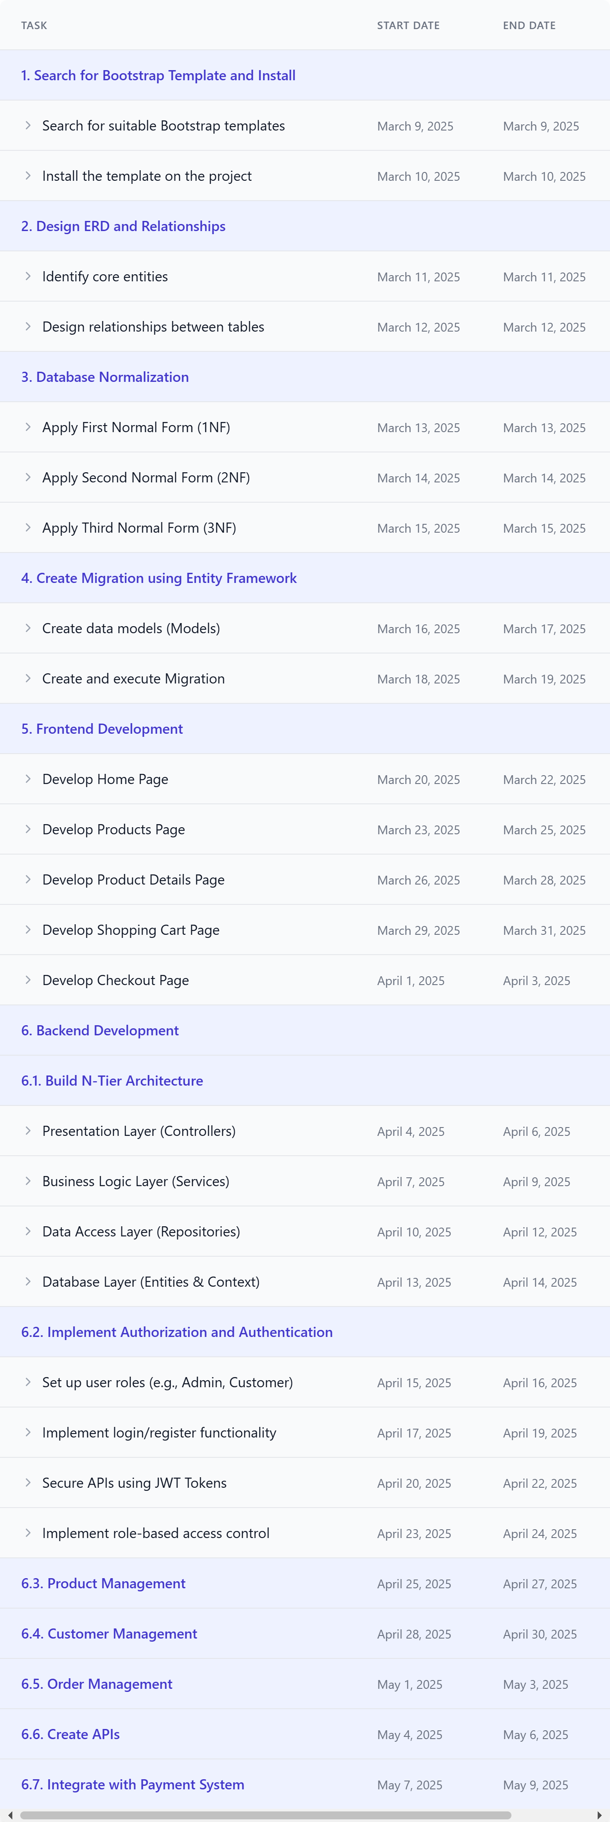

* **Milestones**: Completion of design, development, testing, and final delivery.

### **Task Assignment & Roles**

* **Team Lead & Backend Developer**: Wael Bahaa Aldien.
* **Frontend Developer**: Abdelrahman Hassan.
* **Database Designer**: Shehab Eisa.
* **Tester**: Dina Gamal.

### **Risk Assessment & Mitigation Plan**

* **Potential Risks**: Delays in delivery, integration issues between frontend and backend.
* **Mitigation Plans**: Allocate extra time for testing, hold weekly coordination meetings, and working Implement the code with ASP.NET Core MVC.

### **Key Performance Indicators (KPIs)**

* Page load time: Less than 3 seconds.
* Conversion rate: 5%.
* Customer satisfaction: 90%.

### **Literature Review**

* Research best practices in e-commerce design.
* Study similar platforms like Amazon and Jumia.

### **Stakeholder Analysis**

* **Stakeholders**: Customers, suppliers, development team.
* **Customer Needs**: Easy-to-use interface, competitive pricing, quick technical support.

### **User Stories & Use Cases**

* As a customer, I want to search for laptops by specifications.
* As a customer, I want to add products to the shopping cart and complete the purchase.
* As a merchant, I want to easily manage my product inventory, update prices, and track orders, so I can increase my sales and provide an excellent shopping experience for my customers.

### **Functional Requirements**

* Product management system: Add, modify, and delete products.
* Search system: Filter products by specifications and price.
* Payment system: Support one payment method at least.

### **Non-Functional Requirements**

* Performance: Page load time under 3 seconds.
* Security: Encrypt payment data.
* Availability: System uptime of 99.9%.

### **Problem Statement & Objectives**

* **Problem**: Customers need a reliable platform to purchase laptops at competitive prices.
* **Objectives**: Provide a seamless user experience and excellent customer support.

### **Use Case Diagram**

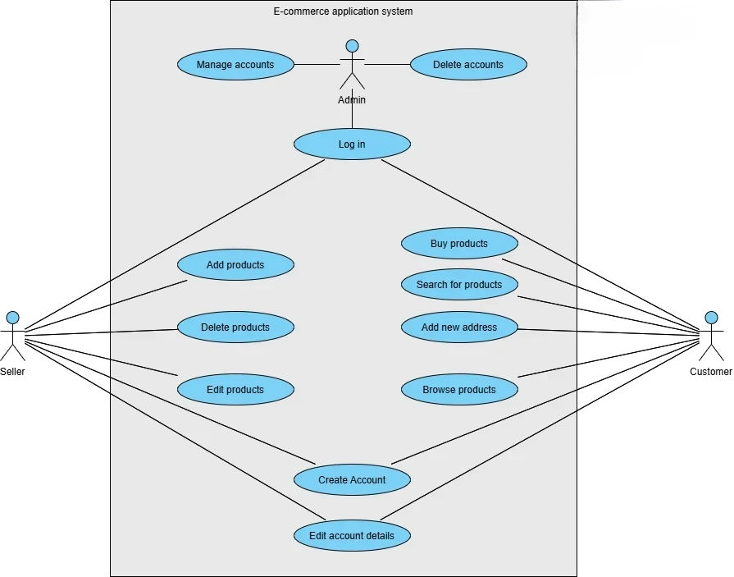

### **Software Architecture**

* Design system based on **MVC (Model-View-Controller) architecture within an n-tier structure.**

### **Database Design**

* **ERD**:

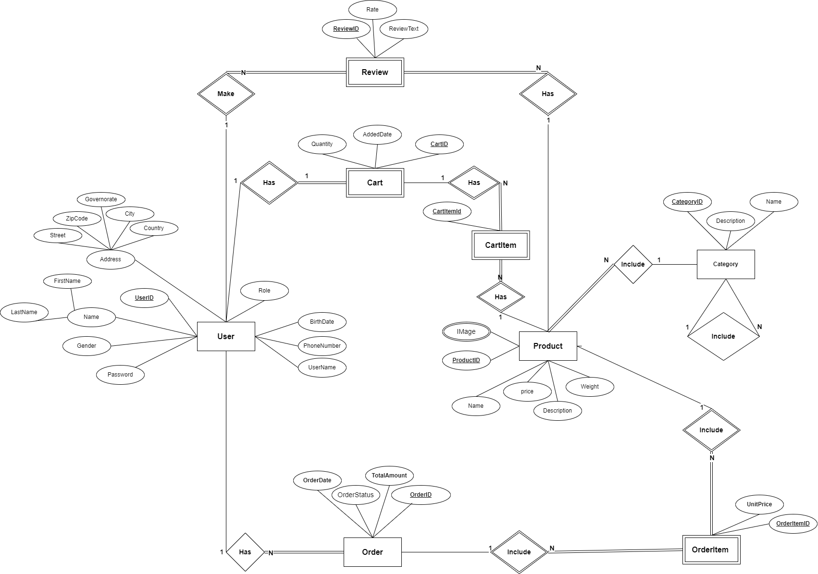

* **Logical Schema**:  
    
  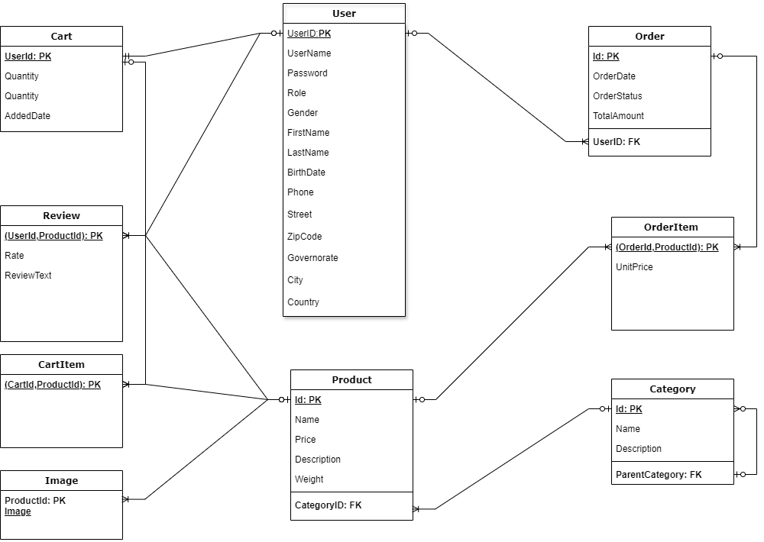

### **Wireframes & Mockups**

* Design search interface, product page, and shopping cart.

### **UI/UX Guidelines**

* **Colors**: Neutral colors with blue accents for technology.
* **Typography**: Easy-to-read fonts.

### **Source Code**

You can access the project repository on GitHub using the following link:

[LapStoreGitHubRepository](https://github.com/WaelAlfnan/E-Commerce_LaptopStore)

In this repository, you will find:

* **Frontend**: Develop using HTML, CSS, JavaScript.
* **Backend**: Develop using C# (.NET Core).
* **Database**: Design using SQL Server.

### **Security Measures**

* Encrypt payment data using SSL.
* Validate inputs to prevent security attacks.

### **Unit & Integration Testing**

* Test each component individually.
* Test integration between frontend and backend.