

SOLAR LOW CARBON EFFICIENT BUILDING

STUDENT ID: K2354862
MSC RENEWABLE ENERGY ENGINEERING

MODULE: AE7203 SOLAR POWER ENGINEERING

Table of Contents
Chapter 1 INTRODUCTION 1
1.1 OBJECTIVES 1
Chapter 2 LITERATURE REVIEW 2
2.1 CONSTRUCTION QUALITY 3
2.2 INSULATING MATERIAL 4
2.3 AREA LOCATION AND METEOROLOGY DATA 5
2.4 PASSIVE SOLAR HEATING 9
2.4.1 House Overview 9
2.4.2 Orientation and Size of Windows' Glazing 10
2.4.3 Roof extend 10
2.4.4 Flooring 10
2.4.5 Compartmental Walls 10
2.4.6 Ceiling 10
2.5 PASSIVE SOLAR HEATING 3D HOUSE DESIGN 11
Chapter 3 METHODOLOGY: POLYSUN (ACTIVE SYSTEM) 14
3.1 ACTIVE SOLAR HEATING (ASH) 14
3.2 PERFORMANCE ANALYSIS POLYSUN (ACTIVE SYSTEM) 14
3.3 POLYSUN PROFESSIONAL REPORT SIMULATION RESULTS 15
3.4 Graphical Specification Data for the Proposed System 20
3.5 Simulation Module Comparison 23
Chapter 4 DISCUSSION OF RESULT 28
4.1 Design Choice and Analysis 28
4.2 CRITIQUE 28
4.3 TECHNICAL SCRUTINY 28
4.4 SOCIO-ECONOMIC, ENVIRONMENTAL AND POLITICAL CONSIDERATION 29
4.5 COST ANALYSIS 29
Chapter 5 CONCLUSION 36
Chapter 6 REFERENCE 36

LIST OF TABLES
Table 1: Basic Building Construction U-values (Liang et al., 2017) 4
Table 2: Hybrid System Annual Values (Polysun Simulation Software, 2024) 15
Table 3: Solar Fraction, heat pump and electricity annual values (Polysun Simulation Software, 2024) 16
Table 4 Flat Plate Collector, Heat pump and Electric consumer (Polysun Simulation Software, 2024) 17
Table 5: Photovoltaics Module and Building Design (Polysun Simulation Software, 2024) 18
Table 6: Heating Element Hot and Cooling Demand (Polysun Simulation Software, 2024) 19
Table 7: System Comparison Hybrid Collector System with and without Battery and Domestic Hot Water & Spacing Heating (Polysun Simulation Software, 2024) 24

LIST OF FIGURES
Figure 1: Carbon Neutral or Net Zero Building (Simon J Crowe, 2023) 2
Figure 2: UK Energy Consumption 2007 (Xing et al., 2011) 3
Figure 3: Hierarchical Approach of Achieving Zero Carbon Refurbishment (Xing et al., 2011) 3
Figure 4: Average Temperature in London (Weather Spark, 2024) 5
Figure 5:Wimbledon Site Area Map Data (Global Solar Atlas, 2024) 6
Figure 6: Solar Elevation and Azimuth in London (Weather Spark, 2024) 6
Figure 7: Solar Elevation and Azimuth in Wimbledon (Global Solar Atlas, 2024) 7
Figure 8: PVout and Solar Radiation for Monthly Average PVout (KWh) and Hourly Average PVout (Wh) (Global Solar Atlas, 2024) 8
Figure 9: Average Hourly PVout (Wh) Profile Data (Global Solar Atlas, 2024) 9
Figure 10: Passive House Floor Plan (AutoCAD 3D, 2024) 11
Figure 11: Front Elevation and Plan for the Passive House (AutoCAD 3D, 2024) 12
Figure 12: North-East View of the Front of a Passive 3D House Design (AutoCAD 3D, 2024) 13
Figure 13: South-East Left View of a Passive 3D House Design (AutoCAD 3D, 2024) 13
Figure 14: Hybrid Collector System with Battery (Polysun Simulation Software, 2024) 14
Figure 15: Location of the Hybrid Collector System (Polysun Simulation Software, 2024) 15
Figure 16: Solar Fraction of the System (Polysun Simulation Software, 2024) 20
Figure 17: Solar Thermal Energy of the System (Polysun Simulation Software, 2024) 20
Figure 18: Energy Generated by the Inverters (Polysun Simulation Software, 2024) 21
Figure 19: Total Fuel & Electricity Consumption (Polysun Simulation Software, 2024) 21
Figure 20: Self-Consumption of the System (Polysun Simulation Software, 2024) 22
Figure 21: Total Electricity Consumption of the System (Polysun Simulation Software, 2024) 22
Figure 22: Sankey Energy Flow Diagram (Polysun Simulation Software, 2024) 23
Figure 23: Domestic hot water and space heating, preheating by PVT (Polysun Simulation Software, 2024) 24
Figure 24: System Comparison CO2 Emission (Polysun Simulation Software, 2024) 25
Figure 25: System Comparison of Self-Consumption and Solar Thermal Energy to the System (Polysun Simulation Software, 2024) 26
Figure 26: System Comparison for Energy Deficit (Polysun Simulation Software, 2024) 26

LIST OF EQUATION
Equation 1: Peak Sun Hour (Global Solar Atlas, 2024) 7
Equation 2: Peak Sun Hour Per Day for a Panel Installed Horizontally (Global Solar Atlas, 2024) 7

NOMENCLATURE
PVT – Photovoltaic Thermal Panel
NPV – Net Present Value
IEA – International Energy Agency
PVout – Specific Photovoltaic power output
GHI – Global Horizontal Irradiation
GIT – Global Tilted Irradiation at Optimum Angle
OPTA – Optimum Tilt of Photovoltaic Modules
PSH – Peak Sun Hour
ASH – Active Solar Heating
GHG – Green House Gas

ABSTRACT
This report presents a comprehensive proposal for a carbon-neutral building design, amalgamating passive and active solar systems to curtail greenhouse gas emissions and bolster energy efficiency. Through detailed analysis and simulation using Polysun software, the efficacy of incorporating PVT panels and heat pumps for heating is examined. The report scrutinizes technical aspects, socio-economic implications, and environmental benefits, while also considering cost analysis and political factors. Results suggest a promising trajectory towards sustainable building practices, emphasizing the significance of energy storage and renewable energy adoption in combating climate change.

INTRODUCTION
The global building sector, responsible for a significant portion of energy consumption and CO2 emissions, is expected to exceed 50% by 2050. Heating and cooling needs, mainly fueled by fossil fuels, contribute 60–70% of this consumption (Lizana et al., 2018). In line with the IEA report solar energy integration in buildings is crucial for carbon reduction, by 2020, 36% of energy use and 37% of CO2 emissions worldwide will come from the building sector (IEA 50, 2022). With projections suggesting substantial growth. China leads in solar energy adoption due to government support. In the solar thermal market, rural areas favour solar water heating, while urban areas increasingly adopt it for space heating. With China's carbon goals, interest in zero-carbon buildings using renewable energy, particularly integrated solar solutions, is rising (Liu et al., 2023).
This tailored proposal on carbon-neutral buildings Fig. 1 aims to reduce GHG emissions by employing low-carbon technologies and passive/active solar systems. They analyse energy usage in buildings and utilize hybrid solar power to meet energy needs. The remaining energy requirements are fulfilled by renewable energy conversion systems, primarily solar-based, ensuring sustainability in the domestic sector (Paul Bullard, 2023).

OBJECTIVES
- Develop an energy-efficient house solution using PVT panels and heat pumps for heating.
- Analyze thermal enclosure elements' impact on energy loss with tools like Polysun.
- Assess Low Carbon Efficient Building's energy efficiency and carbon reduction potential.
- Propose sustainable design strategies for integrating solar heating systems.
- Design a building with a passive Solar System for interior warming and an active solar system for electricity, hot water, and cooling demands.
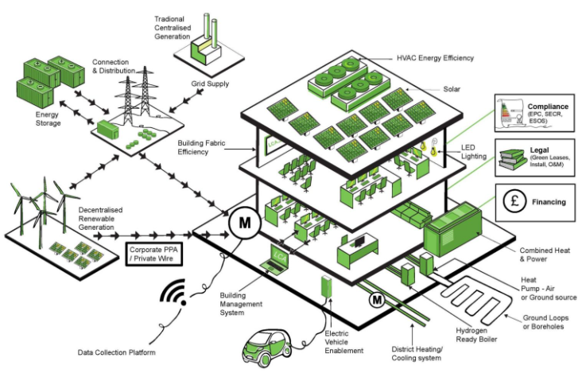
Figure 1: Carbon Neutral or Net Zero Building (Simon J Crowe, 2023)

LITERATURE REVIEW
The demand for energy in buildings arises throughout their lifecycle, encompassing construction, operation, rehabilitation, and eventual demolition, both directly and indirectly through material production (Sartori and Hestnes, 2007). In the UK, the service sector, employing around 80% of the workforce since 2000, has significantly contributed to increased floor areas, intensifying energy needs, particularly for space heating. In 2007, building-related energy usage constituted 43% of the nation's total energy consumption, with space heating being the primary contributor see Fig. 2 (Xing et al., 2011).
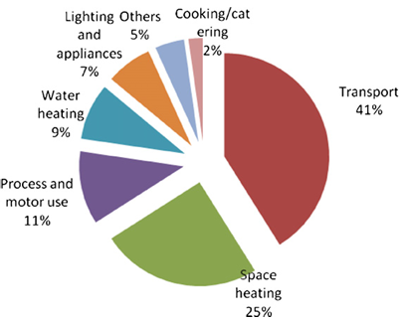
Figure 2: UK Energy Consumption 2007 (Xing et al., 2011)
Achieving zero-carbon refurbishment involves a hierarchical approach focusing on enhancing building fabrics, adopting energy-efficient equipment, and integrating low or zero-carbon energy sources, outlined for practical implementation as shown in Fig. 3 (Xing et al., 2011).

Figure 3: Hierarchical Approach of Achieving Zero Carbon Refurbishment (Xing et al., 2011)

CONSTRUCTION QUALITY
In the UK, residential buildings are major energy consumers, comprising nearly 30% of total energy use and CO₂ emissions. Government targets aim for an 80% reduction in energy consumption and emissions by 2050. Passive Houses, known for energy efficiency, have gained traction globally with over 50,000 built by 2013. These houses meet strict criteria for energy demand (120kWh/m²a), Space heating/cooling (15kWh/m²a or 10W/m²), airtightness (0.6h-1@50Pa), and thermal comfort (10% of hours for over 25°C). This study compares energy performance and indoor air quality of Conventional and Passive Houses in the UK, exploring retrofitting methods to enhance Conventional House efficiency. Table 1 compares the U-values of construction elements for both house types (Liang et al., 2017).
Table 1: Basic Building Construction U-values (Liang et al., 2017)
Elements | Passive House Standard U-values (W/m²K) | Conventional House Current U-values (W/m²K) | Conventional House retrofitted U-values (W/m²K)
Walls | 0.123 | 0.54 | 0.12
Floors | 0.09 | 0.25 | 0.10
Roofs | 0.064 | 2.93 | 0.13
Windows (Glazing) | 0.60 | 1.96 | 0.78

INSULATING MATERIAL
Passive thermal design involves selecting suitable building materials like high thermal mass ones, such as hollow cement blocks and concrete floors, to store and release heat efficiently. Initially rejected, earth bricks are gaining acceptance due to resembling conventional houses while offering superior thermal capacity (Klunne, 2004).

AREA LOCATION AND METEOROLOGY DATA

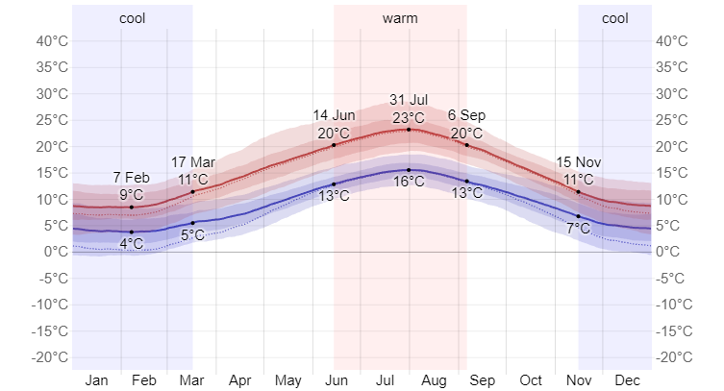
Figure 4: Average Temperature in London (Weather Spark, 2024)
The proposal outlines London's average temperature in Fig. 4 and Wimbledon's solar radiation, estimating 2.836 kWh/KWp daily and 1035.1 kWh/KWp yearly solar power generation in Fig. 5. PVout represents the specific photovoltaic power potential output (Global Solar Atlas, 2024).
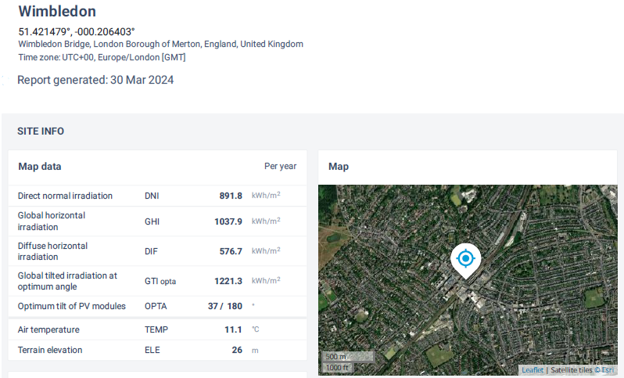
Figure 5:Wimbledon Site Area Map Data (Global Solar Atlas, 2024)
PV modules' optimal tilt is 37° with a solar azimuth angle of 180° indicating due south orientation.
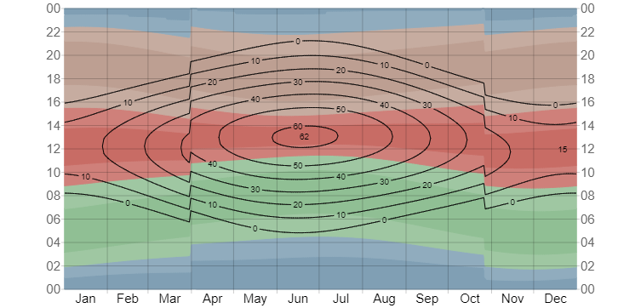
Figure 6: Solar Elevation and Azimuth in London (Weather Spark, 2024)
The sun azimuth for London is shown in Fig. 6, while the azimuth for our site in Wimbledon, England, is shown in Fig. 7.
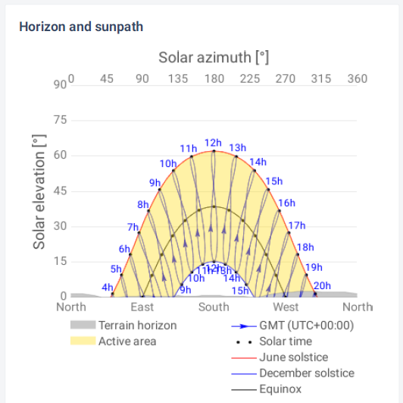
Figure 7: Solar Elevation and Azimuth in Wimbledon (Global Solar Atlas, 2024)
From local meteorological data, we can derive Peak Sun Hour (PSH) using GHI and GTIopta, representing sunlight intensity in Equ. 1. GHI averages 2.844KWh/m² daily and 1037.9KWh/m² yearly, while GTIopta averages 3.346KWh/m² daily and 1221.3KWh/m² yearly (Global Solar Atlas, 2024).
Equation 1: Peak Sun Hour (Global Solar Atlas, 2024)
$$1PSH=1000W/m^{2}⇒1KWh/m^{2}$$
Therefore, calculating our PSH with our GHI;
Equation 2: Peak Sun Hour Per Day for a Panel Installed Horizontally (Global Solar Atlas, 2024)
$$PSH ×GHI ⇒1000 ×2.844=2844W/m^{2}$$
PSH of 2844W/m² denotes daily peak sun hours for a horizontally installed panel. For tilted installations, GTI is recommended to compute PSH/day using Equ. 2 for PV system sizing. The average daily and yearly PVout is 2.718 kWh and 992.155 kWh, respectively, with a GTI of 3.348 kWh/m² per day and 1222.1 kWh/m² per year (Global Solar Atlas, 2024).
To accurately determine tilt angles for our location across seasons, we adjust latitude by ±15°: subtract for summer, add for winter, and maintain for spring/autumn. For our site at (51.421479°, -000.206403°), winter's angle becomes 66° in Fig. 8.
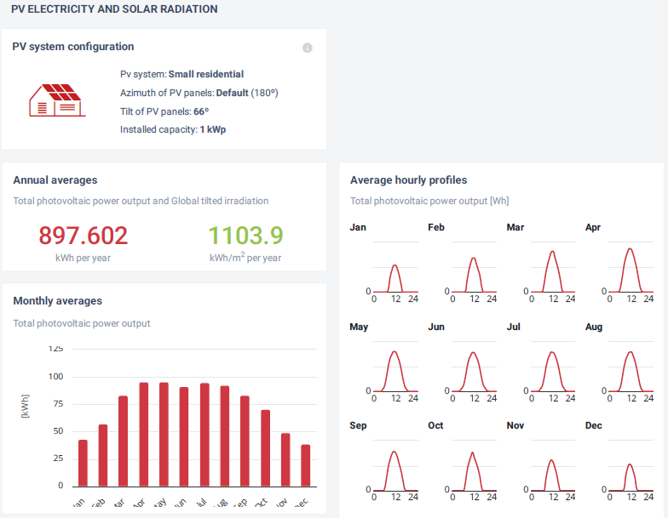
Figure 8: PVout and Solar Radiation for Monthly Average PVout (KWh) and Hourly Average PVout (Wh) (Global Solar Atlas, 2024)
The new tilt angle yields annual PV output of 2.459 kWh/day & 897.602 kWh/year, and Global Tilted Irradiance (GTI) of 3.025 kWh/m²/day & 1103.9 kWh/m²/year. For off-grid systems, tilt equals latitude plus 15°C for optimal winter energy. Fig. 8 and Fig. 9 display monthly and hourly PVout profiles, highlighting April to August as high-output months and January and December as low-output months (Global Solar Atlas, 2024).

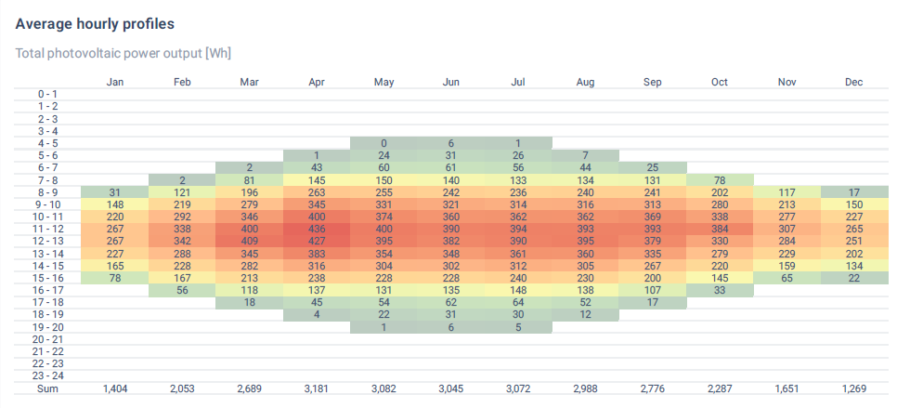
Figure 9: Average Hourly PVout (Wh) Profile Data (Global Solar Atlas, 2024)

PASSIVE SOLAR HEATING
The Passive House standard aims to reduce building energy demand sustainably. Achieving significant heating energy reduction requires suitable design and construction, emphasizing super insulation to lower heat transfer. Materials with low U-values (0.10-0.15 W/m² K) are utilized. Balancing energy efficiency with indoor environmental quality remains a challenge (Wang et al., 2017).

House Overview
Passive solar design minimizes energy needs for comfort. Southern Hemisphere houses benefit from north-facing orientation (within ±15°), optimizing solar gain. Ideal orientation, with most windows facing north, reduces summer heat and winter loss, with minimal added costs (Klunne, 2004).

Orientation and Size of Windows' Glazing
Daylighting enhances natural light while managing seasonal heat loss and gain with double-glazed windows prevalent in colder climates. Passive House windows feature triple-pane glazing, low U-values (0.70-0.85 W/m²K), and advanced thermal properties for efficiency (Wang et al., 2017).

Roof extend
For optimal orientation, a house facing north should feature a roof overhang tailored to summer and winter sun angles, approximately 0.5 meters long, shading windows in summer and admitting light in winter (Klunne, 2004).

Flooring
To optimize thermal efficiency, choose high thermal mass flooring like concrete or clay over carpets, particularly beneficial in single-story homes for utilizing surface as thermal mass (Klunne, 2004).

Compartmental Walls
Shared walls reduce housing shell and energy costs. Despite objections, the Department of Housing favours multi-dwelling units over standalone homes due to improved insulation benefits (Klunne, 2004).

Ceiling
Ceiling installation is crucial for cost-effective, thermally efficient homes, reducing heat flow by trapping air effectively (Klunne, 2004).

PASSIVE SOLAR HEATING 3D HOUSE DESIGN
Fig. 10 shows the proposed passive house design with 2 bedrooms, and a dining room, totalling 149.8 m2, which features 4 windows upstairs, 8 downstairs, and 5 doors (AutoCAD 3D, 2024).
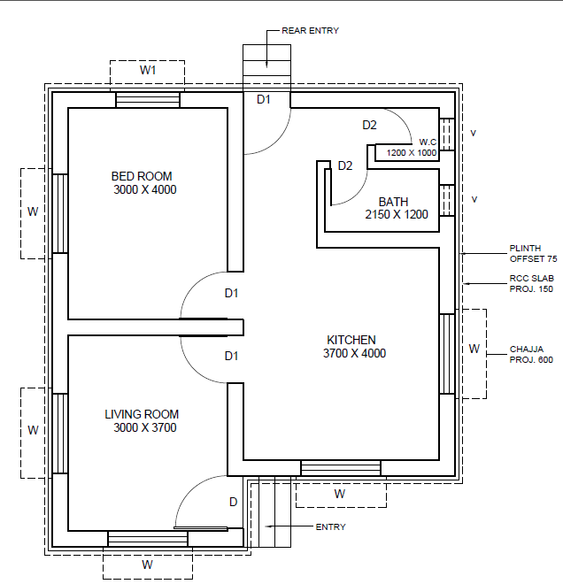
Figure 10: Passive House Floor Plan (AutoCAD 3D, 2024)
Fig. 11 shows the full floor plan and front elevation of the windows (2100mm x 900mm) providing solar lighting, while the roof prevents summer overheating. Additionally, 10 PVT panels will be installed.
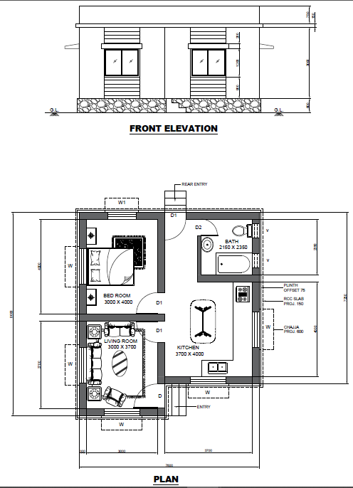
Figure 11: Front Elevation and Plan for the Passive House (AutoCAD 3D, 2024)
Fig. 12 and Fig. 13 display the 3D Passive House Design.
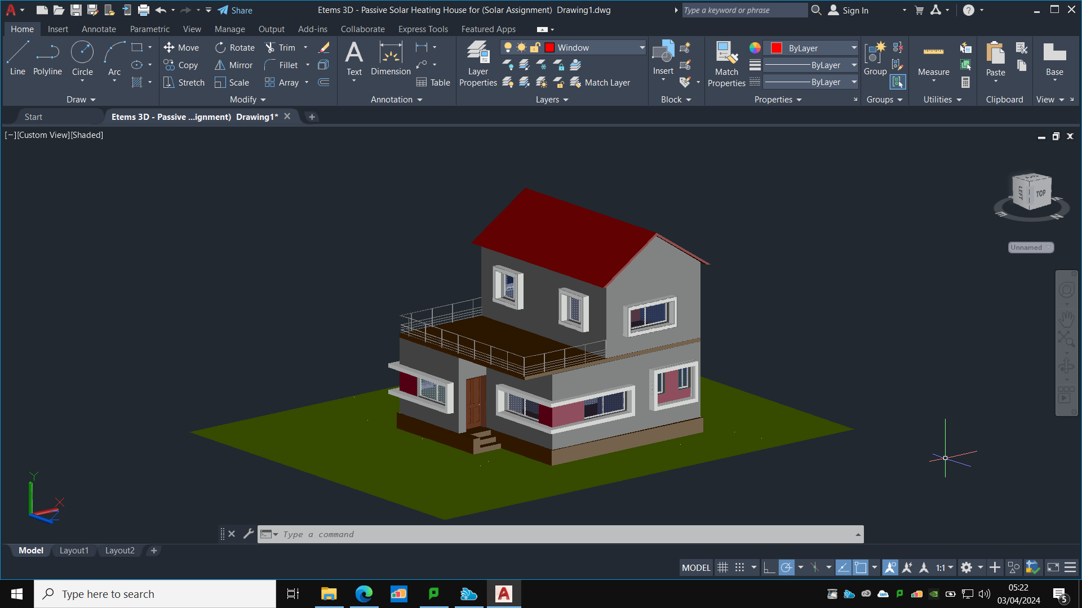
Figure 12: North-East View of the Front of a Passive 3D House Design (AutoCAD 3D, 2024)

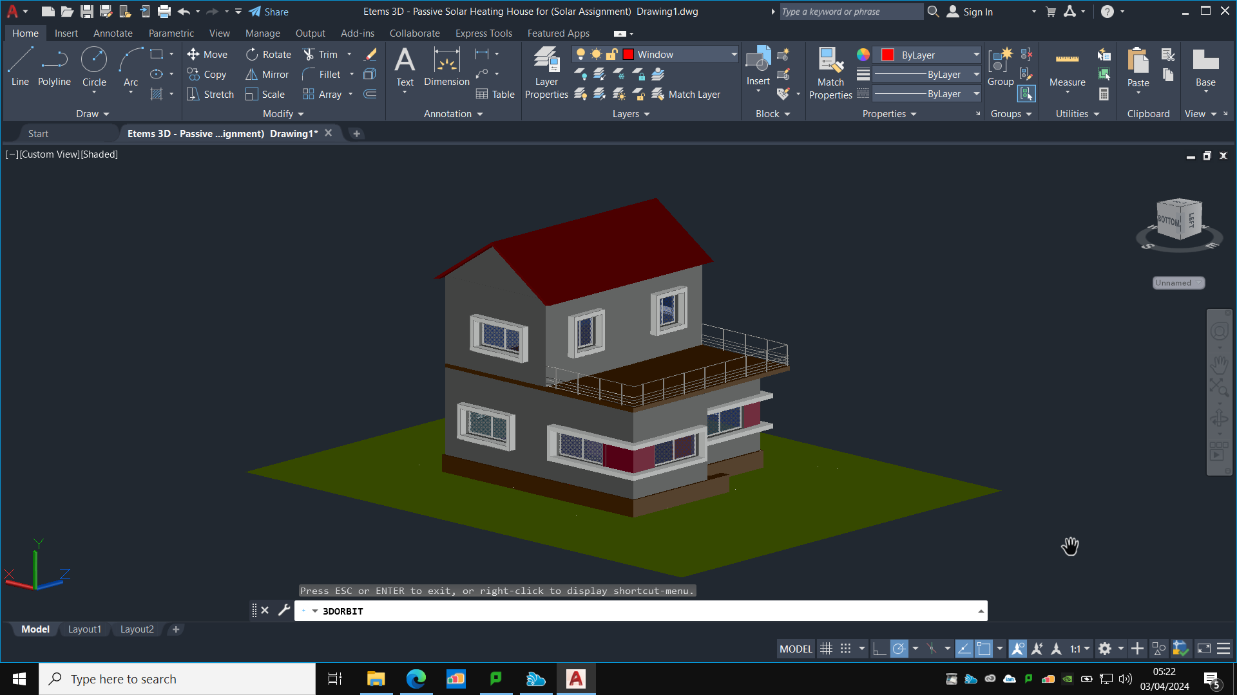
Figure 13: South-East Left View of a Passive 3D House Design (AutoCAD 3D, 2024)

METHODOLOGY: POLYSUN (ACTIVE SYSTEM)

ACTIVE SOLAR HEATING (ASH)
ASH designs integrate renewable energy for buildings, leveraging smart technology to balance energy supply and demand with the UK National Grid, focusing on reducing consumption and generating renewable power (Clarke et al., 2023).

PERFORMANCE ANALYSIS POLYSUN (ACTIVE SYSTEM)
The house incorporates 7 flat plate collectors, 10 PV modules, a 6-kWh battery, a 5kW heat pump, and a 500L storage tank, as planned using Polysun Fig. 14.
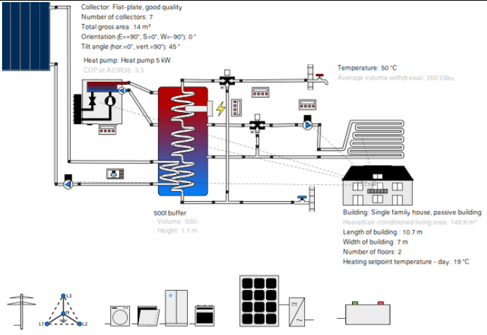
Figure 14: Hybrid Collector System with Battery (Polysun Simulation Software, 2024)

POLYSUN PROFESSIONAL REPORT SIMULATION RESULTS
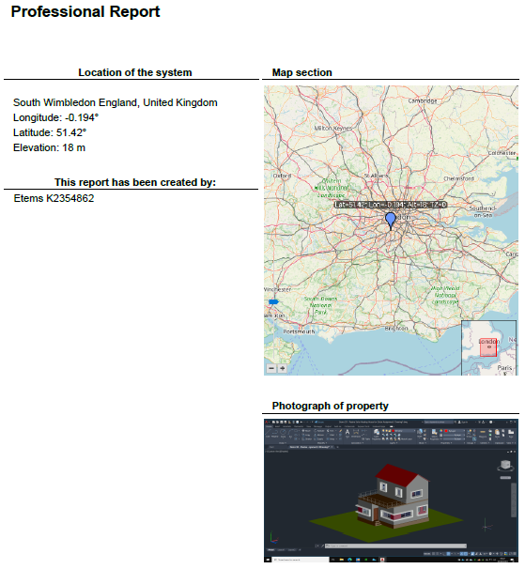
Figure 15: Location of the Hybrid Collector System (Polysun Simulation Software, 2024)

Table 2 incorporates the Active Solar Hybrid collector system for space heating and domestic hot water system with battery.

Table 2: Hybrid System Annual Values (Polysun Simulation Software, 2024)
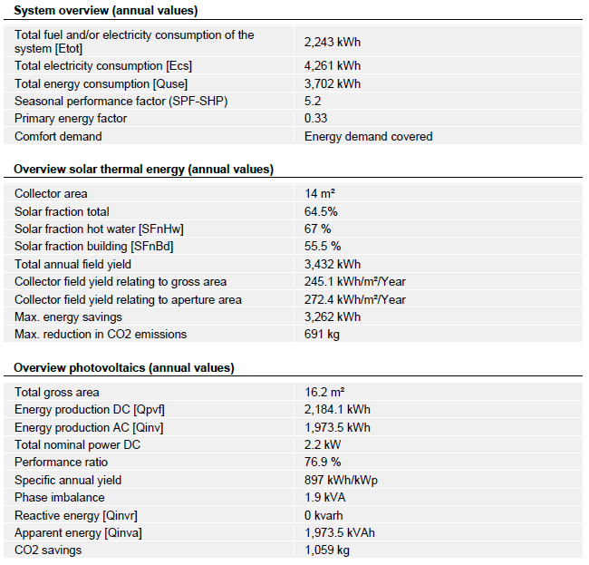

Table 3 below gives the solar fraction data and annual electricity and heat pump values of the hybrid collector system for the active solar design.
Table 3: Solar Fraction, heat pump and electricity annual values (Polysun Simulation Software, 2024)
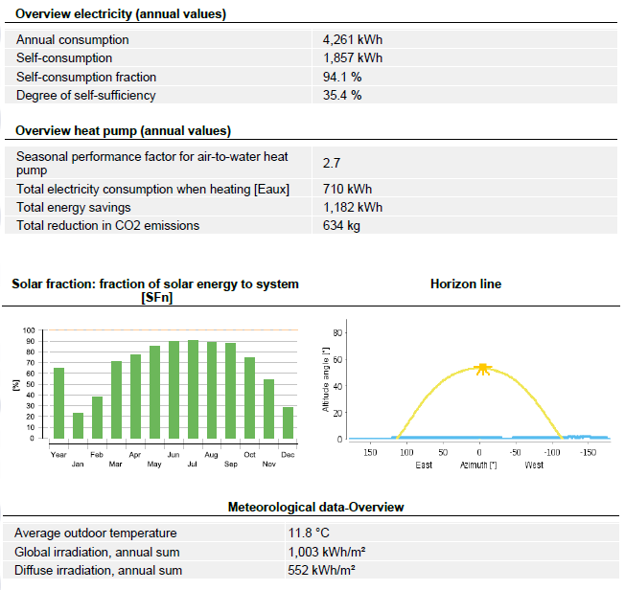

Table 4 outlines the collector plate, heat pump and electric consumer.
Table 4 Flat Plate Collector, Heat pump and Electric consumer (Polysun Simulation Software, 2024)
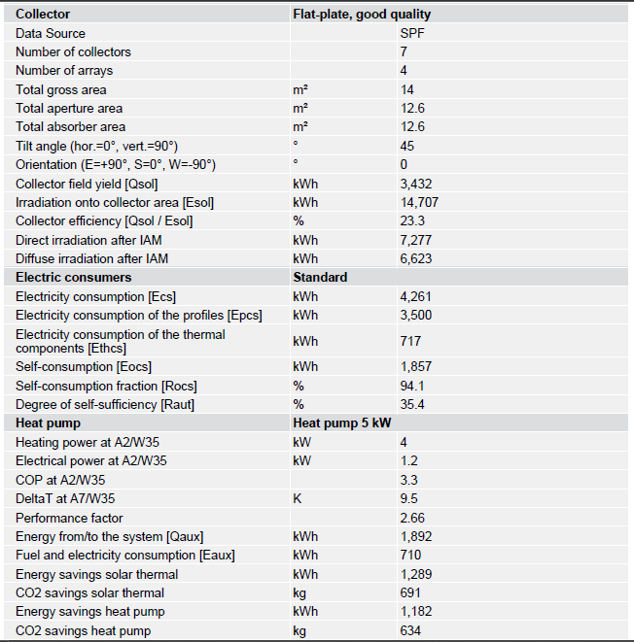

Table 5 outlines the PV module and building parameters.
Table 5: Photovoltaics Module and Building Design (Polysun Simulation Software, 2024)
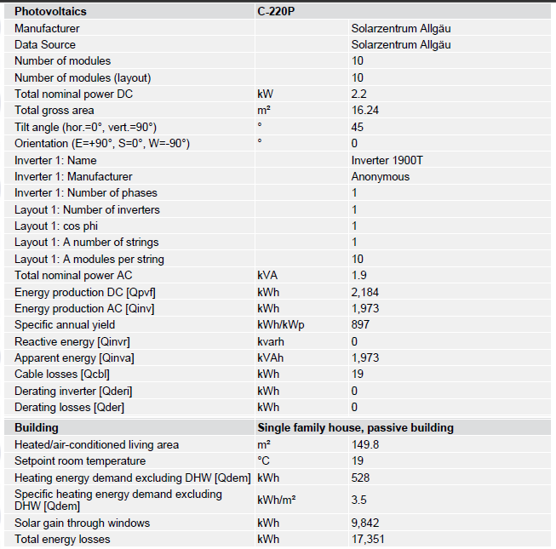
Table 6 outlines the heating and cooling element
Table 6: Heating Element Hot and Cooling Demand (Polysun Simulation Software, 2024)
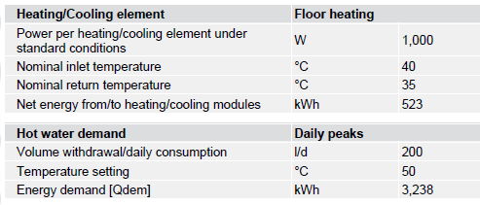

Graphical Specification Data for the Proposed System
Solar fraction (SFn) Fig. 16 represents the percentage of solar energy utilized annually, averaging 64.6%, peaking at 90% in June and July.
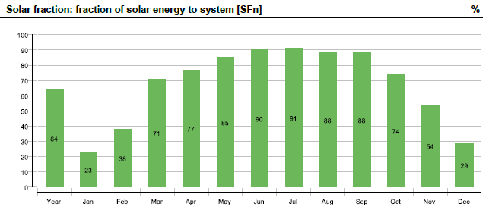
Figure 16: Solar Fraction of the System (Polysun Simulation Software, 2024)

Solar thermal energy (Qsol) is the transfer of energy from flat plate collectors (FPC) to water fluid, totalling 3439 kWh annually, peaking at 382 kWh in July Fig. 17.
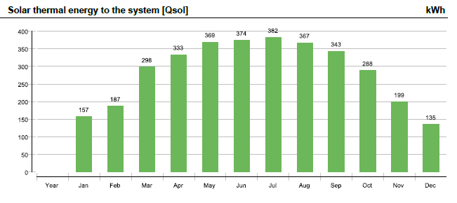
Figure 17: Solar Thermal Energy of the System (Polysun Simulation Software, 2024)

Energy generated by inverters was 1973.5 kWh, with the highest yield of 236 kWh in May Fig. 18.
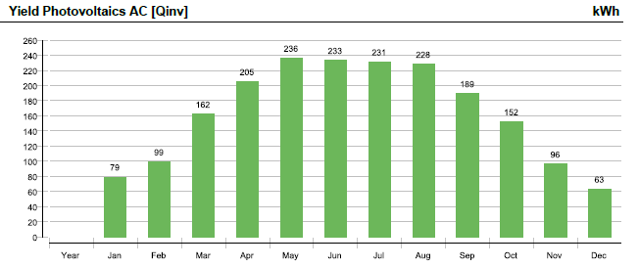
Figure 18: Energy Generated by the Inverters (Polysun Simulation Software, 2024)

Polysun assessed the system's yearly operation of the house's total electricity demand, including thermal components and it was 2243 kWh Fig. 19.
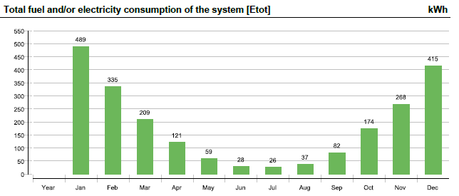
Figure 19: Total Fuel & Electricity Consumption (Polysun Simulation Software, 2024)

Fig. 20 with a degree of self-sufficiency of 35.4%, the PV system had a self-consumption fraction of 94.1%. 1857 kWh were used by the system annually.
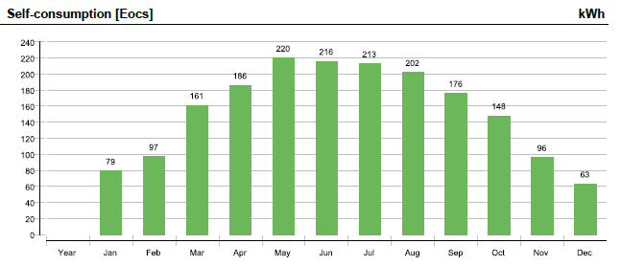
Figure 20: Self-Consumption of the System (Polysun Simulation Software, 2024)

Total electricity consumption, including thermal components, was 4261 kWh, with the lowest recorded in July at 259 kWh Fig. 21.

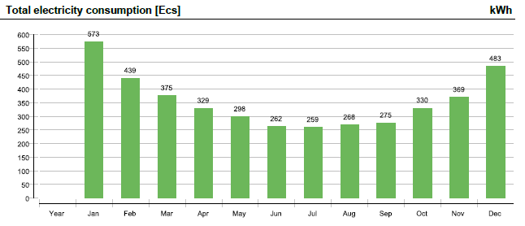
Figure 21: Total Electricity Consumption of the System (Polysun Simulation Software, 2024)

Fig. 22 displays the Sankey diagram of the energy flow of the hybrid collector system.
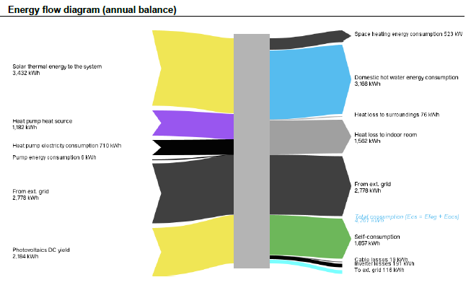
Figure 22: Sankey Energy Flow Diagram (Polysun Simulation Software, 2024)

Simulation Module Comparison
The selected model integrates PVT panels and a heat pump for energy efficiency. The comparison involves the current system, lacking a battery, and a proposed system with 10 PVT collectors, a 100kw boiler, and a 2000L storage tank, matching building specifications see Fig. 23.
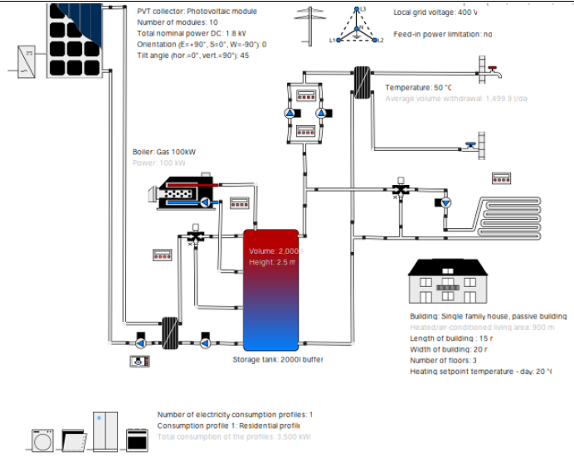
Figure 23: Domestic hot water and space heating, preheating by PVT (Polysun Simulation Software, 2024)

Table 7 outlines the comparison between all three systems and Fig. 24 shows the CO₂ emission.
Table 7: System Comparison Hybrid Collector System with and without Battery and Domestic Hot Water & Spacing Heating (Polysun Simulation Software, 2024)
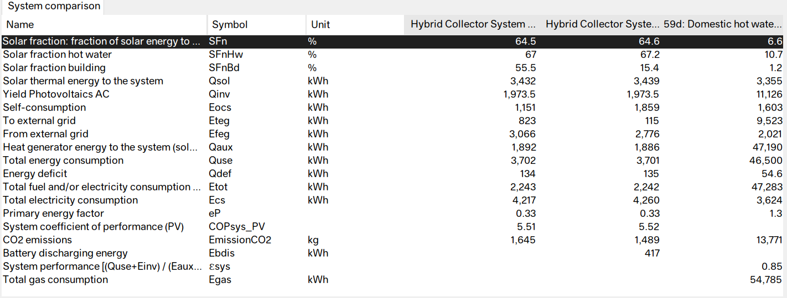
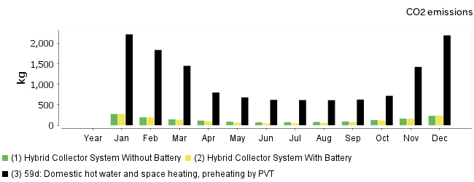
Figure 24: System Comparison CO2 Emission (Polysun Simulation Software, 2024)
While Fig. 25 and Fig. 26 display the energy deficit, self-consumption and solar thermal energy to the system.
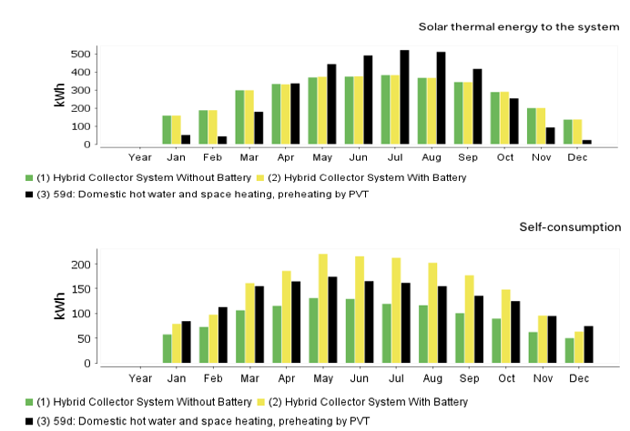
Figure 25: System Comparison of Self-Consumption and Solar Thermal Energy to the System (Polysun Simulation Software, 2024)

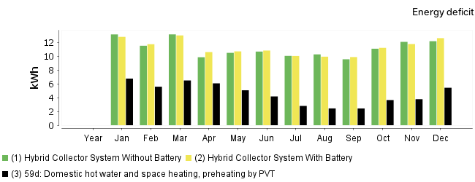
Figure 26: System Comparison for Energy Deficit (Polysun Simulation Software, 2024)

The Polysun Performance of an Active solar heating house design for a hybrid collector system is based on the Comparative Simulation Analysis Report that was completed. A PDF file for each system is included below.

PDF 1: Hybrid Collector System with Battery (Polysun Simulation Software, 2024)

PDF 2: Hybrid Collector System without Battery (Polysun Simulation Software, 2024)

PDF 3: Hybrid Collector System from Polysun Domestic Hot Water and Space Heating (Polysun Simulation Software, 2024)

DISCUSSION OF RESULT

Design Choice and Analysis
The proposed design for a carbon-neutral building integrates both passive and active solar systems, aiming to reduce greenhouse gas emissions through low-carbon technologies. The inclusion of PVT panels and heat pumps for heating aligns with current trends in sustainable building practices. Passive solar heating elements such as the optimal orientation of windows, insulation, and thermal mass flooring further enhance energy efficiency. The use of Polysun software for performance analysis provides a comprehensive evaluation of the proposed system's capabilities.

CRITIQUE
While the design incorporates various sustainable strategies, some aspects warrant scrutiny. For instance, the reliance on Polysun simulations assumes ideal conditions and may not fully capture real-world complexities. Additionally, the comparison between systems lacks depth, particularly in assessing long-term performance and reliability. Further, the emphasis on solar technologies may overlook other renewable energy sources or energy-saving measures that could complement the system.

TECHNICAL SCRUTINY
The Polysun simulation results provide valuable insights into the system's performance metrics such as solar fraction, energy generation, and self-consumption. However, it's essential to critically examine these results considering factors like system efficiency, maintenance requirements, and variability in energy demand. Additionally, the assumed parameters and inputs for the simulations should be rigorously validated to ensure accuracy.

SOCIO-ECONOMIC, ENVIRONMENTAL AND POLITICAL CONSIDERATION
From a socio-economic perspective, the adoption of carbon-neutral building practices can lead to job creation in the renewable energy sector and reduce energy costs for occupants over the building's lifespan. Environmental benefits include decreased reliance on fossil fuels, reduced air pollution, and mitigation of climate change impacts. Politically, government policies and incentives play a crucial role in promoting sustainable building practices and driving market demand for renewable energy technologies.

COST ANALYSIS
While initial costs for implementing solar and heat pump systems may be higher than conventional methods, the long-term economic benefits often outweigh the upfront investment. Factors such as energy savings, potential revenue from excess energy generation, and increased property value due to sustainability features should be considered in the cost analysis. Additionally, government incentives, subsidies, and financing options can significantly offset initial costs and incentivize adoption.
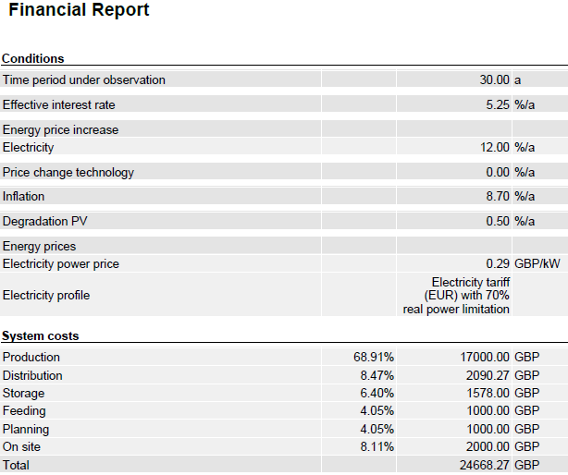

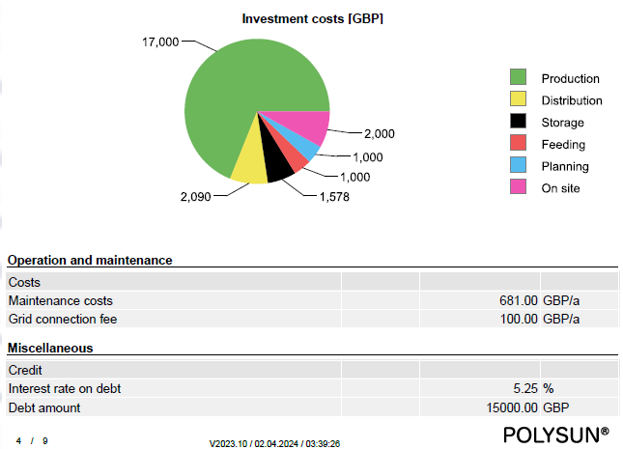

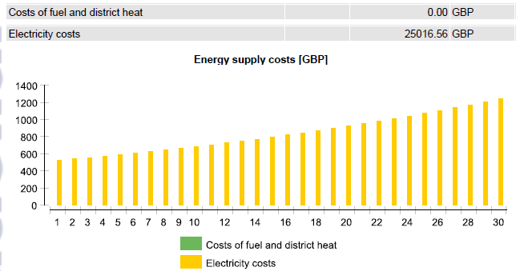

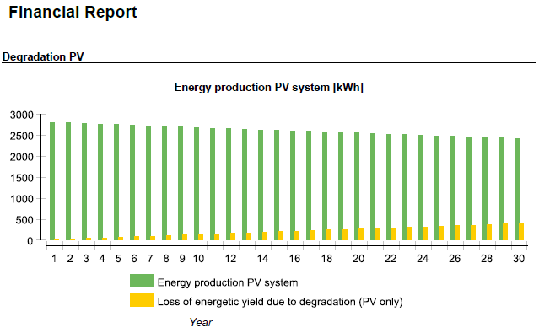
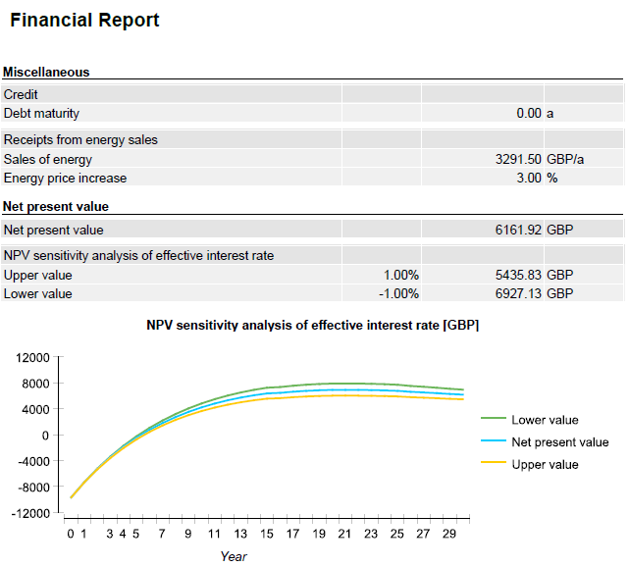

The payback period is about five years since the energy from solar power panels (PVT) offsets the investment expenditures. Additionally, the heat energy from PVT lowers the heat pump load and system heat load, improving the system's economic feasibility. The polysun simulation computes this value.
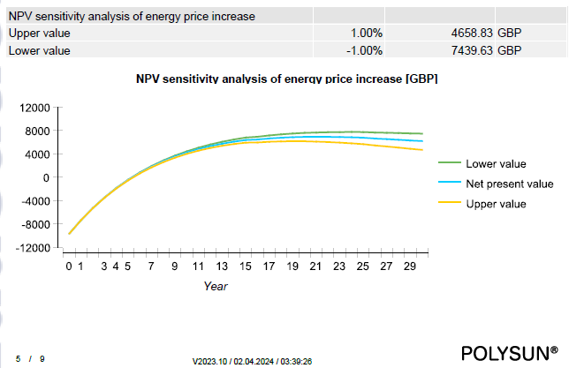

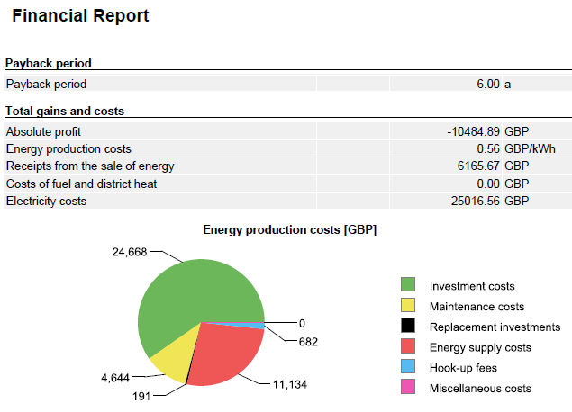
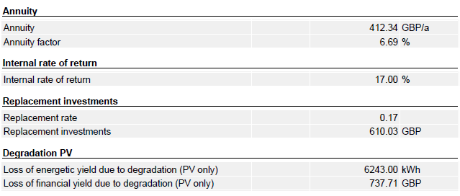

CONCLUSION
In conclusion, the proposed carbon-neutral building design successfully integrates passive and active solar systems, achieving the objectives of reducing greenhouse gas emissions and enhancing energy efficiency. The evidence from Polysun simulations confirms the system's capability in meeting energy demands sustainably. Moreover, the comparison between the hybrid collector system with and without a battery underscores the importance of energy storage in optimizing system performance. Overall, the comprehensive approach towards sustainable building practices demonstrates a significant step towards mitigating climate change and promoting renewable energy adoption in the construction sector.

REFERENCE
AutoCAD 3D. (2024), “Passive Solar Heating House Design ”, AutoCAD, March.
Clarke, J., Littlewood, J.R. and Karani, G. (2023), “Developing Tools to Enable the UK Construction Industry to Adopt the Active Building Concept for Net Zero Carbon Buildings”, Buildings, MDPI, Vol. 13 No. 2, p. 304.
Global Solar Atlas. (2024), “Global Solar Atlas Wimbledon England, United Kingdom.”, Global Solar Atlas .
IEA 50. (2022), “Solar thermal technologies deployed in around 400 million dwellings by 2030”, International Energy Agency , September, available at: https://www.iea.org/reports/solar-thermal-technologies-deployed-in-around-400-million-dwellings-by-2030 (accessed 27 March 2024).
Klunne, W. (2004), “Improved quality of life through passive solar design”, Leading Architecture and Design, pp. 57–60.
Liang, X., Wang, Y., Royapoor, M., Wu, Q. and Roskilly, T. (2017), “Comparison of building performance between Conventional House and Passive House in the UK”, Energy Procedia, Elsevier, Vol. 142, pp. 1823–1828.
Liu, R., He, G., Su, Y., Yang, Y. and Ding, D. (2023), “Solar energy for low carbon buildings: choice of systems for minimal installation area, cost, and environmental impact”, City and Built Environment, Springer, Vol. 1 No. 1, p. 16.
Lizana, J., Chacartegui, R., Barrios-Padura, A. and Ortiz, C. (2018), “Advanced low-carbon energy measures based on thermal energy storage in buildings: A review”, Renewable and Sustainable Energy Reviews, Elsevier, Vol. 82, pp. 3705–3749.
Paul Bullard. (2023), “Understanding Carbon-Neutral Buildings”, SFG 20: The Future of Carbon-Neutral Buildings: Trends and Predictions, 3 October, available at: https://www.sfg20.co.uk/blog/future-carbon-buildings (accessed 27 March 2024).
Polysun Simulation Software. (2024), “Active Solar Heating Project House Design”, Polysun , England, October.
Sartori, I. and Hestnes, A.G. (2007), “Energy use in the life cycle of conventional and low-energy buildings: A review article”, Energy and Buildings, Elsevier, Vol. 39 No. 3, pp. 249–257.
Simon J Crowe. (2023), “Achieving Net Zero Carbon Buildings”, Low Carbon Alliance, available at: https://lowcarbonalliance.co.uk/net-zero/ (accessed 27 March 2024).
Wang, Y., Kuckelkorn, J., Zhao, F.-Y., Spliethoff, H. and Lang, W. (2017), “A state of art of review on interactions between energy performance and indoor environment quality in Passive House buildings”, Renewable and Sustainable Energy Reviews, Elsevier, Vol. 72, pp. 1303–1319.
Weather Spark. (2024), “Climate and Average Weather Year Round in London United Kingdom”, Weather Spark, March, available at: https://weatherspark.com/y/45062/Average-Weather-in-London-United-Kingdom-Year-Round (accessed 31 March 2024).
Xing, Y., Hewitt, N. and Griffiths, P. (2011), “Zero carbon buildings refurbishment––A Hierarchical pathway”, Renewable and Sustainable Energy Reviews, Elsevier, Vol. 15 No. 6, pp. 3229–3236.

