DARwIn-OP User Manual

09 - 12 - 2012

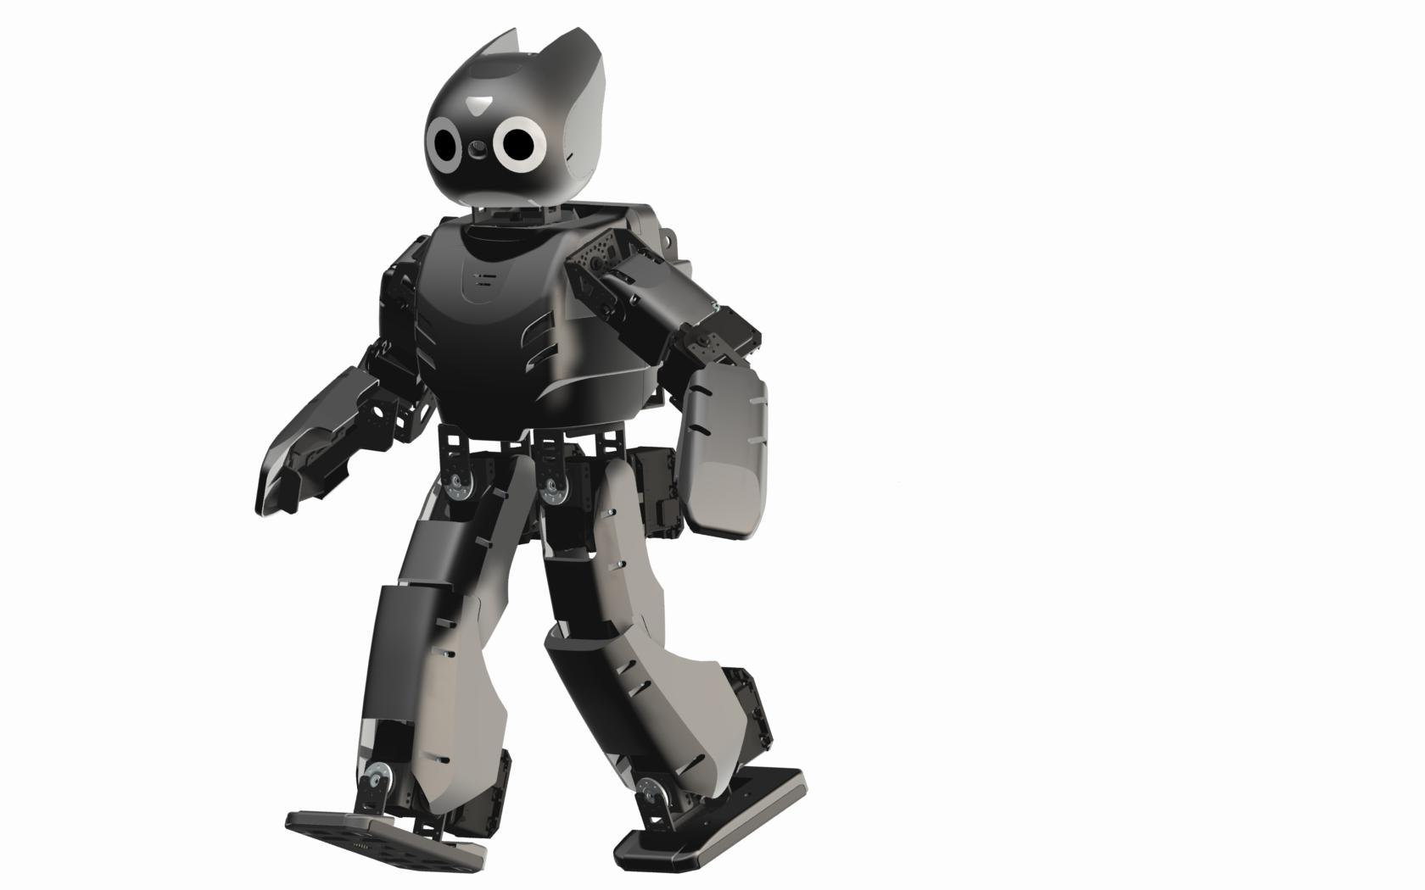

Erik Hansson

Gustaf Svanerud

Arvin Arbab

http://darwinop.sourceforge.net/index.files/image001.jpg

# Downloading source code

In order to download the code you will need to use git to get the files from the repository **https://github.com/E-Hansson/TDDD63-Humanoids**. The most resent code is located in the folder **OldDarwinRemake** and should be public 01-01-2013 or earlier.

You can read more about github here: **https://help.github.com/**

# Configuring Eclipse

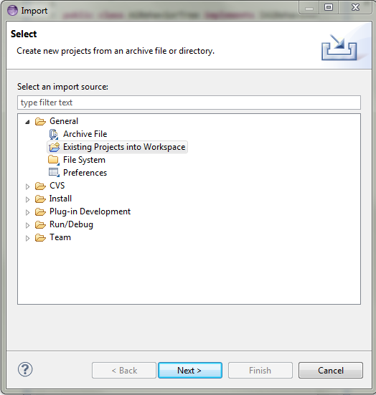When you have downloaded the project you are ready to configure Eclipse to run it. In Eclipse right-click the Project Explorer and select **"Import".** This will open up the Import menu. Now select **"Existing Projects into Workspace"** found under   
**"General"** and press next. Now locate the directory you  
downloaded the project into and press **"Finish"**.The project should now appear in your Project Explorer.

You will now have to add a path to the API. To do this,   
right-click on your newly added project and select   
**"Properties"**. On the left-hand side in the properties  
window select **"PyDev - PYTHONPATH"**.Go to the tab  
**"External Libraries"** and click **"Add source folder"** and  
browse to the PythonApi-folder located at  
 **liurobotapi/PythonApi**.Press "OK" twice.

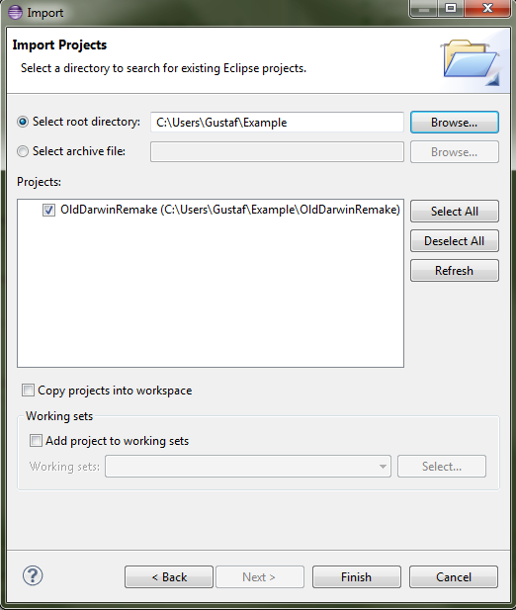

# Running the program on Darwin

Make sure Darwin has a fresh battery properly inserted and turn him on. It is suggested to start Darwin face-down on his stomach with the arms along his body. To initiate the program on Darwin press **"Run" → "External tools" → "Run on Darwin"** in Eclipse. Note that it might take several seconds for Darwin to fully boot, before this he will not be able to receive any code, this will be indicated in Eclipse by a print in the terminal stating that Darwin is not connected if you try to run code before Darwin is fully booted. Eclipse will also indicate that the code has been successfully sent to Darwin with a print in the terminal. After a couple of seconds Darwin should start his program.

# Handling Darwin

Besides the on/off button Darwin has three other buttons sitting close together on Darwin's back, these can be used to control him somewhat. If you would like to end this program you press the middle button, to make Darwin's motors relax you can press the right button.

Since Darwin is an expensive piece of equipment it is important to handle him with care. Here is a list of things to think about when handling Darwin.

* When carrying Darwin, do this using the strap on his back.
* Do not forcefully twist Darwin's joints.
* Never let Darwin leave the mat.
* Always try to be prepared to catch Darwin if he falls.

# Shutting down Darwin

When you feel satisfied with using Darwin press the middle button on his back to end the program, then press the button to the right of it to relax his joints. You should now run **"opShutdown.sh",** in a couple of seconds a green light on Darwin's head and his back will start to flash, when it stops Darwin is ready to be powered off. When this is done you should unplug the battery.