Technical Overview
Forward software for DARwIn-OP
Overview:
In short words the program that simulates a forward on a DARwIn-OP unit is two simple state machine illustrated in the drawing below. The first state machine is the main state machine one where each circle is a state except for the Track Ball Machine which is the second state machine. In the Track Ball Machine all the circles represents a state. There is a check for if the robot has fallen in machines update which will make the robot leave the Track Ball Machine and return to the main state machine.
When the software is executed on DARwIn-OP the first state will be the Get Up state in the main state machine.
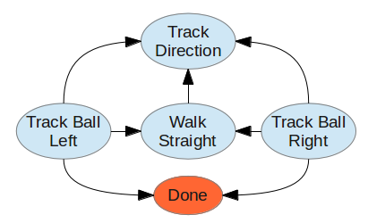
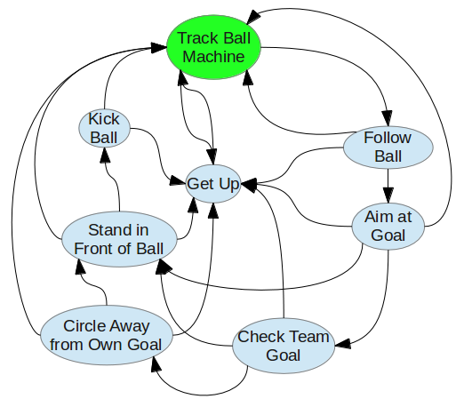
The Different states:
Note 1: A couple of the states in the diagram under Overview are relatively similar to each other. Therefore, they have been implemented as the same state with different parameters.
Note 2: Many of the states express an approximated value on how far it will circle, how long it goes, etc. The reason for that is that it will perform the action for a certain amount of time. Therefore, the distance it will move will differ from time to time due to the fact that its walking is shaky.
The Main State Machine:
Follow Ball and Stand in Front of Ball:
One of the most simple and most used states for the forward program is the one that makes the robot walk after the ball. However, there are two different situations in which the robot wants to keep different distances from the ball. Firstly, the situation in which it wants to go to the ball after it has found it somewhere on the field. Secondly, the situation in which it wants to get close enough to kick the ball.
The reason to why it wants to be at a greater distance after it has found the ball is that it should not accidentally hit the ball during the following state.
Finding the goal:
After the robot knows it is standing in front of the ball the next step is to find a goal. In this state the robot will not care if it is the goal of its opponents or its own. It finds a goal so by circling around the ball and checking if it has a goal in front of it. By moving its head up and down as it circle the ball it is also able to make sure it does not wander to far away from the ball or to close by mistake.
The robot will leave the state either if it finds a goal, if it has not found one during, roughly, one turn or if it has lost possession of the ball.
Kick ball:
This state is pretty much explained by its name. The robot will look down at the ball and calculate the angle to the ball. If the ball is between its feet it will sidestep until it is in front of one of its feet. After that, it will kick the ball, wait some time until it has both its feet on the ground again and then leaves the state.
Circle away from own goal:
Under the circumstances that the robot finds that it is facing its own goal it wants to turn around before it kicks the ball. Therefore, this state makes the robot turn roughly 180 degrees around the ball before it leaves the state. Unlike the state finding the goal this state will not be looking for a goal. Therefore, it will be able to keep its head focused on the ball all the time and by doing so it will have a better precision on walking around the ball. It will also leave the state if it loses possession of the ball.
Track ball left and track ball right:
This is one of the states that might be even more essential than the states based on the behavior of following a ball. The robot will look for the ball by turning its head in a rectangle, low and high, from left to right and from right to left, while it turns around on the spot.
The robot will leave the state either if it has found the ball or if it has turned roughly 360 degrees.
Track direction:
During this state the robot will decide which way it should turn while tracking the ball by using the angles to the ball in the last observation of one. If the last angle implies that the ball was on his left side it will turn left and otherwise it will turn right.
Walk straight:
Since our software does not support localization for the robot it will sometimes find itself in the situation where it can't find the ball and does not know where it is. Therefore, its best chance to find the ball is to simply change location. That it will do by walking forward for some time.
Check team goal:
The purpose of this state is simple. While in this state the robot will look at its last observation of the goal and ask whether the goal belongs to its own team or to the opponent’s team.
Center goal:
The robot can calculate in which angle it has turn its head to if it should be looking at the middle of the goal by; firstly moving its head from the left to the right, store the first observation of a goal, which should be a goalpost, and then do the same from right to left. Due to different circumstances, for example another robot is blocking the view, it might be unable to find two goalposts. Under any of these circumstances the robot will turn its head towards the goalpost it found. Otherwise, it will turn its head towards the middle of the goal.
Line up shot:
The purpose of this state is to adjust the robot's position around the ball so that it is between the goal and the robot. It does so by storing the head position it had when it enters the state, which was set by the previous state, and comparing it with the angle to the ball. If there is to big differences between them, it will adjust it position and check again.
Get up:
This state does exactly what the name implies. Firstly, it starts and follows trough a couple of motions which will take the robot from a lying position to a sitting position. Secondly, as soon as it recognize that it is sitting, by checking the angles of the IMU, it will stand up. Lastly, as the robot exits the state it will start the walk motion before it moves to the next state.
There is one exception to the series of motion that the robot performs while in this state. If it happens to be sitting or standing while entering the state it will simply stand up or exit depending on which position it is in. That makes this state as a good state to begin with since it will take the robot to standing position nevertheless which position it is in when it start.
The transition between the states:
The first thing that should be mentioned about the states is that it could have been smoother implemented by using state machines inside another state machine. One example of the states that could have been implemented in an underlying state machine is the get up state, since the robot will ask itself in the update of all the states.
The use of more than one state machine would also be useful for further improvements in which the robot has to, for example, cooperate with its teammates.
Unfortunately this software does not operate in that manner. Therefore, this state machine has a lot of transitions and most of them are explained by their name and logic. However, some of them are not. Therefore, they are described in the next paragraphs.
From finding the goal to stand in front of ball:
The reasoning for this behavior of the robot is that, since it do not have any possibilities to determine where it is on the field with this software, any guess is as good as another. Note that this only happens if the robot cannot find any goal during a full revolution around the ball.
From check team goal to circle away from own goal:
Like in the transition above this is a solution which was implemented due to the fact that the robot does not have any possibilities to locate its position on the field with this software. The most logical conclusion on what to do, if it only knows where its own goal is located in relation to its own position, is to kick the ball in the opposite direction.
From finding the goal, line up shot, circle away from own goal and stand in front of ball to track direction:
All these states take a while to follow through and therefore they have tests to make sure that the robot is still in possession of the ball. If it has lost the ball it will change state to track direction, in an attempt to relocate the ball before it gets too far away.
From finding the goal to stand in front of ball:
If the robot cannot find a goal during roughly one revolution it will conclude that it can kick the ball forward. The reasoning for that is that the software does not support localization and therefore the only thing it does know is that neither its own goal or the opponents are in front of it. Therefore, it should be safe to kick the ball. To just stand still is not an option since that would give the opponents time to take possession of the ball.
Reflection and conclusion:
Overall the code would have been much more understandable and it would be easier to find bugs if the software had been implemented as state machines inside state machines. As mentioned above, a good example of what would have been better would be to place the state get up in an underlying state machine. Another example the tracking of the ball, which now consists of four states. However, the most useful improvement would be when collaborating with other team mates.
There are also a lot of improvements to be made on the AI. The most significant of them would be localization and the ability to avoid aiming outside the field or walking outside it. Different behaviors for depending on if a team mate got the ball or if it plays the goal keeper.
Lastly the different movements done by DARwIn-OP could have been better. For example, the kicking motion made with his right foot have successfully avoided all our attempts to change the lua-code so that it could kick with it. Another example of what could have been better is the side stepping of the robot which now gains momentum, if you are unlucky, until it falls over.

