**ELEC 1**

**E-Commerce Project**

Group of E-Jhay Bumacod

Members:

Myline Montemayor

Louisa Cuenza

Jan Aldenn Sevillena

Gerrence Brylle Bacayo

Dianna Rose Rastrollo

**Screenshots of the Important Pages**

**CUSTOMER SIDE**

**Landing Page**



Landing Page. This page is the first page that will show up upon loading the system.

**Login Page**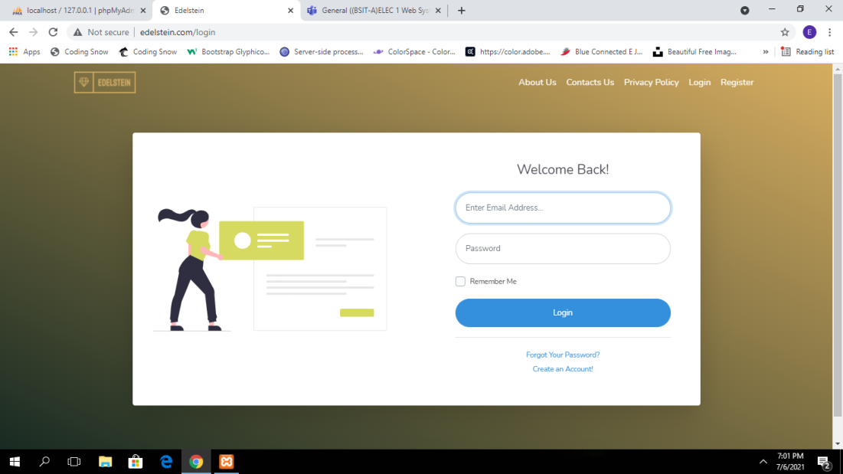

Login Page. Login page is the webpage that accepts use login credentials to enter into the system.

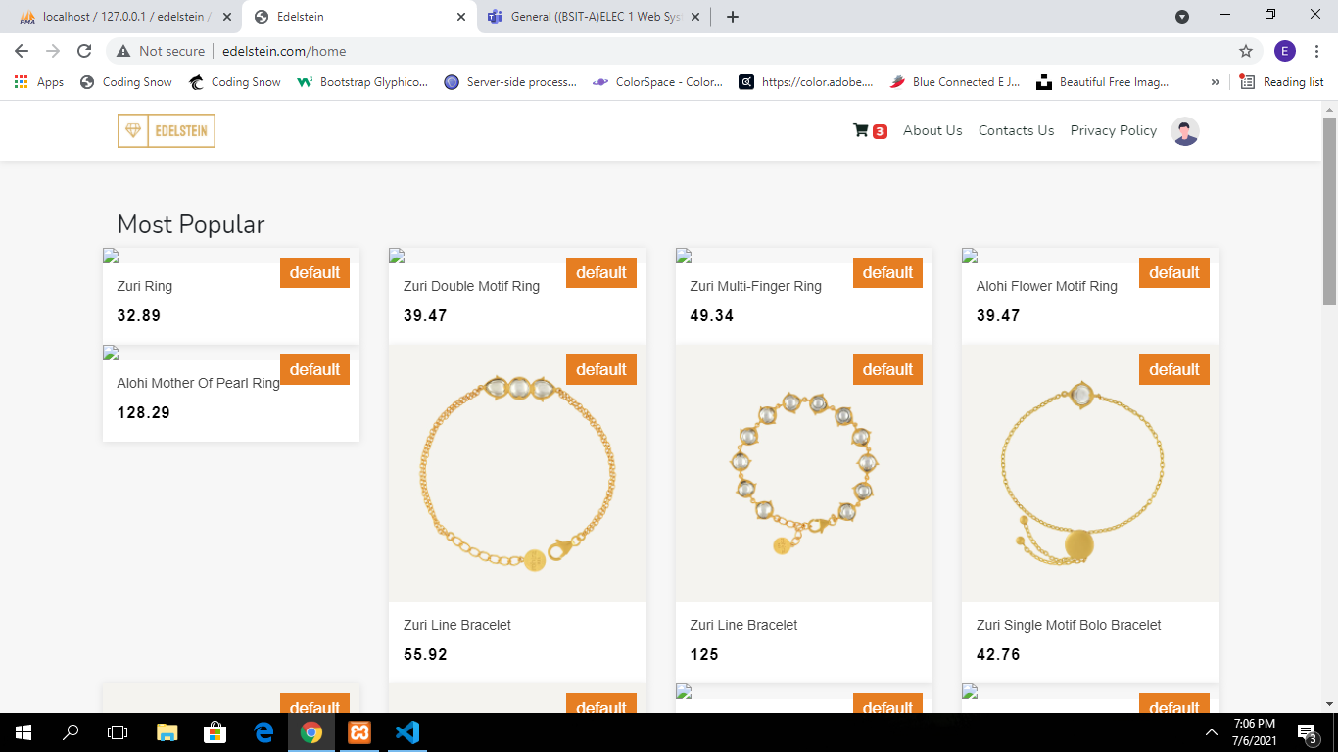**Shop Page**

Shop Page. After logging in, the customer will be rediected to the shop page. This page contains product that the system sells.

**Cart**

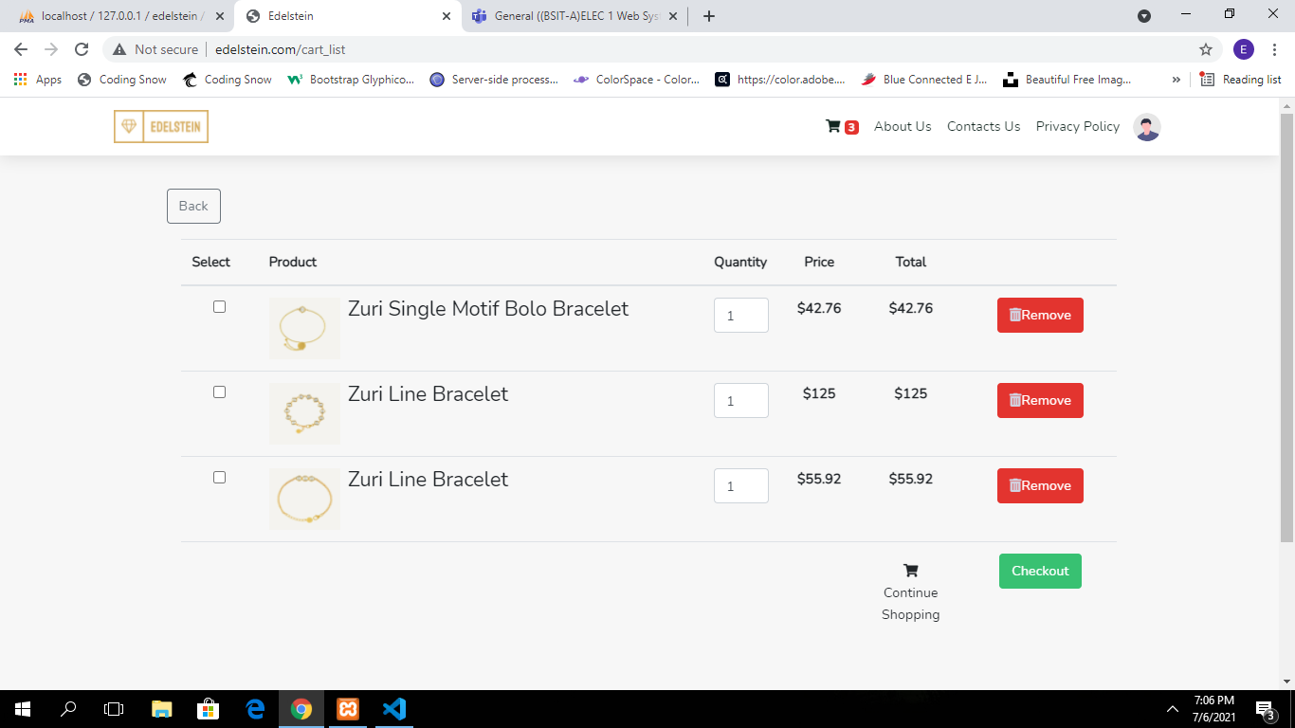

Cart. This Page shows all the products that the custome added into the cart.

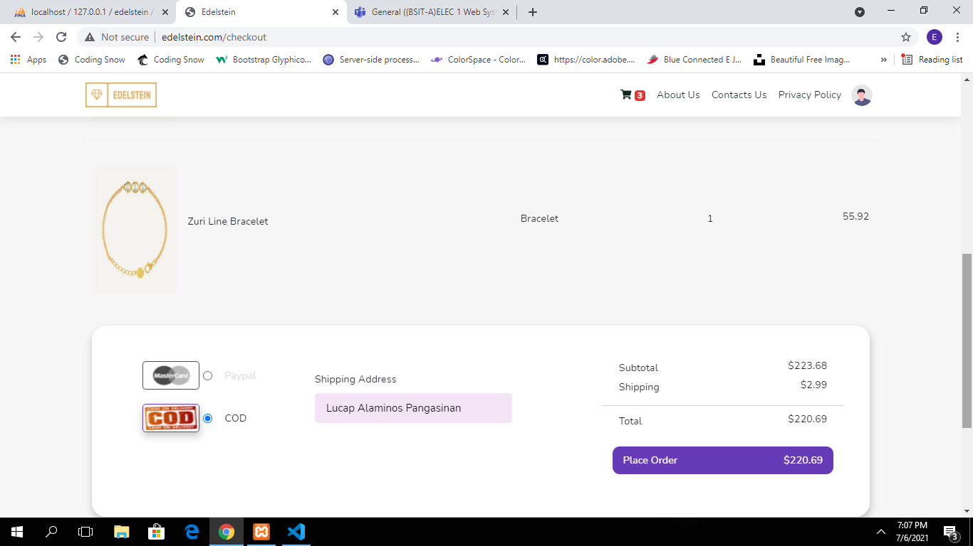**Checkout Page**

Checkout Page. After selecting products in the cart, the customer will be redirected in the checkout page to finalize the checkout transaction.

**Customer Dashboard**

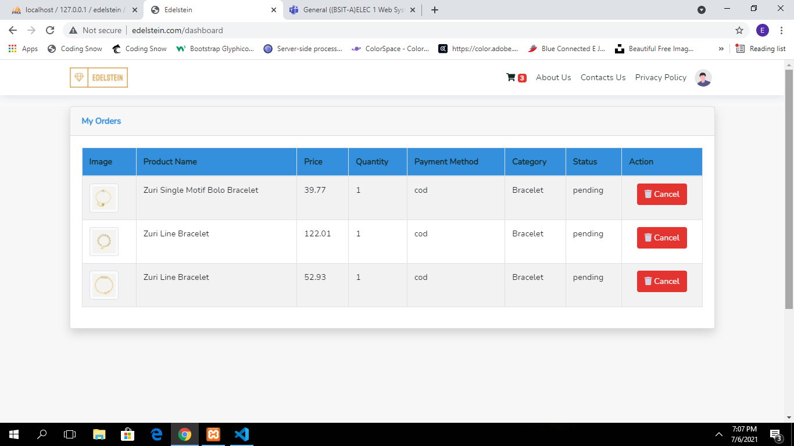

Customer Dashboard. After the checkout transaction, the customer will then redirected on his/he dashboard. Dashboard contains all the orders that the customer has make.

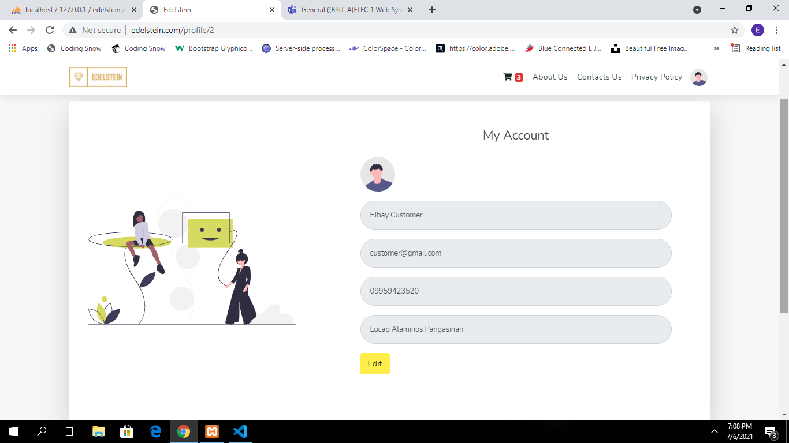**Profile**

Profile Page. Every user has its own profile page where, this page shows the user infromation.

**ADMIN SIDE**

**Admin DashBoard**

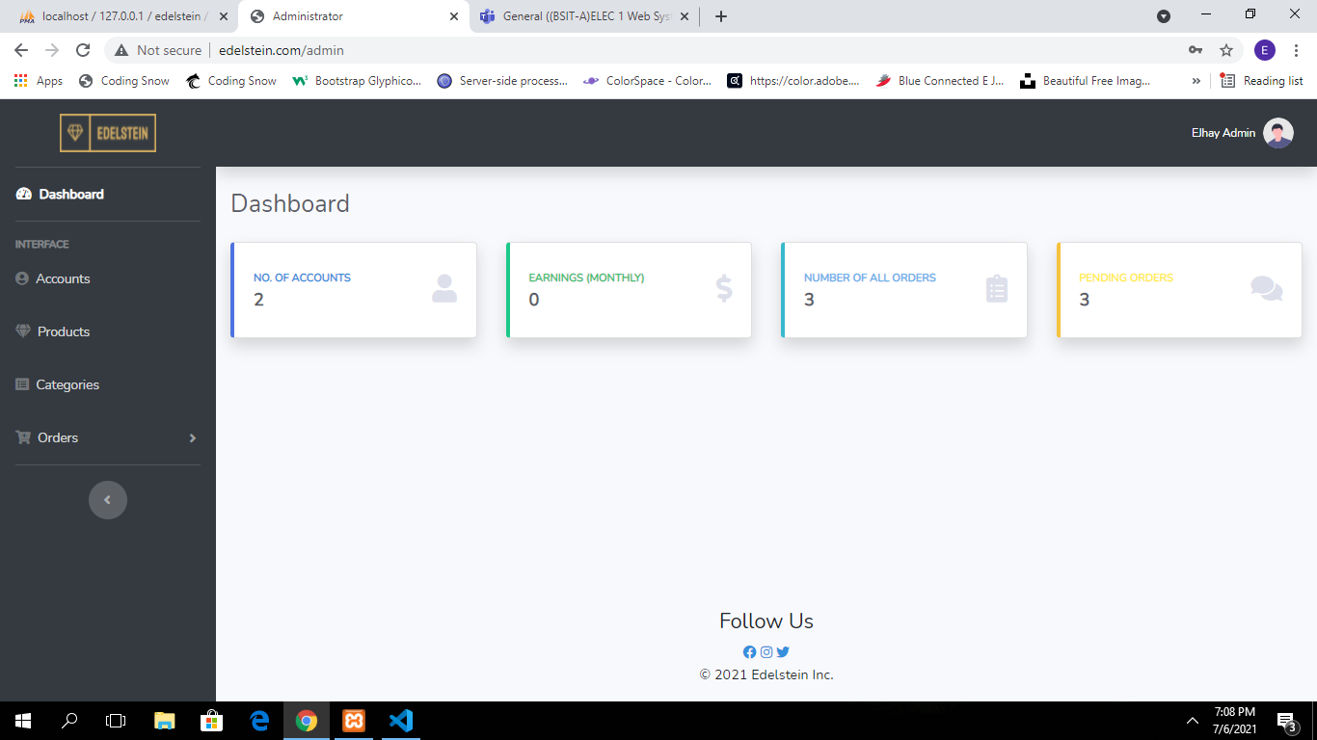

Admin Dashboard. Admin Dashboard is the first page that will show up, when a user that logs in is an admin. This page shows information and transaction about the system.

**Accounts**

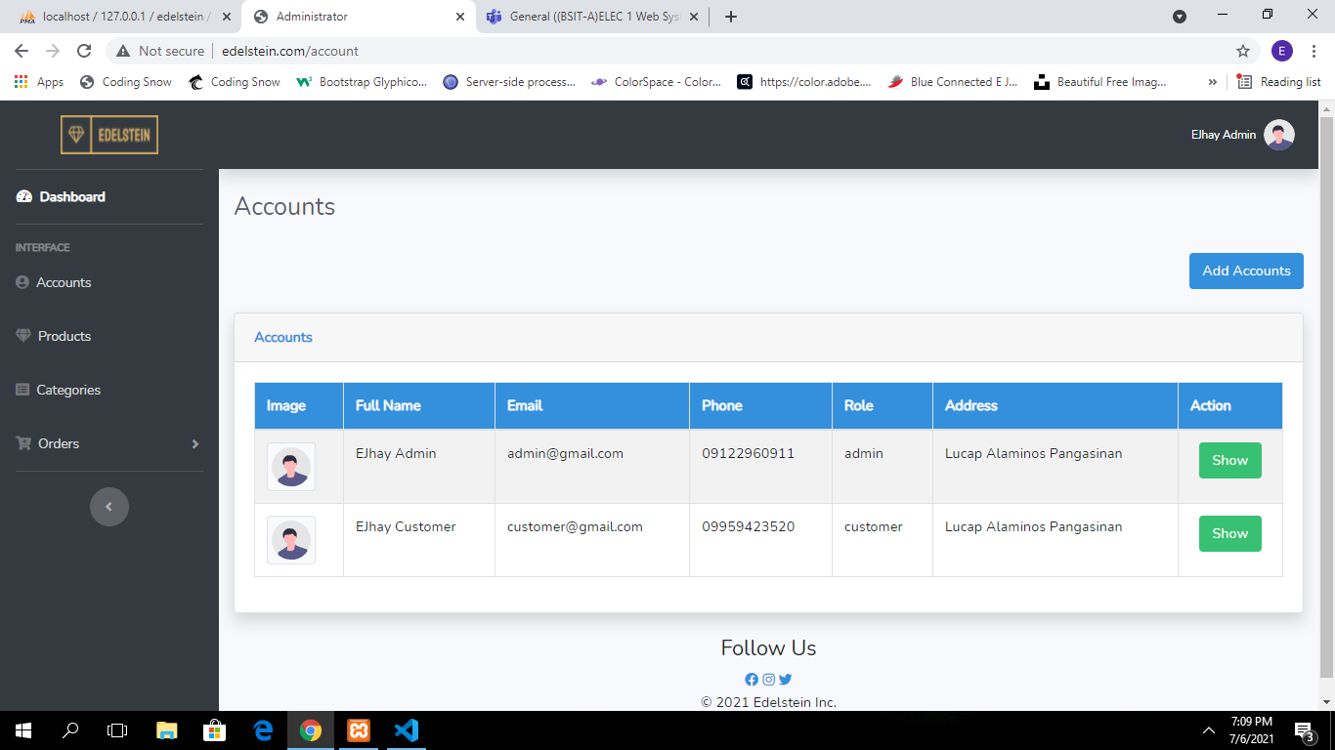

Accounts Page. It is the page where all accounts is being displayed.

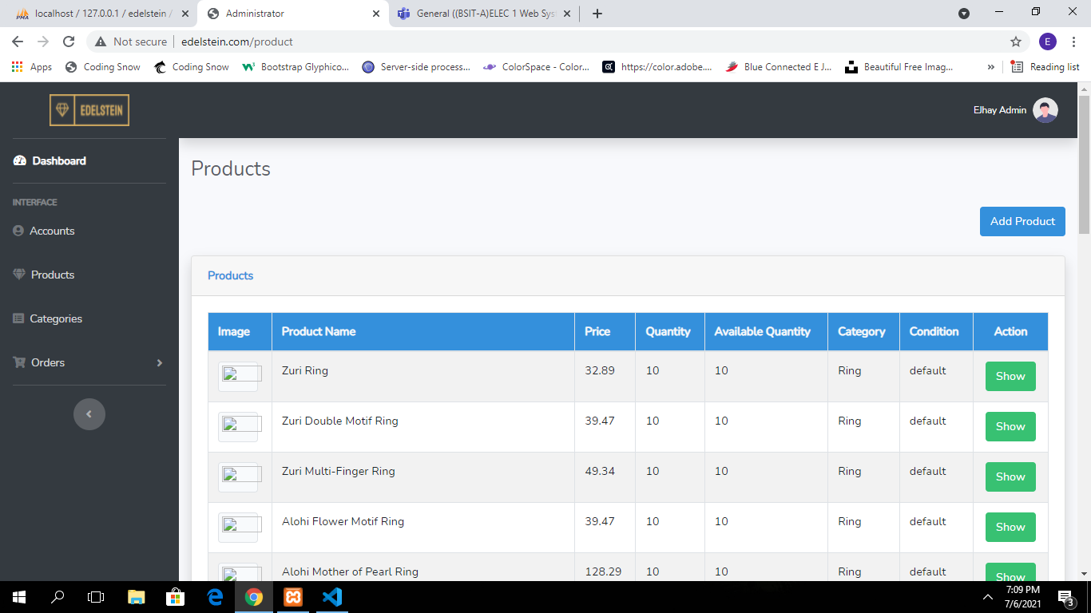**Products**

Products Page. This page shows all the products that is posted in the system. The admin can perform the CRUD Functionality.

**Categories Page**

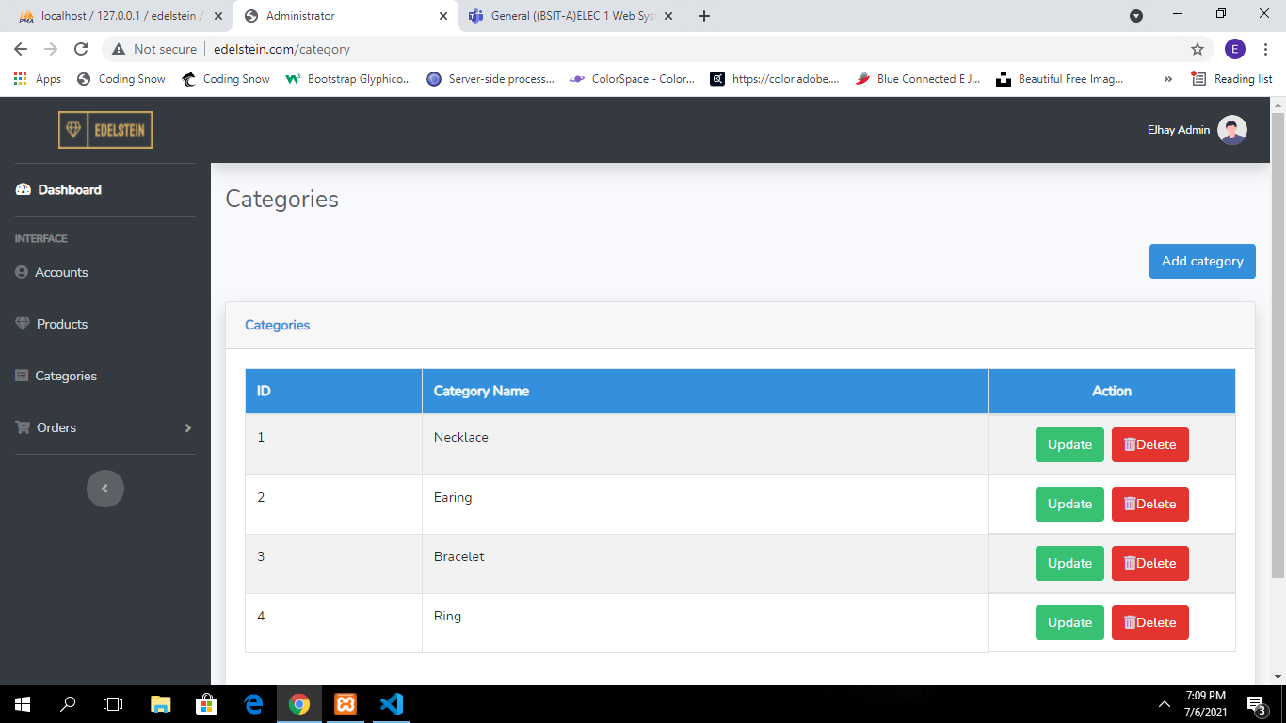

Categories Page. In categories page, All categoies is displayed. The admin can perform the CRUD Functionality.

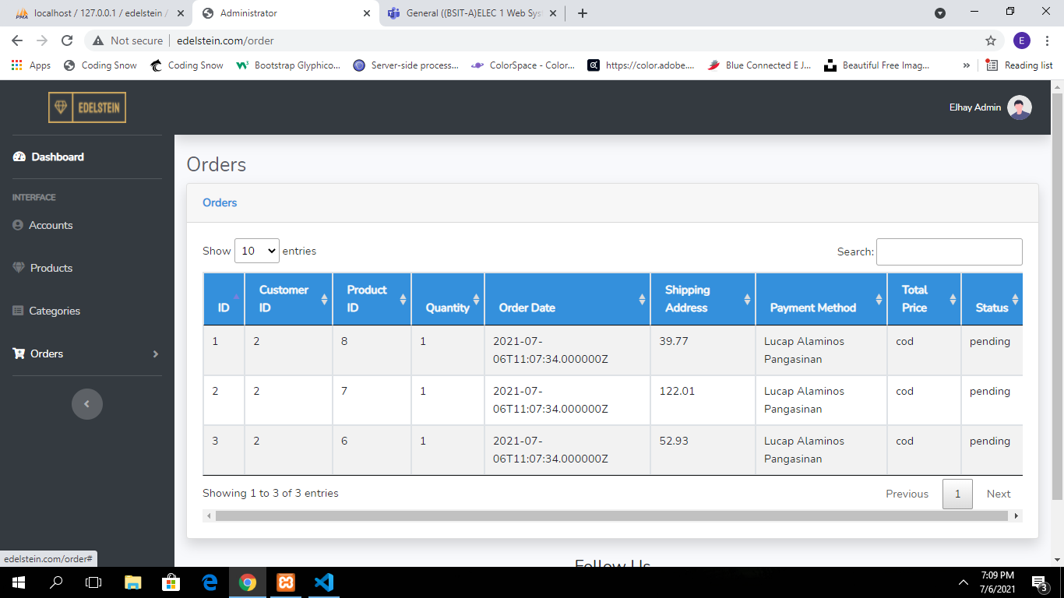**Orders Page**

Orders Page. Show all the oders made in the system, every order has a status.

**Pending Orders**

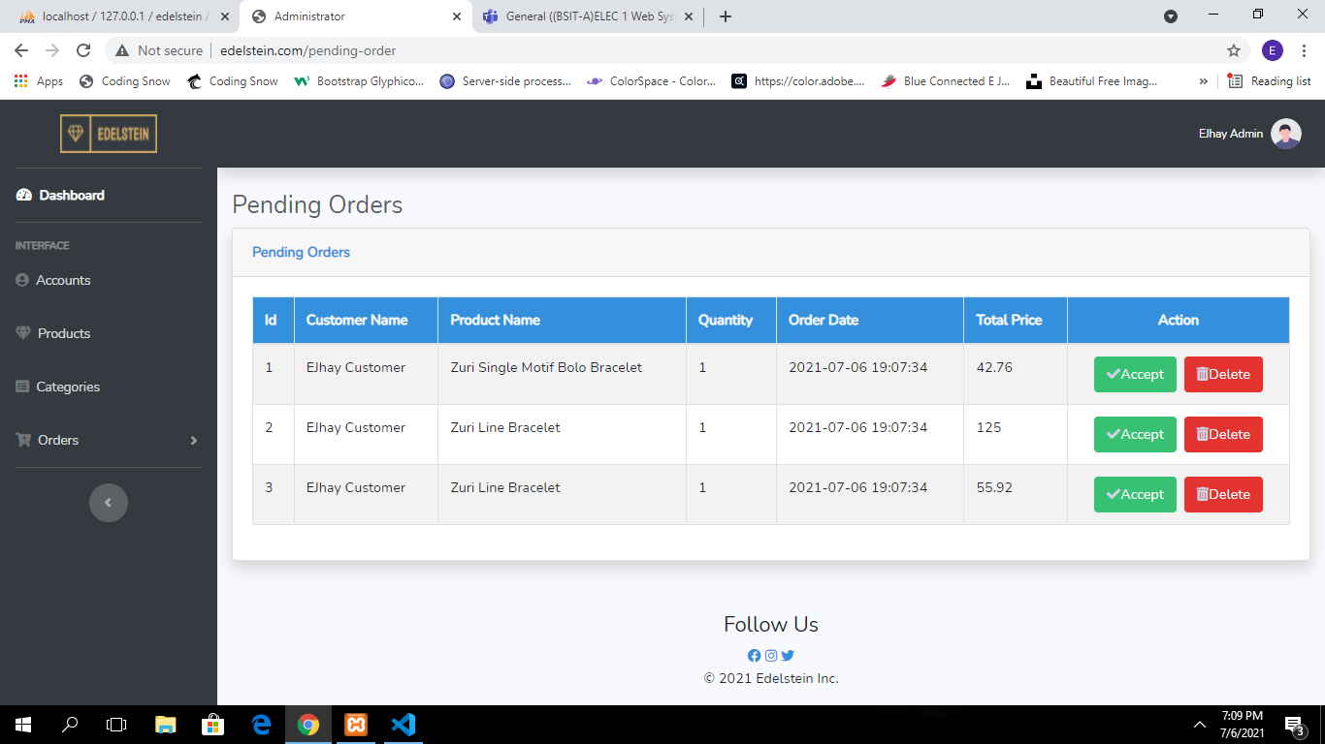

Pending Orders Page. This page shows all the orders that is pending. The admin has a choice to accept the request order or decline the order.