A PROJECT ON
E-Learning Web Application
SUBMITTED IN
PARTIAL FULFILLMENT OF THE REQUIREMENT
FOR THE COURSE OF DIPLOMA IN ADVANCED COMPUTING FROM CDAC

SUNBEAM INSTITUTE OF INFORMATION TECHNOLOGY
Hinjawadi
SUBMITTED BY:
Mr. Shivraj Somavanshi
Mr. Swaraj Rawate
Mr. Sanket Raut
Mr. Omkar Gandhi
UNDER THE GUIDENCE OF:
Mr. Snehal Jadhav
Faculty Member
Sunbeam Institute of Information Technology, Pune

ACKNOWLEDGEMENT

A project usually falls short of its expectation unless aided and guided by the right persons at the right time. We avail this opportunity to express our deep sense of gratitude towards Mr. Nitin Kudale (Center Coordinator, SIIT, Pune) and Mr. Yogesh Kolhe (Course Coordinator, SIIT ,Pune) .
We are deeply indebted and grateful to them for their guidance, encouragement and deep concern for our project. Without their critical evaluation and suggestions at every stage of the project, this project could never have reached its present form.
Last but not the least we thank the entire faculty and the staff members of Sunbeam Institute of Information Technology, Pune for their support.

Shivraj Somavanshi
Swaraj Rawate
Sanket Raut
Omkar Gandhi
PG-DAC
SIIT Pune

A PROJECT ON

“E-LEARNING WEB APPLICATION”

SUBMITTED IN
PARTIAL FULFILLMENT OF THE REQUIREMENT
FOR THE COURSE OF
DIPLOMA IN ADVANCED COMPUTING FROM CDAC

SUNBEAM INSTITUTE OF INFORMATION TECHNOLOGY
Hinjawadi

SUBMITTED BY:

Mr. Shivraj Somavanshi
Mr. Swaraj Rawate
Mr. Sanket Raut
Mr. Omkar Gandhi

UNDER THE GUIDENCE OF:

Mr. Snehal Jadhav
Faculty Member
Sunbeam Institute of Information Technology, PUNE



CERTIFICATE

This is to certify that the project work under the title ‘Web Portal for Student and teacher’ is done by Mr. Shivraj Somavanshi in partial fulfillment of the requirement for award of Diploma in Advanced Computing Course.

Mr. Snehal Jadhav Mr. Yogesh Kolhe
Project Guide Course Co-Coordinator

Date:

INTRODUCTION TO PROJECT

The E-Learning Platform is a modern web-based education system designed to deliver an engaging and efficient learning experience. Built using Spring Boot for the backend, React for the frontend, and MySQL for database management, this platform offers a robust and scalable solution for online education. It allows users to seamlessly navigate through courses, manage learning materials, track progress, and learn efficiently in a secure environment.
This project focuses on providing an intuitive user interface for students and instructors, ensuring that both parties can easily interact with the system. Instructors can create and manage courses, upload content, and monitor student performance, while students can enroll in courses, access learning materials, and track their progress through various interactive features.
The combination of Spring Boot's powerful backend capabilities, React's dynamic frontend, and MySQL's reliable data storage ensures that the platform is not only responsive and user-friendly but also scalable and secure. This makes the E-Learning Platform an ideal solution for institutions looking to offer online education in a flexible and accessible manner.

2.REQUIREMENTS

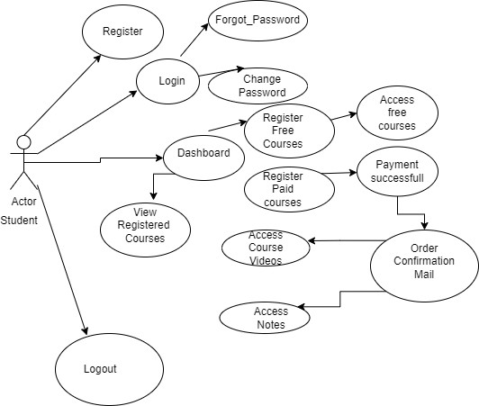
2.1 FUNCTIONAL REQUIREMENTS

Figure :- Student Use Case Diagram

2.1 Student Account
The student, henceforth referred to as the 'user,' will be presented with three options by the e-learning platform at the beginning of their interaction. The user’s choice will depend on whether they are a guest or a registered user, and whether they wish to browse available courses or enroll in them. The terms ‘registered user’ and ‘guest’ are defined below.
A user who has previously registered on the platform will have a user ID and password. This personal information is referred to as the user's ‘profile.’ A user with a profile in the database is called a ‘registered user.’ Registered users can browse available courses, enroll in them, and access course materials after logging into the system.
A new user has the option to: a) Register by providing personal information, or b) Log in as a guest. If the user chooses option a, they become a registered user. If they choose option b, they remain a guest. Guests can browse available courses but cannot enroll in or access detailed course content. A registered user can also act as a guest if they only want to browse available courses. ‘Course availability’ refers to viewing course titles, schedules, and introductory information. The system allows the user to exit at any point during these processes.
2.2 Registration and Creation of User Profile
To enroll in a course or access detailed course materials, a user must register on the platform. During registration, the system will require the user to provide essential information, including a user ID, password, first name, last name, address, phone number, email address, gender, age, and preferred payment method. Upon successful registration, the system will automatically create a ‘course credits’ field in the user’s profile, initialized to zero.
2.3 Quick Search
The platform offers a Quick Search feature that allows any user, without logging into their account, to search for available courses. This feature enables users to explore course offerings and compare them based on various criteria.
After logging in, whether as a registered user or a guest, the system will prompt the user to enter specific search details, such as the course category, level (e.g., beginner, intermediate, advanced), and instructor preferences. The system will then access the course database to check for available courses matching the criteria.
The system will display the search results in a tabular form, providing details for each course, including the course title, instructor, start date, duration, and available slots. If the user has selected a date range, the system will display courses available within that period. A 'Enroll' button will be provided for each course listed in the search results.
The system will then request personal information for all students who will be enrolling, allowing one registered user to enroll multiple users. The platform will then display the total enrollment cost for the selected courses.
2.4 Enrollment and Payment
After the course search and selection process, the system will ask the user if they wish to enroll in the selected course(s). If the user is a guest, they must first register and log in as a registered user. If the user is already registered and logged in, they can proceed with enrollment.
Once the user is validly logged in, the system checks the course start date. If the course start date is imminent (within a set period, e.g., two weeks), the system will inform the user that they must complete the payment immediately. If the course start date is further away, the system will offer the option to reserve a spot in the course or proceed with immediate payment. If the user reserves a spot, the system will notify them of the payment deadline and send a reminder email.
Upon receiving payment details, the system will update the enrollment database, decrementing the number of available slots for the course by the number of students represented by the user. The system will then charge the user’s payment method for the total enrollment cost.
2.5 View Enrollment History
The system allows users to view information about their previous enrollments. After logging in, the user can request details using their enrollment confirmation number. The system will access the user’s enrollment history in the database and present the details of their past courses in a tabular format.

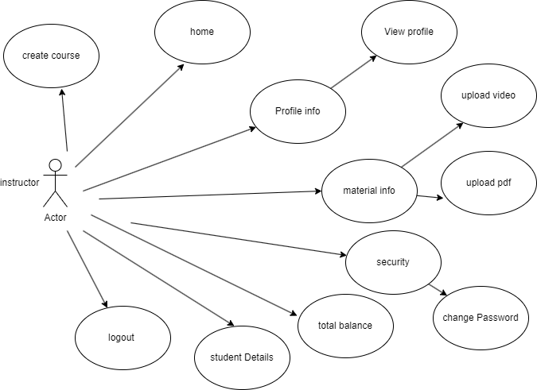

Figure :-Instructor Use Case Diagram

2.1 Instructor Account
The instructor, henceforth referred to as the 'user,' will be presented with three options by the e-learning platform at the beginning of their interaction. The user’s choice will depend on whether they are a guest or a registered instructor and whether they wish to browse the platform's offerings or manage their courses. The terms ‘registered instructor’ and ‘guest’ are defined below.
An instructor who has previously registered on the platform will have a user ID and password. This personal information is referred to as the user's ‘profile.’ A user with a profile in the database is called a ‘registered instructor.’ Registered instructors can browse available courses, create and manage their own courses, and interact with enrolled students after logging into the system.
A new instructor has the option to: a) Register by providing personal information, or b) Log in as a guest. If the user chooses option a, they become a registered instructor. If they choose option b, they remain a guest. Guests can browse available courses and platform features but cannot create or manage courses. A registered instructor can also act as a guest if they only want to browse the platform. The system allows the user to exit at any point during these processes.
2.2 Registration and Creation of Instructor Profile
To create or manage courses, an instructor must register on the platform. During registration, the system will require the user to provide essential information, including a user ID, password, first name, last name, address, phone number, email address, gender, age, academic qualifications, and areas of expertise. Upon successful registration, the system will automatically create an ‘instructor profile’ that includes the number of courses taught and overall student ratings.
2.3 Quick Search
The platform offers a Quick Search feature that allows any user, without logging into their account, to explore available courses and platform features. This feature enables instructors to get an overview of existing courses and how they are structured.
After logging in, whether as a registered instructor or a guest, the system will prompt the user to enter specific search details, such as course category, level (e.g., beginner, intermediate, advanced), and course duration. The system will then access the course database to check for available courses matching the criteria.
The system will display the search results in a tabular form, providing details for each course, including the course title, instructor, start date, duration, and the number of enrolled students. If the user has selected a date range, the system will display courses available within that period. A 'Manage' button will be provided for each course listed in the search results for registered instructors who want to update or manage their courses.
2.4 Course Creation and Management
After exploring the platform and available courses, the system will allow registered instructors to create new courses or manage existing ones. If the user is a guest, they must first register and log in as a registered instructor. Once logged in, the instructor can access the course creation interface.
The system will guide the instructor through the course creation process, asking for details such as course title, description, syllabus, start date, duration, and maximum number of students. Instructors can also upload course materials, set assignments, and schedule assessments.
For existing courses, the system allows instructors to update course content, track student progress, and interact with students through the platform. Instructors can also monitor enrollment numbers and manage course logistics, such as setting deadlines and grading assignments.
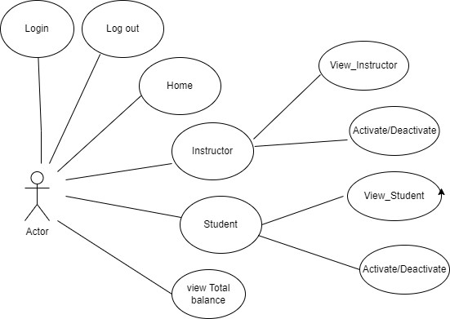
Figure :- Admin Use Case Diagram
2.1 User Account
The admin, henceforth referred to as the 'user,' will be presented with several administrative options upon logging into the e-learning platform. The user’s access is governed by their role as a system administrator, responsible for managing users, courses, and overall platform operations. The terms ‘registered admin’ and ‘guest’ are defined below.
An admin who has previously registered on the platform will have a user ID and password. This personal information is referred to as the user's ‘profile.’ A user with a profile in the database is called a ‘registered admin.’ Registered admins can manage user accounts, oversee course offerings, monitor platform performance, and enforce security protocols after logging into the system.
A new admin must: a) Register by providing personal and administrative information. After registration, the user becomes a registered admin and gains full access to the platform's administrative features. Guests cannot access admin features and must be registered to perform any administrative tasks.
2.2 Registration and Creation of Admin Profile
To perform administrative tasks on the platform, a user must register as an admin. During registration, the system will require the user to provide essential information, including a user ID, password, first name, last name, address, phone number, email address, role, and administrative permissions. Upon successful registration, the system will automatically create an ‘admin profile’ that includes a record of tasks performed and system logs for accountability.
2.3 Quick Overview
The platform offers a Quick Overview feature that allows the admin to quickly view essential platform metrics without logging into their account. This feature provides a snapshot of user activities, course enrollments, and system health.
After logging in as a registered admin, the system will provide access to detailed information, including user statistics, course performance, and system alerts. The admin can filter this data based on various criteria such as date, user type, or course category.
The system will display the overview in a dashboard format, offering insights such as the number of active users, courses in progress, recent registrations, and any system errors or warnings. Admins can click on specific metrics to drill down into more detailed reports.
2.4 User and Course Management
Registered admins have the ability to manage user accounts and course offerings on the platform. This includes creating, updating, or deleting user profiles (students, instructors, and other admins), as well as managing course content and availability.
For user management, the system allows admins to view and modify user details, reset passwords, assign roles, and monitor user activity. Admins can also handle user requests, such as account recovery or role changes, and enforce platform policies.
In terms of course management, admins can oversee the creation, approval, and scheduling of courses. They can also assign instructors to courses, set course visibility, and manage course categories. The system provides tools for admins to monitor course performance, including enrollment numbers, completion rates, and student feedback.
2.5 Monitoring and Reporting
The system provides comprehensive monitoring and reporting tools for admins to ensure the smooth operation of the platform. After logging in, admins can access real-time data on system performance, including server health, database integrity, and user activity logs.
Admins can generate reports on various aspects of the platform, such as user engagement, course success rates, and financial transactions. These reports can be customized based on time periods, user demographics, or specific courses. The system allows admins to export reports for further analysis or to share with stakeholders.
Additionally, the platform includes tools for monitoring and responding to security incidents, such as unauthorized access attempts or data breaches. Admins can set up alerts for critical issues and take immediate action to resolve any problems.

2.2 NON-FUNCTIONAL REQUIREMENTS
2.2.1 Interface
For details on user interfaces, refer to Appendix B.
2.2.2 Performance
- Number of Concurrent Users: The e-learning platform shall be capable of handling at least 1000 concurrent transactions or inquiries per second. This ensures that multiple users can access the platform, view content, and participate in activities without performance degradation.
- Course Access and Continuity: The system is designed to maintain the continuity of course access even in the event of temporary server failures. Utilizing the robust features of Spring Boot and Hibernate, the platform ensures that users can continue their learning activities without interruption, even if the server experiences issues.
2.2.3 Constraints
The e-learning platform shall be capable of handling at least 1000 concurrent transactions or inquiries per second, ensuring reliable performance during peak usage times.
2.2.4 Other Requirements
- Hardware Interfaces: The e-learning platform is expected to function on systems with at least an Intel Core i3 processor or equivalent, 8 GB RAM, and 100 GB HDD or SSD storage. This ensures that the platform can run efficiently on modern hardware.
- Software Interfaces: The e-learning platform shall be compatible with various operating systems, including Windows, macOS, and Linux distributions. The platform will be configured to work with a MySQL database and deployed on an Apache Tomcat server. It is designed to be accessed via modern web browsers such as Google Chrome, Mozilla Firefox, Microsoft Edge, and Safari.
.

3. DESIGN

3.1 Database Design
The following table structures depict the database design.

Table1: User_Info

Field | Type | Null | Key | Default | Extra
id | int | NO | PRI | NULL | auto_increment
amount | decimal(38,2) | YES |  | NULL
email_id | varchar(255) | YES |  | NULL
first_name | varchar(255) | YES |  | NULL
last_name | varchar(255) | YES |  | NULL
password | varchar(255) | YES |  | NULL
phone_no | varchar(255) | YES |  | NULL
role | varchar(255) | YES |  | NULL
status | varchar(255) | YES |  | NULL
address_id | int | YES | UNI | NULL
mentor_detail_id | int | YES | UNI | NULL

Table2: Address

Field | Type | Null | Key | Default | Extra
id | int | NO | PRI | NULL | auto_increment
city | varchar(255) | YES |  | NULL
pincode | int | NO |  | NULL
street | varchar(255) | YES |  | NULL

Table2: Instructor Details

Field | Type | Null | Key | Default | Extra
id | int | NO | PRI | NULL | auto_increment
age | int | NO |  | NULL
bio | varchar(255) | YES |  | NULL
experience | double | NO |  | NULL
highest_qualification | varchar(255) | YES |  | NULL
profession | varchar(255) | YES |  | NULL
profile_pic | varchar(255) | YES |  | NULL

Table3: Course Categories

Field | Type | Null | Key | Default | Extra
id | int | NO | PRI | NULL | auto_increment
description | varchar(255) | YES |  | NULL
name | varchar(255) | YES |  | NULL
status | varchar(255) | YES |  | NULL

Table4: Course

Field | Type | Null | Key | Default | Extra
id | int | NO | PRI | NULL | auto_increment
added_date_time | varchar(255) | YES |  | NULL
author_course_note | varchar(255) | YES |  | NULL
description | varchar(255) | YES |  | NULL
discount_in_percent | int | NO |  | NULL
fee | decimal(38,2) | YES |  | NULL
name | varchar(255) | YES |  | NULL
notes_file_name | varchar(255) | YES |  | NULL
prerequisite | varchar(255) | YES |  | NULL
special_note | varchar(255) | YES |  | NULL
status | varchar(255) | YES |  | NULL
thumbnail | varchar(255) | YES |  | NULL
type | varchar(255) | YES |  | NULL
category_id | int | YES | MUL | NULL
mentor_id | int | YES | MUL | NULL

Table5: Course Section:

Field | Type | Null | Key | Default | Extra
id | int | NO | PRI | NULL | auto_increment
description | varchar(255) | YES |  | NULL
name | varchar(255) | YES |  | NULL
sr_no | varchar(255) | YES |  | NULL
course_id | int | YES | MUL | NULL

Table5: Course Section:

Field | Type | Null | Key | Default |  | Extra
id | int | NO | PRI | NULL | auto_increment
description | varchar(255) | YES |  | NULL
name | varchar(255) | YES |  | NULL
sr_no | varchar(255) | YES |  | NULL
video_file_name | varchar(255) | YES |  | NULL
section_id | int | YES | MUL | NULL

Table5: Booking

Field | Type | Null | Key | Default | Extra
id | int | NO | PRI | NULL | auto_increment
amount | decimal(38,2) | YES |  | NULL
booking_id | varchar(255) | YES |  | NULL
booking_time | varchar(255) | YES |  | NULL
status | varchar(255) | YES |  | NULL
course_id | int | YES | MUL | NULL
customer_id | int | YES | MUL | NULL
payment_id | int | YES | UNI | NULL

Table6: Payment

Field | Type | Null | Key | Default | Extra
id | int | NO | PRI | NULL | auto_increment
amount | decimal(38,2) | YES |  | NULL
booking_id | varchar(255) | YES |  | NULL
card_no | varchar(255) | YES |  | NULL
cvv | varchar(255) | YES |  | NULL
expiry_date | varchar(255) | YES |  | NULL
name_on_card | varchar(255) | YES |  | NULL
payment_id | varchar(255) | YES |  | NULL
customer_id | int | YES | MUL | NULL

4. CODING STANDARDS IMPLEMENTED

Naming and Capitalization
Below summarizes the naming recommendations for identifiers in Pascal casing is used mainly (i.e. capitalize first letter of each word) with camel casing (capitalize each word except for the first one) being used in certain circumstances.
Identifier | Case | Examples | Additional Notes

Identifier | Case | Examples | Additional Notes
Class | Pascal | Student, Course, Enrollment | Class names should represent entities in the e-learning system and be descriptive nouns. No underscores allowed. Do not use type prefixes.
Method | Camel | getStudentInfo, enrollInCourse | Methods should use verbs or verb phrases to describe actions or behaviors.
Parameter | Camel | studentName, courseId | Use descriptive names. The name should provide clarity about the parameter's role and type.
Interface | Pascal with "I" prefix | CourseRepository, StudentService | Interfaces should have a descriptive name with an "I" prefix. No underscores allowed.
Property | Pascal | CourseTitle, EnrollmentDate | Properties should be named using nouns or noun phrases that describe the attribute.
Associated private member variable | _camelCase | _studentName, _courseId | Use underscore camel casing for private member variables to differentiate them from other identifiers.
Exception Class | Pascal with "Exception" suffix | EnrollmentException, CourseNotFoundException | Exception classes should end with "Exception" to clearly indicate their purpose.

Comments
• Comment Each Type and Non-Public Member:
- Provide a comment for each class, method, property, and non-public member to describe its purpose and functionality. This helps in understanding the role and usage of each component.
• Comment Each Region Declaration:
- Include comments for each code region to indicate its purpose and scope. This improves code organization and readability.
• End-Line Comments:
- Use end-line comments only for clarifying variable declarations. Place these comments on the same line as the code, after at least one space.
• Spacing and Formatting:
- Separate comments from comment delimiters (// or /* ... */) with one space. This enhances readability.
• Comment Text Style:
- Begin the comment text with an uppercase letter. This maintains a consistent and professional style.
• End Comments with a Period:
- Conclude each comment with a period to provide a clear and complete statement.
• Explanation Over Repetition:
- Focus comments on explaining the code's functionality or purpose rather than repeating the code itself. This adds value and clarity to the comments.

5. TEST REPORT

Another group called Hotel Management System did the testing and the report of the testing is given here under.
GENERAL TESTING:

SR-NO | TEST CASE | EXPECTED RESULT | ACTUAL RESULT | ERROR MESSAGE
1 | Registration Page | Redirected to the next page | OK | Nothing
2 | Login Page | Pop-up will appear | OK | Please enter username and password again.
3 | Reset Password | Only the user’s password will be reset | OK | Nothing
4 | Quick Search Course | Displays all course details | OK | Nothing
5 | Enroll in Course | All the fields should be filled for submission | OK | Nothing
6 | Check Login Status | User is logged in or not | OK | Nothing
7 | Add Student Details | Add information according to the number of seats allocated | OK | Nothing
8 | Go to Course Page | Set added information about the student | OK | Nothing
9 | Add Information in Enrollment Table | Save all data into the enrollment table | OK | Nothing
10 | Transaction | On back it should revert to the previous page | OK | Nothing
11 | View Transaction History | Displays all previous transactions | OK | Nothing
12 | Logout | Logs out from user profile | OK | Nothing

STATIC TESTING:

SR-NO | DEVIATION | PROGRAM
1 | Commenting not followed | All Web Applications

6. PROJECT MANAGEMENT RELATED STATISTICS

DATE | WORK PERFORMED | SLC Phase | Additional Notes
SEP 11, 2025 | Project Kickoff and Requirement Gathering | Feasibility Study | Team met with stakeholders to gather initial requirements.
SEP 15, 2025 | Initial SRS Document Validation and Team Structure Defined | Requirement Analysis (Elicitation) | Presented SRS to stakeholders for feedback and validation.
SEP 20, 2025 | Designing Use-Cases, Class Diagram, Collaboration Diagram, E-R Diagram, and User Interfaces | Requirement Analysis & Design Phase | Completed database and interface design.
SEP 25, 2025 | Business Logic Component Design Started | Design Phase | Initial design of business logic components began.
SEP 30, 2025 | Coding Phase Started | Coding Phase | 70% of the core library implemented.
OCT 5, 2025 | Implementation of Web Application and Backend Services Started | Coding Phase | Continued development of core library and web services.
OCT 10, 2025 | Off | Off | Day off.
OCT 15, 2025 | Continued Implementation of Web Application and Backend Services | Coding Phase & Unit Testing | Modified core library based on initial testing feedback.
OCT 20, 2025 | Continued Implementation of Web Application and Backend Services | Coding Phase & Unit Testing | Ongoing development and testing of web services.
OCT 25, 2025 | Finalizing Validations and Integration of Modules | Coding Phase & Unit Testing | Module integration performed by the development team.
OCT 30, 2025 | Project Testing by Team Leaders and QA | Testing Phase (Module Testing) | Initial testing of modules by team leaders.
NOV 5, 2025 | Project Submitted for Acceptance Testing | Testing Phase (Acceptance Testing) | Project submitted for external review and testing.
NOV 10, 2025 | Debugging and Error Resolution | Debugging | Errors identified during acceptance testing were resolved.
NOV 15, 2025 | User Documentation and Final Adjustments | Documentation | Completed user guides and made final adjustments.
NOV 20, 2025 | Training Session for End Users | Training | Conducted training sessions for end users.
NOV 25, 2025 | Final System Optimization and Performance Tuning | Quality Assurance | Performed final optimization and tuned system performance.
NOV 30, 2025 | Initial User Feedback Collection | Feedback Collection | Collected feedback from initial users and made adjustments.
DEC 5, 2025 | System Maintenance and Support | Maintenance | Provided ongoing maintenance and support.
DEC 10, 2025 | Feature Enhancement and Bug Fixes | Maintenance | Implemented additional features and fixed reported bugs.
JAN 15, 2025 | Additional User Training and Support | Training | Provided additional training sessions and user support.
JAN 20, 2025 | Preparing for Project Closure | Project Closure | Prepared documentation and reports for project closure.
JAN 25, 2025 | Project Closure and Handover | Project Closure | Officially closed the project and handed over to the client.
FEB 03, 2025 | Final Submission of Project and Completion Report | Final Submission | Completed final submission and delivered completion report.

Appendix A

Data Flow Diagram:

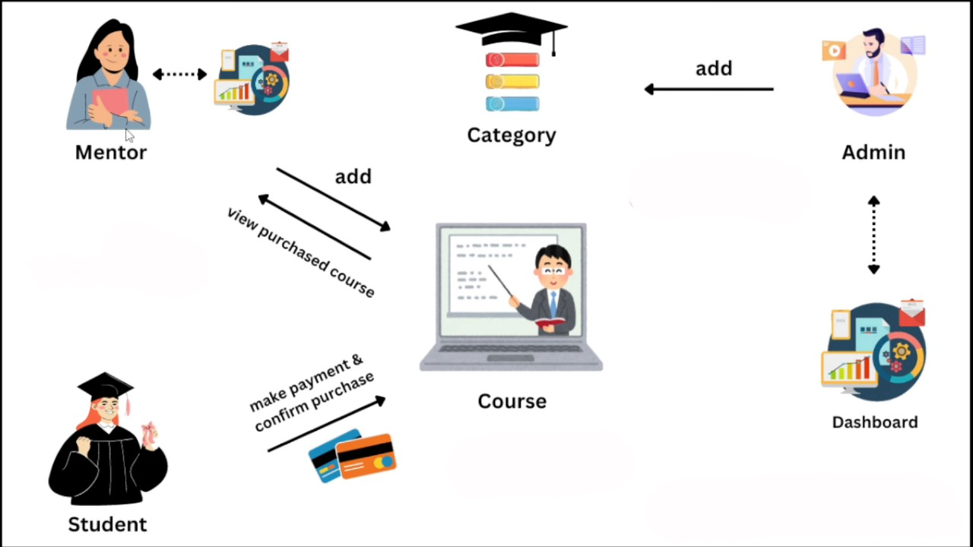

Class Diagram:

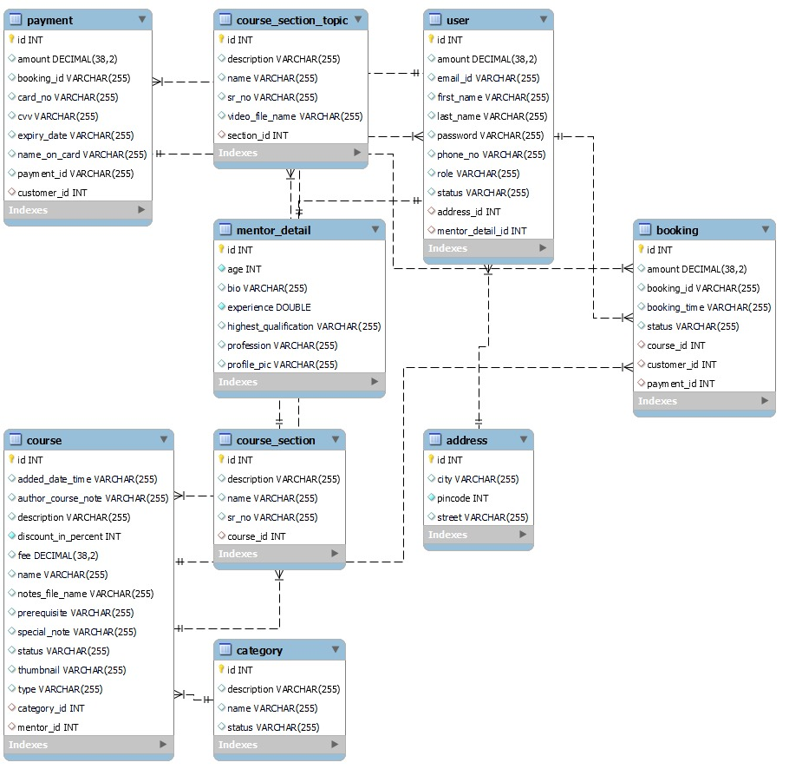

Appendix B

Homepage:



Login:

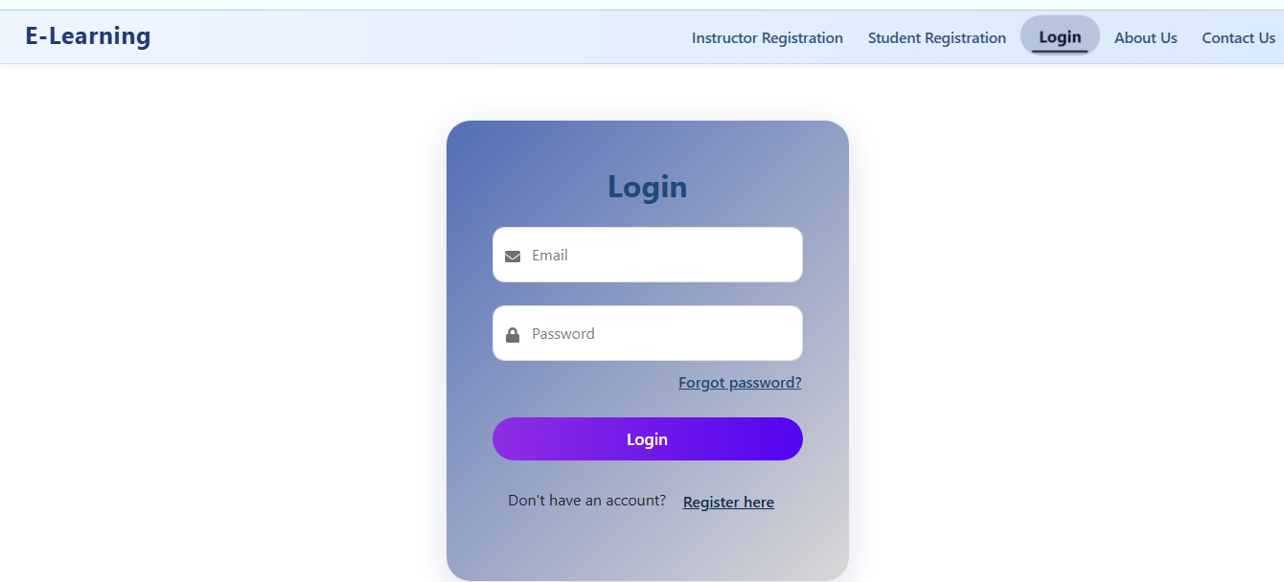

User Registration:
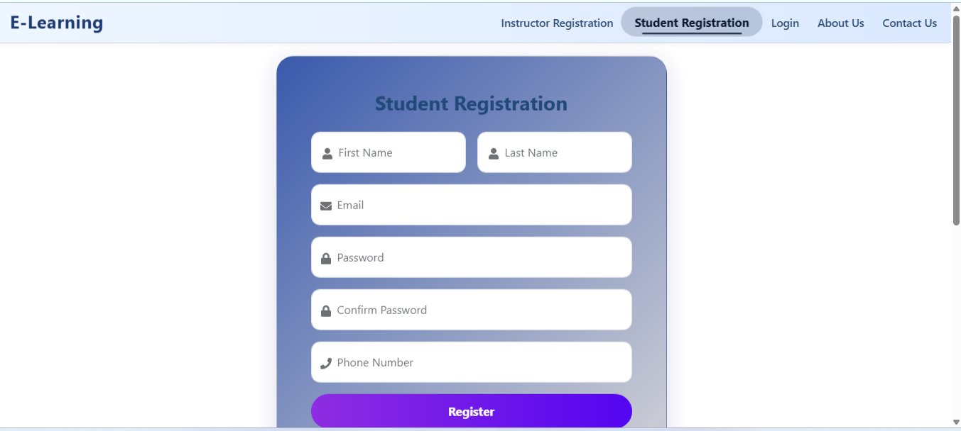

Add Course Category:

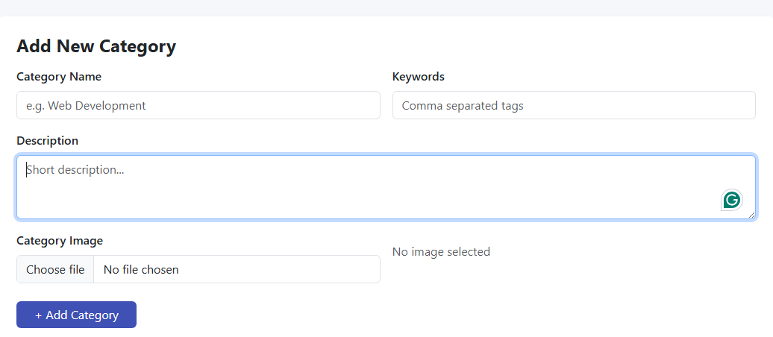

All Course Categories:

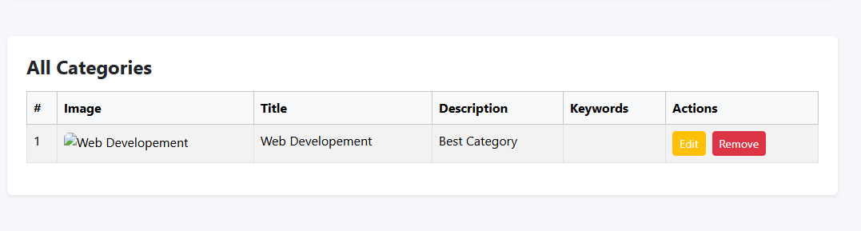

Student Profile :



Course Purchases:


Add Course:

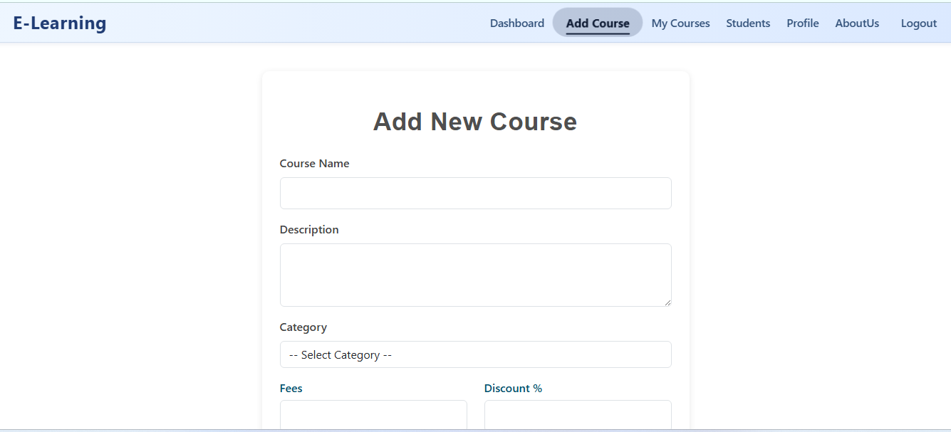

Instructor’s Listed Courses:

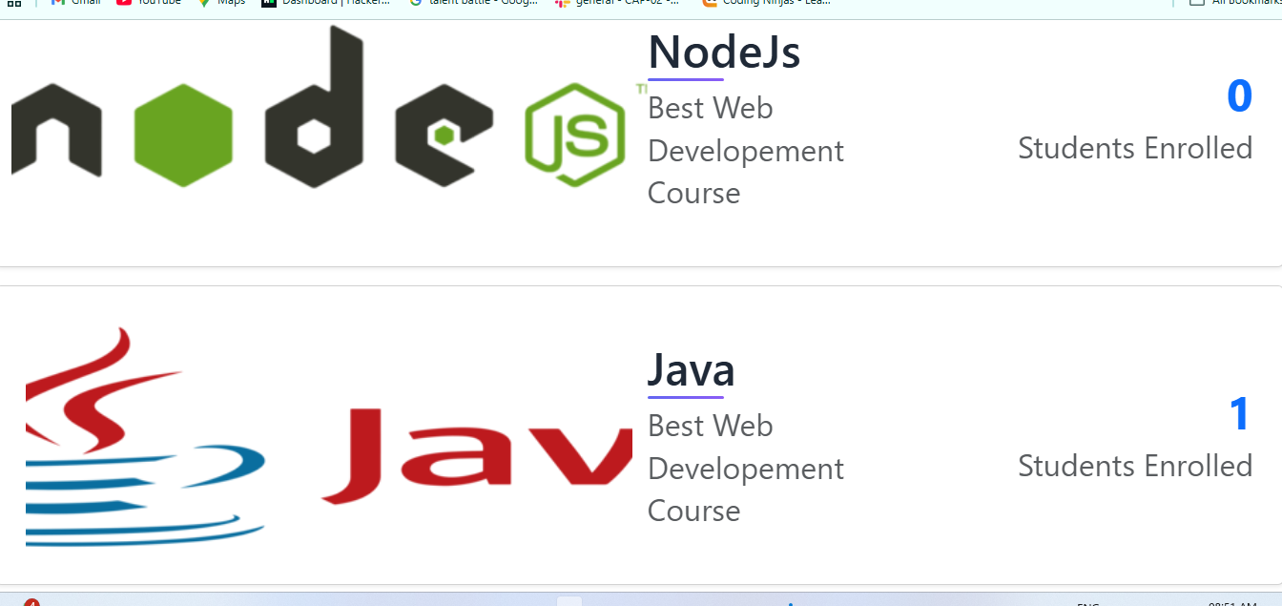

Instructor’s Profile Details:



Student’s Purchased Courses:



Course Details:

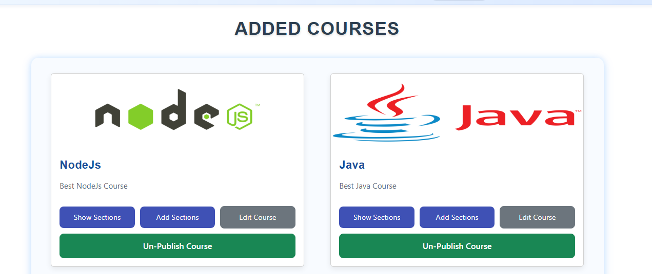

Sections Details:

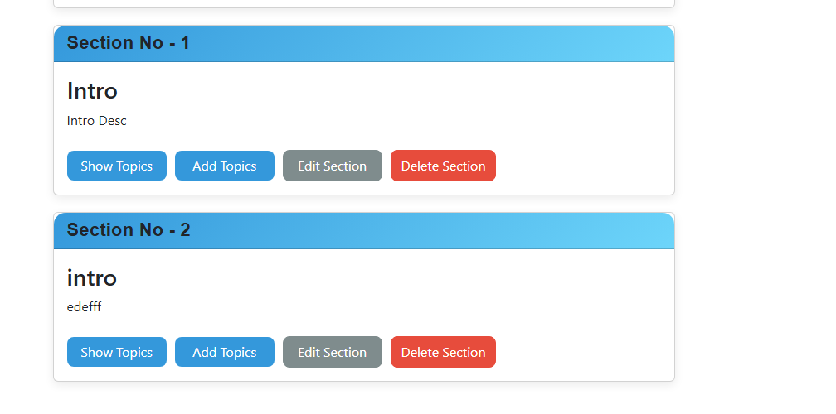

Topic Details:



7. REFERENCES:

- http://www.edx.org
- http://www.coursera.org
- http://www.udemy.com
- http://www.khanacademy.org
- http://www.skillshare.com
- http://www.codecademy.com
- http://www.lynda.com
- http://www.udacity.com
- http://www.teachable.com

