APPLICATION NOTE for
SMIA95-5M Auto Focus camera module
Module model name : TCM8341MD
Sensor model name : ET8EK8-AS

Ver. 2.30b

CONTENTS
a. Overview 3
b. System diagram 3
c. INTERFACE TERMINAL DESCRIPTION 4
1. Power supply control 5
1-1 Power up/down sequence 5
1-2 Timing chart of POWER ON 5
1-3 Initial command settings 6
1-4 Timing chart of POWER OFF 7
1-5 Software Stand-by 7
1-6 Image data of sensor restart 7
2. IIC control I/F 8
3. Register map 9
4. Sensor version information 12
5. Output-mode 12
6. Start pixel information 14
7. Data output specification 14
8. Command effect timing 15
9. PLL and Frame rate setting when CCP2 output 15
10. Picture size and View finder setting 17
10-1 Picture size setting 17
10-1-1 Output format setting 17
10-2 VGA view finder with zoom setting 17
10-3 How to digital zoom in case of VGA 17
11. Analog gain and Digital gain setting 18
11-1 Analog gain 18
11-2 Digital gain 19
13. Preset gain and White balance gain 20
14. Electrical shutter 20
15. Data format of CCP2 Output 21
16. CCP2 Skew Adjustment 24
17. Revision History 25

a. Overview

This document specifies a very compact size of 1/2.5” 5M pixel auto-focus camera module compatible with SMIA95 size.

- SMIA95 size auto focus camera module suitable for the main stream cameras
- Superb picture quality by employing Toshiba’s best-in-class 5 Mega-pixel CMOS sensor with 2.2 um pixel.
- Good object distance coverage by auto-focus actuator.
- Mitigated motion artifact for downsized picture by enabling 30 fps operation .

Table 1 General Overview
Area | Item | Type
Sensor  (model name ET8EK8-AS) | Maximum Resolution | 2592 (H) x 1968 (V)
Sensor  (model name ET8EK8-AS) | Color filtering type | Bayer
Sensor  (model name ET8EK8-AS) | Optical format | 1/2.5 “
Sensor  (model name ET8EK8-AS) | Pixel size | 2.2 um
Optical System | F number | F2.8
Optical System | Focusing type: fixed / auto focus | Auto Focus
Module System | Actuator Driver | Embedded inside camera Module
Data interface | Image data bus | CCP2 sub LVDS
Data interface | Supported output formats | 10 bit RAW Bayer
Data interface | Control bus | IIC bus
Mechanical specification | Module size | 9.5 (D) x 9.5(W) x 8.0(H) mm
Mechanical specification | PAD count | 16
VCM
(1) Operating Condition
- Actuator type: Voice Coil Motor
- Rated Current: 80mA
- Absolute Maximum Current : 100mA
(2) Performance and Characteristics
- Stroke : min 0.31mm ( at all directions, when applied 80mA)
- Starting Current : min 10mA ( at horizontal direction )

b. System diagram

1/2.5”5 M sensor
Image processor
VANA(2.8)V
VDIG (1.8V)
BB engine
XSHUTDOWN
CCP2
IIC
2
2
4
2
VCM actuator
Driver-IC AD5820
Extclk
VBat
2
c. INTERFACE TERMINAL DESCRIPTION

Bottom view
Pad 1
Pad 9
Pad 16
Pad 8
VCAP
VANA
XSHUTDOWN
EXTCLK
SCL
SDA
AGND
DATA+
DATA-
VDIG
DGND
DGND
CLK+
CLK-
Vbat
GNDVbat

Pad No. | Signal name | Signal description
1 | Vbat | Battery voltage supply  Can not be connected to VANA directly
2 | VCAP | Open or can be connected to GND via a capacitor
3 | AGND | Ground for VANA
4 | VANA | Voltage source to camera module
5 | XSHUTDOWN | Power down control
6 | ExtClk | External clock signal from BB engine.
7 | SCL | I2C clock
8 | SDA | I2C data line
9 | DGND | Digital GND
10 | CLK- | CCP2 bus: Differential clock output, negative polarity signal
11 | CLK+ | CCP2 bus: Differential clock output, positive polarity signal
12 | VDIG | Digital GND
13 | DATA- | CCP2 bus: Differential data output, negative polarity signal
14 | DATA+ | CCP2 bus: Differential data output, positive polarity signal
15 | DGND | Digital GND
16 | GNDVbat | Ground for Battery voltage supply

1. Power supply control

1-1 Power up/down sequence

Operating state
EXTCLK ON
XSHUTDOWN ON
XSHUTDOWN OFF
IIC commands
(*1) VANA(2.8V) ON
VDIG(1.8V) ON
IOVDD(2.8V or 1.8V) ON
EXTCLK OFF
Power down state
(*2)VANA(2.8V) OFF
VDIG(1.8V) OFF
IOVDD(2.8V or 1.8V) OFF

Order of input about IIC command.
(1)LSTB (Add:0x126C bit8 = 1, default is 0)
(2) Another commands.
(3) SLEEP(Add:0x1252 bit8 = 1, default is 0)

Fig1-1: Power up/down sequence

1-2 Timing chart of POWER ON

(*1)VANA and VDIG and IOVDD may rise in any order.
The rising separation can vary from 0ns to Indefinite

VANA
T6≧5000EXTCLK

Commands Input
T1≧0
T2≧0
T3≧1(msec)
(2.8V)

VDIG18
(1.8V)

IOVDD
(2.8V or 1.8V)

XSHUTDOWN

EXTCLK

SCL/SDA

Fig1-2: Timing chart of POWER ON

1-3 Initial command settings

When power on, please set these commands only one time.
This initial setting is below status. Please also refer to command settings section.
(1) Serial out
(2)RAW10
(3)5M output, w/o embedded data, 640Mbps

Below file is initial command settings and changing history of setting based on mode2 (5M full output)
And also we recommended input order of register settings about both sensors.
This version is ver1.7
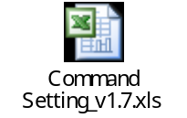

1-4 Timing chart of POWER OFF

VANA
T7≧0
T9≧0

T8≧0
(2.8V)

(*2)VANA and VDIG and IOVDD may fall in any order.
The falling separation can vary from 0ns to Indefinite
VDIG
(1.8V)

IOVDD
(2.8V or 1.8V)

XSHUTDOWN

EXTCLK

Fig1-3: Timing chart of POWER ON

1-5 Software Stand-by

If changing to software standby status, SLEEP set from H to L (Address: 0x1252, D7).

Address | Data | Bit Symbol | Description
0x1252 | D7 | SLEEP | 0d: Software Standby status 1d: Streaming (Active)

Software standby status
 | CCI I/F | Sensor | CCP2 | ISP | VCO
Software standby(*1) | Active | Stop | Hi-Z | Stop | Stop
Operation | Active | Active | Active | Active | Active
(*1)-Software standby is from High level of Xshutdown to first I2C command input
-During after input 30h (Add: 0x1252) and before input B0h (Add: 0x1252).

1-6 Image data of sensor restart

When sensor restarts, Normal image can get 2 frames after.
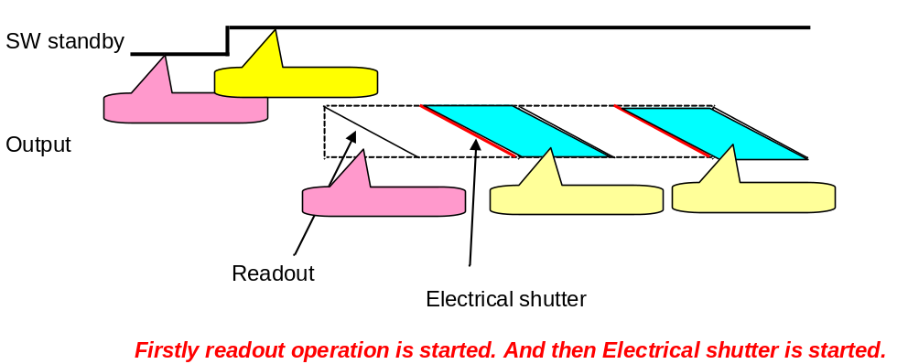

2. IIC control I/F

Sub address is 2 bytes, and first data is MSB, last data is LSB.

Write mode
MSB 7bit MSB 8bit MSB 8bit MSB 8bit

Read mode
MSB 7bit MSB 8bit MSB 8bit MSB 8bit MSB 8bit


Host Command Camera

S : Start condition , P : End condition , A : Acknowledge, Ā : not Acknowledge

Start condition , End condition Bit Transfer
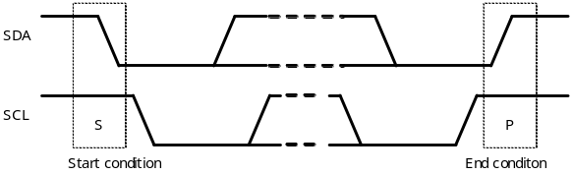
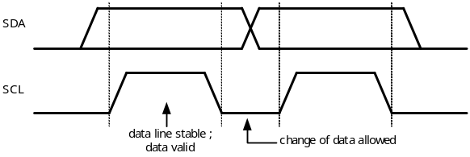

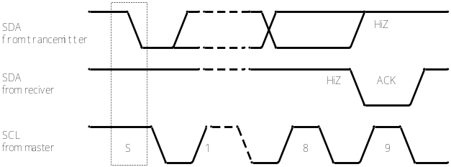
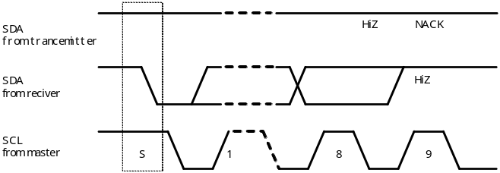
Acknowledge Not Acknowledge

Slave Address ( 2 table can be selected )
Sensor
A6 | A5 | A4 | A3 | A2 | A1 | A0 | R/W
0 | 1 | 1 | 1 | 1 | 1 | 0 | 1/0

7bit Slave address is used.
The system conforms to the I2C Standard Specification defined by Philips.

Actuator driver
A6 | A5 | A4 | A3 | A2 | A1 | A0 | R/W
0 | 0 | 0 | 1 | 1 | 0 | 0 | 1/0

3. Register map
Gray mesh area is not defined. Default value is recommended in white area.
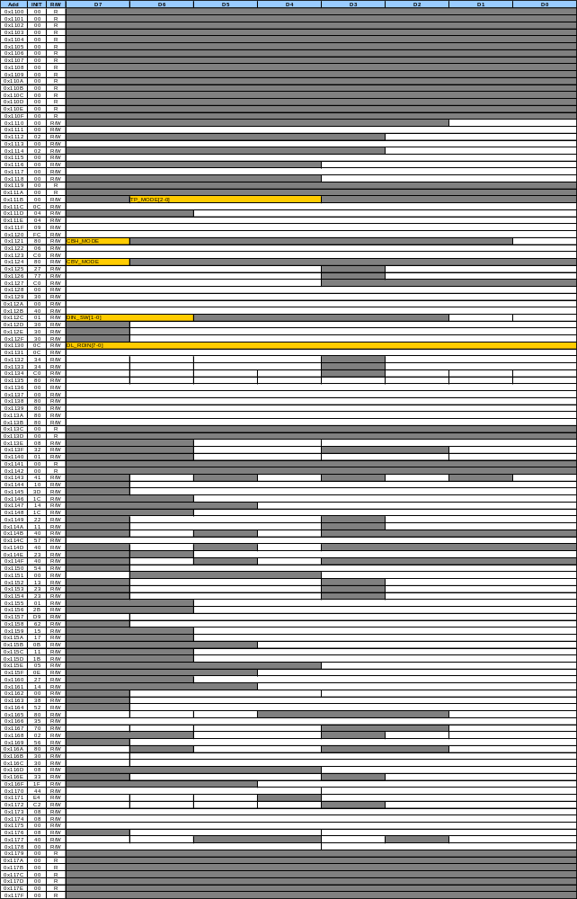

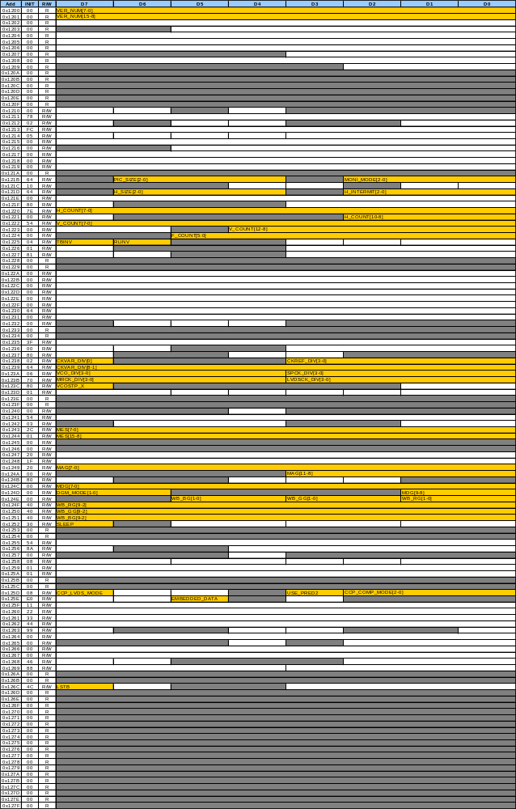

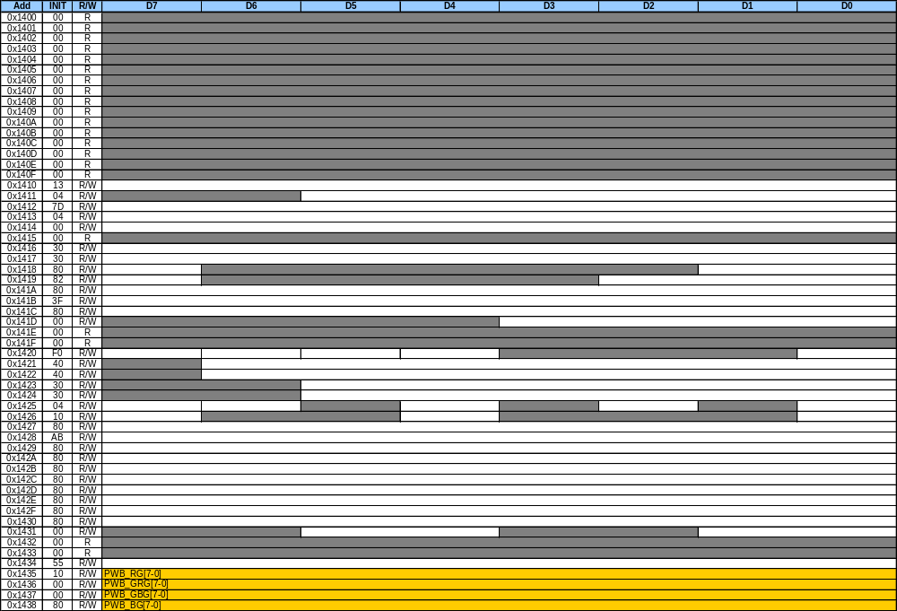

4. Sensor version information

This sensor can be recognized if reading below address data.

Address | Data | Bit Symbol | Description
0x1200 | D7-D0 | VER_NUM[7:0] | VER_NUM[15:0] =01h in case of #1Sensor.
0x1201 | D7-D0 | VER_NUM[15:8] | VER_NUM[15:0] =01h in case of #1Sensor.

5. Output-mode

This sensor has 14 modes of output. ( 7 type serial and 7 type parallel)

Output Serial Raw10
Raw12
Raw8
DPCM 10bits to 8bits
DPCM 12bits to 8bits
DPCM 10bits to 6bits
DPCM 12bits to 6bits

Parallel 12bit
10bit
8bit
DPCM10bits to 8bits
DPCM12bits to 8bits
DPCM10bits to 6bits
DPCM12bits to 6bits

Table5-1: Explanation of Output-mode parameter
Address | Data | Bit Symbol | Description
0x125D | D7 | CCP_LVDS_MODE | 0h : Parallel output (default)  1h : Serial output
0x125D | D3 | USE_PRED2 | The predictor for DPCM compression.  0h : use predictor1 for DPCM 10bits to 8bits  1h : use predictor2 for other DPCMs (default)
0x125D | D2-D0 | CCP_COMP_MODE[2:0] | (1) Serial output case  0h RAW10  1h RAW12  2h RAW8  3h DPCM 10bits to 8bits  4h DPCM 12bits to 8bits (default)  5h DPCM 10bits to 6bits  6h DPCM 12bits to 6bits  (2) Parallel output case  0h 12bit  1h 10bit ( from LSB to 2nd LSB output “L” level)  2h 8bit ( from LSB to 4th LSB output “L” level)  3h DPCM 10bits to 8bits ( from LSB to 4th LSB output “L” level) (default)  4h DPCM 12bits to 8bits ( from LSB to 4th LSB output “L” level)  5h DPCM 10bits to 6bits (from LSB to 6th LSB output “L” level)  6h DPCM 12bits to 6bits (from LSB to 6th LSB output “L” level)

How to set DPCM

[1] DPCM 10bits to 8bits
- CCP_COMP_MODE = 3d
- USE_PRED2 = 0d
- MRCK = SPCK = 1/8 and MRCK=1/8,SPCK=1/7 and MRCK=1/8,SPCK=1/6

[2] DPCM 12bits to 8bits
- CCP_COMP_MODE = 4d
- USE_PRED2 = 1d
- MRCK = SPCK = 1/8

[3] DPCM 10bits to 6bits
- CCP_COMP_MODE = 5d
- USE_PRED2 = 1d
- MRCK = SPCK = 1/6

How to set MRCK and SPCK,
Please refer to the Section 9. PLL and Frame rate Setting when CCP2 output.

6. Start pixel information

Start pixel information is as follows.

- B pixel (In case of No top/bottom flip and No right/left flip)
- Gb pixel (In case of No top/bottom flip and right/left flip)
- Gr pixel (In case of top/bottom flip and No right/left flip)
- R pixel (In case of top/bottom flip and right/left flip)

7. Data output specification

This sensor has dummy data at 1st line and end line.
All of output mode(e.g.binning mode/crop mode ) have dummy data.
5M full output case (No top/bottom flip and No right/left flip)

Image data

LS
FS
Dummy Data

LE
FE
Dummy Data
B
Gb
Gr
R

1966lines
1968lines

Dummy data specification

RAW10 case
0A 07 07 07 55 07 07 07 07 55 07 ・・・・・・ 07 07 07 07 55

RAW8 and other format
0A 07 07 07 ・・・・・・ 07

Dummy bit of multiple of 32 in serial output mode
Dummy data is without 0x00

With or without Dummy data can be selected by a resister. (Add:0x125E, D5. Resister name is
EMBEDDED_DATA. 0h:OFF(without dummy data) 1h:ON(with dummy data) ,default setting is 1h)

Fig7-1: In case of WITH dummy data Fig7-2: In case of WITHOUT dummy data

Image data

LS
FS
Dummy Data

LE
FE
Dummy Data
B
Gb
Gr
R
1966lines
1968lines
1966lines
1968lines

Image data

LS
FS

LE
FE
B
Gb
Gr
R

8. Command effect timing

If changing parameter setting, input at period of imaging data. Setting parameter will be effected next frame.
About electrical shutter, will be effected 2 flames after.

In detail, Command latch timing from FE are following formula.
LTfFE(=Latch Timing from FE) = V blanking -7 (line)
These values depend on mode setting. Also refer to “column M” in a excel sheet at Page14
electrical shutter
W/o electrical shutter

FS
Image data
FE
FS
Image data
FE
FS
Image data
FE

LTfFE
LTfFE
Command latch
Command latch
Command setting

Fig8-1: Command effect timing

9. PLL and Frame rate setting when CCP2 output

(1) About CCP2 output case, please keep to the following relation of frequency

LVDSCK : MRCK = 8 : 1 (w/o DPCM 10bits to 6bits)

(2) Fastest frame rate will be needed, relation(1) and VCO_DIV=0d(x1 setting)

EXTCLK
Divider
CKREF_DIV [3:0]
Phase comparator
VCO
Divider
CKVAR_DIV [8:0]
Divider
VCO_DIV [3:0]
LVDSCK_DIV [3:0]
LVDSCK
Divider
Divider
SPCK_DIV [3:0]
SPCK
MRCK
1/8
MRCK_DIV [3:0]

SPCK: Sensor & ISP system clock before FIFO
MRCK: 1/8 of CCP2 data rate
Fig9-1: PLL circuit

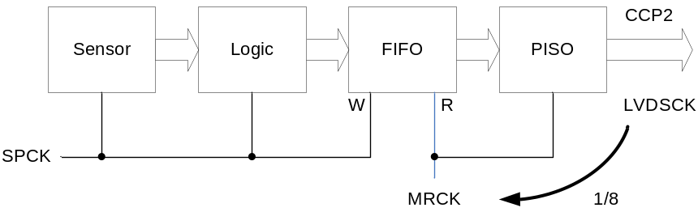

Fig9-2: Relation between SPCK, MRCK and LVDSCK

Table9-1: Explanation of PLL parameter
Address | Data | Bit Symbol | Description
0x1238 | D3-D0 | CKREF_DIV[3:0] | Selection of reference clock for PLL  0d: 1/1, 1d: 1/2 , 2d: 1/3 , 3d: 1/4 ,,,, 15d: 1/16
0x1239 | D7-D0 | CKVAR_DIV [8:0] | Selection of divider clock for PLL  0d to 15d : N/A , 16d: 1/16 , 17d: 1/17 ,,,, 510d: 1/510 , 511d: 1/511
0x1238 | D7 | CKVAR_DIV [8:0]
0x123A | D7-D4 | VCO_DIV[3:0] | Selection of divider of VCO clock  0d: 1/1, 1d: 1/2 , 2d: 1/3 , 3d: 1/4 ,,,, 15d: 1/16
0x123A | D3-D0 | SPCK_DIV[3:0] | Selection of divider for Clock for LOGIC  0d: 1/1, 1d: 1/2 , 2d: 1/3 , 3d: 1/4 ,,,, 15d: 1/16
0x123B | D7-D4 | MRCK_DIV[3:0] | Selection of divider for Clock for LOGIC  0d: 1/1, 1d: 1/2 , 2d: 1/3 , 3d: 1/4 ,,,, 15d: 1/16
0x123B | D3-D0 | LVDSCK_DIV[3:0] | Selection of divider for LVDS clock  0d: 1/1, 1d: 1/2 , 2d: 1/3 , 3d: 1/4 ,,,, 15d: 1/16

Detail of PLL and Frame rate setting, please refer to below a excel sheet (table2).
This version is ver1.7.

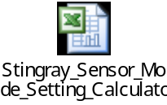

Formula is as follows

VCO [MHz] = EXTCLK * CKVAR_DIV / 3

CCP2 [Mbps] = VCO / { ( LVDSCK_DIV + 1 ) * ( VCO_DIV + 1 ) }

spck [MHz] = VCO / { ( SPCK_DIV +1 ) * ( VCO_DIV + 1 ) }

Frame rate [fps] = { spck / ( IA_H * IA_V ) } * 1,000,000
( IA_H and IA_V : H and V values of Image area readout with blanking. )

10. Picture size and View finder setting

10-1 Picture size setting

Table10-1: Explanation of output format parameter
Address | Data | Bit Symbol | Description
0x1221 | D2-D0 | H_COUNT[10:0] | Selection of total horizontal clock count including blanking  Please refer to excel sheet of table of Setting rage(*1)
0x1220 | D7-D0 | H_COUNT[10:0]
0x1223 | D4-D0 | V_COUNT[12:0] | Selection of total Vertical line count including blanking  Setting rage is from 84d to 2730d.
0x1222 | D7-D0 | V_COUNT[12:0]
0x1225 | D7 | TBINV | ON/OFF of vertical inversion  0d: OFF(normal), 1d:ON (vertical flip)
0x1225 | D6 | RLINV | ON/OFF of horizontal inversion  0d: OFF(normal), 1d:ON (horizontal flip)
0x121D | D6-D4 | H_SIZE[2:0] | Horizontal CROP mode  0d:1/6, 1d: 1/4, 2d: 1/3, 3d: 1/2, 4d: 2/3, 5d: 3/4, 6d-7d: no crop (=full)
0x121D | D2-D0 | H_INTERMIT[2:0] | Horizontal digital scaling mode  0d:1/6, 1d:1/4, 2d: 1/3, 3d:1/2 4d-7d: 1/1(=full)
0x121B | D6-D4 | PIC_SIZE[2:0] | Vertical CROP mode  0d:1/6, 1d: 1/4, 2d: 1/3, 3d: 1/2, 4d: 2/3, 5d: 3/4, 6d-7d: no crop (=full)
0x121B | D2-D0 | MONI_MODE[2:0] | Horizontal pixel binning mode  0d:1/6, 1d:1/4, 2d: 1/3, 3d:1/2 4d-7d: 1/1(=full)
0x1224 | D5-D0 | F_COUNT[5:0] | Selection of intermittent frame output mode  0d: 1/1, 1d: 1/2 , 2d: 1/3 , 3d: 1/4 ,,,, 63d: 1/64

Below excel sheet is table of H_count setting range.



If Night mode setting like a long exposure is needed, please increase value of V_COUNT (not slowing down of
vco/pixclk).

10-1-1 Output format setting
Please refer to a excel sheet at Page 11(table2)

10-2 VGA view finder with zoom setting
Please refer to a excel sheet at Page 11 (table3)

10-3 How to digital zoom in case of VGA
Please refer to a excel sheet at Page 11 (digital zoom page)

11. Analog gain and Digital gain setting

Table11-1: Explanation of Gain setting parameter
Address | Data | Bit Symbol | Description
0x124A | D3-D0 | MAG[11:0] | Analog gain setting  20h: 0dB, 40h: 6dB, 80h: 12dB, 100h: 18dB(max recommended)
0x1249 | D7-D0 | MAG[11:0]
0x124D | D1-D0 | MDG[9:0] | Gain setting of digital gain  0h: x1, 3FF: x 2 (Normal mode) ( **Depend on setting of DGM_MODE)
0x124C | D7-D0 | MDG[9:0]
0x124D | D7-D6 | DGM_MODE[1:0] | 0d : from x1 to x2  1d : from x0 to x2  2d : from x1 to x3  3d : from x0 to x4

11-1 Analog gain

Analog gain can be changed by MAG [11-0]. (Add:0x1249 Data:D7-D0 and Add:0x124A Data:D3-D0)

Analog gain [dB] = 20*log10 (setting value(decimal) /32)
Setting range is from 0x020 to 0x100.

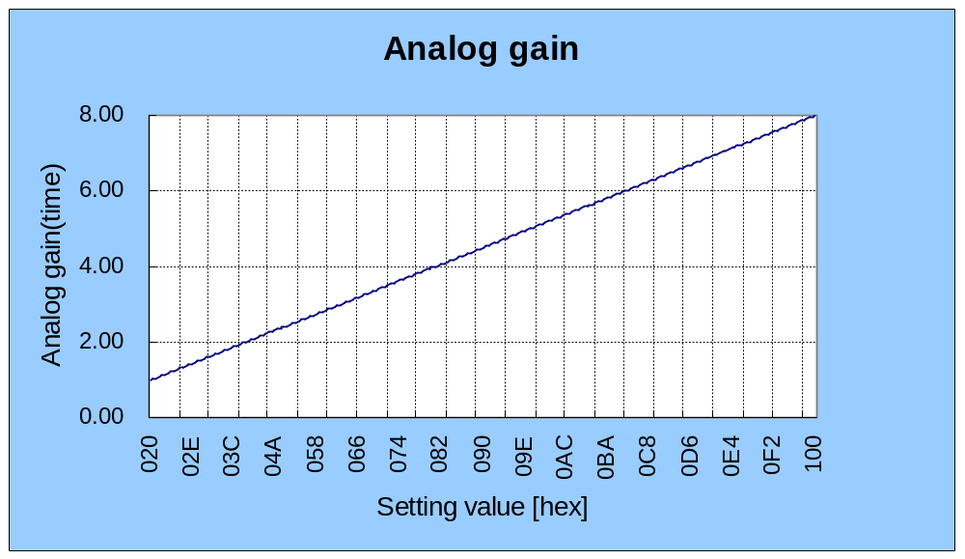
12[dB]

8[dB]

6[dB]

0[dB]

18[dB]

11-2 Digital gain

Digital gain can be changed by MDG [9-0]. (Add:0x124C Data:D7-D0 and Add:0x124D Data:D1-D0)
Changing DGM_MODE(Add:124D D7-D6), characteristics of digital gain can be changed.

DGM_MODE=0d
Digital gain[dB] = 20*log10(1/1023*Setting value(hex)+1)

DGM_MODE=1d
Digital gain[dB] = 20*log10(2/1023* Setting value(hex))

DGM_MODE=2d
Digital gain[dB] = 20*log10(2/1023* Setting value(hex)+1)

DGM_MODE=3d
Digital gain[dB] = 20*log10(4/1023* Setting value(hex))

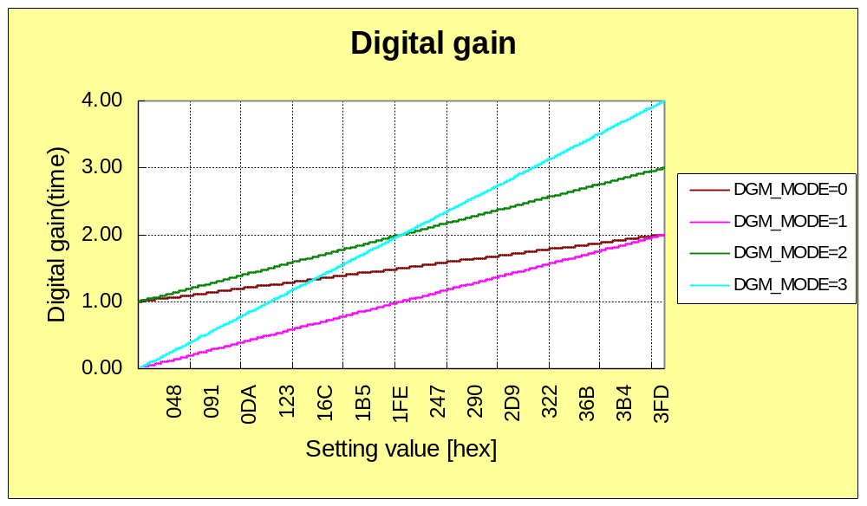
0[dB]

6[dB]

9[dB]

12[dB]

13. Preset gain and White balance gain

Table13-1: Explanation of White balance parameter
Address | Data | Bit Symbol | Description
0x1435 | D7-D0 | PWB_RG[7:0] | Pre-set gain for Red pixel (00h:x1, FFh:x3)
0x1436 | D7-D0 | PWB_GRG[7:0] | Pre-set gain for G pixel in Red line. (00h:x1, FFh:x3)
0x1437 | D7-D0 | PWB_GBG[7:0] | Pre-set gain for G pixel in Blue line. (00h:x1, FFh:x3)
0x1438 | D7-D0 | PWB_BG[7:0] | Pre-set gain for Blue pixel（00h:x1, FFh: x3)
0x124E | D1-D0 | WB_RG[9:0] | Gain setting of B digital gain for white balance  0h: x0, 100h: x1, 200h: x2, 3FFh: x 4
0x124F | D7-D0 | WB_RG[9:0]
0x124E | D3-D2 | WB_GG[9:0] | Gain setting of G digital gain for white balance  0h: x0, 100h: x1, 200h: x2, 3FFh: x 4
0x1250 | D7-D0 | WB_GG[9:0]
0x124E | D5-D4 | WB_BG[9:0] | Gain setting of B digital gain for white balance  0h: x0, 100h: x1, 200h: x2, 3FFh: x 4
0x1251 | D5-D4 | WB_BG[9:0]
0x1439 | D7 | DIG_PWB_SW | Switch of Preset-White-balance (0d:disable / 1d:enable)

14. Electrical shutter

Table14-1: Explanation of Electrical shutter parameter
Address | Data | Bit Symbol | Description
0x1244 | D7-D0 | MES[15:0] | Setting of electrical exposure time  1h: 1H ~ FFFFh: 65535H ( max)
0x1243 | D7-D0 | MES[15:0]
max exp time(MES) = VCOUNT value (=Total line numbers ) - 4line

15. Data format of CCP2 Output

8 byte of synchronization codes are attached at the start and the end of each frame and each line.

 | Code | Value
SOL | Line start code | FF_{H} 00_{H} 00_{H} 00_{H}
EOL | Line end code | FF_{H} 00_{H} 00_{H} 01_{H}
SOF | Frame start code | FF_{H} 00_{H} 00_{H} 02_{H}
EOF | Frame end code | FF_{H} 00_{H} 00_{H} 03_{H}

<Data structure in one vertical scan for CCP2 output>
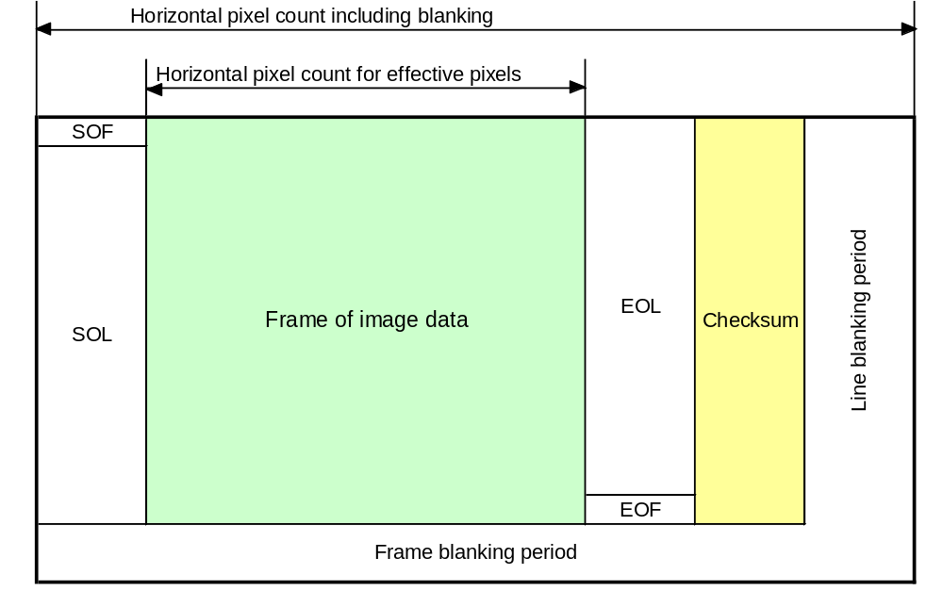

To detect possible errors in transmission, a checksum is calculated over each data line. The checksum is realized as 16-bit CRC. The generator polynomial is x^16+x^12+x^5+1. The checksum sequence is then padded with 16-bit padding sequence (101010 ---10) to fulfill the 32-bit word alignment requirement in the CCP link. The transmission of checksum is illustrated in the figure below.

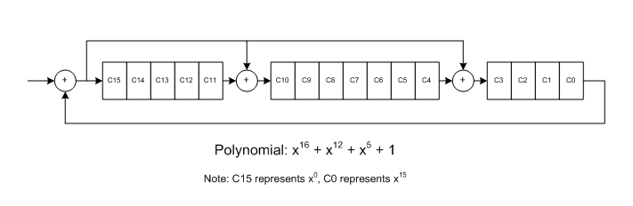
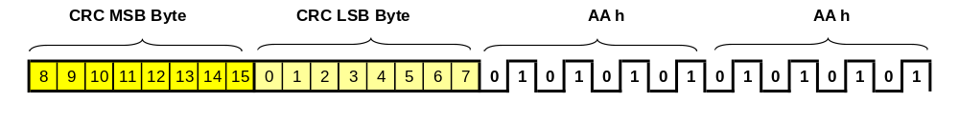

Data description in each byte in one line (LSB first expression)

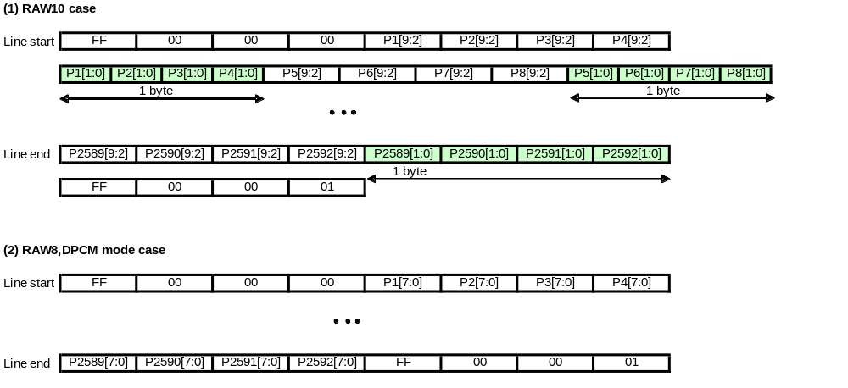

<Bit by bit structure>
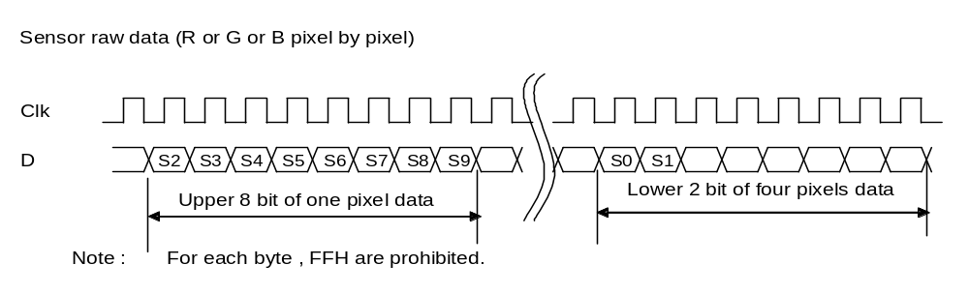Output mode of sensor raw data
10 bit sensor raw data are divided into upper 8 bit and lower 2 bit to send 10 bit depth data in 8 bit data scheme of CCP serial output. The following procedure and data arrangement is implemented to avoid 00h and FFh appearance in each 8 bit data.

(1)
Sensor raw data range is compressed from 0 -1023 to 4 -1023 .
Namely 0-3 data are set to 4 .
This compaction does not affect the picture quality, because ,
for example, the black level is set to 64 level .
(2)
10 bit data ( 4 - 1023) is separated into upper 8bit and lower 2 bit.
The upper 8 bit has never all "0" value.
The four pixel data with 10 bit are arranged into the following five bytes.
1
upper 8 bit of pixel A
2
upper 8 bit of pixel B
3
upper 8 bit of pixel C
4
upper 8 bit of pixel D
5
4 of lower 2 bit for 4 pixels
When all bits of No.5 byte are 0, 00h is replaced by 10h. In the LSB first form, “00001000” is used in conformity with CCP2 specification.
(3)
The host rearranges the five bytes to 4 pixel data with 10 bit.

16. CCP2 Skew Adjustment

I²C command at 0x1269 address is used to adjust the delay of data and strobe signal in CCP2 to compensate skew between data and strobe. CRC data is checked for a certain pattern data by changing the data at address 0x1269 as 40h->30h->20h->10h->00h->01h->02h->03h->04h to find out OK zone. After that 0x1269 is set corresponding to the center of the OK zone.

Address | Data | Bit Symbol | Description
0x1269 | D7-D4 | CCP2SDLY[3:0] | CCP2 strobe signal delay adjustment  0h: No delay, 1h: 0.1nsec delay, 2h: 0.2nsec delay, ~ Fh: 1.5nsec delay
0x1269 | D3-D0 | CCP2DDLY[3:0] | CCP2 data signal delay adjustment  0h: No delay, 1h: 0.1nsec delay, 2h: 0.2nsec delay, ~ Fh: 1.5nsec delay
0x1268 | D7 | CCP2STP_X | CCP2 output ON/OFF  0h: ON(=operate), 1h: OFF(=stop)
0x1263 | D4 | CCP2CRCSW | CRC data output ON/OFF  0h: OFF, 1h: ON(CRC data are added)

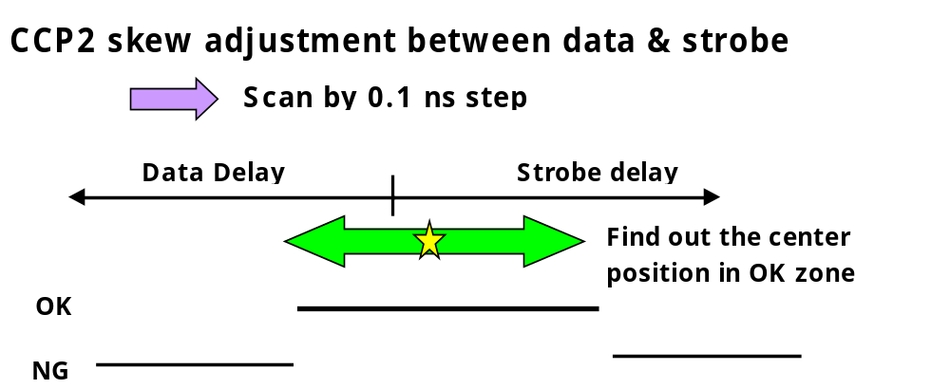

17. Revision History

Revision Date Comments
Ver2.30a 21th Dec, 2008 Draft
Ver2.30b 11th May, 2009 Following yellow hatched items are added.
Sensor/Module model name (P1,P3)
Data format of CCP2 Output(P21)
CCP2 Skew Adjustment(P24)

