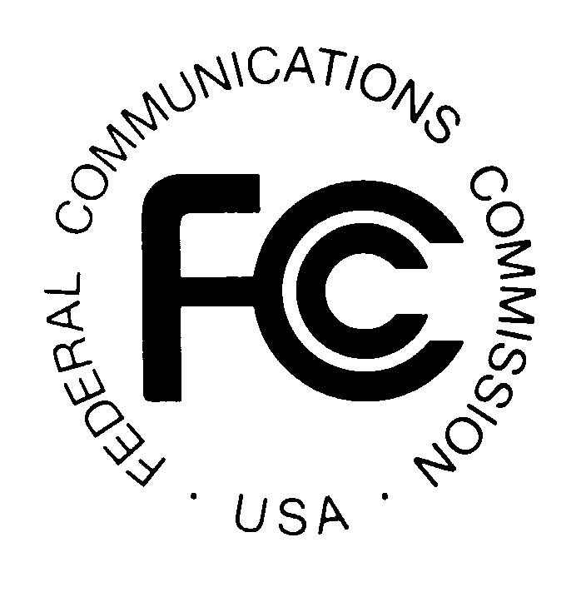
PUBLIC NOTICE
News Media Information 202 / 418-0500
Internet: http://www.fcc.gov
TTY: 1-888-835-5322

Federal Communications Commission
445 12th St., S.W.
Washington, D.C. 20554

DA 09-1128

May 22, 2009

THE WIRELESS TELECOMMUNICATIONS BUREAU REMINDS WIRELESS HANDSET MANUFACTURERS OF THEIR OBLIGATION TO REPORT ON THE STATUS OF COMPLIANCE WITH THE COMMISSION’S HEARING AID COMPATIBILITY REQUIREMENTS BY JULY 15, 2009

New Electronic FCC Form 655 To Be Demonstrated on June 2, 2009

The Wireless Telecommunications Bureau (“Bureau”) reminds manufacturers of devices used to provide commercial mobile radio service (CMRS) of their obligation to report on the status of compliance with the Commission’s hearing aid compatibility requirements. Manufacturers’ status reports are due to be filed with the Commission by July 15, 2009. These reports are required of all manufacturers of devices that are within the scope of the rule, including manufacturers that fall within the de minimis exception, under Section 20.19(i) of the Commission’s rules.

Pursuant to the Commission’s delegation of authority, the Bureau previously promulgated FCC Form 655 for filers’ optional use in submitting their hearing aid compatibility status reports. Effective with the current filing period, the Bureau is introducing an electronic version of FCC Form 655 that will be filed online. Use of the electronic FCC Form 655 will help filers ensure that their reports include all of the required information in Section 20.19(i) of the Commission’s rules. In addition, the electronic system will facilitate the Commission’s compilation of data from the reports, as well as the availability of the reports and summary information to the public.

Electronic FCC Form 655 will be accessible at http://wireless.fcc.gov/hac beginning June 15, 2009. Manufacturers may use electronic FCC Form 655 to file their status reports from June 15, 2009, through midnight, Eastern Daylight Time, on July 15, 2009.

The Bureau has requested clearance from the Office of Management and Budget (OMB) to make use of electronic FCC Form 655 mandatory, and we anticipate that OMB’s clearance will be received before the July 15 filing deadline. The Bureau will issue another Public Notice to announce whether OMB clearance has been obtained. In the event OMB does not approve mandatory use, the Bureau will accept filings on electronic FCC Form 655 on a voluntary basis.

The Bureau will hold a demonstration and webinar training session on how to submit the electronic FCC Form 655 on Tuesday, June 2, 2009, from 1:00 PM – 3:00 PM. The demonstration will take place at the Washington, DC headquarters building, 445 Twelfth Street, S.W., in Room 5B-516. Interested parties should pre-register for the event by May 29, 2009.
Demonstration of New Electronic Filing Process for FCC Form 655
The new interactive online filing process for Form 655 has been integrated into the Commission’s existing Universal Licensing System (ULS). The presentation will include the following:

- Demonstration of how to electronically complete and submit Form 655;
- Discussion of the upcoming filing window for the July 15 reporting deadline; and
- An opportunity for attendees to ask questions.

Remote Attendance
This demonstration will be available for remote attendance via a webinar. It is highly recommended that you test your ability to connect to the webinar a few days before the scheduled event. Beginning May 29, 2009, you will be able to find information about the pre-test at: http://esupport.fcc.gov/webinartest/. You may participate in the webinar at: http://wireless.fcc.gov/presentations/form655-deployment-demo.html.

Reasonable Accommodations
Reasonable accommodations for people with disabilities are available upon request. Such requests should include a detailed description of the accommodation and a way to contact the person making the request if more information is needed. Requests made close to the date of the event will be accepted, but may not be possible to accommodate in the short time frame. Send an e-mail to fcc504@fcc.gov or call the Consumer & Governmental Affairs Bureau at 202-418-0530 (voice), 202-418-0432 (tty).

Registration
Pre-registration is requested. Please contact hacdemo@fcc.gov or Eugene Chun at 202-513-4575. If registering by electronic mail (e-mail), the subject line of the e-mail should state “WTB Demonstration of FCC Form 655.” Please provide your name, organization, telephone number and e-mail address.

For more information or if you have questions, please contact Michael Rowan, Michael.Rowan@fcc.gov, 202-418-1883, or Weiren Wang, Weiren.Wang@fcc.gov, 202-418-7275.

- FCC –

These requirements apply to manufacturers of wireless handsets that are used in the delivery of “digital CMRS in the United States to the extent that they offer real-time, two-way switched voice or data service that is interconnected with the public switched network and utilizes an in-network switching facility that enables the provider to reuse frequencies and accomplish seamless hand-offs of subscriber calls, and such service is provided over frequencies in the 800 MHz-950 MHz or 1.6-2.5 GHz bands using any air interface for which technical standards are stated in the standard document “American National Standard for Methods of Measurement of Compatibility between Wireless Communications Devices and Hearing Aids,” American National Standards Institute (ANSI) C 63.19-2007,” as well as to the providers of such services. 47 C.F.R. § 20.19(a)(1), (2).
See 47 C.F.R. § 20.19(e) (de minimis exception). De minimis entities are not, however, required to respond to all data categories.
See 47 C.F.R. § 20.19(i).
See Public Notice, “The Wireless Telecommunications Bureau Reminds Manufacturers and Service Providers of Their Obligation To Report on the Status of Compliance with the Commission’s Hearing Aid Compatibility Requirements,” 23 FCC Rcd 18078 (WTB 2008).

