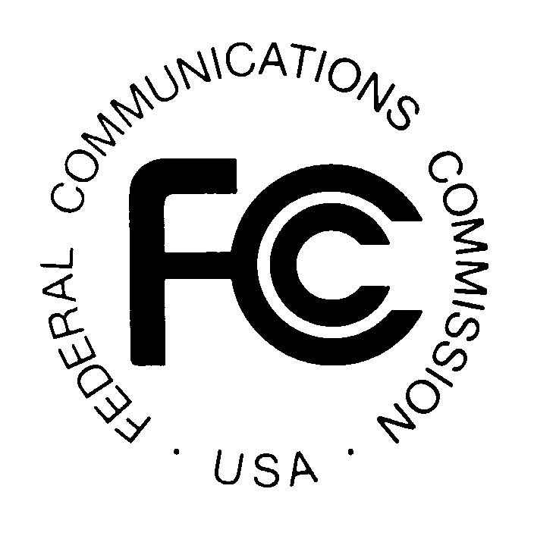
PUBLIC NOTICE
News Media Information 202 / 418-0500
Internet: http://www.fcc.gov
TTY: 1-888-835-5322

Federal Communications Commission
445 12th St., S.W.
Washington, D.C. 20554

DA 09-1298

June 10, 2009

THE WIRELESS TELECOMMUNICATIONS BUREAU RECEIVES CLEARANCE FROM THE OFFICE OF MANAGEMENT AND BUDGET (OMB) TO MAKE MANDATORY THE USE OF ELECTRONIC FCC FORM 655 FOR HEARING AID COMPATIBILITY STATUS REPORTS

The Wireless Telecommunications Bureau (“Bureau”) announces that the new electronic FCC Form 655 has been approved by OMB (Control number 3060-0999) and is now mandatory and the only acceptable means by which reports on the status of compliance with the Commission’s hearing aid compatibility requirements may be submitted. These reports must be filed annually by handset manufacturers and service providers under Section 20.19(i) of the Commission’s rules. Beginning June 15, 2009, electronic FCC Form 655 will be accessible at http://wireless.fcc.gov/hac. A demonstration of the new form may be viewed at http://wireless.fcc.gov/presentations/form655-deployment-demo.html.

Pursuant to the Commission’s delegation of authority, the Bureau previously promulgated the FCC Form 655 for filers’ optional use in submitting their hearing aid compatibility status reports. Effective with the current filing period, the Bureau is introducing an electronic version of FCC Form 655 that will be filed online. Use of the electronic FCC Form 655 will help filers ensure that their reports include all of the required information in Section 20.19(i) of the Commission’s rules. In addition, the electronic system will facilitate the Commission’s compilation of data from the reports, as well as the availability of the reports and summary information to the public.

Manufacturers must use electronic FCC Form 655 to file their reports due on July 15, 2009, and on July 15 of each subsequent year. The filing window for the current reports runs from June 15, 2009, through midnight, Eastern Daylight Time, on July 15, 2009. Service providers must use electronic FCC Form 655 to file their reports due on January 15, 2010, and on January 15 of each subsequent year.

For more information or if you have questions, please contact Michael Rowan, Michael.Rowan@fcc.gov, 202-418-1883, or Weiren Wang, Weiren.Wang@fcc.gov, 202-418-7275.

- FCC –

47 C.F.R. § 20.19(i). The hearing aid compatibility requirements apply to manufacturers of wireless handsets that are used in the delivery of “digital CMRS in the United States to the extent that they offer real-time, two-way switched voice or data service that is interconnected with the public switched network and utilizes an in-network switching facility that enables the provider to reuse frequencies and accomplish seamless hand-offs of subscriber calls, and such service is provided over frequencies in the 800 MHz-950 MHz or 1.6-2.5 GHz bands using any air interface for which technical standards are stated in the standard document “American National Standard for Methods of Measurement of Compatibility between Wireless Communications Devices and Hearing Aids,” American National Standards Institute (ANSI) C 63.19-2007,” as well as to the providers of such services. 47 C.F.R. § 20.19(a)(1), (2).
See Public Notice, “The Wireless Telecommunications Bureau Reminds Manufacturers and Service Providers of Their Obligation To Report on the Status of Compliance with the Commission’s Hearing Aid Compatibility Requirements,” 23 FCC Rcd 18078 (WTB 2008).
See Public Notice, “The Wireless Telecommunications Bureau Reminds Wireless Handset Manufacturers of Their Obligation To Report on the Status of Compliance with the Commission’s Hearing Aid Compatibility Requirements by July 15, 2009,” DA 09-1128 (WTB rel. May 22, 2009).

