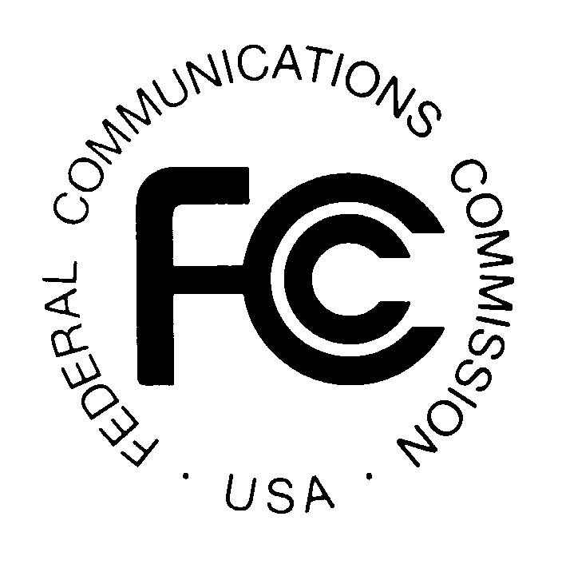
PUBLIC NOTICE
News Media Information 202 / 418-0500
Internet: http://www.fcc.gov
TTY: 1-888-835-5322

Federal Communications Commission
445 12th St., S.W.
Washington, D.C. 20554

DA 09-2476

November 24, 2009

THE WIRELESS TELECOMMUNICATIONS BUREAU REMINDS WIRELESS SERVICE PROVIDERS OF THEIR OBLIGATION TO REPORT ON THE STATUS OF COMPLIANCE WITH THE COMMISSION’S HEARING AID COMPATIBILITY REQUIREMENTS BY JANUARY 15, 2010

Electronic FCC Form 655 To Be Demonstrated on December 8, 2009

The Wireless Telecommunications Bureau (“Bureau”) reminds providers of digital commercial mobile radio service (CMRS) of their obligation to report on the status of compliance with the Commission’s hearing aid compatibility requirements. Service providers’ status reports are due to be filed with the Commission by January 15, 2010. These reports are required of all service providers that are within the scope of the rule, including resellers and holders of spectrum usage rights as well as providers that fall within the de minimis exception, under Section 20.19(i) of the Commission’s rules.

Pursuant to the Commission’s delegation of authority, the Bureau in 2008 made FCC Form 655 available for service providers and device manufacturers to use in submitting hearing aid compatibility status reports. Beginning with the filing deadline for device manufacturers on July 15, 2009, the electronic FCC Form 655 became the only acceptable means by which reports on the status of compliance with the Commission’s hearing aid compatibility requirements may be submitted. Use of the electronic FCC Form 655 helps filers ensure that their reports include all of the required information in Section 20.19(i) of the Commission’s rules. In addition, the electronic system facilitates the Commission’s compilation of data from the reports, as well as the availability of the reports and summary information to the public.

Electronic FCC Form 655 will be accessible to service providers at http://wireless.fcc.gov/hac beginning December 15, 2009. Service providers must use electronic FCC Form 655 to file their status reports from December 15, 2009, through midnight, Eastern Daylight Time, on January 15, 2010.

The Bureau will hold a demonstration and webinar training session on how to submit the electronic FCC Form 655 on Tuesday, December 8, 2009, from 1:00 PM – 3:00 PM. The demonstration will take place at the Washington, DC headquarters building, 445 Twelfth Street, S.W., in Room 7-B516. Interested parties should pre-register for the event by December 2, 2009.
Demonstration of Electronic Filing Process for FCC Form 655
The interactive online filing process for Form 655 has been integrated into the Commission’s existing Universal Licensing System (ULS). The presentation will include the following:

- Demonstration of how to electronically complete and submit Form 655;
- Discussion of the upcoming filing window for the January 15 reporting deadline; and
- An opportunity for attendees to ask questions.

Remote Attendance
This demonstration will be available for remote attendance via a webinar. It is highly recommended that you test your ability to connect to the webinar a few days before the scheduled event. Beginning December 4, 2009, you will be able to find information about the pre-test at: http://esupport.fcc.gov/webinartest/. You may participate in the webinar at: http://wireless.fcc.gov/presentations/form655-deployment-demo2.html.

Reasonable Accommodations
Reasonable accommodations for people with disabilities are available upon request. Such requests should include a detailed description of the accommodation and a way to contact the person making the request if more information is needed. Requests made close to the date of the event will be accepted, but may not be possible to accommodate in the short time frame. Send an e-mail to fcc504@fcc.gov or call the Consumer & Governmental Affairs Bureau at 202-418-0530 (voice), 202-418-0432 (tty).

Registration
Pre-registration is requested by Wednesday, December 2, 2009. Please contact hacdemo@fcc.gov or Eugene Chun at 202-513-4575. If registering by electronic mail (e-mail), the subject line of the e-mail should state “WTB Demonstration of FCC Form 655.” Please provide your name, organization, telephone number and e-mail address.

For more information or if you have questions, please contact Weiren Wang, Weiren.Wang@fcc.gov, 202-418-7275, or Michael Rowan, Michael.Rowan@fcc.gov, 202-418-1883.

- WTB –

These requirements apply to providers of “digital CMRS in the United States to the extent that they offer real-time, two-way switched voice or data service that is interconnected with the public switched network and utilizes an in-network switching facility that enables the provider to reuse frequencies and accomplish seamless hand-offs of subscriber calls, and such service is provided over frequencies in the 800 MHz-950 MHz or 1.6-2.5 GHz bands using any air interface for which technical standards are stated in the standard document “American National Standard for Methods of Measurement of Compatibility between Wireless Communications Devices and Hearing Aids,” American National Standards Institute (ANSI) C 63.19-2007,” as well as to the manufacturers of wireless handsets that are used in the delivery of these services. 47 C.F.R. § 20.19(a)(1), (2).
See 47 C.F.R. § 20.19(e) (de minimis exception). De minimis entities are not, however, required to respond to all data categories.
See 47 C.F.R. § 20.19(i).
See Public Notice, “The Wireless Telecommunications Bureau Reminds Manufacturers and Service Providers of Their Obligation To Report on the Status of Compliance with the Commission’s Hearing Aid Compatibility Requirements,” 23 FCC Rcd 18078 (WTB 2008).
See Public Notice, “The Wireless Telecommunications Bureau Reminds Wireless Handset Manufacturers of Their Obligation To Report on the Status of Compliance with the Commission’s Hearing Aid Compatibility Requirements by July 15, 2009,” 24 FCC Rcd 5821 (WTB 2009).

