CERP and PBC Monthly Reports
Updated 29/Apr/26
This document provides the steps required for composing monthly reports for CERP and PBC grants using the Oyster database and R code files.

- Setup steps:
  - Make sure R/R Studio is installed and the Molluscs/Oysters/R folder can be accessed.

- Data preparation:
  - Make sure all required data has been entered and proofed via ODIN.
  - Once data is proofed, make sure the data sheets have been given to the database manager for final data checks.
  - Data required:
    - CERP = St. Lucie, Loxahatchee, Caloosahatchee
    - PBC = Lake Worth
    - Water quality, dermo, recruitment, survey counts and shell heights (Mar, Sep – all stations, Jun, Dec – SLC1, CRE2, CRW3), sediment trap (PBC)
    - Data required for quarterlies, may not be ready each month:
      - Cage (SLC2, CRE2, CRW4, LXN2)
      - Repro

- Image preparation:
  - Navigate to the Molluscs\Oysters\CERP\Images\Monthly Monitoring Images folder.
  - Check for a folder for the current month, create as needed. Use the naming format of YYYY-MM for the folder name (i.e., 2025-07).
  - Copy all field photos from the camera to the folder.
  - Once files are transferred, use the field book to help identify where pictures were taken. Rename pictures based on year, month, and location of picture. If pictures are of specific stations, include the station number in the file name. If pictures are not station specific, include estuary in file name.
    - Station ex: 2025-07_CRE1; 2025-07_LWL1
    - Site ex: 2025-07_CR; 2025-07_LW
  - Additional one- or two-word descriptions can be included in file name but are not required at this point.

- Data checks and summary:
* Monthly checks and summary output pulls data from the database specified in the R code file so it CAN be run locally. It does NOT require data to be completed in Oysters.
  - The database manager will perform the required database checks.
    - Check ODIN for any unfinished trips, finish as required (RCRT, SRVY, SDTP).
      - COLL will only be finished when checking Repro data
      - CAGE can be completed if proofed data is available
    - Make a local copy of the database to perform data checks.
    - Create a new data checks SQL file in the St Pete folder of the SQL-Database-Corrections github repo following the naming scheme: Datachecks_YYYY MM_StPete.
    - Use R Markdown files in the Oyster-Data-Checks github repo to perform checks of dermo, recruitment, and survey (as needed) data.
      - NOTE: WQ data is entered with COLL data when dermo is collected. WQ is entered with RCRT when dermo is not collected (TB).
      - R code files:
        - Used every month:
          - COLL_DataChecks_Multiple_StPete
          - RCRT_DataChecks_Multiple_StPete
          - SDTP_DataChecks_Multiple_StPete
        - Additional files:
          - SRVY_DataChecks_StPete
          - CAGE_DataChecks_Multiple_StPete
      - Within each R file, update the CheckStart, CheckEnd, and Database lines in the “r VariableSet” section to specify the date range to check and the local database version to use. Update the EstuaryCode to match the params noted at the top of the R code file to check the data for the sites listed.
      - Once updated, hit the Knit button.
      - Complete the checks and corrections needed in the SQL file. Once completed, the R code can be re-knit to confirm checks are complete.
      - Copy the line of SQL code at the bottom of the Knit output into the SQL data checks file. For COLL checks, do NOT copy the SQL code if checking dermo data-only copy if Repro data is being checked and completed.
      - Data checks only need to be completed locally to run summary data gathers. If data checks are applied to the Oysters database, add a comment at the top of the SQL file “—Completed in Oysters YYMMDD” and append the completion data in the same format to the end of the file name.
  - After checks are complete, the database manager will run the CERP_PBC_Monthly_Data R Markdown file in the Oyster-Reports/Data github repo to output the required data.
    - Open the Oyster-Reports.Rproj file.
    - Open the CERP_PBC_Monthly_Data.Rmd code file located in the Data folder.
    - Update the local database to pull from (line 16) and server (line 17).
    - Update the start and end dates between which to summarize data (lines 19-20).
    - Click Knit to update the Excel data file.
  - Data will be updated in the Excel summary file located in the github repo file: ../Monthly/Summary data/CERP_PBC_Monthly_Data.xlsx. Copy and replace this updated file with the Oysters R Monthly Reports Summary data file.
  - Notify staff that the data is ready for the monthly report.
    - Current staff to notify: Darian Blackiston, Lily Harmon.

- Monthly report text:
  - Open the Monthly Reports R project file located in the Molluscs\Oysters\R\Monthly Reports folder.
  - Once the project is loaded, open the CERP Monthly Report.Rmd file either through the R Studio console or by double-clicking on the file in the R\Monthly Reports\Code folder.
  - Within the code file, update lines 7 and 8 to the proper month (mm) and year (YYYY) for the current report timeframe.
  - Update the author’s name in line 20.
  - Click on the ‘Knit’ button at the top of the code screen to run the R Markdown file.
  - Once the code has completed, a Word document should open. This file should also be saved in the R\Monthly Reports\Output folder.
  - In Outlook, open a draft email. For the subject, enter the project name, “Monthly Report”, and the month and year of the report.
    - CERP Monthly Report – May 2025
    - PBC Monthly Report – June 2025
  - Copy the St. Lucie Central summary section for CERP or the Lake Worth Lagoon summary section for PBC from the Word document to the draft email. Copy from “Here is the monthly report…” through the last bullet point with data.
    - If no survey was conducted, the last bullet point should not be included in the email.
  - Repeat for the Caloosahatchee River summary section for CERP or the Lake Worth Restoration summary section for PBC.
  - For PBC reports, copy the Lake Worth sediment trap summary section to the draft email, including the data table. The table formatting can be adjusted once copied to the email as needed.
  - In the email below both summary sections, add a new section with the heading A few additional notes.
  - In this section add bullet points listing any missing data, data collection notes, or other interesting information about the trip.
    - Missing data notes should include missing stringers or blocks of sediment traps. Missing cages can also be noted.
    - Collection notes should include comments on any samples collected differently than the normal protocol:
      - LXS3 samples were collected from the nearby dock
      - Oysters from SLS3 were collected from SLS2 this month
  - Example email:
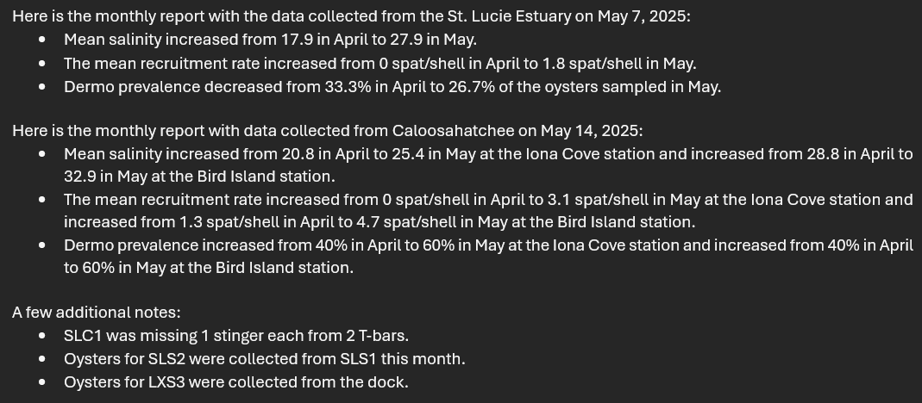

- Monthly report data – skip for PBC
  - CERP monthly reports required updates to summary data files located in the Molluscs\Oysters\CERP\Documents\Grant Reports\CERP 4490 folder. Excel files to update include:
    - CERPMonthlyReportData
    - CERPMonthlyReportData_Rio_Station (05-Present)
  - The data to be added is summarized in tables in the Data summary output section of the Word document.
  - To update the files, either navigate to the file location or use the Excel file links located in the R Word document output showed by the blue Excel file text.
  - Open the Excel files noted by the Word document.
  - Copy the last row of data by highlighting the entire row of data (click on the row number), right-click, and choose Copy.
  - With the row still highlighted, right-click and choose Insert Copied Cells. This should insert a duplicate data row above the currently selected row. Using this method helps to ensure any formulas are updated appropriately.
  - Update the last row of data with the new data from the table in the Word document.
  - Repeat steps e-g for all sheets in the document. Save the Excel file.
  - Once the data has been updated for both Excel sheets, attach the sheets to the draft email.

- Monthly report images
  - Navigate to the Monthly Monitoring Images folder of images containing the proper year and month for the current report.
  - Review the images and select 3 or 4 showing important things to note about sampling or gear (broken T, extra-large oyster, etc.), the crew working in the field, notable events (high/low tides, species encounters, rain/rainbows, etc.).
  - Update the selected image names to add a one- or two-word description to the file name if not already present. File names should include the year and month, the station or site, and a brief description. Remove any counter numbers “(1)” from the file name.
  - Attach the selected images to the draft email.

- Submission
  - Check that the email contains:
    - the monthly report text
    - additional notes
    - updated Excel data files (CERP only)
    - 3 to 4 images
  - Send the CERP monthly report email to
    - bwelch@sfwmd.gov
    - mparker@sfwmd.gov
    - CC:
      - Stephen.Geiger@MyFWC.com
      - Erica.Williams@myFWC.com
  - Send the PBC monthly report email to:
    - eanderson1@pbc.gov
    - tsteinhoff@pbc.gov
    - CC:
      - Stephen.Geiger@MyFWC.com
      - Erica.Williams@myFWC.com
      - Thomas.Reinert@MyFWC.com
      - jbaez1@pbc.gov

** Repeat the process for the PBC report using the PBC Monthly Report.Rmd file. Make sure the email includes: the monthly report text, the sediment data table, additional notes, and 3 to 4 images.

