Task_1

1. Write an SQL query to fetch “FIRST_NAME” from the Worker table using the alias name as <WORKER_NAME>.

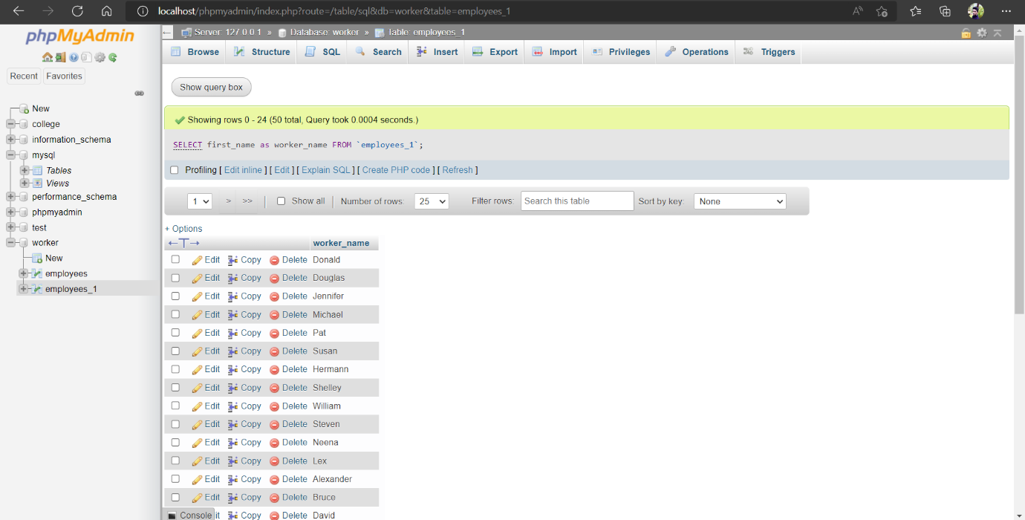

1. Write an SQL query to fetch unique values of DEPARTMENT from the Worker table.

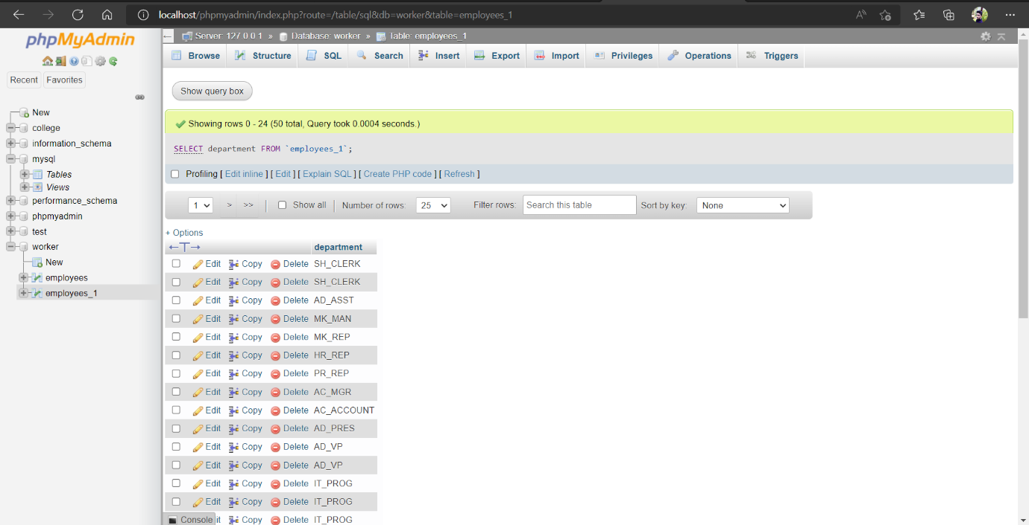

1. Write an SQL query to show the last 5 records from a table.

