A Capstone Project Report
on
EXPLAINABLE GENERATIVE AI FOR WIND SPEED SCENARIO GENERATION
Submitted in partial fulfilment of the requirements for the award of the degree of
[Degree, e.g. Bachelor of Technology]
in
[Department]
Submitted by
[Student Name(s)]
[Register No.]
Under the guidance of
[Guide Name]
[Designation, Department]
[Department]
[University]
[Month Year]
CERTIFICATE
This is to certify that the capstone project report entitled “Explainable Generative AI for Wind Speed Scenario Generation” is a bonafide record of the work carried out by [Student Name(s)] ([Register No.]) in partial fulfilment of the requirements for the award of the degree of [Degree] in [Department], [University], during the academic year [Year], under my supervision and guidance.

[Guide Name] [Head of the Department]
Project Guide Head of the Department
[Department] [Department]

Submitted for the project viva-voce examination held on [Date].

Internal Examiner External Examiner
DECLARATION
I/We hereby declare that the capstone project report entitled “Explainable Generative AI for Wind Speed Scenario Generation”, submitted to [University] in partial fulfilment of the requirements for the award of the degree of [Degree] in [Department], is a record of original work carried out by me/us under the guidance of [Guide Name]. The results embodied in this report have not been submitted to any other university or institution for the award of any degree or diploma. Published work of others used in this report is acknowledged in the text and listed in the references.

Place: [Place] [Student Name(s)]
Date: [Date] [Register No.]
ACKNOWLEDGEMENT
[Acknowledgement to be written by the student(s): thank the project guide, the Head of the Department, the project coordinator, faculty members, the institution, and family and friends. Keep it to one page.]
The authors also acknowledge the Copernicus Climate Change Service (C3S) and ECMWF for the ERA5 reanalysis data used in this project [18].
ABSTRACT
Accurate representation of wind-speed variability is essential for reliable wind-power integration, energy scheduling and grid stability. Conventional forecasting models usually give a single deterministic prediction and offer limited insight into uncertainty or into the physical factors that drive wind-speed variations. This project develops and evaluates an explainable generative AI framework that produces many plausible 24-hour wind-speed trajectories (scenarios) conditioned on the previous 24 hours of meteorological conditions.
A conditional denoising diffusion probabilistic model (DDPM) was implemented from first principles in NumPy, with manual back-propagation and no deep-learning framework, using two denoiser backbones: a multilayer perceptron (MLP) and a multi-head cross-attention network in which the weather history can reach the model only through attention. The models were trained on hourly ERA5 reanalysis data for a single grid point in inland Andhra Pradesh, India (14.6°N, 79.6°E, 1950–2026), using wind speed and direction, temperature, relative humidity, surface pressure, precipitation and solar radiation, and evaluated on an unseen test period (2021–2026) against persistence, climatology and ridge-regression baselines over three random seeds.
The MLP diffusion model gave the best probabilistic skill: a continuous ranked probability score (CRPS) of 0.392 ± 0.005 m/s against 0.413 ± 0.007 m/s for the strongest baseline (about 5 % lower), an energy score of 2.355 against 2.467, and 90 % prediction-interval coverage of 0.900. The diffusion scenarios reproduced the marginal wind-speed distribution better than the other probabilistic models (Kolmogorov–Smirnov distance 0.024–0.027), but were noisier from hour to hour than observed winds (higher autocorrelation and ramp distances than the ridge baseline). The attention model was only slightly better than ridge regression (CRPS 0.406 ± 0.007 m/s), a cost paid for built-in interpretability.
Explanations were produced with group Shapley values (SHAP), occlusion and attention analysis, and counterfactual “what-if” explanations, and their quality was measured. Past wind speed carries about 60–70 % of the attributed importance, the most recent one to three hours receive the most attention, and attention agrees with model-agnostic occlusion (Spearman 0.81 ± 0.07). Scenarios are converted to turbine power to give P10/P50/P90 daily energy estimates for planning and battery scheduling, and an interactive Streamlit application exposes scenario generation, explanations and counterfactual sliders. A generative adversarial network was not implemented; the reasons for choosing diffusion are given in the report.
Keywords: wind-speed scenarios, conditional diffusion model, DDPM, probabilistic forecasting, explainable AI, SHAP, attention, counterfactual explanations, CRPS, ERA5.
TABLE OF CONTENTS
1. Introduction 1
1.1 Background and motivation 1
1.2 Problem statement 1
1.3 Objectives 2
1.4 Contributions 2
1.5 Organisation of the report 3
2. Literature Review 4
2.1 Probabilistic wind forecasting and scenarios 4
2.2 Deep generative models for scenario generation 4
2.3 Explainable AI 5
2.4 Evaluation of probabilistic forecasts and scenarios 5
2.5 Research gap 6
3. Data and Preprocessing 7
3.1 Data source 7
3.2 Feature engineering 7
3.3 Windowing 8
3.4 Train, validation and test split 8
4. Methodology 9
4.1 Framework overview 9
4.2 Choice of generative model 9
4.3 Conditional denoising diffusion probabilistic model 10
4.4 Denoiser backbones 11
4.5 Baselines 12
4.6 Explainability methods 12
4.7 Conversion from wind speed to power 14
5. Evaluation Metrics 15
5.1 Forecasting accuracy 15
5.2 Statistical similarity 15
5.3 Diversity 16
5.4 Uncertainty calibration 16
5.5 Explanation-quality metrics 16
6. Implementation 18
6.1 Software environment and design decisions 18
6.2 Software architecture 18
6.3 Experimental protocol 18
6.4 Testing and verification 19
6.5 Interactive application 19
7. Results and Discussion 22
7.1 Training behaviour 22
7.2 Example scenarios 22
7.3 Forecasting accuracy 23
7.4 Statistical similarity and diversity 24
7.5 Uncertainty calibration 25
7.6 Evaluation in power space 26
7.7 Explainability results 26
7.8 Discussion and delivery against the abstract 31
8. Applications 32
8.1 Wind-farm planning 32
8.2 Battery scheduling 32
8.3 Power-system operation 32
8.4 Risk-aware energy management and operator trust 33
9. Limitations and Future Work 34
9.1 Limitations 34
9.2 Future work 34
10. Conclusion 36
References 37
Appendix A. How to Run the Project 39
Appendix B. Configuration 40
Appendix C. Per-run Results 41

LIST OF FIGURES
Figure 1. Overview of the explainable generative framework. 9
Figure 2. Application, Scenarios tab: wind-speed and power fan charts for the forecast starting 2023-12-04 17:00 (attention model, seed 0, 30 scenarios). 20
Figure 3. Application, Explain tab: per-forecast group Shapley values and attention by head and lag for the same forecast. 21
Figure 4. Training and validation loss of the attention diffusion model (seed 0). 22
Figure 5. Generated scenarios (blue), scenario mean and observed wind speed for one test window (attention model, seed 0). 23
Figure 6. Rank histograms of climatology, ridge and diffusion (attention, seed 0) scenarios; flat = calibrated. 26
Figure 7. Global feature-group importance, attention model (seed 0). 27
Figure 8. Global feature-group importance, MLP model (seed 0). 27
Figure 9. Temporal attribution by occlusion: share of the effect on mean generated wind by history hour (attention model, seed 0). 28
Figure 10. Cross-attention weights by head and history hour, averaged over denoising steps, scenarios and test windows (seed 0). 29
Figure 11. Counterfactual: mean generated wind for the factual history and with surface pressure lowered by 5 hPa (attention model, seed 0). 30
LIST OF TABLES
Table 1. Model input features (per hour of history). 7
Table 2. Chronological data split. 8
Table 3. Denoiser architectures. 12
Table 4. Summary of evaluation metrics. 17
Table 5. Modules of the windgen package. 18
Table 6. Unit tests by module. 19
Table 7. Probabilistic and point accuracy on the test period (mean ± std over 3 seeds; best in bold). 23
Table 8. Paired CRPS comparison on identical test windows (m/s; negative change = better than ridge). 24
Table 9. Statistical similarity and diversity (mean ± std over 3 seeds; lower distances are better). 24
Table 10. Calibration (mean ± std over 3 seeds). 25
Table 11. Share of mean |SHAP| by feature group (%), seed 0 and mean ± std over 3 seeds. 26
Table 12. Counterfactuals: change in mean generated wind (m/s) for the windiest test window. 29
Table 13. Explanation-quality metrics (mean ± std over 3 seeds). 30
Table 14. Delivery against the project abstract. 31
Table 15. Configuration used for all reported runs. 40
Table 16. Diffusion-model results for each run on its test windows. 41
LIST OF ABBREVIATIONS
The following abbreviations are used in this report.
CRPS | Continuous ranked probability score
DDPM | Denoising diffusion probabilistic model
EMA | Exponential moving average (of network weights)
ERA5 | Fifth-generation ECMWF atmospheric reanalysis
ES | Energy score
GAN | Generative adversarial network
KS | Kolmogorov–Smirnov (distance)
MAE / RMSE | Mean absolute error / root-mean-square error
MLP | Multilayer perceptron
PIT | Probability integral transform
RH | Relative humidity
SHAP | SHapley Additive exPlanations
SiLU | Sigmoid linear unit activation
W1 | First Wasserstein (earth mover's) distance
XAI | Explainable artificial intelligence
CF | Capacity factor (fraction of rated turbine power)

1. Introduction

1.1 Background and motivation
Wind power is now a major source of electricity, but its output follows the wind, which changes from hour to hour in ways that cannot be scheduled. Grid operators, wind-farm owners and storage operators must commit generation, reserves and battery charge in advance, so they need to know not only the most likely wind speed but also how far it may deviate. Pinson [1] argues that probabilistic forecasts and scenarios, rather than single-valued predictions, are the appropriate input for operational decisions under uncertainty, and the Global Energy Forecasting Competition 2014 [2] made probabilistic evaluation the standard for wind-power forecasting.
Many decisions depend on the whole trajectory, not just on per-hour uncertainty. The energy stored in a battery, the duration of a low-wind spell and the size of a ramp all depend on how consecutive hours move together. A set of per-hour quantiles cannot answer these questions; a set of scenarios, each a complete and physically plausible trajectory, can. Deep generative models are a natural way to produce such scenarios because they learn the joint distribution of all hours at once.
Generative models are, however, opaque. An operator who is asked to hold extra reserve because the model generated a wide spread of scenarios will reasonably ask why. Explainable AI (XAI) methods can identify which inputs and which past hours drive the generated scenarios, and counterfactual explanations can show how the scenarios would change under different conditions. This project combines the two: a conditional generative model for wind-speed scenarios, and a set of explanation methods whose quality is itself measured.

1.2 Problem statement
Given the previous 24 hours of eight hourly meteorological features (wind speed, wind direction encoded as sine and cosine, 2 m temperature, relative humidity, surface pressure, precipitation and incoming solar radiation) and four calendar features describing the forecast start time, generate M plausible trajectories of hourly 10 m wind speed for the next 24 hours. The generated scenarios should (i) be probabilistically accurate, (ii) reproduce the statistical properties of real wind, (iii) be well calibrated, so that the stated uncertainty matches observed errors, and (iv) be explainable in terms of the input variables and the time lags that drive them.

1.3 Objectives
- Build a leakage-free dataset of input–output windows from long-term hourly reanalysis data for a wind site.
- Implement a conditional generative model (a denoising diffusion model) that outputs multiple wind-speed trajectories for each forecast start.
- Compare it with standard reference methods (persistence, climatology and a regression model with bootstrapped errors) on an unseen test period.
- Evaluate statistical similarity, forecasting accuracy, diversity and uncertainty calibration with established metrics.
- Explain the generated scenarios with SHAP, attention analysis and counterfactual explanations, and quantify the quality of these explanations.
- Translate scenarios into turbine power and energy, and provide an interactive tool that demonstrates use in planning and scheduling.

1.4 Contributions
- A conditional DDPM for 24-hour wind-speed scenarios implemented from scratch in NumPy (forward and backward passes written by hand and verified by gradient checks), which trains in under a minute per run on a laptop CPU.
- An attention backbone designed so that the weather history reaches the network only through cross-attention, which makes the attention weights a direct account of which past hours the model reads.
- A multi-seed comparison (two backbones × three seeds) against three baselines using 13 metrics that cover accuracy, similarity, diversity, calibration and power-space error.
- Group Shapley values, occlusion-based temporal attribution, attention analysis and counterfactual search adapted to a stochastic generator, together with four explanation-quality metrics (deletion faithfulness, top-1 deletion ratio, stability and attention–occlusion agreement).
- A wind-to-power conversion with P10/P50/P90 daily energy, and a Streamlit application with what-if sliders and per-forecast explanations.
- A tested code base (85 unit tests) that reproduces all reported numbers from the raw data with one command.

1.5 Organisation of the report
Chapter 2 reviews related work. Chapter 3 describes the data and preprocessing. Chapter 4 presents the methodology: the diffusion model, the two backbones, the baselines, the explanation methods and the power conversion. Chapter 5 defines the evaluation metrics. Chapter 6 describes the implementation, testing and the interactive application. Chapter 7 reports and discusses the results, Chapter 8 discusses applications, Chapter 9 lists limitations and future work, and Chapter 10 concludes.

2. Literature Review

2.1 Probabilistic wind forecasting and scenarios
Pinson [1] reviews the forecasting challenges that wind energy creates for power-system operation. A central point is that decisions such as reserve allocation, trading and storage control are made under uncertainty, so forecasts should be probabilistic, and that many of these decisions require scenarios, i.e. samples of whole trajectories that respect the dependence between lead times, rather than independent marginal distributions for each hour. The Global Energy Forecasting Competition 2014 [2] included a wind-power track in which participants submitted quantile forecasts that were scored with the pinball loss, which established probabilistic evaluation as the norm in energy forecasting.

2.2 Deep generative models for scenario generation
Generative adversarial networks (GANs) [3] train a generator and a discriminator in a two-player game; the generator learns to map random noise to samples that the discriminator cannot distinguish from real data. Chen et al. [4] applied GANs to renewable scenario generation and showed that a model-free generator trained on historical wind and solar power can produce scenarios with realistic diversity and temporal correlation, without assuming a parametric distribution. GAN training is, however, known to be unstable and may suffer from mode collapse, in which the generator covers only part of the data distribution.
Diffusion models were introduced by Sohl-Dickstein et al. [5], who learned to reverse a gradual noising process. Ho et al. [6] simplified training to the prediction of the added noise (the DDPM objective) and achieved high-quality image synthesis, and Nichol and Dhariwal [7] improved the method with, among other changes, a cosine noise schedule that is used in this project. For time series, TimeGrad [8] combines an autoregressive recurrent network with a diffusion model to forecast multivariate series probabilistically, and CSDI [9] uses a conditional score-based diffusion model with transformer layers for probabilistic imputation of time series. These studies show that conditional diffusion models can represent complex predictive distributions of sequences, which motivates their use for wind-speed scenarios here.

2.3 Explainable AI
The Shapley value [10] from cooperative game theory distributes a total payoff fairly among players and is the only attribution that satisfies efficiency, symmetry, dummy and additivity. Lundberg and Lee [11] unified several feature-attribution methods under the Shapley framework as SHAP. Exact Shapley values require evaluating the model on all subsets of features, so Štrumbelj and Kononenko [12] proposed a sampling estimator based on random permutations of the features, which is the estimator adapted in this work.
Attention mechanisms, popularised by the Transformer [13], compute data-dependent weights over input positions, and these weights are often displayed as explanations. Jain and Wallace [14] showed that, in recurrent text classifiers, attention weights frequently disagree with gradient-based importance and can be changed substantially without changing predictions, so attention should not automatically be read as explanation. This project addresses the concern directly through architecture (history is visible only through attention) and through measurement (agreement with an independent occlusion method).
Counterfactual explanations, as formulated by Wachter et al. [15], describe the smallest change to the inputs that would change a model's output to a desired value. They are intuitive for non-specialists because they answer “what would have to be different?”. Here they are used as what-if analyses (for example, the effect of a 5 hPa pressure drop on the generated scenarios) and as a search for the smallest change that achieves a target shift in mean wind speed.

2.4 Evaluation of probabilistic forecasts and scenarios
Gneiting and Raftery [16] established the theory of strictly proper scoring rules, which reward a forecaster for reporting its true belief. The continuous ranked probability score (CRPS) and its multivariate generalisation, the energy score, are proper and can be computed directly from an ensemble of samples, which makes them suitable for scenario generators. Calibration of ensembles is commonly checked with rank histograms; Hamill [17] explains how flat, U-shaped, dome-shaped and sloped histograms indicate calibration, under-dispersion, over-dispersion and bias respectively, and warns that a flat histogram is necessary but not sufficient for reliability.

2.5 Research gap
The reviewed work covers the three ingredients separately: generative scenario models (GAN and diffusion), explanation methods developed mainly for deterministic classifiers and regressors, and proper scores for probabilistic evaluation. Three gaps motivate this project. First, explanation methods are rarely applied to stochastic generators, where the output changes with the random seed and a value function must be defined before Shapley values make sense. Second, attention is often shown as an explanation without checking whether it agrees with other methods. Third, explanations are rarely evaluated quantitatively. This project defines a deterministic value function for a stochastic generator, builds an attention backbone whose weights are a genuine bottleneck, and reports explanation-quality metrics alongside forecast-quality metrics.

3. Data and Preprocessing

3.1 Data source
The data are hourly ERA5 reanalysis fields [18] for the single grid point at 14.6°N, 79.6°E in inland Andhra Pradesh, India. ERA5 combines a numerical weather model with historical observations to produce a consistent hourly record. Four CSV files were provided: wind (u10, v10), temperature (t2m, d2m), pressure (sp, tp) and radiation (ssrd). They are joined on the timestamp, giving a continuous record from 1950-01-02 00:00 to 2026-08-17 23:00, about 671,000 hours. Precipitation and solar radiation in the files are already per-hour values, so no de-accumulation is applied.
The site is a low-wind location: the mean 10 m wind speed is about 2.7 m/s (2.62 m/s over the test windows). This matters for interpreting the power results in Section 7.6, because a large share of hours lie near or below the cut-in speed of a typical turbine.

3.2 Feature engineering
Table 1 lists the eight hourly model features and how they are derived from the raw ERA5 variables. Wind speed and direction are computed from the eastward (u) and northward (v) components; direction is encoded as a sine–cosine pair so that 359° and 1° are close. Relative humidity is derived from air temperature T and dew-point temperature T_{d} (both in °C) with the Magnus formula.
s = √(u² + v²), θ = atan2(v, u) → (sin θ, cos θ) (3.1)
RH = 100 · exp(17.62 T_{d} / (243.12 + T_{d})) / exp(17.62 T / (243.12 + T)) (3.2)
Table 1. Model input features (per hour of history).
Feature | ERA5 source | Transformation | Unit
Wind speed | u10, v10 | √(u² + v²) | m/s
Wind direction (sin, cos) | u10, v10 | sin and cos of atan2(v, u) | –
Temperature | t2m | none | K
Relative humidity | t2m, d2m | Magnus formula, clipped to 0–100 | %
Surface pressure | sp | none | Pa
Precipitation | tp | log(1 + 1000·tp), tp in m | log(1+mm/h)
Solar radiation | ssrd | ssrd / 10⁶, clipped at 0 | MJ/m² per hour
Calendar (4 values) | timestamp | sin/cos of hour of day and day of year at the forecast origin | –

3.3 Windowing
A sample (window) consists of the 24 hours of history before a forecast origin t₀, an array of shape 24 × 8, the four calendar features of t₀, and the target: the 24 hourly wind speeds from t₀ to t₀ + 23 h. Windows whose 48-hour span crosses a gap in the hourly time axis are discarded, so every window is contiguous.
The history features are standardised with the mean and standard deviation of each feature, and the target is standardised with the mean and standard deviation of training wind speed. All normalisation statistics are computed on the training windows only. The conditioning vector given to the models is the flattened standardised history (192 values) followed by the four calendar values, 196 values in total.

3.4 Train, validation and test split
The data are split by time, so the model is always tested on years it has never seen (Table 2). Training windows are taken every 3 hours and then randomly subsampled to 60,000 to keep CPU training fast; validation and test windows are taken every 25 hours, which shifts the forecast start by one hour each day so that all start hours are represented. The test set is subsampled to 1,000 windows. The random subsamples depend on the run seed, so the three seeds also differ slightly in their training and test windows. A unit test checks that no history hour of any window lies at or after its target hours, and the pipeline refuses to run if the periods overlap.
Table 2. Chronological data split.
Set | Forecast-origin period | Stride | Windows used
Training | 1950 – 2015 | 3 h | 60,000 (random subsample)
Validation | 2016-01-01 – 2020-12-31 | 25 h | 1,754
Test | 2021-01-01 – 2026-08 (end of data) | 25 h | 1,000 (random subsample)

4. Methodology

4.1 Framework overview
Figure 1 summarises the framework. Raw ERA5 data are converted into features and windows. A conditional diffusion model learns the distribution of the next 24 hours of wind speed given the history and calendar, and generates M = 20 scenarios per test window (5–100 in the application). The same windows are passed to three baselines. Scenarios are evaluated with accuracy, similarity, diversity and calibration metrics, converted to turbine power, and explained with SHAP, occlusion, attention and counterfactual analysis.
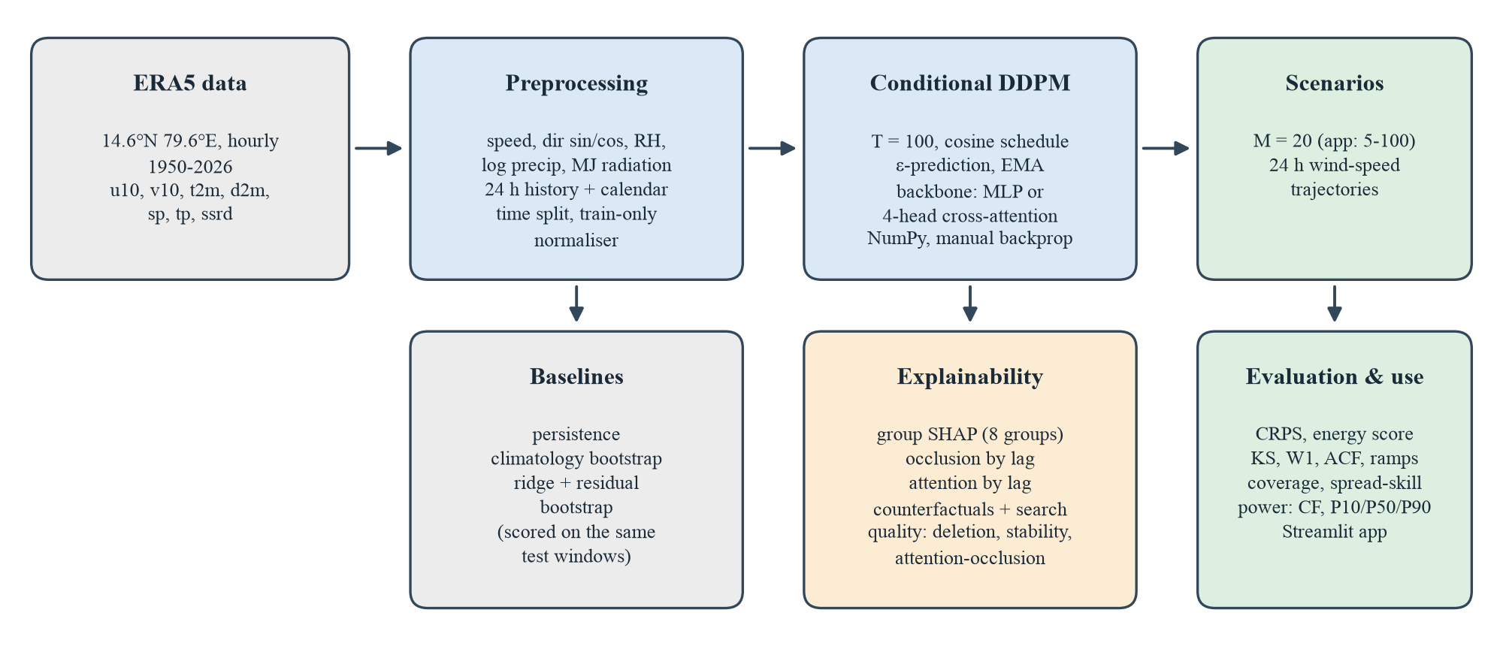
Figure 1. Overview of the explainable generative framework.

4.2 Choice of generative model
The abstract proposed “a conditional diffusion model or a Generative Adversarial Network”. A conditional diffusion model was chosen, for four reasons:
- Stable training. A DDPM is trained with a plain mean-squared-error regression loss on the added noise. There is no adversarial min–max game, so there is no need to balance a generator against a discriminator, and the validation loss is a meaningful indicator of progress (Section 7.1).
- Coverage of the whole distribution. The DDPM objective is derived from a bound on the data likelihood, so failing to produce part of the distribution is penalised. GANs have no such term and are prone to mode collapse, which for scenario generation would mean too little spread and over-confident uncertainty.
- Natural conditioning and calibration. Conditioning is done by giving the history to the denoiser at every step; the spread of the scenarios then follows from the learned conditional distribution, which Chapter 7 shows to be close to calibrated.
- Suitability for a from-scratch implementation. The model needs only one network and one loss, which made it feasible to write and gradient-check the full training code by hand.
The main disadvantage of diffusion models is slower sampling: each scenario needs T = 100 network evaluations. With a small network this takes a fraction of a second per forecast, which is acceptable here. A GAN comparison was not carried out and is listed as future work (Chapter 9).

4.3 Conditional denoising diffusion probabilistic model
Let x₀ ∈ ℝ²⁴ be the standardised target trajectory and c ∈ ℝ¹⁹⁶ the conditioning vector. The forward process gradually adds Gaussian noise over T = 100 steps [6]:
q(x_{t} | x_{t−1}) = N(x_{t}; √(1 − β_{t}) x_{t−1}, β_{t} I), t = 1, …, T (4.1)
which has the closed form
q(x_{t} | x₀) = N(x_{t}; √ᾱ_{t} x₀, (1 − ᾱ_{t}) I), ᾱ_{t} = ∏_{s=1..t} (1 − β_{s}) (4.2)
The noise levels follow the cosine schedule of Nichol and Dhariwal [7], with s = 0.008 and β_{t} clipped to [10⁻⁵, 0.999]:
ᾱ_{t} = f(t) / f(0), f(t) = cos²( ((t/T + s) / (1 + s)) · π/2 ) (4.3)
A neural network ε_{θ}(x_{t}, c, t) is trained to predict the noise that was added. Each training step draws a mini-batch of windows, a random step t and Gaussian noise ε, and minimises
L(θ) = E_{x0, c, t, ε} ‖ ε − ε_{θ}( √ᾱ_{t} x₀ + √(1 − ᾱ_{t}) ε, c, t ) ‖² (4.4)
The step t is given to the network as a 16-dimensional sinusoidal embedding e(t) with sines and cosines at eight frequencies ω_{k} = 1000^{−k/8}. To generate a scenario, sampling starts from pure noise x_{T} ~ N(0, I) and applies the learned reverse process. At each step the clean trajectory is estimated and clipped to ±5 standard deviations, and the posterior mean is formed:
x̂₀ = clip( (x_{t} − √(1 − ᾱ_{t}) ε_{θ}) / √ᾱ_{t}, −5, 5 ) (4.5)
x_{t−1} = [β_{t} √ᾱ_{t−1} / (1 − ᾱ_{t})] x̂₀ + [(1 − ᾱ_{t−1}) √α_{t} / (1 − ᾱ_{t})] x_{t} + σ_{t} z (4.6)
σ_{t}² = β_{t} (1 − ᾱ_{t−1}) / (1 − ᾱ_{t})
where α_{t} = 1 − β_{t}, z ~ N(0, I) and no noise is added at the last step. Different noise draws give different scenarios for the same condition. Finally the trajectory is de-standardised and negative speeds are clipped to zero.
Optimisation. The network is trained with Adam [19] (learning rate 10⁻³, β = (0.9, 0.999)), global gradient-norm clipping at 1.0, a 100-step linear warm-up followed by cosine decay, batch size 256 and 3,000 steps. An exponential moving average (EMA) of the weights is kept and used for sampling:
θ̄ ← d θ̄ + (1 − d) θ, d = min(0.999, (1 + k) / (10 + k)) (4.7)
where k is the step number. The validation loss (Equation 4.4 on validation windows, averaged over four noise draws) is logged every 250 steps.

4.4 Denoiser backbones

4.4.1 MLP backbone
The MLP backbone concatenates the noisy trajectory (24), the conditioning vector (196) and the step embedding (16) into a 236-dimensional input and passes it through three hidden layers of 256 units with SiLU activations to a 24-dimensional output. Weights use He initialisation, with the output layer scaled by 0.1 so that training starts close to predicting zero noise.

4.4.2 Cross-attention backbone
The attention backbone treats the 24 history hours as tokens. Each token is the hour's eight standardised features plus an 8-dimensional sinusoidal position code p_{l} for its lag. The query is built from the noisy trajectory, the calendar and the step embedding. With four heads of dimension d = 16 [13]:
q = W_{q} [x_{t}; c_{cal}; e(t)], K_{l} = W_{k} [h_{l}; p_{l}], V_{l} = W_{v} [h_{l}; p_{l}] (4.8)
a_{h,l} = softmax_{l}( q_{h} · K_{h,l} / √d ), ctx_{h} = Σ_{l} a_{h,l} V_{h,l} (4.9)
ε_{θ} = MLP( [x_{t}; c_{cal}; e(t); ctx_{1..4}] ) (4.10)
The important design decision is that the history enters the network only through the attention context: the MLP receives the noisy trajectory, calendar, step embedding and the 64-dimensional context, but not the raw history. Any influence of a past hour on the output must therefore pass through its attention weight. This answers the objection of Jain and Wallace [14] at the level of architecture: an hour with near-zero attention in every head cannot affect the output. A unit test verifies this property, and Section 7.7 checks the weights against an independent occlusion method.
Table 3. Denoiser architectures.
Item | MLP backbone | Attention backbone
Input to the MLP | x_{t} (24) + history and calendar (196) + e(t) (16) | x_{t} (24) + calendar (4) + e(t) (16) + attention context (64)
History access | Flattened, direct | Only through 4-head cross-attention over 24 tokens
Attention | – | 4 heads × 16 dims; tokens = 8 features + 8-dim position code
MLP | 3 × 256, SiLU | 3 × 256, SiLU
Trainable parameters | 198,424 | 170,520
Pipeline run time (CPU) | ≈ 16 s | ≈ 37 s

The run times are for the complete pipeline of one run (training, sampling all generators, explainability and plots) and were recorded in the result files.

4.5 Baselines
- Persistence. The next 24 hours repeat the previous 24 hours of wind speed. It is a single deterministic scenario, so it has no spread.
- Climatology. Twenty complete 24-hour trajectories are drawn at random from training windows with the same calendar month and start hour (falling back to the same hour if a month–hour group has fewer than 20 windows). It knows the season and the diurnal cycle but not the current weather.
- Ridge regression with residual bootstrap. A linear ridge model (α = 10, intercept not penalised) predicts all 24 standardised hours from the same 196-dimensional conditioning vector. Scenarios are formed by adding whole 24-hour residual trajectories drawn from the training set, which preserves realistic hour-to-hour error correlation. This is a strong and transparent baseline.
W = (XᵀX + α I′)⁻¹ XᵀY, ŷ^{(m)} = X W + r^{(m)} (4.11)
where I′ is the identity with a zero in the intercept position and r^{(m)} is a residual trajectory drawn at random from the training set. All baselines are evaluated on exactly the same test windows as the diffusion model in each run.

4.6 Explainability methods

4.6.1 Value function for a stochastic generator
Explanation methods need a scalar, deterministic model output. For a generator, the output is a random set of trajectories. The explained quantity is therefore defined as the mean generated wind speed over eight scenarios and 24 hours, computed with common random numbers: the same noise sequence is used for every input that is compared, so differences in the value are caused by the inputs alone and not by sampling noise.
v(h, c) = (1 / (8 · 24)) Σ_{m=1..8} Σ_{τ=1..24} x̂^{(m)}_{τ}(h, c; fixed noise) (4.12)

4.6.2 Group Shapley values (SHAP)
The 12 inputs are grouped into eight physically meaningful groups: wind speed, wind direction (sine and cosine), temperature, humidity, pressure, precipitation, radiation and calendar. Each group covers all 24 history hours. The Shapley value [10] of group i is
φ_{i} = Σ_{S ⊆ N∖{i}} [ |S|! (|N| − |S| − 1)! / |N|! ] · [ v(S ∪ {i}) − v(S) ] (4.13)
where v(S) is the value when groups in S take the explained window's values and the other groups take the values of a background window drawn from 64 training windows (an interventional baseline). Following Štrumbelj and Kononenko [12], φ_{i} is estimated by averaging marginal contributions over random permutations: for each of 10 permutations, a background window is chosen and the groups are switched one by one to their actual values in the permuted order, so all G + 1 evaluations of one permutation are done in a single batch. The estimator satisfies efficiency exactly (the contributions sum to the prediction minus the background value), which a unit test verifies. Global importance is the mean |φ_{i}| over 12 evenly spaced test windows, reported as a share of the total.

4.6.3 Temporal attribution by occlusion
To find which past hours matter, each of the 24 history hours is occluded in turn by replacing all of its features with the background mean for that lag, and the absolute change in v is recorded. The changes are averaged over 12 test windows and normalised to shares. Occlusion is model-agnostic and works for both backbones.

4.6.4 Attention analysis
For the attention backbone, the weights a_{h,l} of Equation 4.9 are recorded during sampling and averaged over the 100 denoising steps, the scenarios and 12 test windows, giving a 4 × 24 map of attention by head and lag and an average share per lag.

4.6.5 Counterfactual explanations
A counterfactual applies a controlled change to one group across all 24 history hours and compares the scenario ensembles generated (with common random numbers) for the factual and the altered input. Changes are additive for temperature (K), pressure (Pa), humidity (percentage points, clipped to 0–100) and precipitation, relative for wind speed and radiation, and a rotation for direction. In addition, a counterfactual search in the spirit of Wachter et al. [15] scans a grid of changes in order of increasing size (for pressure, ±100 Pa to ±1,500 Pa in 100 Pa steps) and returns the smallest change that shifts the mean generated wind by a target amount, here −0.2 m/s. The counterfactuals are computed for the windiest test window of each run.

4.6.6 Explanation-quality metrics
Four metrics test whether the explanations can be trusted; they are defined formally in Section 5.5. Deletion faithfulness checks that groups with large |SHAP| really change the output most when they are removed. The top-1 deletion ratio checks that removing the top-ranked group has a much larger effect than removing an average group. Stability checks that the importance ranking is reproduced with a different background sample, different permutations and a different noise seed. Attention–occlusion agreement checks that the attention weights rank the history hours in the same order as occlusion.

4.7 Conversion from wind speed to power
To make scenarios usable for energy planning, 10 m wind speed is extrapolated to a 100 m hub height with the power law (exponent α = 1/7, typical of open terrain) and converted to a capacity factor (fraction of rated power) with a generic turbine curve: cut-in 3 m/s, rated 12 m/s, cut-out 25 m/s, and a cubic rise between cut-in and rated speed.
v_{hub} = v₁₀ (100 / 10)^{1/7} ≈ 1.39 v₁₀ (4.14)
CF(v) = clip( (v³ − v_{in}³) / (v_{r}³ − v_{in}³), 0, 1 ), CF = 0 for v ≥ v_{out} (4.15)
Summing the hourly capacity factor over a 24-hour scenario gives the energy in MWh per MW of installed capacity; the 10th, 50th and 90th percentiles over scenarios give P10/P50/P90 daily energy. At this site the mean 10 m wind of about 2.7 m/s corresponds to roughly 3.75 m/s at 100 m, just above the cut-in speed. The curve is illustrative and does not represent a specific turbine or a site assessment.

5. Evaluation Metrics
Let y ∈ ℝ^{H} (H = 24) be the observed trajectory of a test window and x⁽¹⁾, …, x^{(M)} the generated scenarios. Unless stated otherwise, metrics are averaged over all N = 1,000 test windows and, for per-hour metrics, over the 24 hours. All wind metrics are in m/s.

5.1 Forecasting accuracy
CRPS. The continuous ranked probability score [16] compares the predictive distribution F with the observation; it equals the mean absolute error for a single deterministic forecast, so persistence can be compared directly. Its ensemble form is
CRPS(F, y) = E|X − y| − ½ E|X − X′| (5.1)
≈ (1/M) Σ_{m} |x^{(m)} − y| − (1 / (2M²)) Σ_{m} Σ_{m′} |x^{(m)} − x^{(m′)}|
It is computed exactly for each hour with a sorted-ensemble formula. Power CRPS applies the same score after converting both scenarios and observations to capacity factor (Equation 4.15).
Energy score. The multivariate generalisation of CRPS [16] scores whole trajectories, so it rewards correct dependence between hours:
ES = (1/M) Σ_{m} ‖x^{(m)} − y‖ − (1 / (2M²)) Σ_{m} Σ_{m′} ‖x^{(m)} − x^{(m′)}‖ (5.2)
MAE and RMSE measure the error of the scenario mean x̄ = (1/M) Σ_{m} x^{(m)} as a point forecast.

5.2 Statistical similarity
- KS distance: the Kolmogorov–Smirnov statistic sup_{z} |F_{obs}(z) − F_{gen}(z)| between the pooled observed and generated hourly wind speeds (marginal distribution).
- Wasserstein distance (W1): ∫ |F_{obs}(z) − F_{gen}(z)| dz between the same pooled samples, in m/s.
- ACF distance: (1/6) Σ_{k=1..6} |ρ_{obs}(k) − ρ_{gen}(k)|, the mean absolute difference between the lag-1 to lag-6 autocorrelations of observed and generated trajectories (temporal smoothness).
- Ramp distance: the W1 distance between the distributions of hourly changes y_{τ+1} − y_{τ} and x_{τ+1} − x_{τ} (realism of ramps).

5.3 Diversity
Div = (1/N) Σ_{n} [ 1 / (M(M − 1)) ] Σ_{m ≠ m′} ‖x^{(m)} − x^{(m′)}‖ / √H (5.3)
Diversity is the root-mean-square difference per hour between two distinct scenarios of the same window. More is not automatically better: the spread should match the actual uncertainty, which is what the calibration metrics test.

5.4 Uncertainty calibration
- Rank histogram [17]: the rank of the observation among the M scenarios (ties broken at random), collected over all windows and hours. A calibrated ensemble gives a flat histogram with M + 1 bins.
- Coverage: using randomised PIT values u = (r + U) / (M + 1), with U ~ Uniform(0, 1), the fraction of observations inside the central α interval, i.e. with |u − ½| ≤ α/2. This version avoids the small-ensemble bias of empirical quantile intervals; the ideal value at α = 0.9 is 0.90.
- Calibration error: ¼ Σ_{α ∈ {0.5, 0.8, 0.9, 0.95}} |coverage_{α} − α| (0 is ideal).
- Spread–skill ratio: the mean ensemble standard deviation divided by the RMSE of the ensemble mean. For a calibrated ensemble it is close to, but slightly below, 1 for a finite ensemble (approximately √(M/(M+1)) ≈ 0.98 for M = 20); smaller values indicate under-dispersion.

5.5 Explanation-quality metrics
For each explained window, let Δ_{g} = |v(x) − v(x with group g replaced by its background mean)| be the deletion effect of group g. Then:
- Deletion faithfulness: the Spearman rank correlation between |φ_{g}| and Δ_{g} over the eight groups, averaged over windows (1 = SHAP ranks the groups exactly by their deletion effect).
- Top-1 deletion ratio: Δ_{g*} / mean_{g} Δ_{g}, where g* is the group with the largest |φ| (values well above 1 mean that the top-ranked group really matters most).
- Stability: the Spearman correlation between the global importance shares from two independent explainer runs (different background sample, permutations and noise seed).
- Attention–occlusion agreement: the Spearman correlation between the 24 attention shares by lag and the 24 occlusion shares by lag (attention backbone only).
Table 4. Summary of evaluation metrics.
Metric | What it measures | Best
CRPS, power CRPS | Probabilistic accuracy per hour (m/s; capacity factor) | Lower
Energy score | Probabilistic accuracy of whole trajectories | Lower
MAE, RMSE | Accuracy of the scenario mean | Lower
KS, W1 | Similarity of the marginal distribution | Lower
ACF distance, ramp distance | Similarity of temporal structure and hourly changes | Lower
Diversity | Spread between scenarios (m/s per hour) | Matches uncertainty
Coverage (90 %) | Reliability of the 90 % interval | 0.90
Calibration error | Average coverage error at four levels | Lower
Spread–skill ratio | Ensemble spread relative to error | ≈ 0.98 for M = 20
Deletion faithfulness, stability, agreement | Quality of explanations (Spearman) | Closer to 1
Top-1 deletion ratio | Dominance of the top SHAP group | Well above 1

6. Implementation

6.1 Software environment and design decisions
The project is written in Python using only NumPy, pandas, SciPy and Matplotlib for the model and the experiments, and Streamlit for the interactive application. No deep-learning framework is used: the dense layers, SiLU activations, cross-attention, Adam optimiser, gradient clipping and EMA are implemented directly, with backward passes written by hand. This was a deliberate choice. It keeps every computation visible and testable, it runs on any laptop CPU without a GPU, and it shows that the method does not depend on a particular framework. The cost is that model size and training length are limited (Chapter 9).
A complete run (training, sampling all generators on 1,000 test windows, all explanations and all figures) takes about 16 seconds with the MLP backbone and about 37 seconds with the attention backbone on a laptop CPU, and the full study of six runs takes a few minutes.

6.2 Software architecture
Table 5. Modules of the windgen package.
Module | Responsibility
windgen/data.py | Loading and joining the four CSV files, feature engineering, leakage-free windows, normaliser
windgen/nn.py | Dense layers, MLP with SiLU, cross-attention denoiser, manual back-propagation, Adam
windgen/diffusion.py | Cosine schedule, conditional DDPM training with EMA, DDPM sampling, ScenarioGenerator wrapper
windgen/baselines.py | Persistence, month/hour climatology bootstrap, ridge regression with residual bootstrap
windgen/metrics.py | CRPS, energy score, MAE/RMSE, KS, Wasserstein, ACF and ramp distances, diversity, rank histogram, coverage, calibration error, spread–skill
windgen/explain.py | Group Shapley values, occlusion, attention by lag, counterfactuals and search, explanation-quality metrics
windgen/power.py | Hub-height extrapolation and generic turbine power curve
windgen/pipeline.py | Experiment runner, result files and figures, multi-seed summary
run_pipeline.py, app.py | Command-line entry point; Streamlit application

6.3 Experimental protocol
The study trains both backbones with three seeds each (six runs). The seed controls the training and test subsamples, the network initialisation, the training mini-batches and the sampling noise. Each run writes a results file with all metrics, explanation outputs, training history and configuration, and a summary reports the mean ± standard deviation over the three seeds for each model. Because the baselines are evaluated on the same test windows as the diffusion model in each run, paired comparisons within a seed are also reported (Section 7.3). The full configuration is listed in Appendix B.

6.4 Testing and verification
The code base has 85 unit tests, all of which pass (Table 6). The most important are: numerical gradient checks of both the MLP and the attention denoiser; a check that attention weights form a probability distribution and that the history influences the output only through them; CRPS compared against a brute-force calculation and known values; a check that windows never use future data; deterministic results for a fixed seed; Shapley efficiency; and an end-to-end run of the pipeline on synthetic data and on the real data. As a regression check, the MLP seed-0 run reproduces the CRPS of an earlier version of the code exactly (0.3849 m/s).
Table 6. Unit tests by module.
Test file | Tests | Examples of what is checked
test_data.py | 17 | RH bounds, feature construction, no leakage, gap windows removed, normaliser round trip
test_metrics.py | 17 | CRPS = MAE for one member, CRPS vs brute force, rank histogram shapes, coverage, ACF of AR(1)
test_diffusion.py | 16 | Schedule properties, loss decreases, learns conditional mean and spread, determinism, save/load
test_explain.py | 12 | Shapley efficiency, recovers the only relevant group, occlusion peaks at last lag, counterfactual search
test_baselines.py | 8 | Persistence, climatology pool and fallback, ridge recovers a linear relation
test_nn.py | 7 | Gradient checks (MLP and attention), attention is a distribution and the only path for history
test_pipeline.py | 6 | End-to-end outputs, multi-seed summary, non-overlapping splits, reproducibility, real data
test_power.py | 2 | Power-curve regions, monotonicity, hub-height extrapolation
Total | 85

6.5 Interactive application
The Streamlit application (Figure 2 and Figure 3) loads any trained run and lets the user pick a forecast start in the test period, choose 5–100 scenarios, a random seed and a hub height, and move what-if sliders for pressure (±15 hPa), temperature (±5 K), humidity (±30 percentage points), past wind speed (±50 %) and wind direction (±90°). The Scenarios tab shows a fan chart of wind speed (P10–P90 band, median and observed trajectory, plus the what-if median) and the corresponding turbine output, with summary metrics including the day's CRPS and P50 and P10–P90 daily energy. The Explain this forecast tab shows the Shapley values for the selected forecast and, for attention models, the attention map by head and lag. The Study results tab shows the summary table and the figures of the run. To keep the application self-contained, the SHAP background in the application is drawn from the stored test windows rather than the training windows used in the study.
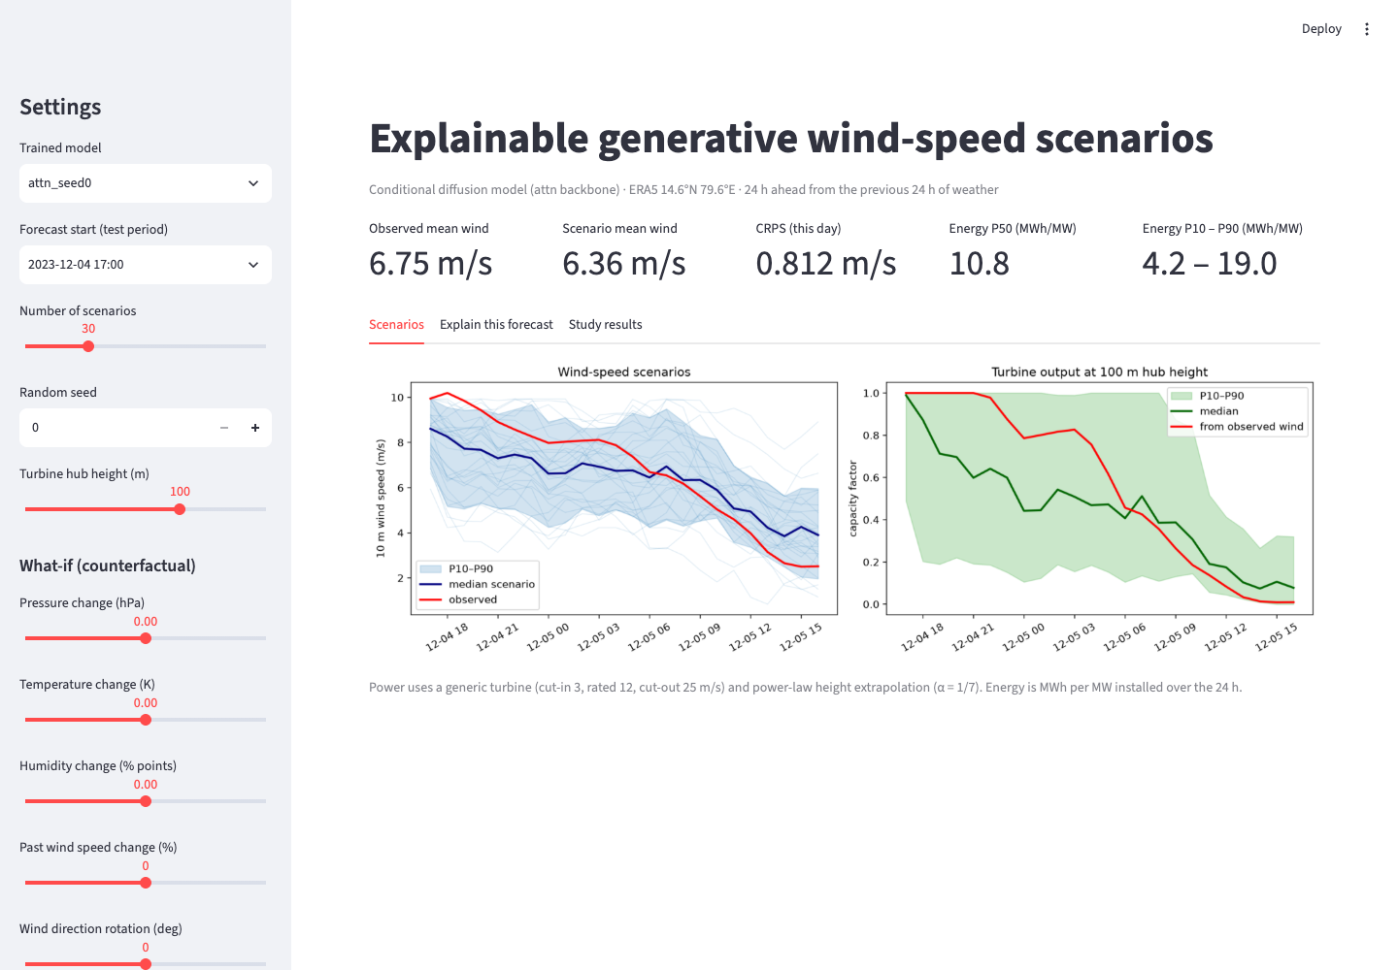
Figure 2. Application, Scenarios tab: wind-speed and power fan charts for the forecast starting 2023-12-04 17:00 (attention model, seed 0, 30 scenarios).
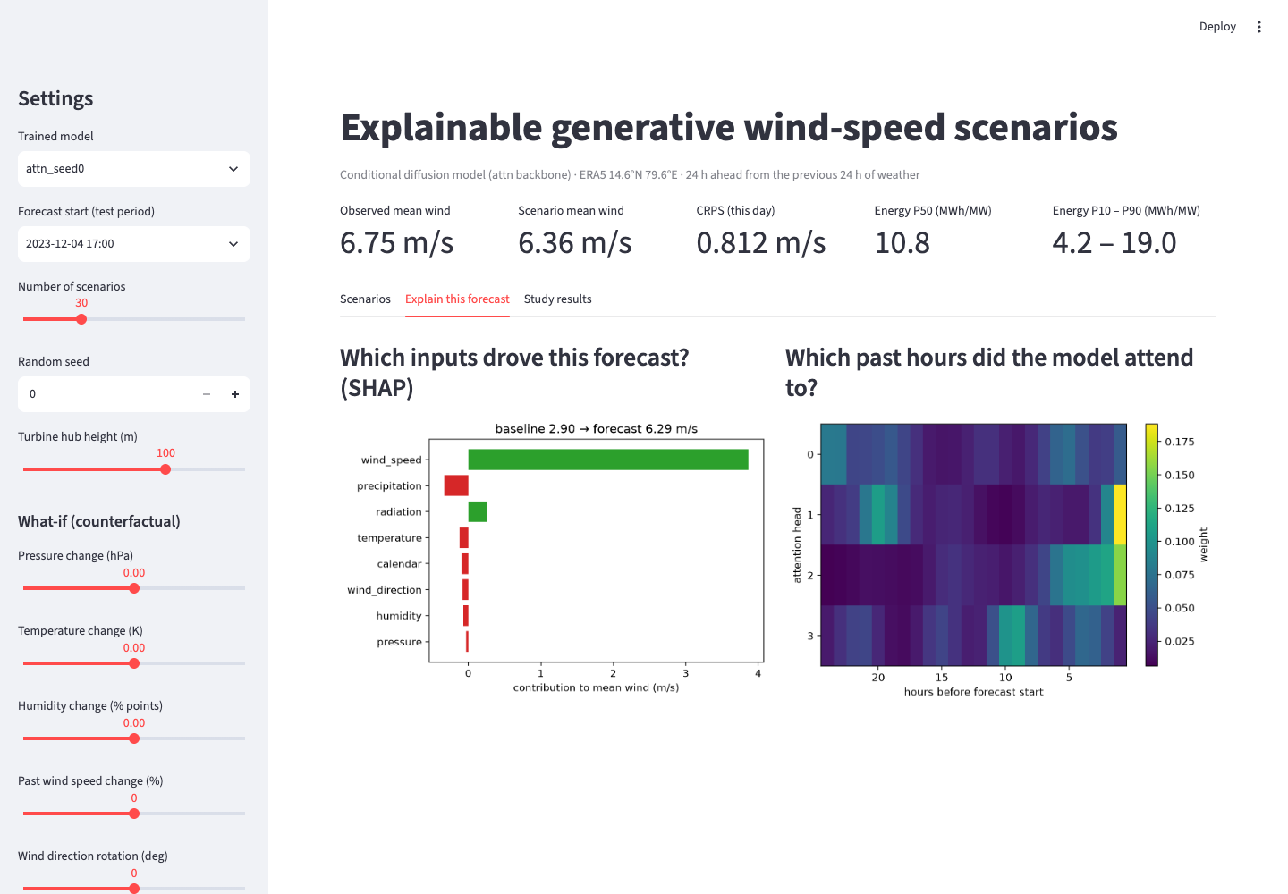
Figure 3. Application, Explain tab: per-forecast group Shapley values and attention by head and lag for the same forecast.

7. Results and Discussion
All results are for the test period (2021 onwards) and, unless stated otherwise, are the mean ± standard deviation over three seeds. The diffusion models are labelled diffusion_mlp and diffusion_attn. Figures are from the seed-0 runs.

7.1 Training behaviour
Figure 4 shows the training and validation noise-prediction loss of the attention model. Both decrease quickly in the first 500 steps and then level off; at step 3,000 the training loss is 0.218 and the validation loss 0.221. Across all six runs the final training loss is 0.213–0.219 and the final validation loss 0.220–0.222, so the gap is small and there is no sign of over-fitting. The initially higher training curve is a logging effect: each point is the average over the preceding 250 steps, which for the first point includes the untrained network.
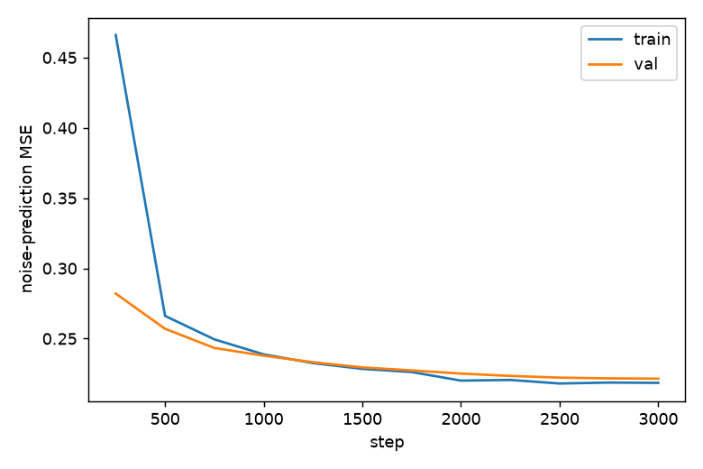
Figure 4. Training and validation loss of the attention diffusion model (seed 0).

7.2 Example scenarios
Figure 5 shows the 20 scenarios generated for the windiest test window of seed 0 (forecast start 2023-12-04 17:00, observed mean 6.75 m/s). The scenarios start near the last observed wind, fan out over the day and follow the observed decline in the second half. The observed trajectory stays within the envelope of the scenarios, although in the first 10 hours it lies in the upper part of the ensemble, so the scenario mean underestimates the wind early in the day.
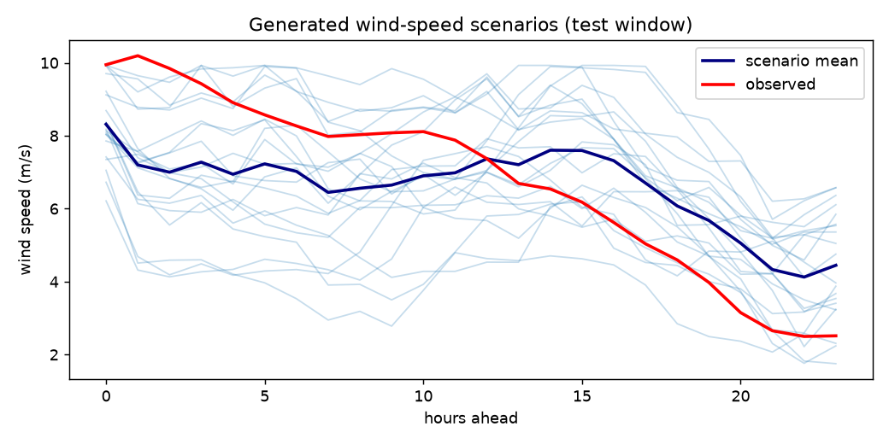
Figure 5. Generated scenarios (blue), scenario mean and observed wind speed for one test window (attention model, seed 0).

7.3 Forecasting accuracy
Table 7. Probabilistic and point accuracy on the test period (mean ± std over 3 seeds; best in bold).
Model | CRPS (m/s) | Energy score | MAE (m/s) | RMSE (m/s) | Power CRPS
Persistence | 0.624 ± 0.013 | 3.778 ± 0.070 | 0.624 ± 0.013 | 0.865 ± 0.021 | 0.0264 ± 0.0004
Climatology | 0.730 ± 0.006 | 4.195 ± 0.029 | 1.035 ± 0.008 | 1.315 ± 0.007 | 0.0320 ± 0.0003
Ridge + bootstrap | 0.413 ± 0.007 | 2.467 ± 0.041 | 0.553 ± 0.010 | 0.747 ± 0.014 | 0.0171 ± 0.0004
Diffusion (attention) | 0.406 ± 0.007 | 2.430 ± 0.037 | 0.556 ± 0.010 | 0.748 ± 0.015 | 0.0174 ± 0.0004
Diffusion (MLP) | 0.392 ± 0.005 | 2.355 ± 0.033 | 0.537 ± 0.009 | 0.726 ± 0.011 | 0.0167 ± 0.0002

Table 7 shows the main accuracy results. The MLP diffusion model is the best model on every accuracy metric. Its CRPS of 0.392 m/s is about 5 % lower than that of ridge regression (0.413 m/s), 37 % lower than persistence and 46 % lower than climatology, and its energy score (2.355 versus 2.467) shows that the improvement holds for whole trajectories as well as individual hours. The difference from ridge is about three times the seed standard deviation.
The attention model reaches a CRPS of 0.406 ± 0.007 m/s, which is only slightly better than ridge regression; the difference is about one seed standard deviation. Its point accuracy (MAE and RMSE) is the same as ridge within the seed spread. This is the price of its interpretable design: the history is compressed into a 64-dimensional attention summary instead of being passed to the network directly.
Because the seed standard deviations include differences in the test subsamples, Table 8 compares models on identical windows within each seed. The MLP model beats ridge in all three seeds by 4.3–5.3 %, and the attention model beats ridge in all three seeds by a small but consistent 1.4–1.7 %.
Table 8. Paired CRPS comparison on identical test windows (m/s; negative change = better than ridge).
Seed | Ridge | Diffusion (MLP) | Change | Diffusion (attention) | Change
0 | 0.4023 | 0.3849 | −4.3 % | 0.3965 | −1.4 %
1 | 0.4174 | 0.3953 | −5.3 % | 0.4102 | −1.7 %
2 | 0.4179 | 0.3968 | −5.0 % | 0.4110 | −1.7 %

7.4 Statistical similarity and diversity
Table 9. Statistical similarity and diversity (mean ± std over 3 seeds; lower distances are better).
Model | KS | W1 (m/s) | ACF distance | Ramp W1 (m/s) | Diversity (m/s)
Persistence | 0.007 ± 0.003 | 0.017 ± 0.006 | 0.0015 ± 0.0005 | 0.003 ± 0.000 | 0.000
Climatology | 0.030 ± 0.003 | 0.112 ± 0.011 | 0.0051 ± 0.0021 | 0.014 ± 0.000 | 1.666 ± 0.015
Ridge + bootstrap | 0.044 ± 0.004 | 0.089 ± 0.005 | 0.0022 ± 0.0003 | 0.030 ± 0.002 | 0.923 ± 0.002
Diffusion (attention) | 0.024 ± 0.003 | 0.054 ± 0.007 | 0.0091 ± 0.0049 | 0.047 ± 0.002 | 0.926 ± 0.006
Diffusion (MLP) | 0.027 ± 0.003 | 0.057 ± 0.005 | 0.0078 ± 0.0002 | 0.050 ± 0.002 | 0.901 ± 0.005

Table 9 gives a more mixed picture, which is reported here in full. Persistence has the smallest distances on all similarity metrics, but this is trivial: its scenario is real data shifted by one day, so its marginal distribution, autocorrelation and ramps are real by construction. It has no spread and is therefore useless for uncertainty assessment.
Among the probabilistic models, the diffusion models reproduce the marginal distribution best: KS distances of 0.024–0.027 and Wasserstein distances of about 0.054–0.057 m/s, compared with 0.044 and 0.089 m/s for ridge regression, whose added residuals distort the distribution, and 0.112 m/s for climatology.
The diffusion models are, however, worse at temporal structure. Their ACF distance (0.008–0.009) is about four times that of ridge regression (0.002), and their ramp Wasserstein distance (about 0.047–0.050 m/s) is higher than ridge (0.030 m/s) and climatology (0.014 m/s). In other words, individual generated trajectories are noisier from hour to hour than real wind. The likely reasons are that the denoisers output all 24 hours at once from a fully connected layer, with no built-in smoothness, and that 3,000 training steps with T = 100 leave some residual sampling noise. The ACF distance of the attention model also varies strongly between seeds (± 0.005). The baselines do better here because they copy real trajectories or real residual trajectories. Improving temporal realism is the most important technical item for future work.
The diversity of the diffusion scenarios (0.90–0.93 m/s per hour) is close to that of ridge regression, and much lower than climatology (1.67 m/s), which ignores the current weather. Whether this spread is appropriate is tested by calibration.

7.5 Uncertainty calibration
Table 10. Calibration (mean ± std over 3 seeds).
Model | Coverage of 90 % interval | Calibration error | Spread–skill ratio
Climatology | 0.901 ± 0.002 | 0.002 ± 0.001 | 0.957 ± 0.004
Ridge + bootstrap | 0.894 ± 0.004 | 0.006 ± 0.004 | 0.908 ± 0.016
Diffusion (attention) | 0.898 ± 0.002 | 0.005 ± 0.002 | 0.894 ± 0.011
Diffusion (MLP) | 0.900 ± 0.001 | 0.007 ± 0.002 | 0.896 ± 0.008

Table 10 shows that all probabilistic models are close to calibrated. The diffusion models' 90 % intervals contain 90.0 % (MLP) and 89.8 % (attention) of observations, and the average coverage error over four levels is 0.005–0.007. Persistence is not listed because a single scenario has no interval. The spread–skill ratios of 0.89–0.90 are below the value of about 0.98 expected for a calibrated 20-member ensemble, so the diffusion and ridge ensembles are slightly under-dispersed: their spread is a little smaller than their error. Climatology is well calibrated, but only because its intervals are very wide.
The rank histograms in Figure 6 are close to flat for all three probabilistic models (the dashed line is the ideal 1/21). For the diffusion model the lowest rank is slightly over-populated and the three highest ranks slightly under-populated, meaning the observation falls below all scenarios a little more often than it should and above all scenarios a little less often. This indicates a small tendency to over-forecast, rather than a U-shape from severe over-confidence [17]. Ridge and climatology show a similar, gentler downward slope.
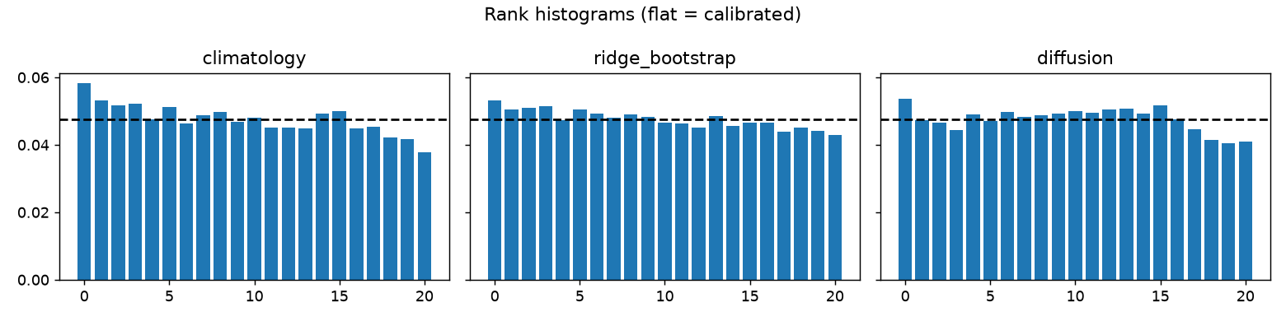
Figure 6. Rank histograms of climatology, ridge and diffusion (attention, seed 0) scenarios; flat = calibrated.

7.6 Evaluation in power space
After conversion to capacity factor (Section 4.7), the ordering of the best models is unchanged but the differences shrink: power CRPS is 0.0167 for the MLP diffusion model, 0.0171 for ridge and 0.0174 for the attention model (in units of rated power), against 0.0264 for persistence and 0.0320 for climatology. In each seed, the attention model is slightly worse than ridge in power space even though it is slightly better in wind space. The main reason is the low-wind site: most hours fall near or below the cut-in speed, where the power curve is flat at zero and differences in wind speed do not change power. The power results therefore confirm that the diffusion scenarios are usable for energy calculations, but they do not separate the best models clearly.

7.7 Explainability results

7.7.1 Feature-group importance (SHAP)
Table 11. Share of mean |SHAP| by feature group (%), seed 0 and mean ± std over 3 seeds.
Feature group | Attention, seed 0 | Attention, 3 seeds | MLP, seed 0 | MLP, 3 seeds
Wind speed | 70.3 | 64.9 ± 4.1 | 63.8 | 58.8 ± 3.6
Wind direction | 9.9 | 11.9 ± 1.4 | 7.1 | 8.6 ± 1.3
Radiation | 6.4 | 6.7 ± 1.0 | 9.0 | 9.0 ± 0.5
Calendar | 6.2 | 7.3 ± 2.5 | 2.8 | 4.6 ± 1.5
Temperature | 2.4 | 2.4 ± 0.4 | 8.6 | 7.5 ± 1.1
Humidity | 2.4 | 2.8 ± 0.6 | 3.5 | 3.9 ± 0.4
Pressure | 1.4 | 2.3 ± 0.7 | 4.3 | 4.8 ± 0.9
Precipitation | 1.1 | 1.7 ± 0.4 | 0.8 | 2.7 ± 1.3

Table 11, Figure 7 and Figure 8 show that past wind speed dominates the generated scenarios: it accounts for 64–70 % of the mean |SHAP| in the seed-0 runs and 56–70 % across all six runs. Its mean absolute Shapley value is about 0.85 m/s of mean generated wind (seed 0, both backbones). This is physically sensible, because wind speed is strongly persistent over a day.
The next most important groups are wind direction, solar radiation, temperature and the calendar, which together describe the regime (for example monsoon versus dry-season flow) and the diurnal cycle: radiation and temperature follow the sun, and the calendar gives the hour and season directly. The two backbones distribute this diurnal information differently: the attention model uses the calendar and direction more, while the MLP uses radiation and temperature more. Pressure (1–5 %), humidity and precipitation contribute little. A single grid point cannot observe the horizontal pressure gradient that actually drives wind, so a weak role for local surface pressure is expected.
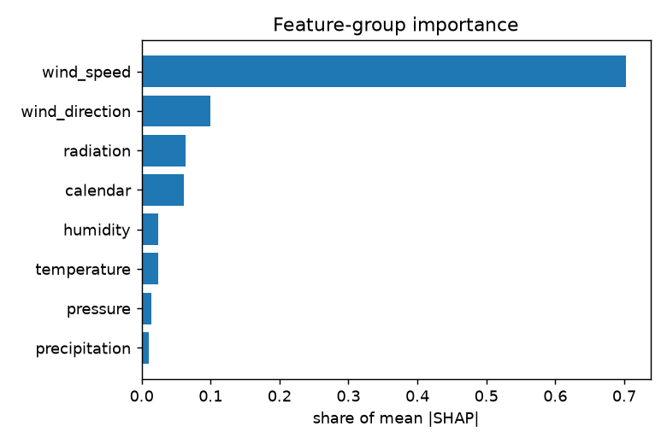
Figure 7. Global feature-group importance, attention model (seed 0).
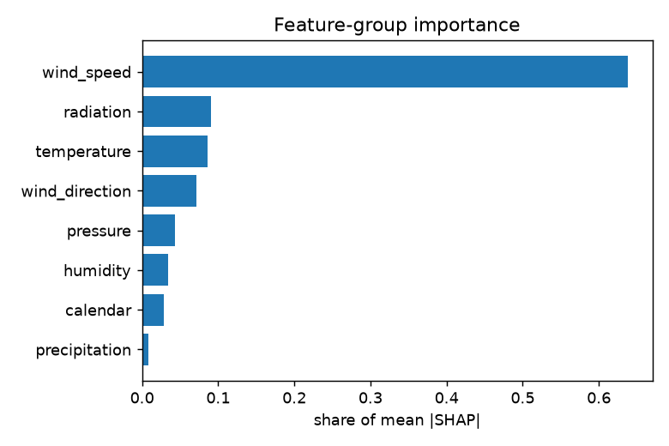
Figure 8. Global feature-group importance, MLP model (seed 0).

7.7.2 Temporal patterns: occlusion and attention
The occlusion analysis (Figure 9) shows that the most recent hour is by far the most important (25 % of the total effect in the attention seed-0 run, 13–25 % across runs), followed by the hour before (about 5–10 %). Smaller secondary peaks around 6–7 h and 14–15 h before the origin reflect the diurnal cycle.
The attention weights (Figure 10) show a clear division of labour between the four heads. Head 1 concentrates on the last one to three hours, with a weight of about 0.32 on the last hour (a uniform weight would be 1/24 ≈ 0.04). The other heads spread their attention more evenly over the day, with mild preferences for particular times of day. Averaged over heads, the last hour receives 11.7 % of the attention, the second-last 7.9 % and the third-last 5.8 %. In the other two seeds the same pattern appears, with one head focusing on the most recent hours (peak weights of 0.17 and 0.25 on the last hour).
Because the history can reach the attention model only through these weights, they are a direct description of what the model reads, not a by-product. They are also consistent with the independent, model-agnostic occlusion method: the Spearman correlation between attention shares and occlusion shares over the 24 lags is 0.81 ± 0.07 across seeds. This addresses the concern of Jain and Wallace [14] that attention may not reflect what actually drives the output.
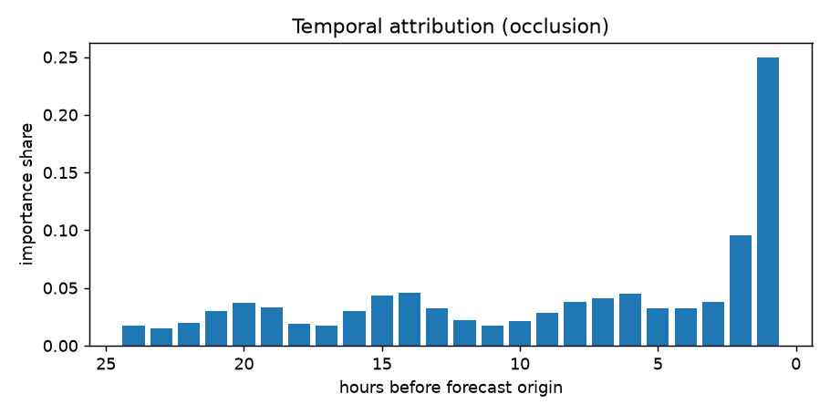
Figure 9. Temporal attribution by occlusion: share of the effect on mean generated wind by history hour (attention model, seed 0).
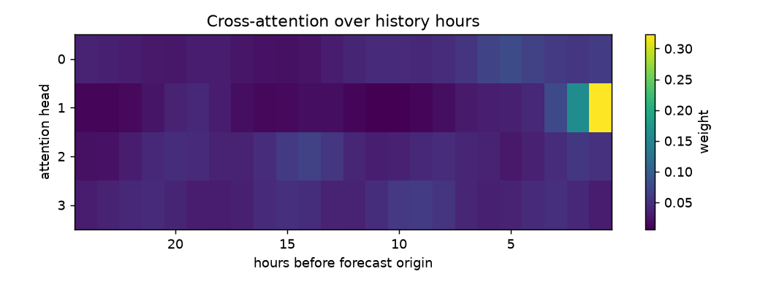
Figure 10. Cross-attention weights by head and history hour, averaged over denoising steps, scenarios and test windows (seed 0).

7.7.3 Counterfactual explanations
Table 12. Counterfactuals: change in mean generated wind (m/s) for the windiest test window.
Change applied to all 24 history hours | Attention, seed 0 | MLP, seed 0 | Range over 6 runs
Pressure −5 hPa (−500 Pa) | −0.265 | −0.331 | −0.33 to −0.15
Past wind speed +20 % | +1.093 | +0.888 | +0.88 to +1.09
Temperature +2 K | +0.002 | +0.003 | −0.19 to +0.11
Humidity +10 percentage points | +0.023 | +0.064 | +0.02 to +0.27
Radiation −30 % | −0.004 | +0.007 | −0.03 to +0.06
Smallest pressure drop giving −0.2 m/s | −400 Pa | −400 Pa | −400 to −700 Pa

Table 12 lists the counterfactuals. In seed 0 the windiest test window starts on 2023-12-04 at 17:00 and its history has a mean wind of 7.26 m/s; in seeds 1 and 2 the test subsample differs and the windiest window is a different day, which explains part of the spread in the last column.
Increasing past wind speed by 20 % (about +1.45 m/s on this day) raises the mean generated wind by 0.89–1.09 m/s, so the models pass on roughly 60–75 % of a change in recent wind, which is consistent with persistence decaying over the day. Lowering the pressure by 5 hPa lowers the generated wind by 0.27–0.33 m/s (seed 0), and the counterfactual search finds that a 4 hPa drop is the smallest pressure change that lowers the mean by 0.2 m/s. Temperature, humidity and radiation changes have almost no effect in seed 0, but their effect is not consistent between runs (for example −0.19 to +0.11 m/s for +2 K), so only the wind-speed and pressure counterfactuals should be relied on.
Figure 11 shows how the pressure counterfactual acts over the forecast horizon: the scenarios are unchanged at the start, which is dominated by the last observed wind, and the gap grows to about 0.4 m/s towards the end of the day. These counterfactuals describe the model's response to altered inputs. They are not causal statements about the atmosphere: a uniform shift of the pressure level at one point is not a physical scenario, and real wind responds to pressure gradients that one grid point cannot observe.
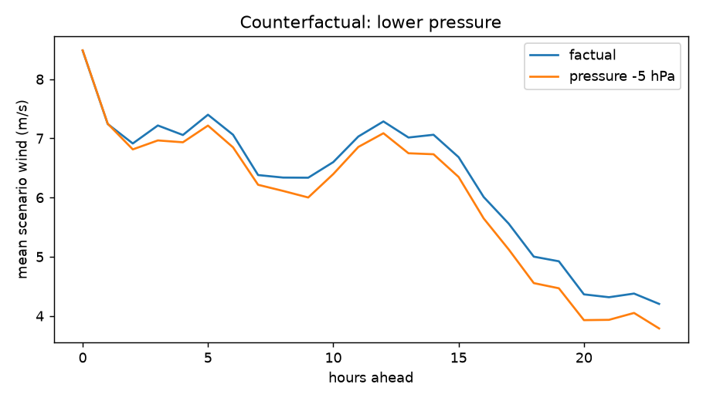
Figure 11. Counterfactual: mean generated wind for the factual history and with surface pressure lowered by 5 hPa (attention model, seed 0).

7.7.4 Quality of the explanations
Table 13. Explanation-quality metrics (mean ± std over 3 seeds).
Metric | Attention | MLP | Ideal
SHAP deletion faithfulness (Spearman) | 0.61 ± 0.06 | 0.67 ± 0.02 | 1
Top-1 deletion ratio | 3.91 ± 0.34 | 3.75 ± 0.57 | ≫ 1
SHAP stability (Spearman) | 0.88 ± 0.09 | 0.89 ± 0.05 | 1
Attention–occlusion agreement (Spearman) | 0.81 ± 0.07 | – | 1

Table 13 shows that the explanations are reasonably trustworthy. Removing the group ranked first by SHAP changes the output about four times as much as removing an average group, so SHAP identifies the dominant driver reliably. The overall ranking of the eight groups agrees moderately with their deletion effects (Spearman 0.61–0.67). Perfect agreement is not expected, because Shapley values average over all coalitions and background windows while deletion uses a single replacement by the mean, and the many small groups are hard to rank precisely. The importance ranking is stable when the explainer is rerun with a different background sample, permutation order and noise seed (Spearman 0.88–0.89), and attention agrees well with occlusion (0.81).
These numbers are computed from 12 explained windows and eight groups, so they are indicative rather than precise; the seed standard deviations (for example ±0.09 for attention stability) reflect this.

7.8 Discussion and delivery against the abstract
The results show a clear trade-off. The MLP diffusion model gives the most accurate and well-calibrated probabilistic scenarios, and is explained post hoc with SHAP, occlusion and counterfactuals. The attention model is slightly less accurate, only marginally better than a well-designed linear baseline, but it is interpretable by construction: its attention map shows which past hours were read for each forecast, and this map is confirmed by an independent method. Both diffusion models reproduce the distribution of wind speeds better than the baselines but generate trajectories that are rougher from hour to hour than real wind.
Table 14 maps each element of the submitted abstract to what was delivered.
Table 14. Delivery against the project abstract.
Abstract element | Delivered | Evidence
Generative model (conditional diffusion or GAN) | Conditional DDPM with MLP and attention backbones; GAN not implemented (reasons in Section 4.2) | Ch. 4; Table 3
Inputs: wind speed, temperature, pressure, RH, direction, atmospheric variables | Wind speed and direction, temperature, RH (from dew point), surface pressure, precipitation, solar radiation, calendar | Table 1
Multiple plausible trajectories | 20 scenarios per window in the study, 5–100 in the application | Figure 2, Figure 5
SHAP, attention analysis, counterfactuals | Group Shapley values, occlusion and attention by lag, counterfactuals and counterfactual search | Section 7.7
Dominant features and temporal patterns | Past wind speed dominant (56–70 %); last 1–3 h most important | Table 11; Figure 7–10
Statistical similarity, accuracy, diversity, calibration | 13 metrics, 5 models, 3 seeds | Table 7–10
Explainability metrics | Deletion faithfulness, top-1 ratio, stability, attention–occlusion agreement | Table 13
Planning, battery scheduling, operation, risk-aware management | Power conversion, power CRPS, P10/P50/P90 daily energy, what-if application (illustrative; no optimisation) | Section 7.6; Ch. 8

8. Applications
The framework produces scenarios, power estimates and explanations that can support the uses named in the abstract. This chapter describes how; the demonstrations are illustrative, because the power curve is generic and no scheduling optimisation was implemented.

8.1 Wind-farm planning
Scenario sets give a distribution of daily energy rather than a single number. Over many days, these distributions show how often a site produces little energy and how variable production is from day to day, which is useful at the planning stage alongside long-term resource assessment. The low-wind character of the studied grid point (mean 10 m wind about 2.7 m/s) is immediately visible in the power fan charts, where many hours are near the cut-in speed.

8.2 Battery scheduling
A battery operator must decide in advance how much energy to store or release. The application reports P10, P50 and P90 daily energy for the chosen forecast. For the forecast starting 2023-12-04 17:00 (attention model, 30 scenarios, 100 m hub height; Figure 2), the median is 10.8 MWh per MW installed and the P10–P90 range is 4.2–19.0 MWh per MW. A conservative schedule can plan on the P10 value and treat energy above it as opportunity, while the full set of trajectories can be passed to a stochastic scheduling model, which needs time-consistent scenarios rather than independent hourly quantiles. The energy score results (Table 7) are the relevant measure of trajectory quality for this use; the weaker ramp realism (Section 7.4) means that scenarios should be smoothed or checked before being used for ramp-sensitive decisions.

8.3 Power-system operation
Operators size reserves according to the uncertainty of renewable output. Calibrated scenarios provide quantiles of wind power for each hour of the next day, from which reserve requirements can be read directly. Because the 90 % intervals of the diffusion models cover 90 % of observations, quantile-based reserve rules would neither systematically over- nor under-provide, although the slight under-dispersion (spread–skill ≈ 0.90) suggests adding a small margin.

8.4 Risk-aware energy management and operator trust
The explanations make the scenarios easier to trust and to challenge. An operator can see that a forecast of strong wind is driven mainly by the last few hours of observed wind (SHAP and attention), and can test sensitivity with the what-if sliders, for example how the scenarios change if the recent wind had been 20 % weaker. If an explanation is implausible, for instance a large response to a variable that should not matter, this is a warning sign that the forecast should not be relied on.

9. Limitations and Future Work

9.1 Limitations
- Single location. The models are trained and tested at one ERA5 grid point; results may differ at other sites, especially at high-wind or complex-terrain sites.
- Reanalysis 10 m wind. ERA5 10 m wind is a model product on a coarse grid, not a hub-height measurement at a turbine. The power conversion uses a generic power law and a generic turbine curve, so power and energy values are illustrative.
- One horizon. Only 24-hour scenarios from 24 hours of history are studied.
- Model size. Because training is done in NumPy on a CPU, the denoisers are small (about 0.2 million parameters), trained for 3,000 steps, and the attention backbone has a single cross-attention layer rather than a full transformer.
- Temporal realism. The generated trajectories are noisier from hour to hour than real wind (ACF and ramp distances worse than the ridge baseline).
- Slight under-dispersion. Spread–skill ratios of about 0.90 indicate slightly too little spread.
- Explanations. Shapley values are estimated by sampling over 12 windows and 10 permutations; counterfactuals are model-based, not causal, and some (temperature, humidity) are not consistent between seeds.
- No GAN comparison was carried out, although the abstract mentioned GANs as an option.
- Test sample. Metrics are computed on 1,000 subsampled test windows per seed rather than every possible forecast start.

9.2 Future work
- Re-implement the denoiser in a deep-learning framework such as PyTorch and use a transformer or 1-D U-Net with temporal convolutions, which should improve smoothness and ramp realism.
- Generate spatially consistent scenarios for several sites or a whole region, and use hub-height or measured wind and a real turbine power curve.
- Compare with a conditional GAN and a normalising flow under the same protocol.
- Use the scenarios in a stochastic battery-scheduling or unit-commitment optimisation and measure the economic value.
- Correct the slight under-dispersion with conformal or post-hoc calibration.
- Extend explanations with more windows, conditional (observational) Shapley values and per-hour attributions.

10. Conclusion
This project set out to generate explainable probabilistic wind-speed scenarios from meteorological conditions. A conditional denoising diffusion model, implemented and verified from first principles, was trained on 76 years of hourly ERA5 data for a site in Andhra Pradesh and evaluated on unseen years from 2021 onwards against persistence, climatology and ridge-regression baselines.
With an MLP denoiser, the diffusion model produced the most accurate scenarios: CRPS 0.392 ± 0.005 m/s, about 5 % better than ridge regression in every seed, and energy score 2.355 against 2.467, with 90 % interval coverage of 0.900. With an attention denoiser in which the history is visible only through attention, it remained slightly better than ridge regression (CRPS 0.406 ± 0.007 m/s) while giving explanations by construction. Both diffusion models matched the marginal distribution of wind speed better than the baselines, but their trajectories were rougher from hour to hour than observed wind, which is the main weakness to address.
The explanations show that recent wind speed, especially in the last one to three hours, dominates the generated scenarios, with the diurnal cycle (radiation, temperature, calendar) and wind direction next and local surface pressure having little influence. The explanations were tested quantitatively: the top SHAP group has about four times the deletion effect of an average group, the ranking is stable across reruns (Spearman 0.88–0.89), and attention agrees with occlusion (Spearman 0.81). Converted to turbine power and presented in an interactive application, the scenarios can support planning, battery scheduling and risk-aware operation. The framework therefore delivers on the abstract, with a clear account of where it falls short.

References
[1] P. Pinson, “Wind energy: Forecasting challenges for its operational management,” Statistical Science, vol. 28, no. 4, pp. 564–585, 2013.
[2] T. Hong, P. Pinson, S. Fan, H. Zareipour, A. Troccoli, and R. J. Hyndman, “Probabilistic energy forecasting: Global Energy Forecasting Competition 2014 and beyond,” International Journal of Forecasting, vol. 32, no. 3, pp. 896–913, 2016.
[3] I. Goodfellow, J. Pouget-Abadie, M. Mirza, B. Xu, D. Warde-Farley, S. Ozair, A. Courville, and Y. Bengio, “Generative adversarial nets,” in Advances in Neural Information Processing Systems 27 (NeurIPS), 2014.
[4] Y. Chen, Y. Wang, D. Kirschen, and B. Zhang, “Model-free renewable scenario generation using generative adversarial networks,” IEEE Transactions on Power Systems, vol. 33, no. 3, pp. 3265–3275, 2018.
[5] J. Sohl-Dickstein, E. Weiss, N. Maheswaranathan, and S. Ganguli, “Deep unsupervised learning using nonequilibrium thermodynamics,” in Proc. 32nd International Conference on Machine Learning (ICML), PMLR vol. 37, pp. 2256–2265, 2015.
[6] J. Ho, A. Jain, and P. Abbeel, “Denoising diffusion probabilistic models,” in Advances in Neural Information Processing Systems 33 (NeurIPS), pp. 6840–6851, 2020.
[7] A. Q. Nichol and P. Dhariwal, “Improved denoising diffusion probabilistic models,” in Proc. 38th International Conference on Machine Learning (ICML), PMLR vol. 139, pp. 8162–8171, 2021.
[8] K. Rasul, C. Seward, I. Schuster, and R. Vollgraf, “Autoregressive denoising diffusion models for multivariate probabilistic time series forecasting,” in Proc. 38th International Conference on Machine Learning (ICML), PMLR vol. 139, pp. 8857–8868, 2021.
[9] Y. Tashiro, J. Song, Y. Song, and S. Ermon, “CSDI: Conditional score-based diffusion models for probabilistic time series imputation,” in Advances in Neural Information Processing Systems 34 (NeurIPS), 2021.
[10] L. S. Shapley, “A value for n-person games,” in Contributions to the Theory of Games II, H. W. Kuhn and A. W. Tucker, Eds., Annals of Mathematics Studies 28. Princeton, NJ: Princeton University Press, 1953, pp. 307–317.
[11] S. M. Lundberg and S.-I. Lee, “A unified approach to interpreting model predictions,” in Advances in Neural Information Processing Systems 30 (NeurIPS), 2017.
[12] E. Štrumbelj and I. Kononenko, “Explaining prediction models and individual predictions with feature contributions,” Knowledge and Information Systems, vol. 41, no. 3, pp. 647–665, 2014.
[13] A. Vaswani, N. Shazeer, N. Parmar, J. Uszkoreit, L. Jones, A. N. Gomez, Ł. Kaiser, and I. Polosukhin, “Attention is all you need,” in Advances in Neural Information Processing Systems 30 (NeurIPS), 2017.
[14] S. Jain and B. C. Wallace, “Attention is not explanation,” in Proc. 2019 Conference of the North American Chapter of the Association for Computational Linguistics (NAACL-HLT), pp. 3543–3556, 2019.
[15] S. Wachter, B. Mittelstadt, and C. Russell, “Counterfactual explanations without opening the black box: Automated decisions and the GDPR,” Harvard Journal of Law & Technology, vol. 31, no. 2, pp. 841–887, 2018 (preprint arXiv:1711.00399, 2017).
[16] T. Gneiting and A. E. Raftery, “Strictly proper scoring rules, prediction, and estimation,” Journal of the American Statistical Association, vol. 102, no. 477, pp. 359–378, 2007.
[17] T. M. Hamill, “Interpretation of rank histograms for verifying ensemble forecasts,” Monthly Weather Review, vol. 129, no. 3, pp. 550–560, 2001.
[18] H. Hersbach et al., “The ERA5 global reanalysis,” Quarterly Journal of the Royal Meteorological Society, vol. 146, no. 730, pp. 1999–2049, 2020.
[19] D. P. Kingma and J. Ba, “Adam: A method for stochastic optimization,” in Proc. 3rd International Conference on Learning Representations (ICLR), 2015.

Appendix A. How to Run the Project
The code is in the wind_scenarios folder. It needs Python with NumPy (≥ 1.24), pandas (≥ 2.0), SciPy (≥ 1.10), Matplotlib (≥ 3.7) and Streamlit (≥ 1.30). The four ERA5 files (wind.csv, temperature.csv, pressure.csv, radiation.csv) are placed in data/raw/.
pip install -r requirements.txt

# one run (about 1 minute on a laptop CPU)
python run_pipeline.py --data-dir data/raw --out-dir outputs

# full study: 2 backbones x 3 seeds, writes outputs/summary.md
python run_pipeline.py --data-dir data/raw --backbones attn mlp --seeds 0 1 2

# smoke test without data
python run_pipeline.py --synthetic --quick --out-dir /tmp/demo

# unit tests (85)
python -m unittest discover -s tests -t . -v

# interactive application
streamlit run app.py
Each run writes results.md and results.json (all metrics, explanations, training history and configuration), the trained model (diffusion_model.npz), the test windows and the figures; a multi-run study also writes summary.md and summary.json.

Appendix B. Configuration
Table 15. Configuration used for all reported runs.
Parameter | Value | Parameter | Value
History length (lookback) | 24 h | Diffusion steps T | 100
Forecast horizon | 24 h | Noise schedule | cosine, s = 0.008
Scenarios per window | 20 | Hidden layers × units | 3 × 256 (SiLU)
Training windows (max) | 60,000, stride 3 h | Attention | 4 heads × 16, position code 8
Validation windows | 1,754, stride 25 h | Optimiser | Adam, lr 10⁻³, clip 1.0
Test windows (max) | 1,000, stride 25 h | LR schedule | 100-step warm-up, cosine decay
Validation start | 2016-01-01 | Training steps / batch | 3,000 / 256
Test start | 2021-01-01 | EMA decay | 0.999
SHAP windows / permutations | 12 / 10 | Explainer scenarios | 8
SHAP background | 64 training windows | Seeds | 0, 1, 2

Appendix C. Per-run Results
Table 16. Diffusion-model results for each run on its test windows.
Run | CRPS (m/s) | Ridge CRPS | Energy score | Coverage 90 % | ACF dist. | Ramp W1 | Time (s)
attn, seed 0 | 0.3965 | 0.4023 | 2.377 | 0.901 | 0.0044 | 0.0475 | 36.9
attn, seed 1 | 0.4102 | 0.4174 | 2.456 | 0.897 | 0.0159 | 0.0490 | 37.5
attn, seed 2 | 0.4110 | 0.4179 | 2.456 | 0.897 | 0.0070 | 0.0449 | 37.1
mlp, seed 0 | 0.3849 | 0.4023 | 2.308 | 0.901 | 0.0079 | 0.0506 | 15.6
mlp, seed 1 | 0.3953 | 0.4174 | 2.375 | 0.900 | 0.0080 | 0.0515 | 15.5
mlp, seed 2 | 0.3968 | 0.4179 | 2.380 | 0.900 | 0.0076 | 0.0472 | 15.7

Runs with the same seed share the same training and test windows, so the ridge baseline is identical for the attention and MLP runs of a seed. The time is the complete pipeline run time recorded in each results file.

