|  |  |  |  |  |  |  |  |  |  |
| --- | --- | --- | --- | --- | --- | --- | --- | --- | --- |
| M5_ENCODER_A | TX5 |  | A14 | 33 | **TEENSY 3.6** | 32 | A13 | TX4 |  |
| M5_ENCODER_B | RX5 |  | A15 | 34 | 31 | A12 | RX4 | M2_DIR_PIN |
| M5_PWM |  | PWM | A16 | 35 | 30 | PWM |  | M2_PWM |
| M6_PWM |  | PWM | A17 | 36 | 29 | PWM |  | M2_LIMIT_SW_EXTEND |
| M6_ENCODER_A | SCL1 | PWM | A18 | 37 | 28 |  |  | M2_LIMIT_SW_FLEX |
| M6_ENCODER_B | SDA1 | PWM | A19 | 38 | 27 |  |  | M2_ENCODER_B |
|  |  |  | A20 | 39 | 26 |  |  | M2_ENCODER_A |
|  |  |  | DAC0 |  | 25 |  |  | M4_DIR |
|  |  |  | DAC1 |  | 24 |  |  | M4_ENABLE |
|  |  |  |  | GND | 3.3v |  |  |  |
| HEARTBEAT |  |  |  | 13 | 12 |  |  | M4_ENCODER_B |
| M4_STEP |  | PWM | A0 | 14 | 11 |  |  | M4_ENCODER_A |
| M4_LIMIT_SW_FLEX |  |  | A1 | 15 | 10 | PWM | TX2 | M1_LIMIT_SW_CCW |
| M4_LIMIT_SW_EXTEND |  | PWM | A2 | 16 | 9 | PWM | RX2 | M1_LIMIT_SW_CW |
| M3_ENABLE |  | PWM | A3 | 17 | 8 | PWM | TX3 | M1_ENCODER_B |
| M3_ENCODER_B |  |  | A4 | 18 | 7 | PWM | RX3 | M1_ENCODER_A |
| M3_ENCODER_A | SCL0 |  | A5 | 19 | 6 | PWM |  | M1_PWM |
| M3_DIR | SDA0 | PWM | A6 | 20 | 5 | PWM |  | M1_DIR |
| M3_STEP |  | PWM | A7 | 21 | 4 | PWM | SDA2 | PRESERVED FOR I2C |
| M3_LIMIT_SW_FLEX |  | PWM | A8 | 22 | 3 | PWM | SCL2 | PRESERVED FOR I2C |
| M3_LIMIT_SW_EXTEND |  | PWM | A9 | 23 | 2 | PWM |  | M1_ENABLE |
|  |  |  |  | 3.3v | 1 |  | TX1 | RESERVED FOR DEBUGGING |
|  |  |  |  | AGND | 0 |  | RX1 | RESERVED FOR DEBUGGING |
|  |  |  |  | VIN | GND |  |  |  |

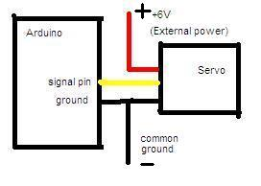

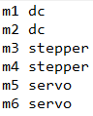6 encoder A (yellow)

6 encoder B (orange)

6 encoder V+ (red)

6 encoder Ground (black)

4 PWM (blue)

4 Direction (green)

2 Step (purple)

2 Enable (white)

NOTE: THE COMMON GROUND IS ONLY FOR PROTOTYPING PURPOSES. THE SERVO’S POWER AND LOGIC CONNECTIONS WILL BE ISOLATED IN THE FINAL DESIGN

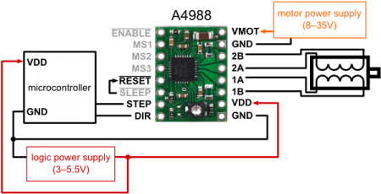 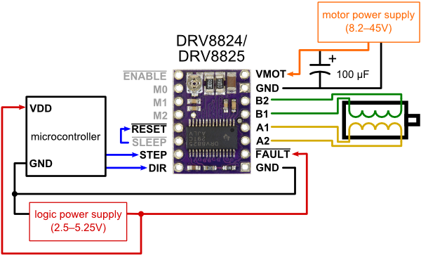

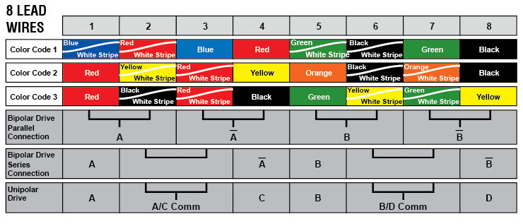

In our case, we’re using the series connection for the stepper motor.

