**Financial Narratives: Sentiment Analysis of SEC Filings**

Shrey Desai

Northeastern University

Boston, Massachusetts

desai.shrey@northeastern.edu

Ethan Virgil

Northeastern University

Boston, Massachusetts

virgil.e@northeastern.edu

Arjun Ramachandrula

Northeastern University

Boston, Massachusetts

ramachandrula.a@northeastern.edu

Mitchell Hornsby

Northeastern University

Boston, Massachusetts

hornsby.m@northeastern.ed

**Abstract**

The goal of this project was to analyze sentiment in financial data using Natural Language Processing (NLP) techniques, focusing on U.S. Securities and Exchange Commission (SEC) filings via the Edgar database. Data is extracted from 10-Q quarterly filings, focusing on the “Management Discussion and Analysis.” Our research suggests that we were successful in creating a bot that can analyze financial data and produce quality, coherent conversation on the topic. Users are able to engage with the bot and get real time, accurate and informed data.

**1 Introduction**

This project is interesting for a variety of reasons. It combines a few areas of extreme importance; something extremely important in our economy, and in the field of academic computer science, is combined with a real world easy to use solution. Financial information, particularly SEC filings, are incredibly difficult to understand [1]. Companies that do not have the best news to share in their filings have, in the past, intentionally obfuscated the nature of their filings in an attempt to make the company look better. The SEC has tried to crack down on this with “plain English” requirements, but filings are still incredibly verbose [2].

Building a solution to the problem of needlessly complicated financial filings was the central goal behind our project. We wanted to create a way for people to engage with this complex data without feeling overwhelmed, and that was a driving goal behind our project. From the start, we wanted to focus on data that is most likely to be relevant to users, this is what led to us focusing on the Dow Jones Industrial Average (Dow), which provides a industry standard for a variety of large companies that touch a plethora of parts of people’s lives, ranging from consumer electronics to fast food franchises [3]. Focusing on user comprehension, simplifying the complex financial data in SEC filings, and building a consistent functional pipeline from the filings to the UI was the core of the project.

This project compelled our team for a variety of reasons. Firstly, our development of this project allowed for us to better understand NLP, chatbots, generative text and how AI handles attention across long inputs, such as the multi year intervals of data we provided in this situation. We were also able to develop our understanding of things outside the scope of computer science, such as how financial data is handled, the rules and regulations around it, how it is structured, and how the general public can interact with SEC data. Finally, our group was able to refine our understanding of machine learning pipelines, as we built a fully functional application that required a functional and reliable pipeline from the EDGAR database, all the way to the UI where the user engages with the chatbot.

**2 Methodology**

Our methodology can best be broken down into three steps: the retrieval of data, the preprocessing and analysis of said data, and the deployment of the chatbot.

**2.1 Retrieval of data**

Data was retrieved through the *ProjectEdgarGetData.py* file. There are two libraries that we relied on: Project Edgar, and Yahoo Finance. This allowed us to collect and synchronize the underlying market data. Using the edgartools module, we initially fetch 10-Q and 10-K filings, extract the financial quantitative data using *get_prices()* and the Management Discussion & Analysis (MD&A) as text via the *get_mda_as_txt()* function. The data will be saved locally as CSV and TXT files for further use in the pipeline. To ensure comparability, the script will ensure that each filing date is adjusted to fall on a valid trading day. Extracted data allows us to easily see both the quantitative performance of a company as well as the qualitative analysis the management provides about the company.

**2.2 Preprocessing and analysis**

The preprocessing and analysis steps were mainly completed in the *sentiment_analysis.py* file. Here, the MD&A data is used to provide a clear analysis of management sentiment to be used in further sections of the pipeline. TXT file MD&A documents are vectorized using term frequency-inverse document frequency (TF-IDF), which was chosen to focus on distinctive words while reducing the influence of more common words that may be common among the legalese-esque rhetoric in MD&As. The TXT files are initially preprocessed and tokenized using NLTK’s *word_tokenize()*. Scikit-learn’s *TfidfVectorizer* is used to apply TF-IDF and extract feature names. FinBERT was integrated, which is designed to analyze the sentiment of financial documents [4]. Data is classified as negative, neutral, or positive, and stored as a dataframe.

**2.3 Deployment of chatbot**

The deployment of the chatbot was conducted through Streamlit, which allowed for efficient development and implementation of the interface [5]. Users can choose a stock ticker from a predefined list of DOW constituents. This will then fetch the MD&A texts, pass them through the pipeline, and provide a chat section to interact with the chatbot. The sentiment information is displayed both classified as negative, neutral, or positive, as well as an overall sentiment score. The user can engage with the chatbot which will provide real time information about the company’s “financial narrative.”

**3 Results**

The machine learning pipeline is successful and results in an extremely competent chatbot that is able to interact in real time and pull from the data from our financial sentiment analysis and provide impressive insight. Below is an example of a user interaction with the bot:

**User:** What do you think about Apple’s performance in the last year?

**Bot:** Based on the provided financial data, Apple showed strong performance in the last year. Total net sales increased significantly across various product categories like iPhone, Mac, iPad, Wearables, Home and Accessories, and Services. The company also released new products and continued to invest in stock repurchases and dividends. However, it’s essential to note that COVID-19 pandemic continues to pose uncertainties that could impact Apple’s operational and financial performance.

**User:** Give a detailed analysis of Apple’s performance in various markets across the last 3 years.

**Bot:** Based on the provided data from Apple’s quarterly reports over the last three years, here is a detailed analysis of Apple’s performance in various markets:

1. **iPhone Sales**:

* **2021**: iPhone net sales saw a significant increase in the third quarter of 2021 compared to 2020, mainly due to higher sales from new iPhone models.
* **2022**: There was a decrease in iPhone net sales in the third quarter and first nine months of 2022 compared to the same periods in 2021, primarily due to lower sales from certain iPhone models.
* **2023**: iPhone net sales continued to decline in the third quarter and first nine months of 2023 compared to 2022, attributed to lower sales of specific iPhone models.

1. **Mac Sales**:

* **2021**: Mac net sales increased in 2021, driven by higher sales of MacBook Air and iMac.
* **2022**: Mac net sales decreased in 2022, mainly due to lower sales of laptops.
* **2023**: Mac net sales continued to decrease in 2023, primarily due to lower sales of MacBook Pro.

1. **iPad Sales**:

* **2021**: iPad net sales increased in 2021, primarily due to higher sales of iPad Air, iPad Pro, and the 10-inch version of iPad.
* **2022**: iPad net sales decreased in 2022, primarily due to lower sales across most iPad models.
* **2023**: iPad net sales were relatively flat in the first nine months of 2023 compared to the same period in 2022.

1. **Wearables, Home, and Accessories**:

* **2021**: Sales in this category increased in 2021, driven by higher sales of Apple Watch and accessories.
* **2022**: Sales slightly increased in 2022 in the third quarter but decreased in the first nine months due to lower sales of wearables and accessories.
* **2023**: Sales increased in the third quarter of 2023 primarily due to higher sales of Wearables, including AirPods, Apple Watch, and Beats products.

1. **Services**:

* **2021**: Services net sales increased in 2021, driven by higher sales from advertising, the App Store, and AppleCare.
* **2022**: Services net sales continued to increase in 2022, primarily due to higher sales from advertising, cloud services, and the App Store.
* **2023**: Services net sales increased in 2023, mainly due to higher sales from cloud services, advertising, and music.

The sentiment analysis also shows an interesting pattern between how inconsistent management sentiment can be a potential indicator for poor stock performance. Overall, the vast majority of subjective analysis from management was positive, regardless of stock performance. Disney (DIS) is a good example of inconsistent messaging reflecting on poor stock performance. While the sentiment of their MD&A sections tend to be positive, quarter of quarter there is inconsistent messaging, with almost half of all the data we analyzed showing neutral sentiment. It is important to contextualize this with the fact that management has a massive incentive to make their MD&A sections more positive than they actually are, and that this much neutral sentiment more than likely corresponds to negative impact on the company than management is implying. This can be seen in their stock performance over the same period of time, which shows a consistent downtrend in the recent quarters despite the lack of negative sentiment in MD&As. Other companies that are consistently positive in their sentiment, or do not share the same lack of consistency as DIS, do not have this downward trend. 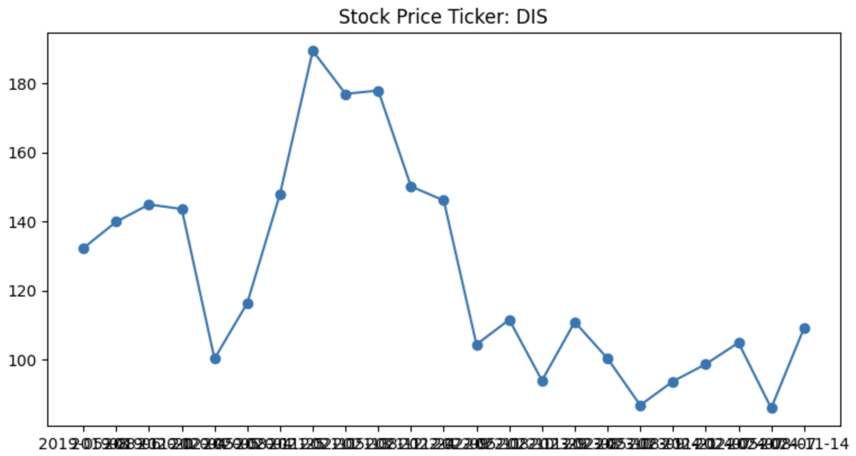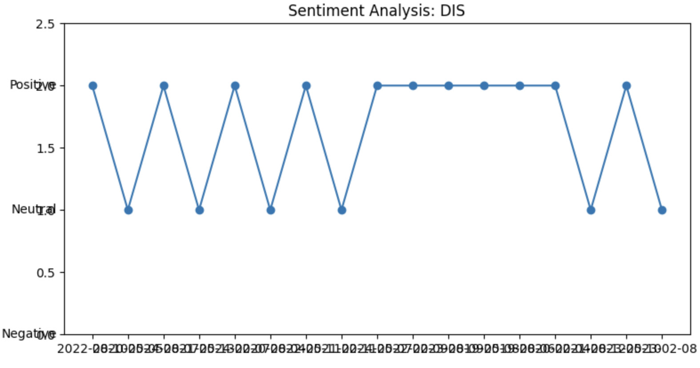

**4 Discussion**

If we had more time to work on this project, or if we were to continue it in the future, either academically or in our own intellectual pursuits, there are a few key items we would want to focus on. The goals we would have in future work can be broken down into the following issues:

* Increasing the time interval that is analyzed.
* Increasing the amount of companies that the chatbot can discuss.
* Provided more context to the chatbot outside of SEC filings.

Increasing the time interval that is analyzed would allow for a more robust chatbot that would be able to give financial advice more accurately as it relates to trends over larger periods of time. Analyzing how a business performs over a three year period is extremely helpful, as it will capture the immediate issues they may be facing; however, in order to properly analyze a business, looking at performance for at least a decade is essential to confirm that the trends of the business are due to their own performance instead of larger macroeconomic issues [6].

The number of companies that the chatbot is able to provide analysis for is currently limited to the DOW. In a larger application, we would want this to be increased significantly. Given how our ML pipeline is currently designed, a proposed solution would be having users input a ticker and run the entire pipeline; however, this would be significantly computationally intensive, not to mention the potential time costs this would take. While there is not a specific immediate next step, and while the DOW is a great starting point to get a diversity of large companies, it does not hold a candle to the massive amount of total stocks available, with the New York Stock Exchange (NYSE) having over 2,000 [7].

Finally, we would want to provide the chatbot with increased context, instead of limiting it to the existing SEC filings. The three largest areas would be: newsmedia, legal, and academic reports. News would provide more subjective analysis of how a company is performing, especially when compared with the management’s sentiment provided in the 10-Qs. Legal documents would allow for better context when regarding upcoming potential impacts on companies, such as large fines and/or regulation overhauls that make their operations cheaper. Finally, academic analysis would provide more context on the macroeconomic scale that would make the financial analysis offered more realistic.

**5 Conclusion**

Overall, our project was successful in developing a chatbot in tandem with a machine learning pipeline that will pull data from the EDGAR database, analyze the 10-Q filings’ sentiment, and establish a coherent conversation with users on the financial data. It is able to provide extremely helpful, clear cut, and easy to comprehend financial analysis. In the future, we would like to implement a larger context window for the chatbot, expand the types of data it is analyzing to newsmedia, academia, and beyond, and provide a wider range of companies to analyze in addition to the DOW.

**6 Acknowledgement**

This project was completed for CS6120 at Northeastern University, instructed by Professor Uzair Ahmad.

**7 References**

[1] C. W. Ricci and S. O. Gavin, "Checking the Checkers: Evaluating the Readability of the SEC's Plain English Documents," *Quarterly Journal of Finance and Accounting*, vol. 60, no. 3/4, pp. 79-100, Summer & Fall 2022. [Online]. Available:<https://www.jstor.org/stable/27224940>. [Accessed: Dec. 5, 2024].

[2] "Frequently Asked Questions Concerning the Plain English Rule of the U.S. Securities and Exchange Commission," *FindLaw*, [Online]. Available:<https://corporate.findlaw.com/corporate-governance/frequently-asked-questions-concerning-the-plain-english-rule-of.html>. [Accessed: Dec. 5, 2024].

[3] "Dow 30," *CNBC*, [Online]. Available:<https://www.cnbc.com/dow-30/>. [Accessed: Dec. 5, 2024].

[4] D. Araci, Z. Genc, "FinBERT: Financial Sentiment Analysis with Pre-trained Language Models," *Hugging Face*, Aug. 2019. [Online]. Available:<https://huggingface.co/ProsusAI/finbert>. [Accessed: Dec. 5, 2024].

[5] “Streamlit Documentation,” *Streamlit*. [Online]. Available:<https://docs.streamlit.io/>. [Accessed: Dec. 5, 2024].

[6] R. Haltom, T. A. Lubik, C. Matthes, and F. Verona, "Moving Macroeconomic Analysis beyond Business Cycles," *Economic Brief*, no. 19-04, Federal Reserve Bank of Richmond, Apr. 2019. [Online]. Available:<https://www.richmondfed.org/publications/research/economic_brief/2019/eb_19-04>. [Accessed: Dec. 5, 2024].

[7] “Market Statistics,” *Focus - World Federation of Exchanges*, Sep. 2024. [Online]. Available:<https://focus.world-exchanges.org/issue/september-2024/market-statistics>. [Accessed: Dec. 5, 2024].