# 

# Final Project Proposal

## Shaders in Graphics Programming: An application developed in Unity to showcase my knowledge of Shaders.

**Overview**

As part of my degree study the main area I have become interested in is graphics programming, specifically shaders. Shaders are pieces of code containing mathematical calculations and algorithms to calculate rendered pixel colour based on lighting and appearance instructions (Technologies, 2018)

Shaders are used to determine the surface texture of an object to get as close to looking like real life. By altering the appearance of objects with shaders they can appeal to different audiences. (Smith, Brown and Summers, n.d.)

I will be making an application in Unity to showcase several shaders of varying styles applied to models to explore the relationship between various gameplaying demographics and game aesthetics.

**Rationale**

I intend to explore how the use of shaders adds a new dimension to the game by altering the way the user interacts with the application. Shaders can be used to alter gameplay by giving a different feel to a scene, for example, in a game where the player goes back in time, a shader could be applied to change the colour to fit the time period they went back to, or if the player didn’t change time periods one possibility could be to add a greyscale effect to show the player that they are not in the present.

Another example of shaders affecting gameplay could be within a FPS game. If the FPS had a realistic shader on, the game would be more violent and some players might have a harder time shooting characters, whereas if the FPS had a cartoon shader applied to it, the game wouldn’t look realistic and those same people might find it easier to play.

I am interested in discovering whether the variety of shaders within a game attracts a wider demographic. It is my belief that light and cartoon shaders would attract more female and younger players, whereas a darker more realistic shader is more likely to attract male players. Plutchik (2001), Oberascher and Gallmetzer (2003), and Valdez (1994) stated that every basic emotion can be linked to a colour, the way different colours are implemented within a game can produce significant effects on the emotions the player feels and the way the player progresses within the story.

|  |  |
| --- | --- |
| **Emotion** | **Colour** |
| Surprise | Light Blue |
| Fear | Dark Green |
| Acceptance | Light Green |
| Joy | Yellow |
| Anticipation | Orange |
| Anger | Red |
| Disgust | Purple |
| Sadness | Dark Blue |

Table 1: Emotions and corresponding colours as identified by Plutchik (2001). The colours and emotions in italics are those used in the present research.

I intend to conduct questionnaires and visual comparison sessions to obtain this information. After I have created the application I will create a questionnaire that will show an object with three different shaders applied, the order of images of what they prefer, their age and their sex.

A negative aspect of the use of shaders was highlighted in the game Destiny 2. Players of the game were left with an abundance of unwanted shaders, which according to *eurogamer.net* Destiny 2 players collectively spent twenty-five years deleting the shaders from their account. (Eurogamer.net, 2018)

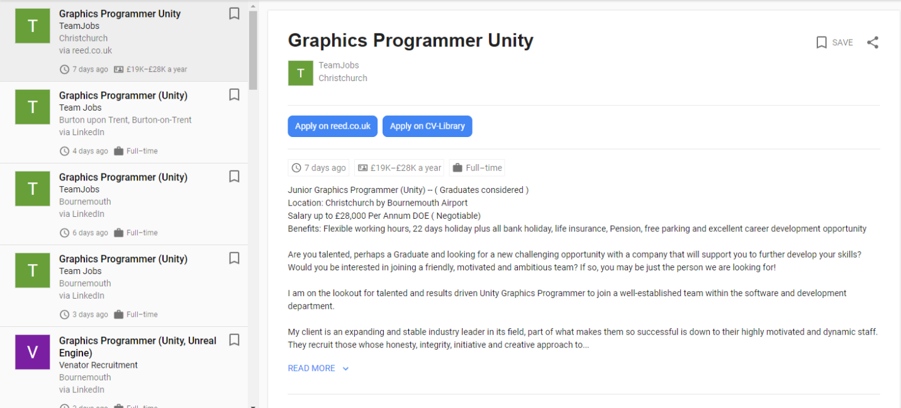**Employment opportunities**

From a recent search on popular job sites, It is apparent that there are numerous graduate Graphics programmer jobs. By working on this project and improving my knowledge I will expand my portfolio making me more attractive to prospective employers.

**Methodology**

I will start by creating the application in Unity which involves an original model followed by a series of three models each with a different shader applied. After I have made the application, I will create a questionnaire showing each shader applied to the model and request order of preference, age and sex. The results from this one hundred random person survey will be analysed to identify preferences.

**Examples of shaders and their application**

(I.ytimg.com, 2018) 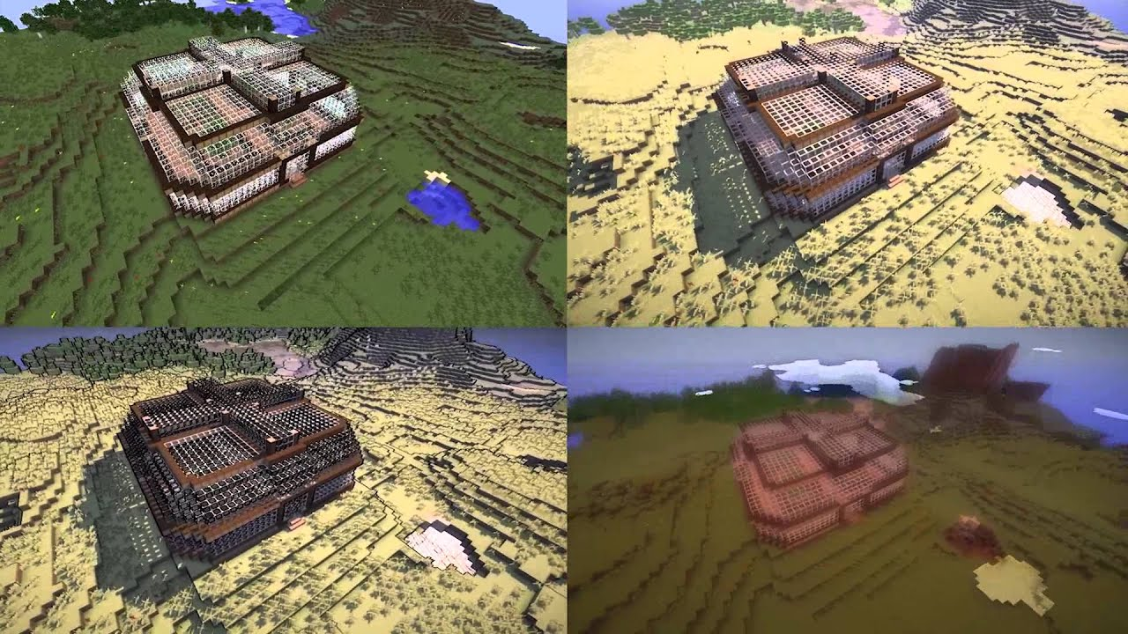

The practical application of shaders includes applying different shaders to different conditions for example when a player in a game gets poisoned; sustains an injury; showing different time lines (past and present); a dream state. This list is not exhaustive.

The above image is an example of how shaders can be applied to manipulate a scene within an application to produce different effects.

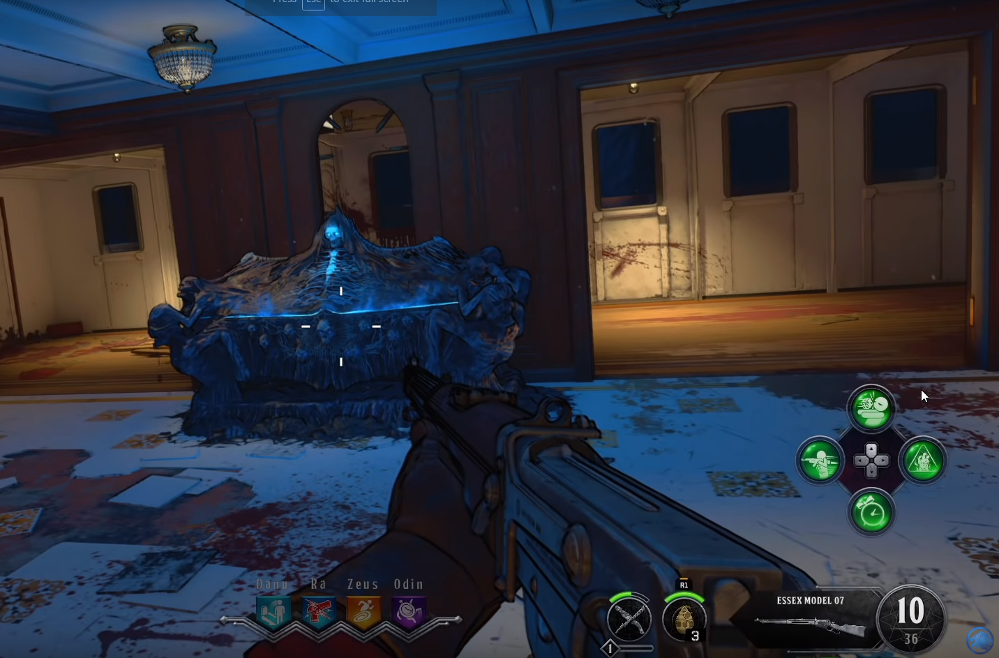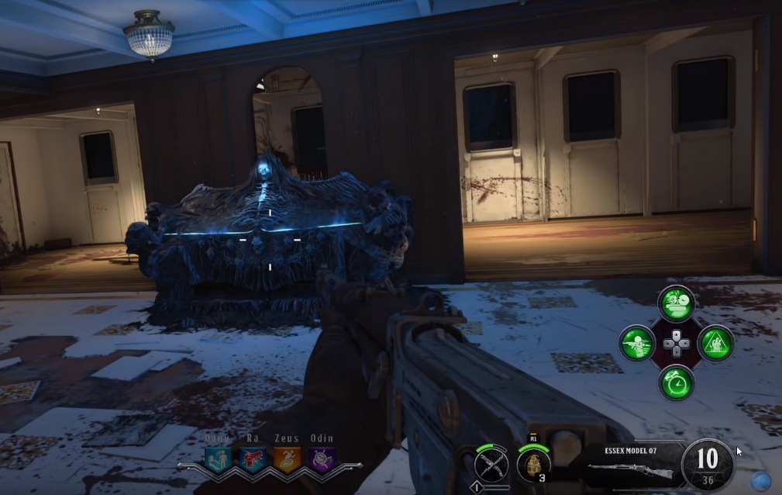In the latest version of Call of Duty: Black Ops 4 in the Zombie mode, there is an option within the settings to turn on cell shading to give the game a cartoon like look and reduce gore, thus making its appeal wider. (YouTube, 2018)

**Management software**

Throughout the development of this application Jira will be utilised to monitor the progress of individual tasks for the current week. This is crucial to keep on top of the workload and to make sure I have a clear understanding of what needs to be achieved. Using a three step minimum viable product (MVP) I will first create a basic model as a foundation, secondly I will create the shaders to improve on the original model and thirdly through communication and feedback I aim to make the product more appealing to a wider audience.

GitHub will be used as a version control software and a place to upload and keep all of my work so it is easily accessible to anyone who wants to view the project.

Finally I will be using a development blog to keep track of and update people on the work I have done on the project each week. The blog will include descriptions and images detailing progress and changes to the project. The blog is a useful tool to keep people up to date.

Overall wordcount: 929 words.

Student Name: Ethan Ward-Taylor

Proposed Final Project title: Shaders in Graphics programming: An application developed in Unity to showcase my knowledge of shaders.

Development Blog URL: https://ethanwardtaylor.weebly.com/final-project

**Annotated Bibliography**

|  |  |  |
| --- | --- | --- |
|  | **Bibliographical item** | **Summary** |
| 1. | Eurogamer.net. (2018). *Why shaders are still driving Destiny 2 players mad*. [online] Available at: https://www.eurogamer.net/articles/2018-09-08-why-destiny-2s-shaders-are-still-driving-players-mad [Accessed 5 Nov. 2018]. | An article with a negative view on shaders. |
| 2. | Google.co.uk. (2018). *unity graphics programming jobs*. [online] Available at: https://www.google.co.uk/search?q=unity+graphics+programming+jobs&rlz=1C1CHBF_en-GBGB733GB733&oq=unity+graphics+programming+jobs&aqs=chrome..69i57.8741j0j7&sourceid=chrome&ie=UTF-8&ibp=htl;jobs&sa=X&ved=2ahUKEwjLt7jY6MTeAhVLJcAKHdYZA4UQiYsCKAF6BAgGECQ#fpstate=tldetail&htidocid=XGa7wor48YbWKsCJAAAAAA%3D%3D&htivrt=jobs [Accessed 5 Nov. 2018]. | Undergraduate Jobs in Unity Programming for graphics. |
| 3. | I.ytimg.com. (2018). [online] Available at: https://i.ytimg.com/vi/-MIHylJB8bU/maxresdefault.jpg [Accessed 5 Nov. 2018]. | Image with shader comparison. |
| 4. | Oberascher L. and Gallmetzer M. 2003. “Colour and emotion.” Proceedings of AIC 2003 Bangkok: Color Communication Management, 370-374. | Journal Article linking colours and emotion |
| 5. | Plutchik, R. (2001). The Nature of Emotions. *American Scientist*. 89 (1), 344-350. | Journal Article linking colours and emotion |
| 6. | Smith, S., Brown, N. and Summers, S. (n.d.). *Toy story*. New York: Bloomsbury Academic, p.82. | Article describing how shaders are used. |
| 7. | Technologies, U. (2018). *Unity - Manual: Writing Shaders*. [online] Docs.unity3d.com. Available at: https://docs.unity3d.com/Manual/ShadersOverview.html [Accessed 5 Nov. 2018]. | The unity documentation describing what a shader is. |
| 8. | Valdez, P. and Mehrabian, A. 1994. “Effects of colour on emotions.” Journal of Experimental Psychology, 123, 394-409 | Journal Article linking colours and emotion |
| 9. | YouTube. (2018). *Black Ops 4 Zombies: 'VOYAGE of DESPAIR' First Live Attempt! w/Syndicate!*. [online] Available at: https://www.youtube.com/watch?v=PB2d5hcoSI4 [Accessed 5 Nov. 2018]. | This is the video where I got the Call of duty comparison screen shots. |

APPENDIX B

|  |  |  |
| --- | --- | --- |
| **Use this grid to plan your project milestones** | | |
| **2018–19** | **Week #** | **Milestone Deliverables and Tasks** |
| 24 – 28 Sept | Week 1 | Look into the different areas I am interested in. |
| 1 – 5 Oct | Week 2 | Pick the area I am interested in |
| 8 – 12 Oct | Week 3 | Talk to my lecturer about Programming for Graphics |
| 15 – 19 Oct | Week 4 | Look more into Graphics to pick a field within that subject |
| 22 – 26 Oct | Week 5 | I have picked shaders to base my dissertation on |
| 29 Oct – 2 Nov | Week 6 | Write my dissertation proposal |
| 5 – 9 Nov | Week 7 | Submission of Final Project Proposal: by noon, Friday 10 Nov 2018 |
| 12 – 16 Nov | Week 8 | Start development of the application |
| 19 – 23 Nov | Week 9 | Add in a basic model to the unity scene that rotates |
| 26 – 30 Nov | Week 10 | Work on the first shader |
| 3 – 7 Dec | Week 11 |  |
| 10 – 14 Dec | Week 12 | Work on the second shader |
| 17 – 21 Dec | **Mid-Winter Festival** | |
| 24 – 28 Dec |
| 31 Dec – 4 Jan |
| 7 – 11 Jan | Null |  |
| 14 – 18 Jan | Null |  |
| 21 – 25 Jan | Week 13 | Work on the third shader |
| 28 Jan – 1 Feb | Week 14 |  |
| 4 – 8 Feb | Week 15 | **Seminar Presentations TBC** |
| 11 – 15 Feb | Week 16 | **Seminar Presentations TBC** |
| 18 – 22 Feb | Week 17 | Finalise the application and make sure it is suitable to be given to people to look at |
| 25 Feb – 1 Mar | Week 18 | Create the questionnaire |
| 4 – 8 Mar | Week 19 | Hand out the questionnaire and ask people |
| 11 – 15 Mar | Week 20 |  |
| 18 – 22 Mar | Week 21 | Collect the data from the questionnaire |
| 25 – 29 Mar | Week 22 | Collate the information into one final document |
| 1 – 5 Apr | Week 23 |  |
| 8 – 12 Apr | Week 24 | Submission of Final Product and Blog: by noon, Friday 12 Apr 2019 |
| 15 – 19 Apr | **Spring Fertility Festival** | |
| 22 – 26 Apr |