Micrograd Library

Micrograd is a tiny autograd engine (automatic differentiation) that builds a computation graph during the forward pass and then uses backpropagation + chain rule to compute gradients automatically.

Learning how to make “Micrograd” library from scratch is good choice to learn core concepts of AI. With this library you can learn basic concepts of Neuron, MLP and Layers related to Deep Learning.

Before starting the paper, I am going to say huge thanks for Dr Andrej Karpathy. His “Zero to Hero” open-source course help us to learn AI. He spends more than 10 hours to create one hour of his online lecture. Thanks.

In order to cover all materials, you must know python programming language with OOP, Derivatives and The Chain Rule from calculus. We are going to make four main classes and one method to visualization. They are Value, Neuron, Layer, MLP classes and graph visualization using dot (Graphviz). I will explain each classes separately. All code examples are written in a Jupyter Notebook. You can get code base at the end of paper, in useful links session. Before reading the paper, watching the whole course of Micrograd by Andrej Karpathy is recommended. This might help you to understand more and more complex topics and ideas.

Value Class

Value class can calculate complex operations. The class can do following mathematical operations:
- addition, subtraction, multiplication, division, power of number, negotiation.
- e^{x}.
- backpropagation.
Here is main structure of the library
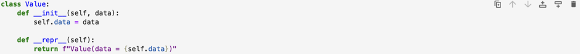

There is a class called Value, inside the class there is two methods __init__ and __repr__. They used for initialize the class and represent the data respectively. I am going to use the term “initializer” in order to represent the method __init__. Next step is, develop the initializer.
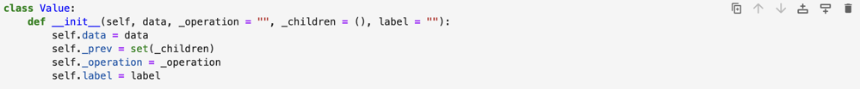

As you can see there is four new properties added. They are, data to store the actual numeric value (either user input or the result of an operation), _operation to record the operation used to create the value (e.g., +, -, tanh, exp), _children to store the parent values that produced the value, allowing us to trace how it was created, label to identify values for debugging and visualization.

Addition – Subtraction – Multiplication – Division features
Addition feature
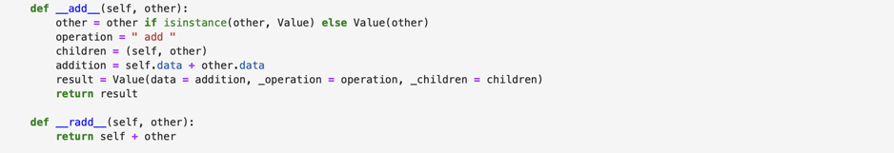

By default, the __add__ method is going to calculate all addition operations. When you add the objects of Value class, Python will automatically identifies the operation and calls __add__ method. You can add float or integer values to a Value object, the class can calculate it easily. You cannot directly add Value object to float or integer values. In this situation, __radd__ (right add) method going to solve the issue. What it does is swap the operands. For example, integer + Value is redirected to Value + integer and recalculated using __add__ method. The following screenshot illustrates this behavior:
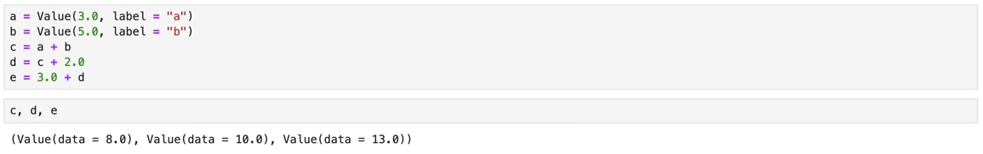

In this section, we explain the screenshot above. There are two Value objects, a and b, each with label. The variable c stores the result of adding two Value objects. Because of the “+” operator, Python automatically determines that __add__ method should be used. This is the core concept behind addition. Let’s look at the structure of __add__ method. In the first line, we used simple conditional check. If you remember from examples, there was a quote that mentioned – “You can add integer or float values to Value object”. First line is helping us to add integer or float values to Value object. It converts numeric values into Value object. The name of operation is stored in the variable called “operation”, parent nodes stored in the variable and called “children”. The actual operation is computed and stored in to variable called “addition”. The final result is converted into a Value object with its data, children and operation. Finally, the result is returned. If this is unclear, read the explanation again. Do not rely on these instructions. Read the explanation and rethink about explanations on your mind. Sometimes, thinking might help to understand more than reading the instructions.

Multiplication feature
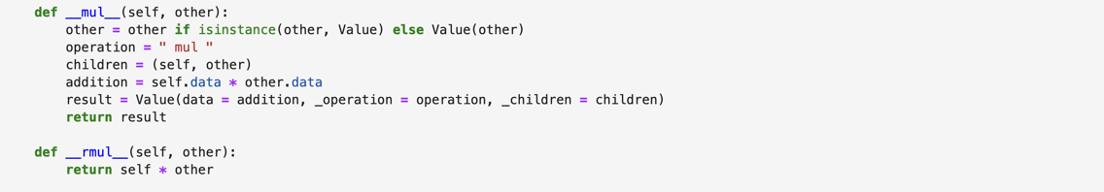

The __mul__ and __rmul__ methods work in exactly same way as __add__ and __radd__. The only difference is that the operation performed is multiplication instead of addition. Therefore, we will focus only on the parts that change. You can see the example of usage on the screenshot.

Subtraction feature
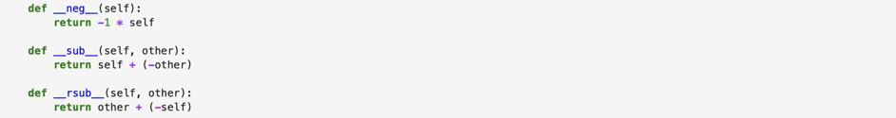

Subtraction feature is a bit more complex, because it builds using combination of different methods. Before diving into structure of the method, let’s first understand how it works mathematically. Imagine, there is an equation
$a=b-c$.
In mathematically, we can represent it with addition operator using negotiation:
$a=b+(-c)$.
When you subtract two Value objects, Python will automatically call __sub__ method. This method depends on __neg__ and __add__ methods. First it will call __neg__ method to negotiate the second variable and then calls __add__ method to for calculation. You can subtract two Value objects or subtract integer or float values from Value object. When it comes to subtract Value object from integer or float values, Python will use __rsub__ method instead. The method __rsub__ behaves same as __rmul__ and __radd__. Here is an example.
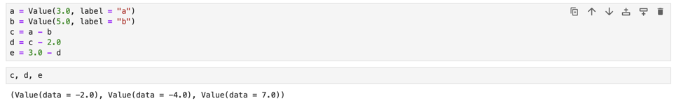

Method __neg__ is used to compute negative value of any object. For example, if an object a = 5, if you can __neg__(a) it will return -5. Because of an operator “-”, Python will identify that, it is subtraction operation, that’s it.
Division feature
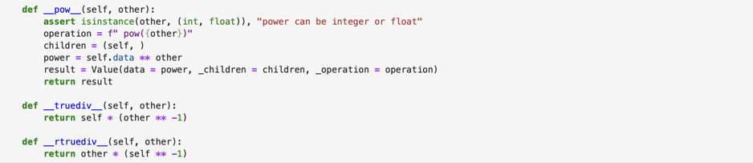

Division feature is a bit tricky. Imagine you have got an expression
c = a / b
With mathematical operations, subtraction can be represented with multiplication and power.
c = a / b → c = a • b⁻¹
When you divide two Value objects, Python automatically calls __truediv__ method. This method is depending on __pow__ and __mul__ methods. First, it will call __pow__ method in order to rise denominator to negative value, then it will call __mul__ method to calculation. You can divide two Value objects or divide Value object to integer or float variables. When it comes to divide integer or float variable to Value object, Python will call __rtruediv__ method. __rtruediv__ is same as other methods that starts with r.
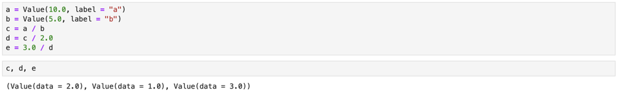

Method __pow__ is used to compute power of an object, but the power must be integer or float not Value object.

e^{x}
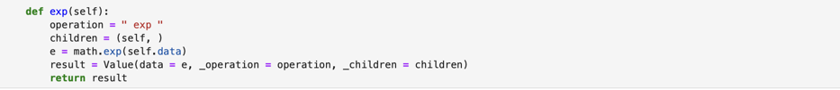

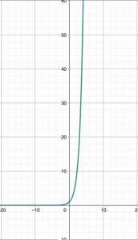
The exponential function exp(x) computes e^{x}, where e is Euler’s number (approximately 2.718). It takes one input value and produces a positive output that grows quickly for larger inputs. In our Value class, exp() follows the same pattern as other operations: it computes the result, creates a new Value, and stores the parent node and the operation name so the computation graph can be built automatically.

tanh

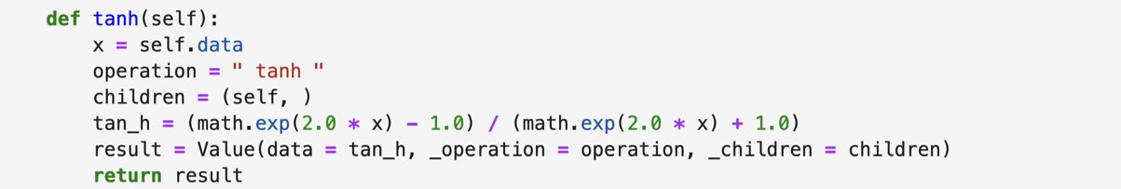

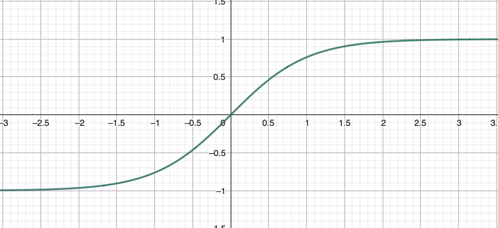
The hyperbolic tangent (tanh) function maps any real-valued input to a range between −1 and 1. It is smooth and continuous, which makes it suitable for gradient-based optimization methods. Beca-use tanh is symmetric around zero, it produces zero-centered outputs, a property that is often preferred in neural networks. For these reasons, tanh is commonly used as an activation function in deep learning models.

Graphviz library
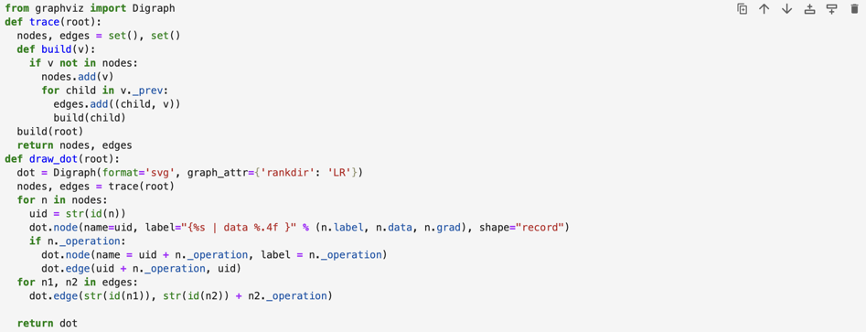

Graphviz is a library that helps to visualize the operations as a tree.

What we did?
Currently, we can do basic mathematic operations including addition, subtraction, multiplication, subtraction. Also, we can calculate power of numbers, exponential value and tanh value. With small example you can what we did yet.
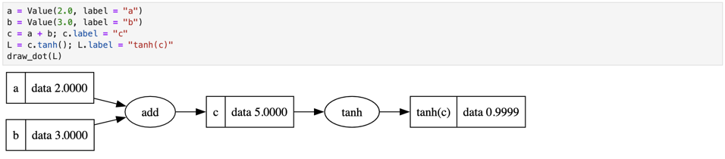

As shown in the graph above, we first apply the addition operation. Each variable has its own label: a and b are added together and the result is stored in c. Then, the tanh function is applied to c, producing the final result (tanh(c) ≈ 0.9999).This visualization is possible because, in the Value class, each operation stores its parent values (_children) and the operation name (_operation). When we compute c = a + b, __add__ method creates a new Value object and records a and b as its parent nodes. This process continues step by step until the final output (tanh(c)), forming a computation graph.

Remember __add__, __radd__, __sub__, __rsub__, __mul__, __rmul__, __truediv__, __rtruediv__ methods are built in methods in Python programming language by developers. They will automatically identify the operator and calls correct method.

This is basic steps of Value class. On the next page, we are going to move on backpropagation topic.

Backpropagation

What problem does backpropagation solve? Backpropagation answers this question - “How should each parameter change to reduce final error?”. In neural network you have:
- input →computations → final output
- a loss function that tells you how wrong the output is.
Mathematically you want to know $\frac{∂Loss}{∂parameter}$ for every parameter(weight, bias ...).

Why cannot we do it directly? Consider a simple chain rule computation:
x → a → b → L
where x is an input, $a=f(x)$, $b=g(a)$, $L=h(b)$. You want to calculate $\frac{∂L}{∂x}$ but L does not depend on x directly. It depends of x through a and b. So mathematically:
$$\frac{∂L}{∂x}= \frac{∂L}{∂b}•\frac{∂b}{∂a}•\frac{∂a}{∂x}$$
This is chain rule. Backpropagation I nothing more than applying the chain rule repeatedly and systematically. With following link, you can fully understand what Is chain rule and usage of the chain rule.

Why is it called backpropagation? Because:
- Forward pass: compute values from left → right
- Backward pass: compute gradients from right → left
You start from the final L and propagate derivatives backward through the computation graph. That’s why the starting point of backpropagation is 1.

Let’s take very simple function $L=tanh⁡(c)$.
- $c=a+b$
- $L=tanh⁡(c)$
Can you calculate $\frac{∂L}{∂a} and \frac{∂L}{∂b}$ ? Without chain rule it is impossible. Let’s use the chain rule to find the derivation:
Step 1: Derivative of L according to c
$\frac{∂L}{∂c}=1-\tanh^{2}(c)$
Step 2: Derivative of c according to a and b:
$\frac{∂c}{∂a}=1$ and $\frac{∂c}{∂b}=1$
Step 3: The chain rule:
$\frac{∂L}{∂a}= \frac{∂L}{∂c}•\frac{∂c}{∂a}=\left(1-\tanh^{2}\left(c\right)\right)•1$
$\frac{∂L}{∂b}= \frac{∂L}{∂c}•\frac{∂c}{∂b}=\left(1-\tanh^{2}\left(c\right)\right)•1$
done. The result might similar, but more complex problems you are going to see much more different values.

Why backpropagation is efficient? Naively, computing gradients for many parameters would be very expensive. Backpropagation avoids recomputation by:
- storing intermediate values during the forward pass
- reusing them during the backward pass
This makes gradient computation linearly, not exponentially. That’s why neural networks with millions of parameters are even possible.

Why you need backpropagation (deep explanation).
In machine learning, you are not trying to compute a value, you are trying to improve a model. Mathematically this means:
- you have a model with parameters $θ=(w_{1}w_{2}… b2)$
- you define a loss function $L(θ)$
which measures how wrong the model is. Learning means solving the problem
Why just computing the loss is useless? Suppose $L=10$. What does that tell you? Nothing about:
- which parameter caused the error
- hot to fix it
- in which direction to change parameters.
the number 10 is just a score, not guidance. To improve the model, you need directional information.
Gradients = Directions
Mathematically, the gradient answers:
$$\frac{∂L}{{∂w}_{i}}$$
This tells you:
- how sensitive the loss is to parameter $w_{i}$
- whether increasing $w_{i}$ increases or decreases the loss
- how strongly $w_{i}$ affects the loss
think of the loss as a surface
- height = error
- parameters = coordinates
The gradient tells you “Which way is downhill”
Why backpropagation is necessary(not optional). Consider a simple neuron:
$$y=tanh⁡( w_{1} x_{1}+ w_{2} x_{2}+b)$$
And a loss:
$$L={(y- y_{true})}^{2}$$
Now ask:
$$\frac{∂L}{∂ w_{1}}$$
This derivative Is not direct. L depends on $w_{1}$only through a chain of function:
$$w_{1}→\left( w_{1} x_{1}+…\right)→\tanh\left(•\right)→L$$
So Mathematically:
$$\frac{∂L}{∂w_{1}}= \frac{∂L}{∂y}• \frac{∂y}{∂z}• \frac{∂z}{∂w_{1}}$$
where $z= w_{1}x_{1}+w_{2}x_{2}+b$
Why “manual gradients” do not scale? For one neuron, you can do it by hand. For 10 neurons, you already feel the pain, 1000 neurons very difficult, millions of parameters are impossible. Backpropagation is turns impossible calculus into systematic local derivatives.

Why learning fails without backpropagation? Training updates parameters like this:
$$θ← θ- η∇_{θ}L$$
if you do not have gradients:
- you do not know the sign (increase or decrease)
- you do not know the magnitude
- you do not know which parameter matter
So, learning becomes random guessing. Backpropagation turns learning into informed adjustment. Backpropagation does not make model intelligent. It only answers this question – “If I slightly change this parameter, how will the final error change?” That’s all learning is. Backpropagation is needed because a loss value alone does not tell us how to improve a model; gradients tell us how each parameter contributed to the error.

The code idea:
Backpropagation is the chain rule applied to computation graph, starting from to output and moving backward, accumulated how much each contributed the final result.

That’s all about backpropagation. On the next page we are going to edit backpropagation feature to Value class.

Initialization part we added grad and _backward parameters. Grad is going to save the derivation of values, _backward is going to connect leaves each other.
