**1ST COMMENCEMENT CONVOCATION**   
of   
**Damiefa School**  
**Dabwe Town Community,   
Gardnersville, Liberia**

**Sunday July 9, 2023 | 12:00** Noon  
Held @  
**Damiefa School Campus**

Class of   
2022/2023  
(“The Class of Success”)

**MEET THE ADMINISTRATIVE STAFF**

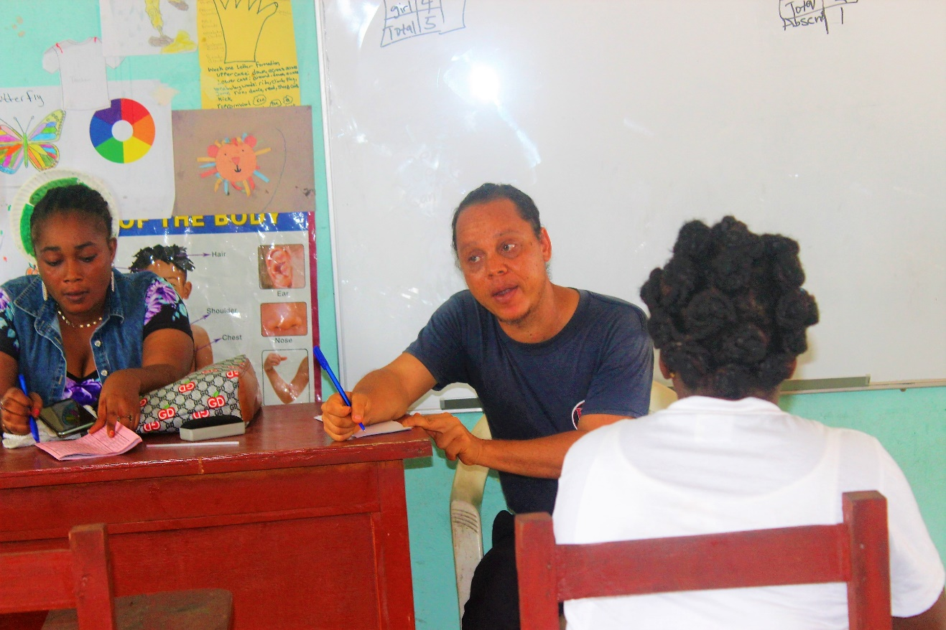

**Mr. Michael Diliberto  
Principal Damiefa School**

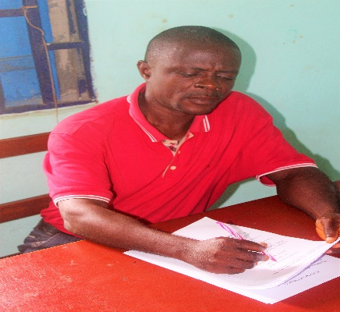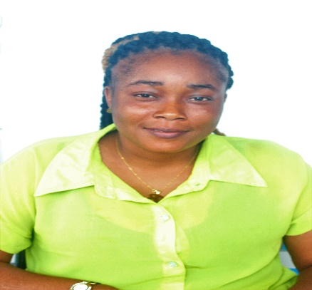

**Mr. Jallah M. Quoiyan  
2nd and 3rd Grade Teacher**

**Miss. Baze Lawubah  
2nd and 3rd Grade Teacher**

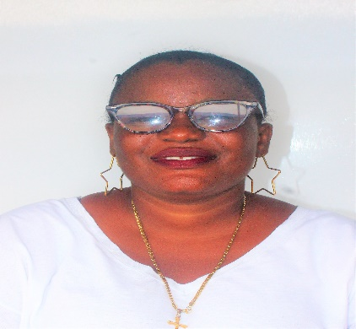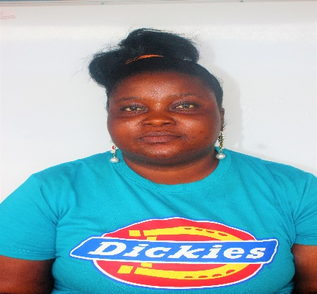

**Miss Yassa S. Armah  
ACB Teacher**

**Miss Tete Flomo  
Grade 1 Teacher**

**ORDER OF PROGRAM**

1. **Prelude/Musical - Music**
2. **Procession - Graduating Class Administrative Staff**
3. **Invocation - Emmanuella Amani**
4. **Welcome Remark – Palyn N. Beyan**
5. **Praise and Worship - Saydiyah Roberts and Others**
6. **Introduction of Occasion - Divine Gbidi**
7. **Bible Quotations - Diamond Parker (K-II) & Saydiyah Roberts, Eject**
8. **Reciting the 15 counties/Liberia - Lawrence Bowen**
9. **The seven ladies that made - Favor Dixon**

**The Liberian flag**

1. **Naming the colors on the flag – Momo Kaikai**

**of Liberia and their meaning**

1. **Song - Saydiyah Roberts**
2. **LR Demonstration – Saydiyah Roberts, Palyn N Beyan, J Josiah Var, Erna Pattern**
3. **Naming of shapes & spelling - ABC Class**

**The colors on them**

1. **Valedictorian Address - Eject Grear**
2. **Presentation of Graduates - Ms. Baze Lawubah**
3. **Receiving of Graduates - The Administration**
4. **Selection - Voice of Damiefa**
5. **Introduction of Keynote - Jonathan Sulonteh**

**Speaker**

1. **Keynote Address - Joseph Saye Zankah, Jr.**
2. **Pinning of Graduates - Audience**
3. **Remarks - Community**

**- The Administration**

**22. Vote of Thanks - Chairman, Program Committee**

**23. Announcement -**

**24. National Anthem - Audience**

**25. Closing Prayer - Jallah**

**26. Presentation of Certificate - Michael Diliberto**

**MEET THE GRADUATING CLASS OF 2022/2023 “Class of Success”**

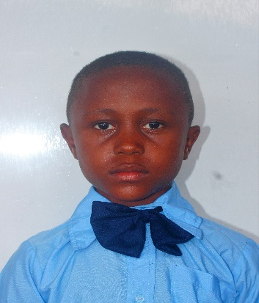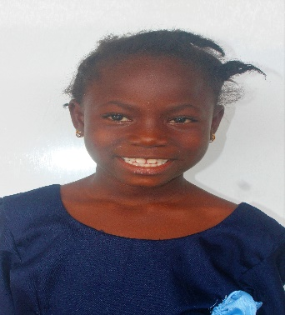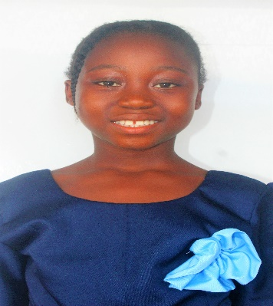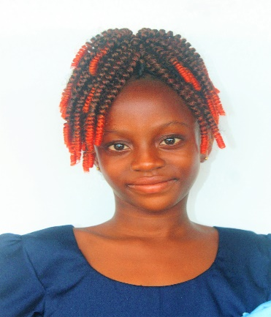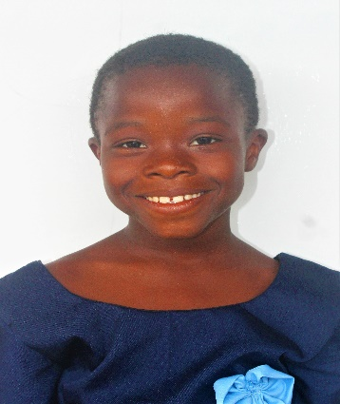

**Kpadeh Sepoe**Lofa County **Lawyer**

**EJEST GREAR**Grand Gedeh  
**Doctor**

**Saydiyah Roberts**Bong County **Administrator**

**Diamond Parker**Bong County **Politician**

**Faith J. Kamara**Lofa County **Nurse**

**Class of  
 2022  
2023**

Congratulations!