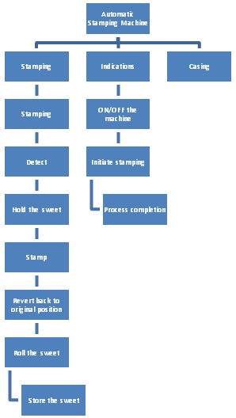
Stamping Unit
Indicating Unit

