Beauty

Plumbing

Electrical

Nails

Makeup

Massage

Tattoos

Hair

Sprovider1

Sprovider2

**Personal profile page:**

* Service provider profile picture
* Service provider name
* Salon name or independent
* address
* Co-workers
* Customers Repeating
* Rate & reviews
* Feedback
* Joined date on Hiletask
* Location
* experience
* skills
* services (Dreads, pencil, butterfly, plante,….)
* Service photos for each service
* Time for each service taken
* Price for each service

Sprovider3

Iyi flow nagerageje kureba umukiriya aramutse aje kuri web uko byaba bigaragara. Kuririya test wakoze igaragaza categories ariko ntigaragaze service exactly. Urugero nkokuri beauty category bigaragarako service itagwa ari beauty kd mubyukuri beauty ifitemo categories nyishi na services zitandukanye murizo categories. Urugero muri **Beauty** harimo (Makeup, Barbershop, hair, nail, skin care, eyebrows & Lasher, massage, day spa,.. ). Rero izi categories harimo services zitandukanye irinazo zizajya zitagwa. Rero nkumva hakabayeho ko muri registration umuntu uri muri beauty yahita agaragaza specialty ye muri beauty, urugero Hair, noneho agahita yandika services atanga muri hair. Gusa si categories zose, nka plumbing yahita atangira ku listing. Nibanze kuri beauty kuko ariyo ari complex iramutse flow yawe ukunze izindi ziroroshye.

Beauty

Hair

Services:

Dreads (photo, price)

Pencil (photo, price)

Braids (photo, price)

Butterfly (photo, price)

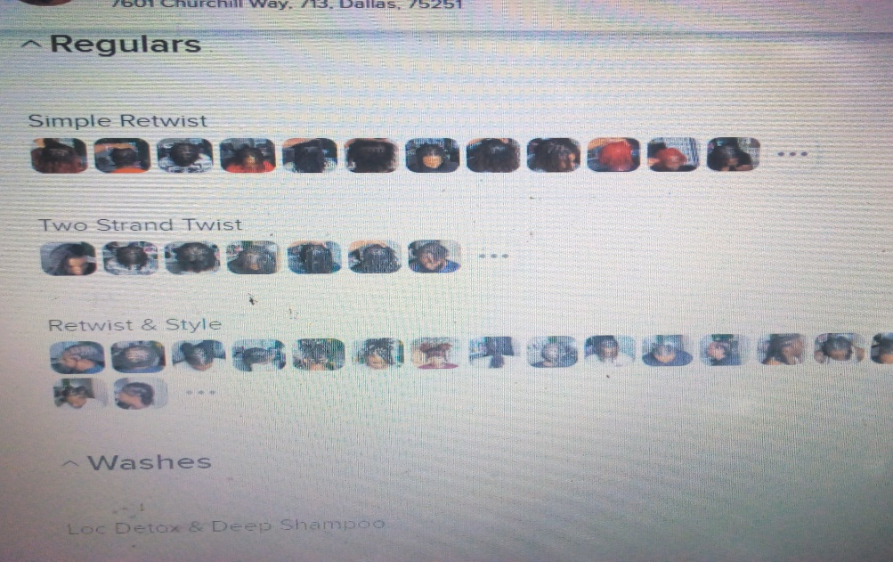.

**Rates scores:** Nifuzagako stars bazajya bazitanga bashingiye kuribi kikurikira:

**1.Kubahiriza igihe**,

**2.service niyo customer yatse kandi yakozwe neza,**

**3.Hygiene,**

**4.customer care**.

**6.Discipline**

**REGISTRATION**

**Service provider Dashboard**:

Nabonye harimo utuntu twishi ntazi cyeretse turi kumwe ukasobanurira. Gusa numva izaba ihamakuru n’ubushobozi service provider yo kubona reports, historic, ……

**Profile:** ntabwo yabashije gufunguka ngondebe ibirimo

**Edit profile:** wakongeramo option zo kwa adding ID, education certificates, criminal records certificate, local leader recommendation (ibibyabari ugusuzuma niba umuntu yemerewe gukora izi services kd yujuje criterial ntabwo byagaragara on public), Ahogushyira skills, experience, ahokwandika niba afite umufasha (assistant) kuko bizafasha cyane mbusuka, about you, kugaragaza niba akorera muri place ye cg asanga umukiriya aho ari cg byose abikora ( at my place, at the clients place or both), aho umukiriya yamusanga (address location), igihe yagereye kuri Hiletask,….

**Booking:**  Ahanabonye service provider abona appointments zose zabaye booked kandi yakabaye abona appointments ze gusa.

**Adding services:** Ahanaho nabonye hari information ziburamo, services yifuza gutanga (dufite Beauty, plumbing, painting, electrical….), dufashe imwe nka Beauty nayo yifitamo (nail, makeup, hair solon, barbershop, massage, eyebrows & lashes, tattoos,…. ) kd ntabwo umuntu yazi running zose. Rero yakwandikako ari muri Beauty then akagaragaza niba akora makeup cg hair (gusuka imisatsi,) yarangiza agatangira ku listing services azajya atanga. Buri service agahita ashyiraho amafoto ari gutanga iyo service, igihe service atwara(1h, 1h30’, 30min,…), price na discounts. Service provider azajya agaragaza availability ye kugirangi hirirwe appointments canceling.

**Description** nabonye ari sawa, gusa wakoberaho aka option kokwa uploading photo mugihe ashaka kwerekana neza ikintu ashaka, **including** nayo ni sawa , **excluding** nayo ntaribi, gusa nifuzako wakongeraho akandi kamwe ka **Our works**, kazajya kajyamo noneho amafoto yibyo bakoze byose, styles zose zivanze noneho.

**Sign up:** ahanaho numva migihe cya registration hazajya habaho verification tukamuha code kuri phone cg link kuri email akayikoresha mugihe yiyandikisha. Wenda wabwira niba byabari sawa cg Atari ngobwa

**Customer Dashboard**: aha ntakintu nabonyemo ariko ntakerezako hajya hagaragara appointments yatse, historic, kubayakora booking kumu service provider basanzwe bakorana atagombye guca munzira zisazwe, gukora booking canceling. Kubona notifications, …..

**COMMUNITY CENTER**

Hiletask ikaba ifiteho community center aho service provider bazajya baganira kubintu bijyezweho muri industry dukoreramo, ufite ikibazo akakibaza bakamusubiza kijyanye nibyo dukora, muri community center hakaba harimo discussion room izaba uhuriyemo service providers bahuje service batanga, aba beauty ukwabo, home improvement ukwabo, electronics ukwabo,….. service provider ku joining bikaba obligation, Aba kiriya bacu muri registration bagasabwa ku joining community center kubushake, nundi utari umukiriya akazabasha kuba ya joining. Bibi bizatuma umuntu wese ufite ikibazo kijyanye na service dutanga akibaza akabona ibisubizo byishi kandi byiza, akamenya ibijyezweho, izafasha kd abantu biga ibijyanye na services dutanga kwihugura, kugira connection nababatanze mukazi, izabari social cyane kd na Hiletask ihanyuza information ishaka kubaha. Iyi center numva yazagira impact nziza. Yazaba ifite nahantu ba uploading photos zijyanye nibintu bishyashya cg biharawe muricyo gihe abantu bakajya bamenya ibijyezweho. Nibazako byazagira nuruhare mukuzamura search engine yacu.

**NB:** 1. Ese ntakuntu twakora integration ya map na website kuburyo umuntu azajya abasha kubona uho umutu aherereye byoroshye.

2. calendar remainder izajya ifasha kwibutsa abantu kuri appointments bafite.

**FAQs:** numva niyi features twayongeraho kuko irafasha cyane mugutanga amakuru kuri web.

**Landing page:** Find and book service provider near you.

Ziriya photos zikaba arizigaragaza service dutanga zi sliding. Searching numva habaho location, time and service then hakabaho kuba haba filter ujyendeye kuri price, at my place or client place, location.

**Service booked:** nabonye iyo umuntu agiye ku booking hatagaragaraho izina rya service provider.

Stracture ya web muri rusange nabonye ntakibazo ari sawa uretse kujyenda twongeramo ibyo birungo. Haribyo nanditse kandi birimo uzajya urebako ntacyo navuze kandi kirimo. Ibindi nabona cg najyenda bibuka nazajyenda mbikubwira. Nawe ibyo wabona bishoboka ukabyongeraho.