###### E-WASTE COLLECTION SYSTEM

**CASE STUDY:**

**BY:**

**BBICT**

**This Project Is Submitted In Partial Fulfillment of Requirement for The Mount Kenya University Award of Bachelor Of Business Information Communication And Technology**

# DECLARATION

I, declare that this project work entitled, “**E-Waste Collection System**” is the result of my work and effort. This work has not been submitted for any previous academic credit at Mount Kenya University or any other institution

Signature:

Name:

IDNo:…………………………….Date:…………………………………

# SUPERVISOR

I the undersigned do hereby certify that this is a true report for the project undertaken by the above-named student under my supervision I and has been submitted to Mount Kenya University with my approval.

Signature:………… Date:………………………….

# ACKNOWLEDGMENT

I am profoundly grateful to the Almighty God and my family for their unwavering support throughout my journey. A special thanks to Dr. Douglas NYABUGA for his insightful guidance, invaluable advice, and enormous patience throughout the development of the system, which were crucial to the success of this E-WASTE COLLECTION SYSTEM project. My special thanks to the Mount Kenya University administration and my amazing classmates for their encouragement and collaboration. Lastly, my deepest thanks to everyone who played part in bringing this project tolife

### TABLE OF CONTENT

Contents

DECLARATION 2

SUPERVISOR 3

ACKNOWLEDGMENT 4

TABLE OF CONTENT 6

LIST OF FIGURES 8

ACRONYMS AND ABBREVIATIONS 9

Chapter1 INTRODUCTION 11

Chapter2 LITERATURE REVIEW 18

Chapter3 RESEARCH METHODOLOGY 21

Chapter 4: ANALYSIS AND DEVELOPMENT OF DDEMS 27

CHAPTER FIVE: SYSTEM DESIGN 31

5.0 Introduction 31

5.1 System Architecture 31

5.2 Data Flow Design 31

5.3 Database Design 32

5.4 User Interface Design 35

5.5 Security Design 37

5.7 Summary 37

CHAPTER SIX: SYSTEM IMPLEMENTATION AND TESTING 37

6.0 Introduction 38

6.1 Software Technologies 38

6.1.1 Tools and Languages Used 38

6.1.2 Static Pages 38

6.1.3 Dynamic Pages 39

6.2 Hardware Technologies 39

6.3 System Testing 39

6.3.1 Objectives of Testing 39

6.3.2 Unit Testing 39

6.3.3 Validation Testing 39

6.3.4 System Testing 40

6.3.5 Testing Approaches 40

CHAPTER SEVEN: LIMITATIONS, RECOMMENDATIONS, AND CONCLUSION 41

7.1 Introduction 41

7.2 Limitations 41

7.3 Recommendations 41

7.4 Conclusion 42

# LIST OF FIGURES

Figure 1:collection of disposed electronic devices 12

Figure 2:Already recycled devices to be reused 13

Figure 3:Agile Methodology 22

Figure 4:E-waste Database 25

Figure 5:Case Diagram 28

Figure 6: Data Flow Diagram 29

Figure 7:ERD Diagram 30

Figure 8:company dashboard 31

Figure 9:Citizen Dashboard 32

Figure 10:Admin Dashboard 33

Figure 11: Citizen publishing devices 34

Figure 12:Admin Report 35

Figure 13:list of Companies 35

Figure 15: pdf document 36

Figure 16:excel document 37

# ACRONYMS AND ABBREVIATIONS

IDE: Integrated Development Environments CSS: Cascading Style Sheets

DFD: Data Flow Diagram

EEE: Electrical and Electronics Engineering ERD: Entity Relationship Diagram

E-waste: Electronic Waste

GIS: Geographic Information Systems HTML: HyperText Markup Language

ICT: Information and Communications Technology IDE: Integrated Development Environments

Js: Java Script

MySQL: Structured Query Languag UI/UX: User Interface/ User Experience

WEEE: Waste Electrical and Electronic Equipment

#### ABSTRACT

The project addresses the escalating challenge of electronic waste (E-waste) management in Rwanda, spurred by the digital revolution and subsequent EEE proliferation. Despite economic advances, improper E-waste disposal has led to severe environmental and health risks. This initiative proposes a comprehensive E-Waste Collection System aimed at enhancing collection, recycling, and public awareness, thus mitigating environmental damage and tapping into economic opportunities from recyclable materials. By integrating innovative technologies and standardized practices, the" E-Waste Collection System" seeks to foster a sustainable circular economy, reducing E-waste's adverse impacts while promoting resource recovery and economic growth. Initially focused on Rwanda, this scalable model combines qualitative and quantitative research methods, employing web and software development tools for an efficient, user-friendly system. The project aims to bridge the E-waste management gap, offering a replicable blueprint for global sustainability efforts in E-waste management.

## Chapter1 INTRODUCTION

#### Introduction and Background

The digital revolution has led to an explosive production and an extensive use of EEE, which has launched the social and economic advancement for most countries in 21st century. However, this rapid economic advancement has resulted into a massive generation of EEE waste commonly known as E-waste. In 2020, there was an estimated of 41.8 million tons of global E-waste, with this estimate expected to grow to 49.8 million tons in 2023, with an annual growth rate of 4 to 5 per cent, and most of these go to developing countries for reuse. (E waste

, 2020) Due to the current rapid economic growth and modernization, the distribution of EEE has also significantly increasing in Rwanda. Furthermore, the growing dependence on the use of ICT in all sectors of the economy has led to increased utilization of EEE in various domains including mobile communication, education, health, finance, service delivery, etc. On one hand, proper handling of E-waste is an emerging challenge as some EEE contains toxic and hazardous substances such as lead, mercury, arsenic, cadmium, and selenium, among others, which pose severe threats and risks to human health and to the environment if not properly handled and disposed of. On the other hand, there is also an opportunity in adequate E-waste

management: recycling and refurbishment allow the recovery of precious metals such as gold, silver, platinum, palladium, copper, and tin from disposed components, and creates income and tax generation through new businesses and employment opportunities in E-waste value chain management.

###### collection of disposed electronic devices.

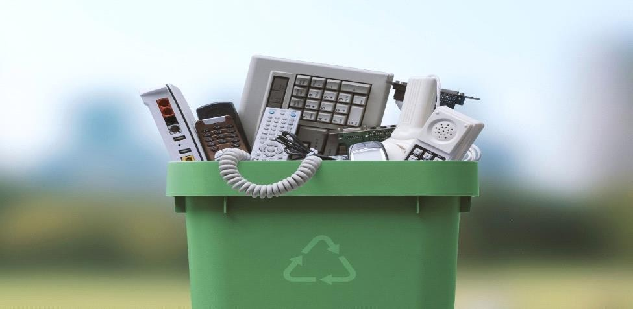

*Figure 1:collection of disposed electronic devices*

Source: Internet

###### Already recycled devices to be reused

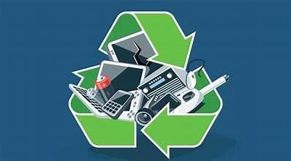

*Figure 2:Already recycled devices to be reused*

Source: internet

#### Problem statement

Despite the substantial generation of e-waste, only a small fraction, approximately 17.4%, is officially collected and recycled, indicating a significant gap in e-waste management infrastructure and practices. The large volume of e-waste left untreated and disposed of improperly poses considerable risks to both human health and the environment, including contamination of soil, water, and air with hazardous substances. With most old electronic devices ending up in landfills due to inadequate recycling efforts, there is a pressing concern regarding the capacity and sustainability of landfills, leading to potential environmental degradation and health hazards for nearby communities. Additionally, the neglect of proper e- waste disposal represents a wasted business opportunity, as valuable materials within electronic devices remain untapped, hindering potential resource recovery and economic benefits for industries involved in recycling and refurbishment.

#### Specific objectives

**Efficient Collection and Coordination** Establish a centralized system for the collection of disposed electronic devices, working collaboratively with other recycling companies to ensure comprehensive coverage and efficient logistics.

**Standardized Refurbishment** Practices Develop and implement standardized refurbishment procedures for electronic devices within the E-waste Collection System framework, in collaboration with partnering companies in the recycling industry.

**Sustainable Recycling Practices** Enhance the recycling capabilities of the System by leveraging partnerships with other companies specialized in e-waste recycling.

**Public Awareness and Engagement** Collaborate with other organizations and stakeholders in the recycling sector to raise public awareness about the importance of responsible e-waste disposal and promote participation in recycling programs

#### interest of the project

**Environmental Protection** the “E-Waste Collection System " aims to address the significant environmental challenges posed by the improper disposal of electronic waste (E-waste).

**Resource Recovery and Economic Opportunities** E-waste contain valuable materials that can be recovered and reused, contributing to resource conservation and economic growth.

**Technological Innovation and Efficiency** The development and implementation of the "E- waste Collection System " involve the use of innovative technologies and streamlined processes to enhance the efficiency of E-waste management.

#### Scope of the project

The project's initial focus will be on implementation inside Rwanda. This will enable focused efforts and thorough coverage in a controllable region.

This project will also be on managing electronic waste, or "E-waste," which includes gathering, repairing, and recycling discarded electronic gadgets. This includes a wide range of electronic devices, including televisions, Radio, computers, cellphones, and other consumer gadgets.

The " E-Waste Collection System " will involve the development and implementation of a centralized system for managing the entire life cycle of electronic devices, from collection to disposal such as public awareness and engagement initiatives to promote responsible disposal habits and encourage participation in recycling programs.

This project will also leverage various technologies, including digital platforms, data management systems, and communication tools, to support the implementation of the “E- Waste Collection System”. This may involve the development of user-friendly interfaces, integration with existing E-waste collection networks and recycling facilities, and the utilization of innovative recycling techniques and technologies.

#### METHODOLOGY

###### Research Design

The research will adopt a mixed methods approach to gather and analyze data. Qualitative methods such as interviews, focus groups, and case studies will be used to explore stakeholders' perspectives on e-waste management practices and identify key challenges and opportunities.

###### Design and Prototyping:

Design a user-friendly interface for the E-Waste Collection System platform, incorporating features for electronic device collection scheduling, and recycling status updates. Prototype the system to test functionalities and gather user feedback for iterative improvements.

###### Integration and Testing:

Integrate the " E-Waste Collection System" platform with existing e-waste collection networks and recycling facilities to ensure seamless coordination and data exchange.

Conduct rigorous testing of the system's performance, security measures, and scalability to handle varying volumes of electronic devices.

###### Technologies to be used:

**Front-end Development:**

HTML, CSS, JavaScript

###### Back-end Development:

Frameworks:

1. Blade (Front-end)
2. Laravel (Back-end)

###### Database Management

MySQL for data storage

#### Organization of the project

###### Project Team:

Our project team consists of the following members, each contributing their expertise to different aspects of the project:

Full stack developer: Daniel Ngabonziza

###### Project Timeline:

The project was organized into different phases that had to take 3 Month.

###### Phase 1: Requirements Gathering (2weeks):

* **Identify Stakeholders:** We Determined who will be using the system and who will be affected by it.
* **Use Surveys and Questionnaires:** Distribute surveys to gather quantitative data from a larger group of stakeholders and Design questions to capture specific requirements and preferences.

###### Phase 2: Design Phase (3-4 weeks):

* **User Interface Design:** Our designers crafted intuitive and user-friendly interfaces, prioritizing usability and accessibility to enhance the user experience.
* **Database Design:** We designed a well-structured database schema to efficiently store and manage the system's data, ensuring data integrity and security.

###### Phase 3: Implementation (6- 8 weeks):

* **Development:** we develop diligently translated the design specifications into functional code, ensuring adherence to best practices and coding standards.

###### Phase 4: Testing (1 week):

* **System Testing:** The entire system underwent thorough testing to validate its compliance with the specified requirements and identify any defects or inconsistencies.

**Phase 5: Maintenance**: Ongoing

#### Communication Plan:

Ensuring clear and consistent communication is essential for the project's success. Daily team gatherings will be conducted to review advancements, address obstacles, and plan upcoming tasks. In addition, we will utilize Google Meet and WhatsApp for immediate interactions and reserve in person meetings for important discussions. Timely updates will be shared with the supervisor through email or face to-face interactions as neede

## Chapter2 LITERATURE REVIEW

#### Introduction

In this literature review, we'll be diving into existing research and studies relevant to our project on e-waste collection systems. Electronic waste, or e-waste, is a significant global issue because of its complex composition and the improper ways it's often disposed of, which poses risks to both the environment and human health. As technology keeps advancing, more and more electronic devices are being produced, which makes it even more urgent to find effective ways to manage e-waste.

Our review is focused on exploring the key themes and findings from academic publications, industry reports, and government initiatives that specifically deal with e-waste collection systems. By looking at what's already been studied and learned, we hope to figure out what's working well, what challenges still need to be addressed, and what are the best ways to go about collecting and recycling e-waste. We'll also be looking at how new technologies, government policies, and involving different groups of people (like businesses and communities) play a role in how e-waste is managed

#### Theoretical Framework

Our project's foundation is based on a few key ideas: the circular economy, stakeholder theory, innovation diffusion, and systems thinking. We use these concepts to shape how we connect people who have e-waste with companies that can repurpose them. The circular economy

principle helps us focus on reusing and recycling e-waste to protect the environment and use resources efficiently. Stakeholder theory reminds us to consider everyone's needs, like individuals, businesses, and government agencies, to make sure our project benefits everyone involved. With innovation diffusion theory, we aim to spread awareness and encourage more people to use our e-waste collection system. And systems thinking helps us understand how different parts of e-waste management fit together, so we can design solutions that work well in the real world. By using these ideas, we hope to create an e-waste collection system that's effective, sustainable, and helpful for everyone.

#### Related Work

**Global Practices:** Studies indicate that countries like Sweden and Japan have advanced e- waste management systems that prioritize consumer education, strict legislation, and efficient recycling processes. The European Union's WEEE Directive is an exemplary legal framework that mandates the collection, recycling, and proper disposal of e-waste.

**Local Initiatives:** In the Rwandan context, e-waste management is nascent, with limited formal structures for collection and recycling. The few existing initiatives, primarily led by non-governmental organizations, lack the scale and infrastructure to manage the growing volume of e-waste effectively.

**Technology in E-Waste Management:** Technological solutions, including database management systems and GIS for tracking e-waste, have been effective in enhancing collection and recycling rates. However, there is a gap in integrating these technologies into user-friendly systems accessible to the public and small-scale recycles.

**Legislation and Policy:** While several countries have robust e-waste management policies, enforcement remains a challenge. Furthermore, there is a lack of harmonization between national and international regulations, complicating e-waste trade and recycling practices.

#### Gaps in Current Research

The literature reveals a significant gap in the development and implementation of integrated e- waste management systems in developing countries, including Rwanda. There is also a need for more research on the social and economic aspects of e-waste recycling, such as consumer behavior and the viability of recycling businesses.

#### Significance of Our Project

Our project aims to address these gaps and contribute to the improvement of e-waste management practices in Rwanda by:

**Enhancing Awareness:** Our e-waste management system includes educational initiatives and outreach programs to raise awareness about the importance of proper e-waste disposal and recycling.

**Improving Infrastructure**: We develop infrastructure solutions, such as e-waste collection centers and recycling facilities, to improve the collection and recycling of e-waste across Rwanda.

**Harnessing Technology:** We leverage digital solutions, by developing a web application, to streamline e-waste collection, transportation, and recycling processes, enhancing efficiency and transparency.

#### Summary

The review highlights the complexity of e-waste management and the necessity for comprehensive approaches that encompass legal, technological, and social dimensions. The proposed project aims to address these challenges by E-Waste Collection System that with bridge gap between Individuals that has unused electronic devices to Companies that are capable to transform these devices into valuable thing, tailored to the Rwandan context, leveraging technology to enhance efficiency and compliance with environmental standards.

## Chapter3 RESEARCH METHODOLOGY

#### Introduction

This chapter outlines the methodology employed in the E-Waste Collection system. It covers the software development process, the rationale for selecting Agile methodology, and the data collection and processing techniques used. The goal is to provide a comprehensive understanding of the approaches and methods utilized in developing a system that is efficient, user-friendly, and effective in managing the disposal of electronic devices.

#### Software Development Process Model

The software development process model chosen for this project is Agile. Agile methodology is a practice that promotes continuous iteration of development and testing throughout the software development life cycle of the project. In the context of this project, Agile methodology allows for adaptive planning, evolutionary development, early delivery, and continual improvement, which encourages rapid and flexible response to changes.

#### Rationale for Agile Methodology

We've chosen the Agile methodology for our project because it's known for being flexible and efficient, especially when it comes to dealing with changes. Our project deals with electronic waste collection, which is constantly evolving due to changing regulations and the diverse needs of our users. Agile methodology allows us to adapt quickly to these changes. It's important for us to focus on the users' needs, and Agile supports this approach well. This way, we can develop a system that meets the varied requirements of our users.

The iterative process of Agile allows for regular feedback from users and stakeholders, ensuring that the system is aligned with user needs and expectations. Furthermore, Agile facilitates better risk management by breaking down the project into manageable units, allowing for more immediate error detection and correction.

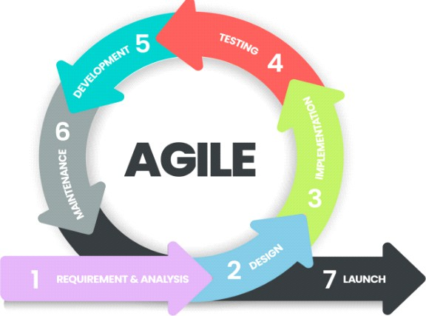

*Figure 3:Agile Methodology*

Source: internet

#### Data Collection Techniques

Data collection are crucial components of the system development process. The following techniques will be employed:

###### Interview

Interviews were conducted with a select group of **20 individuals** who have unused electronic devices and **5 companies** involved in recycling electronic devices. For individuals, the aim was to understand their reasons for not using these devices, their willingness to participate in a collection program, and their preferences regarding the disposal of their electronics. For companies, the goal was to gather insights into their capabilities for refurbishing or recycling electronic devices, their requirements for sourcing materials, and their potential interest in collaborating with an e-waste collection system. The interviews sought to explore opportunities for partnership and incentives that could encourage companies to participate in the program.

###### Field Visit

Visit locations such as households, offices, and storage facilities where there are a lots of unused electronic devices such as government schools , hospitals and even our homes. Observe the types and conditions of electronic devices being discarded or stored and identify potential barriers to participation in a collection program, such as lack of awareness, concerns about data security, or uncertainty about the value of unused devices. Additionally, visit companies engaged in refurbishing or recycling electronic devices such as EnviroServe Company to understand their processes, capacity, and requirements for sourcing materials. Evaluate the feasibility of partnering with these companies to repurpose collected electronic devices.

###### Questionnaire

Administer a questionnaire to individuals with unused electronic devices and companies involved in repurposing electronics. For individuals, inquire about the types and quantities of unused devices they possess, their reasons for not using these devices, and their preferences for disposing or repurposing them. Assess their awareness of e-waste management practices and their willingness to participate in a collection program. For companies, gather data on their expertise in refurbishing or recycling electronic devices, their capacity for processing collected materials, and their interest in collaborating with an e-waste collection system. Include

questions about potential incentives, logistical considerations, and expectations for the outcomes of the collaboration.

#### Tools and Programming Languages

The "**E-Waste Collection System**" project necessitates the usage of a number of tools and programming languages that are frequently employed in related projects.

These include:

###### Programming Languages Frontend Development:

HTML, CSS, JavaScript

###### Backend Development:

Frameworks:

1. Laravel Blade (Front-End)
2. Laravel PHP (Back-End)

#### Database Management Systems:

the data will be stored using MySQL database technology the data will be stored using MySQL database technology.

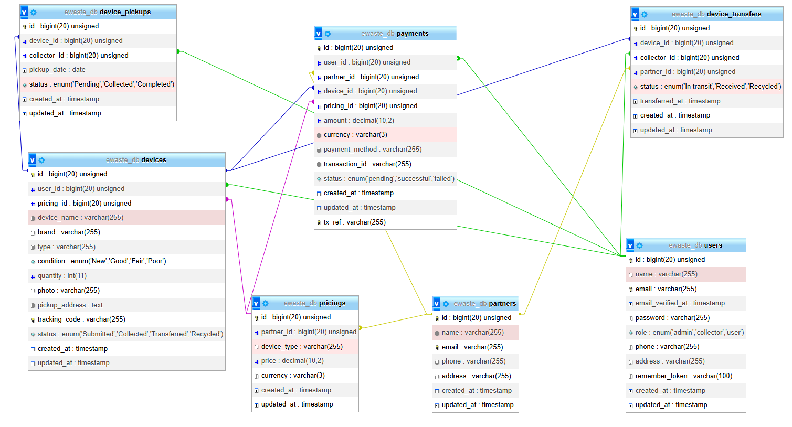

*Figure 4:E-waste Database*

**device_collection_requests**: This table stores user requests for device collection by a company.

**devices_to_be_collected**: This table references all devices in a request.

**device_price**: This table stores the prices of devices per company, as companies may offer different prices for the same device. Users will choose a company based on the price it offers for such a device.

We have included **user_id** in the company table to reference the user table. This allows us to identify the company when it logs in and continue with other processes. If there is a better way to achieve this, please let us know.

#### Development Tools:

Integrated Development Environments (IDEs) such as Visual Studio Code, Version Control Systems like Git,

Design Tools is Figma for UI/UX design.

## Chapter 4: ANALYSIS AND DEVELOPMENT OF DDEMS

#### introduction

The rapid growth of technology has led to a significant increase in the generation of electronic waste (e-waste) worldwide. E-waste, comprising discarded electronic devices such as computers, smartphones, and televisions, poses a substantial environmental and public health concern. Improper disposal of e-waste can release toxic substances like lead, mercury, and cadmium, contaminating soil, water, and air. Effective management of disposed electronic devices is crucial to mitigate the negative impacts and promote sustainable practices. This analysis will explore the current state of e-waste management, identifying the challenges and opportunities for improvement. The development of innovative strategies and technologies will be discussed to enhance the collection, processing, and recycling of e-waste. Sustainable solutions that prioritize environmental protection and resource conservation will be the focus of this study.

##### Existing System

The urban e-waste recycling initiative aims to set up places where people can drop off their old electronics, educate the public about recycling, and make the recycling process more organized. However, it faces problems like not having enough places to collect the electronics, many people not knowing about recycling, difficulty working with informal recycles, the government not enforcing recycling rules strongly enough, uncertainty about where the money will come from in the future, worries about the safety of the workers, and questions about whether recycling electronics will make enough money to be worth it. These issues make it hard for the project to work well and continue into the future. To solve these problems, the project is trying to make more places to collect old electronics, use the internet and social media to tell people about recycling, give training and support to the people who recycle things, and talk to the government about making better rules. They're also making sure that the people who work in recycling are safe and that recycling makes enough money to keep going.

#### Proposed System

###### Use case

A use case for an e-waste collection system depicts the different actions users can perform and how they interact with the system. It identifies actors, such as citizen, the company managing collections, and administrators, and showcases their roles in the system. Use cases represent specific tasks or functionalities of each user in the system

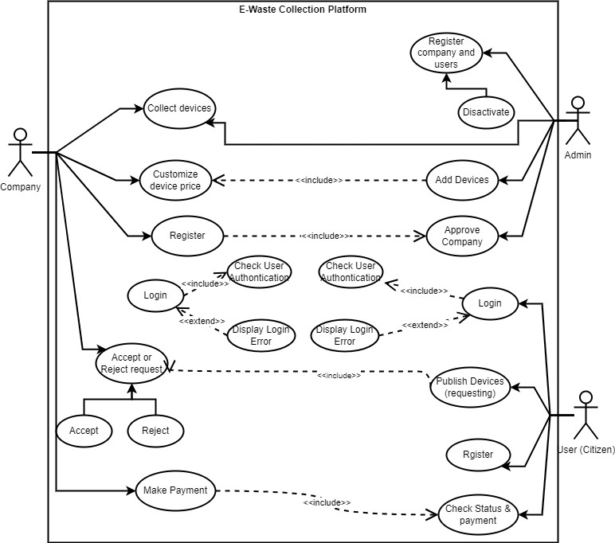

*Figure 5:Case Diagram*

Source: Own

###### Data Flow Diagram

A data flow diagram (DFD) for an e-waste collection system outlines the flow of data among three key users: clients, the company responsible for collections, and system administrators. It visually represents how information such as collection requests, pickup schedules, and inventory data moves between these entities within the system.

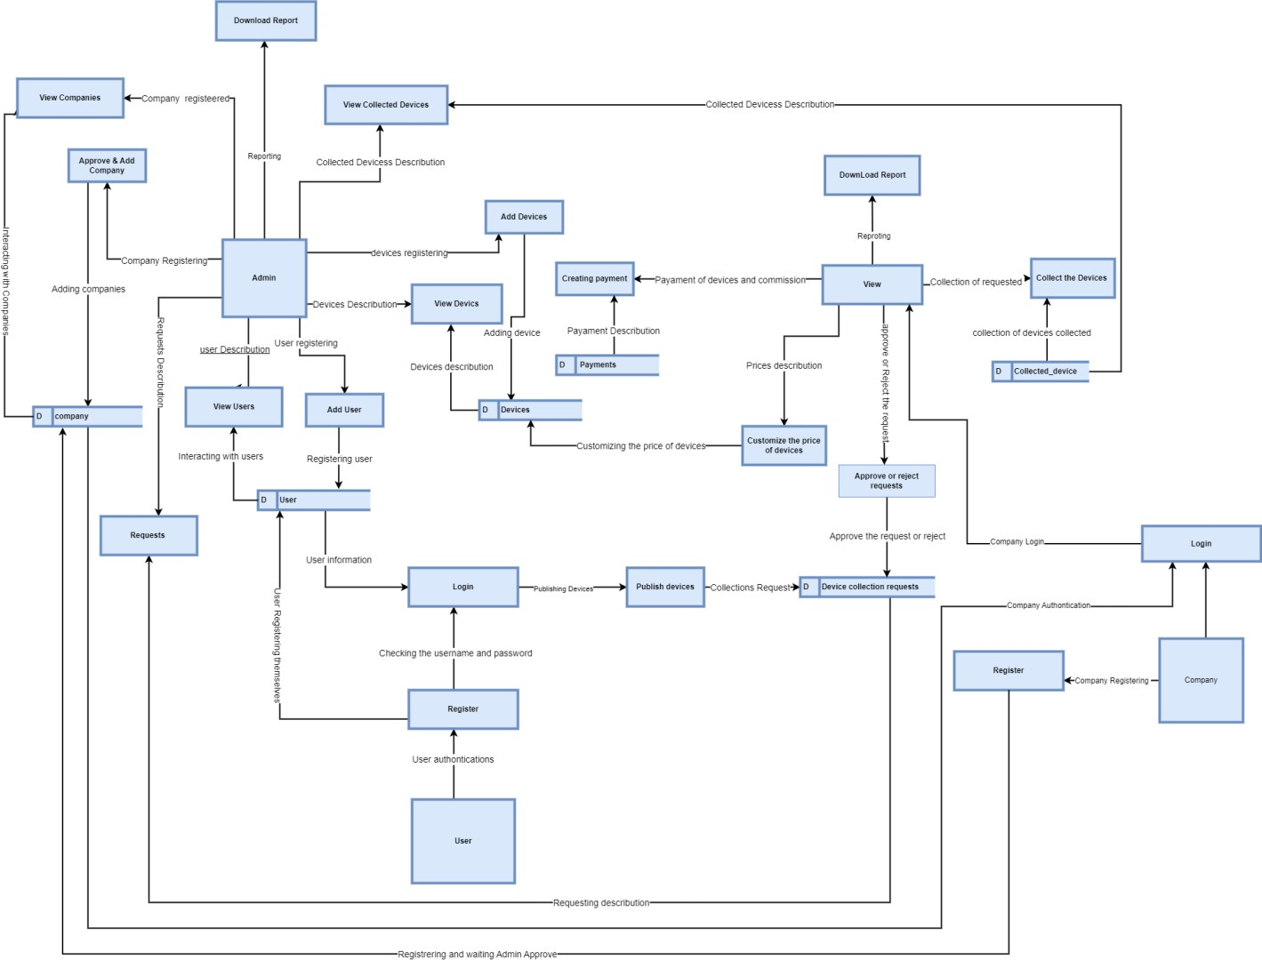

*Figure 6: Data Flow Diagram*

Source: Own

###### ERD Diagram

An Entity-Relationship Diagram (ERD) serves as a graphical depiction of the underlying data model within a database, illustrating the connections and associations between various entities. These entities represent the different types of objects or concepts stored in the database, such as clients, companies, and administrators. Each entity is represented by a table in the diagram, containing attributes that describe the properties or characteristics of the entity. Relationships between entities are depicted using lines or connectors, indicating how they are connected or associated with each other. For example, in a database containing information about clients, companies, and administrators, there would be separate tables for each entity. The relationships between these tables would be shown through lines connecting them, illustrating how clients are related to companies and how administrators manage the system independently

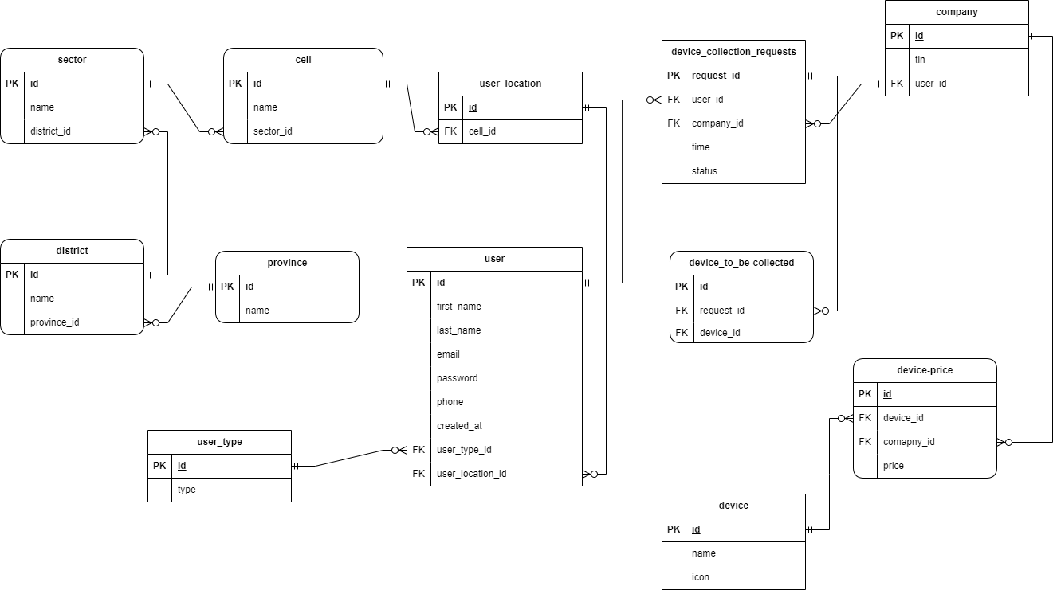

*Figure 7:ERD Diagram*

# CHAPTER FIVE: SYSTEM DESIGN

## 5.0 Introduction

This chapter outlines the system design of the E-Waste Management and Collection System (EWMS), a platform developed to improve the management, tracking, and collection of electronic waste from users and partner companies. The design process covers the system architecture, data flow, user interface layout, and database structure. Emphasis is placed on ensuring a user-friendly, secure, and scalable platform for both end-users submitting devices and partner companies managing collections and pricing plans.

## 5.1 System Architecture

The EWMS adopts a three-tier architecture for modularity, scalability, and maintainability:

Presentation Layer (Frontend):

Developed using HTML, CSS, JavaScript, and Blade templates.

Provides interfaces for users to submit devices, track their status, view pricing plans, and make payments.

Partner companies can manage their pricing, view incoming collection requests, and track device statuses.

Application Layer (Backend):

Developed using Laravel PHP framework.

Handles device submissions, tracking logic, payment processing, Unique code generation (for device identification), and notifications.

Ensures business rules are applied, such as linking devices to user accounts and partner pricing.

Data Layer (Database):

Uses MySQL to store information about users, devices, partners, pricing plans, and payment records.

Ensures data consistency, integrity, and fast retrieval for tracking and reporting features.

This layered architecture allows independent development and future feature expansion, such as adding more payment options or analytics dashboards.

## 5.2 Data Flow Design

The EWMS data flow describes how information moves between users, partners, and the system:

Device

Submission: User selects a partner pricing plan → Adds device details → Device record is created in the database → System generates a tracking code → User is redirected to payment.

Payment

Processing: Payment confirmation updates the device status to Submitted → Partner receives notification → Device status updates to Collected, Transferred, or Recycled as it progresses.

Tracking

System: User enters tracking code → System retrieves current device status → Displays status (Submitted, Collected, Transferred, Recycled).

Partner

Management: Partners manage pricing plans → Receive device collection requests → Track and update device statuses.

This ensures accurate tracking, real-time updates, and accountability throughout the e-waste lifecycle.

## 5.3 Database Design

The EWMS database is designed for normalization, security, and efficiency. Key tables include:

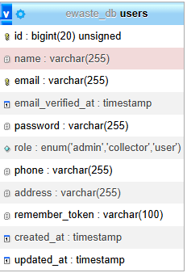

**Figure** Users Table – Stores user details (name, email, phone, role).

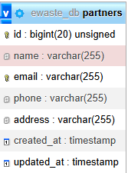

**Figure** Partners Table – Stores partner companies’ information.

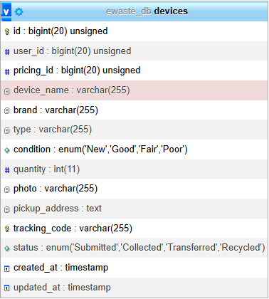

**Figure** Devices Table – Holds device submissions, tracking codes, condition, and status.

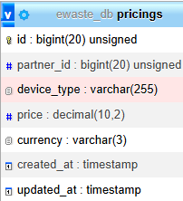

**Figure** Pricings Table – Stores partner-specific pricing plans for different device types.

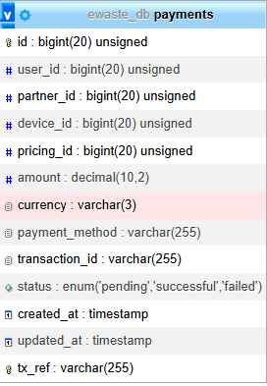

**Figure** Payments Table – Logs payment details for device submissions.



Figure Relationships are established using foreign keys, e.g., devices linked to users and partners, ensuring data integrity and simplifying queries for tracking and reporting.

## 5.4 User Interface Design

The EWMS interfaces focus on usability and clarity:

Device Submission Form – Users select a partner, choose a pricing plan, add device details, and submit for collection.

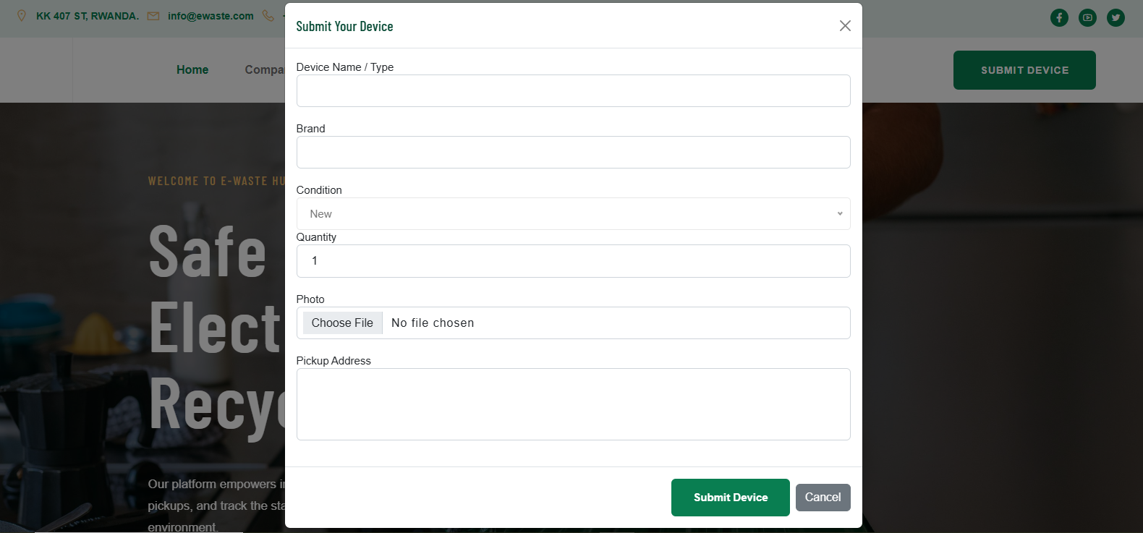

Figure Device submission

Tracking Interface – Users enter a tracking code to see the current status of their device.

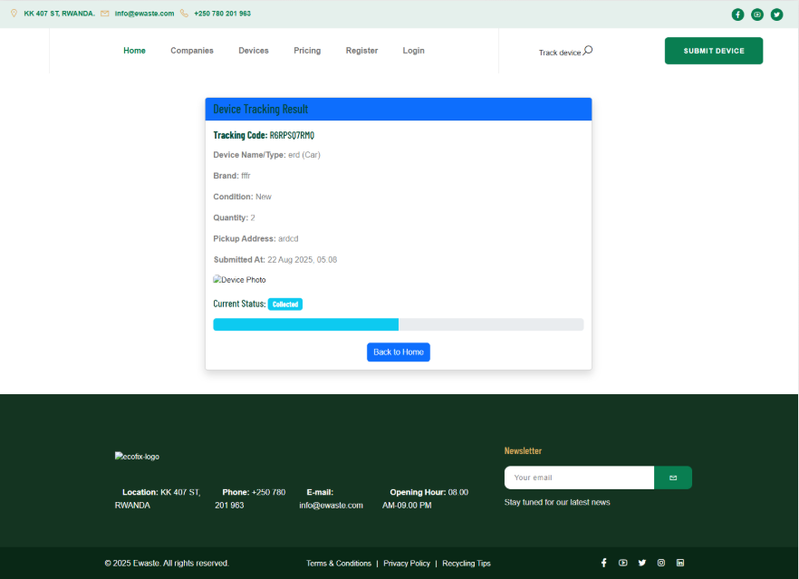

Figure Track device

Report Dashboard – view device report, pickup report, and payment report.

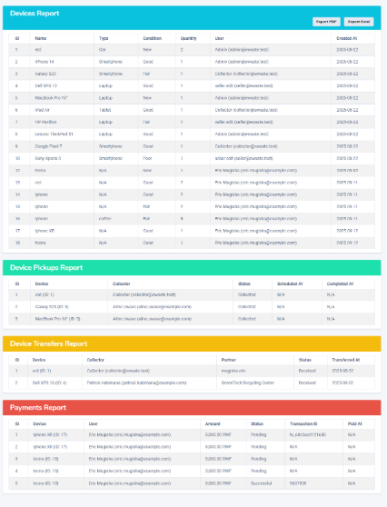

Figure Report

Pricing page - select device pricing for collection

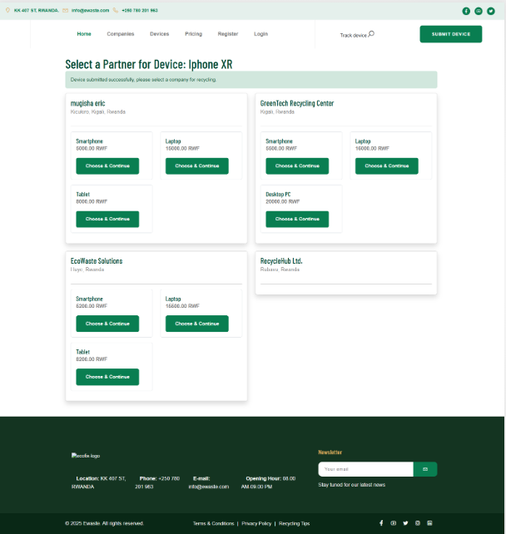

Payment Interface – Users are redirected to a secure payment page after device submission.

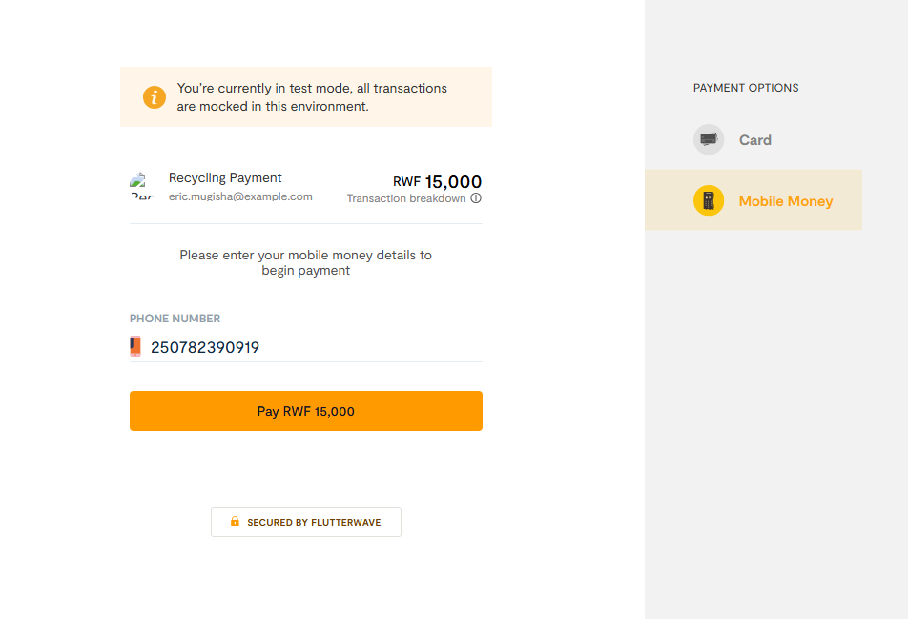

Figure Payment.

Wireframes and Blade templates were designed for each interface to ensure consistent user experience across desktop and mobile devices.

## 5.5 Security Design

Security considerations are critical for EWMS:

Role-Based Access Control – Admins, partners, and users have defined permissions.

Input Validation & Sanitization – Prevents malicious data submission.

Encrypted Tracking Codes – Ensures device tracking is secure and tamper-proof.

Payment Security – Integrates secure payment gateways with SSL protection.

Regular Backups – Protects against data loss.

## 5.7 Summary

This chapter presented the system design for the EWMS, covering architecture, database schema, data flow, user interfaces, and security measures. The design ensures the system is efficient, secure, and user-friendly, providing a solid blueprint for the implementation and testing phases outlined in Chapter Six.

# CHAPTER SIX: SYSTEM IMPLEMENTATION AND TESTING

## 6.0 Introduction

System implementation is the process of deploying a developed system into a real-world environment to meet the intended objectives. The E-Waste Management and Collection System was designed to streamline the process of e-waste collection, recycling, and monitoring. The platform empowers citizens to responsibly submit devices, track recycling progress, and view environmental benefits, while companies and partners manage pricing, collection, and payment workflows.

During the testing phase, the system underwent thorough validation, including unit testing, integration testing, validation testing, and system testing, to ensure reliability, functionality, and user satisfaction. Implementation involved deploying the platform, onboarding users (citizens, collectors, and partners), training relevant staff, and collecting feedback for system improvements.

## 6.1 Software Technologies

Software technologies provided the foundation for designing, implementing, and deploying the system effectively.

### 6.1.1 Tools and Languages Used

HTML5: Structured content for web pages, including submission forms, pricing views, and device tracking pages.

CSS3 & Bootstrap: Styled the system with a responsive, modern design, ensuring mobile and desktop compatibility.

JavaScript (with jQuery & AJAX): Enhanced interactivity, such as modal pop-ups for tracking devices, dynamic pricing updates, and map-based collection point views.

PHP (Laravel Framework): Server-side logic handling device submissions, tracking, partner management, payments, and generating receipts.

MySQL: Relational database storing users, devices, partners, pricing plans, and payment records.

XAMPP Server: Provided the development environment with Apache, PHP, and MySQL.

PhpMyAdmin: Database management and query testing tool.

Flutter wave API: Integrated for secure online payments during checkout.

Browsers (Chrome, Firefox, Edge): Used to test responsiveness and compatibility across devices.

### 6.1.2 Static Pages

Informational pages such as environmental awareness, recycling benefits, and partner introduction were implemented as static pages.

### 6.1.3 Dynamic Pages

Core functionalities such as device submission, tracking status, payment processing, and admin dashboards were developed as dynamic modules, adapting based on user inputs and actions.

## 6.2 Hardware Technologies

To support smooth operation, the following hardware resources were required:

* Server: Hosts the platform and manages large volumes of device and user records.
* Workstations: Used by collectors, recycling partners, and administrators to manage submissions, update statuses, and track analytics.
* User Devices (Laptops/Smartphones): Citizens access the platform through mobile or desktop devices for submitting and tracking e-waste.
* Networking Equipment (Routers & Switches): Ensures stable connectivity for real-time payment and tracking updates.

## 6.3 System Testing

Testing was performed to ensure the platform met functional, security, and usability requirements.

### 6.3.1 Objectives of Testing

* Detect and resolve software bugs and performance issues.
* Verify that all modules meet functional and non-functional requirements.
* Ensure secure transactions during payment.
* Validate smooth workflows for users, collectors, and partners.

### 6.3.2 Unit Testing

* Each module was tested independently:
* Device submission and validation.
* Partner pricing display and selection.
* Flutter wave payment integration.
* Device tracking functionality.

### 6.3.3 Validation Testing

Validated against requirements gathered from stakeholders. Examples include:

* Users could successfully submit and track devices using unique tracking codes.
* Partners could update device statuses (Submitted → Collected → Recycled).
* Payments were securely processed with transaction confirmation.

### 6.3.4 System Testing

End-to-end testing was conducted across all modules:

* User selects a partner and pricing plan.
* Submits device details.
* Redirected to checkout for payment.
* Status updates displayed in the tracking module.
* Receipts generated after successful payment.

### 6.3.5 Testing Approaches

#### 6.3.5.1 White-Box Testing

Focused on the internal logic:

* Optimized Laravel queries for device tracking.
* Verified secure handling of user credentials and payments.
* Ensured database relationships worked correctly (Users ↔ Devices ↔ Partners ↔ Pricing).

#### 6.3.5.2 Black-Box Testing

Focused on system behavior without code visibility:

* Tested input (e.g., device details, payment) against expected outputs (e.g., payment confirmation, status update).
* Checked error handling (e.g., invalid tracking codes).
* Simulated different user roles (admin, partner, citizen).

# CHAPTER SEVEN: LIMITATIONS, RECOMMENDATIONS, AND CONCLUSION

## 7.1 Introduction

This chapter presents the challenges faced during the development and implementation of the platform, provides recommendations for future improvements, and concludes the study. While the system successfully delivers the intended features such as partner-based pricing plans, device management, and integrated payment with Flutter wave, certain limitations were encountered. The recommendations outlined aim to guide further enhancement, scalability, and sustainability of the system.

## 7.2 Limitations

During the development of the platform, the following limitations were observed:

Limited Payment Options – The system currently integrates only Flutter wave for payment processing.

Users who prefer other options such as PayPal, Stripe, or Mobile Money outside Flutter wave’s ecosystem are not yet supported.

Network Dependency – Since the checkout and payment processes rely on stable internet connectivity, users in areas with unstable networks may experience disruptions during transactions.

User Feedback Collection – The platform lacks a comprehensive feedback and review mechanism for partners, which could help in improving services and tailoring offerings to customer needs.

Scalability Concerns – While the system supports multiple partners and pricing plans, performance testing under very large data volumes (e.g., thousands of partners and users) has not been fully explored.

Language Support – The platform currently supports only English, limiting accessibility for users who are more comfortable with other local languages.

Basic Analytics – Reporting and analytics modules remain basic, offering limited insights into user behavior, payment trends, and partner performance.

Device Management Complexity – Although the system allows device registration after plan selection, additional features like bulk device imports, automated validation, or hardware integration were not implemented in this phase.

## 7.3 Recommendations

To improve the platform and ensure long-term efficiency, the following recommendations are proposed:

Expand Payment Options – Integrate multiple payment gateways such as PayPal, Stripe, and direct Mobile Money APIs to provide users with flexible payment methods.

Introduce Offline Capabilities – Allow device addition and temporary plan selection in offline mode, with automatic synchronization once internet connectivity is restored.

Enhance Reporting and Analytics – Upgrade the reporting module to include detailed dashboards, trend analysis, and predictive insights to support better decision-making for both users and partners.

Improve Multilingual Support – Introduce support for languages such as Kinyarwanda and French to make the platform more inclusive and accessible.

Strengthen Security – Implement two-factor authentication for both users and partners, as well as encrypted transaction logs to ensure maximum security of sensitive data.

Optimize for Scalability – Conduct load and stress testing to ensure the platform can efficiently handle large numbers of partners, users, and transactions without performance degradation.

User Feedback System – Integrate a feedback and rating feature that allows customers to review partners and pricing plans, ensuring transparency and continuous improvement.

## 7.4 Conclusion

The platform demonstrates a significant step forward in streamlining partner-based pricing, device management, and secure online payments. By offering a structured workflow where users can select a plan, register devices, and complete transactions seamlessly, the system improves convenience, enhances user experience, and promotes partner engagement.

Although limitations such as restricted payment methods, language constraints, and basic analytics exist, the modular design ensures flexibility for future growth. With the implementation of recommended enhancements such as multilingual support, advanced analytics, and expanded payment options, the platform can scale effectively to meet the needs of a larger and more diverse user base.

In conclusion, the project provides a strong foundation for digital service management and payment integration, and with continuous improvement, it has the potential to evolve into a robust, user-centered, and scalable solution that empowers both partners and customers.

REFERENCES

* + 1. [E-Waste Management in East Africa: An Interview with Wastezon Founder, Ghislain Irakoz](https://www.rema.gov.rw/info/details?tx_news_pi1%5B%40widget_0%5D%5BcurrentPage%5D=3&tx_news_pi1%5Baction%5D=detail&tx_news_pi1%5Bcontroller%5D=News&tx_news_pi1%5Bnews%5D=667&cHash=9b871c908ac61c013d6ba2ac3bee9653)e on

**12,03,2024**

* + 1. <https://www.cloudi5.com/blog/web-technology-used-in-web-development-86/> on **18,03,2024**
    2. [https://environment.ec.europa.eu/topics/waste-and-recycling/waste-electrical-and-electronic-](https://environment.ec.europa.eu/topics/waste-and-recycling/waste-electrical-and-electronic-equipment-weee_en/)

[equipment-weee_en/](https://environment.ec.europa.eu/topics/waste-and-recycling/waste-electrical-and-electronic-equipment-weee_en/) on 03/04/2024

* + 1. [https://www.epa.gov/smm/sustainable-materials-management-non-hazardous-materials-and-](https://www.epa.gov/smm/sustainable-materials-management-non-hazardous-materials-and-waste-management-hierarchy/on)

[waste-management-hierarchy/on](https://www.epa.gov/smm/sustainable-materials-management-non-hazardous-materials-and-waste-management-hierarchy/on) 8/04/2024

* + 1. [https://www.globalewaste.org//on](https://www.globalewaste.org/on) 15/04/2024
    2. <https://www.itu.int/en/ITU-D/Environment/Pages/Spotlight/Global-Ewaste-Monitor-2020.aspx/on>

17/3/2024