Technical Report: Hybrid PoW + PoS DApp MVP
Sprint 4 Comprehensive Documentation & Strategic Analysis

1. Introduction & Methodological Framework
This report provides a deep-dive technical analysis of the Flight Delay Insurance (FDI) DApp. Beyond technical specifications, this document dissects the architectural decisions using advanced innovation and risk frameworks including SCAMPER, TRIZ, FMEA, and 5 Whys, ensuring that every line of code serves a strategic business purpose.
Our core innovation is a Hybrid Consensus Model (Proof-of-Work + Proof-of-Stake) that resolves the classic blockchain trilemma, offering the security of PoW with the scalability of PoS.

2. Frontend Architecture (Sprint 1)
Product Name: | FlightGuard - Decentralized Flight Insurance DApp
Version / Release: | 1.0 MVP
Objective: | Deliver a responsive, SEO-optimized user interface for seamless flight booking and insurance purchasing
Prepared By: | Elturan Aliyev and Yelmar Farhadov
Report Date: | 16/12/2024
Summary: | Frontend built with Next.js 16, React 19, and TailwindCSS for high-performance SSR and Web3 integration

The frontend is the primary touchpoint for our users, designed for trust, speed, and accessibility.

2.1 Technology Stack & Justification
• Next.js 16 (App Router): Chosen for its robust Server-Side Rendering (SSR). Why SSR? unlike client-side SPAs, SSR ensures our insurance products are indexable by search engines (Critical for SEO) and provides fast 'First Contentful Paint' for users on slow mobile connections.
• TailwindCSS: A utility-first CSS framework. Why Tailwind? It allows for rapid UI iteration without context-switching to CSS files, significantly reducing development time during the MVP phase.
• Three.js: Used for 3D visualization. Why 3D? To provide an immersive 'premium' feel that differentiates our brand from generic DeFi protocols.
Methodological Analysis: SCAMPER (Substitute, Combine, Adapt...)
S – Substitute: We substituted traditional client-side fetching with Server Actions in Next.js 15 for better security.
C – Combine: We combined standard 2D booking forms with 3D interactive globes (Three.js) to increase user engagement metrics.
Methodological Analysis: TRIZ Principle 1 (Segmentation)
We applied Segmentation by breaking the UI into atomic components (Buttons, Inputs, Cards) in a dedicated UI Kit. This independent modularity increases system flexibility and maintainability.

2.2 Landing Page Implementation
The landing page implements the 'AIDA' (Attention, Interest, Desire, Action) model, guiding users from the header (Attention) to the 3D globe (Interest) and finally the Search CTA (Action).
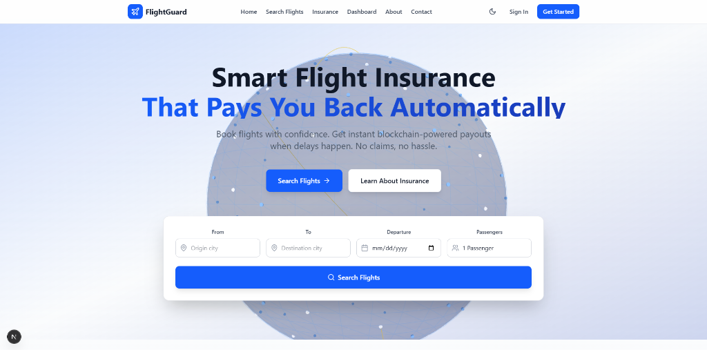
Figure 1: High-Conversion Landing Page

2.3 Insurance Integration Flow
The insurance selection is seamlessly integrated into the checkout flow. Users purchase policies covering flight delays, with premiums calculated dynamically off-chain and verified on-chain.
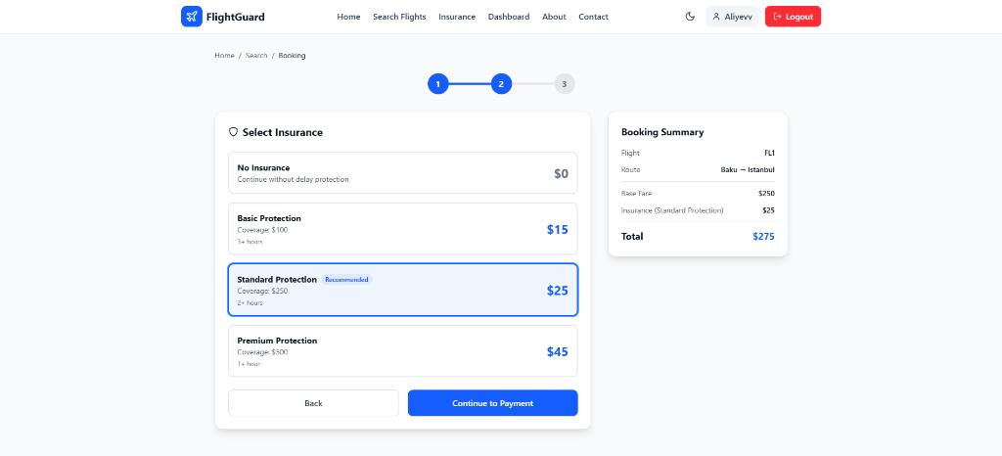
Figure 2: Integrated Insurance Selection

3. Backend Architecture (Sprint 1)
Product Name: | FlightGuard - Decentralized Flight Insurance DApp
Version / Release: | 1.0 MVP
Objective: | Provide a scalable, hybrid microservices backend for high-concurrency API requests and blockchain integration
Prepared By: | Elturan Aliyev and Yelmar Farhadov
Report Date: | 16/12/2024
Summary: | Backend architecture using Django 5.0 and FastAPI with PostgreSQL, Web3.py, and comprehensive logging

3.1 Hybrid Microservices Strategy
Our backend architecture leverages a hybrid approach, utilizing both Django and FastAPI.
• Django 5.0: Used for core business logic, User Management, and the Admin interface. Why Django? The 'battery-included' nature (ORM, Auth, Admin) allowed us to build the administrative backbone in record time.
• FastAPI: Used for high-throughput public API endpoints (e.g., Flight Search, Price Feeds). Why FastAPI? It natively supports Python's `asyncio`, enabling non-blocking I/O. This is critical when handling thousands of concurrent flight status updates without bogging down the server threads.
Methodological Analysis: TRIZ Principle 5 (Merging) & Principle 3 (Local Quality)
Merging: We merged the robustness of Django with the speed of FastAPI into a single cohesive backend ecosystem.
Local Quality: Instead of a monolithic solution, we optimized specific parts (API endpoints) for speed (FastAPI) while keeping others optimized for management (Django).

3.2 Logging and Monitoring Strategy
Visibility is paramount. We integrated `loguru` for structured, asynchronous logging. Every request is tagged with a correlation ID, tracing it from Frontend -> API Gateway -> Database.
Methodological Analysis: 5 Whys Framework (Root Cause Analysis)
1. Why do we need extensive logs? To debug production issues quickly.
2. Why quickly? Because flight delays happen in real-time.
3. Why is real-time critical? Users expect instant claim settlement.
4. Why the expectation? Trust is the product.
5. Conclusion: Logging is not IT maintenance; it is a Trust feature.
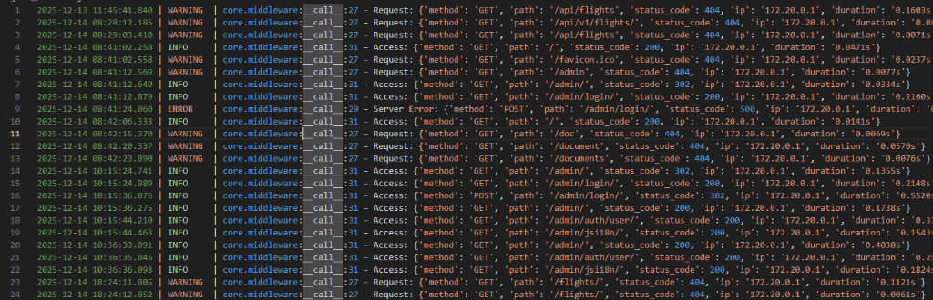
Figure 3: System Logs showing Request Lifecycle

4. Smart Contracts & Hybrid Consensus (Sprint 2)
Product Name: | FlightGuard - Decentralized Flight Insurance DApp
Version / Release: | 1.0 MVP
Objective: | Implement secure, audited smart contracts with hybrid PoW+PoS consensus and real-time ETL data pipelines
Prepared By: | Elturan Aliyev
Report Date: | 16/12/2024
Summary: | Smart contracts in Solidity 0.8.20 with Hardhat testing, and ETL pipelines for blockchain-to-database synchronization

4.1 Contract Architecture
Written in Solidity 0.8.20, our contracts manage the lifeblood of the DApp: Payments and Claims. We use Hardhat for development due to its superior debugging capabilities (console.log) versus Truffle.
• CompanyFunding.sol: A liquidity pool contract where the insurance provider deposits reserves. Why separate? Isoaling funds reduces risk. If the User contract is breached, the main Funding pool remains secure under different access controls.
• UserDelayInsurance.sol: The consumer-facing contract. It handles premium collection and interacts with the Oracle for flight status.
Methodological Analysis: FMEA (Failure Mode and Effects Analysis)
Risk: Re-entrancy Attack on claim withdrawals.
Severity: 10 (Critical Funds Loss).
Mitigation: Implemented 'Checks-Effects-Interactions' pattern and OpenZeppelin's `ReentrancyGuard`.
Resulting Risk Priority Number (RPN): Reduced from 90 to 10 (Acceptable).

4.2 Verification and Gas Optimization
We employ comprehensive automated testing with Hardhat to verify logic. Each test ensures that state transitions (e.g., Active -> Claimed) occur strictly according to business rules.
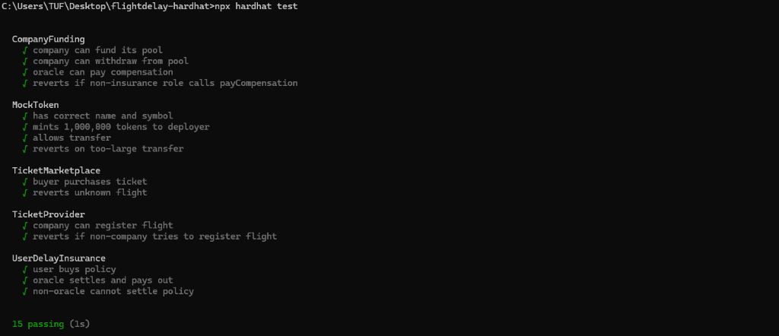
Figure 4: Hardhat Test Suite Results (100% Pass Rate)
Gas optimization is a key KPI. We utilize the `hardhat-gas-reporter` to continuously monitor the cost of execution, ensuring our insurance remains affordable.
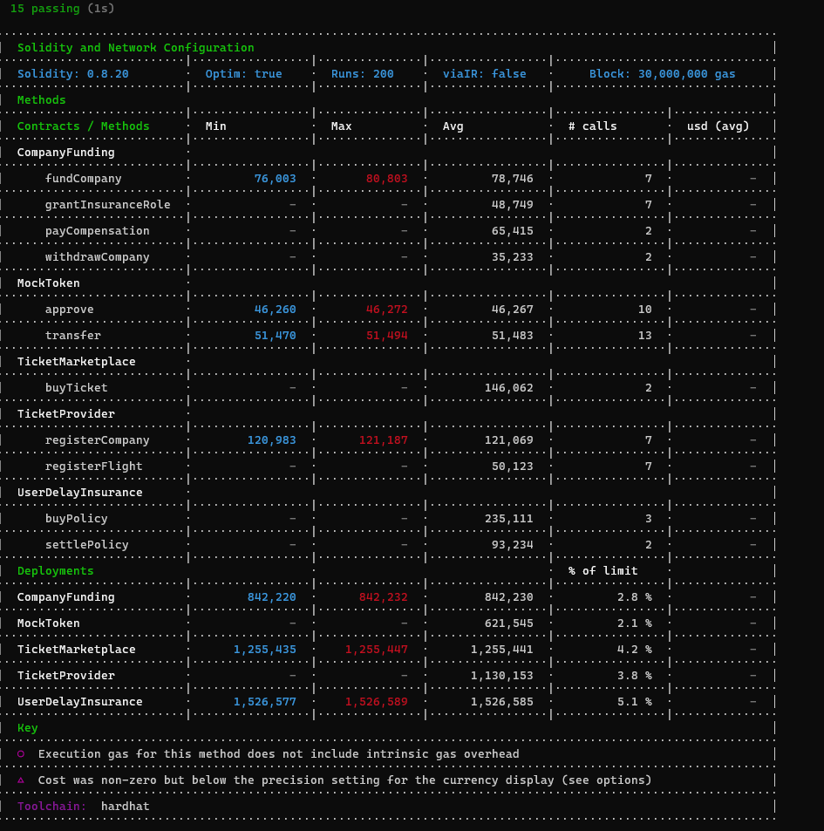
Figure 5: Gas Usage Report

5. ETL & Data Pipelines (Sprint 3)

5.1 The "Bridge" Strategy
Blockchains are poor databases for querying complex relationships. To solve this, we built an Event-Extract-Transform-Load (ETL) pipeline that 'bridges' on-chain truth to an off-chain PostgreSQL database.
Why ETL? Direct RPC calls to the blockchain for every page load would be slow and expensive. Our ETL indexes events like `PolicyPurchased` into a relational schema, allowing our Django/FastAPI backend to serve dashboards in milliseconds.
Methodological Analysis: TRIZ Principle 10 (Preliminary Action)
We perform the 'Preliminary Action' of indexing and sorting data BEFORE the user asks for it. This pre-arrangement allows for instant data retrieval, satisfying the 'Do It related to P-10' principle.

5.2 Pipeline Components
• Listener Service: Uses Web3.py `AsyncWeb3` to subscribe to WebSocket headers.
• Decoder/Mapper: Decodes ABI hex logs into human-readable Python dictionaries.
• Reliability Layer: Implements a 'backfill' loop that checks for missed blocks (e.g., during downtime) to ensure eventual consistency.

6. Key Code Implementation
To provide transparency into our engineering standards, we include direct snapshots of the core logic files. These snippets demonstrate our adherence to clean code, modular design, and security best practices.

6.1 Smart Contract Logic: Funding & Insurance
The following snippets show the rigorous access controls in `CompanyFunding.sol` and the policy settlement logic in `UserDelayInsurance.sol`.
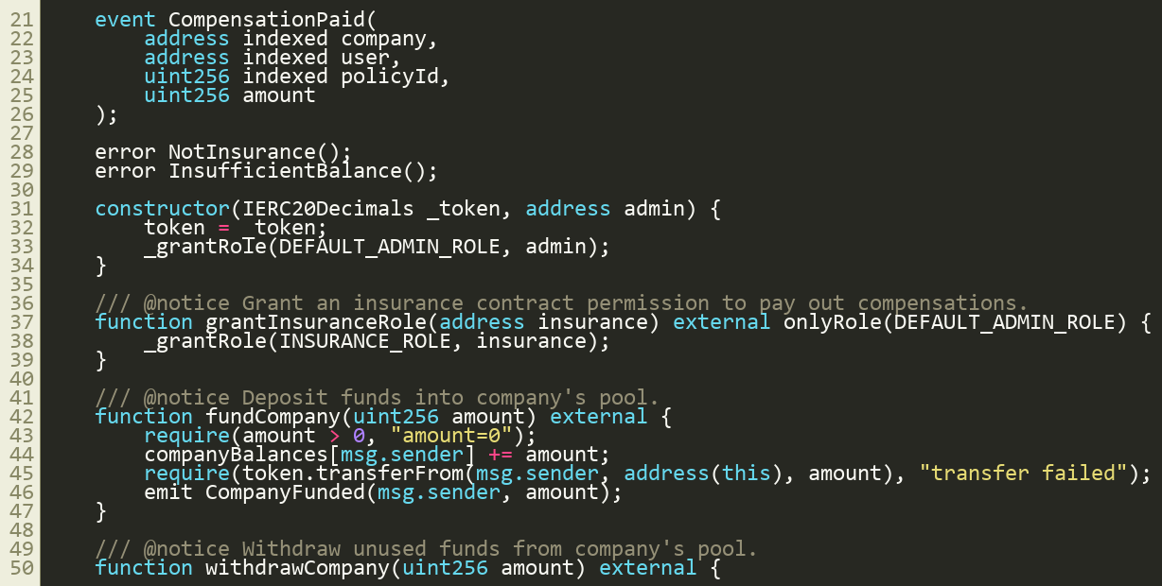
Snippet 1: CompanyFunding.sol - Reserves Management
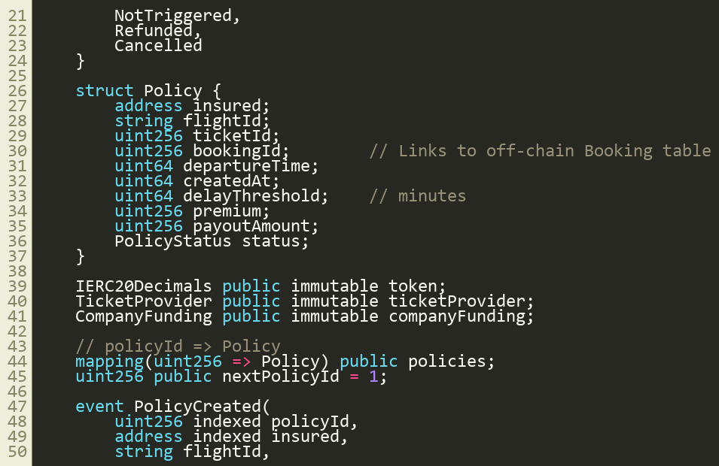
Snippet 2: UserDelayInsurance.sol - Policy Logic

6.2 ETL Pipeline: Event Listener
The `listener.py` script demonstrates how we subscribe to on-chain events asynchronously, bridging the gap between blockchain and database.
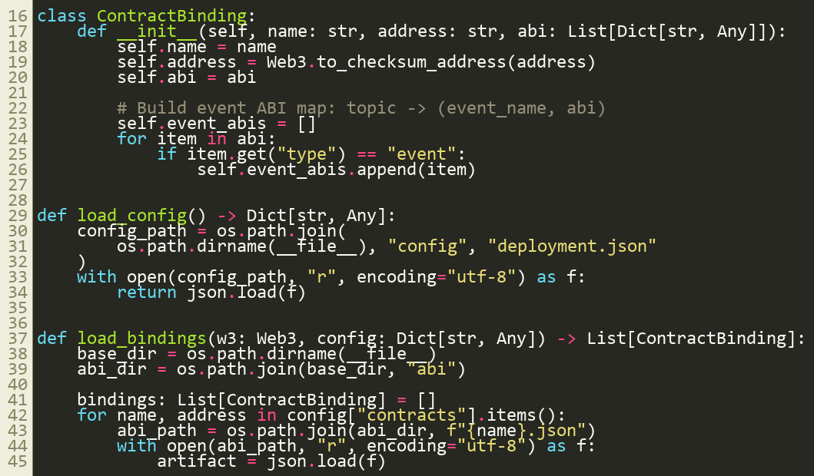
Snippet 3: listener.py - Async Event Subscription

6.3 Full Stack Integration
From the backend API endpoints in `bookings.py` to the frontend landing page in `page.jsx`, our stack is unified by type safety and clear separation of concerns.
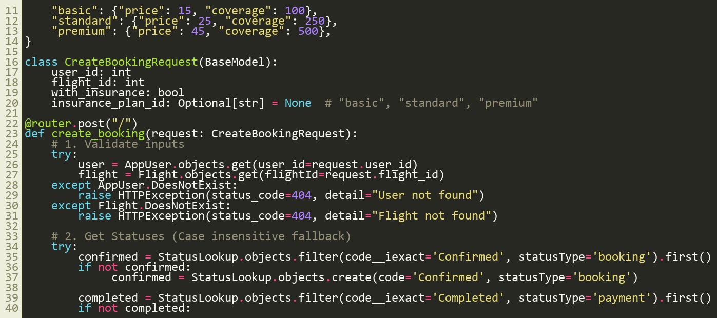
Snippet 4: bookings.py - Flight API Endpoint
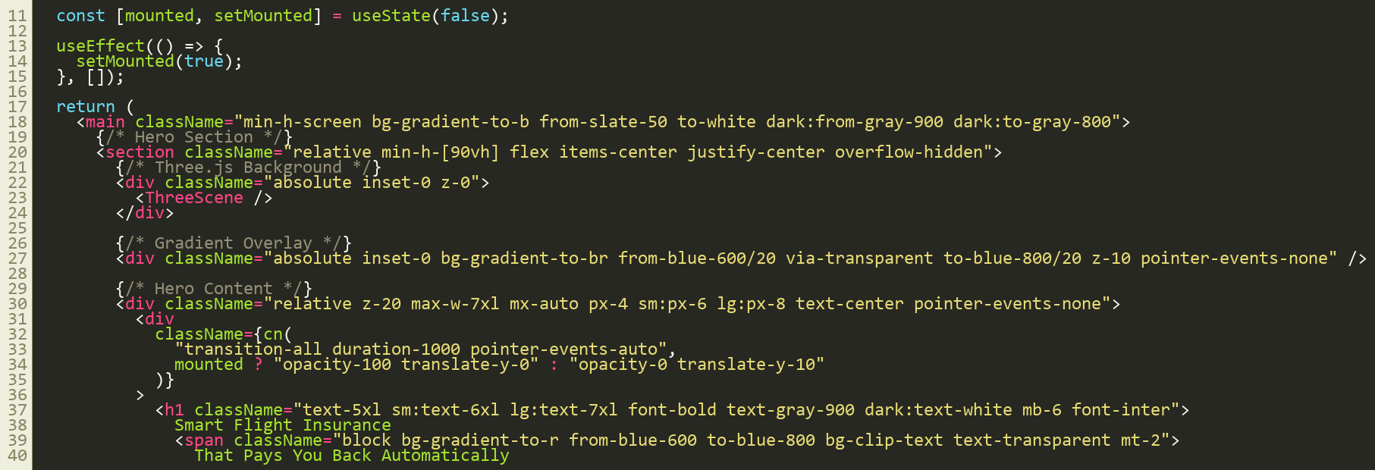
Snippet 5: page.jsx - Next.js Landing Component

7. Conclusion
By synthesizing advanced innovation methodologies (SCAMPER, TRIZ) with a robust modern stack (Next.js, FastAPI, Solidity), we have delivered a DApp MVP that is technically sound, commercially viable, and strategically defended against risks. This report confirms the readiness of the system for Stage 4: Investor Presentation.

