**Downloader User Manual**

**Introduction:**

The Downloader User Manual provides step-by-step instructions for using the downloader tool to flash firmware onto a connected device. This guide covers all the necessary procedures, from setting up the downloader application to connecting the device and flashing the firmware. It also includes instructions for debugging the device, making it easier for users to troubleshoot and verify the functionality of the device post-flashing. This manual is designed for users of all experience levels and ensures a smooth, hassle-free flashing and debugging process.

**1.** **Opening the Downloader Folder:**

* Navigate to the folder containing the downloader files.
* When you open the folder, it will display the subfolders and the downloader.exe file.

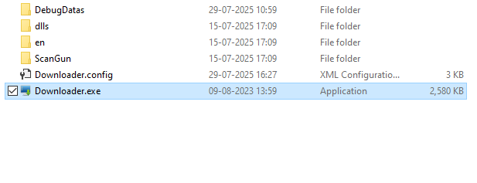

2. **Running Downloader.exe:**

* Double-click on the downloader.exe file to open the program.
* Upon opening, the downloader interface will appear as shown below.

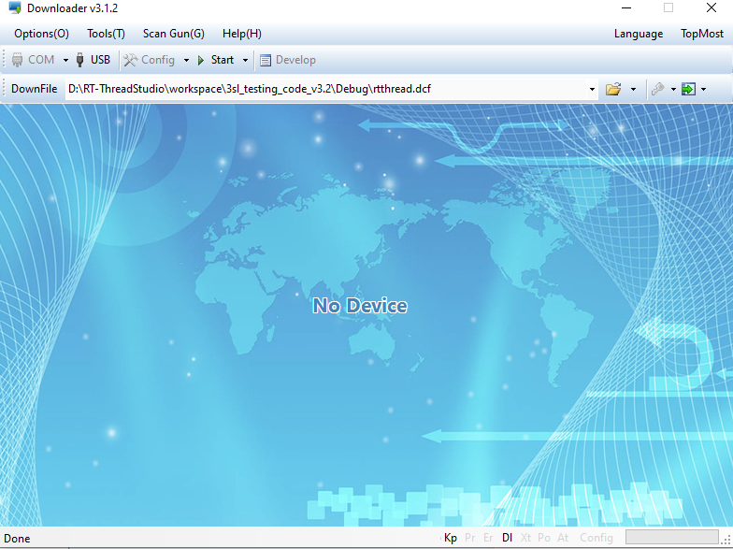

3.**Connecting the Device:**

* Connect your device via a USB cable to the computer.
* The downloader will automatically detect the connected device. Select the appropriate COM port for the connection.

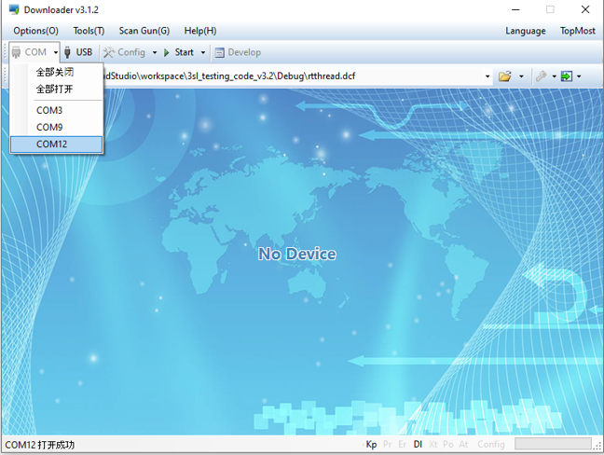

4. **Selecting the COM Port:**

* If the device is connected to COM 12, select COM 12 from the available list.
* The downloader will confirm that the device is ready to flash the code.

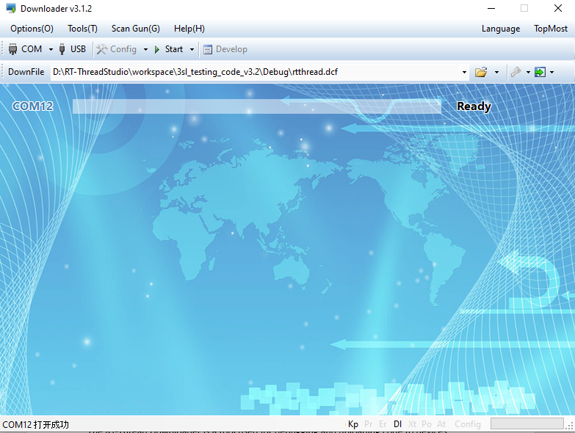

5.**Selecting the Firmware File:**

* Click on the "Select File" button and choose the rtthread.dfc firmware file you want to flash onto the device.
* Once selected, the file will appear in the downloader interface.

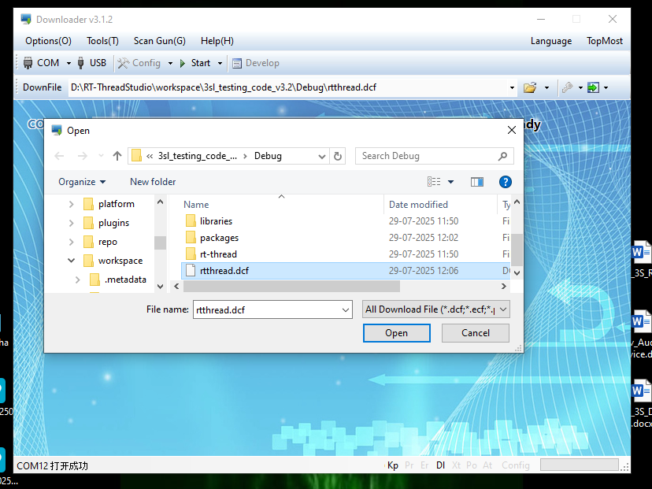

6. **Flashing the Firmware:**

* After selecting the rtthread.dfc file, click the "Start" button to begin flashing the code onto the device.
* The process will proceed, and a success message will appear once the code has been successfully flashed.

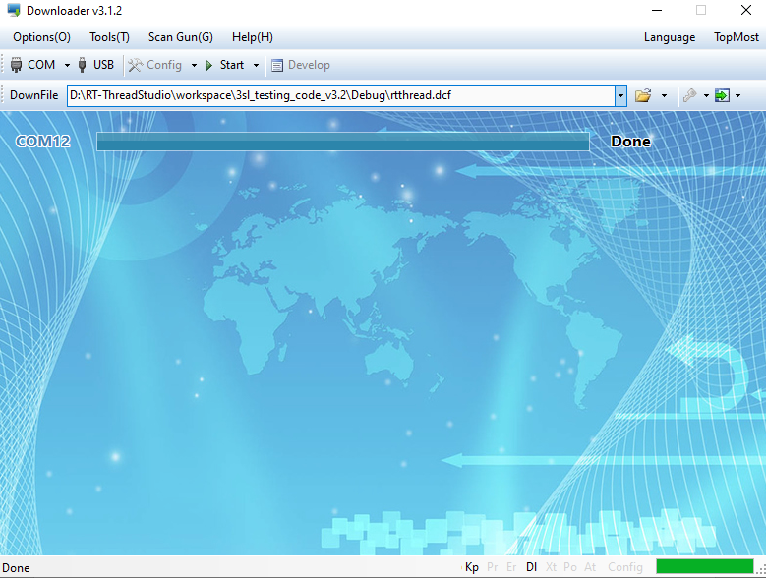

7. **Development and Debugging:**

* To begin debugging, click on the "Develop" button.
* The interface will show a progress message indicating that the code is being flashed, followed by a debugging terminal.

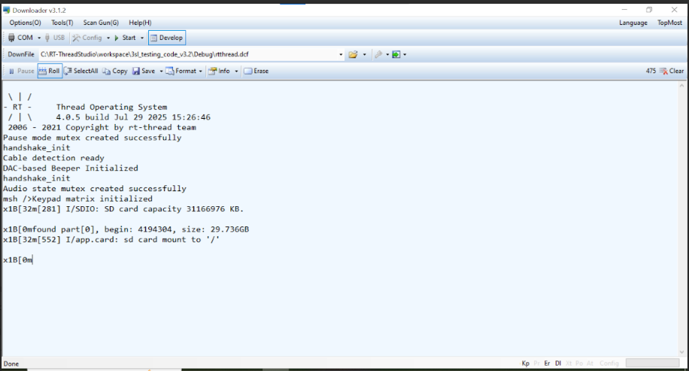

8. **Debugging the Device:**

* Click the "Play" button to start debugging.
* The terminal will display the debug information as the device is being tested.

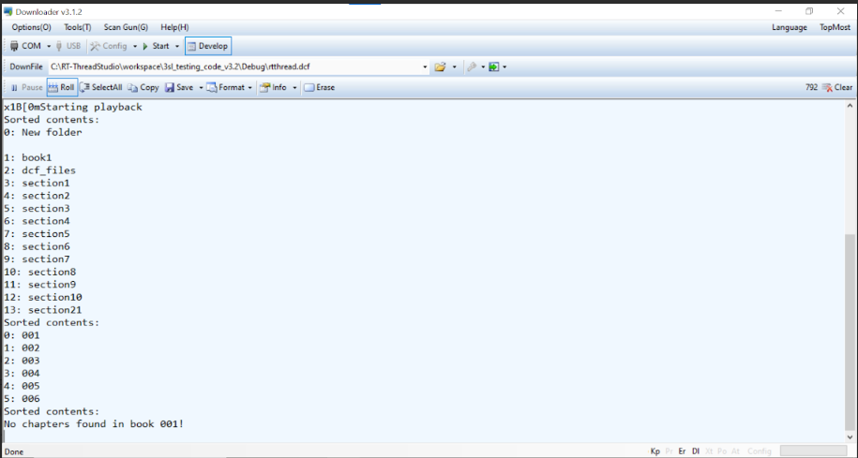

9. **Using the "Section Forward" Button:**

* The "Section Forward" button allows you to move through the code step by step. Clicking it will execute one instruction at a time.

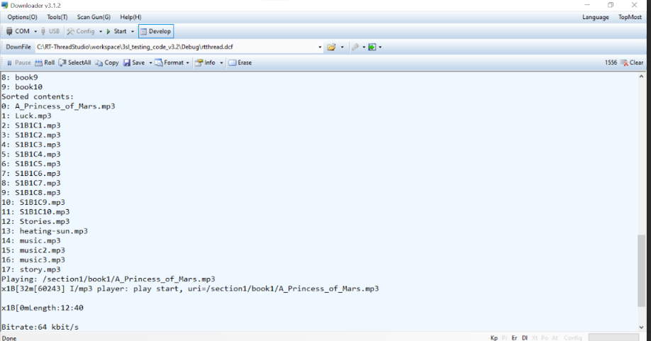

10. **Using the "Book" Button:**

* The "Book Forward" button enables you to move forward in larger increments, skipping over certain sections of the code.

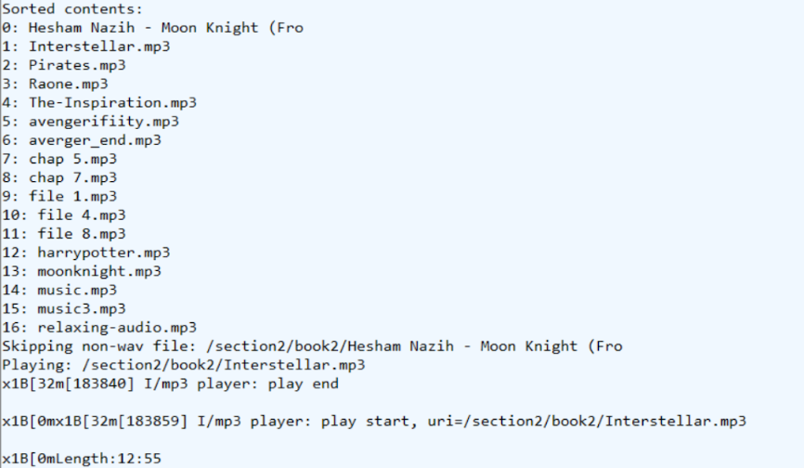

11. **Navigating Chapters:**

* Use the "Chapter Forward" button to navigate through different chapters or sections of the code.

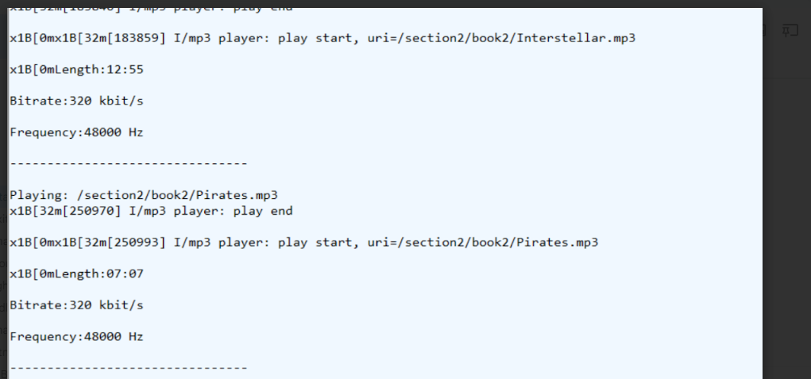

1. 12. **Adjusting Volume:**

* The "Volume" button can be used to adjust the volume of the debug output if necessary.

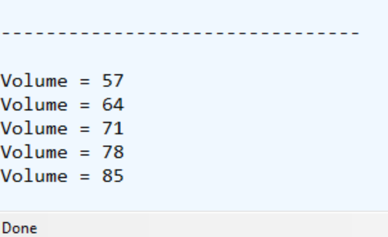

**Conclusion:**

By following this user manual, you should now be equipped to efficiently flash firmware onto your device using the downloader tool. The manual has covered every necessary step to ensure the device is connected, the firmware is successfully flashed, and the device can be debugged if needed. Should any issues arise during the process, the debugging features provided in the downloader can help resolve them. With this guide, you'll be able to confidently work with the downloader tool to manage your device's firmware and debugging needs.