**BMP180 Sensor Barometric Pressure Sensor**

BMP180 is one of sensor of BMP XXX series. They are all designed to measure Barometric Pressure or Atmospheric pressure. BMP180 is a high precision sensor designed for consumer applications. Barometric Pressure is nothing but weight of air applied on everything. The air has weight and wherever there is air its pressure is felt. BMP180 sensor senses that pressure and provides that information in digital output.

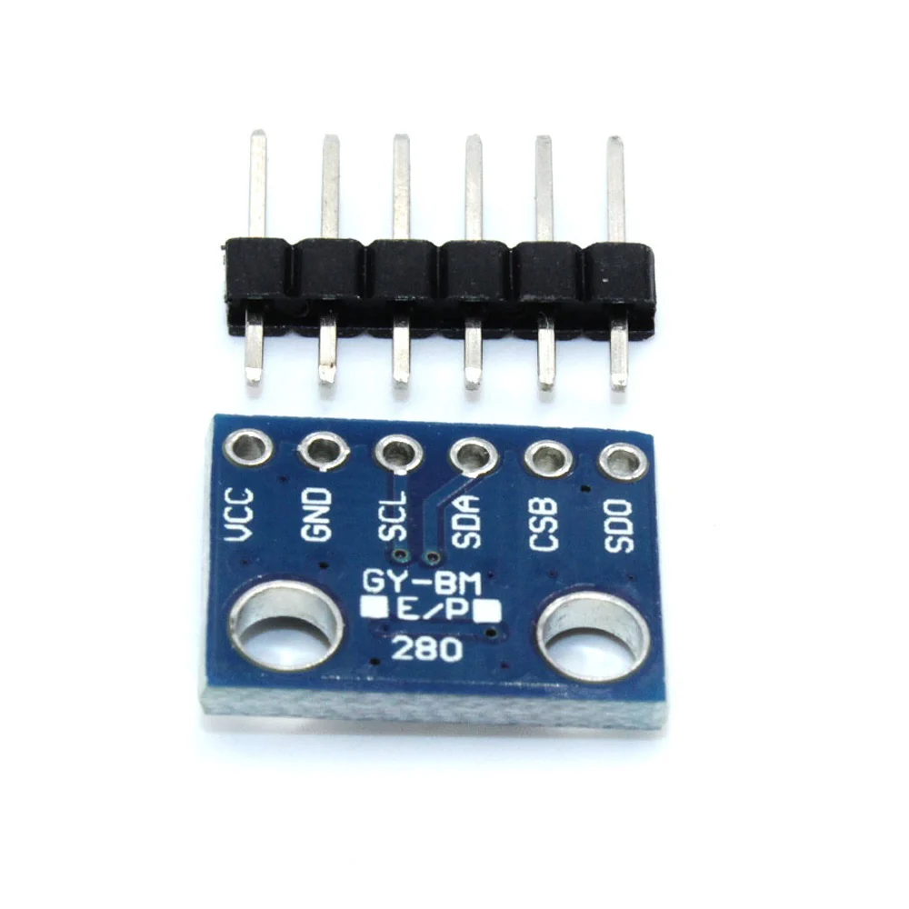

 Technical Specification:

* Operating  voltage of  BMP180: 1.3V – 3.6V
* Input voltage of  BMP180MODULE: 3.3V to 5.5V
* Peak current : 1000uA
* Consumes 0.1uA standby
* Maximum voltage at SDA , SCL : VCC + 0.3V
* Operating temperature: -40ºC to +80ºC
* Pressure range: 300 to 1100hPa
* Pressure conversion time: 5msec

Features:

* Can work on low voltages
* 4Mhz I2C interface
* Low power consumption (3uA)
* Potable size
* Can measure temperature and altitude
* It is available in two modules: 4-pin and 5-pin. The latter has an extra +3.3V as compared to the 4-pin.
* BMP180 works at low voltages – from 1.8V to 3.6V (3.3V is the advised voltage).
* Low demand for electricity
* Conversion of pressure within 5 milliseconds
* Wide pressure ranges from 300 to over 1,000 hectoPascals
* Portability
* High level of accuracy with more or less than 0.15hPa deviation
* Fast UI courtesy of a TWI interface
* Compatibility with I2C devices like memories and real-time clocks
* Can function as an altimeter and temperature sensor
* Data protection courtesy of EEPROM (electrically erasable read-only memory)
* BMP180 “communicates” through the I2C standard.

Applications:

* Indoor navigation
* Sport devices
* Computer Peripherals
* GPS
* Weather forecast
* Vertical velocity Indication
* Hobby projects
* BMP180 sensor
* Utilize the STM32F407VGt6 microcontroller as the core processing unit.
* Integrate the BMP180 sensor for temperature and pressure measurement.
* Ensure appropriate wiring and connections between the BMP180 sensor and the
* STM32 board using the CAN interface.
* Confirm compatibility and calibration of the BMP180 sensor with the STM32
* board for accurate temperature and pressure readings.
* Develop sensor data acquisition routines on the STM32 board tailored for the
* BMP180 sensor.
* Configure the STM32 board to sample temperature and pressure readings from
* the BMP180 sensor at regular intervals.
* Implement algorithms to convert raw sensor data into meaningful temperature
* values based on the BMP180 sensor's characteristics.

The BMP180 barometric pressure sensor, while not a primary safety component, can be used in vehicles for various functionalities that indirectly enhance safety. It's , which can be valuable for navigation and driver assistance systems. Additionally, it contributes to accurate air pressure readings, which can be used by the vehicle's computer for optimizing fuel injection and ignition timing.

1. Altitude and Vertical Velocity:

* The BMP180 measures atmospheric pressure, which changes with altitude.
* By calculating altitude, it can assist in navigation systems, especially when GPS signals are weak or unavailable.
* It can also be used to determine the vehicle's vertical velocity (rate of ascent or descent), which could be useful in situations like off-roading or when navigating inclines.

2. Engine Management:

* The sensor's pressure readings are used by the vehicle's Engine Control Unit (ECU) to optimize fuel injection and ignition timing.
* This optimization ensures the engine runs efficiently and smoothly, which indirectly contributes to safer driving by reducing the risk of stalling or poor performance.

3. Enhancing GPS Navigation:

* The BMP180 can improve the accuracy of GPS navigation systems, especially in areas with poor GPS signal reception, by providing altitude information.
* This can be helpful in mountainous regions or urban canyons where GPS signals are often obstructed.

4. Other Potential Applications:

* In specialized vehicles, like emergency response vehicles, the BMP180 could be used to monitor air pressure in tires or other critical systems.
* It could also be used in conjunction with other sensors to detect changes in road conditions, such as changes in elevation that could affect vehicle stability.

Important Considerations:

* The BMP180 is a relatively small and low-power sensor, making it suitable for integration into various vehicle systems.
* It's important to note that the BMP180 is not a direct safety component like airbags or braking systems. Instead, it provides data that can be used to improve the performance and functionality of other systems that contribute to overall vehicle safety.
* Proper calibration and integration of the BMP180 with other vehicle systems is crucial to ensure accurate and reliable data for safety-critical applications.