Resource requirements:
1)PIR Motion Sensor
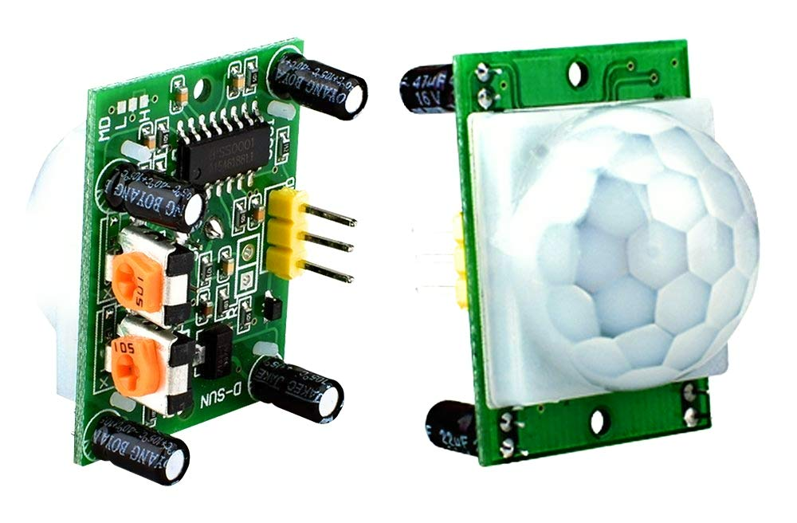

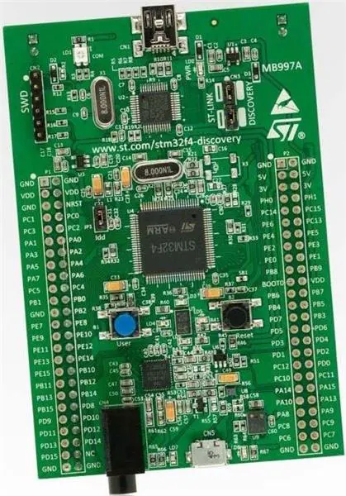
A PIR sensor is an electronic sensor used in motion detectors such as automatically triggered lighting devices and protection systems that measure devices emitting infrared light in their field of view.

2)STM32f407VGT6

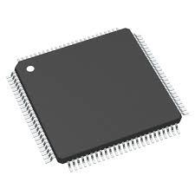
The STM32F407VGT6 is a high-performance microcontroller from STMicroelectronics, part of the STM32F4 series, built around the ARM Cortex-M4 core. Operating at up to 168 MHz, it delivers efficient processing with integrated digital signal processing (DSP) and floating-point unit (FPU) capabilities, making it suitable for applications requiring intensive computation and real-time performance.

Key Features
- Core: ARM Cortex-M4 32-bit RISC processor with FPU and DSP instructions.
- Clock Speed: Up to 168 MHz.
- Memory:
  - 1 MB Flash memory.
  - 192 KB SRAM.
  - 4 KB backup SRAM.
- Peripherals:
  - 16-bit and 32-bit timers.
  - 3 × 12-bit ADCs with up to 24 channels.
  - 2 × 12-bit DACs.
  - DMA controller with 16 streams.
  - True random number generator.
- Communication Interfaces:
  - 3 × I2C.
  - 3 × SPI.
  - 2 × CAN.
  - USART/UART.
  - USB 2.0 OTG (Full-Speed).
  - SDIO/MMC.
  - Ethernet MAC.
  - Camera interface (DCMI).
- Operating Voltage: 1.8V to 3.6V.
- Package: 100-pin LQFP.

Applications
The STM32F407VGT6 is versatile, catering to a wide range of applications:
- Industrial Automation: Used in motor control, programmable logic controllers (PLCs), and industrial sensors.
- Consumer Electronics: Found in audio systems, home appliances, and multimedia devices.
- Medical Devices: Employed in diagnostic equipment and patient monitoring systems.
- Networking: Utilized in Ethernet-enabled devices and communication modules.
- Automotive: Integrated into in-vehicle systems for control and monitoring purposes.
With its robust processing capabilities, extensive peripheral support, and low-power features, the STM32F407VGT6 is well-suited for complex embedded systems requiring high performance and versatility.

3) BPM 180 Sensor
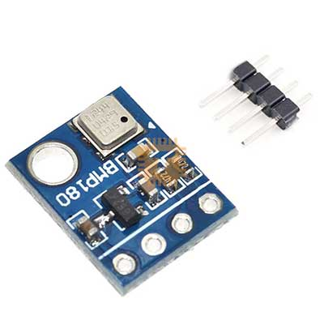

BMP180 is a next-generation sensor that performs a wide variety of functions, including working as an altimeter It provides high-precision reading and runs with its proprietary firmware or software for a more convenient digital use.

The BMP180 is a compact digital barometric pressure sensor developed by Bosch Sensortec, designed for applications requiring precise atmospheric pressure and temperature measurements. It is widely used in weather stations, altimeters, GPS navigation systems, and various portable devices.

Key Features
- Pressure Range: 300 to 1100 hPa, corresponding to altitudes between approximately -500 m to +9000 m above sea level.
- Temperature Range: -40°C to +85°C.
- Accuracy:
  - Pressure: ±0.12 hPa.
  - Temperature: ±1.0°C.
- Resolution:
  - Pressure: 0.02 hPa (approximately 0.17 m).
  - Temperature: 0.1°C.

nterface: I2C (Inter-Integrated Circuit), with a default address of 0x77.
- Power Consumption:
  - Active Mode: Approximately 3 µA.
  - Standby Mode: Approximately 0.1 µA.
- Operating Voltage: 1.3V to 3.6V, with onboard voltage regulation allowing compatibility with 5V systems.

Applications
- Weather Monitoring: Used in DIY weather stations to track atmospheric pressure and predict weather changes.
- Altitude Measurement: Serves as an altimeter in various devices, providing altitude data based on atmospheric pressure.
- GPS Enhancement: Improves GPS navigation accuracy by providing additional altitude information.
- Portable Devices: Integrated into smartphones, tablets, and sports devices for environmental sensing

4) MCP2551 CAN Controller
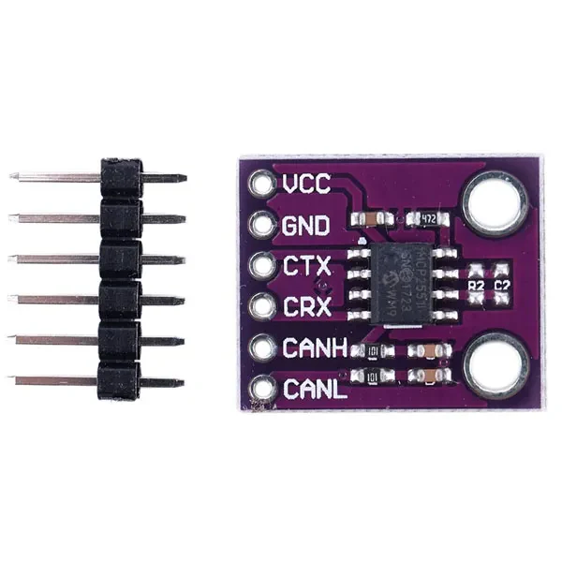

The MCP2551 is a high-speed, fault-tolerant CAN (Controller Area Network) transceiver developed by Microchip Technology. It serves as the interface between a CAN protocol controller and the physical bus, facilitating differential transmit and receive capabilities. Compliant with the ISO-11898 standard, the MCP2551 supports communication speeds up to 1 Mbps and is suitable for both 12V and 24V automotive systems. Its robust features include protection against short circuits, high voltage transients, and thermal shutdown, ensuring reliable operation in demanding environments.

Key Features
- High-Speed Operation: Supports up to 1 Mbps data rate.
- Wide Voltage Range: Operates between 4.5V and 5.5V.
- Fault Tolerance: Includes protection against short circuits, high voltage transients, and thermal shutdown.
- ISO-11898 Compliance: Fully compatible with the ISO-11898 standard, including 24V requirements.
- Bus Load Capacity: Can drive a minimum load of 45Ω, allowing up to 112 nodes on the CAN bus.
- Temperature Range: Industrial grade (-40°C to +125°C) for harsh environments.

5) GAS Sensor

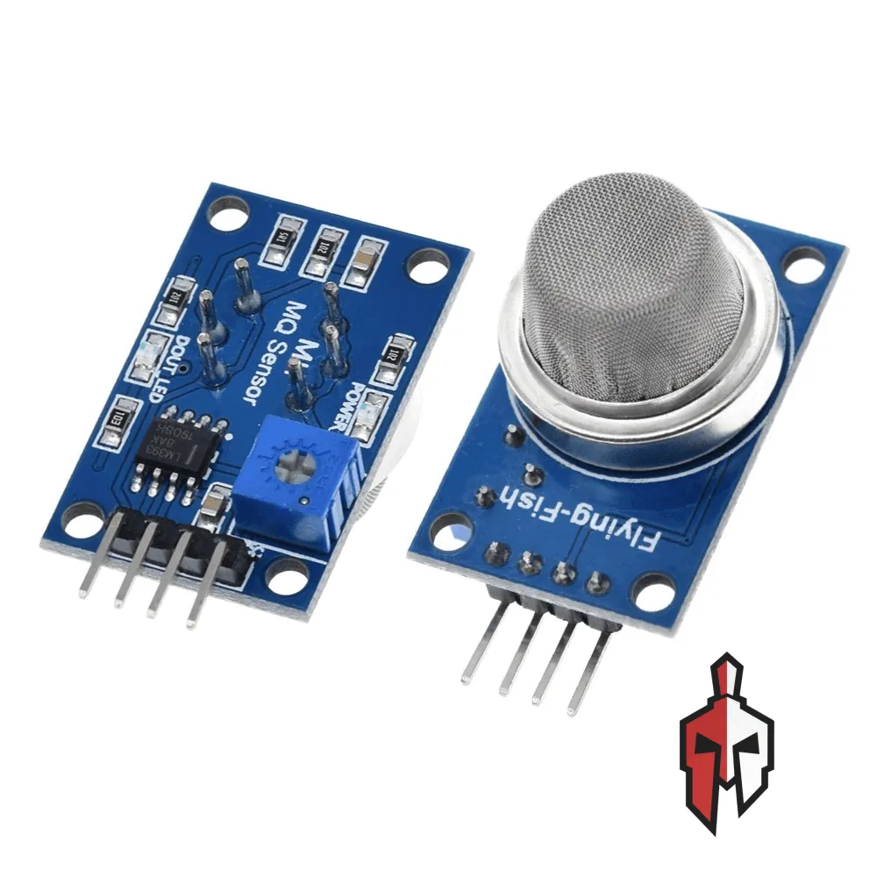

Defination:
A gas sensor is a device that detects and measures the presence and concentration of specific gases in a given environment These sensors are crucial for various applications, including environmental monitoring, industrial safety, and domestic safety systems. They work by detecting chemical reactions between a gas and a sensing material, converting this reaction into an electrical signal.

How they work:
Gas Interaction:
Gas molecules interact with the sensing material of the sensor, causing a change in its electrical properties (like resistance, conductivity, or capacitance)
Signal Conversion:
This change in electrical properties is then converted into a measurable electrical signal, which is proportional to the gas concentration.
Measurement:
The device then interprets this electrical signal to determine the presence and concentration of the target gas

Application
monitoring gas concentrations during production, detecting gas leaks, and ensuring process efficiency and safety
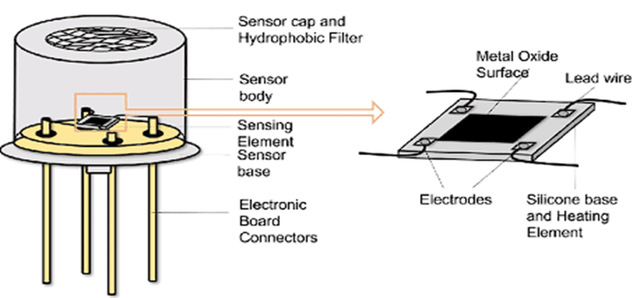

6) Connecting Wires
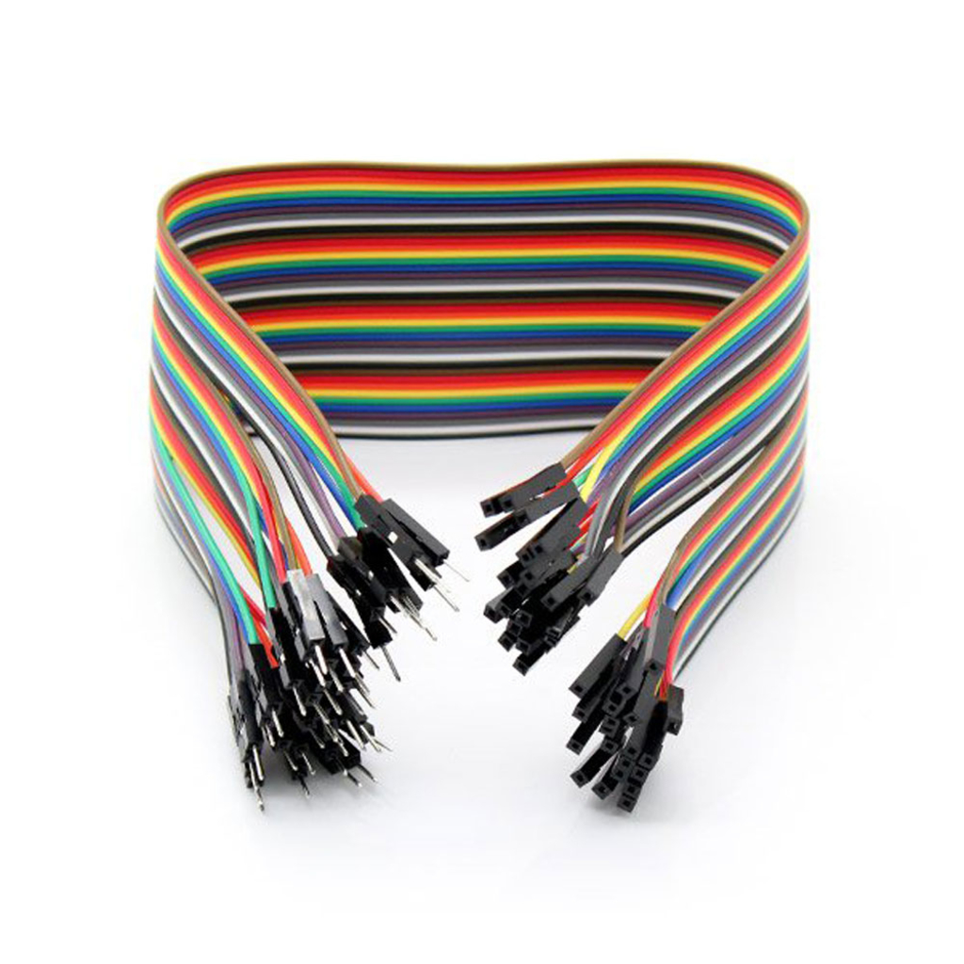

When selecting jumper wires, consider the specific requirements of your project, such as the type of connections needed, wire length, and flexibility. The products listed above offer a range of options to suit different breadboarding needs.

7) Electronics Breadboard
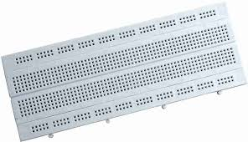

A breadboard, also known as a solderless breadboard or protoboard, is a tool used for building and testing electronic circuits without the need for soldering. It consists of a plastic board with a grid of holes into which electronic components and jumper wires can be inserted to create temporary circuit connections. Underneath the holes are metal clips that make electrical connections between components placed in the same row or column

