### Project Report



**ON**

## ‘Safety System For Mining Workers Based On RTOS’

Submitted in the partial fulfillment of the requirements for the PG Diploma

In

### Embedded Systems and Design (PG-DESD)

By

### Suraj Dahake (E2_Suraj_86882) Roshan Avadan (E2_Roshan_87176) Yash Rane (E2_Yash_86830)

**Vipin singh (E2_Vipin_86817)**

Sunbeam Institute of Information Technology, Pune and Karad

Year: 2024-25

**Sunbeam Institute of Information Technology, Pune and Karad.**

CERTIFICATE

Certified that the Project Progress report entitled, **‘Safety System For Mining Workers Based On RTOS’** is a bonafied work done by

### Vipin Singh (E2_Vipin_86817) Roshan Avadan (E2_Roshan_87176) Yash Rane (E2_Yash_86830)

**Suraj Dahake (E2_Suraj_86882)**

in partial fulfillment of the requirements for the award of **PG Diploma in Embedded Systems and Design (PG-DESD)**

Date: 12 /02/2025

E-Mail:



Student:

[vsvipinsingh22@gmail.com](mailto:vsvipinsingh22@gmail.com) [awadanroshan01@gmail.com](mailto:awadanroshan01@gmail.com) [raneyash392@gmail.com](mailto:raneyash392@gmail.com) [surajdahake2017@gmail.com](mailto:surajdahake2017@gmail.com)

# ACKNOWLEDEMENT

I dream it a great pleasure and privilege to have an opportunity to take up the project work under the guidance **Prof. Devendra Dhande** and **Prof. Ankush** , of “**Sunbeam Institute of Information Technology, Pune and Karad.**” and empress gratitude for rendered excellent guidance and valuable suggestions.

Finally, I thank all friends for their valuable help and all those who directly or indirectly helped me for completion of this project report.

**Vipin Singh (E2_Vipin_86817) Roshan Avadan (E2_Roshan_87176) Yash Rane (E2_Yash_86830) Suraj Dahake (E2_Suraj_86882)**

**Index**

|  |  |  |
| --- | --- | --- |
| **Contents** | | **Page** |
| ABSTRACT | | 01 |
|  | |  |
| 1 | Introduction | 02 |
|  | |  |
| 1. Required Components and Their Specifications    1. ESP32DevKit V1    2. STM32F407VG (ARM Cortex-M4)    3. MQ135 Sensor    4. Ultrasonic- Sensor    5. Gas Sensor    6. UART Communication.    7. ADC    8. Miscellaneous Components       1. USB Micro       2. Breadboard       3. Connecting Wire | | 03-10 |
|  | |  |
| 3 | Software requirement   * 1. STM32CubeIDE   2. Arduino IDE | 11 |
|  | |  |
|  | |  |
| 1. Block diagram of project    1. Explanation of Block diagram    2. Circuit Diagram    3. Schematic Diagram | | 12-16 |
|  | |  |
| 5 | Result  5.1 Web page | 17-20 |
|  | |  |
| 1. Advantages and disadvantages    1. Advantages of safet helmet sydtem    2. Disadvantages of Safety Helmet | | 21 |
|  | |  |
| 7 | Approximate Costing | 22 |
|  | |  |
| 8 | Future scope | 23 |
|  | |  |
| 9 | Conclusion | 24 |
|  | |  |
| 10 References | | 25 |

# ABSTRACT

To design and develop a real-time safety helmet system for mining workers using RTOS. The proposed system enhances worker safety by continuously monitoring environmental and physiological parameters. It integrates multiple sensors with the STM32F407 microcontroller and utilizes RTOS to ensure efficient multitasking and real-time data processing. The collected data is transmitted via ESP32 to a cloud platform, providing remote monitoring and timely alerts.

The system is designed to address the numerous hazards present in mining environments, such as toxic gas exposure, high temperatures, and worker fatigue.By incorporating advanced sensor technologies, the helmet continuously tracks critical parameters, ensuring early detection of potential risks. The integration of RTOS enables seamless task execution, optimizing real-time monitoring and response mechanisms.

Additionally, the helmet system enhances situational awareness by providing real- time feedback through various alert mechanisms, including visual and audio indicators. The adoption of UART and ADC communication ensures efficient data transfer, reducing latency and improving the overall responsiveness of the system. This approach not only enhances worker safety but also contributes to improved operational efficiency in mining industries.

The proposed system features sensors to detect hazardous gases, temperature, humidity, and worker vitals such as heart rate and motion. Data is sent to the cloud using UART communication protocol, ensuring real-time updates and alerts through an application. The system is crucial in industrial mining environments where immediate detection of dangerous conditions is essential for worker safety.

Mining safety is a critical concern, as workers are exposed to various risks, including gas leaks, high temperatures, and physical hazards. The deterioration of environmental conditions in underground mines can lead to severe health issues or accidents. The use of gas sensors, temperature probes, and physiological monitoring devices ensures continuous assessment of working conditions. The measured data is processed using STM32F407VG for sensor data processing and ESP32 for heart rate monitoring and processed locally and transmitted via UART to a monitoring system for visualization on dashboards and alerts through wearable indicators.

**Index Terms-** STM32F407VG, ESP32, RTOS, Sensors, Safety Monitoring, UART and ADC Communication, Embedded Systems, Real-Time Data Processing, Mining Worker Protection.

# INTRODUCTION

The RTOS(Real Time Operating System) is a rapidly expanding concept in this era of industrialization and technological advancement. It has become crucial for manufacturing companies and industries to prioritize , safety, and overall working conditions. RTOS enables the monitoring of physical objects connected through wired networks, and real-time data access. Addressing workplace safety concerns using RTOS-based solutions has become essential in high-risk industries such as mining.

Mining environments present significant risks, including toxic gas exposure, extreme temperatures, and physical hazards. The proposed system introduces a **real-time safety helmet** that integrates IoT and **RTOS** to continuously monitor environmental and physiological parameters. The system utilizes an **STM32F407 microcontroller** with various sensors, including **DHT11** for temperature and humidity measurement, **MQ2** for gas detection, **MAX30100** for heart rate monitoring, and an **ultrasonic sensor** for obstacle detection. A **red-led** provides immediate alerts when hazardous conditions are detected. Data is processed in real time using RTOS and transmitted via **UART and ADC communication** to a monitoring system for analysis and visualization.

Hazardous working conditions in mining industries pose severe threats to worker health and safety. Exposure to toxic gases, high temperatures, and industrial accidents can lead to severe health issues, including respiratory diseases, cardiovascular conditions, and physical injuries. Without proper safety measures, workers are at a constant risk of life-threatening incidents.

To mitigate these risks, the proposed **RTOS-based smart helmet** ensures real-time tracking of safety parameters and immediate alert mechanisms. The RTOS-based system optimizes multitasking by efficiently managing multiple sensor inputs, reducing latency, and enhancing response times. Unlike conventional safety mechanisms, this system offers continuous monitoring, automated hazard detection, and real-time notifications, significantly improving situational awareness in hazardous environments.

The smart helmet provides a **cost-effective, reliable, and scalable** safety solution for mining industries, ensuring real-time monitoring of environmental and worker health parameters. By integrating IoT and RTOS technology, this system enhances workplace safety, minimizes accident risks, and contributes to improved operational efficiency.

# REQUIRED COMPONENTS AND THEIR SPECIFICATIONS

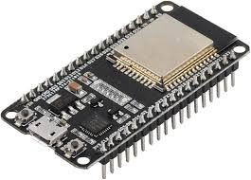

### NodeMCU ESP32

ESP32 is **a powerful microcontroller** designed for real-time data acquisition, processing, and wireless communication. It integrates built-in Wi-Fi and Bluetooth, making it suitable for IoT and embedded applications. In this project, ESP32 plays a key role in **collecting sensor data, processing it efficiently, and transmitting information** using UART and ADC interfaces. The system ensures seamless communication between **sensors and the monitoring unit**, improving safety measures in mining environments.

It supports a dual-core Xtensa LX6 processor, running at 160 MHz to 240 MHz, enabling high-speed multitasking and efficient real-time computations. Equipped with 520 KB SRAM and 4 MB flash memory, the ESP32 can handle complex tasks while ensuring stable performance. Its versatile communication interfaces, including UART, SPI, I2C, and ADC, allow smooth integration with sensors such as DHT11 for temperature and humidity, MQ2 for gas detection, MAX30100 for heart rate monitoring, and ultrasonic sensors for obstacle detection. Additionally, the buzzer module is controlled via ESP32 to provide immediate alerts in hazardous situations.

The ESP32 is widely used in IoT applications due to its low power consumption, making it ideal for battery-powered systems. It supports deep sleep and low-power modes, significantly extending battery life while ensuring continuous operation. The integrated Wi-Fi module enables real-time data transmission to cloud platforms, facilitating remote monitoring and data logging for analysis. Additionally, the ESP32 can operate as both a client and server, enabling flexible communication within IoT networks.

One of the key advantages of using **ESP32 is its capability to handle multiple sensors and execute complex algorithms without lag**. This makes it particularly suitable for applications requiring real-time decision-making, such as safety monitoring in mining environments. The microcontroller's support for **over- the-air (OTA) updates also allows for remote firmware upgrades**, minimizing downtime and ensuring system reliability.

SPECIFICATIONS:

* USB connector: Micro USB
* Operating voltage: 3.3 v
* Flash Memory/SRAM: 4MB / 520KB
* Digital I/O Pins: 34
* Analog In Pins: 18
* ADC Range: 0 – 3.3
* WiFi Built-In: 802.11 b/g/n **ESP32DevKit V1**

### STM32F407VG Discovery Board

The MQ-2 gas sensor module is designed for gas leakage detection in both household and industrial applications. It has high sensitivity to combustible gases such as methane, butane, and smoke, making it ideal for monitoring hazardous gas levels.

Additionally, it can detect smoke, carbon monoxide, and other harmful gases. The module provides an analog voltage output corresponding to the gas concentration, which can range from 200 to 10,000 ppm.

**Features:**

**Core:** ARM® 32-bit Cortex®-M4 CPU with FPU, operating at up to 168 MHz. It includes an Adaptive Real-Time Accelerator (ART Accelerator) for zero-wait state execution from flash memory, achieving up to 210 DMIPS/1.25 DMIPS/MHz (Dhrystone 2.1) with DSP instructions.

**Memory:** Supports up to 1 Mbyte of Flash memory, 192+4 Kbytes of SRAM, including 64-Kbyte core coupled memory (CCM) data RAM, and 512 bytes of OTP memory.

**External Memory Support:** Flexible static memory controller compatible with Compact Flash, SRAM, PSRAM, NOR, and NAND memories.

**LCD Interface:** Parallel interface supporting 8080/6800 modes.

##### Clock and Power Management:

* Operates on 1.8 V to 3.6 V supply for applications and I/Os.
* Features power-on reset (POR), power-down reset (PDR), programmable voltage detector (PVD), and brown-out reset (BOR).
* Includes an internal 16 MHz factory-trimmed RC oscillator with 1% accuracy.
* Supports a 32 kHz RTC oscillator with calibration and an internal 32 kHz RC oscillator.

**Low-Power Modes:** Sleep, Stop, and Standby modes with VBAT supply for RTC, 20×32-bit backup registers, and optional 4 KB backup SRAM.

##### Analog-to-Digital Conversion:

* 3×12-bit, 2.4 MSPS ADCs with up to 24 channels.
* 7.2 MSPS capability in triple interleaved mode.

##### Communication Interfaces:

* Up to 3 × I2C interfaces supporting SMBus/PMBus.
* Up to 4 USARTs and 2 UARTs (10.5 Mbit/s), including ISO 7816, LIN, IrDA, and modem control support.
* Up to 3 SPIs (42 Mbit/s), 2 with multiplexed full-duplex I2S for high-accuracy audio processing.
* 2 × CAN interfaces (2.0B Active) and an SDIO interface for storage applications.

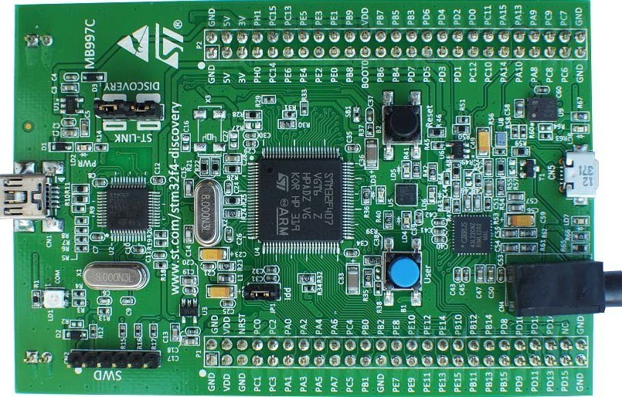

#### SPECIFICATIONS:

* STM32F407VG micro-controller featuring 32-bit Arm Cortex-M4 with FPU core, 1-Mbyte Flash memory and 192-kbyte RAM in an LQFP100 packages
* USB OTG FS
* ST MEMS 3-axis accelerometer
* SR-MEMS audio sensor omni-directional digital microphone Audio DAC with integrated class D speaker driver
* User and reset push-buttons Eight LEDs
* Board connectors
* Flexible power-supply options:ST-LINK,USB,Vbus,or external sources External application power supply: 3V and 5V
* Comprehensive free software including a variety of examples, part of STM32CubeF4 MCU package,or STSW-STM32068 for using legacy standard libraries
* On-board ST-LINK/V2-A debugger/programmer with USB re-enumeration capability: mass storage

#### APPLICATIONS:

* + Motor drive and application control
  + Medical equipment
  + Industrial applications: PLC, inverters, circuit breakers
  + Printers, and scanners
  + Alarm systems, video intercom, and HVAC
  + Home audio appliances

### MQ 135 Sensor

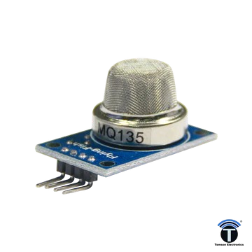

|  |  |  |
| --- | --- | --- |
| The MQ135 utilizes a SnO2 semiconductor material, which has lower | |  |
| conductivity in clean air, but its conductivity increases as the concentration | | |
| of polluting gases rises. This change in conductivity can be converted into a | | |
| gas concentration reading using a simple electronic circuit |  | |

**Applications:**

The MQ135 air quality sensor is utilized across various sectors to detect a range of gases, including ammonia, sulfide, benzene, smoke, and CO2, making it suitable for applications such as air quality monitoring in homes, offices, and vehicles, as well as in agricultural settings and industrial gas leak detection systems

**Product Highlights**:

Wide detecting scope Fast response and High

sensitivity Stable and long life

Simple drive circuit

#### SPECIFICATIONS:

The MQ135 air quality sensor detects various gases (NH3, NOx, CO2, alcohol,benzene, smoke) within 10-1000 ppm, operates at 2.5V-5V (typically 5V, 150mA), provides analog/digital outputs, requires a ~30-second preheat, and is compact (18mm diameter, 17mm high or module

size of 35mm x 22mm x 23mm),

offering good sensitivity and long-term stability.

**Working of MQ135 Sensor:**

The MQ135 air quality sensor requires two voltage inputs: heater voltage (VH) and circuit voltage (VC). After wiring VCC and GND, the module's power LED

illuminates. A preheat time of at least 2 minutes is needed. It's normal for the sensor to slightly heat up due to an internal heating wire, but overheating is not

normal. When no target gas is present or the concentration is below the threshold, the digital interface (D0) outputs a high level, and the analog interface (A0) voltage is around 0V. When the gas concentration exceeds the threshold, D0 outputs a low level, the digital indicator lights up, and the A0 voltage increases with gas concentration, potentially reaching up to 4V, with typical values of 0.1-0.3V in relatively clean air. A potentiometer adjusts the sensing range for the TTL

output. The digital output (D0) can directly drive a relay or positive buzzer module to create a gas switch or alarm. The analog output (A0) connects to an AD module for approximate ambient gas concentration values via AD conversion. The MQ135 detects gases such as ammonia, sulfide, benzene, CO2, and smoke. It operates from

2.5V to 5.0V, consuming around 150mA.

### DHT11

The DHT11 sensor is designed for measuring temperature and humidity. It operates by sending a start signal from the microcontroller and waiting for a response from the sensor. The sensor then transmits a 40-bit data packet, consisting of 16 bits for humidity, 16 bits for temperature, and 8 bits for a checksum. The microcontroller reads this data, allowing for precise monitoring of environmental conditions such as temperature and humidity.

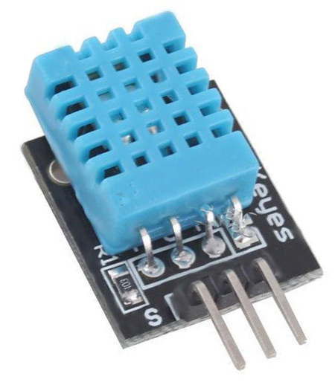**APPLICATIONS:**

Indoor climate monitoring  
• Weather stations  
• Agricultural automation  
• Smart home systems

##### SPECIFICATIONS:

• Power: 3.3V - 5V DC  
• Humidity Range: 20% – 90% RH  
• Temperature Range: 0°C – 50°C  
• Accuracy: ±5% RH, ±2°C  
• Sampling Rate: 1 reading per second  
• Communication: Single-wire digital signal  
• Dimensions: 15.5mm × 12mm × 5.5mm

##### WORKING:

The DHT11 sensor uses a capacitive humidity sensor and a thermistor to measure humidity and temperature. The microcontroller first sends a start signal, and the sensor responds with a digital pulse sequence. This 40-bit data packet contains humidity and temperature values, which the microcontroller reads and processes. The sensor operates on a single-wire communication protocol, making it simple to interface with microcontrollers like STM32, Arduino, and Raspberry Pi.

### Ultrasonic sensor

The ultrasonic sensor is designed for distance measurement and obstacle detection using sound waves. It operates by transmitting ultrasonic pulses and measuring the time taken for the echoes to return. This makes it highly effective for detecting objects and calculating distances with high accuracy.

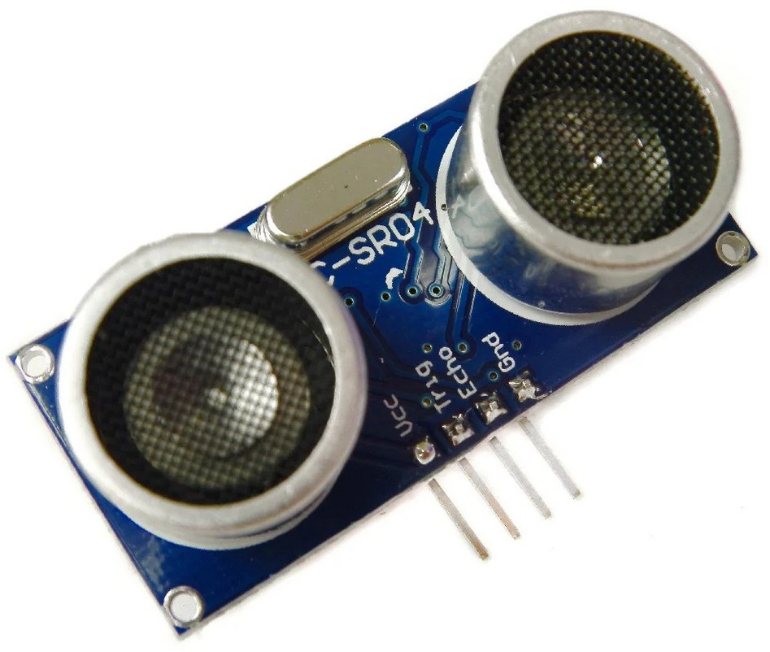

**APPLICATIONS:**

* Obstacle detection in automation systems
* Distance measurement in robotics
* Parking assistance systems
* Liquid level measurement

#### SPECIFICATIONS:

* Power: 5V DC
* Operating Frequency: 40 kHz
* Measurement Range: 2 cm to 400 cm
* Resolution: 3 mm • Output Signal: Digital pulse
* Trigger Input: 10µs TTL pulse • Echo Output: TTL signal proportional to distance
* Sensor Angle: <15°
* Dimensions: 45.0mm × 20.0mm

**WORKING:**

This is a simple-to-use ultrasonic distance sensor, suitable for detecting objects and measuring distances in real-time. The sensor transmits ultrasonic pulses at **40 kHz** and listens for the echo reflected from an object. The time taken for the echo to return is used to calculate the distance. The sensor provides a digital output signal that can be read using a microcontroller or ADC for further processing. The system is ideal for obstacle detection and proximity sensing in various applications.

### MISCELLANEOUS COMPONENTS

#### USB MICRO B

Enable you to easily transfer all your files from or to cell phone. USB 2.0 data sync and power charger cable. Flat design, convenient use with portability and durability.

#### BREADBOARD

A thin plastic board used to hold electronic components (transistors, resistors, chips, etc.) that are wired together. Used to develop prototypes of electronic circuits, breadboards can be reused for future jobs. They can be used to create one-of-a-kind systems but rarely become commercial products. See printed circuit board.

### USB MICRO B

**Breadboard**

The breadboard contains spring clip contacts typically arranged in matrices with certain blocks of clips already wired together. The components and jump wires (assorted wire lengths with pins at both ends) are plugged into the clips to create the circuit patterns. The boards also typically include metal strips along the side that are used for common power rails and signal buses.

* + 1. **CONNECTING WIRES**

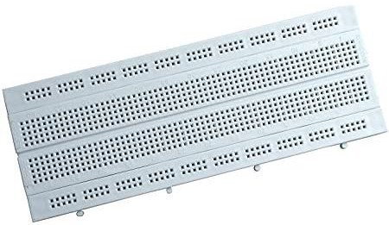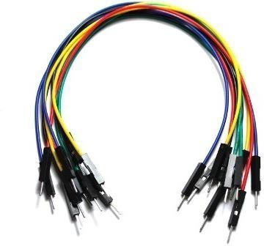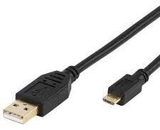

Jumper wires are simply wires that have connector pins at each end, allowing them to be used to connect two points to each other without soldering. Jumper wires are typically used with breadboards and other prototyping tools in order to make it easy to change a circuit as needed.

Though jumper wires come in a variety of colors, the colors don’t actually mean anything. This means that a red jumper wire is technically the same as a black one. But the colors can be used to your advantage in order to differentiate between types of connections, such as ground or power.

# SOFTWARE REQUIREMENT

* 1. **Arduino IDE**

The Arduino Integrated Development Environment - or Arduino Software (IDE) - contains a text editor for writing code, a message area, a text console, a toolbar with buttons for common functions and a series of menus. It connects to the Arduino and Genuino hardware to upload programs and communicate with them.

Programs written using Arduino Software (IDE) are called **sketches**. These sketches are written in the text editor and are saved with the file extension .ino. The editor has features for cutting/pasting and for searching/replacing text. The message area gives feedback while saving and exporting and also displays errors. The console displays text output by the Arduino Software (IDE), including complete error messages and other information. The bottom righthand corner of the window displays the configured board and serial port. The toolbar buttons allow you to verify and upload programs, create, open, and save sketches, and open the serial monitor.

Arduino is a company based in Italy that manufactures microcontroller boards, interactive objects, and kits that has created a full IDE to work on the hardware that they manufacture. It is the most preferred IDEs among all in the list. It is a complete package with many examples and pre- loaded libraries. Arduino is easy to use and implement so that a 10-year-old enthusiast can work easily with it. This IDE includes support for



##### STMCubeIDE:

STM32CubeIDE is a comprehensive software development environment from STMicroelectronics, tailored for their STM32 microcontrollers and microprocessors. It aims to encompass all stages of development, from chip selection and project configuration to code writing, compiling, and debugging.A key feature of STM32CubeIDE is the integrated STM32CubeMX, which offers a graphical interface for configuring the microcontroller.

This tool allows you to set up pin assignments, clock configurations, and middleware components, automatically generating the necessary initialization code.Built upon the Eclipse framework, STM32CubeIDE uses the GCC toolchain and GDB debugger, ensuring compatibility with many Eclipse plug-ins and offering ARM toolchain support in both C and C++ languages.Debugging is made easier with advanced features like live variable monitoring, access to CPU core and IP registers, memory views, Serial Wire Viewer, and tools for analyzing CPU faults.

The code editor includes automatic code completion, syntax highlighting, call hierarchy display, function previews, and code templates. Build and stack analyzers provide insights into project status and memory usage. To facilitate transitions from other tools, STM32CubeIDE supports importing projects from TrueSTUDIO and AC6 (SW4STM32). Finally, STM32CubeIDE is designed to work across different operating systems, including Windows, Linux, and macOS.



# BLOCK DIAGRAM OF PROJECT

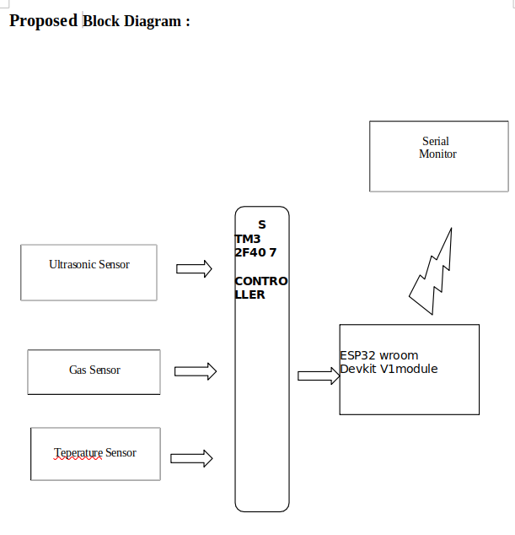

### Explanation of Block diagram:

### **STM32F407 Microcontroller:** The heart of the system. It processes data from the sensors and communicates with the ESP32.

* DHT11 (Temperature and Humidity Sensor): Typically connects via a single digital data pin to the STM32F407. The STM32F407 will use a software library to read the DHT11's specific communication protocol.
* Ultrasonic Sensor (HC-SR04): Requires two digital pins on the STM32F407: one for triggering the sensor and another for receiving the echo pulse. The STM32F407 calculates distance based on the echo pulse width.
* MQ135 (Gas Sensor): Outputs an analog voltage proportional to the gas concentration. This connects to an Analog-to-Digital Converter (ADC) input pin on the STM32F407.
* ESP32 (Optional): If you need Wi-Fi or Bluetooth connectivity, the ESP32 can act as a communication module. The connection between the STM32F407 and ESP32 is usually serial (UART). The STM32F407 sends sensor data to the ESP32, which then transmits it to a display, cloud server, or other device.
* Serial Communication (UART): Used for communication between the STM32F407 and ESP32. It's a common and reliable way to exchange data.
* Analog Input (ADC): The STM32F407's ADC converts the analog voltage output from the MQ135 sensor into a digital value that the microcontroller can understand.
* Power Supply: Provides power to all components (STM32F407, sensors, and ESP32 if used). Ensure the power supply is appropriately rated for the voltage and current requirements of each device.
* Display/Cloud/etc.: Represents the output stage. This could be an LCD display connected to the STM32F407, data sent to a cloud platform via the ESP32, or other output mechanisms.

Important Considerations:

* Pin Assignments: The specific pins on the STM32F407 used for each sensor and communication interface will depend on your hardware setup and code. Refer to the STM32F407 datasheet and your chosen development board's documentation.
* Software Libraries: You'll likely need to use software libraries for the DHT11, ultrasonic sensor, and potentially the MQ135 (for calibration and processing). The STM32CubeIDE or other STM32 development environments provide HAL (Hardware Abstraction Layer) functions that simplify working with peripherals.
* Power Management: Carefully consider the power requirements of all components and ensure the power supply can provide enough current.
* Signal Conditioning (for MQ135): The MQ135 often requires a specific circuit (including a load resistor) to function correctly. Consult the MQ135 datasheet.
* Communication Protocol: If using the ESP32, you'll need to decide on the communication protocol (e.g., UART, SPI, I2C) between the STM32F407 and ESP32. UART is the most common for this type of application.

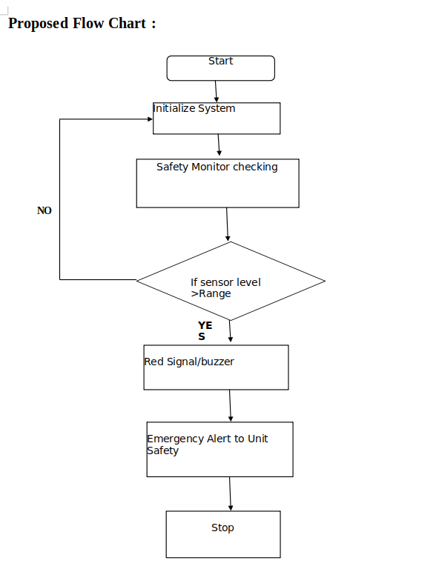

### **Flowchart Explanation:**

1. Start:
   * The system begins its operation.
2. Initialize System:
   * The necessary components of the system are initialized, such as sensors and monitoring units.
3. Safety Monitor Checking:
   * The system continuously monitors the environment using sensors to check safety parameters.
4. Decision Point – If Sensor Level > Range:
   * The system checks whether the sensor readings exceed a predefined safe range.
   * If NO, the system continues monitoring in a loop.
   * If YES, it triggers an emergency response.
5. Red Signal/Buzzer:
   * If the sensor reading is above the safe limit, the system activates a red warning signal or buzzer to alert users.
6. Emergency Alert to Unit Safety:
   * An emergency alert is sent to the safety unit to take appropriate action.
7. Stop:
   * The system stops its operation or enters a critical state.

### Circuit Diagram:

### 

### 

The breadboard diagram provides a real-world visual representation of component placement.

### **Component Placement**

* ESP32 and STM32F407 are placed separately.
* Sensors are mounted on the breadboard.
* Connections follow the schematic, ensuring proper wiring.
* A 5V battery pack is used as the power source.
* Wires interconnect different modules, matching the schematic wiring.

## **Flow of Operation**

1. Powering the System
   * The 5V battery pack powers both the ESP32 and STM32F407.
   * Voltage regulation ensures stable operation.
2. Sensor Data Acquisition
   * The MQ-135 detects gas concentration and outputs an analog voltage.
   * The DHT11 provides temperature and humidity readings.
   * The HC-SR04 ultrasonic sensor measures distance using ultrasonic waves.
3. Data Processing
   * The STM32F407 microcontroller reads sensor data.
   * It processes the data and decides whether to activate the LED alert.
4. Communication with ESP32
   * The ESP32 may be used to send sensor data wirelessly.
   * Could be programmed for IoT applications.
5. LED Alert System
   * If gas levels exceed a threshold, the LED lights up.
   * The system can trigger alarms or notifications.

### Schematic Diagram:

### 

The schematic diagram presents the structured electrical connections between components.

### **Components Used**

* ESP32 Wroom Devkit v1
* STM32F407 Microcontroller
* MQ-135 Gas Sensor
* DHT11 Temperature Sensor
* Ultrasonic Sensor (HC-SR04)
* LED Indicator (Red, 633nm)
* Resistors (1kΩ each)
* 5V Battery Power Supply

### **Connections Breakdown**

1. ESP32 Wroom Devkit v1
   * Connected to the STM32F407 microcontroller.
   * Communicates via GPIO pins.
   * Provides Wi-Fi/Bluetooth functionalities.
2. STM32F407 Microcontroller
   * Controls the sensors and processes the data.
   * Connected to various sensors via GPIOs.
3. MQ-135 Gas Sensor
   * VCC connected to 5V.
   * GND connected to GND.
   * AOUT (Analog Output) connected to STM32's analog input pin.
4. DHT11 Temperature Sensor
   * VCC connected to 5V.
   * GND connected to GND.
   * Data Pin connected to STM32 GPIO pin.
5. Ultrasonic Sensor (HC-SR04)
   * VCC connected to 5V.
   * GND connected to GND.
   * Trigger Pin (TRIG) connected to STM32 GPIO.
   * Echo Pin (ECHO) connected to STM32 GPIO.
6. LED Indicator
   * Connected to STM32 via a 1kΩ resistor.
   * Used for alerting gas detection or other events.
7. Resistors (R1, R2, R3, R4 - 1kΩ each)
   * Pull-up resistors for sensors and signal conditioning.

# ADVANTAGES AND DISADVANTAGES

**#Advantages**

* Real-time Monitoring:Smart helmets provide real-time information about the miner's surroundings and their vital signs, which helps prevent accidents and reduces the risk of injury.
* Hazard Detection: The helmets can detect harmful gases like methane and carbon monoxide, high temperatures, humidity, and fire. They can also identify air pollution from coal mines, including carbon monoxide (CO) and carbon dioxide (CO₂).
* Location Tracking: GPS and proximity sensors help miners navigate the mine and alert them to obstacles or dangers nearby. GPS tracking technology improves the ability of mining companies to track worker locations in real-time, which can reduce response times in emergencies. RF-based circuitry can also detect workers moving through the mining site and map their current location.
* Emergency Assistance: Smart helmets often include a panic/emergency button that workers can press to signal an emergency, such as toxic gas inhalation, cave-ins, or physical injury. In case of an accident, the helmet can send an alert message and the user's location to pre-defined contacts via GSM.
* Vital Sign Monitoring: They can monitor the miner's vital signs, such as heart rate and body temperature, to ensure their health and safety.
* Alerts and Communication: The helmet can trigger a buzzer and send notifications to a control room in case of potential hazards, ensuring the real-time safety of the miner. Wireless transmission via a GPRS module with cloud IoT technology allows gas situation information to be uploaded to a server for monitoring and analysis.
* Helmet Detection: Some systems include a helmet removal sensor to ensure miners are wearing their safety helmets.

## #Disadvantages

* Cost  
  Developing and deploying smart helmets involves significant investment in sensors, microcontrollers (STM32F407), wireless modules (ESP32), and cloud infrastructure. Additional costs arise from software development, testing, and implementation.
* Maintenance and Reliability  
  Regular maintenance is required due to the reliance on multiple sensors (DHT11, MQ135, Ultrasonic), wireless communication (ESP32), and power management. Sensor malfunctions could lead to inaccurate readings, affecting miner safety.
* Potential for Malfunctions  
  Since smart helmets operate in hazardous environments, failures in decision-making processes (such as false alarms or sensor errors) can lead to safety risks. Human supervision is essential to validate the system’s decisions.
* Dependence on Infrastructure  
  Wireless communication and GPS tracking require a strong and stable network across the mining site. Underground mines may have limited connectivity, affecting real-time monitoring and response systems.

1. **Approximate Costing**

|  |  |
| --- | --- |
| **Components** | **Price** |
| NNodeMCU ESP32 | 500 RS |
| SSTM32F407VG | 2100 RS |
| MQ135 | 145 RS |
| UUltrasonic sensor | 90 RS |
| DHT11 | 60 RS |
| Connecting Wires | 50 RS |
| UUSB Micro B | 100 RS |
| **Total** | **3045 RS** |

# FUTURE SCOPE

The proposed system's architecture will enable real-time analysis of workplace safety conditions, providing authorities with accurate data for immediate action and preventive measures.

The future scope of real-time safety monitoring systems includes advancements in sensor technology, deeper integration with AI and machine learning, real-time hazard detection and response, and expanded sensor networks for enhanced workplace safety.

* **Wearable Smart Safety Gear** – Integration of additional wearable devices to improve real-time worker health monitoring.
* **Machine Learning (ML) for Improved Accuracy** – AI-based predictive models to identify potential hazards before they occur.
* **Integration with Industrial IoT** – Connecting safety monitoring systems with industrial automation for improved situational awareness.
* **Environmental Impact Assessments** – Using real-time data to evaluate and mitigate workplace environmental risks.
* **Enhanced Communication Networks** – Implementation of advanced wireless communication for improved real-time safety alerts and monitoring.

By implementing these future advancements, the safety monitoring system will continue to evolve, ensuring improved worker protection, workplace compliance, and enhanced industrial safety standards.

## Conclusion.

Safety monitoring systems play a crucial role in ensuring worker protection and minimizing risks in hazardous environments such as mining. By continuously tracking environmental conditions and worker health parameters, these systems provide valuable insights that contribute to proactive safety management and accident prevention.

The proposed system is developed to monitor real-time safety conditions for mining workers. It is designed to be cost-effective and energy-efficient, leveraging UART and ADC communication protocols for seamless data transmission. The project presents a comprehensive summary of various safety monitoring techniques, which are elaborated in detail. One of the most effective techniques used in the proposed system is real-time sensor-based monitoring with an integrated alert mechanism.

The collected data is processed and displayed on a monitoring interface, ensuring quick response times and timely hazard detection.

By implementing this advanced safety helmet system, mining workers can operate in a safer environment, reducing exposure to dangerous gases, extreme temperatures, and other workplace hazards. This solution contributes to enhanced workplace safety, improved worker well-being, and a significant reduction in occupational accidents

DESD (SUNBEAM, PUNE.

## References

L. Deng et al., "Design and Implementation of a Smart Helmet System for Mining Safety," IEEE IoT Journal, 2022.

G. Singh et al., "Real-Time Air Quality Monitoring Using IoT and Cloud Integration," International Journal of Smart Systems, 2023.

STMicroelectronics. (2023). STM32F407 Datasheet.  
Link: https://www.st.com/resource/en/datasheet/stm32f407vg.pdf

STMicroelectronics. (2023). STM32F407 Reference Manual (RM0090).  
Link: https://www.st.com/resource/en/reference_manual/dm00031020.pdf

STMicroelectronics. (2023). STM32Cube HAL/LL API Documentation.  
Link: https://www.st.com/en/embedded-software/stm32cube-f4.html

Y. Zhang and X. Li, "Design of Remote Monitoring System Based on STM32F407 Microcontroller," International Journal of Smart Home, 2020.