HTML
INTRODUCTION TO HTML
What is the HTML?
HTML stands for HyperText Markup Language.
-A markup language defines the structure and presentation of raw text.
-A HyperText is text displayed on a computer or device that provides access to other text through links (hyperlinks).
HTML is a markup language used to create documents on the web. It describes the structure and layout of a web page.
History of HTML
HTML was originally developed by Tim Berners-Lee while at CERN. While working at CERN, he became frustrated at having to log on to different computers to find different information and thought that there must be a better way. He figured that there must be a way to hop from one set of information to another that's on different computers. This concept of a hypertext system (connected with the networking technology and protocols needed to pass information between computers) would go on to form the basis for the fundamental language of the world wide web. HTML is a very evolving markup language and has gone through several changes since its inception.
Version Year
HTML 1991
HTML 2.0 1995
HTML 3.2 1997
HTML 4.01 1999
XHTML 2000
HTML5 2014
HTML Page Structure
The <head> element contains metadata about the page. HTML metadata is data about the HTML document and metadata is not displayed. Metadata typically defines the document title, character set, styles, scripts, and other meta information.
The <body> element indicates what should appear in the main browser window.
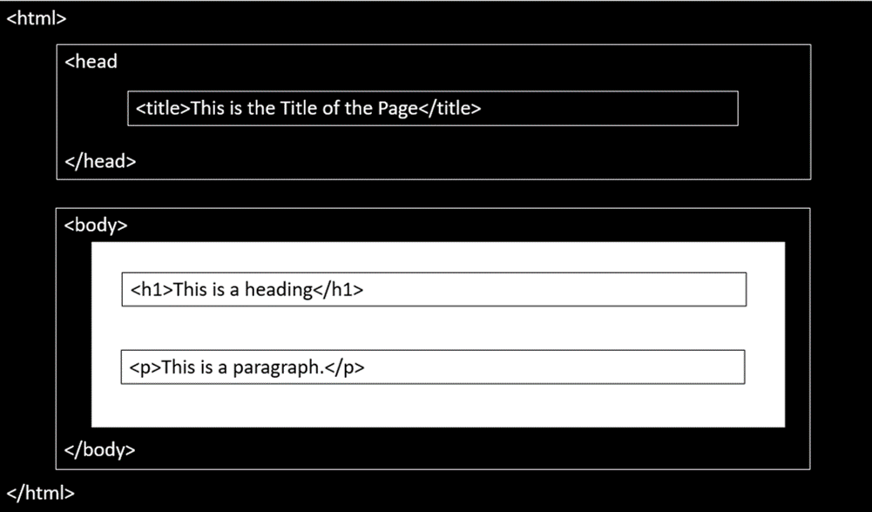
A Simple HTML Document
<!DOCTYPE html>
<html>
<head>
<title>Page Title</title>
</head>
<body>
<h1>This is a Heading</h1>
<p>This is a paragraph.</p>
</body>
</html>
Output:
This is a Heading
This is a paragraph.
Explanation of HTML Document:
The <!DOCTYPE html> declaration defines this document to be HTML5.
The <html> element is the root element of an HTML page.
The <head> element contains meta information about the document.
The <title> element specifies a title for the document.
The <body> element contains the visible page content.
The <h1> element defines a large heading.
The <p> element defines a paragraph.
HTML ELEMENTS AND TAGS
HTML Elements
HTML is composed of elements. HTML uses these elements to describe the structure of pages. A tag and the content between it is called an HTML element. Elements are usually made up of two tags: An opening tag and a closing tag. The opening tag is also called the starting tag, and the closing tag is called the end tag. Each HTML element tells the browser something about the information that is between its opening and closing tags.
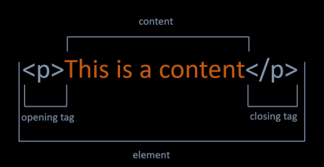
Nested HTML Elements
HTML documents consist of nested HTML elements. HTML elements can contain elements (elements can be nested). All HTML documents composed of nested HTML elements.
<!DOCTYPE html>
<html>
<body>
<h1>This is a Heading</h1>
<p>This is a paragraph.</p>
</body>
</html>
HTML Document above contains four HTML elements.
The HTML element includes the body element.
The body element includes the h1 and p elements.
Empty HTML Elements
If a HTML element does not have any content, it is called empty element.
Empty HTML elements do not have a closing tag.
For example, <br> and <img> elements are empty elements.
You will learn more about elements in this course.
HTML Tags
HTML tags are element names surrounded by angle brackets. The element name indicates the tag's purpose. For example, p stands for paragraph.
The opening tag denotes the start of a piece of content. The opening tag is composed of the left-angle bracket, element name, and right-angle bracket.
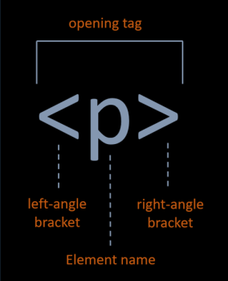
The closing tag denotes the end of an HTML element. The closing tag is composed of the left-angle bracket, forward slash, element name, and right-angle bracket.
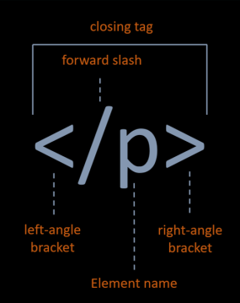
HTML Attributes
Attributes provide additional information about the contents of an element. Attributes are always specified in the opening tag and are made up of two parts: a name and a value, separated by an equals sign. For example, The style attribute is used to specify the styling of an element, like color, font, size etc.
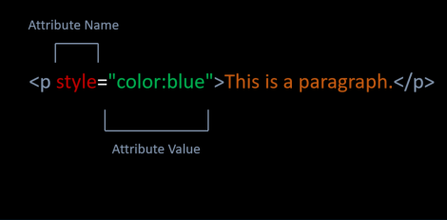
HTML TEXT
HTML Headings
Headings are used to describe content, like the title of an article. HTML has six "levels" of headings, which are graded according to importance. Headings are defined with the <h1> to <h6> tags. <h1> defines the most important heading. <h6> defines the least important heading.
<!DOCTYPE html>
<html>
<body>
<h1>The most important heading</h1>
<h2>This is heading 2</h2>
<h3>This is heading 3</h3>
<h4>This is heading 4</h4>
<h5>This is heading 5</h5>
<h6>The least important heading</h6>
</body>
</html>
HTML Paragraphs
The HTML <p> element stands for paragraph.
Paragraph element contains blocks of text.
<!DOCTYPE html>
<html>
<body>
<p>This is first paragraph.</p>
<p>This is second paragraph.</p>
</body>
</html>
Horizontal Lines
The <hr> tag creates a horizontal line.
The <hr> tag is displayed as a horizontal rule.
The <hr> tag is used to separate content on a HTML page.
<!DOCTYPE html>
<html>
<body>
<h1>This is heading</h1>
<p>Horizantal Line is below. </p>
<hr>
<p>Horizantal Line is above. </p>
</body>
</html>
HTML Line Breaks
The HTML <br> tag stands for a line break.
The <br> tag is used to add a single line of text.
The <br> tag has no end tag.
<!DOCTYPE html>
<html>
<body>
<p>This is a paragraph </p>
<p>This is <br> a new line.</p>
</body>
</html>
Output:
This is a paragraph
This is
a new line.
HTML Comments
Comments can add the text between these characters.
<!-- This is a comment-->
The browser does not display comments, but with comments, we can place warnings, descriptions and other notes.
Comments are also imported for debugging HTML. We can use comments for searching errors.
HTML Formatting Elements
HTML < b > Element
The <b> element is used to define bold text.
<!DOCTYPE html>
<html>
<body>
<p>This is a <b>bold</b> text</p>
</body>
</html>
Output:
This is a bold text
HTML < strong > Element
The <strong> element is used to define strong text.
The <strong> element uses for the semantic important texts.
<!DOCTYPE html>
<html>
<body>
<p>This is a <strong>strong</strong> text</p>
</body>
</html>
Output:
This is a strong text
HTML < i > Element
The <i> element is used to define italic text.
<!DOCTYPE html>
<html>
<body>
<p>This is an <i>italic</i> text</p>
</body>
</html>
Output:
This is an italic text
HTML < em > Element
The <em> element is used to define emphasized text.
<em> means that the text is "important".
<!DOCTYPE html>
<html>
<body>
<p>This is an <em>emphasized</em> text</p>
</body>
</html>
Output:
This is an emphasized text
The Difference Between Bold and Strong, Emphasized and Italics.
<strong> and <b> tags make text bold. They're identical when it comes to presentation.
<strong> represents a span of text with strong importance. There is an important semantic meaning here. They may look the same to humans. But, when a search engine spiders and analyzes a page, text in <strong> tags is considered important. Text in <b> tags is not.
Just like <strong> and <b>, <em> and <i> are identical in terms of presentation. They both make text italic. There is no semantic meaning for <i> tag. But, <em> tag represents a span of text with emphatic stress like <strong> tag.
HTML < small> Element
The <small> element is used to define smaller text.
<!DOCTYPE html>
<html>
<body>
<p>This is a <small>smaller</small> text</p>
</body>
</html>
Output:
This is an smaller text
HTML < sup > Element
The <sup> element is used to define superscript characters such as the suffixes of dates.
<!DOCTYPE html>
<html>
<body>
<p>Today is 15<sup>th</sup> of february.</p>
</body>
</html>
Output:
Today is 15th of february.
HTML < sub > Element
The <sub> element is used to define subscripted text.
<!DOCTYPE html>
<html>
<body>
<p>This is a <sub>subscripted</sub> text</p>
</body>
</html>
Output:
This is a _{subscripted} text
HTML < mark > Element
The <mark> element is used to define marked text.
<!DOCTYPE html>
<html>
<body>
<p>This is a <mark>marked</mark> text</p>
</body>
</html>
Output:
This is a marked text
HTML < ins > Element
The <ins> element is used to define inserted text.
<!DOCTYPE html>
<html>
<body>
<p>This is an <ins>inserted</ins> text</p>
</body>
</html>
Output:
This is an inserted text
HTML < del > Element
The <del> element is used to define deleted text.
<!DOCTYPE html>
<html>
<body>
<p>This is a <del>deleted</del> text</p>
</body>
</html>
Output:
This is a text
Summary of HTML Formatting Elements
Tag | Description
< b > | Bold text
< i > | Italic text
< strong > | Strong text
< em > | Emphasized text
< small > | Smaller text
< sup > | Superscripted text
< sub > | Subscripted text
< mark > | Marked text
< ins > | Inserted text
< del > | Deleted text
<!DOCTYPE html>
<html>
<body>
<p>This is a <b>bold</b> text</p>
<p>This is a <strong>strong</strong> text</p>
<p>This is an <i>italic</i> text</p>
<p>This is an <em>emphasized</em> text</p>
<p>This is a <small>small</small> text</p>
<p>Today is 15<sup>th</sup> of february.</p>
<p>This is a <sub>subscripted</sub> text</p>
<p>This is a <mark>marked</mark> text</p>
<p>This is a <ins>inserted</ins> text</p>
<p>This is a <del>deleted</del> text</p>
</body>
</html>
Output:
This is a bold text
This is a strong text
This is an italic text
This is an emphasized text
This is an smaller text
Today is 15th of february.
This is a _{subscripted} text
This is a marked text
This is an inserted text
This is a text
HTML Formatting Elements
Ordered List Elements
- The <ol> element is used to create ordered lists with a sequential order.
- Each list item is defined by the <li> tag.
<!DOCTYPE html>
<html>
<body>
<h1>Ordered HTML List</h1>
<ol>
<li>Chevrolet</li>
<li>Chrysler</li>
<li>Dodge</li>
</ol>
</body>
</html>
Output:
Ordered HTML List
- Chevrolet
- Chrysler
- Dodge
Unordered List Elements
- The <ul>element is used to create unordered lists with no particular order.
<!DOCTYPE html>
<html>
<body>
<h1>Unordered HTML List</h1>
<ul>
<li>Apple</li>
<li>Microsoft</li>
<li>Intel</li>
</ul>
</body>
</html>
Output:
Unordered HTML List
- Apple
- Microsoft
- Intel
HTML Tables
Basics of Table
- In order to create a table in HTML, we use <table> tag.
- The <tr> tag is used to define each table row.
- The <th> tag defines a table header.
- A table cell is defined with the <td> tag.
- Here is an example of a simple table with four rows and two columns.
<!DOCTYPE html>
<html>
<body>
<table>
<tr>
<th>Day</th>
<th>Lesson</th>
</tr>
<tr>
<td>Monday</td>
<td>Java</td>
</tr>
<tr>
<td>Tuesday</td>
<td>HTML</td>
</tr>
<tr>
<td>Wednesday</td>
<td>CSS</td>
</tr>
</table>
</body>
</html>
Output:
Table Border
- We can add border to table with border attribute in table tag like example below.
<table border="number">
- Avoid:The border attribute is not supported in HTML5. Use CSS instead.
<!DOCTYPE html>
<html>
<body>
<h1>Course Program</h1>
<table border="1">
<tr>
<th>Day</th>
<th>Lesson</th>
</tr>
<tr>
<td>Monday</td>
<td>Java</td>
</tr>
<tr>
<td>Tuesday</td>
<td>HTML</td>
</tr>
<tr>
<td>Wednesday</td>
<td>CSS</td>
</tr>
</table>
</body>
</html>
Output:

Course Program
Day | Lesson
Monday | Java
Tuesday | HTML
Wednesday | CSS

Colspan Attribute
- We can span two or more columns by using the colspan attribute like example below.
< td colspan="2" >Java< /td >
<!DOCTYPE html>
<html>
<body>
<h1>Course Program</h1>
<table border="1">
<tr>
<th>Day</th>
<th>Lesson-1</th>
<th>Lesson-2</th>
</tr>
<tr>
<td>Monday</td>
<td colspan="2">Java</td>
</tr>
<tr>
<td>Tuesday</td>
<td>Maven</td>
<td>Gradle</td>
</tr>
<tr>
<td>Wednesday</td>
<td>HTML</td>
<td>CSS</td>
</tr>
</table>
</body>
</html>
Output:

Course Program
Day | Lesson-1 | Lesson-2
Monday | Java
Tuesday | Maven | Gradle
Wednesday | HTML | CSS

Rowspan Attribute
- We can span two or more rows by using the rowspan attribute like example below.
< td rowspan="2" >Java< /td >
<!DOCTYPE html>
<html>
<body>
<h1>Course Program</h1>
<table border="1">
<tr>
<th>Day</th>
<th>Lesson-1</th>
<th>Lesson-2</th>
</tr>
<tr>
<td>Monday</td>
<td>Java</td>
<td>Git</td>
</tr>
<tr>
<td rowspan="2">Tuesday</td>
<td>Maven</td>
<td>Gradle</td>
</tr>
<tr>
<td>HTML</td>
<td>CSS</td>
</tr>
</table>
</body>
</html>
Output:

Course Program
Day | Lesson-1 | Lesson-2
Monday | Java | Git
Tuesday | Maven | Gradle
Tuesday | HTML | CSS

Align Attribute
- To change table or cell position, we can use the align attribute inside <table> tag or <td> tag.
<td align="center">java</td >
<!DOCTYPE html>
<html>
<body>
<h1>Course Program</h1>
<table border="1">
<tr>
<th>Day</th>
<th>Lesson-1</th>
<th>Lesson-2</th>
</tr>
<tr>
<td>Monday</td>
<td align="center" colspan="2" >Java</td>
</tr>
<tr>
<td>Tuesday</td>
<td>Maven</td>
<td>Gradle</td>
</tr>
<tr>
<td>Wednesday</td>
<td>HTML</td>
<td>CSS</td>
</tr>
</table>
</body>
</html>
Output:

Course Program
Day | Lesson-1 | Lesson-2
Monday | Java
Tuesday | Maven | Gradle
Wednesday | HTML | CSS

HTML Images
The < img > Tag
- We can improve the design of a web page by adding images.
- The <img> tag is used to define an image.
- The <img> tag is empty. It means that it does not have a closing tag.
- The src attribute allows us to specify the web address (URL) of the image and it is mandatory.
<!DOCTYPE html>
<html>
<body>
<h1>HTML Image</h1>
<img src="https://lms.clarusway.com/theme/image.php/boost/theme_boost/1581703952/ Clarusway-LOGOTYPE">
</body>
</html>
Output:

HTML Image

The alt attribute
- The alt attribute is used to provide an alternate text for an image in case the image fails to load on a web page or it is not supported by the browser, etc.
- Moreover, Visually impaired users browse the web via screen reading software. the screen reading software can read the text inside an alt attribute for impaired users.
- We should add alt attribute to the image tag just like the src attribute.
<!DOCTYPE html>
<html>
<body>
<h1>HTML Image</h1>
<img src="https://clarusway.comt/uploads/2019/11/ClaruswayLOGO_png100_326.png" alt="Clarusway">
</body>
</html>
Output:

HTML Image
The width and height attributes
- The width and height attributes are used to resize images.
<!DOCTYPE html>
<html>
<body>
<h1>HTML Image</h1>
<h2>Clarusway</h2>
<img src="https://clarusway.com/wp-content/uploads/2019/11/ClaruswayLOGO_png100_326.png" alt="Clarusway" width="100%" height="auto">
</body>
</html>
Output:

HTML Image

Clarusway

The border attribute
- By default, an image has no borders.
- To add a border around the image, we can use border attribute.
<!DOCTYPE html>
<html>
<body>
<h1>HTML Image</h1>
<img src="https://clarusway.com/wp-content/uploads/2019/12/cw_sonk%C3%BC%C3%A7%C3%BCk2.png" alt="Clarusway" border="2px">
</body>
</html>

HTML LINKS
The < a > Tag
- One of the advantages of HTML , is the ability to link to other web pages.
- The <a> element and including text is used to define a link.
<!DOCTYPE html>
<html>
<body>
<h1>HTML Links</h1>
<a>Welcome clarusway</a>
</body>
</html>
Output:

HTML Links
Welcome clarusway

The href Attribute
- Technically, we didn't complete the HTML link.
- We need href attribute inside opening <a> tag to specify which page we want to link.
- The href attribute defines the address of the link.
<!DOCTYPE html>
<html>
<body>
<h1>HTML Links</h1>
<a href="http://clarusway.com/">Welcome clarusway</a>
</body>
</html>
Output:

HTML Links
Welcome clarusway

The target Attribute
- The target attribute is used to specify how a link should open.
- In order to open link in a new page, the target attribute requires a value of _blank.
- We should add the target attribute inside opening <a> tag like href attribute.
<!DOCTYPE html>
<html>
<body>
<h1>HTML Links</h1>
<a href="http://clarusway.com/" target="_blank">Welcome clarusway</a>
</body>
</html>
Output:

HTML Links
Welcome clarusway

Image as a Link
- We can use an image as a link in HTML.
- For this, it is enough to put an <img> tag between opening and closing <a> tag.
<!DOCTYPE html>
<html>
<body>
<h1>HTML Links</h1>
<a href="http://clarusway.com/" target="_blank"><img src="https://drive.google.com/open?id=1u4ycHASa7sVNknCxXeca2dwD7l9Va0PK" alt="A lighthouse" width="50%" height="auto"></a>
</body>
</html>
Output:

HTML Links


