LINUX
INTRODUCTİON OF LİNUX
What is Linux?
Linux is an operating system just like Windows, iOS, and Mac OS. In fact, Android, one of the world's most popular platforms, is operated by the Linux operating system. An operating system is a software that manages all of your desktop or laptop's hardware resources. To put it simply, the operating system manages the communication between your software and your hardware. The software would not operate without the operating system (OS).
The History of Linux
Linus Torvalds invented Linux. While still a student at the University of Helsinki, he started developing Linux to create a system similar to MINIX, a UNIX operating system. In 1991 he released version 0.02; Version 1.0 of the Linux kernel, the core of the operating system, was released in 1994. At about the same time, American software developer Richard Stallman and the FSF made efforts to create an open-source UNIX-like operating system called GNU. In contrast to Torvalds, Stallman and the FSF started by creating utilities for the operating system first. These utilities were then added to the Linux kernel to create a complete system called GNU/Linux, or, less precisely, just Linux.
- Linus announces the kernel to the world (1991).
- Release of the first "major" Linux distributions (1993).
- Linux kernel hits 1.0 (1994).
- KDE (1996) / GNOME (1999) projects are released.
- First release of Linux-based Android (1998).
- Kernel development moves to Git (2005).
- Today Linux is everywhere. Supercomputers, smartphones, desktop, web servers, tablets, laptops and home appliances like washing machines, DVD players, routers, modems, cars, refrigerators, etc use Linux OS.
The components of Linux
There are several components of the Linux operating system.
Hardware
Computer hardware is the physical components that a computer system requires to function. It encompasses everything with a circuit board that operates within a PC or laptop; including the motherboard, graphics card, CPU (Central Processing Unit), power supply, and so on.
Boot-loader
The software that manages the boot process of your computer.
Kernel
It is the core part of the operating system and manages the CPU, memory, and peripheral devices. The kernel is the lowest level of the OS.
GNU Core
The GNU Core Utilities are the basic file, shell and text manipulation utilities of the GNU operating system. These are the core utilities that are expected to exist on every operating system.
X server
This is the sub-system that displays the graphics on your monitor. It is commonly referred to as the X server or just X.
Graphical User Interface
The Linux GUI is often referred to as a Desktop Environment. This is the piece that the users actually interact with. Several desktop environments are available to choose from (GNOME, Cinnamon, Mate, Pantheon, Enlightenment, KDE, Xfce, and so on).
Applications
Desktop environments do not have the full range of applications available. Just like Windows and macOS, Linux provides thousands upon thousands of software titles of high quality that can be easily found and installed.
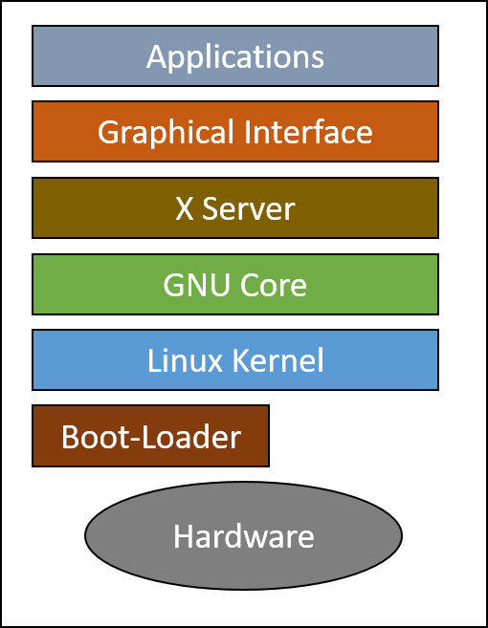

Popular Linux Distributions
Linux has a number of different versions to suit any type of user. These versions are called distributions (or, in the short form, “distros”).
Linux Mint
Linux Mint is a community-driven Linux distribution based on Ubuntu or Debian that strives to be a "modern, elegant and comfortable operating system which is both powerful and easy to use." Linux Mint provides full out-of-the-box multimedia support by including some proprietary software, such as multimedia codecs, and comes bundled with a variety of free and open-source applications.
Debian
Debian is an independent Linux distribution that was started by the joint association of individuals with the desire to make a free Operating System available to the world. It is designed to be a computing powerhouse capable of running on different types of hardware especially when being used for development.
Ubuntu
Ubuntu is one of the most popular, stable, and best fitted for the newcomers, which is a Debian based Linux distro. It has its own software repositories, which regularly synced with the Debian repository so that all the applications get stable and latest release.
OpenSUSE
openSUSE is a professionally and community-supported Operating System designed to provide field experts with a reliable computing environment for their work. It is distributed in 2 versions, Leap – a Long Term Support (LTS) release, and Tumbleweed – a rolling release, and they both use the YaST package manager for delivering applications to users. openSUSE is an independent Linux distribution that is sponsored by SUSE Linux in collaboration with other companies and it aims to dramatically simplify the process of developing and packaging software for developers and vendors.
Manjaro
Manjaro is an accessible, friendly, open-source Linux distribution and community. Based on Arch Linux, providing all the benefits of cutting-edge software combined with a focus on getting started quickly, automated tools to require less manual intervention, and help readily available when needed.
Fedora
Fedora is a free and open-source Linux distribution built with the aim of encouraging cutting edge technologies by spearheading innovation, working closely with Linux communities, and being amongst the first to integrate new technologies. It is sponsored by the Fedora Project and owned by Red Hat, developed independently of any other Linux distribution.
Red Hat Enterprise Linux (RHEL)
Red Hat Enterprise Linux (RHEL) is a Linux-based operating system from Red Hat designed for businesses. RHEL can work on desktops, on servers, in hypervisors or in the cloud. Red Hat and its community-supported counterpart, Fedora, are among the most widely used Linux distributions in the world.
Linux Embedded Systems
Embedded System
An embedded system is a computer system that is dedicated to one or two specific functions. This system is embedded as part of a complete computer system including hardware such as mechanical and electrical components.
Embedded Linux
Embedded Linux is a type of Linux operating system/kernel that is designed to be installed and used within embedded devices and appliances. It is a compact version of Linux that offers features and services in line with the operating and application requirement of the embedded system.
Android OS is a type of embedded Linux, customized to be used on smartphones. Many systems that use Linux embedded are:
- Smart TVs
- Tablet PCs
- Navigation devices
- Wireless routers
- Other industrial and consumer electronic equipment
Desktop Applications
Firefox
Mozilla Firefox, also known as the Firefox browser, or simply Firefox, is a free and open-source web browser developed by the Mozilla Foundation and its subsidiary, Mozilla Corporation. It is introduced in 2004 as part of the Mozilla Application Suite. Firefox included almost all the features offered by other browsers at that time, as well as a number of new features, including a bookmarks toolbar and tabbed browsing.
Thunderbird
Thunderbird is a free and open-source email, newsfeed, chat, and calendaring client, that’s easy to set up and customize.
LibreOffice
LibreOffice is community-driven and developed software, and is a project of the not-for-profit organization, The Document Foundation. LibreOffice is free and open-source software, originally based on OpenOffice.org (commonly known as OpenOffice), and is the most actively developed OpenOffice.org successor project. LibreOffice includes several applications that make it the most versatile Free and Open Source office suite on the market:
Writer (word processing)
Calc (spreadsheets)
Impress (presentations)
Draw (vector graphics and flowcharts)
Base (databases)
Math (formula editing)
GIMP
GIMP is an acronym for GNU Image Manipulation Program. It is a freely distributed program for such tasks as photo retouching, image composition, and image authoring.
Server Applications
Apache Web Server
Apache Web Server is an open-source web server creation, deployment, and management software. Initially developed by a group of software programmers, it is now maintained by the Apache Software Foundation. Apache Web Server is designed to create web servers that can host one or more HTTP-based websites. Notable features include the ability to support multiple programming languages, server-side scripting, an authentication mechanism, and database support. Apache Web Server can be enhanced by manipulating the code base or adding multiple extensions/add-ons.
NGINX
NGINX is open-source software for web serving, reverse proxying, caching, load balancing, media streaming, and more. It started as a web server designed for maximum performance and stability. In addition to its HTTP server capabilities, NGINX can also function as a proxy server for email (IMAP, POP3, and SMTP) and a reverse proxy and load balancer for HTTP, TCP, and UDP servers.
MySQL
MySQL was a free-software database engine originally developed and first released in 1995. It was originally produced under the GNU General Public License, in which source code is made freely available.
MySQL is very popular for Web-hosting applications because of its plethora of Web-optimized features like HTML data types, and because it's available for free. It is part of the Linux, Apache, MySQL, PHP (LAMP) architecture, a combination of platforms that are frequently used to deliver and support advanced Web applications. MySQL runs the back-end databases of some famous websites, including Wikipedia, Google, and Facebook- a testament to its stability and robustness.
Samba
Samba is an open-source software suite that runs on Unix/Linux based platforms but can communicate with Windows clients like a native application. So Samba can provide this service by employing the Common Internet File System (CIFS). At the heart of this CIFS is the Server Message Block (SMB) protocol.
Samba performs:
- File & print services
- Authentication and Authorization
- Name resolution
- Service announcement (browsing)
ownCloud
ownCloud is a client-server suite of applications for creating and using file hosting service. The functionality of ownCloud is similar to dropbox. However, your files are stored on your connected hardware.
Development Languages
Shell
Shell is a command language interpreter that executes commands read from the standard input device such as a keyboard or from a file. A shell script is a list of commands in a computer program that is run by the Unix shell. The most common Linux shell is named Bash. The name is an acronym for Bourne-again shell. Bash (like many other shells) has the ability to run an entire script of commands, known as a "Bash shell script" (or "script").
C
C is a high-level and general-purpose programming language used for a wide range of applications from Operating systems like Windows and iOS to software that is used for creating 3D movies.
Java
Java is a high-level programming language originally developed by Sun Microsystems and released in 1995. Java runs on a variety of platforms, such as Windows, Mac OS, and the various versions of UNIX. Java is Platform Independent, portable, robust, and dynamic, with the ability to fit the needs of virtually any type of application.
JavaScript
JavaScript is a high-level, cross-platform, object-oriented computer programming language. It is also one of the core technologies of the web, along with HTML and CSS. JavaScript is used to create client-side dynamic web pages. Java and javascript are completely different and distinct languages.
Perl
Perl is a highly capable, feature-rich programming language with over 30 years of development. Perl runs on over 100 platforms from portables to mainframes and is suitable for both rapid prototyping and large scale development projects.
Python
Python is a high-level programming language, with applications in numerous areas, including web programming, scripting, scientific computing, and artificial intelligence. Python has extensive object-oriented programming support with a clean and consistent syntax.
PHP
PHP is a popular general-purpose scripting language that is especially suited to web development. Fast, flexible and pragmatic, PHP powers everything from your blog to the most popular websites in the world.
Package Management Tools
Contemporary distributions of Linux-based operating systems install software in pre-compiled packages, which are archives that contain binaries of software, configuration files, and information about dependencies. Furthermore, package management tools keep track of updates and upgrades so that the user doesn’t have to hunt down information about bug and security fixes. Without package management, users must ensure that all of the required dependencies for a piece of software are installed and up-to-date, compile the software from the source code (which takes time and introduces compiler-based variations from system to system), and manage configuration for each piece of software. Without package management, application files are located in the standard locations for the system to which the developers are accustomed, regardless of which system they’re using.
Package management systems attempt to solve these problems and are the tools through which developers attempt to increase the overall quality and coherence of a Linux-based operating system.
dpkg
On Linux operating systems that use Debian package management, the dpkg command queries, installs, removes, and maintains Debian software packages and their dependencies.
apt-get
APT stands for the Advanced Packaging Tool. apt-get is a command-line tool that helps in handling packages in Linux. Its main task is to retrieve the information and packages from the authenticated sources for installation, upgrade and removal of packages along with their dependencies.
rpm: Red Hat Package Manager
RPM Package Manager (also known simply as RPM), originally called the Red-hat Package Manager, is a program for installing, uninstalling, and managing software packages in Linux. It is an open packaging system, which runs on Red Hat Enterprise Linux as well as other Linux and UNIX systems.
yum: yellowdog updater modified
Yum is an automatic updater and package installer/remover for rpm systems. It automatically computes dependencies and figures out what things should occur to install packages. It makes it easier to maintain groups of machines without having to manually update each one using rpm. Yum has a plugin interface for adding simple features. Yum can also be used from other python programs via its module inteface.
Open-Source Software and Licensing
What is open source?
Open-source software is software with source code that anyone can inspect, modify, and enhance.
"Source code" is the part of software that most computer users don't ever see; it's the code computer programmers can manipulate to change how a piece of software—a "program" or "application"—works. Programmers with access to the source code of a computer program can enhance the system by adding features to it or repairing sections that don't always work properly.
How does open-source software vary from other types of software?
Most software has source code that can be changed only by the individual, team, or organization that developed it — and retains sole control over it. That type of software is called "proprietary" or "closed source" software.
Only the original authors of proprietary software can legally copy, inspect, and alter that software. And in order to use proprietary software, computer users must agree (usually by signing a license displayed the first time they run this software) that they will not do anything with the software that the software's authors have not expressly permitted. Microsoft Office and Adobe Photoshop are examples of proprietary software.
Open-source software is different. Its authors make its source code available to others who would like to view that code, copy it, learn from it, alter it, or share it. LibreOffice and the GNU Image Manipulation Program are examples of open-source software.
Open-source Licensing
Open source licenses are licenses that comply with the Open Source Definition — in brief, they allow the software to be freely used, modified, and shared. To be approved by the Open Source Initiative (also known as the OSI), a license must go through the Open Source Initiative's license review process.
Types of open source license
There are generally two categories: permissive licenses and copyleft licenses.
A license that is permissive is simple and the most basic form of open source license. It allows you to do whatever you want with the software, as long as you abide by the requirements for notification. Permissive licenses provide the software as-is, with no warranties. So permissive licenses can be summarized as follows:
- Do whatever you want with the code
- Use at your own risk
- Acknowledge the author/contributor
Copyleft licenses add requirements to the permissive license. In addition to the requirements listed above, copyleft licenses also require that:
- If you distribute binaries, you must make the source code for those binaries available
- The source code must be available under the same copyleft terms under which you got the code
- You cannot place additional restrictions on the licensee's exercise of the license
Popular Licenses
Apache License 2.0
BSD 3-Clause "New" or "Revised" license
BSD 2-Clause "Simplified" or "FreeBSD" license
GNU General Public License (GPL)
GNU Library or "Lesser" General Public License (LGPL)
MIT license
Mozilla Public License 2.0
Common Development and Distribution License
Eclipse Public License version 2.0
FSF and OSI
Free Software Foundation (FSF)
The Free Software Foundation (FSF) is a nonprofit with a worldwide mission to promote computer user freedom. Free software is about having control over the technology we use in our homes, schools, and businesses, where computers work for our individual and communal benefit, not for proprietary software companies or governments who might seek to restrict and monitor us. The Free Software Foundation exclusively uses free software to perform its work.
The Free Software Foundation is working to secure freedom for computer users by promoting the development and use of free (as in freedom) software and documentation—particularly the GNU operating system—and by campaigning against threats to computer user freedom like Digital Restrictions Management (DRM) and software patents.
Open Source Initiative (OSI)
The Open Source Initiative (OSI) is a non-profit organization dedicated to the promotion of open-source software. OSI was founded in 1998 by Bruce Perens and Eric Raymond. OSI is quite distinct from the Free Software Foundation (FSF) led by Richard Stallman. Although they have similar history and motivation, OSI considers its ends as more pragmatic and business-driven, while FSF is based on anti-establishment and moralistic viewpoints. The OSI is actively engaged in building open source community, public advocacy, education, and promoting awareness regarding the significance of non-proprietary or open-source software. In order to establish an open-source environment around the world, OSI preserves and supports the Open Source Definition and also provides the OSI-Certified Open Source Software Certification Program. To achieve this OSI certification, the software should be distributed using a license that ensures the legal right to freely read, use, modify, and re-distribute the software.
Command Line Basics
What is the "Shell"?
Shell is the interface between the end-user and the Linux system.
Shell is a program that receives commands from the user and relays them to the operating system to process and displays the output. The main part of Linux is the shell. His distros come in the GUI (Graphical User Interface), but essentially Linux has a CLI (Command-Line Interface).
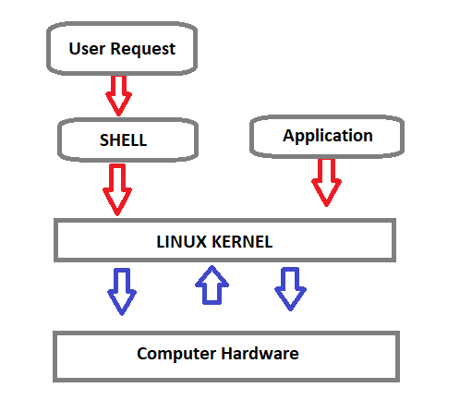
Shell Types
C Shell : If you are using a C-type shell, the % character is the default prompt.
- C shell (csh)
- TENEX/TOPS C shell (tcsh)
Bourne Shell : If you are using a Bourne-type shell, the $ character is the default prompt.
- Bourne shell (sh)
- Korn shell (ksh)
- Bourne Again shell (bash)
- POSIX shell (sh)
An enhanced version of it called BASH (which stands for Bourne Again SHell) serves as the shell program on most Linux systems.
- The standard Linux shell (BASH) is both a command-line interpreter and a programming language.
The most common interpreter is BASH or the Bourne Again Shell, but there are others available, some of them not using the dollar sign.
Command Prompt
The command prompt at the beginning of the command line is a short text string. The command prompt for Linux generally shows the current user, the current host, and the appropriate directory.
The prompt of the command is easily modified to display as desired more or less information. At the end of the prompt list, the $(dollar sign) signifies the current user being unprivileged.
- Dollar sign ($) means you are a normal user.$ sign prompt indicates you are logged in with the normal account.
- Hash (#) means you are the system administrator (root). # sign prompt indicates you are logged in with root account.
- The "root" account on a Linux computer is the account with full privileges.
- Root access is often necessary for performing commands in Linux, especially commands that affect system files. Because root is so powerful, it's recommended to only request root access when necessary, as opposed to logging in as the root user.
Basic Shell Commands
This is a list of most frequently used Linux commands.
- The ~ (tilde) symbol stands for your home directory.
- The pwd (stands for print working directory) command will allow you to know in which directory you're located.
- The ls command will show you the list of folders and files in your current directory.
- The cp command will make a copy of a file.
- The cd command will allow you to change directories.
- The rm command removes or deletes a file in your directory.
- The rmdir command will delete an empty directory.
- The mkdir command will allow you to create directories
- The mv command will move a file to a different location or will rename a file.
- cd - Navigate to the last directory you were working in.
- cd ~ or just cd Navigate to the current user's home directory.
- cd .. Go to the parent directory of current directory (mind the space between cd and ..)
Quoting
Quoting is used to disable special treatment of certain characters and words, as well as to prevent parameter expansion and preserve what is quoted.
The bash shell knows rare, special characters like $ (dollar sign), which is used to extend the value of the element. For example $PATH is used to extend the value of PATH element which is predefined variable in bash to hold system paths as shown below.
clarusway@f85a0c1549f4:~$ echo $PATH
/usr/local/sbin:/usr/local/bin:/usr/sbin:/usr/bin:/sbin:/bin:/usr/games:/usr/local/games
The special character $ can also be used with the user's custom element. For example, in the bash shell, the user can define an element like greeting="Hello from Clarusway" and extend the value of this element as shown below.
clarusway@f85a0c1549f4:~$ greeting="Hello from Clarusway"
clarusway@f85a0c1549f4:~$ echo $greeting
Hello from Clarusway
There are three types of quotes:
- Double Quotes : The double quote " preserve the literal value of most characters contained within the quotes, exceptions include $ (for variables), ' (for single quoting), \ (for escaping a character) .
clarusway@f85a0c1549f4:~$ echo $SHELL
/bin/bash
clarusway@f85a0c1549f4:~$ echo "$SHELL"
/bin/bash
clarusway@f85a0c1549f4:~$ echo "path to shell $SHELL"
path to shell /bin/bash
- Single Quotes: The single quote ( 'quote' ) protects everything enclosed between single quotation marks.
clarusway@f85a0c1549f4:~$ echo $SHELL
/bin/bash
clarusway@f85a0c1549f4:~$ echo '$SHELL'
$SHELL
clarusway@f85a0c1549f4:~$ echo 'path to shell $SHELL'
path to shell $SHELL
- Backslash: Use the backslash to change the special meaning of the characters or to escape special characters within the text such as quotation marks.
clarusway@f85a0c1549f4:~$ echo "\$SHELL"
$SHELL
clarusway@f85a0c1549f4:~$ echo "path to shell \$SHELL"
path to shell $SHELL
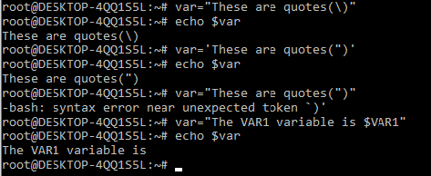
File Permission
Linux File Ownership
Each file and directory on Linux system has 3 types of owners assigned,
- User : A user is the owner of the file.
- Group : A user- group can contain multiple users.
- Other/All : Any other user who has access to a file.
Permission
Each file and directory on your Linux system has 3 permissions defined for all the 3 owners.
- Read : The read permission gives you the authority to open and read a file.
- Write : The write permission gives you the authority to modify the contents of a file.
- Execute : In Linux, you cannot run a program unless the execute permission is set.
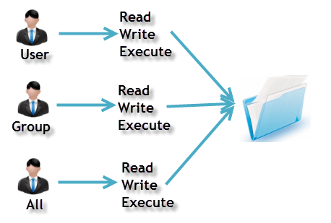
ls
ls -a
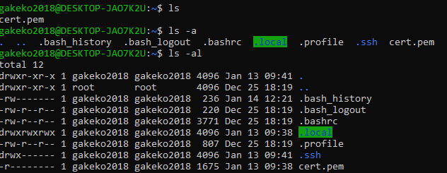
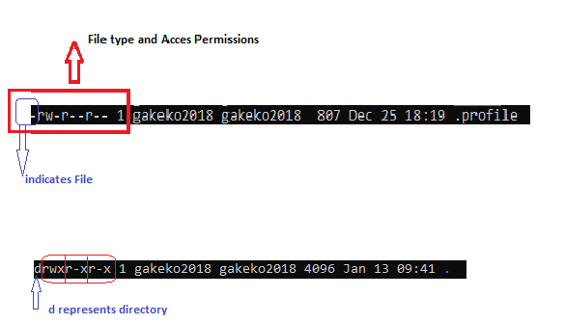
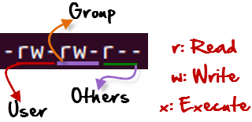
r = read permission
w = write permission
x = execute permission
- = no permission
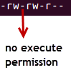
Changing Permission with chmod Command
We can use the chmod command which stands for change mode.
Using the command, we can set permissions (read, write, execute) on a file/directory for the owner, group and the world.
chmod permissions filename
The table below gives for all for permissions types.
Symbol | Permission Type
--- | No Permission
--x | Execute
-w- | Write
-wx | Execute+Write
r-- | Read
r-x | Read+Execute
rw- | Read+Write
rwx | Read+Write+Execute
Example
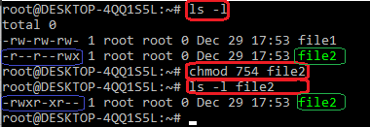
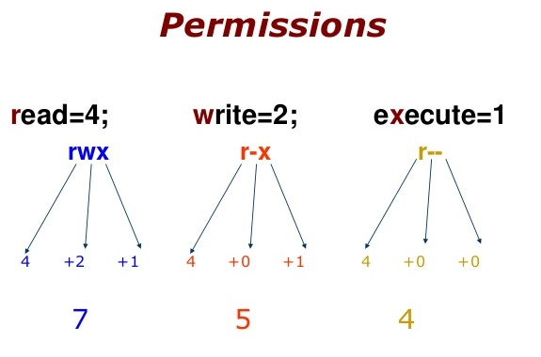
754 code says;
- Owner can read, write and execute
- Usergroup can read and execute
- Other can only read
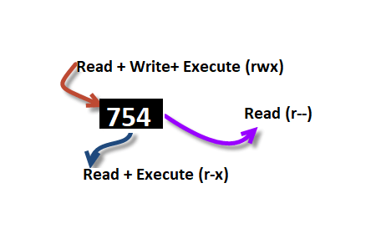
Ping & SSH Command
Ping Command
Ping or Packet Internet Groper is a network administration utility used to check the connectivity status between a source and a destination computer/device over an IP network. It also helps you assess the time it takes to send and receive a response from the network.
ping host-name/IP
Example
ping 54.93.34.220
Press CTRL+C (in MacOS => CMD+C) to exit.
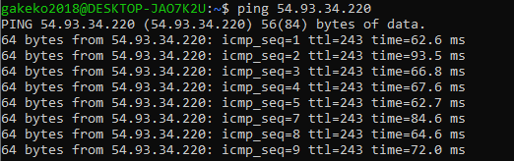
SSH
- ssh stands for “Secure Shell”.
- It is a protocol used to securely connect to a remote server/system.
- ssh is secure in the sense that it transfers the data in an encrypted form between the host and the client
ssh user@host(IP/Domain_name)
Example
ssh -i cert.pem ec2-user@54.93.34.220
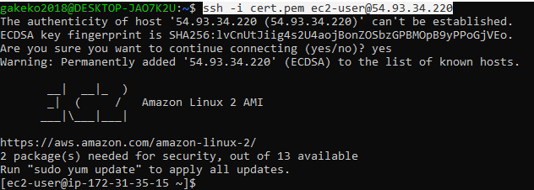
whoami Command
Displays user, group and privileges information for the user who is currently logged on to the local system.
- whoami command is used both in Lunix Operating System and as well as in Windows Operating System.
- It is basically the concatenation of the strings “who”,”am”,”i” as whoami.
whoami
Example:
clarusway@f85a0c1549f4:~$ whoami
clarusway
Using the Command Line to Get Help
Man Pages
- A man page (short for manual page) is a form of software documentation usually found on a Unix or Unix-like operating system.
- Man pages are the traditional package documentation for application usage. What that means is that they're typically installed when you install a package. So if we install a package to do some task, the man page for that package will typically be installed at the same time. This gives us the ability to take a look at that documentation and make sure that we're using it in a manner consistent with its design.
Usage
The man page for a particular command is invoked by preceding the command with man.
man <command>
man ls
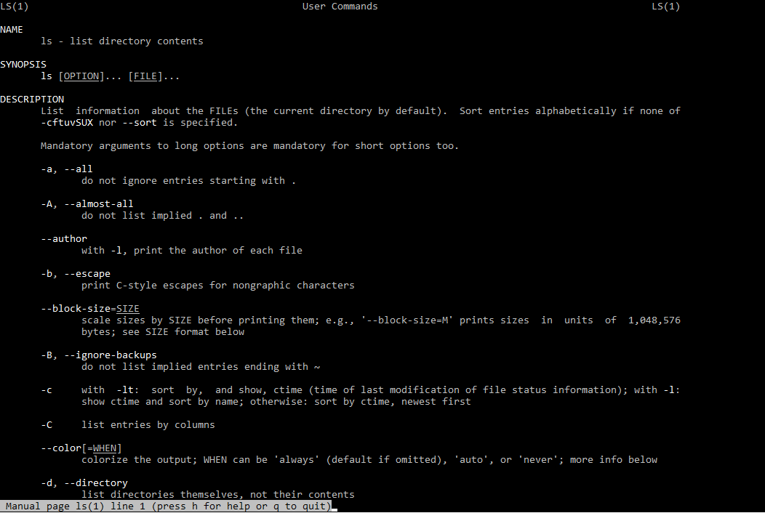
NAME
Program or Function name(s) followed by descriptions of functionality.
SYNOPSIS
A short overview of available options
DESCRIPTION
Detailed information about arguments and options.
Info Pages
Info pages are additional documentation with more robust capability in detail. Info Page normally provides more detailed information about a command than its respective man page. Additionally, Info uses a structure for linking these pages together, and they may be assembled into a larger collection.
Usage
The info page for a particular command is invoked by preceding the command with info.
info <command>
info echo
The main difference between Man and Info is the amount of content that they have; Info contains a whole lot more than Man does.
If no info page exists, info can pull documentation from the man page.
Using Directories and Listing Files
Files and Directories
The file system hierarchy standard (FHS) defines the structure of the file systems on Linux.
- In the FHS, all files and directories appear under the root directory / , even if they are stored on different physical or virtual devices.
- Most of these directories exist in all UNIX operating systems and are generally used in much the same way; however, the descriptions here are those used specifically for the FHS, and are not considered authoritative for platforms other than Linux.
- / (Root) : Primary hierarchy root and root directory of the entire file system hierarchy. Every single file and directory starts from the root directory.
- /bin : Essential command binaries that need to be available in single user mode.
- /boot : Boot loader files.
- /dev : Essential device files.
- /etc : Host-specific system-wide configuration files.
- /home : Users’ home directories, containing saved files. Home directories for all users to store their personal files
- /lib : Libraries essential for the binaries in /bin/ and /sbin/
- /mnt : Temporarily mounted filesystems.
- /opt : Optional application software packages.
- /proc : Contains information about system process.
- /sbin : Essential system binaries, e.g., fsck, init, route.
- /srv : Site-specific data served by this system, such as data and scripts for web servers, data offered by FTP servers, and repositories for version control systems. srv stands for service.
- /tmp : Temporary files. Often not preserved between system reboots, and may be severely size restricted.
- /usr : Secondary hierarchy for read-only user data; contains the majority of (multi-)user utilities and applications.
Hidden Files and Directories
Files and directories can be hidden from the basic listing. Files and directories in Linux may be set as hidden by preceding their name with a . (a single period).
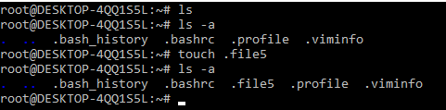
Hidden files can be listed via ls using the -a option (meaning show all files).
Home Directories
User home directories contain files specific to users. A directory under /home is typically created for every ordinary user on the Linux system.
cd (change directory) without a specified path
~ used to represent the user's home directory
$HOME environment variable used to store home directory path
To navigate to your home directory, use cd or cd ~
Absolute and Relative Paths
The path is the unique location of a file or directory.
The path to a file or directory location can be specified as an absolute path (starts with a /), or a relative path. Below is the pwd command show the absolute path of current working directory
[cloud_user@ip-10-0-1-10 ~]$ pwd
/home/cloud_user
Relative Path
Below, the cat command is used to show the content of file1 specified with a relative path.
[cloud_user@ip-10-0-1-10 ~]$ cat file1
Good Day
Absolute Path
Below, the cat command is used to show the content of same file1 specified with a absolute path.
[cloud_user@ip-10-0-1-10 ~]$ cat /home/cloud_user/file1
Good Day
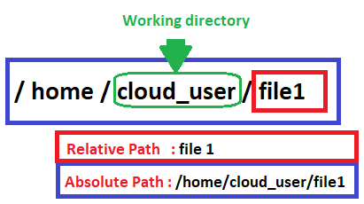
Creating, Moving, and Deleting Files
Creating, Moving, Deleting
Creating, moving, and deleting files and directories.
touch - create a file
rm - delete the file
cp - used to copy file or folder
mv - used to move file or folder
mkdir - create a folder
rmdir - delete folder
Working with directories
Create a new directory mkdir <NAME>
Copy a directory cp -r <SOURCE> <DESTINATION>
Move a directory mv <SOURCE> <DESTINATION>
Delete a directory rm -r <DIRECTORY>
Delete an empty directory rmdir <DIRECTORY>
Working with files
Create a new file touch filename
Removing Files rm -option filename
Option -r includes the contents of a directory and the contents of all subdirectories when you remove a directory.
Option -i prevents the accidental removal of existing files or directories.
Case Sensitivity
Most of the common Linux file systems are case sensitive; this is something to keep in mind when creating and moving directories and files.
Using Case Sensitivity
Lower-case and upper-case letters have different ASCII representation.
Example;
touch newfile
touch Newfile
The commands above will create two different files.
Simple Globbing
Globbing is primarily used to match patterns in filenames or text by using a wildcard character to create the pattern.
? (Question mark) : Match any single character
* (Asterisk) : Match any number of character(s)
[] (Brackets) : Match character from a range
^ (Caret) : Used to match starting character
$ (Dollar sign) : Used to match ending character
{} (Curly brace) : Used to match more than one pattern
| Pipe : Used for applying more than one condition
Example :
clarusway@f85a0c1549f4:~$ ls
all file1 file2 file3 file4 happiness loneliness reverse
clarusway@f85a0c1549f4:~$ ls file?
file1 file2 file3 file4
clarusway@f85a0c1549f4:~$ ls ?????
file1 file2 file3 file4
clarusway@f85a0c1549f4:~$ ls ????1
file1
clarusway@f85a0c1549f4:~$ ls file*
file1 file2 file3 file4
clarusway@f85a0c1549f4:~$ ls *
all file1 file2 file3 file4 happiness loneliness reverse
clarusway@f85a0c1549f4:~$ ls *ness
happiness loneliness
clarusway@f85a0c1549f4:~$ ls *[1-4]
file1 file2 file3 file4
clarusway@f85a0c1549f4:~$ ls *[2-3]
file2 file3
clarusway@f85a0c1549f4:~$ ls *[[:digit:]]
file1 file2 file3 file4
- [[:upper:]] or [[A-Z]] - match upper-case character
- [[:lower:]] or [[a-z]] - match lower-case character
- [[:digit:]] or [[0-9]] - match digits
- [[:alpha:]] or [[a-zA-Z]] - match either case character
- [[:alphanum:]] or [[a-zA-Z0-9]] - match alphanumeric
Manipulating Text Files with Text Editors
Why should I use an editor?
It is very important to be able to use at least one text mode editor. The first step toward independence is learning how to use an editor on your system.
We need to master an editor because we need it to edit files that affect our environment. You might want to start writing scripts, or books, creating websites or new programs as an advanced user. Mastering an editor will boost your productivity and your skills tremendously.
Which editor should I use?
Our focus for text editors is on the ones which can also be used in terminal windows and in systems without a graphical environment. The further advantage of mastering a text editor is its use on remote computers. Because you don't need to move the whole graphical environment over the network, working with text editors greatly enhances network speed.
Using the Vim editor
What’s Vim:
Vim stands for “Vi Improved”. Vim is a highly configurable text editor for efficiently creating and changing any kind of text. It is included as "vi" with most UNIX systems and with Apple OS X.
Vim can operate in two modes: command mode and insert mode.
The editor always starts in command mode. When you run vim filename command to edit a file, Vim starts out in command mode. It means that, instead of adding those characters, all alphanumeric keys are bound to commands. For example, Typing h won’t insert the character “h”, it will move the cursor to the left.
To enter the insert mode, type i for (“insert”) and now the keys will act the way you would expect. In the insert mode, you can type, move through the text, search, replace, mark blocks and perform other editing tasks. After pressing Escape, you are back in command mode.
Basic commands
Commands that switch the editor to insert mode
Vim Command | Description
a | append: it moves the cursor one position to the right before switching to insert mode
i | insert
o | insert a blank line under the current cursor position and move the cursor to that line.
Moving through the text
Moving through the text is usually possible with the arrow keys. If not, use:
Vim Command | Description
h | move the cursor one character to the left.
j | move the cursor down one line.
k | move the cursor up one line.
l | move the cursor one character to the right.
0 | move the cursor to the beginning of the line.
$ | move the cursor to the end of the line.
w | move forward one word.
b | move backward one word.
G | move to the end of the file.
gg | move to the beginning of the file.
Basic operations
Vim Command | Description
ndd | delete n lines starting from the current cursor position.
ndw | delete n words at the right side of the cursor.
x | delete the character on which the cursor is positioned
:n | move to line n of the file.
u | undo the last operation.
Ctrl-r | redo the last undo.
:w | save (write) the file
:q | exit the editor.
:q! | force the exit when you want to quit a file containing unsaved changes.
:wq | save and exit
:w newfile | will save the text to newfile.
:wq! | override read-only permission (if you have the permission to override permissions, for instance when you are using the root account.
:recover | will recover a file after an unexpected interruption.
Searching And Replacing
Vim Command | Description
/text | search the text in the file and position the cursor on the first match below its position.
n | move the cursor to the next instance of the text from the last search. This will wrap to the beginning of the document.
N | move the cursor to the previous instance of the text from the last search.
?text | search for text in the document, going backward.
:%s/text/replacement text/g | search through the entire document for text and replace it with the replacement text.
:%s/text/replacement text/gc | search through the entire document and confirm before replacing text.
Copying And Pasting
Vim Command | Description
v | highlight one character at a time.
V | highlight one line at a time.
Ctrl-v | highlight by columns.
y | yank text into the copy buffer.
p | paste text after the current line.
P | paste text on the current line.
np | paste it n times.
Using the nano editor
What’s nano:
GNU nano is a small and friendly text editor. Besides basic text editing, nano offers features like undo/redo, syntax coloring, interactive search-and-replace, auto-indentation, line numbers, word completion, file locking, backup files, and internationalization support.
Opening and Creating Files
To open an existing file or to create a new file, type nano followed by the file name:
nano filename
The default screen of nano consists of five areas. From top to bottom these are the title bar, a blank line, the edit window, the status bar, and two help lines.
The title bar consists of three sections: left, center and right. The section on the left displays the version of nano being used. The center section displays the current filename, or "New Buffer" if the file has not yet been named. The section on the right displays "Modified" if the file has been modified since it was last saved or opened.
The status bar is the third line from the bottom of the screen. It shows important and informational messages.
The two help lines at the bottom of the screen show some of the most essential functions of the editor. These two lines are called the Shortcut List.
Editing Files
Unlike vi, nano is a modeless editor, which means that you can start typing and editing the text immediately after opening the file.
Shortcut List
In both the toolbar and in the help text within the editor, key combos appear with standard Linux shortcut codes. All commands are prefixed with either ^ or M character. The caret symbol (^) represents the Ctrl key. For example, the ^G commands mean to press the Ctrl and G keys at the same time. The letter M represents the Alt key.
Command | Meaning | Description
Ctrl G | Get Help | display a complete list of commands and associated hotkeys.
Ctrl X | Exit | Close the program. You'll be prompted to save the current buffer or to exit without saving.
Ctrl O | Write Out | Save the current buffer to the filesystem.
Ctrl R | Read File | Open a file from the filesystem.
Ctrl W | Where Is | Search for a text string.
Ctrl \ | Replace | Replace one text string for another.
Ctrl K | Cut Text | Remove the current line of text.
Ctrl U | Uncut Text | Uncut from the cutbuffer into the current line
Ctrl J | Justify | Justify the current paragraph
Ctrl T | To Spell | Spell-check the current buffer.
Ctrl C | Cur Pos | Display the position of the cursor relative to the contents of the buffer as a whole.
Alt U | Undo | Undo the last operation
Alt E | Redo | Redo the last undone operation
Alt M | Mark Text | Mark text starting from the cursor position
Alt 6 | Copy Text | Copy the current line and store it in the cutbuffer

